Non-destructive investigation of the Kyathos (6th-4th centuries BCE) from the necropolis Volna 1 on the Taman Peninsula by Neutron Resonance Capture and XRF Analysis
Nina Simbirtseva^{1,2}, Pavel V. Sedyshev¹, Saltanat Mazhen^{1,2}, Almat Yergashov^{1,2}, Andrei Yu. Dmitriev¹, Irina A. Saprykina³, Roman A. Mimokhod³
¹ Frank Laboratory of Neutron Physics, Joint Institute for Nuclear Research, Dubna, Russia
² Institute of Nuclear Physics, Almaty, 050032, the Republic of Kazakhstan
³ Institute of Archaeology of the Russian Academy of Sciences, Moscow, Russial
ABSTRACT
The method of Neutron Resonance Capture Analysis (NRCA) is currently being developed at the Frank Laboratory of Neutron Physics (FLNP). The Analysis determines the elemental and isotope compositions of objects non-destructively, which makes it suitable measurement tools for artefacts without sampling. NRCA is based on the registration of neutron resonances in radiative capture and the measurement of the yield of reaction products in these resonances.
The potential of NRCA at the Intense Resonance Neutron Source (IREN) facility is demonstrated on the investigation of a Kyathos (6th-4th centuries BCE) from the necropolis Volna 1 on the Taman Peninsula. In addition, X-ray analysis was applied to the same archeological object. The element composition determined by NRCA and XRF data is in agreement.

Section: RESEARCH PAPER
Keywords: Neutron Resonance Capture Analysis; Non-destructive neutron analysis; XRF Analysis
Citation: Thomas Bruns, Dirk Röske, Paul P. L. Regtien, Francisco Alegria , Template for an Acta IMEKO paper, Acta IMEKO, vol. A, no. B, article C, Month Year, identifier: IMEKO-ACTA-A (Year)-B-C
Section Editor: name, affiliation
Received month day, year; In final form month day, year; Published Month Year
Copyright: This is an open-access article distributed under the terms of the Creative Commons Attribution 3.0 License, which permits unrestricted use, distribution, and reproduction in any medium, provided the original author and source are credited.
Funding:buy
Corresponding author: Paul P. L. Regtien, e-mail: paul@regtien.net

- Introduction
The Neutron Resonance Capture Analysis (NRCA) is non-destructive; the induced activity in experiments with bronze artefacts is very low, what was evaluated in several works one of them you can find in Ref. [1]. All this makes it promising for a research of archeological artifacts and objects of cultural heritage. NRCA is currently being developed in the Frank Laboratory of Neutron Physics [2]. The method is based on the use of a pulsed neutron source and time-of-flight technique [3]. The experiment was carried at the Intense Resonance Neutron Source (IREN) facility with multi-sectional liquid scintillator detector (210 liters) which was used for the registration prompt gamma-quanta and was created at FLNP JINR [4].
The method relies on registration of neutron resonances in radiative capture and measurement the yield of reaction products in these resonances. The resonance energies are known practically for all stable nuclei and set of energies doesn’t coincide completely for any isotopes pair. The energy positions of resonances give information about isotope and elemental composition of an object. Also, if you know area under the resonances, you can calculate the number of the element or isotope’s nuclei.
Apparently, Hans Postma from the Delft University of Technology (Delft, the Netherlands) should be considered the founder of research in cultural-heritage objects using neutron spectrometry methods. Under his leadership, experiments on the GELINA pulsed neutron source of the Institute of Reference Materials and Measurements of the Joint Research Center (Gel, Belgium) were carried out as part of a number of scientific programs devoted to this area (see, for example, the review [5] and references therein). Now such measurements are also being carried out on the ISIS pulsed neutron and muon source in the United Kingdom [6] and the J-PARC pulsed neutron source in Japan [7]. At the JINR FLNP, studies are being conducted on the IREN pulsed source of resonance neutrons [8], [9].
To implement neutron resonance analysis, the same methodology for measuring and processing experimental data is used as for determining resonance parameters. However, there are a number of features associated with the study of samples of irregular shape and heterogeneous composition, which is typical for archaeological sites.
This analysis was carried out for the kyathos which was transferred by the Institute of Archeology RAS.
- The Kyathos
In 2016-2018 a Sochi Expedition group of Institute of Archaeology of the Russian Academy of Sciences (IA RAS) under the leadership of Roman A. Mimokhod [10] conducted excavations of an antique town soil necropolis Volna 1 on the Taman Peninsula (Figure 1).
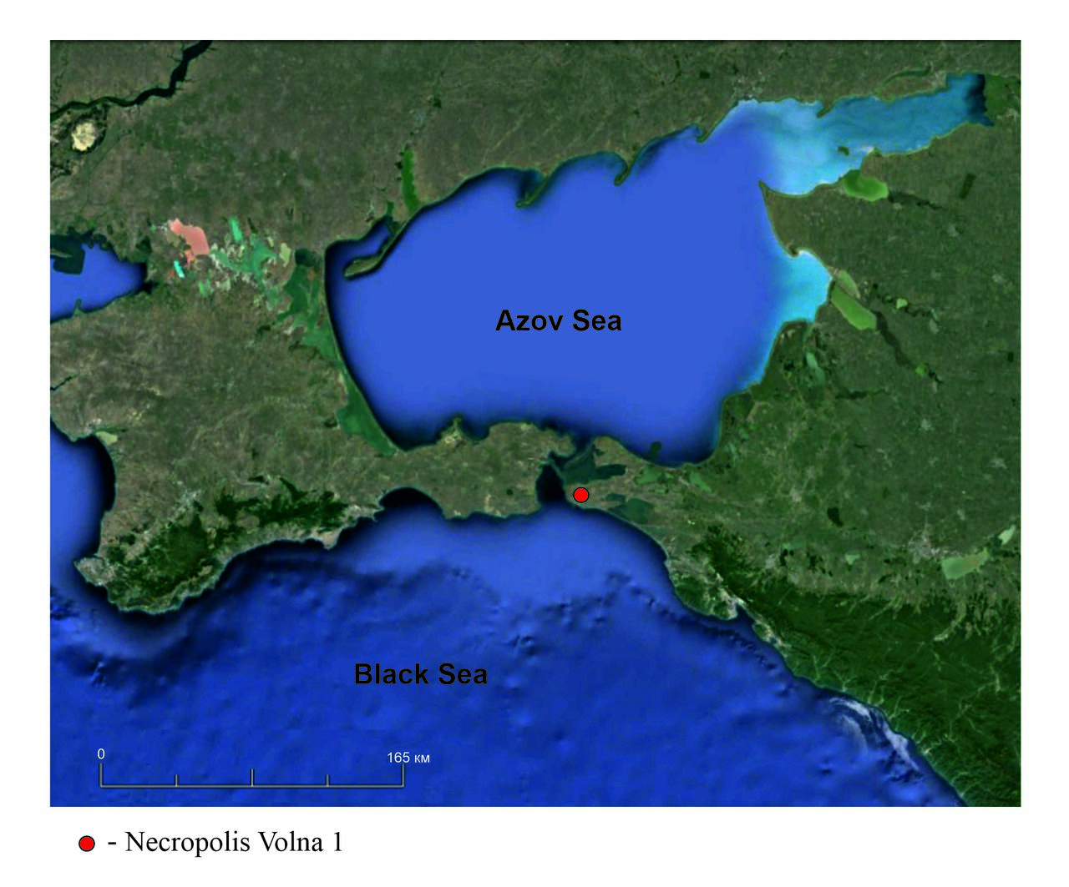
Figure 1. Location of the Volna 1 necropolis.

The necropolis is dated to the middle / second quarter of the 6th century BC - the beginning of the 3rd century BC, the main period of its use dates back to the second half of the 6th-5th centuries BC. The burials of the Volna 1 necropolis were supposedly left by the Greek and Barbarian population; the earliest burials may have been left by settlers who arrived from the territory of Magna Graecia (children's burials in amphorae, burials in the "rider's pose", etc.). The burial ground Volna 1 is an important monument for studying of a problem of Greek-Barbarian relations on the territory of the borderland - the Northern Black Sea region, the clash and interaction of two different ethnocultural layers of the population. The social structure, economic and political position of the first Greek colonies on the territory of the Bosporus depended on the nature of these contacts, their duration and strength, and the development of adaptive mechanisms. This interaction process was extremely complex, multifaceted and contradictory. On the one hand, with the emergence of the Greek colonies, confrontational relations with the local population inevitably developed, on the other hand, the Greek colonists and the local population influenced on each other. This process was superimposed on the specificity and uniqueness of the Northern Black Sea region, where for a long time societies of fundamentally different economic structures, the level of development of social, political and economic life came into contact.
More than 2,000 burials have been uncovered within the boundaries of the necropolis. An anthropological material, representative and significant for the history and archeology of the Northern Black Sea region, was obtained. The collection of items obtained during the excavations is represented by ceramic materials, incl. production of ceramic centers of Ancient Greece (container amphoras, kiliks, skyphoses, drinking bowls, lekythoses, askoses, etc.), Phoenician glass, weapons (spears, swords, arrows), protective weapons (full armor, helmet of the Corinthian type), jewelry (bronze, silver and gold earrings and rings, etc.), coins and other categories of burial objects.
All this testifies to the fact that the Volna 1 burial ground is a city necropolis. This places it in the category of the most prestigious necropolises of the Bosporan Kingdom. The necropolis was associated with the settlement of the same name, to which it adjoins from the north. In a settlement, existed from the pre-Greek period to the 3rd century BC, the systems of urban planning, stone house-building were studied. The fact that it is not a rural settlement, but a polis is evidenced by a number of prestigious finds, including, for example, a ceramic mask, which most likely indicates the presence of a theater in the city.
In the burials, objects rare for the territory of the Northern Black Sea region were found: a bronze prosthesis with a wooden support structure for a leg, an iron plate armor, a bronze Corinthian helmet of the "Hermione" type, musical instruments (cithara, lyre), a wreath on a gilded bone base with bronze petals and gold beads, as well as a series of kiathoi - ancient Greek vessels for pouring wine [11].
There are in total 17 burials from the materials of the excavations of IA RAS, where bronze kyathoi or their fragments were found. Their planigraphy is illustrative. Burials with these items are located in the early section of the necropolis, in the northwestern part (Figure 2).
In the excavations of the IA RAS in 2016, which is located to the south, kiathoi were not found. A Burial 656, in which the item, considered in the article, was found (Figure 3, 1), was paired.
One skeleton belonged to a man 45-55 years old, the second - to a woman 20-25 years old. The burial was done in a box, which was made of mud blocks. The dead were laid on a klinai - a wooden bed, from the legs of which characteristic recesses remained in the grave. The burial had pronounced military attributes. Fragments of an iron sword have been found near the male skeleton, an accompanying burial of a horse was done next to the pit. The kyathos was found in the filling of the burial pit. Its original position is unclear. However, the grave contains vessels that are clearly associated with wine drinking: skyphos (Figure 3, 3) and kilik (Figure 3, 4). The kyathos, as an item for scooping and pouring wine, complements this set. The volume of the scoop was 0.045 liters, that is, a quarter of a sextarius. In contrast to various similar finds made of clay (their production from clay began at the end of the 6th century BC), the kiathoi found on the territory of the necropolis Volna 1 were made of metal. It moves them in to the category of special objects. Presumably, these kiathoi refer to Greek imports that entered the northern Black Sea region along with the Greek colonists.

- NRCA experiment
The investigations were carried out at the IREN facility. The main part of the IREN facility is a linear electron accelerator. The facility parameters: the average energy of electrons was ~ 60 MeV, the peak current was ~ 1.5 А, the width of electron pulse was ~ 100 ns, and the repetition rate was 25 Hz. Neutron producing target is made of tungsten-based alloy and represents a cylinder 40 mm in diameter and 100 mm in height placed within an aluminum can 160 mm in diameter and 200 mm in height. Distilled water is circulated inside the can, providing target cooling and neutron moderation. Water layer thickness in a radial direction is 50 mm. The total neutron yield was about 3∙10¹¹ s⁻¹. The measurements were carried out at the 58.6 meters flight path of the 3rd channel of the IREN. The big liquid scintillator detector was used for the registration of γ-quanta. The sample was placed inside the detector. The neutron flux was permanently monitored by the SNM-17 neutron counter.

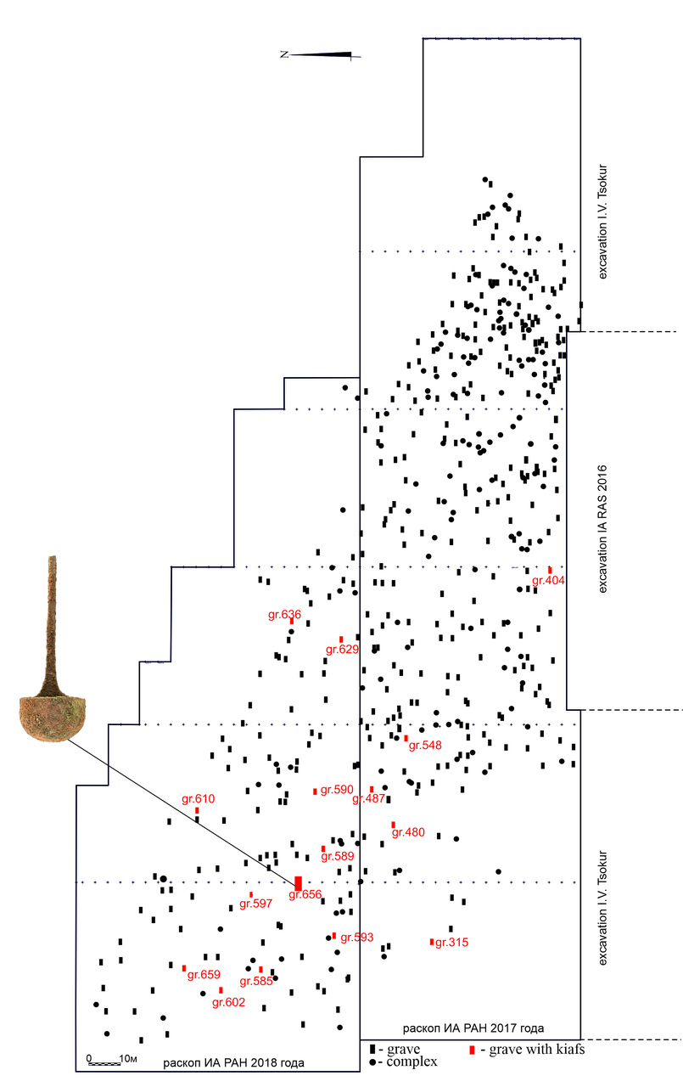
Figure 2. The scheme of the necropolis of excavations 2017 - 2018 and a location of the burials with kiathoi.

The signals from the detector and the monitor counter were simultaneously fed to the two independent inputs of time-to-digital converter (TDC).

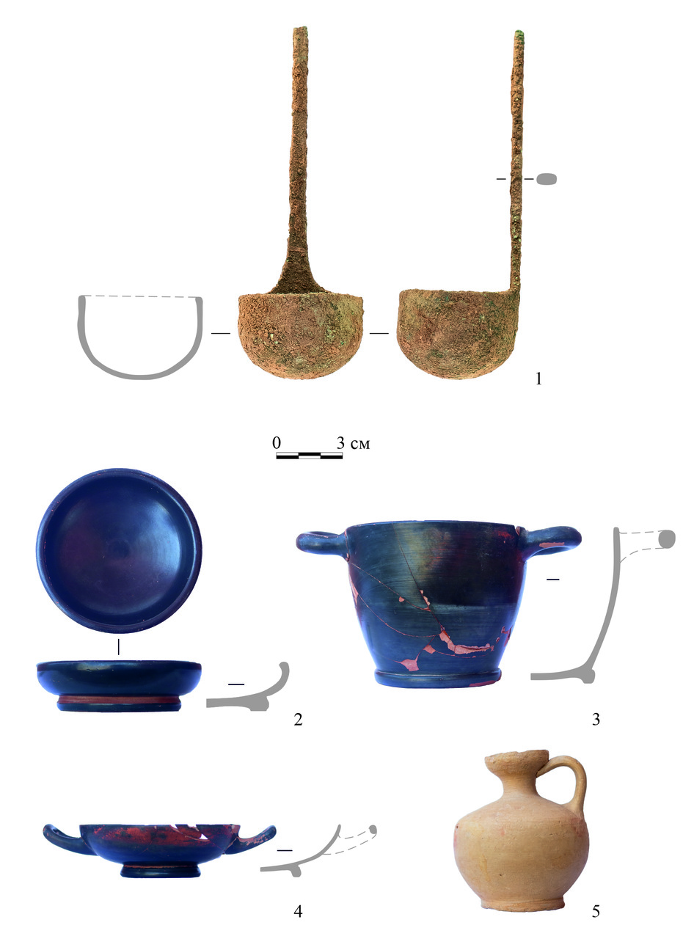
Figure 3. Volna 1. Items from burial 656: 1 – kyathos, 2 - bowl, 3 – skyphos, 4 - kilik, 5 - lekythos.

The measurements with the sample lasted about 136 hours. The resonance energies were determined according to the formula:
$$E=\frac{5227L^{2}}{t^{2}} ,$$ | (1)
where t is time of flight in microseconds, L is flight path in meters, E is kinetic energy of a neutron in eV.
The resonances of silver, tin, copper and arsenic were identified on the time-of-flight spectrum (Figure 4, Figure 5 ) [12] [13].

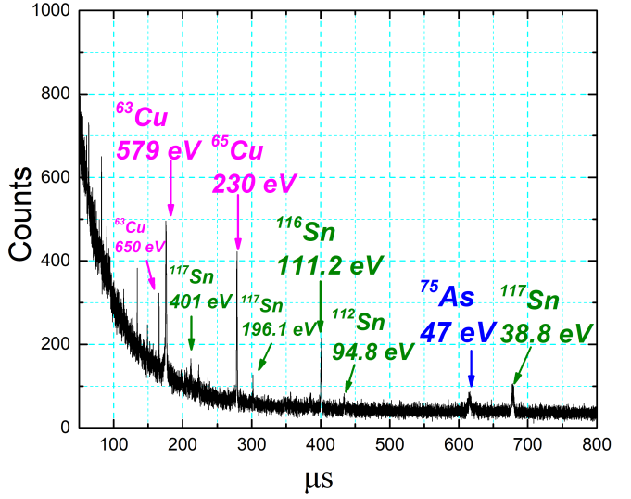
Figure 4. The part of time-of-flight spectrum of (n,γ) reactions on the kyathos material.
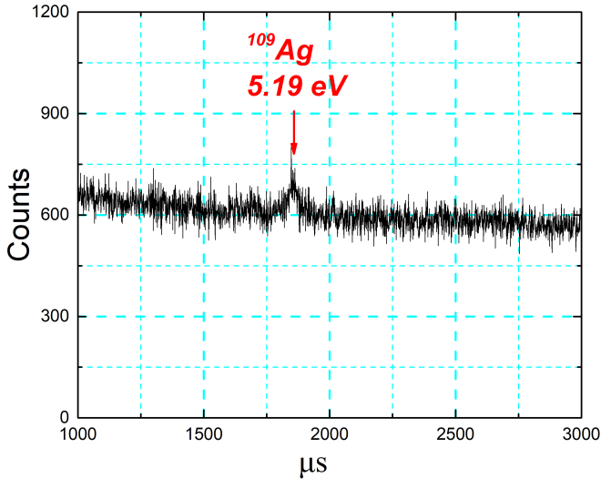
Figure 5. The part of time-of-flight spectrum of (n,γ) reactions on the kyathos material.

The measurements with standard samples of silver, tin, copper and arsenic were made in addition to the measurement with the investigated sample (Figure 6 - Figure 9).

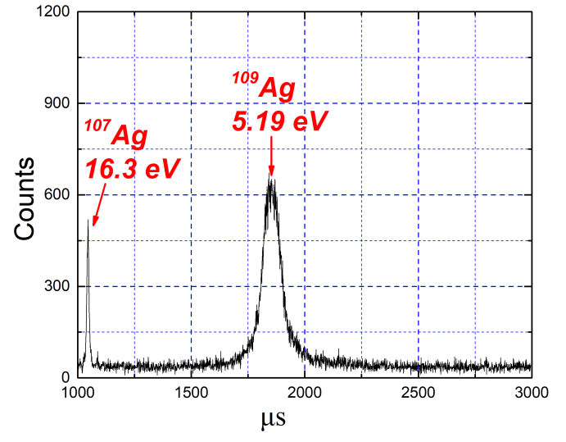
Figure 6. The part of time-of-flight spectrum of (n,γ) reactions of the standard silver sample.

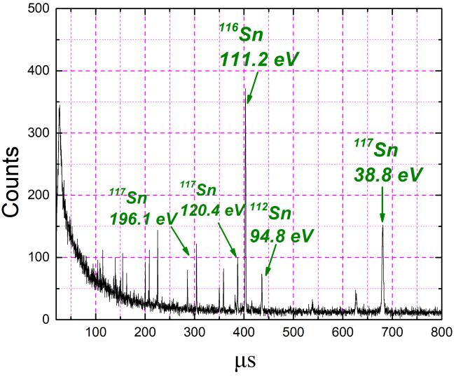
Figure 7. The part of time-of-flight spectrum of (n,γ) reactions of the standard tin sample.

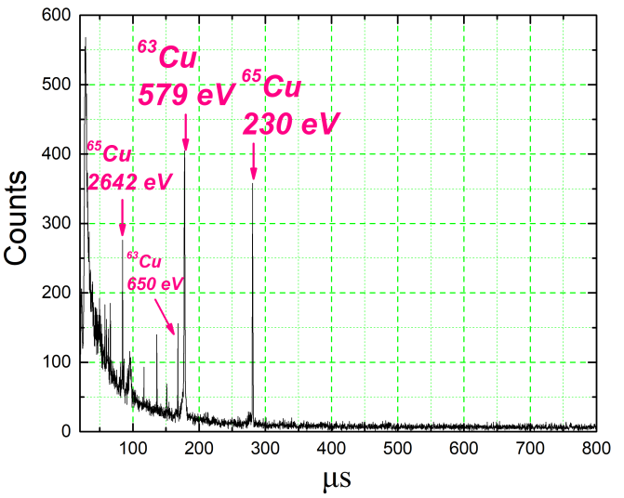
Figure 8. The part of time-of-flight spectrum of (n,γ) reactions of the standard copper sample.

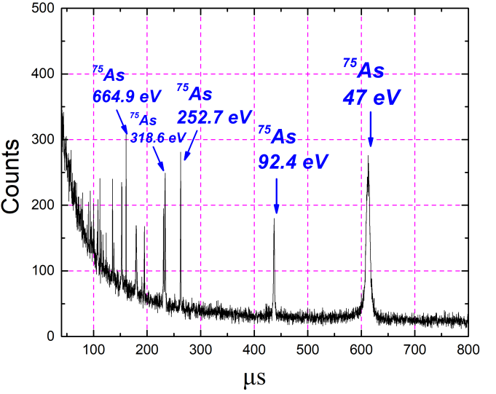
Figure 9. The part of time-of-flight spectrum of (n,γ) reactions of the standard arsenic sample.
- Data analysis and results
Five resonances of tin, two resonances of copper, one resonance of silver and one resonance of arsenic were selected during the analysis of the experimental data. Only well-resolved, without overlapping, with sufficient statistics and unambiguously known parameters resonances were analyzed. The sum of the detector counts in resonance is expressed by the formula:
. | (2)
Here, f (Е₀) is the neutron flux density at the resonance energy E₀, S – the sample area, t – measuring time, ε_{γ} – the detection efficiency of the detector radiative capture, Гγ, Г – the radiative and total resonance widths.
$A=\int_{E1}^{E2}{\left[1-T\left(E\right)\right]}\text{dE}$ | (3)
– resonance area on the transmission curve, where E1, E2 – initial and final values of energy range near resonance.
$T\left(E\right)=e^{-nσ\left(E\right)}$ | (4)
– the energy dependence of the neutron transmission by the sample; σ(Е) – the total cross section at this energy with Doppler broadening, n – the number of isotope nuclei per unit area. The value А was determined from experimental data for investigated sample by the formula:
$A_{x}=\frac{\sum{N_{x}⋅M_{s}⋅S_{s}}}{\sum{N_{s}⋅M_{x}⋅S_{x}}}⋅A_{s}$ . | (5)
Here,$\sum{N_{x}}$, $\sum{N_{s}}$ counts under the resonance peak of the investigated and standard samples, S_{x}, S_{s} – the area of the investigated and standard samples. M_{x}, M_{s} – the number of monitor counts during the measurement of the investigated and standard samples.
We used a program written according to the algorithm given in [14] for calculation of As (resonance area on the transmission curve of the standard sample) and nx (the number of isotope nuclei per unit area of the investigated sample) values. This procedure is schematically shown in (Figure 10). The As value was calculated by means of known resonances parameters and ns parameters for the standard sample. The nx value was determined from the investigated sample Ax value.
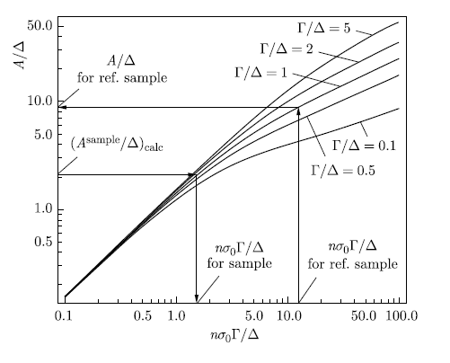
Figure 10. Ddependence of value A on a number of nuclei and resonance parameters with taking into account Δ (Doppler effect) [14].

The first measurement with the Kyathos [16] hadn’t shown satisfactory results for copper and arsenic. It was decided to repeat the measurement but take into account archeological object and neutron flux features. The Kyathos is a relatively long object (a length is about 16 cm) and has uneven thickness distribution (a handle and a bucket). As we know the neutron flux intensity decrease from a center to an edge it makes sense to measure the investigated object in parts and place every part to the center of the beam line. This experiment was carried out and we have obtained two spectrums (with the handle and with the bucket separately) that were summarized taking into account monitoring coefficients (Figure 4, 5). The analysis results are presented in the Table 1.

Table 1. The results of measurements with the kyathos by NRCA (the bulk).
№ | Element | Mass, g | Weight, %
1 | Cu | 59.7±3.9 | 68.8±4.5
2 | Sn | 5.29±0.23 | 6.10±0.26
3 | As | 0.1892±0.0081 | 0.02179±0.0094
4 | Ag | 0.0131±0.0014 | 0.0151±0.0016

The NRCA has limitations correlated to the neutron flux intensity at IREN facility at the present time, using of certain type of a detector system in an experiment and a matrix of elements in an investigated object. And besides that, this method has low sensitivity to elements lighter than iron and to elements that have atomic mass close to magic mass numbers (bismuth, lead, etc.) Additional measurements therefore were carried out by X-ray fluorescence (XRF) on 4 points of archeological object by means portable spectrometer 5i Tracer (Bruker) (Table 2).

Table 2. The results of measurements with the kyathos by XRF, averaged over four points (the surface).
№ | Element | Weight, %
1 | Cu | 61.63±0.31
2 | Si | 21.57±0.15
3 | Al | 7.02±0.19
4 | Sn | 4.58±0.25
5 | Fe | 4.254±0.075
6 | Pb | 0.684±0.073
7 | Ti | 0.327±0.057
8 | As | 0.050±0.017

The element composition of the Kyathos determined by NRCA and XRF are in agreement; some differences in wt% could be well understood due to the different nature of the analysis. The application of the XRF analysis allows determining the elemental composition on the surface. NRCA, in turn, does not measure the element and isotope compositions just on the surface but rather in the bulk (through the whole volume of the object), the analytical results are not significantly affected by surface corrosion.
- conclusion
NRCA carried out at the Intense Resonance Neutron Source (IREN) facility for the Kyathos from the necropolis Volna 1 on the Taman Peninsula showed that this method delivers satisfactory results. The mass of kyathos, determined by weighing is 86.7 g. According to the result of NRCA the value of determining total elements mass coincides with the kyathos mass within the margin of error and considering the presence of silicon, aluminum and iron on the surface of the object. The element composition of the Kyathos determined by NRCA and XRF are in agreement.
The results obtained confirm the using of tin bronze to make the investigated kyathos. The recorded presence of tin in the composition of the alloy, its quantitative characteristics, along with the established presence of arsenic, refers us to the type of alloy characteristic of archaic Greece [17]. The presence of such elements as arsenic, silver point to the conclusion that copper was obtained from polymetallic ores.
NRCA allows not only identifying the elemental and isotopic composition of the sample but also makes it possible to determine the amounts of elements and isotopes in the whole volume of the object. The method is non-destructive; the induced activity of the bronze samples is practically absent. All this makes it promising for research of archaeological artifacts and objects of cultural heritage. Although the number of facilities that can provide suitable neutron beams is limited, NRCA might be a useful additional analyzing technique.
Acknowledgement
The authors express their gratitude to the staff of the IREN facility and to A. P. Sumbaev, the head of the development of the facility, to V. V. Kobets, the head of sector No.5 of the Scientific and Experimental Injection and Ring Division of the Nuclotron (Veksler and Baldin Laboratory of High Energy Physics), for the supporting with uninterrupted operation of the facility in the process of measurements.
References
- H. Postma, M. Blauw, P. Bode, P. Mutti, F.Corvi, P. Siegler, “Neutron-resonance capture analysis of materials”, Journal of Radioaanalitical and Nuclear Chemistry, vol. 248, No. 1, 2001, pp. 115-120.
- N. V. Bazhazhina, Yu. D. Mareev, L. B. Pikelner, P. V. Sedyshev, V. N. Shvetsov, “Analysis of element and isotope composition of samples by neutron spectroscopy at the IREN facility”, Physics of Particles and Nuclei Letters, vol. 12, 2015, pp. 578–583.
- O. V. Belikov, A. V. Belozerov, Yu. Becher, Yu. Bulycheva, A. A. Fateev, A. A. Galt, A. S. Kayukov, A. R. Krylov, V. V. Kobetz, P. V. Logachev, A. S. Medvedko, I. N. Meshkov, V. F. Minashkin, V. M. Pavlov, V. A. Petrov, V. G. Pyataev, A. D. Rogov, P. V. Sedyshev, V. G. Shabratov, V. A. Shvec, V. N. Shvetsov, A. V. Skrypnik, A. P. Sumbaev, A. V. Ufimtsev, V. N. Zamrij, “Physical start-up of the first stage of IREN facility”, Journal of Physics: Conf. Ser. 205, 2010, 012053.
- H. Maletsky, L. B. Pikelner, K. G. Rodionov, I. M. Salamatin, E. I. Sharapov, “Detector of neutrons and gamma rays for work in the field of neutron spectroscopy”, Communication of JINR 13-6609 (Dubna, JINR, 1972) 1-15 (in Russian).
- H. Postma and P. Schillebeeckx, “Neutron resonance analysis,” in Neutron Methods for Archaeology and Cultural Heritage. Neutron Scattering Applications and Techniques, Ed. by N. Kardjilov and G. Festa (Springer, Cham, 2017), pp. 235–283.
- G. Gorini (Ancient Charm Collab.), “Ancient charm: A research project for neutron-based investigation of cultural-heritage objects,” Nuovo Cim. C 30, 2007, pp. 47–58.
- H. Hasemi, M. Harada, T. Kai, T. Shinohara, M. Ooi, H. Sato, K. Kino, M. Segawa, T. Kamiyama, and Y. Kiyanagi, “Evaluation of nuclide density by neutron transmission at the NOBORU instrument in J-PARC/MLF,” Nucl. Instrum. Methods Phys. Res., Sect. A 773, 2015, pp. 137– 149.
- O. V. Belikov, A. V. Belozerov, Yu. Becher, Yu. Bulycheva, A. A. Fateev, A. A. Galt, A. S. Kayukov, A. R. Krylov, V. V. Kobetz, P. V. Logachev, A. S. Medvedko, I.N.Meshkov, V. F. Minashkin, V. M. Pavlov, V. A. Petrov, et al., “Physical start-up of the first stage of IREN facility,” J. Phys.: Conf. Ser. 205, 012053 (2010).
- E. A. Golubkov, V. V. Kobets, V. F. Minashkin, K. I. Mikhailov, A. N. Repkin, A. P. Sumbaev, K. V. Udovichenko, and V. N. Shvetsov, “The first results of the commissioning of the second accelerating section of the LUE-200 accelerator of the IREN installation,”Soobshch. OIYaI R9-2017-77 (Dubna, OIYaI,2017).
- R.A. Mimokhod, N.I. Sudarev, P.S. Uspensky, “The necropolis Volna 1(2017). ) (Krasnodar Territory, Taman Peninsula)”, Rescue archaeological research materials, vol. 25, Institute of Archeology RAS, 2018, pp. 220–231.
- R.A. Mimokhod, N.I. Sudarev, P.S. Uspensky, “Necropolis Volna-1 on the Taman Peninsula” (2019), New archaeological projects. Recreating the past. To the 100th anniversary of Russian academic archeology. Edited by Makarov M., IA RAN, 2019, pp. 80–83.
- S. F. Mughabghab, “Neutron Gross Sections, Neutron Resonance Parameters and Thermal Gross Sections”, Academic Press, New York, 1984.
- S. I. Sukhoruchkin, Z. N. Soroko, V. V. Deriglazov, “Low Energy Neutron Physics. Landolt-Bornstein.V. I/16B”, Berlin: Springer Verlag, 1998.
- V.N. Efimov, I.I. Shelontsev, “Calculation for graphs of determining the parameters of neutron resonances by the transmission method”, Communications of the JINR P-641 (Dubna, 1961) 1-19 (in Russian).
- P. V. Sedyshev, N. V. Simbirtseva, A. M. Yergashov, S. T. Mazhen, Yu. D. Mareev, V. N. Shvetsov, M. G. Abramzon, and I. A. Saprykina, “Determining the Elemental Composition of Antique Coins of Phanagorian Treasure by Neutron Spectroscopy at the Pulsed Neutron Source IREN in FLNP JINR”, Pis’ma v Zhurnal Fizika Elementarnykh Chastits i Atomnogo Yadra, ISSN:1547-4771, Physics of Particles and Nuclei Letters, vol.17, No.3, pp.389-400.
- Simbirtseva N. V., Sedyshev P. V., Mazhen S. T., Yergashov A. M., Saprykina I. A., Mimokhod R.A., Preliminary result of investigation of element composition of Kyathos (6th-4th centuries BCE) from the necropolis Volna 1 on the Taman Peninsula by Neutron Resonance Capture Analysis. IMEKO TC4 International Conference on Metrology for Archaeology and Cultural Heritage, 22-24 October, 2020, Trento, Italy, Proceedings, 2020, https://www.imeko.org/publications/tc4-Archaeo-2020/IMEKO-TC4-MetroArchaeo2020-073.pdf
- Orfanou S., Early Iron Age Greek copper-based technology: votive offerings from Thessaly. Institute of Archaeology, UCL, Thesis submitted for PhD in Archaeology/Archaeometallurgy,2015, p. 87, tab. 2.2 https://discovery.ucl.ac.uk/id/eprint/1471577/1/Orfanou_Orfanou%202015%20Early%20Iron%20Age%20Greek%20copper-based%20technology.pdf

