Development of a noncontact operation system for radiographic consoles using an eye tracker for severe acute respiratory syndrome coronavirus 2 infection control: a feasibility study
Mitsuru Sato¹, Mizuki Narita², Naoya Takahashi¹, Yohan Kondo¹, Masashi Okamoto¹, and Toshihiro Ogura²
¹ Department of Radiological Technology, School of Health Sciences, Niigata University, Niigata, Japan
² Department of Radiology, Gunma Prefectural College of Health Sciences, Gunma, Japan
ABSTRACT
Sterilization of medical equipment in isolation wards is essential to prevent the transmission of severe acute respiratory syndrome coronavirus 2 (SARS–CoV-2) infection. Particularly, the radiographic console of portable X-ray machines requires frequent disinfection because it is regularly moved; this requires considerable infection control effort as the number of patients with coronavirus disease 2019 (COVID-19) increases. To evaluate the application of a system facilitating noncontact operation of radiographic consoles for patients with COVID-19 to reduce the need for frequent disinfection. We developed a noncontact operation system for radiographic consoles that used a common eye tracker. We compared calibration errors between with and without face shield conditions. Moreover, the use of console operation among 41 participants was investigated. The calibration error of the eye tracker between with and without face shield conditions did not significantly differ. All (n = 41) observers completed the console operation. Pearson’s correlation coefficient analysis showed a strong correlation (r = 0.92, P < 0.001) between the average operation time and the average number of misoperations. Our system that used an eye tracker can be applied even if the operator uses a face shield. Thus, its application is important in preventing the transmission of infection.

Section: RESEARCH PAPER
Keywords: Infection control, SARS-CoV-2, eye-tracking manipulation, noncontact device, radiographic console
Citation: Thomas Bruns, Dirk Röske, Paul P. L. Regtien, Francisco Alegria , Template for an Acta IMEKO paper, Acta IMEKO, vol. A, no. B, article C, Month Year, identifier: IMEKO-ACTA-A (Year)-B-C
Section Editor: name, affiliation
Received month day, year; In final form month day, year; Published Month Year
Copyright: This is an open-access article distributed under the terms of the Creative Commons Attribution 3.0 License, which permits unrestricted use, distribution, and reproduction in any medium, provided the original author and source are credited.
Corresponding author: Paul P. L. Regtien, e-mail: paul@regtien.net

- Introduction
An outbreak of severe acute respiratory syndrome coronavirus (SARS-CoV-2) infection occurred in Wuhan, China, in December 2019 [1]–[5]. Since then, the virus has been transmitted worldwide, and consequently, the World Health Organization declared it a pandemic on March 11, 2020. This infection can be primarily transmitted via droplets and contact routes [6]-[8]. Currently, infection control measures, including social distancing, using masks or face shields, and frequent handwashing and disinfection, are important [9],[10], particularly in the medical field. Hospitals with isolation wards for patients with coronavirus disease 2019 (COVID-19) are taking various measures to prevent infection transmission. The environment where patients with COVID-19 are treated is zoned as clean (cold zone), intermediate (warm zone), and unclean (hot zone) areas [11]-[13] to prevent hospital-wide infection. However, it is difficult to completely control infection despite such isolation measures [14].
Chest radiography is important for the management of COVID-19, and portable X-ray machines are used in isolation wards. In most hospitals, after imaging patients in the isolation ward is completed, all areas that may have come in contact with the patient or been exposed to droplets, including the device, the flat panel detector, and imaging console attached to the flat panel detector system, should be disinfected [13]. However, medical staff can be mentally and physically exhausted during a pandemic, making it difficult to perform appropriate disinfection. Moreover, disinfection may not have been strictly practiced prior to the pandemic [15]-[17]. When several patients with COVID-19 undergo imaging, the console should be disinfected to prevent secondary infections, such as due to methicillin-resistant Staphylococcus aureus and vancomycin-resistant enterococci infections, even if imaging was conducted in the same ward. Nevertheless, it is difficult to disinfect a plastic bag covering a complex-structures medical device while wearing personal protective equipment. Therefore, the radiographic console, which is touched frequently, can be a source of infection [18].
Reducing the frequency of touching the imaging equipment, which can be achieved using noncontact input devices, is important in addressing these issues. Currently, several noncontact devices are available. However, their use for protection against SARS-CoV-2 infection has not been reported. Previous studies have assessed the use of noncontact input devices to operate medical devices without touching them in the clinical setting [19]-[24]. Such devices are effective in maintaining sterile rooms [19]. Therefore, this study aimed to assess the use of an eye tracker, which does not require body movement, as a noncontact input device.
Image display systems have been successfully manipulated via eye tracking during interventional radiology, thereby allowing images to be paged and magnified using the observer’s eye movements alone [25]. In this study, we applied such technology to develop a radiographic console operation system for infection control during portable X-ray imaging of patients with COVID-19. Face shields are used as personal protective equipment in the management of patients with COVID-19, and they create an obstruction between the eye tracker and the eyes. Therefore, we evaluated the accuracy of our operating system by assessing calibration errors between with and without face shield conditions, average time required for console operation, and average number of misoperations.
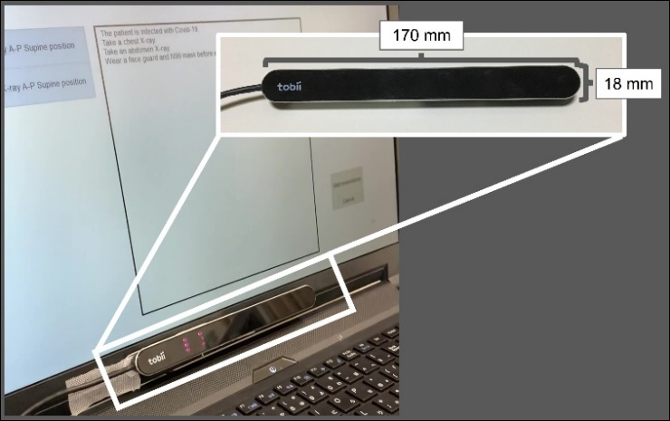
Figure 1. Overview of Tobii PCEye Mini (Tobii, Stockholm, Sweden).
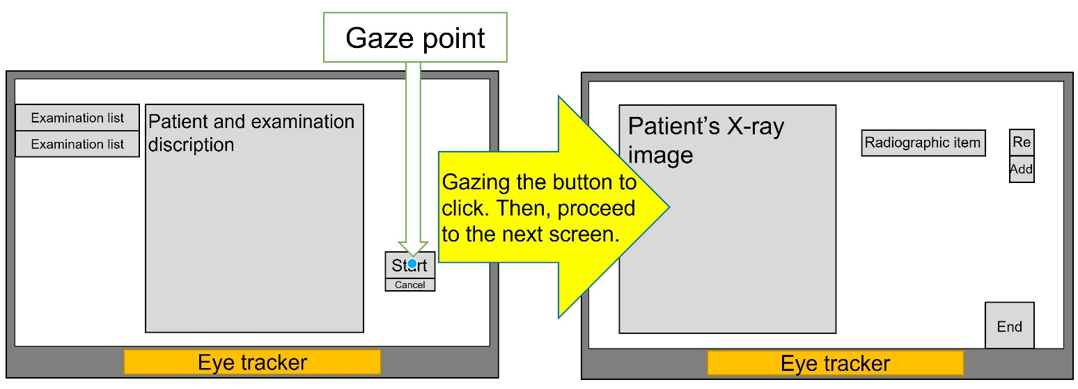
Figure 2. Operation of the radiographic console used in isolation wards. Real-time gaze analysis allows operations required in conducting examinations, such as clicking buttons based on gaze duration.

- Material and Methods
  - Development of a noncontact operation system using an eye tracker
In this study, we used Tobii PCEye Mini (Tobii, Stockholm, Sweden) as the eye tracker for our noncontact operation system (Figure 1). This small and light weight devices has the following measurements: width,: 169.5 mm170 mm; height,: 17.8 mm18 mm; thickness,: 12.4 mm13 mm; and weight,: 59 g. It can be easily installed on the radiographic console used in portable X-ray systems. The usable distance from the eye detector ranges from 45 to 85 cm, the sampling rate of the eye tracker is 60 Hz, and the recommended screen size is up to 19 in. We used a computer with the following specifications: Windows 10 Home 64 bit, Intel Core i7-6700HQ central processing unit, and NVIDIA GeForce GTX 960M; its screen size was 17 in (Monitor size: width, 38.4 cm; height, 21.6 cm). The eye tracker could be easily used with a universal serial bus connection; however, it requires prior calibration. The system provided with the Tobii PCEye Mini was used for calibration. There was a function in this system to inform the observer whether the position of the observer is appropriate in order to properly calibrate the system. In addition, instructions are displayed on the screen regarding the location to be gazed for calibration so that it can be facilitated. Specifically, we entered the gaze detection range and gazed at seven points on the screen, i.e., center, upper right, upper center, upper left, lower right, lower center, and lower left. We used the pupil center corneal reflection method to calibrate the operator’s gaze point by measuring the corneal reflection point of the irradiated infrared light and the position of the pupil when gazing at each point, which improved with the eye tracker [26].
We developed a noncontact operation system for radiographic consoles that used an eye tracker to prevent the transmission of SARS-CoV-2 infection. We used Microsoft Visual Studio (Microsoft, Redmond, WA, USA) as an integrated development environment, C# (Microsoft), and the Nuget package of Tobii.Interaction v.0.7.3 (Tobii Core SDK, Tobii). The principle of the operation was based on the characteristics of eye movement. The two types of fixations are saccade, which is a quick movement of the gaze, and fixation, which requires the maintenance of gaze on the same spot [27],[28]. The vector was calculated as the amount of gaze point movement on the screen for 0.02 s to detect the fixation state.
In this study, we considered the saccade state if the amount of movement exceeded 200 pixels (0.02 cm per pixel, which is approximately 4 cm). An amount of movement of 200 pixels in 0.02 s could be considered a saccade [25]. If the amount of movement was below this threshold, the system was considered in fixation state. The only commands required to operate the radiographic console were moving the cursor and clicking. Therefore, we developed a method to move the cursor in accordance with the movement of the gaze point and to click when the fixation state is reached. Figure 2 shows the use of the console operation system for imaging.
In total, 41 students from radiological technology participated, and they were briefed in advance about the operation system. Each student performed the operation experiment five times. Table 1 shows the characteristics of the observers.
Table 1. Characteristics of the participants
Observer | Eye condition
1 | Bare
2 | With glasses
3 | With soft contact lenses
4 | With soft contact lenses
5 | With soft contact lenses
6 | With soft contact lenses
7 | With soft contact lenses
8 | With soft contact lenses
9 | With soft contact lenses
10 | With soft contact lenses
11 | With soft contact lenses
12 | With glasses
13 | With soft contact lenses
14 | With soft contact lenses
15 | With soft contact lenses
16 | Bare
17 | With soft contact lenses
18 | Bare
19 | With soft contact lenses
20 | With glasses
21 | With soft contact lenses
22 | With soft contact lenses
23 | With soft contact lenses
24 | With soft contact lenses
25 | Bare
26 | Bare
27 | Bare
28 | With soft contact lenses
29 | With soft contact lenses
30 | With soft contact lenses
31 | With soft contact lenses
32 | With soft contact lenses
33 | With soft contact lenses
34 | With soft contact lenses
35 | With soft contact lenses
36 | With soft contact lenses
37 | With soft contact lenses
38 | With glasses
39 | With soft contact lenses
40 | With soft contact lenses
41 | With soft contact lenses

  - Considerations of the system
Because eye tracking may not be possible when a face shield is worn, the developed system was used with and without face shield. We used a face shield (Logi Meister, Osaka, Japan) made of polyethylene terephthalate with following measurements: height, 22 cm; width, 33 cm; and thickness, 0.25 mm. The distance from the eyeball to the face shield is approximately 4 cm (Figure 3). We performed (1) a comparison of calibration errors between the two face shield conditions and (2) an analysis of console operation.
In experiment 1, calibration of the eye detector was performed with and without a face shield. Subsequently, the error between the actual gaze point coordinates on the screen and the detected gaze point coordinates on the screen was measured at the following nine points on the monitor: top left, top, top right, left, center, right, bottom left, bottom, and bottom right. A gazing point was displayed on the screen to measure the error (Figure 4). The points on the four corners of the screen were displayed at a distance of 150 pixels each in the x and y coordinates from the screen edge (resolution: 1920 pixels × 1080 pixels) to assess the calibration error in the periphery as much as possible. The other five points were placed at the center of the x and y coordinates. The coordinates of the mouse cursor while the operator was gazing at each point were measured five times. The measurement results were averaged to reduce measurement error due to nystagmus. Nystagmus is a cyclic and involuntary oscillatory movement of the eyeball. The effect of physiological nystagmus was reduced. The distance was calculated from the obtained coordinates. The calibration error was defined as the distance between actual gaze point which is the location coordinates of gazed by observer and the detection point coordinates for each of the nine points.
In experiment 2, the developed system was used to evaluate the operability of the console simulating the radiographic console attached to the flat panel detector system while the operator is wearing a face shield. This radiographic console simulated that used in the clinical setting (Console Advance DR-ID300CL; Fujifilm, Tokyo, Japan) and was divided into the patient selection (Figure 5a), radiographic item confirmation (Figure 5b), and (3) radiographic screens (Figure 5c). The clicked locations are listed below.

• (1) Patient selection screen: Select a patient from the list (Figure 5a-1)
• Select button (Figure 5a-2)
• (2) Radiographic item confirmation screen: Start examination button (Figure 5b-3)
• (3) Radiographic screen: Select the radiographic item (Figure 5c-4)
• Re-imaging process (Figure 5c-5)
• Add the same type of imaging (Figure 5c-6)
• Click the End button (Figure 5c-7)

These buttons measured 26 cm × 1 cm, 3 cm × 1 cm, 4 cm × 2 cm, 10 cm × 2 cm, 2 cm × 2 cm, 2 cm × 2 cm, and 4 cm × 4 cm, respectively. The experimental procedure was based on the actual examination procedure, and the console was operated in the order of patient selection, confirmation of radiographic items, and operation of the radiographic screen (Figure 6). The time between the start of the operation and the completion of clicking the end button was measured. The number of clicks on the screen was recorded, as was the number of clicks caused by accidental eye pauses. The procedure mentioned above was performed five times with each observer.

  - Statistical analysis
The data obtained were the calibration errors at each of the nine positions under the two face shield conditions in experiment 1. We used the paired t test to investigate whether significant differences existed in the average calibration error of all observers. We also investigated whether significant differences existed in the average calibration error at each point for all observers. A P value of < 0.05 was considered statistically significant.
The average operation time and the average misoperation time for the radiographic console were obtained in experiment 2. Moreover, we investigated whether the calibration errors obtained from experiment 1 was correlated with the average operation time and the average number of misoperations. Furthermore, the correlation between the average operation time and the average number of misoperations was evaluated via Pearson’s product–moment correlation coefficient analysis.
The results ranged from −1.0 to 1.0, with −1.0 and 1.0 representing a negative and positive correlation, respectively. An absolute value of < 0.2 was defined as almost no correlation; 0.2–0.4, weak correlation; 0.4–0.7, medium correlation; and ≥ 0.7, strong correlation. A P value of < 0.05 indicated a correlation between the two face shield conditions.
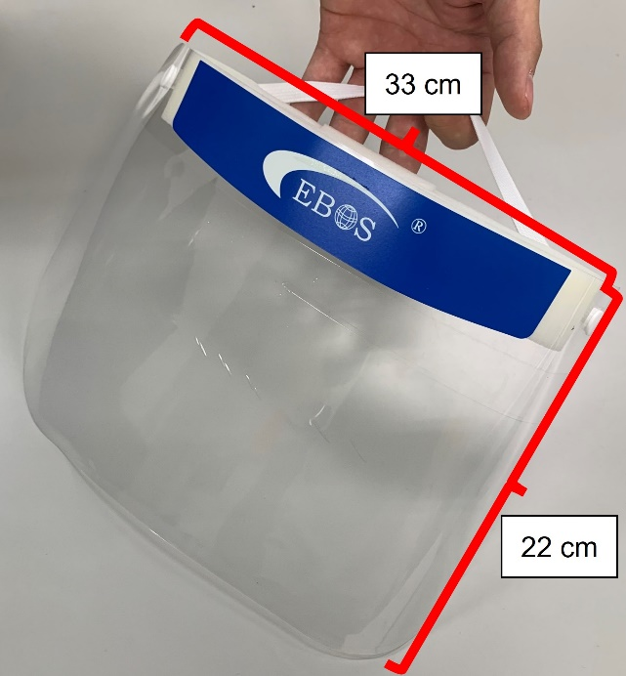
Figure 3. Image of the face shield made of polyethylene terephthalate (Logi Meister, Osaka, Japan) used in this study.
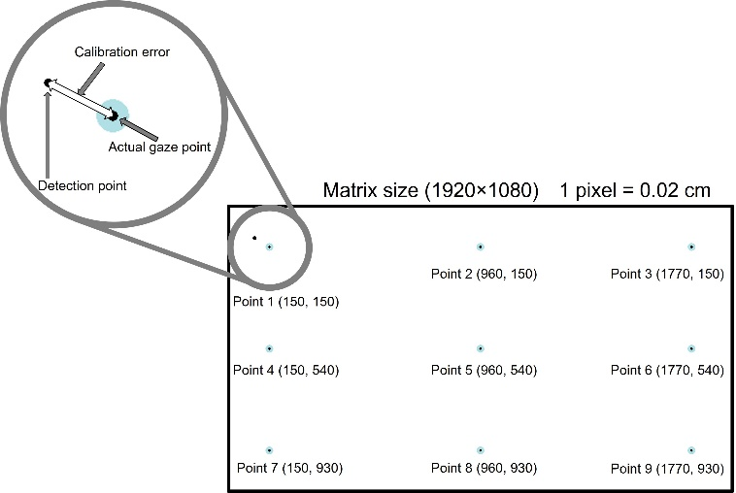
Figure 4. Illustration of the nine measurement points evaluated in this study. The calibration error was measured by calculating the difference in the coordinates between the detection and actual gaze points.

- Results
  - Experiment 1
The average ± standard deviation (SD) calibration errors at all points for all observers with a face shield and those without a face shield were 1.22 ± 0.94 cm and 1.19 ± 0.79 cm, respectively (Figure 7). No significant difference between the two face shield conditions was observed. Data about the average calibration error at each point for all observers are shown in Figure 8. The nine measurement points corresponded to top left, top, top right, left, center, right, bottom left, bottom, and bottom right. Only measurement point 7, which represented the bottom left, had a significantly larger calibration error in the no face shield condition. Data about the average calibration error for all points for each observer are shown in Figure 9. There was no tendency for operation either with a face shield or that without a face shield to be consistently larger, although significant differences were observed for 16 of the 41 observers.
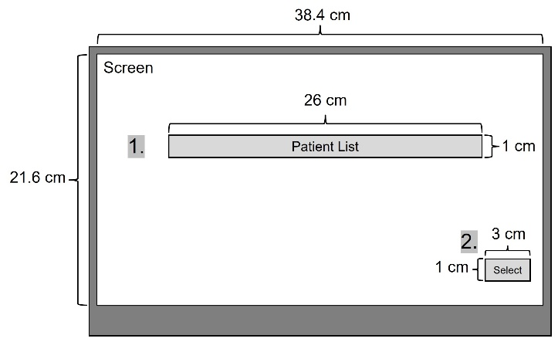
Figure 5a. Components of the radiographic console used in this study (Patient selection). The numerals in boldface indicate the button click steps.
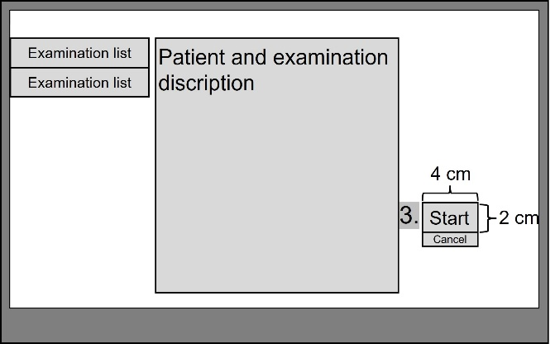
Figure 5b. Components of the radiographic console used in this study (Radiographic item confirmation). The numerals in boldface indicate the button click steps.
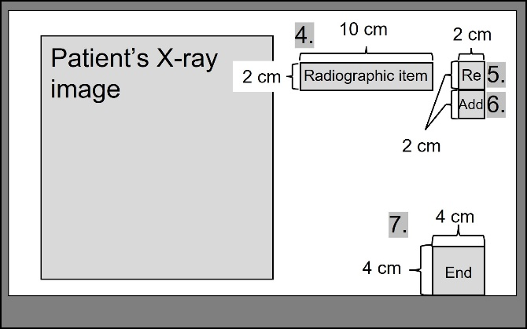
Figure 5c. Components of the radiographic console used in this study (Radiographic screens). The numerals in boldface indicate the button click steps.
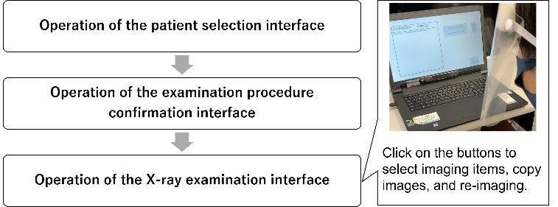
Figure 6. Overall scheme of the experimental procedure.

  - Experiment 2
Although students and not radiologists participated in this study, they were able to operate the console easily. There was no significant difference between the calibration error of the eye tracker with and without the face shield. The results of the experiment revealed that all observers (n = 41) were able to operate the console. The average operation time was 37.89 ± 24.22 s, and the average number of misoperations was 5.4 ± 4.1. Pearson’s product–moment correlation coefficient analysis found a very strong positive correlation (r = 0.92, P < 0.001) between the average time required to complete the operation and the average number of misoperations (Figure 10a). It found no correlation (r = 0.24, P = 0.13) between the average operation time and the calibration error (Figure 10b) also between the average number of misoperations and the calibration error (r = 0.28, P = 0.08) (Figure 10c).
Figure 7. Comparison of calibration errors between the use and nonuse of a face shield at all measurement points for all observers.

- Discussion
There have been no studies to utilize eye tracker for infection control of SARS-CoV-2. In previous study, there are methods to manipulate image display systems using motion sensors [19]-[24]. however, there are very few cases in which manipulation was achieved using an eye tracker. Therefore, the study by use of an eye tracker was state-of-the-art. Furthermore, it is versatile and useful because it can be used not only for SARS-CoV-2, but also for infection control against other viruses and pathogenic bacteria.
The method proposed in this study can not only prevent the risk of contact infection but also save supplies and improve the time efficiency of disinfection. The mean calibration errors at all points for all observers did not significantly differ with and without the use of face shield. Forty-one observers participated in this study, representing a relatively large number of people.
One of the primary characteristics of eye detectors is that the four corners of the screen are prone to errors during calibration. In this study, we followed the guidance of the calibration system attached to the eye tracker, made the distance between the computer screen and the observer constant, and calibrated the system to have the same geometric arrangement. However, because the pupil center corneal reflection method was used to detect the shape of the eyeball and the position of the reflection of infrared light on the eyeball, even a slight shift in position may have affected the calibration error. Nevertheless, poor operability on the four corners of the screen is not an uncommon outcome. In such a case, operability can be improved by placing the buttons closer to the center and making them appear with gazing time or eye movement.
The larger the calibration error, the larger is the gap between the gazed position and the coordinates of the mouse cursor. Therefore, there was a possibility of accidental clicking on a position other than the button owing to calibration errors. Moreover, the larger the calibration error, the more difficult it was to adjust the click position with the gaze point, which could increase the average operation time. Pearson’s product–moment correlation coefficient analysis showed that there was a very strong correlation between the average operation time and the average number of misoperations. However, there was no correlation between the average calibration error and the average operation time and average number of misoperations. Although it is natural for the operation time to increase with the number of misoperations, because the average calibration error does not correlate with the average number of misoperations, it is possible that a small calibration error, such as that in this study, would not have a significant impact on usability. Nevertheless, when we obtained feedback on the system’s operability from observers after the experiment, several stated that the buttons were difficult to operate because of their small size and that they were able to click on the button by moving their eyes according to the amount of the shift when they clicked on a position different from the one they were looking at. Therefore, it is possible to reduce the effect of calibration error via the operator’s effort, although the operation time will tend to increase because of misoperation. Despite the system’s potential, its user interface needs to be improved because it can be easily operated at the same level as the current touch pad or touch panel operation for clinical use.
Figure 8. Calibration errors according to measurement point.
However, the average operation time was longer (20–80 s) than that when the same operation was performed with a mouse (approximately 10 s). The eye tracker was affected by the calibration error, and the detection results showed coordinates that were slightly different from the actual gaze point. Therefore, even a calibration error of a level that would not be problematic in such studies as a gaze analysis would be problematic in such cases as this one that require detailed button operation of the imaging console. We considered that this was a result of the small size of the buttons. If the button size is smaller than the calibration error, then it could be difficult to operate (Figure 11).
This study showed that it is possible to operate imaging consoles while wearing a face shield. Although it is difficult to immediately introduce this technology to the clinical setting, it can be used in clinical practice in the near future because the usability of the radiographic console can be improved by simply increasing the size of the buttons. Furthermore, the observers in this study were students; the system we developed is useful as it can be operated by observers who are not familiar with radiographic consoles. Taken together, the proposed manipulation method that used an eye tracker for infection control is not ready for clinical use. However, because it can be used even when a face shield is worn, its clinical application is feasible with improvements in the radiographic console.
Figure 9. Calibration errors of all measurement points according to observer. Significant differences were detected between some observers. However, these do not necessarily indicate that a calibration error is significantly larger than another.
It is necessary to improve the eye tracker and the UI in order to use the method in actual clinical situation. The first priority should be improvement of the UI. As mentioned above, the influence of calibration error can be reduced by improving the button size. Although the observer determined the operating position according to the system's instructions during the experiment, operation was possible even if the observer's position was slightly moved. However, there were cases when the gazing position could not be detected correctly while the operating position differed significantly from the position at the calibration. As a mentioned above, the usable distance of the eye tracker ranges from 45 to 85 cm, which is approximately equal to the distance from which touch panel operation and/or mouse operation is performed. Therefore, it is usable within the range of normal use.
Figure 10. (a)–(c) Results of Pearson’s product–moment correlation coefficient analysis of the manipulation experiment data obtained for each observer.
Figure 11. Effect of button size characteristics on difficulty in operating our noncontact system that used an eye tracker. If the button size is larger than the calibration error, then the misoperation can be reduced if the button is pressed.
It was possible that the eye tracker would be unusable in the existence of natural light. However, experiments in this study were conducted in a laboratory where natural light existed and under fluorescent lighting. In other words, the experiments were conducted in an environment similar to a hospital room. In addition, there are cases in which eye tracker was used in hospital rooms in previous studies, although these studies were not directly operating computers [29],[30]. Therefore, we believe that the system in this study can be used without problems in the isolation ward where it is planned to be used.
- Conclusions
Feasibility of a noncontact operation system for radiographic consoles using an eye tracker for SARS-CoV-2 infection control has been demonstrated by this study.
The system developed in this study is extremely useful even when the operator uses a face shield. However, because of its long average operation time, a radiographic console designed with an eye tracker should be developed for daily clinical use. Thus, our proposed method can be useful for controlling not only SARS-CoV-2 infection but also other potential conditions in the future.

- Acknowledgement
The authors thank the students of Gunma Prefectural College of Health Sciences who participated as study observers for their assistance in the measurements as well as Haruka Hirasawa and Madoka Hasegawa of Gunma Prefectural College of Health Sciences for their helpful assistance.

- Research ethics and patient consent
All procedures involving human participants were performed in accordance with the ethical standards of the relevant institutional and/or national research committee and the Declaration of Helsinki and its later amendments or comparable ethical standards. Informed consent was obtained from all participants. This research, which involves the development of a medical device operation system, specifically an image display system, using a noncontact device, was approved by the Ethical Review Committee of Gunma Prefectural College of Health Sciences (approval no.: 2020-16). This work was not previously published in part or its entirety.

- Declaration of conflict of interests
The authors declare that there is no conflict of interest.

- Funding
This research did not receive any specific grant from any funding agency in the public, commercial, or not-for-profit sector.

References
- Huang C, Wang Y, Li X, et al. Clinical features of patients infected with 2019 novel coronavirus in Wuhan, China. Lancet. 395 (2020) pp. 497–506.
DOI: https://doi.org/10.1016/S0140-6736(20)30183-5
- Shi H, Han X, Jiang N, et al. Radiological findings from 81 patients with COVID-19 pneumonia in Wuhan, China: a descriptive study. Lancet Infect Dis. 20 (2020) pp.425–434.
DOI: https://doi.org/10.1016/S1473-3099(20)30086-4
- Yang X, Yu Y, Xu J, et al. Clinical course and outcomes of critically ill patients with SARS-CoV-2 pneumonia in Wuhan, China: a single-centered, retrospective, observational study. Lancet Respir Med. 8 (2020) pp. 475–481.
DOI: https://doi.org/10.1016/S2213-2600(20)30079-5
- Chen N, Zhou M, Dong X, et al. Epidemiological and clinical characteristics of 99 cases of 2019 novel coronavirus pneumonia in Wuhan, China: a descriptive study. Lancet. 395 (2020) pp. 507–513.
DOI: https://doi.org/10.1016/S0140-6736(20)30211-7
- Shigemura J, Ursano RJ, Morganstein JC, et al. Public responses to the novel 2019 coronavirus (2019-nCoV) in Japan: mental health consequences and target populations. Psychiatry Clin Neurosci. 74 (2020) pp. 281–282.
DOI: https://doi.org/10.1111/pcn.12988
- Otter JA, Donskey C, Yezli S, et al. Transmission of SARS and MERS coronaviruses and influenza virus in healthcare settings: the possible role of dry surface contamination. J Hosp Infect. 92 (2016) pp. 235.
DOI: https://doi.org/10.1016/j.jhin.2015.08.027
- Wilder-Smith A, Chiew CJ, Lee VJ. Can we contain the COVID-19 outbreak with the same measures as for SARS? Lancet Infect Dis. 20 (2020) pp. 102.
DOI: https://doi.org/10.1016/S1473-3099(20)30129-8
- Pena P, Morais J, Gomes AQ, et al. Sampling methods and assays applied in SARS-CoV-2 exposure assessment. Sci Total Environ. 775 (2021) pp. 145903.
DOI: https://doi.org/10.1016/j.scitotenv.2021.145903
- Morawska L, Tang JW, Bahnfleth W, et al. How can airborne transmission of COVID-19 indoors be minimised? Environ Int. 142 (2020) pp. 105832.
DOI: https://doi.org/10.1016/j.envint.2020.105832
- World Health Organization. Epidemic-prone and pandemic-prone acute respiratory diseases. Summary guidance: infection prevention & control in health-care facilities. Geneva: World Health Organization, 2007. [Accessed 22 December 2021].
https://apps.who.int/iris/handle/10665/69793
- Ogawa F, Kato H, Sakai K, et al. Environmental maintenance with effective and useful zoning to protect patients and medical staff from COVID-19 infection. Acute Med Surg. 7 (2020) pp. 536.
DOI: https://doi.org/10.1002/ams2.536
- Mimura K, Oka H, Sawano M. A perspective on hospital-acquired (nosocomial) infection control of COVID-19: usefulness of spatial separation between wards and airborne isolation unit. J Breath Res. 15 (2021) pp. 042001.
DOI: https://doi.org/10.1088/1752-7163/ac1721
- An P, Ye Y, Chen M, et al. Management strategy of novel coronavirus (COVID-19) pneumonia in the radiology department: a Chinese experience. Diagn Interv Radiol. 26 (2020) pp. 200.
DOI: 10.5152/dir.2020.20167
- World Health Organization. Infection prevention and control of epidemic- and pandemic-prone acute respiratory infections in health care. Geneva: World Health Organization, 2014. [Accessed 22 December 2021).
http://apps.who.int/iris/bitstream/10665/112656/1/9789241507134_eng.pdf?ua=1
- Pittet D. Improving compliance with hand hygiene in hospitals. Infect Control Hosp Epidemiol. 21 (2000) pp. 381–386.
DOI: https://doi.org/10.1086/501777
- Girou E, Oppein F. Handwashing compliance in a French university hospital: new perspective with the introduction of hand-rubbing with a waterless alcohol-based solution. J Hosp Infect. 48 (2001) pp. 55–57.
DOI: https://doi.org/10.1016/S0195-6701(01)90015-5
- Pittet D. Compliance with hand disinfection and its impact on hospital-acquired infections. J Hosp Infect 48 (2001) pp. 40–46.
DOI: https://doi.org/10.1016/S0195-6701(01)90012-X
- Pintaric R, Matela J, Pintaric S. Suitability of electrolyzed oxidizing water for the disinfection of hard surfaces and equipment in radiology. J Environ Health Sci Eng. 13 (2015) pp. 6.
DOI: https://doi.org/10.1186/s40201-015-0160-8
- Tan JH, Chao C, Zawaideh M, et al. Informatics in radiology: developing a touchless user interface for intraoperative image control during interventional radiology procedures. Radiographics. 33 (2013) pp. 61–70.
DOI: https://doi.org/10.1148/rg.332125101
- Ruppert GCS, Reis LO, Amorim PHJ, et al. Touchless gesture user interface for interactive image visualization in urological surgery. World J Urol. 30 (2012) pp. 687–691.
DOI: https://doi.org/10.1007/s00345-012-0879-0
- Jacob MG, Wachs JP, Packer RA. Hand-gesture-based sterile interface for the operating room using contextual cues for the navigation of radiological images. J Am Med Inform Assoc 20 (2013) pp. 183–186.
DOI: https://doi.org/10.1136/amiajnl-2012-001212
- Ogura T, Sato M, Ishida Y, et al. Development of a novel method for manipulation of angiographic images by use of a motion sensor in operating rooms. Radiol Phys Technol. 7 (2014) pp. 228–234.
DOI: https://doi.org/10.1007/s12194-014-0259-0
- Sato M, Ogura T, Yasumoto Y, et al. Development of an image operation system with a motion sensor in dental radiology. Radiol Phys Technol. 8 (2015) pp. 243–247.
DOI: https://doi.org/10.1007/s12194-015-0313-6
- Mewes A, Hensen B, Wacker F, et al. Touchless interaction with software in interventional radiology and surgery: a systematic literature review. Int J Comput Assist Radiol Surg 12 (2017) pp. 291–305.
DOI: https://doi.org/10.1007/s11548-016-1480-6
- Sato M, Takahashi M, Hoshino H, et al. Development of an eye-tracking image manipulation system for angiography: a comparative study. Acad Radiol (2020) pp. 1–10.
DOI: https://doi.org/10.1016/j.acra.2020.09.027
- Tobii. How do Tobii eye trackers work? Learn more with Tobii Pro. Stockholm: Tobii, 2015. [Accessed 22 December 2020].
https://www.tobiipro.com/learn-and-support/learn/eye-tracking-essentials/how-do-tobii-eye-trackers-work/
- Holmqvist K, Nyström M, Andersson R, et al. Eye tracking. A comprehensive guide to methods and measures. UK: Oxford University Press. 2011, ISBN: 9780199697083, pp 1-560.
- van der Gijp A, Ravesloot CJ, Jarodzka H, et al. How visual search relates to visual diagnostic performance: a narrative systematic review of eye-tracking research in radiology. Adv Health Sci Educ Theory Pract. 22 (2017) pp. 765–787.
DOI: https://doi.org/10.1007/s10459-016-9698-1
- Bates, R., Donegan, M., Istance, H.O. et al. Introducing COGAIN: communication by gaze interaction. Univ Access Inf Soc, 6(2007), 159–166.
DOI: https://doi.org/10.1007/s10209-007-0077-9
- Debeljak, M., Ocepek, J., Zupan, A. Eye Controlled Human Computer Interaction for Severely Motor Disabled Children. Computers Helping People with Special Needs. ICCHP 2012. Lecture Notes in Computer Science, 7383(2012) pp. 153-156.

