Archives enhancement through design drawings survey, BIM modeling and prototyping
Giulia Bertola¹
¹ Politecnico di Torino, Department of Architecture and Design, MODLab Arch, viale Mattioli 39, 10125, Torino, Italy, giulia.bertola@polito.it

Abstract – Architectural archives of the 20th century are today the focus of many scholars in the disciplines of conservation, valorization and communication.
The enhancement of archival heritage could benefit from the methodologies, techniques and tools offered by the current digital revolution.
This is the case of the work shown in this proposal. A parametric modelling experience was developed for the project of "Due case a Capri" by architect Aldo Morbelli (1942) starting from archival documentation and from a previous graphic, manual and critical reading of the project.
The aim of this research is to build a methodology able to reproduce 3D objects through BIM technology, integrating geometry with semantic information up to the realization of a scale models, through the application of different prototyping techniques.
- Introduction
Archives of 20th century architecture represent today an important source for scholars to gain a profound understanding of architectural designs. The interpretation, use and sharing of archive materials are activities aimed at deepening the knowledge of contemporary masters and the different architectural movements [1].
The present proposal intends to continue a study previously carried out on the project for the "Due case a Capri" by Aldo Morbelli (1942) through the use of traditional tools and techniques (fig.1) [2] proposing digital reconstruction using the BIM Revit® software.
BIM is applied here as a tool to rediscover, analyse, interpret and highlight architectural design, thus contributing to the recognition of architectural archives as Cultural Heritage.
The author, after a careful analysis of the project drawings of the villas, obtained the 3D model working directly with Revit® on the archive drawings, and then focused the final attention on the different methods for the realization of a scale model.

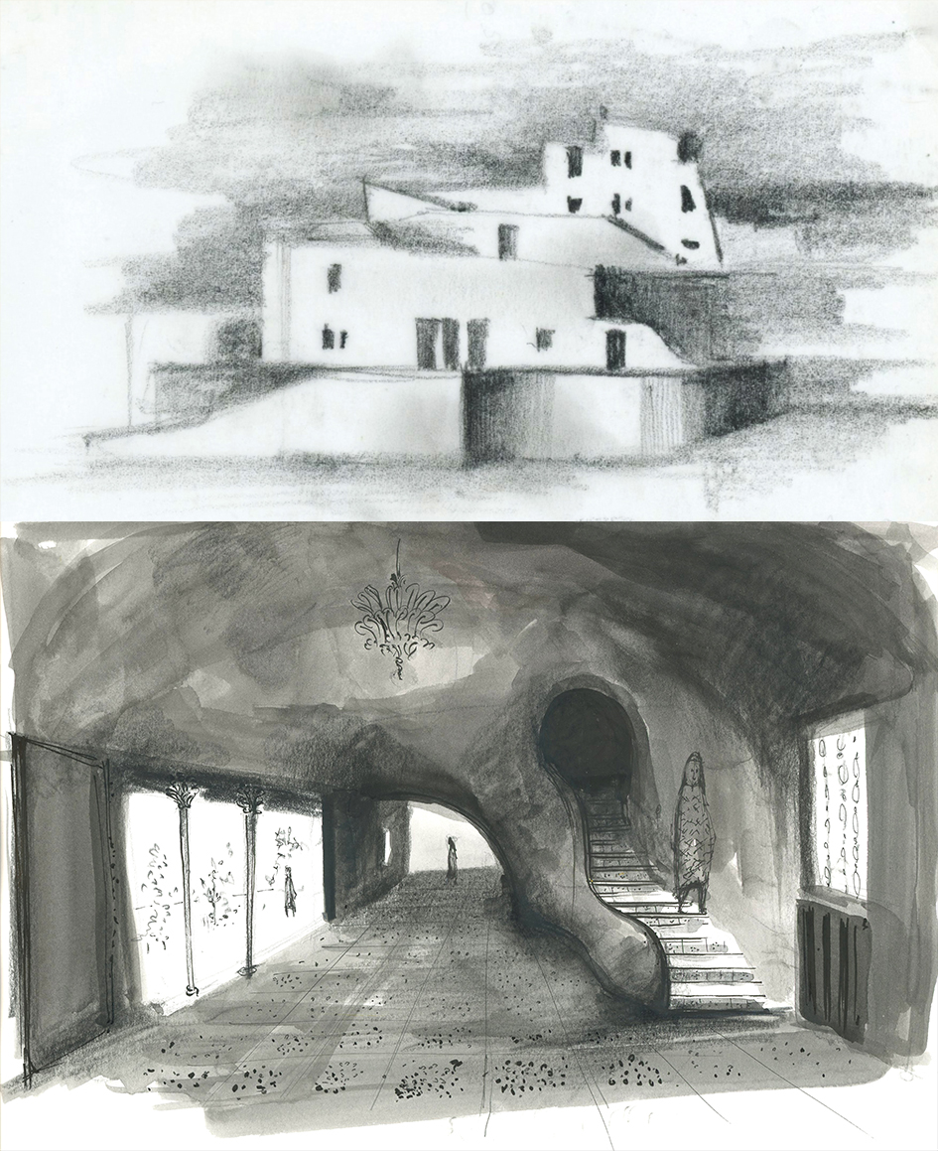Fig. 1. Interpretative drawings for the project of the “Due case a Capri” (Drawings by Giulia Bertola)
- DRAWING AND ARCHITECTURAL LANGUAGE OF ALDO MORBELLI AND THE PROJECT FOR the “DUE CASE A CAPRI”
Aldo Morbelli (1903-1963) is an Italian architect, born in Orsara Bormida in Piedmont. After graduating from the Faculty of Architecture in Rome, he founded his professional studio in Turin in the 1930s. During his professional activity Aldo Morbelli produced several architectural projects concerning single-family houses, social housing for the INA-CASA Plan, entertainment buildings, company representative offices and post-war reconstruction works. In addition to these projects, he has also worked on interior design and furniture design studies.
Aldo Morbelli's archive is kept in the Biblioteca di Architettura "Roberto Gabetti" of Politecnico di Torino and contains several documents relating to his projects, both completed and unfinished.
Despite the fact that in the past many of his projects have obtained recognition in internationally renowned magazines and the critics have dedicated a monographic issue in L'architettura Italiana to his single-family houses, to date, the figure of Aldo Morbelli is still little studied [3].
He affirms himself through a poetics that tends to a process of formal simplification, to a careful research of balance between project and insertion in the context (fig.2). This is particularly evident in the project of "Due case a Capri”.
The buildings, never realized and defined by Morbelli Large house (located lower down) and Little house (higher up), are thought to be situated on a land among the olive groves at the foot of Mount Tuoro, in the region "La Cercola".
The two buildings are facing west because of the steep slope of the land. He breaks the compactness of the volumes through the reference to the local architecture, solved through the insertion of segmental arches, the choice of colors and materials for walls and coatings such as white.

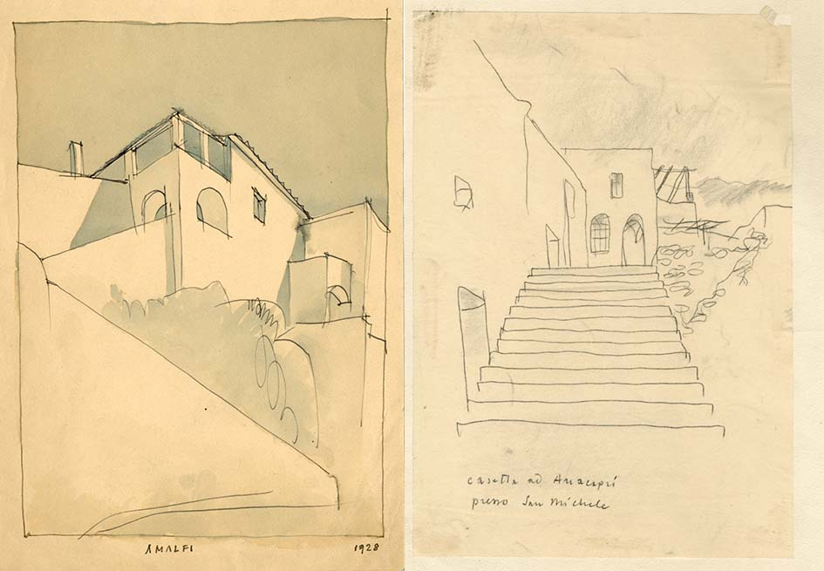
Fig. 2. A. Morbelli, real-life drawings of Mediterranean architecture (Archivi della Biblioteca Centrale di Architettura "Roberto Gabetti", Politecnico di Torino. In the following Archivi BCA. Fondo Aldo Morbelli).
Also in the interior spaces there is a clear intention to give the rooms a plastic sense: the walls and the distributive elements, such as the "S" staircase of the Large house adapt to the plan (fig.3).
The Little house is on three levels, basement floor for servants and storage, ground floor with living room and kitchen, through which is accessed through a sloping wall with arched entrance, and first floor with two bedrooms.
The Large house, instead, is only on two levels, the lower level is for the living area, with the living and dining area at double height that occupies all the sea view front and that of the services develops towards the mountain, while the highest level is for the sleeping area, with four bedrooms.
Looking at the drawings, it can be seen that the architect wanted to experiment with the insertion of different types of roofing: horizontal flat and sloping flat for the Little house, barrel and net vaulted for the Large house.
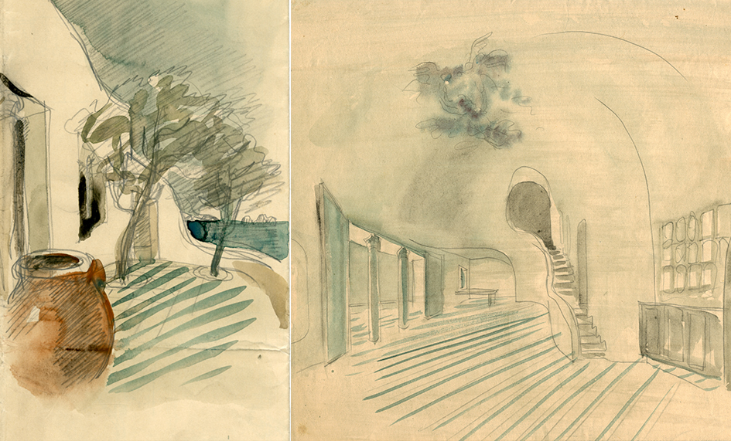
Fig. 3.A. Morbelli, study sketches for the two houses in Capri (Archivi BCA. Fondo Aldo Morbelli).
- the bim model generated by archive drawings
This contribution aims to show a methodology for the management, preservation and communication of archival material by integrating data with 3D modelling techniques.
This type of documentation, if inserted within a virtual database, can become an active component of the Archive itself, contributing to the general knowledge of lost or non-existent architectural artefacts. Archives could therefore become a place where to build, communicate and share knowledge within a complex system of relationships made up of different actors (institutions, curators, scholars, public), types of heritage (material, immaterial, real three-dimensional artefacts) and digital technologies (interaction, immersion, virtual and augmented reality). [4]
The construction of the model makes it possible to produce a variety of elaborates including real three-dimensional models to be made available to different users.
As underlined by the London Charter (2008) [5], it is the responsibility of the scientific community to ensure the sustainability of digital heritage, for example by promoting the use of open formats, favouring as much as possible the access to data to the community of users, experts or not. A BIM information system can represent the "sustainable container" and the appropriate means for the transmission of knowledge (for example through advanced Building Information Exchange systems).
In the HBIM environment, as in this case study, the operator must be able to manage complex and heterogeneous survey data (photographs, documents, sketches), master geometrical constructions, know construction techniques. The potential of Historical Building Information Modeling systems, despite the methodological and operational difficulties, allows to build a database capable of managing large amounts of multidisciplinary data. [6][7]
Some significant examples of the use of BIM technology as a tool for interoperability and advanced information management technology have emerged in some studies by Saygi and Remondino (2013) [8] which emphasize the semantic enrichment of three-dimensional digital models through the integration of heterogeneous data sets and in the Arches (2018) [9] and Inception (2016) [10] projects; the latter aim to make available interoperable information through multiple services such as websites, digital maps, applications and 3D models. While the first one is focused on the creation of an international community of computer scientists and heritage professionals to share experiences, knowledge and skills for the management of digital inventories, the second one is a project that aims at the development of advanced 3D modelling for the access and understanding of European cultural heritage. In particular, the HBIM modelling process, starts with the documentation of user needs, the identification of Cultural Heritage buildings semantic ontology and data structure for information catalogue integrated with the 3D geometric model.
A last interesting study is Cult Project (2018) [11], a project in which a software toolkit was developed to store data from architectural heritage research projects and share them with websites, tourism applications and BIM and GIS interfaces.
For the case of the “Due case a Capri”, it was decided to use the Building Information Modelling methodology and build a three-dimensional model using Revit 2021®. After scanning and digitizing the original drawings of the project, the documents were inserted into the Revit 2021® software.
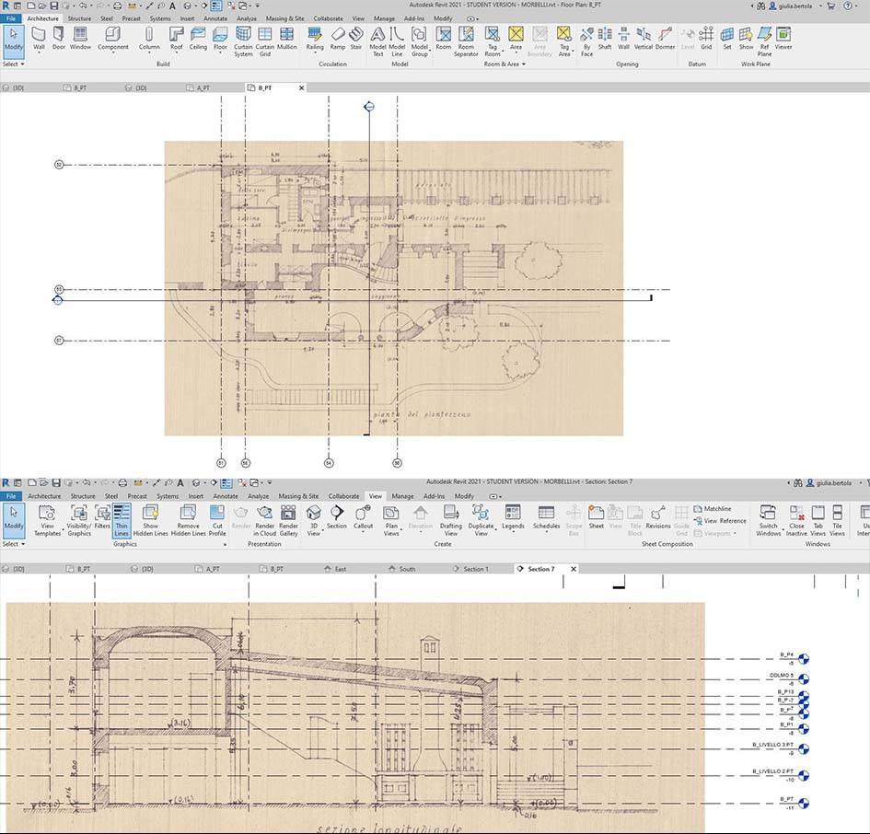
Fig. 4. Inserting archive images (Archivi BCA. Fondo Aldo Morbelli) on Revit 2021® (Graphic processing by G. Bertola).
To optimize the modeling process, the files in .jpg format, were not imported into the model but only linked to it. Initially, the plans were linked at 1:200 and 1:500 scale. Thanks to these, it was possible to correctly set the geolocation data, create a topographic surface and importing contour data.
After having identified the correct positioning of the buildings, we proceeded with the insertion of technical drawings at scale 1:100 containing plans, elevations and sections of each villas and territorial sections.
Each drawing has been scaled with reference to the dimensions reported on them and used as a base on which to set the model. Following the scaling of the images, the most significant work plans have been identified and a grid has been built for the alignment of plans, elevations and sections (fig.4).
The axes of the grid, besides being a useful trace for the construction of all the elements that will compose the model, also represent the tool to facilitate the reading and verification of the original drawings.
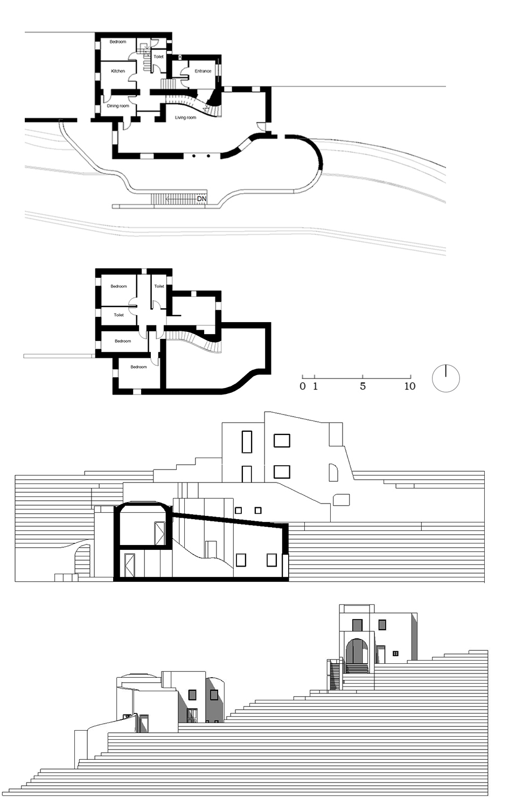
Fig. 5. Plans, section and elevation of Casa Grande on Revit 2021® (Drawing by Giulia Bertola).

This phase of work, to be done correctly, requires prior knowledge of the main volumes that make up the buildings. Once the volumes had been identified, we proceeded with the identification of the types of walls and floors, attributing to each one a specific thickness: perimeter walls (60 cm), partition walls (10 cm, 20 cm), and floors (40 cm) (fig.5).
Where it was not viable to refer to a System family, it was decided to use the In-place masses to create the roofs and curved elements present in some portions of the external walls and on the railing of the internal staircase of the Casa Grande.
All the masses have been transformed into surfaces.
During the modelling of these elements, some problems related to the rigidity of the BIM method in the modelling of unconventional shapes emerged.
The In-place masses were created using the Swept Blend command, which, however, did not make it possible to faithfully reproduce some of the most characteristic architectural elements of the project and typical of Aldo Morbelli's poetic.
During the final phase of elaboration of the BIM model, it was chosen to refer to the original plastic models not preserved but documented photographically. In order to maintain formal coherence, it was decided to create monochrome grayscale rendered views (fig.6).
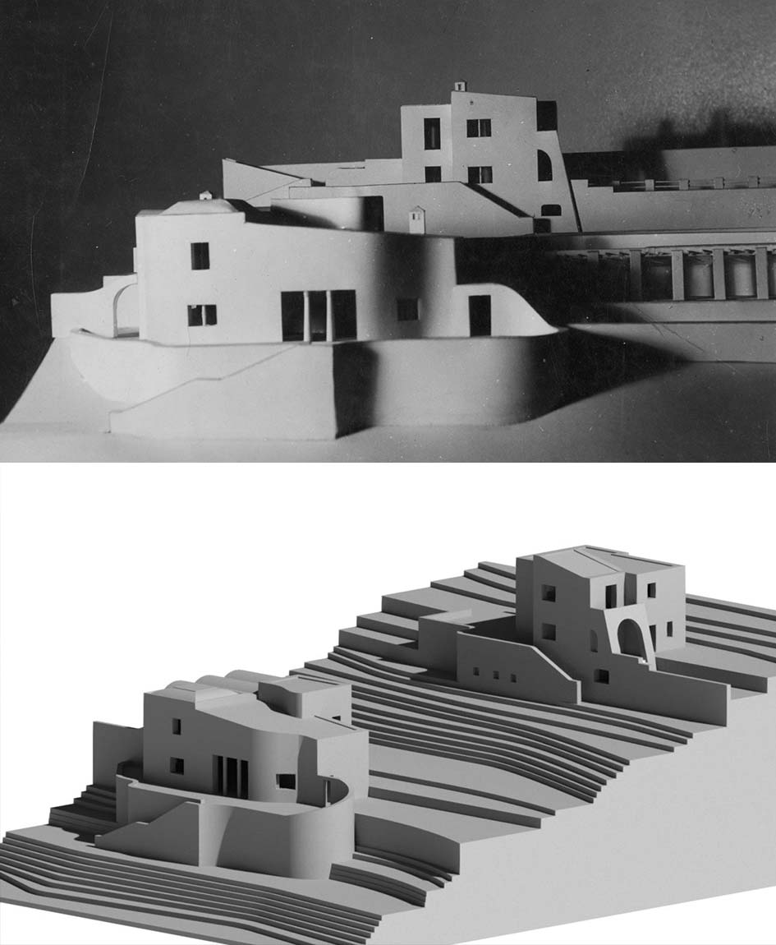
Fig. 6. A.Morbelli, photograph of the original model (Archivi BCA. Fondo Aldo Morbelli) and view rendered on Revit 2021® (Rendered by Giulia Bertola)

Also in the elaboration of plans and sections, it has been chosen to reach a level of detail that can be hypothesized at a scale of 1:200 in order to avoid distorting the original project by providing incorrect interpretations and additional information. Moreover, since it is a preliminary project, without detailed information about structures, stratigraphies and construction details, it was decided to use generic model families, avoiding the customization of the library of parametric objects.
- from bim model to prototype
This contribution also aims to focus attention on the effectiveness of digital fabrication techniques as a tool for the valorisation of archival heritage.
Starting from the virtual BIM environment it is possible to transform the digital model into a real model by using different Digital fabrication devices.
These, although still subject to improvement, allow accurate reproduction levels to be achieved. The more complex is the shape, the more complex will be the model fabrication process.
Here below, we compare two prototyping techniques that can be divided into two classes: subtractive and additive methods of manufacturing.
The first are based on the idea of reproducing an object by sculpting a block, removing material over a predetermined path. This operation is feasible through two types of machines: the CNC and Laser Beam machine.
The CNC machine is a milling tool that has the advantage of being able to process a wide range of materials (wood, stone and metal). In addition, it also provides a very large working space allowing the creation of large reproductions. The greatest difficulties, however, lie in the presence of geometrical and kinematic constraints that require design, slowing down the model processing.
Laser cutting is a process of thermal separation. The laser beam hits the surface of the material and heats it up to the point where it is melted or completely vaporized. Once the laser beam has completely penetrated the material at a certain point, the cutting process begins. The laser system follows the selected geometry and during this process the material is separated.
The additive process, usually called 3D printing, is instead a process by which solid shape (usually of small size) are construct by building one layer at time. All 3D printing processes involve the simultaneous collaboration of software, hardware and materials and have the great advantage, compared to subtractive processes, of being independent from the geometric complexity of the digital model. There are four main types of 3D printing.
The first is Fused Deposition Modelling (FDM): it is the most common 3D printing technology. This method uses a filament (a string of solid material), which, under the thrust of a heated nozzle, melts. The printer continuously moves this nozzle around, laying down the melted material at a precise location, where it instantly cools down and solidifies. This builds up the model layer by layer. During the construction of these solid shapes it is often necessary to use vertical supports to sustain overhanging parts. The main materials used are plastics (ABS or PLA). To avoid seeing the layers it is often necessary to sand and polish the surfaces.
The second is Laminated object manufacturing (LOM): this technique is based on cutting several layers which are then glued on top of each other. This printing technique allows the use of cheap materials such as paper, plastic and sheet metal.
The third is Granular materials binding (GMD): it involves the use of a binding material (such as glue) which, combined with a heat source (the laser), melts layers of loose powder and transforms them into a solid object. There are many materials that can be applied to this process (nylon, plaster, ceramic, resin, concrete and metals). This technique is suitable for processing particularly complex geometric shapes.
The fourth is Photopolymerization: it is a process in which a polymer changes its properties when exposed to light. This generally refers to photopolymers that are in a liquid resin state and harden when exposed to UV light.
The manufacturing process takes place in successive layers by lifting a mobile platform that lifts the already solidified resin to deposit the next resin layer. [12]

Two prototyping techniques were used for this work: Fused Deposition Modeling (FDM) for buildings and Laser Beam Machining (LBM) for the ground. The machining was chosen according to the printing scale and for reasons of economy, speed of execution, durability over time and final aesthetic effects. To proceed with the 3D printing, since an STL Exporter for Revit 2021® is not yet available, the file was exported in 1:100 scale in FBX format, imported in Rhinoceros® and then exported in STL. During the import phase in Rhinoceros®, the 3D model was scaled to 1:200 and the unit of measurement was changed to millimeters. For dimensional issues related to the printing dimensions of the machine, the models were divided into parts: building blocks and outer walls.
For the construction of the terrain, we started with the 2D file generated by Revit 2021® and proceeded with the print layout operations, defining the cutting power values with the Job Control® software (fig. 7).
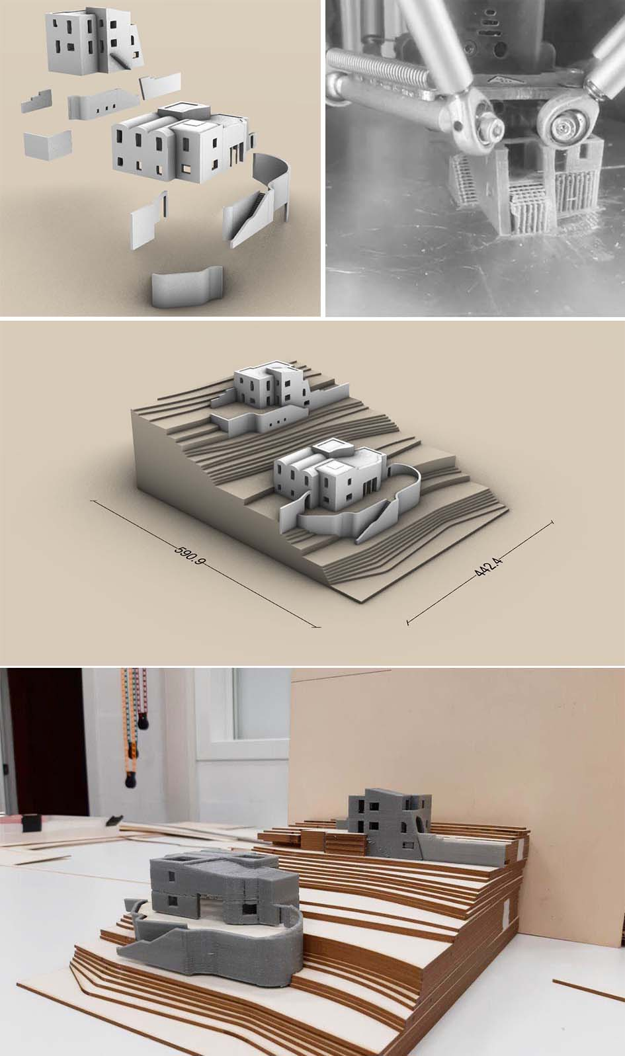
Fig. 7. Organization of the model for the printing process, 3D printing process, the final model (Model by Giulia Bertola)
- CONCLUSION
In the scenario of the digitization of archives, the 3D modeling phase allows to extend the consultation of archival material, placing drawings and photographs alongside three-dimensional models that can be explored through virtual reality and augmented reality experiences [13], with the application of different digital interfaces, machine learning techniques and computer supports. These technologies allow archives to catalogue and publicly show their content at any time through interactive support, allowing curators and scholars to greatly enrich the narrative experience. Archives can place visitors virtually within the experience, leaving them free to explore the content actively, helping to build a deeper connection between visitor and archival. [14]
The prototyping phase could, in addition to becoming an ideal context to experiment with the flexibility of the different printing techniques, give users the possibility, during the visit to the archive, to consult not only the original drawings but also plastic models (possibly decomposable) that allow a better understanding of the three-dimensionality of the artefact. This could be particularly useful and significant in the case of unrealized architectures, such as those treated in this case study, and thus become the first and only physical representation of the artefact.
The aim is to demonstrate that the conjectural reconstruction through digital models is an act of clarification of some aspects of architecture, often only left to the written word; through the construction of new representations the words take shape through a new figurative corpus; the digital model is not only the virtual image of the building but it becomes a possible image, becoming its only existential reality. [15]
References
- R. Spallone, G. Bertola, “F. Ronco, SfM and Digital Modelling for Enhancing Architectural Archives Heritage, in Metrology for Archaeology and Cultural Heritage”, Proc. of IMEKO TC-4 International Conference on Metrology for Archaeology and Cultural Heritage, 2019, pp. 142-147.
- R.Spallone, G. Bertola, “Design drawings as Cultural Heritage. Intertwining between drawing and architectural language in the work of Aldo Morbelli”, in Luis Agustín ed., The graphics of heritage, Cham, Springer, 2020, pp.73-85.
- A. Melis, “Architetti italiani. Aldo Morbelli”, L'architettura Italiana, 1942. No. 3, pp.49-72.
- M. Lo Turco, “The digitization of museum collections for the research, menagement and enhancement of cultural heritage”, S. Parrinello (ed.), “Digital & Documentation. Database and Models for the enhancement of Heritage”, Pavia University Press, Pavia, 2019, pp. 92-103.
- London Charter (Carta di Londra). LONDONCHARTER.ORG, Retrieved from: http://www.londoncharter.org/fileadmin/templates/main/ docs/london_charter_2_1_it.pdf., (20 September 2020).
- Nicastro S., “L’integrazione dei sistemi di Building Information Modeling nei processi di conoscenza del Patrimonio Culturale. Premesse teoriche, criteri metodologici e introduzione del Level of Reliability”, Tesi di Dottorato in Storia, Disegno e Restauro dell’Architettura, Sapienza Università di Roma, Rel. Bianchini C, 2017.
- Bianchini C., "Survey, modeling, interpretation as multidisciplinary components of a Knowledge System, SCIRES-IT-SCIentific RESearch and Information Technology, No. 4, 2014, pp. 15-24.
- Saygi, G., Remondino, F., Management of Architectural Heritage Information in BIM and GIS: State-of-the-Art and Future Perspectives”, International Journal of Heritage in the Digital Era, No. 2, 2013 pp. 695-713.
- Myers, D., Dalgity, A., Avramides, I., “The Arches heritage inventory and management system: a platform for the heritage field”, Journal of Cultural Heritage Management and Sustainable Development, No. 6, 2016, pp. 213-224.
- Maietti, F., Di Giulio, R., Piaia, E., Medici, M., Ferrari, F., “Enhancing Heritage fruition through 3D semantic modelling and digital tools: the INCEPTION project”, IOP Conference Series: Materials Science and Engineering, No. 364, 2018.
- Cult project, Retrieved from: http://cult.dicea.unipd.it, (25 September 2020).
- R. Scopigno, P. Cignoni, N. Pietroni, M. Callieri and M. Dellepiane, “Digital Fabrication Techniques for Cultural Heritage: A Survey”, Computer graphics forum, Vol. 34, 2015, pp.1-17.
- M.Lo Turco, Marotta A., “Modellazione 3D, ambienti BIM, modellazione solida per l’Architettura e il Design, in Uno (nessuno) centomila| prototipi in movimento. Trasformazioni dinamiche del disegno e nuove tecnologie per il design”, Milano/Roma, 2014, pp.17-24.
- V. Palma, “Tra spazio reale e realtà virtuale, in, Progetto e data mining”, a cura di L. Siviero, Lettera ventidue, 2019, pp.88 - 99.
- Maggio, F., “Architetture nel cassetto”. In A. Di Luggo, P. Giordano, R. Florio, L.M. Papa, A. Rossi, O. Zerlenga, et al. a cura di, Territori e frontiere della rappresentazione/Territories and frontiers of representation, Roma, Gangemi, 2017, pp.451 – 458.

