Major points of extension:

- 1. Introduction
- 3. Method
- 3.1 Survey technology and photogrammetry
- 4. Conclusions
- References
- Figures

In order to facilitate the revision process, all additional parts have been underlined.

Ancient metrology in architecture: a new approach in the study of the Roman bridge of Canosa di Puglia (Italy)
Germano Germano’
Department of Humanities, University of Bari, 70121, Italy
ABSTRACT
The Roman bridge of Canosa di Puglia (Italy) was built in the 2nd century A.D. to cross the Ofanto river along the Via Traiana, the route built at the behest of Emperor Trajan that connected Rome with the port of Brindisi, on the Adriatic Sea. Over the centuries, restorations, collapses and architectural transformations have deeply altered the original structure, making it lose the traces of the monumental central arch. Archival and field research, conducted through various surveys, has produced new data that have provided an update of the monument's history. The purpose of this research is to study the monument with a metrological approach, showing how indispensable this method has proven to be to formulate interesting hypotheses about the original configuration of the bridge and to affirm its central span as one of the longest among the bridges of the Roman Age.

Section: RESEARCH PAPER
Keywords: ancient metrology, method, archaeology, roman architecture, bridge
Citation: Thomas Bruns, Dirk Röske, Paul P. L. Regtien, Francisco Alegria , Template for an Acta IMEKO paper, Acta IMEKO, vol. A, no. B, article C, Month Year, identifier: IMEKO-ACTA-A (Year)-B-C
Section Editor: name, affiliation
Received month day, year; In final form month day, year; Published Month Year
Copyright: This is an open-access article distributed under the terms of the Creative Commons Attribution 3.0 License, which permits unrestricted use, distribution, and reproduction in any medium, provided the original author and source are credited.
Corresponding author: Paul P. L. Regtien, e-mail: paul@regtien.net

Introduction
A metrological approach is essential when studying ancient monuments. To believe that one can dispense with it is tantamount to wanting to study Roman civilization without knowing Latin. The language of architecture makes use of numbers and measurements that are specific to each culture or geographical area, and their interpretation can provide a key to developing hypotheses about the original look of an artifact and unlocking its meaning. This interpretation is often made difficult by the gaps frequently found in the structural stratigraphy of the monument itself and almost always the sources are not fully comprehensive in telling the story of the monument, especially for those of antiquity [1]. This difficulty also lies in the use of a different construction vocabulary in the ancient world whose references are inevitably made up of measurement systems that cannot be superimposed on the ones used nowadays, globally recognized in the International System of Units.
One route of interpretation lies in recognizing the recurrence of round numbers or multiples and submultiples of the numeral system of a certain culture, starting from today's metric data, comparing it with known ancient units of measurement and cross-referencing the data to verify the existence of similarities. This approach [2] has proven to be useful in the study of a stone bridge dating back to the time of Roman Emperor Trajan (2nd century BC) and located along the Ofanto river near Canosa di Puglia, in Southern Italy. Before reaching its present configuration, the bridge is described in ancient documents as having only three arches, of which the central one, wider and higher than the others, lent an impressive air to the whole structure. This characteristic is common to many Roman bridges, which aimed to cross the course of the river with an arch as wide as possible in order to obstruct the flow of the river as little as possible. The first (as well as the only) systematic study of the bridge dates back to 1985, when an archaeological excavation was carried out under the scientific direction of professor Raffaella Cassano of the University of Bari [3]-[4]. On that occasion, the archaeological investigation focused in particular on the study of the platea and its construction techniques.
After more than thirty years, the research presented in this paper embraces the heritage of those studies, adding new data on the architecture of the bridge and on the basis of these updates formulating new hypotheses with the aim of shedding new light on the millennial history of the monument [5].
HIstorical background
The history of the bridge follows the events of the road network established in this large flat area of Apulia, called the Tavoliere (Italian for “Table”) which thanks to its geographical characteristics was considered ideal not only for transhumance practices but also for passage to the south of the region and subsequently Greece, the East Mediterranean or beyond.
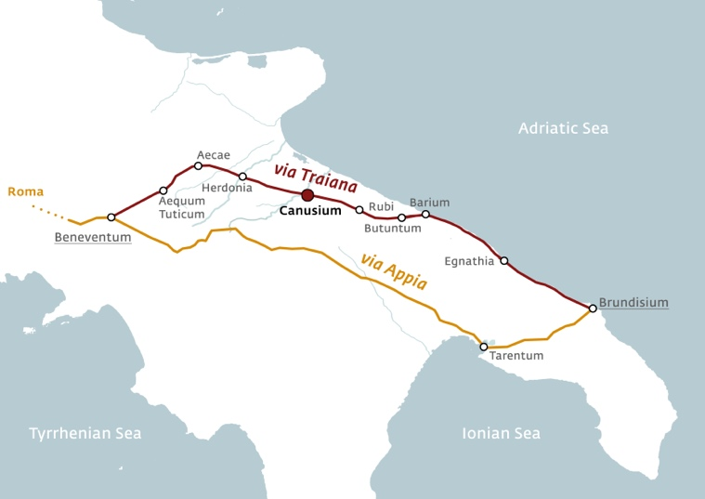
Figure 1. The route of Via Appia (the Appian Way) and Via Traiana (the Trajan Way) with the major cities along the road and, in red, the city of Canusium (Canosa di Puglia) near the Ofanto river. Map by Germano Germano’.

The bridge in the Roman Age
The original structure was erected on the occasion of the construction of the Via Traiana (Trajan Way) ordered by Emperor Trajan in 109 A.D. and originating from the city of Benevento, as an alternative to the Via Appia (Figure 1), this would allow a faster connection between Rome and Brindisi, the main port towards the East. Lying on a route already in prior use, the Via Minucia [6], it is not clear if there was already a bridge prior to the imperial age. In any case, the presence of a well-preserved foundation stone paved platea reveals an ex novo construction which is consistent with the construction techniques of the imperial age.

First works of restoration are documented in Roman times through inscriptions [7] that attest repairs under Septimius Severus and Caracalla, in the Tetrarchic Period, between the end of the 3rd century AD and the beginning of the 4th century AD. as well as in the Constantinian Age. However, the epigraphs only report these operations in a generic and celebrative way, without providing any useful data to determine measurements.

The bridge in Middle Ages
In the Middle Ages the bridge was still in use, since it was located along the Via Francigena, a road by which Christian pilgrims from all over Europe reached the ports of Puglia en route to the Holy Land. In the Middle Ages even flocks, herds and shepherds used it when they seasonally migrate from the altitudes of Abruzzo and Molise to the more temperate plains of Tavoliere, through the so called “tratturi” (drover’s roads), one of which was passing right through here.

During this long period new works were certainly necessary, but these are not documented until 1521, as the fragment of an inscription, reused in the Mausoleum of Boemondo d'Altavilla in Canosa, would bear.
The first report has been provided by an Italian traveler who at the end of the 16th century described the bridge as "wonderful" and reported the size of the central arch: 128 palms long and 40 palms high [8].

18th century: first survey, the collapse and the reconstruction
More than a century later, earthquakes, floods and wear and tear would weaken the structure of the bridge, making further restoration work necessary. The institution in charge of its maintenance, as belonging to the area of its domain, was the Regia Dogana delle Pecore (Sheep Customs Office), established in nearby Foggia in 1480. The documents relating to the interventions of the eighteenth century are still preserved in its archives [9].
In these archives it is stated that in 1749 a technical expert's report was commissioned to Francesco Delfino in which he warned of the dangers of stability. Attached to it, he schematically drew an architectural representation of the bridge in which he indicated the possible breaking points (Figure 2).
In the same document he also reported the exact measurements of the arches:

"[…] the main arch (is) 112 palms wide, high from the floor to the top (of) 44 palms, with a front of 5 palms, (while) the two lateral arches are wide 50 palms each, and high 25 palms".

Due to the stalling of a targeted action that inevitably would have involved large costs that none of the parties involved wanted to bear (Customs, the Crown, local administrators and landowners) the central arch collapsed on 11 February 1751.
Several considerations were made by technical experts who immediately intervened afterwards in the matter, among which, in the end, a safer reconstruction prevailed, but which would have definitively changed the millenary aspect of the bridge. In fact, it was decided not to rebuild the central arch but two smaller ones in its place resting on a newly built central pillar, thus lowering the profile of the bridge to a height similar to that visible today.

The bridge today
The bridge visible today, however, does not date back to these interventions because the current structure is the result of a reconstruction carried out in the mid-twentieth century, after the retreating German troops in World War II bombed the bridge [10], of which only the piers and the abutments were saved.
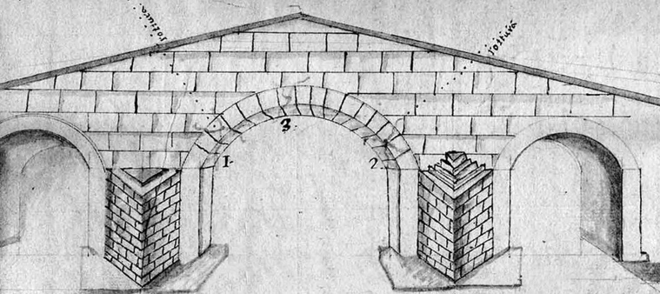
Figure 2. Drawing of the bridge by Francesco Delfino, 1749, detail. (National Archive, Foggia)
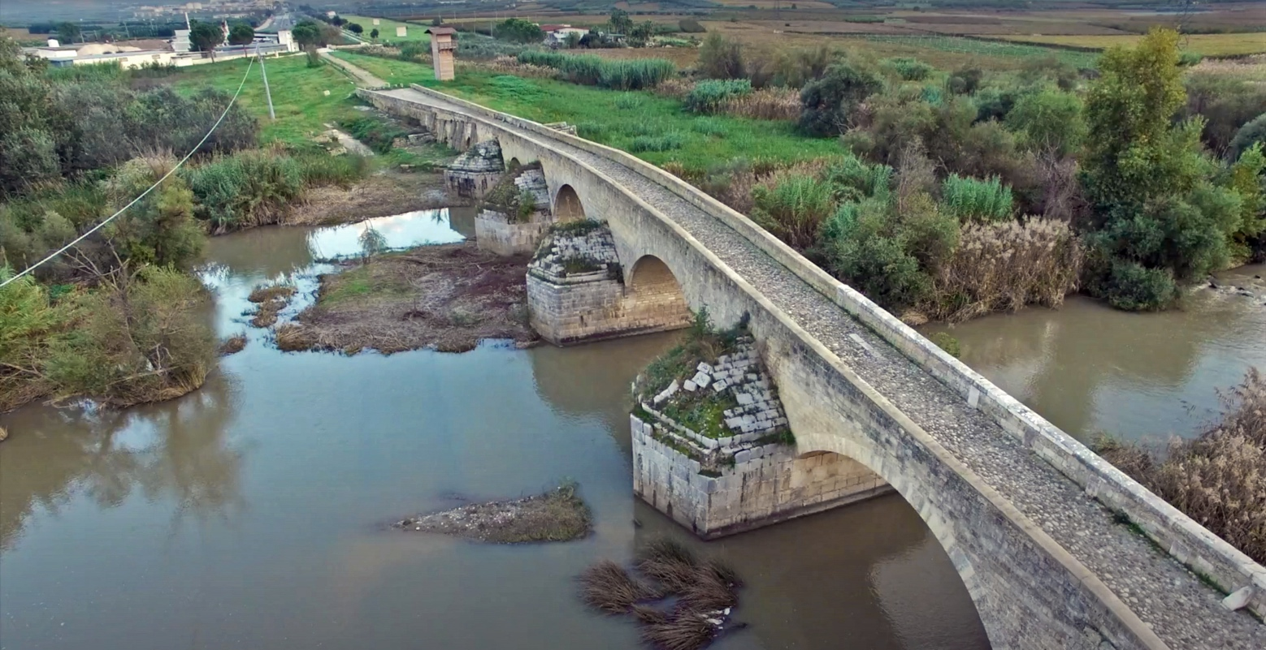
Figure 3. The bridge of Canosa di Puglia. View from West.
The bridge today (Figure 3) features five arches of different sizes and morphology (starting from the East: 6.50 m, 13 m, 12.10 m, 12.10 m, 13 m) based on four piers of different sizes, ranging from a minimum of 6.2 m to a maximum of 8.4 m. These are composed of square blocks in isodomic work and equipped with triangular starlings and pyramidal cones, upstream and downstream. The walkway above stretched for a length of 170 m and a width of 4.5 m, its trend is not straight and in correspondence of the abutments. Of the original structure remains only the piers, the abutments, and the foundation platea, [4], the latter visible when the river is dry. When the river level is low, it is also possible to see the concrete boardwalk built for the passage of American tanks in the last phase of World War II (Figure 4).
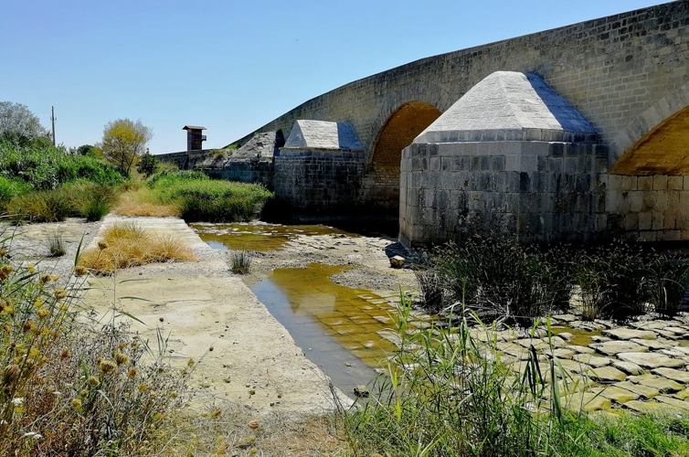
Figure 4. The bridge during the dry season, when the paving blocks of the roman platea and the concrete boardwalk built in the first half of the 20th century are visible.
Today, the bridge is only accessible on foot, so as not to overburden the structure with the passage of vehicles, which is instead provided by a bridge built in the 20th century a few hundred meters further upriver.
method
Once the research aim had been set up and the parts of the artefact considered to be original had been ascertained, the following steps were taken:

- archival research, through published sources and unstudied documents,
- comparison with historical photographs,
- on-site survey with manual and drone technology,
- photogrammetry operations,
- identification and recording of the different SSU (Structural Stratigraphic Units) [11],
- 3D modeling,
- graphic restitution and reconstruction hypotheses.

All the on-site operations highlighted the complexity of data collection for a river-situated historical site. In particular, the photographic campaign and the acquisition of the metric data with the integrated survey were found to be difficult due to the high flow of the river and the dense vegetation. For this reason, survey operations must take into account the natural context in which they are carried out and must also be appropriately planned according to the season.
However, also thanks to drone technology, it was possible to overcome some of the obstacles described above.

Survey with drone technology and photogrammetry
The drone used is a Dji Mavic 2 Pro equipped with a high resolution camera that supports a 78.8° shooting angle of 26.6 mm, a 1/2.3'' CMOS sensor of 12.7 Megapixel and a GLONASS GPS system with vertical-horizontal accuracy error of +/- 0.1 m and +/- 0.3m respectively. Proceeding with an aerial photo acquisition in manual flight, three photo acquisitions were made: two in rotation around the artifact at an altitude of 5 meters and 15 meters and one top view at an altitude of 25 meters.
The rotation photographic acquisition at 5 meters was made with a camera inclination of 0°, then with a view perpendicular to the structure in order to reduce the aberrations during data processing, and at 15 meters with a camera inclination of 45° for a photo acquisition necessary to receive data of the intersection node between the vertical and horizontal surfaces. Finally the one above 25 meters was captured with nadiral camera inclination for the acquisition of data from the upper part of the bridge, producing a total of 154 photographs with GSD (Ground Simple Distance) of
4.55mm/pix. During the acquisitions it was not necessary to use GCP (Ground Control Points) for a subsequent scaling of the model, as the measurements were taken using the architectural elements present in the structure such as the widths of the spans and the width of its the extrados through direct survey operations and the use of laser level and laser rangefinder.
Figure 5. Survey report. Reconstructed digital elevation model.
The photogrammetry operations (Figure 5) were carried out with the help of Agisoft Photoscan software, through which a dense point cloud composed of 12,490,415 points was generated, on which a textured mesh composed of 396,783 polygons and 396,783 vertices was produced. The model was scaled according to the points detected in the campaign phases.

Ancient metrology and data analysis
A metrological approach has been adopted in the interpretation of data resulting from the survey, comparing it with dimensional measures mentioned in ancient sources and cross-referencing them by synchronic or diachronic conversion of numerical data. The first case applies for historically and culturally related contexts, while the second case implements a multi-layered reading of different ages.
Discarding the parts ascertained as added or reconstructed, only the original elements still in situ were taken into consideration. Finally, a reconstructive hypothesis of the original morphology of the monument was formulated, based on Roman construction and measurement methods.
A certain degree of approximation is to be expected both in reporting the measures and, consequently, in converting them to reconstructive hypothesis. However, the margin of error is limited enough to consider the data as valid for the purpose of the research.

While the fundamental unit of measurement used during the Roman age was the foot (pes) and followed closely the measures of its Greek counterpart, the Attic foot, corresponding to 0.296 m [12], the authors of the two reports describe the bridge using the same unit of measurement, i.e. the palmo. (Table 1).

Table 1. Ancient units and their mutual correspondence.
Unit | Roman  Feet | Neapolitan  Palms | Meters
Pes | 1 | 1.1225 | 0.2960
Palmo | 0.8909 | 1 | 0.2637
Canna | 7.1270 | 8 | 2.1096
Meter | 3.3784 | 3.7922 | 1

As the two cases, 1584 and 1749, fall within the time span of the dominion of the Kingdom of Naples, which included the whole of southern Italy, we have therefore to assume that they were referring to the Neapolitan palm, corresponding to 0.26367 meters [13], calculated on the basis of the measurement of an oxidized bar kept in Castel Capuano in Naples used as the governmental standard [14], according to an edict (lost) issued on 6 April 1480 by Ferdinand I of Aragon and in force until 1840. Applying a metrological approach it is possible to derive different hypotheses about the construction phases of the bridge.

Synchronic conversion: what happened between the two key dates (1584 - 1749)?
A first conversion, of synchronic type, is made within the same measurement system to hypothesize the changes between the two sources key dates: it is interesting to note that both measurements are a multiple of 8. In the Kingdom of Naples, the unit of measurement that follows that of the palmo is the canna, which measures exactly 8 palms. Reading it in multiples, the 1749 survey describes an arch span reduced from 16 to 14 canne, exactly one canna per side (2.1 meters). A margin of error of 4.2 meters appears too large for a width of about 30 meters. One possibility is that consolidation works were necessary following one or both of the devastating earthquakes, the first in 1627 and the second in 1731 [15], which struck the Capitanata and in particular Canosa. In this sense, the work may have involved the overlaying or covering of the inner part of the pillars with a masonry reinforcement designed on the basis of a standard building measure, i.e. one canna.
Within Delfino's design there are two elements protruding from the piers (Figure 6), an unusual fact that supports this hypothesis, as an expert surveyor would hardly have invented or exaggerated, despite the evident schematization of the work.
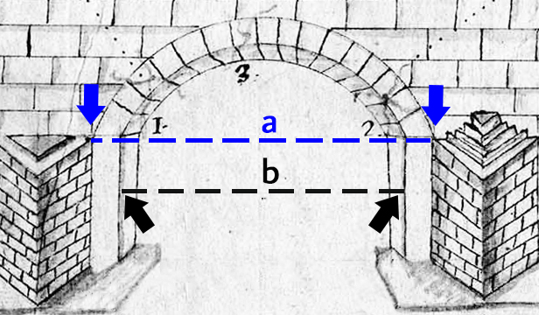
Figure 6. Drawing of the bridge by Francesco Delfino, 1749, with detail of the central arch (National Archive, Foggia). Possible traces of structural changes between 1584 (a) and 1749 (b) would explain the different dimensional data of the two reports mentioned in the text.
Table 2. Diachronic measures conversion chart

Element of  the bridge | Palms | Meters | Roman feet
Main arch  (span)  (height) | 112  44 | 29.53  11.60 | 99.78 ≃ 100  39.20 ≃ 40
Lateral arches  (span)  (height) | 50  25 | 13.19  6.59 | 44.54 ≃ 45  22.27
Front | 5 | 1.31 | 4.45

Diachronic conversion: reconstruction hypothesis
Through a diachronic conversion of the units of measurement (Table 2) it is possible to read the dimensions of the monument with the same measuring standards of the Roman builders. As previous said, the central arch was imposing and larger than the other two, as shown by Delfino's drawing and, even if with a more simplified style, other graphic sources preserved in the archives. Therefore, if we accept the dimensions reported in the document (112 palms) and hypothesize them as unchanged as compared to the Roman Age, having assumed the lateral piers as dating back to the imperial age, we obtain a measure (29.49 m) that is, with the due margin of error, exactly corresponding to 100 Roman feet. This measurement is an architectural constant of the monumental Roman architecture [16], present in one of the most famous monuments of Emperor Trajan in Rome, the column called "centenaria" for its height, as well as the Aurelian column. Similarly the measurement appears in the diameters of many monuments such as mausoleums (Emperor Augustus, Cecilia Metella, L. M. Plancus and Sempronius Atratinus and the most famous pyramid tomb of Caius Cestius, whose side measures exactly 100 Roman feet) public buildings (the hall of the Palatine Basilica of Constantine in Trier) theater orchestras (Aquileia) bridges (Narni, Alcantara) and many others, just to mention a few [17] – [20].
Also the height, 44 palms, would correspond to about 40 Roman feet, still a multiple decimal number, but this data is subject to more variables since in case of restoration or collapse the section of the arches is the part most exposed to sensitive alterations.
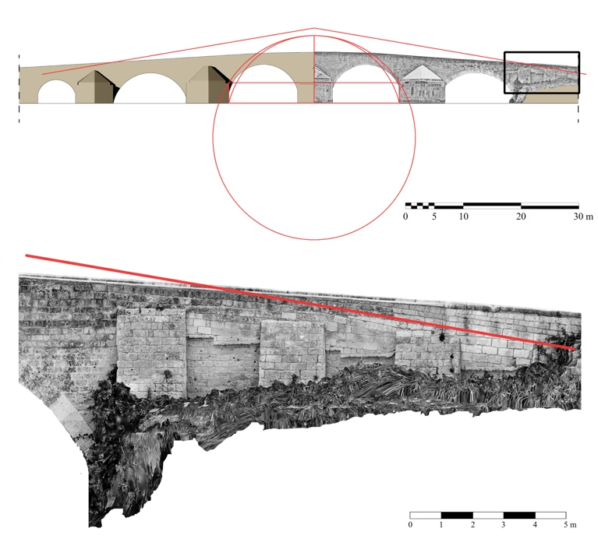
Figure 7. Upper, the bridge with the geometrical construction of the hypothesized shape . Lower, northwest front of the bridge, abutment. The red line shows the probable original incline still identifiable in the grade of the rows of blocks.
Moreover, it must be considered that it is not indicated in the sources whether the measurements were taken at the height of the water or the foundation platea.
Given these measurements, therefore the arc of the circle tangent was traced to the ideal segment at the level of the piers, about 3 meters high, obtaining a figure that outlines a donkey-back profile (Figure 7), based on a comparison with similar bridges, such as that of Ascoli Satriano on the Carapelle river (2nd century AD) and the Pont Julien at Bonnieux, in France (Augustan Age). The inclination of this profile corresponds to that found in the joints of the abutments (Fig.5), especially on the western side, which would confirm the presence of the original outline of the bridge (Fig. 6).
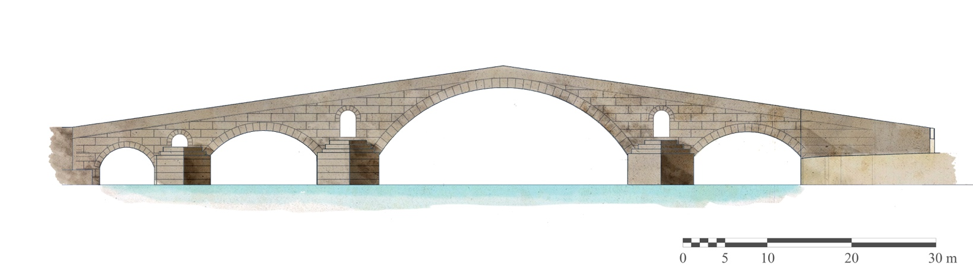
Figure 8. Graphical reconstruction of the bridge of Canosa in Roman times. Elaboration by Germano Germano’.
Further information comes from some inscribed slabs found in Cerignola [10] that could belong to the bridge. This type of inscribed slabs bore the inscription relating to the work, exalting its completion, and was part of the construction program of the Via Traiana. Also in this case, even if we do not have any information on what the original parapet looked like, the metric data relative to the "front" (5 Neapolitan palms, that is 132 cm) corresponds exactly to the height of the slab of Cerignola, letting us imagine that it was set along the balustrade that delimited the passage on the bridge (Fig. 7).
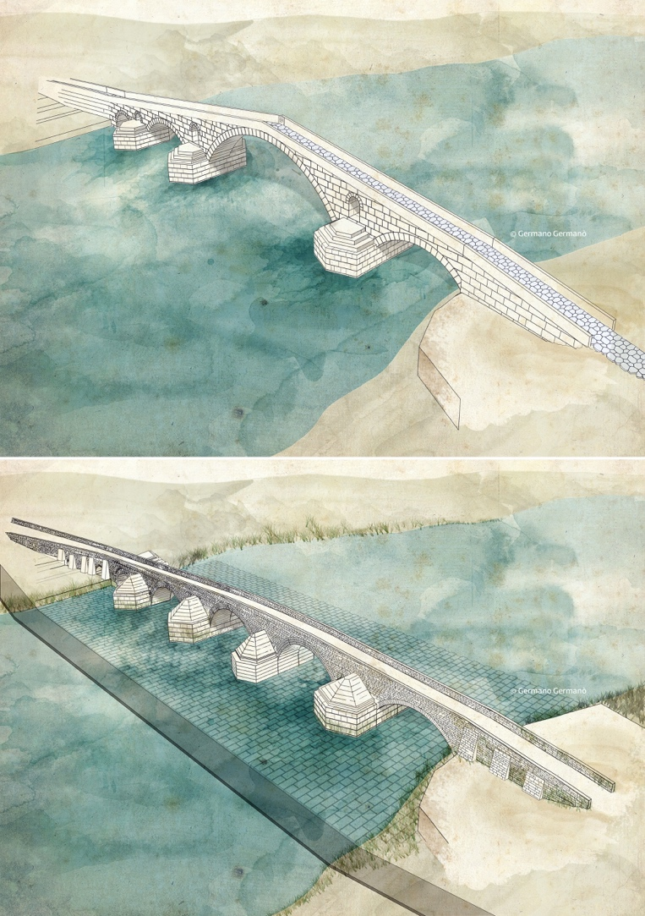
Figure 9. Illustration of the two main phases: upper, the Roman bridge;
lower, the bridge nowadays showing the foundation platea. Elaboration by Germano Germano’.
Conclusions
Despite an impervious context such as a river, challenging due to the frequent lack of sources and archaeological data, the research has shown how useful metrology has proved to be in formulating the reconstructive hypothesis with a high degree of reliability on a monument that has been strongly compromised over the centuries.
Beyond the theories on the exact morphology of the bridge, the research brings to light an architectural reality whose scope has been unfairly underestimated, and which places the bridge back in the history of ancient architecture, counting it among those with a central span among the longest in Roman times.
The results of this study would confirm the tendency in Roman monumental architecture to use the 100-foot module, although the variables involved encourage a careful approach, in order to prevent the temptation of a “metrological pareidolia”.
References
G. Germano’, The role of archives in the graphic restitution of monuments: the case of the Roman bridge over the Ofanto river in Canosa di Puglia, Italy, Bitàcora Arquitectura, 45, 2020, pp. 4-11. http://dx.doi.org/10.22201/fa.14058901p.2020.45.77630
G. Germano’, The Roman bridge of Canosa di Puglia: a metrological approach, Proc. of the 2020 IMEKO TC-4 International Conference on Metrology for Archaeology and Cultural Heritage, Trento, Italy, October 22-24, 2020, pp. 605-610. https://www.imeko.org/publications/tc4-Archaeo-2020/IMEKO-TC4-MetroArchaeo2020-115.pdf
R. Cassano, Canosa. Campagna di scavo 1985: il ponte romano sull’Ofanto, in: Le Rassegne archeologiche in Puglia. Atti del XXV Convegno di Studi sulla Magna Grecia, Taranto, 3-7 ottobre 1985, Napoli 1986, pp. 408-142.
R. Cassano, Il ponte sull’Ofanto, in: Principi, Imperatori, Vescovi, Duemila anni di Storia a Canosa. R. Cassano (editor). Marsilio, Venezia, 1992, ISBN 8-8317-5377-0, pp. 708-711.
G. Germano’, Il ponte romano sull’Ofanto: analisi delle tecniche costruttive, ipotesi di restituzione e valorizzazione, Tesi di specializzazione in Beni Architettonici e del Paesaggio, Bari, Italy, 2019 (Unpublished results).
G. Ceraudo, Via Gellia: una strada ‘fantasma’ in Puglia centrale, Studi di Antichità, 12, 2008, pp. 187-203.
M. Chelotti, V. Morizio, M. Silvestrini, Le epigrafi romane di Canosa II, Edipuglia, Bari, 1990, ISBN 978-88-7228-065-2.
P. Ieva, La sepultura di Re Boamundo in una inedita brieve descrittione tardo-cinquecentesca, in: “Unde boat mundus quanti fuerit Boamundus”: Boemondo I di Altavilla, un normanno tra Occidente e Oriente: atti del Convegno internazionale di studio per il IX centenario della morte, Canosa di Puglia, 5-6-7 maggio 2011. C.D. Fonseca, P. Ieva (editors). Società di storia patria per la Puglia, Bari, 2015, p. 301-335.
M. R. Tritto, I restauri settecenteschi del ponte romano di Canosa di Puglia, in: Canosa. Ricerche Storiche 2004. L. Bertoldi Lenoci (editor). Schena Editore, Fasano, 2005, pp. 71-100.
G. Germano’, Cultural heritage in times of war: the case of the Roman bridge of Canosa di Puglia, in: Antiquities, Sites and Museums Under Threat: Cultural Heritage and Communities in a State of War (1939–45), International Conference, University of Ghent, Belgium, 2020 (Unpublished results).
E. Fenthress, C. J. Goodson, Patricians, monks, and nuns: the abbey of S. Sebastiano, Alatri, During the Middle Ages, Archeologia Medievale, XXX, 2003, pp. 67-105.
A. Mazzi, Nota metrologica, in: Archivio Storico Lombardo. Società Storica Lombarda, Milano, 1901, p. 354.
C. Salvati, Misure e pesi nella documentazione storica dell'Italia del Mezzogiorno, L’arte tipografica, Napoli, 1970, pp. 34-35.
E. Lugli, The Making of Measure and the Promise of Sameness, University of Chicago Press, Chicago, 2019, p. 20.
A. Rovida, R. Camassi, P. Gasperini, M. Stucchi, Italian Parametric Earthquake Catalogue (CPTI11). Istituto Nazionale di Geofisica e Vulcanologia (INGV), Milano, Bologna, 2001, https://doi.org/10.6092/INGV.IT-CPTI11.
M. S. De Rossi, Analisi geologica ed architettonica delle catacombe romane, Roma, 1864, p. 75.
A. Carandini, La Roma di Augusto in 100 monumenti, UTET, Roma, 2019, ISBN 9788851169909.
C. Inglese, L. Paris (editors), Arte e tecnica dei ponti romani in pietra, Sapienza Università Editrice, Roma, 2020, ISBN 978-88-9377-150-4.
J.-P. Brun, P. Munzi, S. Girardot, A. R. Congès, M. Pierobon. Un mausoleo a tumulo di età tardo-repubblicana nella necropoli settentrionale di Cuma, in: Dall’immagine alla storia. Studi per ricordare Stefania Adamo Muscettola. C. Gasparri, R. Pierobon Benoit (editors). Naus Editoria, Pozzuoli, 2010, ISBN 978-88-7478-017-4. pp. 279-302. https://hal.archives-ouvertes.fr/hal-01435853/document
A. R. Ghiotto, G. Fioratto, G. Furlan, Il teatro romano di Aquileia: lo scavo dell’aditus maximus settentrionale e dell’edificio scenico, FOLD&R, 495, 2021.
http://www.fastionline.org/docs/FOLDER-it-2021-495.pdf
G. Ceraudo, A proposito delle lastre iscritte dei ponti della Via Traiana, in: Atlante Tematico di Topografia Antica 22. L. Quilici, S. Quilici Gigli (editors). L’Erma di Bretschneider, Roma, 2013, ISBN: 978-88-8265-772-7, pp. 143-153

