Multi-analytical approach for the study of an ancient Egyptian wooden statuette from the collection of Museo Egizio of Torino
Luisa Vigorelli^{1,2,3}, Alessandro Re^{2,3}, Laura Guidorzi^{2,3}, Tiziana Cavaleri⁴, Paola Buscaglia⁴, Marco Nervo^{3,4}, Paolo Del Vesco⁵, Matilde Borla⁶, Sabrina Grassini⁷, Alessandro Lo Giudice^{2,3}
¹ Dipartimento di Elettronica e Telecomunicazioni, Politecnico di Torino, C.so Duca degli Abruzzi 24, 10129 Torino, Italy
² Dipartimento di Fisica, Università degli Studi di Torino, Via Pietro Giuria 1, 10125 Torino, Italy
³ INFN, Sezione di Torino, Via Pietro Giuria 1, 10125 Torino, Italy
⁴ Centro Conservazione e Restauro “La Venaria Reale”, Piazza della Repubblica, 10078 Venaria Reale, Torino, Italy
⁵ Fondazione Museo delle Antichità Egizie di Torino, Via Accademia delle Scienze 6, 10123 Torino, Italy
⁶ Soprintendenza ABAP-TO, Torino, Piazza San Giovanni 2, 10122 Torino, Italy
⁷ Dipartimento di Scienza dei Materiali e Ingegneria Chimica, Politecnico di Torino, C.so Duca degli Abruzzi 24, 10129 Torino, Italy

ABSTRACT
In the field of Cultural Heritage, the interdisciplinary and multi-technique approach to the study of ancient artifacts is widely used, providing more reliable and complementary results. To study these great value objects, non-invasive approach is always preferred, although micro-invasive techniques may be necessary to answer specific questions. In this work, a study based on both non-invasive and micro-invasive techniques in a two-step approach was applied as a powerful tool to characterize materials and their layering, as well as to get a deeper understanding of the artistic techniques and the conservation history. The object under study is an ancient Egyptian wooden statuette, belonging to the collections of the Museo Egizio of Torino. Analyses were performed at the Centro Conservazione e Restauro “La Venaria Reale” (CCR), starting from non-invasive multispectral and X-ray imaging on the whole object in order to obtain information about the technique of assembly and on some aspects of the constituents materials, and subsequently, non-invasive XRF analysis and FT-IR, SEM-EDX and optical microscopy on micro-samples. This work is intended to lay the groundwork to the study of other wooden objects and statuettes belonging to the same funerary equipment, with the definition of a measuring protocol to study the most significant aspects of the artistic technique.

Section: RESEARCH PAPER
Keywords: Egypt; statuette; multi-analytical; Museo Egizio; tomography
Citation: Thomas Bruns, Dirk Röske, Paul P. L. Regtien, Francisco Alegria , Template for an Acta IMEKO paper, Acta IMEKO, vol. A, no. B, article C, Month Year, identifier: IMEKO-ACTA-A (Year)-B-C
Section Editor: name, affiliation
Received month day, year; In final form month day, year; Published Month Year
Copyright: This is an open-access article distributed under the terms of the Creative Commons Attribution 3.0 License, which permits unrestricted use, distribution, and reproduction in any medium, provided the original author and source are credited
Funding: NEXTO project (progetto di Ateneo 2017) funded by Compagnia di San Paolo, neu_ART project funded by Regione Piemonte
Corresponding author: Alessandro Re, e-mail: alessandro.re@unito.it

- Introduction
Scientific research in the Cultural Heritage field involves, in most cases, the development and use of physical and chemical methods to answer specific questions for a better understanding of objects produced in different contexts during history. Through the analyses, it may be possible to reveal and identify materials and technologies used in the past, and also provide more grounded parameters for the preservation and conservation of cultural heritage artefacts [1].
The use of non-invasive methods (with no sampling) is very suitable in this kind of study allowing the analysis of different types of objects fully respecting their integrity. Some of these non-invasive techniques cover a large part of the electromagnetic spectrum, ranging from the analysis with gamma and X-ray radiation going through the ultraviolet, visible and infrared regions [2]-[7]. Furthermore, for chemical and compositional analysis, some micro-invasive techniques are often used [8], [9]. Together, all these complementary methods are powerful to give valuable information on the elemental composition as well as on the state of preservation, getting to the artistic processes performed by the artists [10], [11].
In this paper a multi-technique approach was used to finalize an in-depth study on an ancient Egyptian wooden statuette, belonging to the collection of Museo Egizio of Torino. All the measurements were performed at Centro Conservazione e Restauro (CCR) “La Venaria Reale”, where several scientific laboratories for the study and characterization of materials of art objects and ancient finds are available, before carrying on the required conservation treatments. In particular, instruments that allow imaging investigations, microscopy analysis and spectroscopic measurements are present at CCR and their characteristic will be described in section 3.1.
The approach is based on the combination of imaging techniques, in particular ultraviolet fluorescence (UVF), visible-induced infrared luminescence (VIL) and infrared reflectography (IR) that were employed to map the distribution of the different materials, such as the pigments used in the polychromies, their thicknesses and layering, as seen in previous studies [12]-[14]. Among imaging analyses, a radiographic (RX) and tomographic (CT) study was also performed in order to investigate the inner part of the objects and to reach a deeper understanding on the execution technique and state of preservation [15], [16]. The next sections show in addition the results of compositional and chemical elemental analysis acquired both directly on the surface with the non-invasive x-ray fluorescence (XRF) technique, and on samples with optical microscopy, Fourier transform infrared spectroscopy (FT-IR) and scanning electron microscopy (SEM-EDX), largely used also in some other studies [17]-[21] .
All the techniques listed above proved to be equally important in this study, providing each one different and complementary information, but essential to get a thorough knowledge of the artefact and to finally implement the best conservation strategy.
This work contribute to the creation of a measuring protocol, applicable to other wooden objects and statuettes belonging to the same funerary equipment, in order to obtain as much information as possible on the entire assemblage treasured at the Museo Egizio of Torino.

- THE STATUETTE
The painted wooden statuette, representing an offering bearer (S.8795, fig. 1), was found during the 1908 excavation season of the Italian Archaeological Mission, directed by Ernesto Schiaparelli, in the necropolis of Asyut (Egypt), a site situated some 375 km south of Cairo. The statuette was part of the conspicuous funerary assemblage of the so-called “tomb of Minhotep”, which included additional statuettes of offering bearers, larger wooden statues, a model of a bakery, boat models, as well as coffins, wooden sticks, a bow with arrows and numerous earthenware jars and bowls [22], [23]. Most of the equipment derived from specialized workshops operating in Asyut during the early Middle Kingdom (ca. 1980-1900 BCE).
These types of artefacts, generally given as a gift to the temples with a votive function, or put inside the tombs with a protective function, began to be common in particular starting from the New Kingdom although even earlier examples are documented, such as the one analysed here. The figurine in question represents an ordinary person engaged in daily activities, with service functions, attributable to the typology of serving statues of a typically funerary context: it is a 'bearer of offer', or a sculpture with richly dressed female features and bearing on his head a basket full of offerings, generally held in position with the left hand, and animal or other offerings held in the other hand (in this particular case the two arms are missing).
The statuette is structurally composed of three elements: the basket, the human figure and the base, with a total dimension of 60 (h) × 12,5 (d) × 25,5 (w) cm.
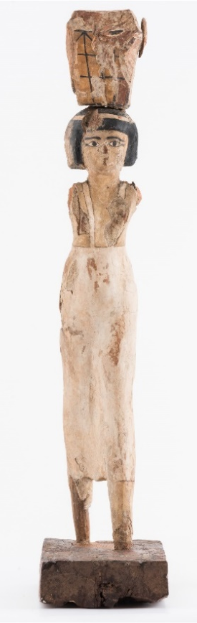
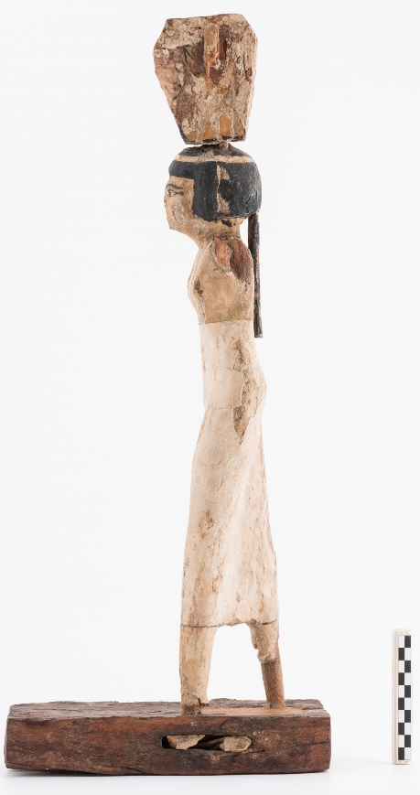

Figure 1. The analysed “Bearer” statuette (S. 08795), frontal and lateral views after the conservation treatment.

- MATERIAL AND METHODS
In the field of Cultural Heritage, diagnostic protocols usually give priority to non-invasive and imaging analyses because they provide an overview of the main characteristics of the object highlighting some material differences; consequently, they are essential for selecting the most representative subsequent analysis and sampling points. With this approach, the taking of some micro-samples from the artefact is the last step of the diagnostic campaign necessary to answer specific questions that arise during the early stages of the investigation.
In this specific case study, non-invasive investigations (imaging and chemical analysis) were initially carried out; the results then led to the need of very small samples (~µm) for more in-depth measurements, such as microscopic investigation and FT-IR spectroscopy, in order to obtain useful information on the state of preservation and previous restorations.

  - Techniques and instrumentation

UV induced visible fluorescence (UVF)
The statuette was irradiated with UV Labino® spot lamps (UV light MPXL and UV FLOODLIGHT), with emission peak at 365 nm. The fluorescence produced in the Vis region was captured with a Nikon D810 full-frame reflex camera equipped with a PECA 916 filter. The post-production of the photographs using Adobe's Lightroom software provided for the chromatic balance thanks to a 99% Spectralon® and a Minolta ceramic. This technique allows to evaluate characteristics such as homogeneity and distribution of surface layers based on the color and intensity of the visible fluorescence induced by UV radiation.

Infrared Reflectography 950 nm (IR1)
The investigation was carried out after the first cleaning phase, that provided the removal of superficial dust, to reduce its interference facilitating the study of the artistic technique. The measure was made with Ianiro Varibeam Halogen 800W lamps. The images were acquired in the photographic infrared range (750-950 nm) with a Nikon D810 IRUV full frame reflex camera, with B + W 093 filter. The post-production of the images using Adobe's Lightroom software provided for color and exposure correction. This technique shows the presence of preparatory traces or changes under the painted film.

Visible-induced infrared luminescence (VIL)
The VIL technique allows the localization of details made with the Egyptian blue pigment, even when in poor conservation state due to its intense fluorescence emission at around 916 nm when illuminated with visible light [24].
The lighting was guaranteed by LED lamps without IR emission and the images were acquired in the photographic infrared range (750-950 nm) with a Xnite Nikon D810 (Digital Camera UV + Vis + IR Functionality) modified full frame reflex camera equipped with Hoya R72 filter. The post-production carried out with Adobe's Lightroom software provided for the chromatic balance using ColorChecker® Classic of 24 colors and a reference standard of Egyptian blue (Kremer Pigmente n ° 10060) inserted in the shooting field.

Radiography (RX) and Tomography (CT)
The radiographic and tomographic analysis are useful for studying, for example, the techniques used in assembling the structure (e.g. joining elements) or to detect evidence of previous interventions. In particular, CT allows to observe the inner sections of the object, the orientation in space of its constituent parts, the sequence of the layers that compose it and their thickness. In this particular case a first radiographic measurement was performed using a fixed X-ray imaging set-up, developed in the context of the neu_ART project [25], [26], and already used on very different kind of artworks [27] and archaeological finds [16], [28]. It consists of a General Electric Eresco 42MF4 X-ray source, a rotating platform and a Hamamatsu C9750-20TCN linear X-ray detector of 200 μm × 200 μm pixel dimension that scans at about 0.2-6 m/min over an area of about 2×2 m². Since this set-up was optimized for CT of large artefacts, a second RX followed by a CT analyses were performed using a flat panel detector (FP) Shad-o-Box 6K HS by Teledyne Dalsa, which, with an area of only about 160 cm² and a pixel dimension of 49.5 µm, is more suitable for small objects or for part of large objects where a higher resolution is needed. For both measurements, a voltage of 80 kV and a current of 10 mA was set as acquisition parameters.
For the radiography, the elaboration of the images was made with the open-source software ImageJ, whereas for the CT sections reconstruction a filtered back-projection algorithm by means of a non-commercial software-utility developed by Dan Schneberk of the Lawrence Livermore National Laboratory (USA) was used; the 3D rendering and segmentation was processed using VGStudio MAX 2.2 from Volume Graphics.

X-Ray Fluorescence (XRF)
The measurements were performed on representative points selected on the basis of the responses of the imaging techniques. The technique identifies the chemical elements present in the analysed area (spot diameter between 0.65 mm and 1.50 mm) for a variable depth based on the chemical nature of the materials present (approximately 150 μm). The collected data are employed to make hypotheses on the inorganic materials (mineral pigments) of the pictorial palette. For the analysis a portable Micro-EDXRF Bruker ARTAX 200 spectrometer was used with a fine focus X-ray source with molybdenum anode and ADC with 4096 channels; the anode voltage is adjustable between 0 kV and 50 kV, the anode current between 0 μA and 1500 μA (maximum power 50 W). The measurements were carried out with a voltage of 30 kV and a current of 1300 μA, by fluxing helium on the measurement area in order to optimize the detection limit of the instrument.

Fourier Transform Infrared Spectroscopy (FT-IR)
The analyses were carried out to characterize original organic substances or possibly localized intervention materials previously detected through UV fluorescence imaging. Infrared spectrophotometry allows to identify the organic and inorganic components present in the sample. The measurements were conducted on selective micro-samples with a Bruker Vertex 70 FT-IR spectrophotometer coupled with a Bruker Hyperion 3000 infrared microscope working in transmission with the aid of a diamond cell.

Optical Microscopy and Scanning Electron Microscopy with EDX (OM and SEM-EDX)
The stratigraphic samples were carried out after the non-invasive analytical campaign, in order to study the materials in depth. The observation with OM in stratigraphy allows to obtain information on the executive technique adopted for the realization of the preparations, the polychromies and the finishes; the SEM-EDX analysis instead allows to obtain compositional information on the chemical elements present in the different layers. Following sampling, the fragments identified for stratigraphic analysis were incorporated in transparent resin (Struers Epofix epoxy resin). The samples prepared in a polished section are observed by means of an OLYMPUS BX51 mineropetrographic microscope, in visible and UV light, interfaced to a PC by means of a digital camera. The acquisition and processing of images is carried out using analySIS Five proprietary software. For the SEM analysis, the samples were observed with a Zeiss EVO60 electron microscope for morphological investigations (mainly by means of Back-Scattered electrons Detector, BSD). The EDX Bruker microprobe allows semi-quantitative elemental analysis. The analyses were performed in high vacuum for which the sections were pre-treated with a surface graphitization process.

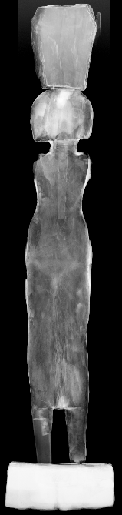
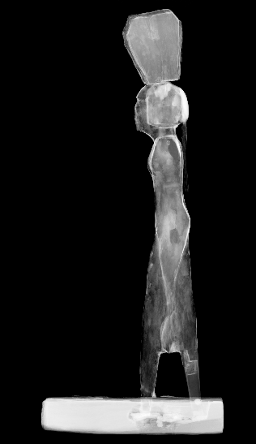
a
g
f
e
d
a
c
b
1
4
3
2
6
5
8
7

Figure 2. Frontal and lateral pictures of the statuette under different illumination for the multispectral analysis: (a) and (e) visible light, (b) and (f) UV fluorescence, (c) IR reflectography, (d) and (g) radiography. In picture (a) the measure points for XRF analysis are signed with numbers 1-8.

- results and discussion
  - Assembly and modelling techniques

The close observation and the analyses carried out made it possible to describe the assembly technique of the two portions
(the basket and the body), which were originally assembled by inserting wooden dowels, with circular section, free of glue or filler material. Moreover, a non-uniformity of the surface and the presence of gaps distributed over the entire body could be immediately noticed. In correspondence with some of these, such as on the chest or the hips, it was possible to observe the presence of a double layer of preparation.
The first, light brown-coloured and coarser, is directly spread on the wooden material; on this, a second, thinner, white layer was perceivable (fig. 3a). In some areas of the sculpture, the thin white layer seems to be applied directly on the wooden material, as observed for example on some gaps in the garment (fig. 3b). The pictorial decoration was realized on this white preparation. For a better understanding of the construction technique and the contribution of the preparatory layers in modelling the shape, radiographic and tomographic analyses were carried out. Data were acquired on the whole statuette for radiography, while for CT the acquired portion is limited from the basket down to the hips of the statuette. Thanks to the X-ray imaging, it was possible to visualize details and features of the object: tomographic data in particular provided important information not only on the assembly but also on previous structural interventions (discussed in section 4.3.). At first glance, it was possible to notice areas of the radiographic images with different radiopacity over the entire volume of the body (fig. 2d). This confirm the non-homogeneity of the preparatory layer distribution, which is more radiopaque than the wooden support.
a
b

Figure 3. Particular of the chest and the dress of the statuette; (a) the preparation layer on which the painted layer is applied; (b) the painted layer applied directly on the wood.

Thanks to the CT slices it was also possible to localize the presence of the double layer of preparation mentioned before. The capability of detecting the materials of the ground layer allowed us to confirm that they have contributed to partially polish the shape (e.g. head, breasts and hips), and to correct the gaps in volume due to possible defects of the wood or to refine some imprecisions in carving. Where the carving was enough refined, a single preparation layer has been laid (fig. 4). As regards the assembly technique, the junction between the basket and the head has been realized by means of wooden dowels insertions, as the radiographic, and the tomographic images, have shown (fig. 4). The same anchoring system is evident in correspondence of the missing arms, as shown in fig. 4e. From the tomographic sections of the head (fig. 4c), multiple portions assembled by wooden dowels, peculiarly oversized, are observed, employed in order to achieve the final volume; CT demonstrated to be useful also in understanding the direction of insertion of each dowel. Also in correspondence with the right breast, the same type of assembly technique can be seen: the observation of the inner growth rings trend allows recognizing this insertion as a remediation for a material detachment probably in the notching phase (fig. 4d).
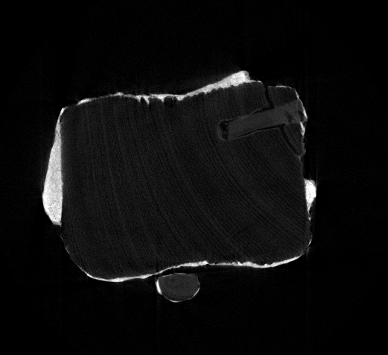
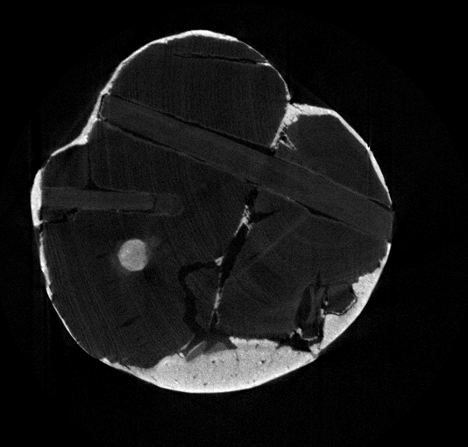
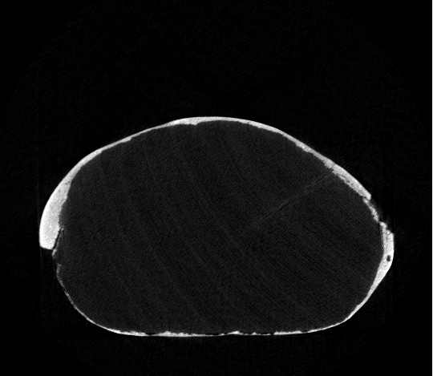
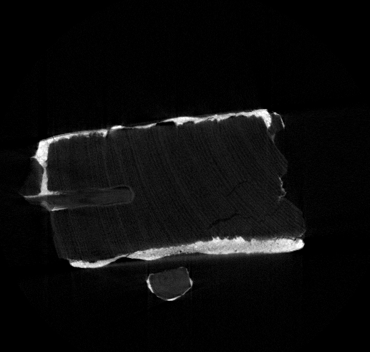
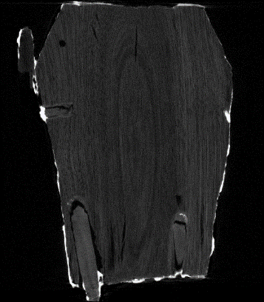
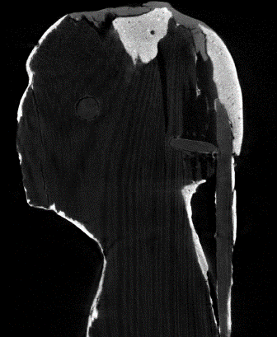
f
d
c
e
a
b

Figure 4. Radiographic image and CT vertical and horizontal slices of the statuette: (a) basket; (b) and (c) head, (d), (e) and (f) body (green arrows: wooden dowels for assemblage; blue arrows: wooden joints; pink arrows: thicker preparation layer).

To investigate the nature of materials used for the preparation layers (and pigments, as detailed in section 4.2), non-invasive XRF analysis were performed on some representative points (fig. 2a and table 1) and two stratigraphic samples, one from the white
garment (fig. 5) and one from the black wig (fig. 6), were analysed by OM and SEM-EDX. The white thin preparation layer results to be made of a calcium carbonate-based material, with a little fraction of quartz.

  - Pigments and finishing layers

For a better understanding of the pictorial materials, imaging analyses have been followed by non-invasive XRF and analysis on two cross-sections, as previously explained.
The yellow pale colour used for the skin of the figure results made of yellow ochre and/or earth, probably mixed with gypsum and/or calcium carbonate (see fig. 2a and table 1).
Table 1. XRF analysis results (+++ = main chemical elements; ++ = secondary elements; + = trace elements; - = not detected).

The warm white colour of the garment results made of gypsum with minimal impurities of iron oxides, as detected in the cross-section (fig. 5). Considering the rarely documented use of gypsum as a pigment, this data appears very interesting and could be one of the features to be investigated also on the other finds of the funerary equipment. A black pigment results to be used in profiling the dress, the eyes, and the eyebrows, and to colour the wig. The IR reflectography (fig. 2c) suggests it is probably a carbon-based material, based on its strong absorption. OM and SEM-EDX analyses of the cross section of the wig allowed confirming the carbonaceous nature of this black (fig. 6).
As regards the wig, the preliminary hypothesis that there could
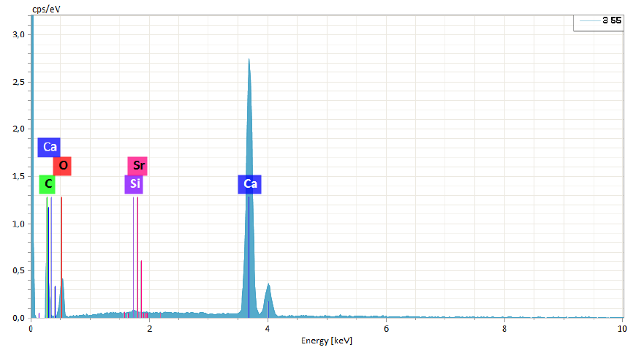
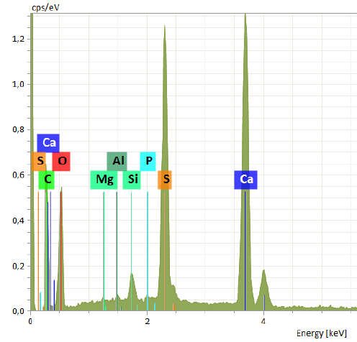
a
b
2
1
c
+
+
+
+
d
e

Figure 5. (a) Stratigraphic sample of the white preparation, taken from the body of the statuette; (b) Cross section under OM in visible light (1, preparation layer; 2, warm white pictorial layer); (c) SEM-BSD image of the cross section; (d, e) SEM-EDX spectra respectively of the preparation and pigment layers.

be some Egyptian blue pigment mixed with black was ruled out thanks to the VIL survey which did not detect any luminescence of the pigment on the statuette. The preliminary close observation of the statuette and the UVF analysis allowed excluding the presence of a finish layer distributed on the surface, rather confirming a strong material non-homogeneity due to the state of preservation and previous interventions (fig. 2b,f), as already observed also by the X-ray imaging analysis. A selective sampling from one of the areas with the greatest surface yellowing, that showed yellow-orange UV fluorescence, was taken for further materials investigations with FT-IR analysis (see 4.3).

Measurement point | Element
Measurement point | Mg Al Si P S Cl K Ca Ti Mn Fe Sr
1_face yellow | + + + + ++ + + ++ + + +++ +
2_body yellow | - + + + ++ + + +++ + + +++ +
3_body yellowish white | + + + + ++ + + +++ + - + +
4_body clean white | - + + + ++ + + +++ + + + +
5_leg gap white | + + + + + + + +++ + + + +
6_ eyebrow black | + + + + ++ + + +++ + + +++ +
7_basket dark yellow | - + + + + + + +++ + + +++ +
8_basket red | - + + + + + + +++ + + ++ +

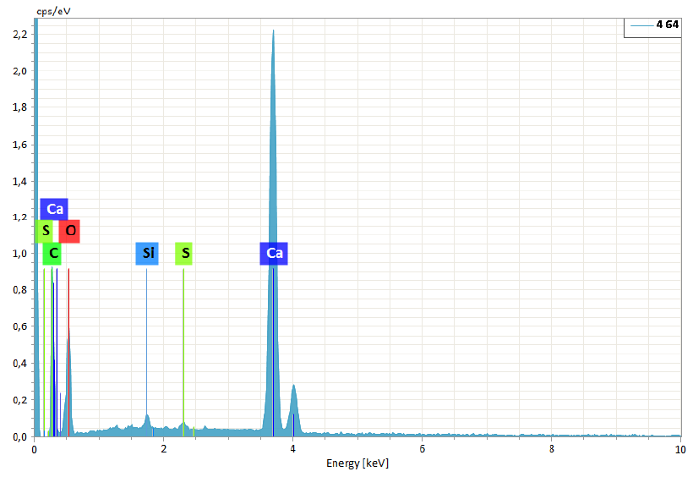
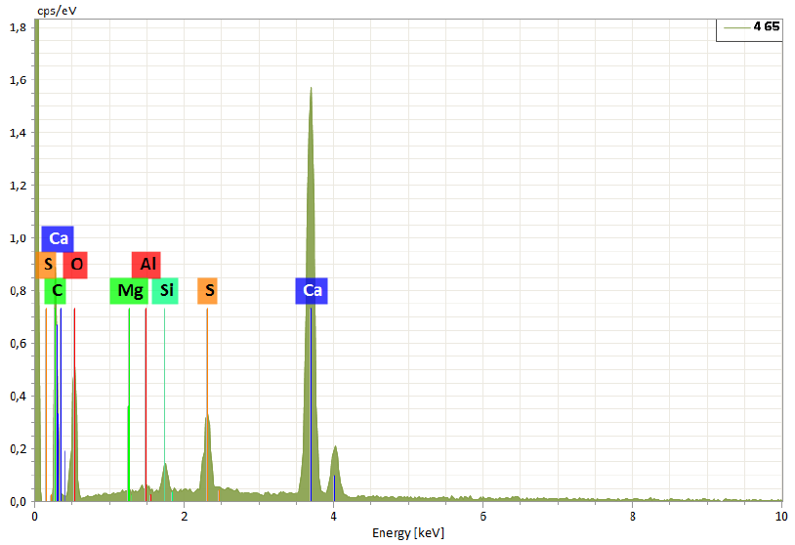
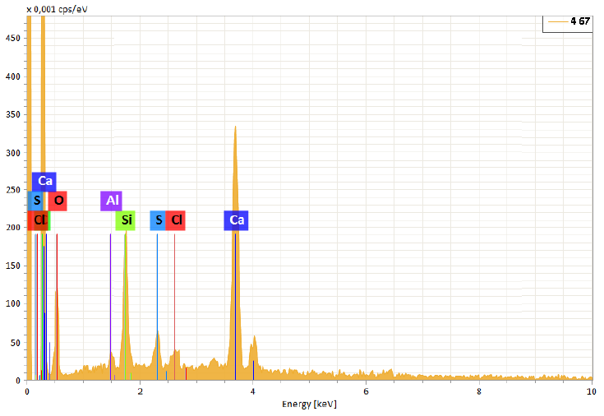
a
1
3
2
+
+
+
+
+
+
e
f
d
c
b

Figure 6. (a) Stratigraphic sample from the black wig on the back of the statuette; (b) Cross section under OM in visible light (1, white preparation layer; 2, warm white pictorial layer; 3, black pictorial layer); (c) SEM-BSD image of the cross section; (d, e, f) SEM-EDX spectra respectively of the white, warm white and black layers.

  - Conservation history and previous interventions

As regards the state of preservation of the find, it showed a general greying of tones and some gaps in the preparation and paint layers distributed over the entire surface, as documented by photographs in visible light and X-ray imaging. After the close observation and a careful reading of the imaging analyses, in particular of the UV fluorescence, FT-IR analysis were performed on micro samples taken from (i) an area that showed orange-yellow UV fluorescence and (ii) from the face of the bearer, where a glossy, surface film-forming material seemed to be present. From the resulting spectra, an acrylic resin identified as Paraloid was found in both the analysed samples (fig. 7). The adhesive material Paraloid resulted to be distributed over the entire surface and the data is compatible with the general greying of the surface, due to the typical Paraloid absorption of dust and atmospheric particulate in time.
In addition to this, the base of the statuette showed some peculiar characteristics: from a first general observation, it was hypothesized that it could be traced back to a reuse of a wood fragment, perhaps taken from a coffin. This hypothesis could be reasonably confirmed by the evidence of a presumably original joint in correspondence of the lower portion of the base, attributable to the portion of the feet, but no longer in place, that led to think of a reuse. More insights concerning this specific characteristic should be provided, in consideration of a similar element observed in another find of the equipment.
As regards the figure-base anchoring, the complete absence of the feet (generally made of wood, sometimes partially completed with details in modelling material, often equipped with a tenon for the base joint) was immediately noted, and a

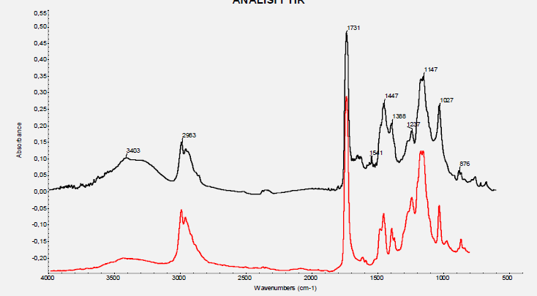
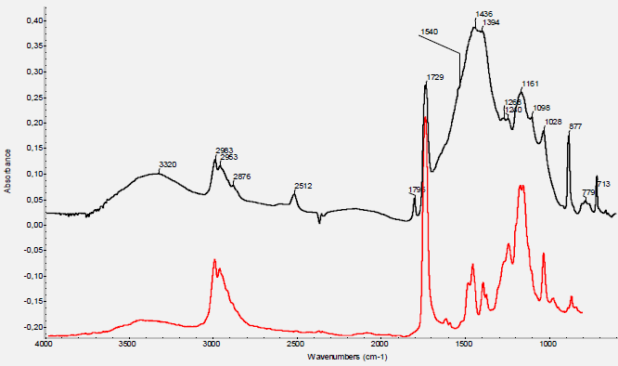
a
b

Figure 7. FT-IR spectra (black curves) of the two samples taken from the body (orange-yellow UV fluorescence area) (a) and from the face area (greying of tones) (b). The substance was identified as Paraloid (the red curve is the Paraloid standard spectrum, for comparison).

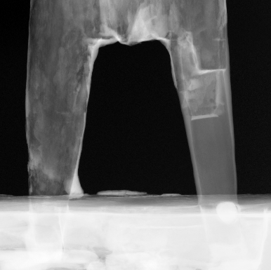
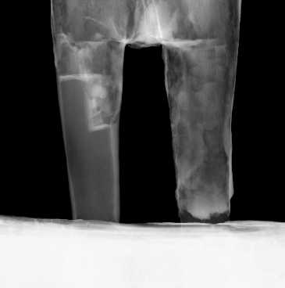
a
c
b

Figure 8. The detail of the statuette’s legs, (a) the wooden insert for the legs anchorage, (b) and (c) the radiographic images, frontal and lateral respectively, in which the joint is clearly visible.

wooden insert to which the legs were anchored, attributable to a previous intervention, was present (fig. 8a). In fact, a complete discrepancy between the main block and this wooden insert was observed (for colour, compactness and grain of the wood), grouted on the perimeter and hidden on the surface by a pictorial retouching attributable to a previous intervention, rather recent. Thanks to the radiographic analysis, this portion in the base was clearly distinguished and it could be observed that the insert reaches about half the total thickness of the base. Furthermore, the X-ray images showed how both the legs and the wooden insert were applied and fixed: in fact, X-rays enhanced the presence of two holes created to accommodate the end portions of the two legs. The legs and the big wooden insert in correspondence of the base were fixed by applying a filler material (similar to a mortar), more radiopaque respect to the wooden material (fig. 9)
Concerning the legs, a fracture of the wooden matter in the right back leg of the bearer and, at the calf level, corresponded to a tongue and rebate joint for the completion of the leg anatomy, which can be clearly observed from the radiographic images of the lower part (fig. 8b,c). In literature, many of the sculptures represented in a progressive position present an assembly of two separate elements for the back leg, a practical ruse to smoothly carve the internal parts. Taking into account both this aspect and the fact that this kind of joint is already documented starting from very ancient chronologies and the characteristics of the wood are rather similar to those of the central body (colour, compactness), the originality of the part could not be excluded in a first phase, despite of some anomalies.
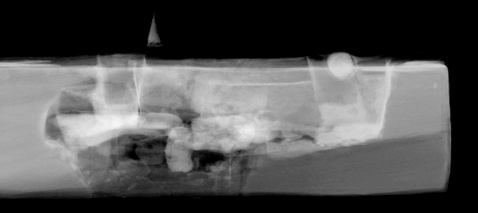

Figure 9. Radiographic image of the base of the statuette.

In fact, the presence of an intervention mortar at the junction between the leg and the body (attributable to a bonding) and the
chromatic and morphological differences between the wooden material of the base insert and that of the leg itself, are not sufficient to attribute the leg portion to an original or subsequent intervention. Regarding this issue, a comparison with a wooden sculpture picture (XVIII dynasty, collections of the Museo Egizio of Torino), taken before restoration in the late 1980s by the Doneux laboratory results very interesting: also in this case a wooden insert is observed for the lower portion of one of the two legs, in this case certainly a non-original operation, but conceptually comparable to the one discussed here [29]. More insights should be provided to ascertain this aspect.

Figure 10. Details of the adhesive residues detected at the basket-head interface.

As of the basket-head anchoring, evidence of previous intervention was identified. On the basket, in fact, a significant presence of an adhesive material was observed, for whose characterization no specific analysis was conducted; however, due to its mechanical and optical characteristics, in addition to the specific reactivity in contact with polar solvents, it has probably a synthetic origin (presumably of a vinyl nature, fig. 10).
Finally, both from the radiographic analysis and at the time of disassembly, a metal element inserted to fix the two portions, of reduced diameter and size, was identified (fig. 11).

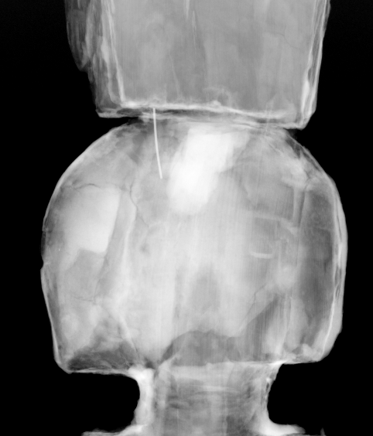
a
b

Figure 11. Metallic element: (a) detail of the RX image that allows its localization and (b) the metallic pin after removal during the intervention.

- conclusion
The present work reports on the results of a two-step scientific approach useful for the characterization of the materials and stratigraphies of ancient objects. The combination of imaging and punctual techniques, along with the visual inspection of the artwork, could give indication of the used materials and techniques of assembly, repairs, over paintings, finishes and treatments that have occurred in antiquity and through the centuries.
In the specific case under study, the close observation and the tomographic analysis carried out allowed to describe the assembly technique. In fact, the use of several portions assembled using wooden dowels and of a preparation material based on calcium carbonate to achieve the final volume was observed. Thanks to chemical investigations also conducted in consideration of the multispectral imaging results, it was possible to define the nature of the different materials used for the statuette manufacturing. In addition to VIL, XRF analysis in combination with OM and SEM-EDX methodology gave the possibility to identify the pigments used for the decoration. It has been also possible to distinguish modern interventions, probably dated from the second half of the twentieth century, when taking into account the identification of synthetic materials and the FT-IR analysis results, and, possibly, more ancient interventions, such as the insertion of wooden elements to complete the figure (specifically on the right leg).
All the performed analysis and the consequent evaluations contributed to the definition of the best conservation process for the statuette.
In the future, it will be possible to apply the same investigation strategy to other wooden artefacts and statuettes belonging to the same framework, in order to make comparisons among the objects. Analogies and differences in terms of materials, manufacturing techniques and state of preservation will support also the Egyptological study focusing on detecting hopefully, specific technical features useful for a correct grouping of the finds within specific workshops.
Acknowledgements
The NEXTO project (progetto di Ateneo 2017) funded by Compagnia di San Paolo, the neu_ART project funded by Regione Piemonte, and the INFN CHNet network are warmly acknowledged.
References
- M.A. Rizzutto, J.F. Curado, S. Bernardes, P.H.O.V. Campos, E.A.M. Kajiya, T. F. Silva, C.L. Rodrigues, M. Moro. M. Tabacniks, N. Added, “Analytical techniques applied to study Cultural Heritage objects”, INAC 2015, São Paulo, SP, Brazil, ABEN
- E. Peccenini, F. Albertin, M. Bettuzzi, R. Brancaccio, F. Casali, M. P. Morigi, F. Petrucci “Advanced imaging systems for diagnostic investigations applied to Cultural Heritage”, Journal of Physics: Conference Series 566 (2014) 012022, IOP Publishing
- S. Bruni, V. Guglielmi, E. Della Foglia, M. Castoldi, G. Bagnasco Gianni, “A non-destructive spectroscopic study of the decoration of archaeological pottery: from matt-painted bichrome ceramic sherds (southern Italy, VIII-VII B.C.) to an intact Etruscan cinerary urn”, Spectrochimica Acta Part A: Molecular and Biomolecular Spectroscopy 191 (2018) 88–97
- M. Hain, J. Bartl, V. Jacko, “Multispectral analysis of Cultural Heritage artefacts”, MEASUREMENT SCIENCE REVIEW, Volume 3, Section 3, 2003
- T. Cavaleri, P. Croveri, A. Giovagnoli, “Spectrophotometric analysis for pigment palette identification: the case of “Profeta Stante””, 10th International Conference on non-destructive investigations and microanalysis for the diagnostics and conservation of cultural and environmental heritage, AiPnD, 2011
- M.P. Morigi, F. Casali, M. Bettuzzi, R. Brancaccio, V. D’Errico, “Application of X-ray Computed Tomography to Cultural Heritage diagnostics”, Appl Phys A (2010) 100: 653–661
- G. Fiocco, T. Rovetta, M. Malagodi, M. Licchelli, M. Gulmini, G. Lanzafame, F. Zanini, A. Lo Giudice, A. Re, “Synchrotron radiation micro-computed tomography for the investigation of finishing treatments in historical bowed string instruments: Issues and perspectives”, European Physical Journal Plus 133(12), 2018: 525
- M. Schreiner, M. Melcher, K. Uhlir, “Scanning electron microscopy and energy dispersive analysis: applications in the field of cultural heritage”, Anal Bioanal Chem (2007) 387:737–747
- C. Invernizzi, G. V. Fichera, M. Licchelli, M. Malagodi, “A non-invasive stratigraphic study by reflection FT-IR spectroscopy and UV-induced fluorescence technique: The case of historical violins”, Microchemical Journal 138 (2018) 273–281
- A.Mangone, G. E. De Benedetto, D. Fico, L. C. Giannossa, R. Laviano, L. Sabbatini, I. D. van der Werfb, A. Traini, “A multianalytical study of archaeological faience from the Vesuvian area as a valid tool to investigate provenance and technological features”, NewJ. Chem., 2011, 35, 2860–2868
- G. Barone, S. Ioppolo, D. Majolino, P. Migliardo, G. Tigano, “A multidisciplinary investigation on archaeological excavation in Messina (Sicily). Part I: a comparison of pottery findings in “the Strait of Messina area”, Journal of Cultural Heritage 3 (2002) 145–153
- S. Bracci, O. Caruso, M. Galeotti, R. Iannaccone, D. Magrini, D. Picchi, D. Pinna, S. Porcinai, “Multidisciplinary approach for the study of an Egyptian coffin (late 22nd/early 25th dynasty): Combining imaging and spectroscopic techniques”, Spectrochimica Acta Part A: Molecular and Biomolecular Spectroscopy 145 (2015) 511–522
- Abdrabou, M. Abdallah, I. A. Shaheen, H. M. Kamal, “Investigation of an ancient Egyptian polychrome wooden statuette by imaging and spectroscopy”, Internation Journal of Conservation Science, Volume 9, Issue 1, January-March 2018: 39-54
- T. Cavaleri, P. Buscaglia, C. Caliri, E. Ferraris, Marco Nervo, F. P. Romano, “Below the surface of the coffin lid of Neskhonsuennekhy in the Museo Egizio collection”, X-Ray Spectrom. 2020;1–14.
- A. Otte, T. Thieme, A. Beck, “Computed tomography alone reveals the secrets of ancient mummies in medical archaeology”, Hellenic Journal of Nuclear Medicine, 16(2), 2013, pp.148-149
- A.Re, A. Lo Giudice, M. Nervo, P. Buscaglia, P. Luciani, M. Borla, C. Greco, “The importance of tomography studying wooden artefacts: a comparison with radiography in the case of a coffin lid from ancient Egypt”, Internation Journal of Conservation Science, Volume 7, Special Issue 2, 2016: 935-944
- C. Calza, R. P. Freitas, A. Brancaglion Jr., R. T. Lopes, “Analysis of artifacts from ancient Egypt using an EDXRF portable system”, 2011 International Nuclear Atlantic Conference - INAC 2011, Belo Horizonte,MG, Brazil, October 24-28, 2011, ASSOCIAÇÃO BRASILEIRA DE ENERGIA NUCLEAR – ABEN
- N.M. Badr, M. Fouad Ali, N. M. N. El Hadidi, G. Abdel Naeem, “Identification of materials used in a wooden coffin lid covered with composite layers dating back to the Ptolemaic period in Egypt”, Conservar Património 29 (2018) 11-24, ARP - Associação Profissional de Conservadores-Restauradores de Portugal
- M. Abdallah, H. M. Kamal, A. Abdrabou, “Investigation, preservation and restoration processes of an ancient Egyptian wooden offering table”, Internation Journal of Conservation Science, Volume 7, Issue 4, October-December 2016: 1047-1064
- A. Abdrabou, M. Abdallah, H. M. Kamal, “Scientific investigation by technical photography, OM, ESEM, XRF, XRD and FTIR of an ancient Egyptian polychrome wooden coffin”, Conservar Património 26 (2017) 51-63, ARP Associação Profissional de Conservadores-Restauradores de Portugal
- H. A.M. Afifi, M. A. Etman, H. A.M. Abdrabbo, H. M. Kamal, “Typological study and non-destructive analytical approches used for dating a polychrome gilded wooden statuette at the Grand Egyptian Museum”, SCIENTIFIC CULTURE, Vol. 6, No. 3, (2020), pp. 69-83, DOI: 10.5281/zenodo.4007568
- J. Kahl, A.M. Sbriglio, P. Del Vesco, M. Trapani “Asyut. The excavations of the Italian Archaeological Mission (1906-1913)”, Modena, 2019
- P. Del Vesco, B. Moiso (eds.), “Missione Egitto 1903–1920: L’avventura archeologica M.A.I. raccontata- Le tombe di Assiut”, Torino and Modena, 2017
- G. Verri, “The use and distribution of Egyptian blue: a study by visible-induced luminescence imaging” in K Uprichard & A Middleton (eds), The Nebamun Wall Paintings. Archetype, London, pp. 41-50, 2008
- A. Re, F. Albertin, C. Bortolin, R. Brancaccio, P. Buscaglia, J. Corsi, G. Cotto, G. Dughera, E. Durisi, W. Ferrarese, M. Gambaccini, A. Giovagnoli, N. Grassi, A. Lo Giudice, P. Mereu, G. Mila, M. Nervo, N. Pastrone, F. Petrucci, F. Prino, L. Ramello, M. Ravera, C. Ricci, A. Romero, R. Sacchi, A. Staiano, L. Visca, L. Zamprotta, “Results of the Italian neu_ART project”, IOP Conference Series: Materials Science and Engineering 37, 2012, 012007.
- M. Nervo, “Il Progetto neu_ART. Studi e applicazioni/Neutron and X-ray Tomography and Imaging for Cultural Heritage”, Cronache, 4, Editris, Torino, 2013
- A. Re, F. Albertin, C. Avataneo, R. Brancaccio, J. Corsi, G. Cotto, S. De Blasi, G. Dughera, E. Durisi, W. Ferrarese, A. Giovagnoli, N. Grassi, A. Lo Giudice, P. Mereu, G. Mila, M. Nervo, N. Pastrone, F. Prino, L. Ramello, M. Ravera, C. Ricci, A. Romero, R. Sacchi, A. Staiano, L. Visca, L. Zamprotta, “X-ray tomography of large wooden artworks: the case study of “Doppio corpo” by Pietro Piffetti”, Heritage Science 2(1), 2014: 19
- A. Re, J. Corsi, M. Demmelbauer, M. Martini, G. Mila, C. Ricci, “X-ray tomography of a soil block: a useful tool for the restoration of archaeological finds”, Heritage Science 3(1), 2015: 4
- E.F. Marocchetti, La scultura in legno al Museo Egizio di Torino. Problemi di conservazione e restauro, in “Materiali e Strutture. Problemi di conservazione. Sulla scultura”, nuova serie anno VI, numeri 11-12, pagg. 9-31, 2008

