Heritage documentation and management processes: Castiglioni Chapel in Pavia
Elisabetta Doria¹, Francesca Galasso², Marco Morandotti³
¹ DICAr – University of Pavia, st. Ferrata 3, 27100 Pavia (IT)
² DICAr – University of Pavia, st. Ferrata 3, 27100 Pavia (IT)
³ DICAr – University of Pavia, st. Ferrata 3, 27100 Pavia (IT)
ABSTRACT
The project of the reuse of an architectural environment must consider the set of residual services provided by the building. The activation of a documentation process allows you to be aware of what an environment offers. The spatial and material analysis of the current state must be accompanied by a material, technological and tech-system survey. In the case study of the Castiglioni Chapel in Pavia (IT), the various diagnostic outputs were associated with the detailed survey, with the aim of planning interventions for the site conservation project. Conservation takes place both with physical actions and with museumization processes. The action methodology involved numerous phases such as detailed digital survey, technological analysis, and digitization through three-dimensional models. All the analyses carried out are integrated in an immersive virtual system structured by layers and scenarios. The chapel can be orbited with AR platforms that allow you to enhance valuable frescoes and see the different levels of analysis in real time. All the processes underway in this project are aimed at making the space a place of knowledge with real and digital use.

Section: ACTA IMEKO Special Issue
Keywords: digital survey; cultural heritage conservation; Augmented Reality; documentation, Cappella Castiglioni Pavia
Citation: Thomas Bruns, Dirk Röske, Paul P. L. Regtien, Francisco Alegria , Template for an Acta IMEKO paper, Acta IMEKO, vol. A, no. B, article C, Month Year, identifier: IMEKO-ACTA-A (Year)-B-C
Section Editor: name, affiliation
Received month day, year; In final form month day, year; Published Month Year
Copyright: This is an open-access article distributed under the terms of the Creative Commons Attribution 3.0 License, which permits unrestricted use, distribution, and reproduction in any medium, provided the original author and source are credited.
Funding: The project has EDiSU Pavia, Ente per il Diritto allo Studio Universitario (Institute for the Right to University Study), as its client, based on its own funds and research contribution from the Fondazione Comunitaria of Pavia.
Corresponding author: Paul P. L. Regtien, e-mail: paul@regtien.net

- Introduction
The documentation processes of the architectural heritage must consider many aspects including the material conservation of the asset and the enhancement of its intangible value. The intangible value, in the case of a place, is its ability to be an identity element for the city [1]. This awareness is essential to guide professionals towards interventions capable of protecting and consciously managing the built heritage intended as a value for all. The community attributes a value to the built heritage according to the importance in the historical events that involved it and in terms of how it is perceived in a given context. Considerations regarding heritage values ​​are fundamental in conservation processes, in which even what is immaterial becomes something to be safeguarded.
The research topic on safeguard methodologies for the existing heritage is emerging with new forms of investigation of the related digital documentation to cultural heritage [2], [3]. This is combined with cognitive and interactive models and with the elaboration of 3D digital products for investigations e simulations relating to shapes and structures. For historic buildings with criticalities and stratifications, it is essential to start with the building knowledge phase. The knowledge of the heritage guides the documentation process and becomes an instrument of memory conservation [4]. The project of Cappella Castiglioni (Castiglioni Chapel) presented in this paper is part of a broader path, characterized by diversified analyses, which include both the documentation phase and the technological investigation of architectural elements (Figure 1). In the project the documentation process is conducted for the planned conservation, starting from the geometric and materic survey up to the diagnostic and characterization stage of degradation for the definition of a possible intervention of conservation [5]. The research project aims to define a conservation and valorisation project of the chapel.
The methodology used to achieve the goal is based on the structuring of a database for the geometric, material and technological documentation of the chapel. The first phases were two: the digital survey and the request to the Superintendency for the authorization to invasive analysis of materials. The survey was carried out with widely tested digital tools: TLS digital laser scanner (Terrestrial Laser Scanner) [6], photogrammetry for the interior, UAV photogrammetry for roofs and external fronts [7], cameras and georadar analysis for the study of the subsoil. Starting from the survey, detailed vector drawings were created that acted as level 0 from which to start to add subsequent analyses. In addition to the instruments for surveying, the use of 360° photo and video cameras allows expansion of virtual platforms, enrichment of the navigable models that are being developed with an enablement for Augmented Reality (AR) systems [8]. AR technology allows you the development of a multilevel information system describing the real object through the use of a display. The immersive digital environment is used for both purposes of the research: an additional tool to visualize the data collected for the conservation of the object and the modelling of a digital place enriched with information and images for the museum of the chapel. [9].
- historical processes and current STATE OF CONSERVATION
The building that today incorporates Collegio Castiglioni (Castiglioni College) was donated to the brothers Castiglioni in 1419 by Pope Martino V. The morphology of the building that exists today was born from the union of two residential structures, originally separated from each other, of which today no trace remains. Chapel has a square-plan structure, covered by a cross vault with double curvature and raised center painted with architectural trompe l'oeil. In the 19th century the chapel changed its intended use and was used as the house of the custodian of the Brugnatelli house. In this historical phase the frescoes were seriously compromised because of interventions, such as the installation of stoves led to damage to the decorative apparatus. The first reliefs with which a comparison is possible date back to 1948 and are available to document the current state of the building. In addition to the surveys, we have at our disposal a series of material analyses conducted by Professor Carlo Aschieri, at the time inspector of the Superintendence [10]. Castiglioni Chapel presents itself today with numerous critical issues. The structural aspect is compromised, there are important cracks on the vault and along the perimeter walls. As for decorations, the valuable frescoes are attacked by infiltrations and rising damp. The chapel has always been a private place but also known by the local community. Nowadays, however, it is losing its value as a place of identity for citizenship due to its inaccessibility [9].
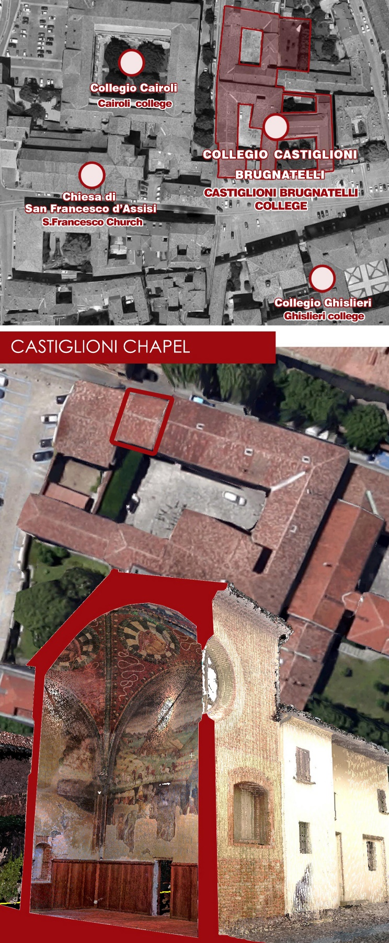
Figure 1. Setting of the College in Pavia city centre and a section of Castiglioni Chapel made by TLS point cloud.
  - The painting in the Chapel
Castiglioni Chapel was founded together with the College dedicated to Saint Augustine in 1429 but, thanks to the discovery of archival sources, it appears that the Oratory was active from 1437 [9] (Figure 2). The frescoes are considered as an important testimony of Bramante's influence in Lombardy [11], [12].
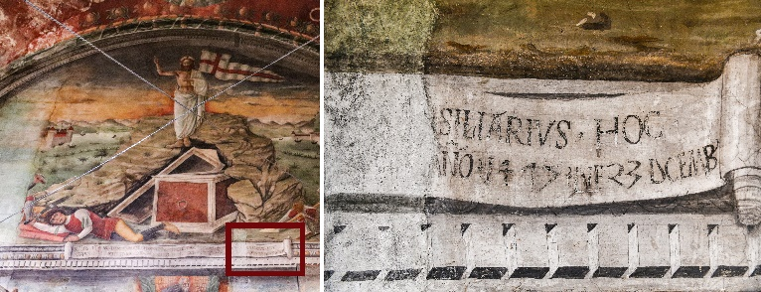
Figure 2. The end date of the frescoes is reported in a frescoed inscription below the scene of the Resurrection. The paintings were made by 23 December 1475, a date that probably must correspond to that of the dedication of the oratory.
The vault of the chapel is painted with trompe l'oeil, including structural elements such as ribs, shelves and decorative elements, pillars with polychrome marble and ending with corinthian capitals that support a shelf collecting the ribs of the vault and floral festoons [13]. The vault has a red background and it is characterized by plant elements, with pomegranates, other fruits, and green-leaved elements. In the vault there are four oculi that integrate the symbols of the Evangelists (Figure 3). The oculi are represented to look like holes in the vault; two of them have as background the pictorial representation of the leaded glass, comprising the preciousness of the materials with the insertion of coloured marble paintings [14].
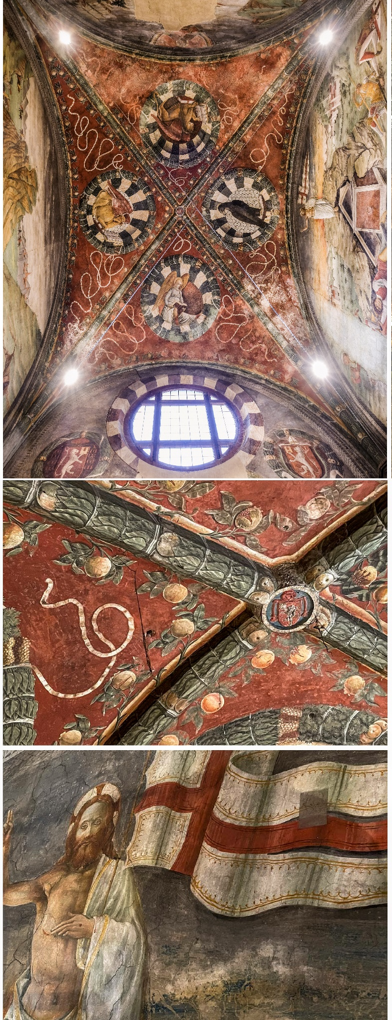
Figure 3. Intrados of the vault of the Castiglioni Chapel and evident deterioration and criticalities of the wall frescoes.
  - Architectural interventions of the past
From the twentieth century begin the concerns of the institutions about the state of degradation of the chapel, after its function as home of the custodian of Casa Brugnatelli. Inside the chapel an attic was built in order to obtain two levels for the house. Inside the house walls had been built to delimit the different environments. Also evident are the new openings in the wall which today have been filled in. Another important element is the fireplace with its own flue, the construction of which involved serious losses in the decorative apparatus.
The restoration work on the chapel involved the elimination of all internal partitions to restore the spatial conformation to the original one. The restoration activities also focus on the pictorial elements, treated with consolidation, fixing, removal of improper ancient restorations, cleaning, and final plastering in neutral colour of the frescoed parts now totally lost. The walls most subject to degradation are those facing south and north; to avoid the total loss of the decorations, portions were torn in these two walls in 1966. These frescos are then replaced in their original position by arranging them on special frames, made to measure, to keep the plasters spaced from the masonry [14] (Figure 4).
- SURVEY, DOCUMENTATION and criticalities analysis as METHODOLOGICAL APPROACH
The documentation actions described here are aimed at defining the knowledge bases of representation necessary for the subsequent phases of technological and diagnostic analysis, with invasive and non-invasive interventions, for the integral mapping of the state of conservation [15]. The survey phase aimed to digitally reconstruct the chapel in order to create a virtual copy as a basis for subsequent analyzes. Various tools were used: Terrestrial Laser Scanner Faro CAM2 S150, DJI Mavic Mini 2, DJI Spark, Nikon D850, Sony Alpha6000, GoPro White7.
One of the most damaged technological elements is the vault, which shows evident fractures and saline efflorescence due to water infiltration from the roof. Verifying the causes of the alterations on the vault is complex both for the height of the intrados and for the inaccessibility of the extrados of the vault: the attic is not communicating with other portions of the building and is accessible only by uncovering the roof. The attic is also very small in height, between 80 cm and 30 cm. In order to understand the construction technique of the vault and directly observe if the cracks found on the intrados passed through the extrados, it was decided to proceed by opening an opening in the roof to access, where possible, the attic. It was necessary to create a temporary access compartment for the inspection of the extrados of the vault through the use of a spider lifting platform. The inspection opening was made on both sides because it was not possible to move with tools from the inside and to avoid overloading the extrados of the vault.
The TLS survey was carried out with colour scans of different resolution: 44 scans of 10,400,000 points and 6 scans of 25,000,000 connection points. The registration error of the chapel is 0.9 mm, while the registration error with the outside is greater due to the lifting platform: 3.4 mm
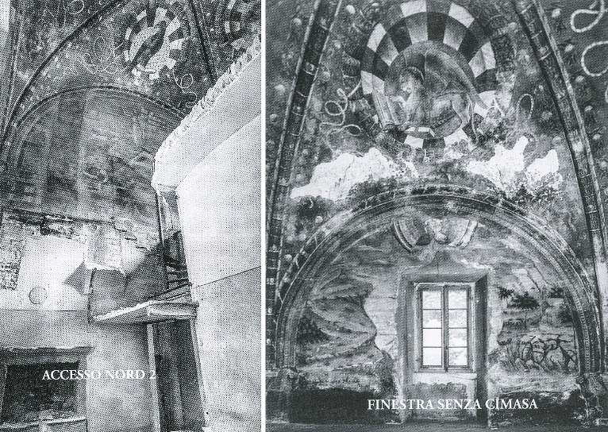
Figure 4. Casa Brugnatelli/Brugnatelli Home: view of the chapel with the partitions made to adapt it as a home (see Vicini, 2010).
The most complex part of the survey was the attic; it was essential for obtaining information on the structure of the vault. The goal was to define the technology without intervening on the intrados. In order to operate in the least invasive way possible, the opening in the roof is, the opening in the roof has been reduced to the distance between the joists, to disassemble only those necessary for the insertion of the laser tool and for the passage of a person. The narrow passage in the roof made it possible to proceed with the laser scanner survey, taking care to use a suitable tripod. It was necessary to use specific tripods and tripods due to the low height.
The survey and documentation of the extrados of the vault was carried out at two different times. The court side pitch was detected in September 2019 and the street side pitch was detected in February 2020 due to health safety regulations. Once the access to the roof was opened, the terrestrial laser scanner survey, the direct survey of some portions and the photographic campaign were carried out. From the lifting platform it was possible to make other elevated scans in order to cover the shadow cones that were generated with the relief from the ground. The use of the spiderlift has complicated the laser scanner survey due to the intrinsic mechanical vibrations of the lifting vehicle. This required careful error checking in post-production to verify that vehicle oscillations had not affected the scan results. The scans were recorded in groups by first recording the internal environment of the chapel with the outside from the ground. The ground recording was combined with the platform recording so as not to amplify possible vibration errors.
The global registration makes it possible to discover a value that until then was totally unknown: the thickness of the vault. The numerical value together with the direct relief of the bricks of the extrados allowed to define the construction technology with which it was made.
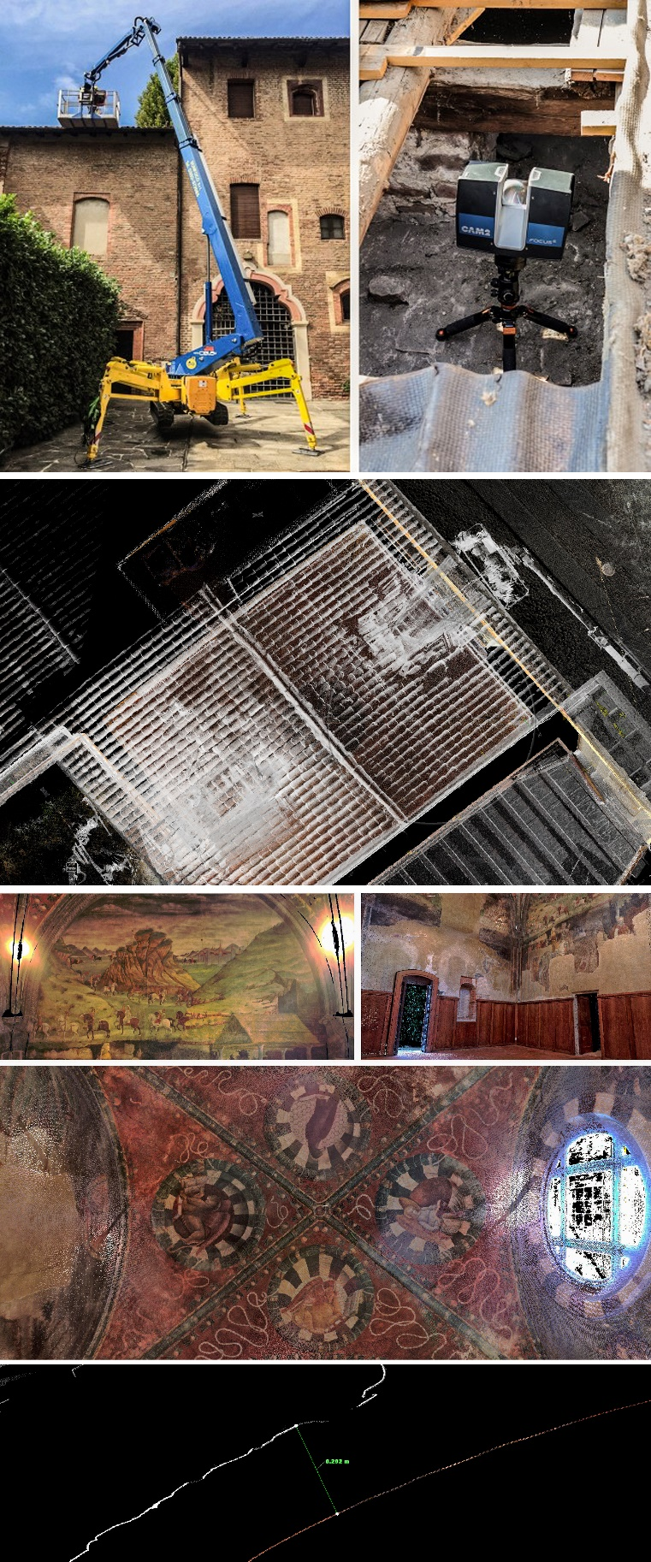
Figure 5. From the top: spiderlift elevator platform used to access the extrados of the chapel vault. Images of the TLS point cloud: in the first one is visible the elevator platform and the dimension of the access to the attic. Image below: Slice of the point cloud. It is one of the control points used to check the thickness of the vault. In the upper part of the image (white/grey profile) are visible the profiles of the bricks.
The thickness of the vault varies between 25.4 and 30 cm and the main thickness is in correspondence with bulges in the decorations on the intrados. The thickness of the vault, including plaster and fresco of the intrados, has an average size of 27 cm and on the extrados, it is possible to see the head of the bricks (6 cm x 12 cm approximately). In a particularly damaged point of the intrados, it was possible to see the head of a brick; at that point there is a great deterioration which has led to the detachment of the plaster, which is about 2.5 cm thick. This information has led to suppose an arrangement of the bricks in fascia with the heads in the intrados and extrados (Figure 5).
  - Photographic acquisition for colorimetric and materic survey
The main acquisition problem encountered during the survey inside the chapel was the absence of natural light which complicated the photographic acquisition.
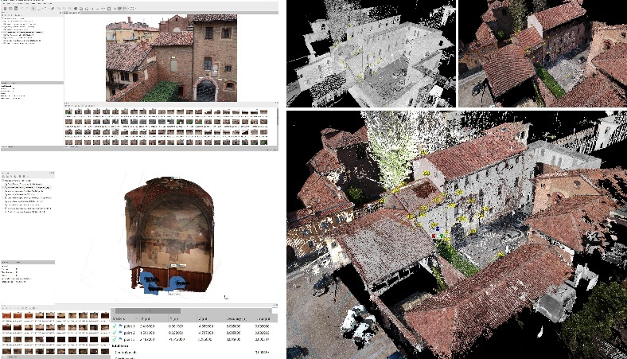
Figure 6. The integrated laser scanner and UAV survey made it possible to fully acquire the internal and external surfaces of the chapel.
The chapel has a single large circular window and it was necessary to use artificial lighting to photographically capture the vault and walls. The photographic acquisitions with Structure from Motion photogrammetric technique were carried out in moments of the day when there was no direct sun from the window, i.e. during the morning. However, to obtain a functional result for post-production processes for the creation of ortho-images, the photos were taken with remote control and photographic tripod in order to increase exposure and limit vibrations caused by the operator.
The colorimetric acquisition of the laser scanner was instead conducted with the artificial lights on and with a vertical balance. The TLS point cloud is totally coloured except for the attic, which is too dark and not illuminable. The point cloud contains the colorimetric details of the pictorial decorations; the only alteration of the data is in correspondence of the artificial lights. In addition to the photographic survey of the interiors, a survey was also carried out with UAV instruments.
The UAV tools were used for three types of acquisitions: SfM of the fronts, SfM of the coverage and detailed photographs of details. The fronts were acquired with a manually conducted serpentine drone path. The covers were acquired with the manually guided drone path to point of interest [16]. Two different drones of less than 300 gr. were used due to the presence of traffic and people. From this technique, it was possible to obtain a point cloud that can be integrated with the TLS point cloud (Figure 6).
The drone point cloud includes the high portions of the fronts and the roofs. The alignment of the two clusters was carried out thanks to morphological points chosen on the fronts and on the ground with the help of targets. The alignment error was 1.8 mm. The combined point cloud completes the gaps related to the shadow cones and guarantees a complete product. The final product made it possible to obtain a cloud of points from which to investigate both the external characteristics of the roofs and the detail of the extrados of the vault.
- Criticalities documentation and actions the for restoration and managment
Following the post-production of the data, vector drawings and material ortho-images were created starting from the point cloud and the SfM technique. Starting from the drawings, the process proceeded with material analysis phase. First of all, a census was made of the alterations found, representing them on the drawings and building an atlas made up of cards (Figure 7).
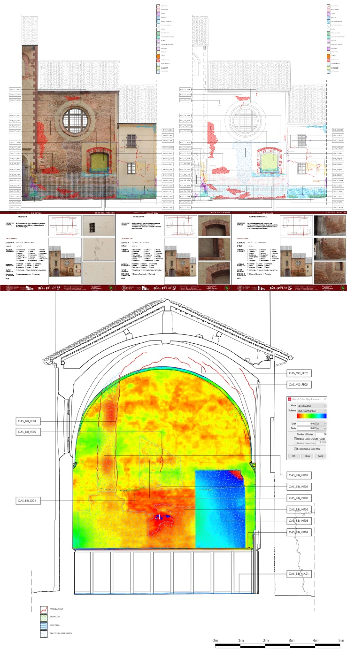
Figure 7. The analysis of the alterations was carried out according to the ICOMOS guidelines integrated with the graphic signs of the Italian Normative Nor.Ma.L.1 / 88. The uniquely coded alterations were reported both on the mapping of 2D vector drawings and on special census forms for each code.
Below: Elevation maps were made starting from the point cloud to observe irregularities in the masonry. In this elevation map (north wall), the part of the fresco that has been detached from the wall and repositioned on a protruding frame is evident (blue).
The census of the alterations was carried out by the database manager FileMaker. Thanks to this choice, the data entered are not static, but can be interrogated and organized according to the parameters chosen for the census [17].
The documentation project and the technological investigations have as their purpose not only the definition of research methods, but also a new functionalization of an environment which is now in disuse. The theme of the reuse of ecclesiastical buildings is an important theme for the city of Pavia, which has numerous representative cases within it. The ecclesiastical patrimony of Pavia was reused in 55% [18] of the cases with functions related to the University; the building in which the Castiglioni Chapel is located follows this majority line despite the fact that the chapel itself does not yet have a defined functional reality. The chapel is a perfect historical heritage on which to base a research process that allows the comparison of different methodologies for the documentation and the management project of the built heritage. Its small size, the decorative richness, the stratifications of the centuries and the technological complexity make it an ideal case study for comparing different analyses and modes of action [19].
The carrying out of diagnostic investigations is functional to the material and petrographic characterization of the elements, to the determination of degradation and to the monitoring of some instability phenomena. The set of knowledge that will be acquired in this phase will be functional to determine possible conservation strategies. The research project, still under development, has suffered a blockage of field documentation activities due to the COVID-19 pandemic. From January 2020 it was possible to resume the planned activities. Other laboratories of the University of Pavia were also involved in the project, which dealt with specific analyses on materials and subsoil. Material samples were taken for petrographic analysis by Prof. Massimo Setti and was built an internal scaffolding that allowed a detailed analysis of the alterations in height, otherwise not directly observable in person. In addition to the material investigations, a thermal camera and georadar analysis was conducted in collaboration with Prof. Francesco Zucca, the results of which indicated possible ancient underground structures (figure 8).
The last step to be carried out is to prepare trenches to check in the points highlighted by the georadar. This was approved by the relevant Superintendency because the floor is no longer the original one but was redone during the restoration in the 1960s. The result of these investigations will be an integrated set of geometric, technological, and material knowledge aimed at targeted interventions for the recovery. and the planned management of the asset.
- Augmented reality technology for investigations and management of historical buildings
The research project developed in the Castiglioni Chapel case study, here described for the documentation and survey phases, lays the foundations for further research focused on the enhancement of the asset itself.
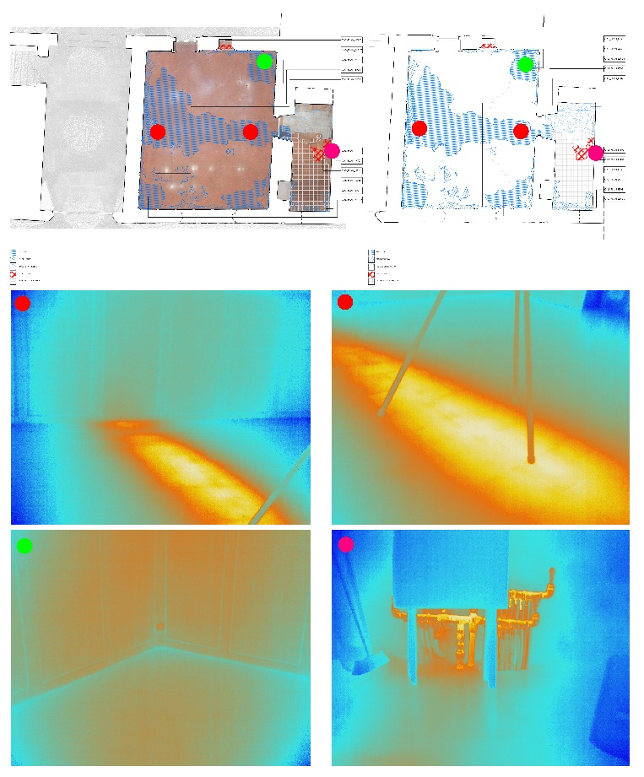
Figure 8. In addition to the materic analyses, two diagnostic campaigns with thermal imaging cameras were carried out. In this image you can see the study of the flooring. Pressurized hot water pipes were found under the chapel flooring.
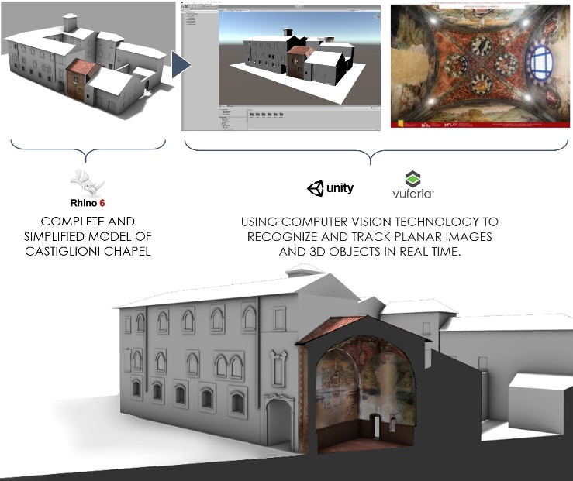
Figure 9. Software and application used to make the 3D model usable digitally. AR tools allow you to define new uses of architecture, ensuring better accessibility to the property and increasing the possible actions remotely, both in the tourism and diagnostics and investigation fields.
The intent of conserving an architectural artefact of such artistic relevance should not be understood as the arrival point of the research, but as part of the process of museum display and protection and enhancement of the cultural heritage [20][21].
Starting from the two-dimensional drawings obtained from the post-production phase, a three-dimensional model was created. The modeling operations took place through the Rhinoceros software, in which it was possible to create cutting plans, in order to obtain cross sections describing the geometry of the chapel and to verify that the constructive logic detected on site is respected in the model [22] [23].
Once the digital copy of the Chapel had been reliably modelled, it was made usable in the field of augmented reality application. The model was imported into Unity Engine and thanks to the use of Vuforia Engine it was possible to create a Chapel augmented reality application (Figure 9) [24] [25].
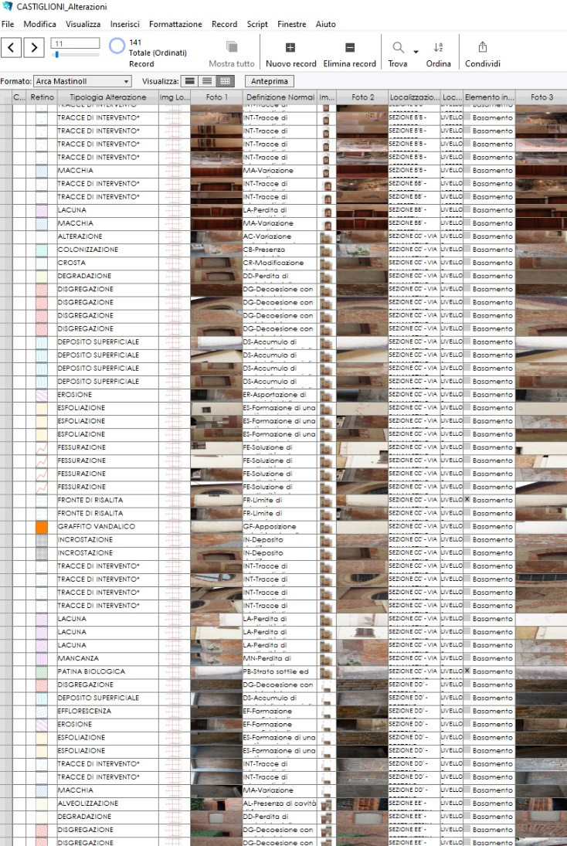
Figure 10. The alterations database includes photographs, definitions and specific values ​​including extent, location, type of alteration (structural or surface). It has been managed with FileMaker and can be exported in formats compatible with data entry on GIS and information systems.
Vuforia is an artificial vision tool that allows you to analyse two-dimensional digital media, such as images, or three-dimensional, such as 3D models, and recognize graphic targets, associating them with the display of three-dimensional representations in real time on AR applications [26]. In the case of the Castiglioni Chapel, it was used an image target. Image Targets are tracked based on their natural features which can be enhanced through the colour and light contrast settings (Figure10). As a first test, a low-contrast black and white image was combined; in this way, the software has detected few graphic targets, causing anomalies during the real-time display of the three-dimensional model. Subsequently, it was to use a higher contrast color image and the number of targets was significantly increased, improving tracking between the model and the image.
Thanks to the use of mobile devices, it was possible to frame the reference image and view the model of the Chapel [27].
The use of C# codes made it possible to develop touch controls to orbit, rotate and resize the model. Movement within the model is not limited to ground level but can be placed on the same level as higher decorations; those movements allow to look at the decorative apparatus present inside the model at whatever level it is.
Based on the model and application, the next phase of this research aims to focus attention on two main aspects:
- adding graphic information relating to the diagnostics of the Castiglioni Chapel; it will be possible to associate elevation map or degradation images to the model, for a remote structural or morphological evaluation.
- developing an application for a virtual museum; through the creation of a specific graphical interface, it will be possible to access an interactive system that returns historical and artistic information to the user.
Starting from these assumptions the intent is to create an Augmented Reality application that can be used in real time with the Target Image. The AR application will become a tool thanks to which the user, within the real space, will be able to access historical, constructive, and artistic information, increasing the value culture of a place almost unknown today [28].
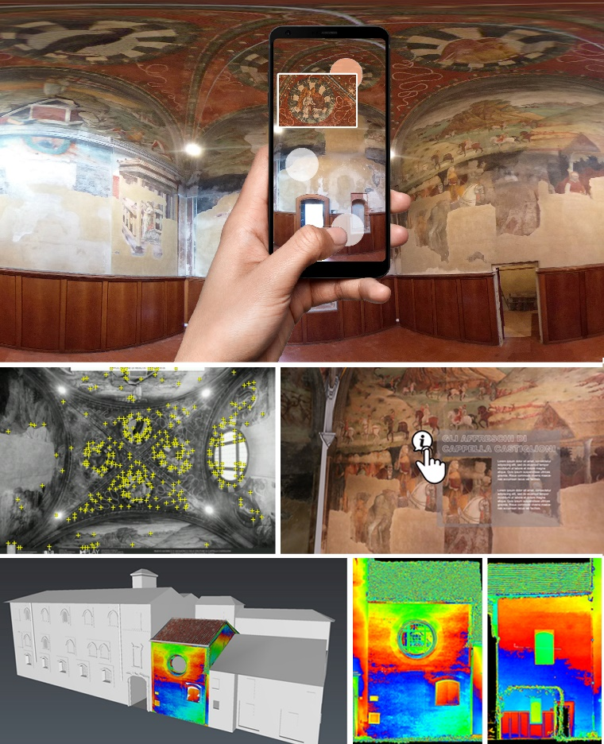
Figure 11. AR system that can be interacted with starting from the frame of the vault image (2D target). Examples of information layers that have been integrated into the application.
- Conclusions
It is on the basis of these assumptions that, in parallel with the diagnostic investigations, it is important to start evaluations regarding the development of the process of knowledge of the cultural value of the asset in the urban context of the city of Pavia. It is essential to define the processes of remote use of the asset addressing the different types of users.
The integration between augmented reality technologies and diagnostics becomes a tool for understanding, through information layers, various interrelated information; for example, the possibility of seeing historical images and alterations as superimpose\ed layers in order to understand their cause-and-effect relationships, simply by framing the wall with a mobile device (Figure 11). To sort the different information in a logical way, it is increasingly essential to create digital systems localised within a 3D representation of the object of study in which different types of data can be entered, stored and displayed. With the use of Augmented Reality and Virtual Reality technologies it will be possible to create an informative digital site through a three-dimensional representation of the architectural artefact.
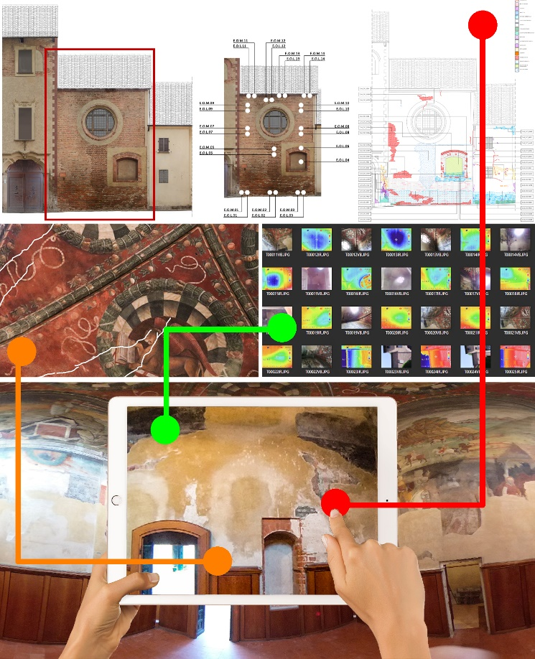
Figure 12. The use of AR technology is analyzed here not as a simple visualization but as a tool to address the problem of conservation. The result is meant to be one combination of digitized information including digital historical 3D reconstruction, existing documentation, alteration analysis, information layers of the analyzes conducted and information for tourist functionality.
This tool allows to show morphologically reliable information, not only as a synthesis of the collected data, but also including historical, artistic, or variable information as needed. The story of the architectural asset is no longer limited to its use in situ but, thanks to digital technology, it becomes interactive and allows remote access, facilitating its dissemination.
Acknowledgement
The research project concerning the geometric and material documentation and investigations for the diagnostics of Cappella Castiglioni is conducted by the research laboratories of the University of Pavia (STEP Lab, DAda-LAB and PLAY Lab). The project has Prof. Marco Morandotti as scientific manager.
The project has EDiSU Pavia, Ente per il Diritto allo Studio Universitario (Institute for the Right to University Study), as its client, based on its own funds and research contribution from the Fondazione Comunitaria of Pavia.
Chapters I and VI is due to M.M., chapters V is due to F.G., chapter II-IV is due to E.D.
References
- M. Morandotti, D. Besana, E. Zamperini, V. Cinieri, La gestione sostenibile del patrimonio immobiliare tra riuso e valorizzazione, in: Stefano della Torre (edited by), La strategia della Conservazione programmata, dalla progettazione delle attività alla valutazione degli impatti. Proceedings if the International Conference Preventive and Planned Conservation, Monza-Mantova 5-9 maggio 2014. Milano: Nardini Editore. 2014. ISBN: 9788840403144.
- M. Balzani, F. Maietti, Architectural Space in a Protocol for an Integrated 3D survey aimed at the documentation, representation and conservation of cultural heritage, in: diségno. 1 (Jul. 2017), pp. 113–122, 2017. DOI: https://doi.org/10.26375/disegno.1.2017.13.
- S. Parrinello, R. De Marco, Digital surveying and 3D modelling structural shape pipelines for instability monitoring in historical buildings: a strategy of versatile mesh models for ruined and endangered heritage, in: ACTA IMEKO, Vol. 10, Number 1, 84 – 97, March 2021. DOI: http://dx.doi.org/10.21014/acta_imeko.v10i1.895
- S. D’Urso, Il riuso delle memorie dei luoghi, in Fabio Minutoli (edited by), VI Convegno Internazionale sulla documentazione, conservazione recupero del patrimonio architettonico e sulla tutela paesaggistica. 11-14 ottobre 2018, ReUSO2018, Roma: Gangemi Editore, 2018. ISBN: 9788849286595.
- S. Della Torre, Italian perspective on the planned preventive conservation of architectural heritage, Frontiers of Architectural Research, Volume 10, Issue 1, pp. 108-116, March 2021. DOI: https://doi.org/10.1016/j.foar.2020.07.008
- M. G. Bevilacqua, G. Caroti, A. Piemonte, A. A. Terranova, Digital technology and mechatronic systems for the architectural 3D metric survey, Mechatronics for Cultural Heritage and Civil Engineering 92, pp. 161-180, 2018. DOI: 10.1007/978-3-319-68646-2-7
- F. Remondino, Heritage recording and 3D modeling with photogrammetry and 3D scanning, Remote Sens. 3, pp. 1104-1138, 2011. DOI: https://doi.org/10.3390/rs3061104
- J. Linowes, K. Babilinski, Augmented Reality for Developers: Build practical augmented reality applications with Unity, ARCore, ARKit, and Vuforia. Packt Publishing 9 ottobre 2017, p.584, 2017. ISBN: ‎ 9781787286436
- E. Vicini, “Il Palazzo Castiglioni Brugnatelli nel XX secolo. Il manufatto ridonato all’Università e alla città”. TCP Edizioni, Pavia, 2010.
- E. Vicini (a cura di), “I Dipinti Murali della Cappella Castiglioni. Sintesi della giornata di studi.”, Pavia, 2009.
- M. G. Albertini Ottolenghi. “Sulle Tracce Di Giacomo Vismara: Un'ipotesi.” Arte Lombarda, no. 119 (1), 1997, pp. 39–47.
- G. Natali, Gli affreschi dell’Oratorio del Colelgio Castiglioni a Pavia, in “Bollettino della Società Pavese di Storia Patria, vol.7”, 1907, pp. 337-342.
- M. Albertario, “Pavia 1475. Gli affreschi della Cappella Castiglioni”. Arti grafiche Zacchetti, Milano, 2004, pp. 22 and panles.
- M. G. Albertini Ottolenghi, “Il collegio castiglioni” in: A. Peroni (edited by) “Pavia. Architetture dell’età sforzesca”, Torino, 1978, pp.152-166.
- S. Parrinello, F. Picchio, “Dalla fotografia digitale al modello 3D dell’architettura storica.” DISEGNARECON, 6(12), X / 1-14. Oct. 2013. DOI: https://doi.org/10.6092/issn.1828-5961/3870.
- S. Parrinello, R. De Marco, A. Miceli, Documentation strategies for a non-invasive structural and decay analysis of medieval civil towers: an application on the Clock Tower in Pavia. Restauro Archeologico, 28(2), 18-43. 2021, DOI: https://doi.org/10.13128/rar-9518
- E. Doria, F. Picchio, The census of the city: the technological survey and the structuring of a database for the building heritage. In: Parrinello, S. (edited by) 3D Bethlehem - Management and Control of Urban Growth for the Development of Heritage and Improvement of life in the city of Bethlehem, 2021. ISBN:9788892800281
- D. Besana, “[RICH*] Reuse and Improvement of Cultural Heritage”, edA quaderni di Architettura. Canterrano (RM): Aracne Editrice, pp.339, 2017. ISBN: 9788825500424.
- M. Morandotti, “Planning the re-use: Sustainability through resilience evaluation.” Innovative Built Heritage Models. Edited contributions to the International Conference on Innovative Built Heritage Models and Preventive Systems (CHANGES 2017), February 6-8, 2017, Leuven, Belgium, 2017. DOI: 10.1201/9781351014793-3
- P. Durante, I. Ferrari, F. Gabellone, S. Gianmarco, F. Giuri, R. Lorusso Romito, M. Masieri, D. Melica, G. Quarta, M. Volinia, La chiesa di Santo Stefano a Soleto (LE). La ricerca dopo il restauro, tra reale e virtuale, Proc. 32° Convegno Scienza e Beni Culturali Eresia ed ortodossia nel restauro. Progetti e realizzazioni, vol.1, pp. 607-616. 2016
- Bonacini, E. Nuove tecnologie per la fruizione e la valorizzazione del patrimonio culturale. Aracne Editrice, Roma. pp. 268, 2011. ISBN:8854842907
- V. Croce, G. Caroti, A. Piemonte, M. Giorgio Bevilacqua, From survey to semantic representation for Cultural Heritage: the 3D modeling of recurring architectural elements. ACTA IMEKO March 2021, Volume 10, Number 1, 98 – 108. 2021. DOI: http://dx.doi.org/10.21014/acta_imeko.v10i1.842
- M. Centofanti, S. Brusaporci, Architectural 3D modeling in historical buildings knowledge and restoration processes, in: C. Gambardella (edited by), Le Vie dei Mercanti, X Forum Internazionale di Studi, More or Less. Fabbrica della Conoscenza, vol. 16, pp. 331-340, 2012. Online [Accessed 26 March 2021] ISBN 978-88-6542-129-1
- J.-T. Hwang, T.-C. Chu, 3D building reconstruction by multiview images and the integrated application with augmented reality, Int. Arch. Photogramm. Remote Sens. Spatial Inf. Sci., XLI-B1, pp. 1235–1241, 2016. DOI: https://doi.org/10.5194/isprs-archives-XLI-B1-1235-2016
- X. Liu, Y.-H. Sohn, D.-W. Park, Application Development with Augmented Reality Technique using Unity 3D and Vuforia. International Journal of Applied Engineering Research Volume 13, Number 21, 2018. pp. 15068-15071. ISSN 0973-4562
- J. Linowes, K. Babilinski, Augmented Reality for Developers: Build practical augmented reality applications with Unity, ARCore, ARKit, and Vuforia. Packt Publishing (9 ottobre 2017), pp.584, 2017. ISBN: ‎ 9781787286436
- D. Cisternino, C. Gatto, L.T. De Paolis, Augmented Reality for the Enhancement of Apulian Archaeological Areas. In: De Paolis L., Bourdot P. (eds) Augmented Reality, Virtual Reality, and Computer Graphics. AVR 2018. Lecture Notes in Computer Science, vol 10851, 2018. Springer, Cham. DOI: https://doi.org/10.1007/978-3-319-95282-6_27
- C. Santagati, M. Lo Turco, From structure from motion to historical building information modeling: populating a semantic-aware library of architectural elements," Journal of Electronic Imaging 26(1), nov. 2016. DOI: https://doi.org/10.1117/1.JEI.26.1.0

