Operational methodology for the reconstruction of Baroque Ephemeral apparatuses: the case study of the funeral apparatus for Cardinal Mazarin in Rome.
Margherita Antolini¹
¹via di S. Valentino 16, 00197, Rome, Italyl
ABSTRACT
This paper aims to develop a methodology of study of Ephemeral artefacts that takes into consideration all the different aspects of the specific art form that is Ephemeral Baroque Architecture.Through the study of the social and artistic characteristics of this art form, the analysis of a wide range of case studies will help defining some common and recurring features, especially regarding available data (engravings, paintings, manuscripts, …). The main goal of the research will be to outline a methodology of approach to the single cases based on reconstruction from text and graphic data, with special attention reserved to the relationship between the ephemeral apparatus and the surrounding urban space. The effectiveness of the methodology is tested by the application to the case study of the funeral apparatus for Cardinal Mazarin in Rome (1661).

Section:RESEARCH PAPER
Keywords:Ephemeral Baroque; Virtual Reconstruction; Reconstruction from Text
Citation:Thomas Bruns, Dirk Röske, Paul P. L. Regtien, Francisco Alegria, Template for an Acta IMEKO paper,Acta IMEKO, vol. A, no. B, article C, Month Year, identifier: IMEKO-ACTA-A (Year)-B-C
Section Editor:name, affiliation
Receivedmonthday, year; In final formmonth day, year; PublishedMonthYear
Copyright: This is an open-access article distributed under the terms of the Creative Commons Attribution 3.0 License, which permits unrestricted use, distribution, and reproduction in any medium, provided the original author and source are credited.
Funding:/
Corresponding author: Paul P.L. Regtien, e-mail: paul@regtien.net

- Introduction
From an historical and artistic point of view the Baroque Ephemeral is the most complete example of artistic and social synthesis, that englobes not only visual arts, but also music, literature and contemporary technical-scientific advancements, in order to achieve a product that can be enjoyed by the public as well as by the aristocracy and intellectuals and convey political and cultural messages at the same time.
The Baroque Ephemeral apparatuses are not limited to the celebration but are part of a system of documents edited with a communicative purpose in order to disseminate and explain the event and its symbolic meaning. If on one hand this implies a certain wideness in the corpus of available sources, on the other hand opens an important question regarding their validity and objectivity in the representation of the events. Moreover, the concept of “ephemeral” itself, meaning existing for a limited time, poses issues of difficult solution in terms of conservation, mainly regarding the contraposition of ephemeral/permanent and reality/representation.
These were the issues that started the present study, founded on the research of an experimental methodology for study, representation and communication -and consequently conservation- of Baroque Ephemeral artworks in their entireness: as artistic, architectonic, urban, social and political phenomena.
Without forgetting the pioneering excursions of Bragaglia[1], Kernodle[2] and Tintelnott[3], only in the second half of the last century there was an effective reawakening of interest around this line of Italian creativity in the wake of Povoledo[4], Viale Ferrero[5], Zorzi[6], Ricci[7], the Fagiolo dell'Arco brothers. Although failing to exhaust such a complex theme, they have defined its outlines and focused the main aspects, restoring dignity to an artistic expression long ignored, promoting publications and exhibitions: we find one in Naples in 1997[8], in Parma in 2018[9], and in Florence in 2019[10], which represent a focal moment of study around the theme and available corpus of works.
But it is certainly Maurizio Fagiolo dall'Arco in the 70s and 80s to conduct the most exhaustive and systematic study of the Baroque Ephemeral published to date: among his publications we find Bibliografiadella festa barocca, and a work edited with Silvia Carandini who represents the real cornerstone for studies on the theme, L’effimerobarocco: strutturedella festa nella Roma del ‘600, as well as numerous publications and articles on the subject.
Only in the recent years the theme of the reconstruction of Baroque Ephemeral gained the attention of various academics such as Paolo Belardi[11] and Paolo Lattuada[12] who conducted experiments on the representation of ephemeral apparatuses, whereas Macarthur, Leach[13], Delbeke [14] and Conforti, d’Amelio, Grieco [15] continue the tradition of historical analysis through documents in the footsteps of Fagiolo dall’Arco and Carandini.
- CHARACTERISTICS OF THE PHENOMENON
The concept of ephemeral architecture - and therefore temporary and "false" - as well as the construction techniques used have their roots in theatrical scenography, an artistic practice that experienced a moment of intense development in the 16th and 17th centuries, with the birth of melodrama and the works of artists such as Palladio, Scamozzi, Serlio and Peruzzi. The idea of arranging urban spaces to celebrate events is the logical consequence of the conception of the new acting space, and it naturally encompasses all of its characters.
On the other hand, the depictions of pomp and luxury that characterize these projects are only a staging of power: rather than representing the stability of the institutions and their highest representatives, these evanescent creations actually seem to be the symbol of an equally labile and inconsistent power, of the political void of a fragmented and often subject to foreign domination country[16]. Used to divert the attention of ordinary people from the precarious reality and to create a fictitious link between the various social classes, ephemeral constructions found a particularly fertile terrain during the XVII century when, with the spread of Baroque poetry, the spectacular effect became the primary component of any artistic expression.
Thus art becomes an instrument of political propaganda and manipulation of the people who, through a new form of panem et circenses finds a moment of liberation from the working reality and contact with the unreachable world of the Roman aristocracy.At the same time celebrations are a demonstration of strength also towards other nations. A clear example are the installations built for the celebration of the birth of foreign princes, as in the case of the Dauphin of France in 1662 designed by Bernini, or the exceptional one for the arrival in Rome of Christina of Sweden in 1655. On this occasion, on the 23rd and 24th of December 1655, apparatuses similar to those of the Papal possession were set up for the entrance into Rome, in a path that unraveled among Porta del Popolo, San Pietro and Palazzo Farnese, by Gian Lorenzo Bernini, Giovan Paolo Schor, Ercole Ferrata and Carlo Rainaldi; in February of the following year the presence of the former queen animated the Carnival with special floats in Via del Corso, and theatrical performances at Palazzo Barberini designed by Giovanni Francesco Grimaldi.
The religious-political-social program of the Baroque Ephemeral exploits the technique of wonder according to the politics of persuasion, giving the artist a particular role as an image specialist. In this case, art does not give us the real face of the century but the face it believed (or wanted to be believed) to have: splendid, idealized, sumptuous, rich. The relationship of the artist with the client, and therefore with power, becomes particularly delicate to interpret at this point. Despite being an instrument in the hands of religious-political power, the artist manages to impose his intellectual power, integrating the allegory, bearer of the political message, in the imaginative method.
Festive occasions retrace the entire life span of illustrious personalities, first of all of the Pope, in a mixture of civil and religious occasions. The public feast, enjoyed by the community in an integral manner, is an complete event, both sacred and profane at thesame time, during which the judgment is suspended and one deliberately enters into a reality different from the daily life.
From a planning and organizational point of view, the celebration follows the same process regardless of the occasion. The main manager is the intellectual, who often coincides with the client: man of culture or religion, he takes care of drafting the ideological program of the festival, experimenting with new tools for cultural diffusion. In the next phase, the artist and the creator collaborate to identify a more or less complex communication code, which will then be translated into forms. In every single apparatus, the plastic, pictorial and literary solutions are therefore a support for the ideological and cultural connotation, and are arranged in a spatial - and consequently temporal -succession in order to fulfill all the allegorical implications of the program. [17]
The event is also completed by a report drawn up by the intellectual and illustrated with few engravings, in which the apparatus and its meaning are described and explained,with the aim of functioning as a booklet for those who participate in the occasion, but also as means of diffusion especially in foreign courts.
In this context, the relationship with the place and the city is fundamental: Rome first of all presents itself as a spectacle, with its history and its tradition. The ancient city becomes an immense and prestigious theater and, if on the one hand it recalls the almost obsessive use of theatrical terminology in Baroque culture, on the other it clarifies the particular political, social and urban configuration of the city in relation to the shows that on that scene take place.
- mETHOLODOGICAL ISSUES
The study of the cultural phenomenon of the ephemeral in the Baroque era has highlighted several characterizing and relevant aspects for the study of the individual artefacts: in particular the literary and socio-political components were found to be fundamental.
Approaching the individual projects, some recurring features from the documentary point of view emerge. Analyzing a wide range of examples, it was clear that there are several basic structures which, if analyzed, can facilitate and simplify the study. In particular:
- each occasion presents recurring types and expedients, explained in specific treaties;
- each artist uses a more or less homogeneous language, and given the short time dedicated to the design and construction of the apparatus, he often reuses the same pieces on different occasions;
- each occasion is documented by a written text and some "official" engravings, as well as paintings and other testimonies.
In this study, attention is paid to the latter as the only tool available for the reconstruction of ephemeral apparatuses.
The relationship between text and architecture is a theme dealt with starting from the reading of Vitruvius in the 16th century, or of Leon Battista Alberti's Descriptio Urbis Romae, and is still an object of interest in various areas of study. In these cases, unlike what happens in the field of restoration and archeology, the reconstruction does not start from the study of the artefact to be integrated with iconographic sources, but proceeds in the opposite direction, using texts and images as a starting point to then be confronted with the built reality.
Some scholars attempted reconstructions of baroque ephemeral systems, achieving results that we believe are partial and not very relevant, but which open the way to a series of interesting reflections and observations.
On the one hand Paolo Lattuada[12] reconstructs, in a virtual and physical environment, the celebratory machine designed by Ferdinando Sanfelice in 1740 for the birth of the Reale Infanta in Naples. If on the one hand he manages to interpret all the metric and space integration aspects, both the realization in wooden panels and the virtual restitution are lacking considering the figurative restitution of the desired atmosphere and obtained by the designer. On the other side, Paolo Belardi and Valeria Menchetelli [13] deal with Giuseppe Piermarini's work by returning well-defined and metric correct models, but completely ignoring the material, figurative and integration aspects with the context.
The need of an operative methodology that would allow to obtain a historical, critical and virtual reconstruction of the baroque ephemeral architectures arose from the analysis of the two proposed examples and archival documents. By these terms it is understood that the methodology presented aims to indicate a series of effective steps which, if followed and applied with a critical conscience on a case-by-case basis, return a historically reliable product that takes into account the historical distance and the transformations that happened in the places and in the urban fabric.
The choice of the virtual environment as the main theater of restitution derives from a reasoning on the most appropriate means for communicating this form of intangible heritage. Two aspects have led to the exclusion of pure two-dimensional representation and the hypothesis of the construction of temporary constructions:
- the virtual environment respects the idea of temporary set-up without producing fake and always temporary artefacts, however allowing to interact with the place and participate in a possible museum project; [18, 19]
- the virtual environment is the contemporary response to the baroque desire to expansion and manipulation of space.
In addition to these premises, the method was empirically deduced from the study of the sources of a case series varied from the point of view of the occasions and the artists involved, which unfolds during the XVII and XVIII centuries in Rome.
The process is structured in four fundamental phases, which can be summarized in the study of the sources, study of the object, analytical phase and restitution; while the first and the last clearly represent the initial and final moment of the work, the two intermediates can be considered complementary and represent the real critical moment of the study. [Table 1]
Once a project to be analyzed has been selected, the first step in the process is thecollection and study of the sources relevant to the case study. In most cases it will be a report and official engravings, which can be accompanied by commemorative paintings and period chronicles. Fagiolo dell'Arco and Carandini [20] have already drawn up a catalog of ephemeral apparatuses realized in Rome, which lists each project according to year, occasion, artists, material produced, material available and transcription of textual sources. This volume is extremely relevant and can constitute the beginning of a systematic study, but it is limited to a documentation without interpretation of the data collected.
The second moment aims at the appropriation of the data with the aim of analyzing it later: it is therefore a matter of transcribing the texts, often manuscripts or Seventeenth century prints, and of redesigning the engravings collected. In this way it is possible to begin to discern the characteristic elements and the amount of information available regarding the specific case.
Afterwards, two courses of study open up: on one side the study of the object, on the other the analytical phase. The following will be presented one after the other, but it is clear that there is a continuous exchange between the two.
As for the study of the object, it was highlighted how the place was a fundamental component of the Baroque festival and the design of the equipment. For this reason, it is firstly planned to carry out the survey of the area concerned, in its current configuration and in a reconstructive hypothesis of the contemporary configuration at the date of the celebration. For this, we will apply on the one hand the methods of integrated surveying with massive acquisition for the survey of the current state, and on the other the techniques of historical research through archival documents, historical maps, analysis of the walls, etc.
The operations described will result in a pointcloud and a timeline, which will be graphed in a two-dimensional (drawings) and three-dimensional(models) restitutions of the current state of the place and of the reconstructive hypothesis of the historical moment involved in the study. In this case it is not strictly necessary to study in depth each building phase, but it is certainly important to have a clear vision of the evolution of the fabric and the construction.
At the same time it is possible to start the analytical phase, studying the cultural environment. Given the importance of the ideological and allegorical contents, attention will be paid in particular to the figure of the client and the artists involved, as well as to the research for comparisons of similar cases. Considering the scarcity of iconographic material, in fact, the deepening of the artist's style can lead to valid interpretations of the data gaps, or to clarifications of unclear points.
At this point the actual analysis of the documents begins: firstly we will analyze the geometric-proportional aspects of the graphic data, interpreting the techniques and graphic choices used in the engravings and paintings, and applying the rules of reversed perspective and of the orthogonal projection. In this way, it will be possible to establish the reliability of the designs and their correspondence to reality, and to understand if particular visual effects have been sought. Knowing the geometry of the place, in fact, it will be sufficient to overlay the two representations to notice any deformations, technical tricks, or inaccuracies.
A similar approach will be applied to textual data, from which all possible information will be derived. Graphic and textual data will then be interpolated to develop a model as exhaustive as possible regarding elements, geometries, colors, settings, lighting, details, allegorical meanings, plastic solutions, etc.
To proceed in the knowledge we then proceed by working on classifications that synthesize the distinction between ephemeral and permanent elements, the artistic techniques used, which range from painting to sculpture to pyrotechnic installations, but also musical, to finally distinct an abacus of serial and special elements.
Note how these two phases are the most conditioned by the specificity of each case.
The last moment is the restitution. This can take different forms depending on the sensitivity of the operator, the specific case study, and the use that will be made of it, but it must necessarily be composed of a series of two-dimensional drawings regarding the appearance of the place during the party, and of the three-dimensional models that present the layout in its original setting and the integration of the layout in today's environment.
Table 1.Flowchart of the proposed methodology.

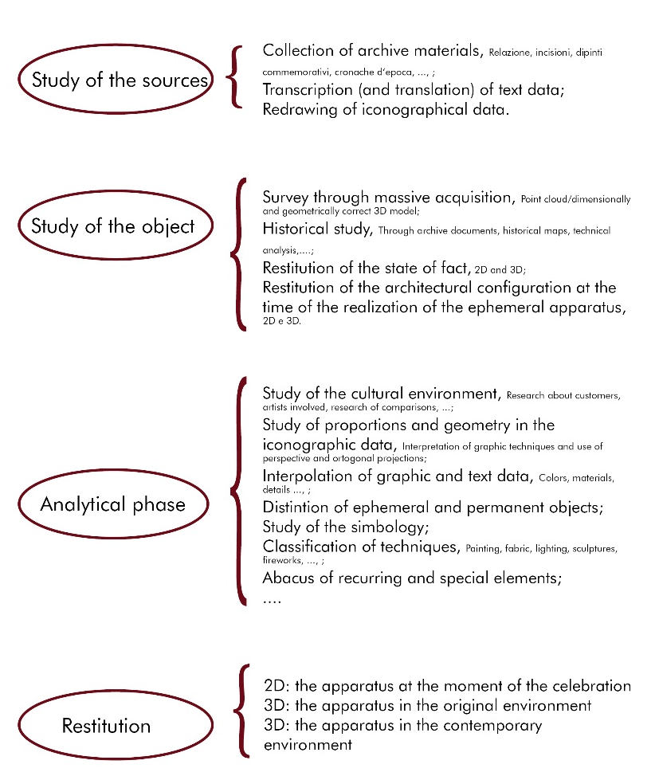
- CASE STUDY
The chosen case study is the Pompa Funebre nell'Esequie celebrate in Roma al Cardinal Mazarini nella Chiesa dei SS Vincenzo e Anastasiothattook place in 1661.
A few years earlier, Cardinal Giulio Mazzarino, minister of Louis XIV, financed the construction of a church in the area of Piazza di Trevi, the church of Saints Vincent and Anastasius at Trevi, which was completed a few months before his death. Here the funeral was celebrated in Rome, with an apparatus created by Elpidio Benedetti as the intellectual of reference and Giovanni Francesco Grimaldi as the artist.
At this time, an important role was played by Castrum Doloris and funeral celebrations in general. Menestrier[21] describes the regulations for the funeral ceremony: the funeral is divided into different moments (invitation, convoy, service, funeral eulogy, burial) which must correspond to the different parts of the church decoration (external facade, nave, altars, inscriptions, catafalque) as places appointed for an allegorical representation that culminates in the luminous vision of the Castrum Doloris, where the triumph of death and religious and temporal power represented by the deceased are celebrated. The catafalque is the mirror of Baroque taste, increasingly aimed at dematerialisation and to the refined invention, which will culminate in the triumphs of the macabre designed by Bernini.
It is possible to trace a real typological evolution in the forms taken by the catafalques during the 17th century from the forms of the ancient mausoleums: from an initial temple shape (Catafalque for Sixtus V, D. Fontana, 1591) we move on to a temple or pyre type (Catafalque for Philippe the III, Torriani, 1621), and then prefer real miniature mausoleums (Catafalque for Gregorius XV, Lippi, 1623) ; these typologies are accompanied by exotic experiments, such as the Catafalque della Valle in 1627, while in the second half of the century pyramid forms are preferred (Catafalque for the Jesuits, Sacchi, 1639) and types based on assembly, such as the temple type- baldachin (Catafalque for Philippe the IV, Del Grande, 1665), mausoleum with obelisks (Catafalque for Philippe IV, C. Rainaldi, 1665) and triumphal arch and small temple with pyramid (Catafalque for Anne of Austria, Grimaldi, 1666), up to pyramids supported by living skeletons (Catafalque Beaufort, 1668).[17] Throughout his life Grimaldi enjoyed the admiration and favor of a large group of admirers, thanks to his ability to adapt to the client's needs, from his good-natured and quiet character and perhaps from the moderate rewards required. Among the first to express appreciation on the artist was Elpidio Benedetti himself: notes of commendation appear in the reports drawn up on the occasion of feasts and religious celebrations where he worked, as the judgment reported to him by Antonio Perez De Rua when the artist he decorated the external facade of the church of San Giacomo degliSpagnoli on the occasion of the funeral rite of the Spanish king Philip the IV: «cuiodiseno es de Iuav Francisco Grimaldi Bolognese, no menosvalienteen el pincel, que bizarro en el compas, y enestegenero de obrasestimado por el primero desta Corte.» [22]
  - Study of the sources
Upon the death of Cardinal Mazarin on March 9, 1661, Benedetti received instructions from Louis XIV to create an adequate funeral pump.
The funeral report, [23] written and published by Benedetti, contains five engravings by Dominique Barrière which document the catafalque, the decorations for the facade, the counter-facade, the nave and the choir on one facade drawing, three views of the interior, one towards the choir, the second towards the main entrance and the third of the walls of the lateral nave, and of the catafalque.
Barrière’s name appears only in the engravings of the facade and the catafalque, while all the engravings bear the inscription Abbas Elpidius Benedictus Inven., and Grimaldi is referred to as Architect of the entire funeral apparatus, or artist responsible for its construction.
In the decoration of the facade and the interior it is difficult to find Grimaldi's hand: the two landscapes on the facade, representing the sunset and the rising sun, are somewhat elementary and do not seem to be the work of a specialist, so it seems that he entrusted this project to his aid given the contemporary commitment in the Palaces Santacroce and Nunez. On the other hand, the engraving of the cardinal's catafalque highlights the typical stylistic elements of Grimaldi, on the basis of which both the invention and the execution are attributable to him.
The catafalque is a simple structure which, although lacking specific preparatory studies, retains many elements also found in the preparatory studies for the catafalque for Anne of Austria, designed and built by Grimaldi in 1666 [22]: some of the elements present in the first sketch were incorporated into the catafalque of cardinal Mazarin, for example the candle holders on the sides, the antique style putti on the right at the base of the catafalque of Anne of Austria are also present next to that of cardinal Mazarin. Likewise, the two female figures holding the urn reappear in Mazarin's catafalque, although their function has been changed. Furthermore, the two putti holding the queen's coat of arms perform almost the same function when they raise the cardinal's hat. Finally, in both monuments, the urn is placed on top of the funeral structure and above the urn appears the portrait of the deceased flanked by two figures.
The second sketch contains elements that are found in the catafalque of Cardinal Mazarin, such as the pyramidal structure at the base of which, both in the drawing and in the engraving, two putti hold the coat of arms of Cardinal Mazarin while in an elaborate urn is placed high. In both cases, the entire structure ends with the portrait of the deceased flanked by two figures. Although the catafalque of Cardinal Mazarin is different, all the elements that compose it as well as the style of the female figures, the putti, the olive trees and palm trees refer back to Grimaldi rather than Benedetti. Grimaldi has in fact repeatedly used the same elements in his career.
It is not clear who created the iconography: it could have been a collaboration between the French authorities, Benedetti and, perhaps, Grimaldi. In any case, it is based on a tribute to Cardinal Mazarin's services to the French crown and Christianity. At the foot of the square base sit two parts of the world in reference to Cardinal Mazarin's broad political action. Above the base there are the coat of arms and the cardinal's hat and above it there is a representation of Rome in tears over the death of the cardinal and on the other three sides are the relief representations of France, Spain and Christianity. Above the pyramidal structure rests the urn of Cardinal Mazarin who acts as a support for his portrait surrounded by a laurel wreath.
On the left an olive tree, a symbol of peace, under which the Religion appears and behind it the Justice. On the right a palm tree, a symbol of war, with the Fortress underneath and Providence behind. Among the branches, two cherubs hold an olive crown with the inscription ET PACE and a palm crown with the inscription ET BELLO.
  - Study of the object
The survey of the church of Santi Anastasio e Vincenzo was carried out with the integrated survey methodologies with massive acquisition through laser scanner and Structure from Motion.In this way, a point cloud was obtained which was satisfactory for the set objective.
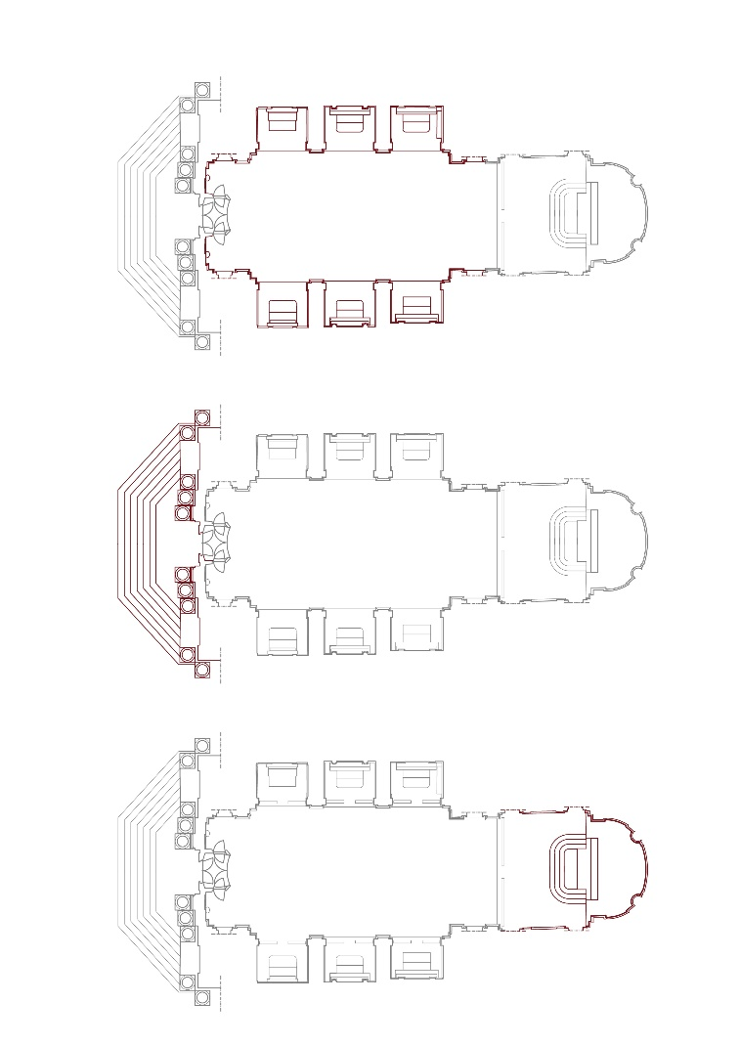
Figure 1. Graphic representation of the three construction phases of the church of Santi Anastasio e Vincenzo in Rome.
Parallelly, through an historical research, it was possible to delineate a well-defined timeline for the construction of the church [24, 25]
Given the narrowness of the site, the original organism consisted of a nave flanked by chapels which, without a transept, ended in the presbytery with a flat deep wall, at the height of the pilasters that will then frame the eighteenth-century tribune. The Tribune, with the high altar and the elliptical dome above it, belong to the intervention after 1748.
Regarding the nineteenth-century interventions, in addition to the decoration of the chapels, we highlight the fresco of the vault in 1818 and the restoration of 1857 with remaking of the marble floor.
The building history can therefore be summarized in three main phases [Figure 1]:
- 1641-1646; Interior construction, with back wall and six chapels by Gaspare de Vecchi;
- 1646-1650; Construction of the facade by Martino Longhi the Younger;
- Post 1748; Extension of the church with Tribune, apse and dome; decoration of the chapels.
For the purpose of the study, the configuration relating to 1661, i.e. shortly after the completion of the second phase, was analyzed and redesigned, based on the comparison between the current configuration of the church, archival documents, engravings of landscape painters and engravings related to the apparatus.
  - Analytical phase
Following the previously described methodology, once the place and the general characteristics of the case study have been studied, the attention is focused on the iconographic sources of the apparatus. As for the funeral in question, no paintings or engravings other than those of the report were found, i.e. five engravings by Dominique Barrière depicting the facade, the counter-facade, the nave, the altar and the catafalque.
First of all, it was necessary to deal with the problem of scale and deformation: the engravings in fact have no dimensional indication and are not all represented on the same scale, but rather designed to fit the same format. Therefore they have been divided into two groups, as two of them are drawn in orthogonal projection while the other three in central perspective.
Analyzing those in orthogonal projection, that is the facade and the nave, at first it seemed sufficient to exploit the geometry of the church, that is to say trivially to superimpose the engraving on the reconstructive hypothesis advanced during the historical study of the place. However, the operation has been proved not sufficient, since the drawings are deformed in height, probably to obtain visually more captivating effects of grandeur and vertical development. [Figure 2]
Figure 2. Analysis of the scale and deformation in the engraving of the nave in relation to the survey.

As for the counter-façade, the altar and the catafalque, they were divided into two further subgroups. The first includes the engravings of the counter-façade and the altar: in this case too the solution seemed simple, that is to apply the rules of descriptive geometry and of the reverse perspective to obtain the real measurements, but a more detailed examination revealed that these two engravings present three central vanishing points and therefore are an assembly of three overlapping perspectives. Here too, as for the orthogonal projections, the goal of the engraver was to obtain a vertical expansion of the space of the drawing compared to the real space. The process was therefore to recognize the three perspectives with their vanishing points, horizons and landlines, and to recognize which parts of the drawing referred to the single system of projections, and then to apply the rules of inverse perspective. [Figure 3].
Figure 3. Analysis of the perspective and deformation in the engraving of the altar.
The last reasoning concerns the catafalque: as far as the perspective study is concerned, it was much simpler here as the drawing is a central perspective with a single vanishing point. However, the engraving exclusively shows the catafalque, removed from the architectural context, so it was possible to reconstruct its geometry but not its dimensions and position. Thanks to the integration with the textual data and with the stylistic comparisons, it was possible to know the position of the catafalque in the church and tonotice how all the Grimaldi catafalques respond to the same dimensional relationships between the catafalque and the setting.
At this point it was possible to integrate the information deriving from the graphic data with the survey and reconstruction drawings previously produced, obtaining the nature, position and size of each element; at the same time it was possible to distinguish the elements of the ephemeral apparatus from those of the permanent architecture.
An interesting detail is the study of shadows in the engravings. These, in fact, have been designed with such detail as to allow to distinguish the painted elements from those in relief, and for the latter to determine their depth and position with respect to the background.
At the same time, the textual data was analyzed, first reading and transcribing the report carefully. The informative nature of the text was immediately evident, given the celebratory but at the same time simple language used by the author, and the absence of Latinisms.
The report consists of seventeen pages of text. The first two cite a praise of all those who were involved in the organization of the funeral and introduce the following five chapters, each of which accompanied by an engraving. All these chapters follow the same approach: commendation of the deceased, description of a part of the apparatus and explanation of the allegorical meaning.
As mentioned above, the text played a crucial role in defining the position and size of the catafalque, but also provided a number of important information. First of all, the analysis of the text confirmed the distinction of the elements in ephemeral and permanent; subsequently, it allowed the characterization of the models with data regarding materials, colours, lighting and desired atmosphere, and finally a further characterization through the allegorical reading. [Figure 4]
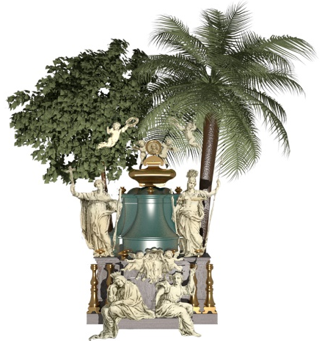
Figure 4. Results of the graphic data interpretation, the textual data information and final 3D model.
To obtain this result, the text has been reread several times, highlighting the different types of information and classifying them according to: element involved, chromatic, material, and symbolic data. These informations were interpolated with the result of the analysis of the graphic data, and generated an abacus of elements based on the artistic techniques used and the seriality or not of the artefact, which clarified all the characteristics of the apparatus and facilitated the modeling process.
Symbology information was not easy to integrate with two-dimensional models, but can be added to the three-dimensional model as easy-to-understand interactive pop-ups.

  - Restitution
The final result of the study consists of two-dimensional (1:50 scale) and three-dimensional (potentially in 1: 1 scale) elaborations, born from the integration of relief, historical study, analysis of textual data and analysis of graphic data.
At the communicative level, if two-dimensional drawings can be more useful for communication at an academic level and are easily readable, the model is more versatile for dissemination and possible use in the context of museum display, while maintaining the same level of reliability and scientificity .
The models produced, moreover, not only want to return the reconstruction of the 1661 exhibition, but investigate the relationship that is created between the apparatus designed by Grimaldi with the current location, establishing a critical dialogue between past and present, between ephemeral and permanent, in which both become changeable and question the concept of real space and space of representation. [Figure 5]
- CONCLUSIONS
The presented study therefore achieved two complementary results valid for further developments.
First of all, there is the creation of the 3D models of the setting up of Mazarin's funeral, or the outcome of the analysis carried out on the case study. These can be immediately made available and used for academic purposes but also, and above all, for communicative and conservative reasons.
However, the models mentioned are the result of the application of a study and analysis method drawn up here to address and resolve representation issues that have never been fully analyzed so far.
If applied systematically and correctly, i.e. with a critical sense, the methodology could lead to interesting results in several areas:
- first of all, the study of a fundamental cultural phenomenon for Baroque society;
- as seen previously, the design of the ephemeral apparatuses gave the possibility to the artists to create study models on a 1: 1 scale of stable architectures that they would later build.
- Their knowledge could open new scenarios regarding the design process of Baroque architects;
- Communication and museum display of artifacts that can facilitate users in understanding the society of Baroque Rome with immediate, easily available and low-cost means of management;
- Conservation of the intangible heritage in the manner most appropriate to the specific characteristics of the phenomenon.
Overall, the methodology aims to be operational, historically reliable, critical of the transformations of places and to return the results in a virtual environment, and is the result of an empirical approach.

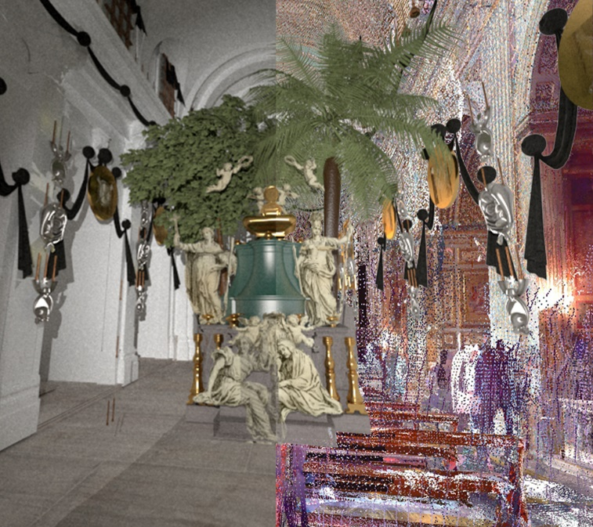
Figure 5. Composition of the setting in the original location (3D Model) and in the contemporary environment (Pointcloud).

Lacking previous research based on the specific topic, it was fundamental first to understand the phenomenon of the Baroque Ephemeral from an ethnographic point of view, to establish its importance and to better interpret the relationship between the apparatuses and the places, or the relationship between artists, power and the city.
Subsequently, by deepening the historical-artistic aspects, it became clear the fundamental role that the celebrations play in Baroque poetics, as the sum of its three fundamental aspects: the aim for wonder, experimentalism and the synthesis of the arts.
From the beginning, the relevance of these projects evident, as well as the recurring characteristics in the conduct of the celebrations and above all in their representation. Therefore a study of a wide range of cases was considered necessary to confirm the hypothesis. Hence the need for a study method that would take into account both the specific features of each apparatus and their typicality, and which could open up the possibility of studying this artistic practice in a systematic way.
Acknowledgement
We thank professor Alfonso Ippolito (Università di Roma La Sapienza) for supporting this research as a tutor and mentor.
References
- A.G. Bragaglia, Scenotecnica barocca, Emporium, Vol. LXXXVI, n.515, 1937, pp. 608-614,
- G.R. Kernodle, The theatre in history, University of Arkansas Press, 1989, 606 p.
- H. Tintelnot, Annotazioni sull’importanza della festa teatrale per la vita artistica e dinastica nel Barocco, Retorica e Barocco: atti del 3° Congresso internazionale di studi umanistici, Venezia, 1954, Fratelli Rocca, Rome, 1955, pp.233-242
- E. Povoledo, Il Teatro nel Teatro e la tradizione iconografica della scena barocca in Italia, Vita teatrale in Italia e Polonia fra Seicento e Settecento, Państwowewydawnictwonaukowe, Warsaw, 1984, pp. 232-243
- M. Viale Ferrero, Feste politiche e politica della festa, in:Milleottocentoquarantotto: Torino, l'Italia, l'Europa, Archivio Storico della città di Torino, Turin, 1998,ISBN 8886685319, pp.53-68
- L. Zorzi, Figurazione pittorica e figurazione teatrale, in: Storia dell’Arte italiana, vol. I, Einaudi, Turin, 1978, pp. 421-456
- G. Ricci, La scenografia, Grafica Gutenberg, Gorle, 1977
- S. Cassani, Capolavori in festa: effimero barocco a Largo di Palazzo, 1683-1759, Electa, Naples, 1997, ISBN 8843586998, 254 p.
- F. Magri, C. Mambriani, Il dovere della festa. Effimeri barocchi farnesiani a Parma, Piacenza e Roma (1628-1750), Grafiche step, Parma, 2018, ISBN 8878981621, 139 p.
- M.M. Simari, A. Griffo, Il carro d’oro di Johann Paul Schor: l’effimero splendore dei carnevali barocchi., Sillabe, Florence, 2019, EAN 9788833400761.
- P. Belardi, V. Menchetelli, “Architetture immateriali. La ricostruzione digitale di progetti e apparati effimeri di Giuseppe Piermarini”, Giuseppe Piermarini tra Barocco e Neoclassicismo Roma Napoli Caserta Foligno, EFFE Fabrizio Fabbri Editore, Perugia, 2010, ISBN 9788896591277, pp.285-287
- http://www.paololattuada.net/progetti/recupero-e-restauro/ricostruzione-filologica/
- J. Macarthur, A. Leach, Mannerism, Baroque, Modern, Avant-garde, The Journal of Architecture, n.15(3), pp. 239-242
- M. Delbeke, Framing history: the jubilee of 1625, the dedication of new Saint Peter’s and the Baldacchino, in: Festival Architecure, Routledge 2008, ISBN 978-0-415-70129-7, pp.129-154
- C. Conforti, M.G. d’Amelio, L. Grieco, Grande come il vero. Full-size architectural models in the modern period. Frascari Symposium IV: The secret lives of architectural drawings and models: from translating to archiving, collecting and displaying, Kingston School of Art, London, June 27-28 2019
- F. Mancini, Perennità dell’effimero, in Capolavori in Festa. Effimero barocco a Largo di Palazzo (1683-1759), Electa, Naples, 1997, ISBN 8843586998, p.3
- M. Fagiolo Dell’Arco, S. Carandini, L’effimero barocco: strutture della festa nella Roma del ‘600, vol.II Testi, Bulzoni, Roma, 1977-78, 390 p.
- De Felici Sara, La rappresentazione scenica dal bozzetto alla realizzazione: potenzialità espressive e di indagine delle tecnologie informatiche, Tesi di dottorato, tutor: Antonino Gurgone, Marco Carpiceci, Roma: Dipartimento di Storia, Disegno e Restauro dell’Architettura, 2012, 145 p.
- Fabio Luce, La comunicazione dell’architettura: nuove forme di rappresentazione, nuovemodalità di fruizione, Tesi di dottorato, tutor: Roberto de Rubertis, co-tutor: Giovanna A. Massari, Roma: Dipartimento di Storia, Disegno e Restauro dell’Architettura, 2012, 111 p.
- Fagiolo Dell’Arco, S. Carandini, L’effimero barocco: strutture della festa nella Roma del ‘600, vol. I Catalogo, Bulzoni, Roma, 1977-78, 390 p.
- C.F. Menestrier, Des decorations funebres. Ou il estamplementtraité des tentures, des lumières, des mausolées, catafalques, inscriptions, &autresornementsfunèbres, J.B. de La Caille, A Paris, 1683, 367pp.
- D. Batorska, Giovanni Francesco Grimaldi (1605/6-1680), Campisano, Roma, 2011, 252 p.
- Elpidio Benedetti, Pompa funebre nell’esequie celebrate in Roma al Cardinal Mazarini nella chiesa de SS. Vincenzo & Anastasio, Roma, 1661.
- A. Pugliese, S. Rigano, Martino Lunghi il giovane: architetto, Bulzoni, Roma, 1972.
- V. Rizzi, Indagine su di una facciata barocca : la facciata della Chiesa dei Ss. Vincenzo e Anastasio di Martino Longhi il Giovane a Roma rilevata e disegnata da Viviana Rizzi, Fratelli Palombi, Roma, 1979, 34 tav., pp. 80-81.

