Automatic Control Points Computation for the Acoustic Noise Level Audits
Drábek Tomáš¹, Petrík Vladimír², Holub Jan¹
¹Department of Measurement, Faculty of Electrical Engineering, Czech Technical University in Prague, Prague, Czech Republic, tomas.drabek@fel.cvut.cz, +420 224 353 992, holubjan@fel.cvut.cz, +420 224 352 000
²Czech Institute of Informatics, Robotics, and Cybernetics, Czech Technical University in Prague, Prague, Czech Republic, vladimir.petrik@cvut.cz, +420 224 354 225

Abstract – The acoustic noise level in the interior is one of the quantities specified by a standard and is subject to audits to ensure a comfortable living environment. Currently, the noise level audits are performed manually by a skilled operator, who estimates the floor plan and uses it to calculate the control points location in which the measurement is performed. We propose to automate the computation by formulating an optimization problem for which we designed an algorithm. Algorithm computes the solution that satisfies all constraints specified in the standard, for example, the minimum distance among the control points and fixed obstacles (walls or columns). In the proposed optimization problem, we designed the fitness function based on the measurement purpose, and we analysed two typical use-cases: (i) long-term stationary noise measurement and (ii) recurring short-term noise measurement. Although the set of control points for both use cases obeys the given standard, it is beneficial to distinguish the location of control points based on the measurement purpose. We maximize the number of control points for the stationary noise and maximize the immediate coverage area for the short-term noise. We tested the proposed algorithms in simulation for several floor plans of different complexity.

Keywords – Noise, Measurement, Algorithms, Automation, Determination of Control Points.

- Introduction
The acoustic noise level is measured in human-occupied buildings to ensure comfortable living conditions. The measurement process is described in national standards that specify, for example, restrictions for placing control points, the duration of the individual measurements, or measurement device specifications. The goal of this paper is to design automatic algorithms for placing the control points into a given room by obeying all 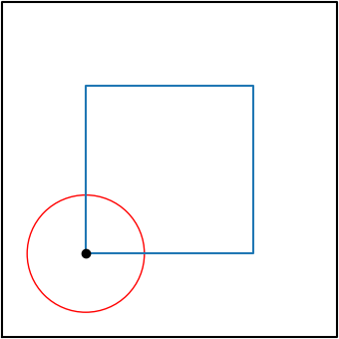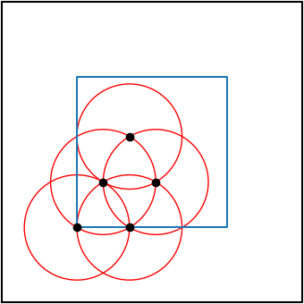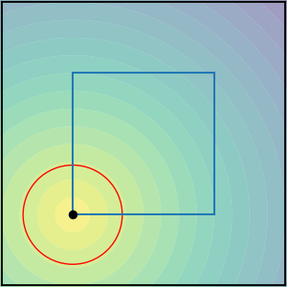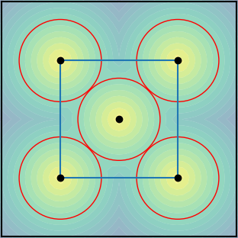
Fig. 1. The control points location (black dots) for stationary noise (top row) and short-term recurring noise (bottom row) measurement. The left figures show the first iteration of both processes, in which the control point is located to the corner of the polygon defined by 1 m distance from walls. The algorithm for stationary noise measurement (top) is placing control points step-by-step to put as many control points as possible while not placing them closer than the minimum distance visualized by the red circle. On the other hand, the short-term recurring noise spread points quickly leading to broad coverage in a short time by minimizing the objective function visualized by the contour plot. The total number of control points that can fit into the room is, therefore, smaller for short-term recurring noise.
constraints given by the standard. The measurement of the noise level is then performed in these control points.
The national standard [1], for which we design the proposed method, does not distinguish different measurement purposes and specifies only general rules for control points location. Here, we propose to distinguish between two measurement purposes: (i) living condition verification for long-term stationary noise and (ii) living condition verification for short-term recurring noise. For the former, the algorithm can plan for resource allocation as the noise is presented continuously. Therefore, the algorithm aims at covering the room with as many control points as possible at the end of the measurement. For the later, the resource allocation cannot be planned in advance as the period of the noise signal is not known as a priory. Therefore, the proposed algorithms place the control points to cover the maximum area in the limited time, in our case, at each iteration. These two different criteria result in different control points placing strategies, as depicted in Fig. 1.
- State of the Art
Noise is an integral part of life, which affects our comfort, health, and other aspects. For this reason, an international standard [2] is introduced and implemented into national law [1]. These standards are used by national supervisory authorities or private companies to determine noise levels both indoors and outdoors. Based on the measured values, they provide final recommendations.
The current measurement procedure is performed by measuring noise levels in a network of control points. The control points are distributed around the room based on the restrictions given by the standard, and their density and positions are determined by a qualified operator. The distance of adjacent control points must not be less than 0.7 m and at least one control point must be located in a corner. In addition, all points must be at least 0.5 m away from the wall and at least 1 m away from significantly sound-transmitting elements such as windows or entrance openings for air supply. Windows and doors must be closed during measurement. The location of the measuring points defined in this way is determined manually by the operator according to the dimensions of the room. Noise measurements are then made at these points at a height between 1.2 m and 1.5 m from the ground. The measuring instrument is directed towards the source of the incoming noise, or vertically upwards if the direction of the noise source is not defined. A certified sound level meter is used as the measuring instrument.
Several articles have been published to measure and reduce noise. In the article [3], the interior noise reduction index (NRI) was determined. The article deals with the definition of the index for NRIs with open windows for the summer months. A theoretical model was created and compared with experimentally obtained data.
Today, several software programs simulate acoustic conditions in the buildings. Based on the created model of rooms with specified noise sources, technicians can create a noise map. In the article [4], authors simulated a noise map and used it to identify critical areas by using reference measurements and RAP-ONE software (Room Acoustics Prediction and Occupational Noise Exposure).
Article [5] deals with the measurement of noise at the place of residence of 44 schoolchildren. The measurements were performed in the children's rooms and in the room where the schoolchildren spent most of their time. Outdoor noise was also recorded during the measurement.
The sound pressure level affects not only the workplace but also, for example, medical facilities where patients are treated. Article [6] deals with the measurement of noise around and inside the hospital. A total of 24 measurements were performed on the outer facade of the hospital and 21 measurements inside. From the measured data, it was evident that they exceeded the set limit.
Noise measurement using a robotic unit is becoming more common these days. In paper [7], the humanoid robotic unit was equipped with, among other sensors, a sound level meter. The humanoid measured values at 20 points in the room. Robot evaluated the comfort for the room based on an interaction with a human operator and from the measured values.
All the publications mentioned above focused on the processing of the noise measurement data. This paper aims to show the possibility of automating the process of determining control points for measuring indoor noise.
Our algorithms for calculating control points in a room are based on the assumption that they do not have previous information about the parameters of the room besides the floor plan. Therefore, we are not able to identify individual elements (windows, openings in the wall, etc.). Therefore, we set the condition so that the control points are placed at a distance of at least 1 m from the wall. This condition is based on the requirement for distance from significantly sound-transmitting elements. All the above distances meet this condition.
- Proposed Approach
Indoor noise measurements are performed at control points. We will mark the set of control points with the symbol $χ$ and the individual control points with the symbol$x$:
$χ=\left\{x_{1},x_{2},…,x_{n}\right\}$ 1
where n is the number of control points.
First, let us define the area where we will perform the measurements. We denote the area of the room as $P$, and the wall of the room (boundary) represents the polygon $∂P$. Then the control points will be located in the inner area $I$ defined as:
$I=\left\{x|x∈P∧d\left(x,∂P\right)≥1\right\}.$ (2)
All control points $x_{n}$ are located in the inner area of the room $I$:
$x_{n}∈I.$ (3)
The standard specifies the minimum requirement for the mutual Euclidean distance of control points, and it is 0.7 m:
$d\left(x_{i},x_{j}\right)≥0.7,$ (4)
where $x_{i}$ a $x_{j}$ are control points and indices take values:
$i,j∈\left\{1,…,n\right\};i≠j.$ (5)
According to the above standard, there should be at least one control point in the corner of the room. We define a corner as a point that makes an angle below 180° between two lines representing the walls of a room. The corners between 60° and 120° have priority in the selection. The corner(s) with the nearest angle to 90° is selected in case that there is not any corner in this range. The above parameters are shown in Fig. 2.
Manually determining and setting control points is time-consuming, so we decided to automate this process for two specific noise measurement purposes. The first is a long-term stationary noise, and the second is a regular short-term noise. We have created software algorithms for both of these purposes.
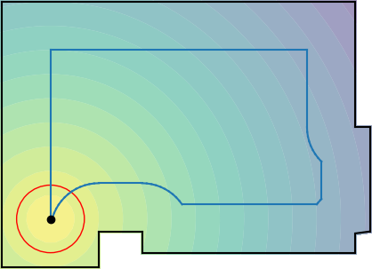
Fig. 2. The walls of the room (black lines) represent the boundary of the polygon $∂P$, where $P$ represents the area of the room. The blue lines delimit the measuring area that is at 1 m distance from $∂P$. The colored background of the room is used only in the algorithm for regular short-term noise, where it shows the distance from each already determined control point in space. At the control point, the background brightens and darkens with increasing distance. This illustration is used for regular short-term noise when it is appropriate to find the farthest control point in the defined area from already specified control points. The color background is recalculated each time iteration.
- Long-term stationary noise
Long-term stationary noise is caused, for example, by operation from a factory in the neighbourhood or on a construction site. The measurement takes place at the measuring point for an unnecessarily time to ensure a sufficiently long and high-quality noise measurement and the measurement at the given control point has been declared demonstrable. After this interval, the measuring apparatus is moved to a new control point for further recording. The proposed algorithm searches for the maximum set of control points according to the specified parameters for maximum noise capture in a given space. We are looking for a maximum set that meets the following conditions:
$χ^{*}=\max\left|χ\right|,$ (6)
where $χ^{*}$ is the maximum number of control points in a given room, and $\left|χ\right|$ is the number of control points for the set $χ$.
The entire algorithm was designed to obtain the maximum number of control points in the area $I$. Obtaining data from the maximum number of control points would provide a more accurate map of capturing noise levels in space. The algorithm works by creating a list of all corners in the measured area $I$ (Eq. 2). It then passes through the individual corners and determines two intersections at a distance of 0.7 m from the given corner with $∂I$. Thus, the algorithm obtains at least two initial variants for each corner. The program uses a recursive algorithm for each initial variant and creates a list of control points for each such recursion by following these steps:
- From the already determined points, it draws a circle with a radius of 0.7 m. The intersections with other circles give new control points.
- If such an intersection does not exist, and there is an intersection with $∂I$, it places a control point at this intersection.
- If the algorithm does not find any new control point in the iteration, it terminates the recursion and saves the total number (list) of found control points for the given variant.
The algorithm provides the list of the best results set – the maximal list of control points.
- Short-term recurring noise
This is a noise caused, for example, by public transport (trams, buses) at the place of residence, workplace or school. Measurements shall be made at a given control point until the noise level exceeds a specified value. Subsequently, the measuring apparatus is moved to a new measuring point, and the entire process is repeated. Due to the lack of knowledge of the number of occurrences of exceeding the specified noise level, the algorithm looks for the best distribution of control points in each iteration in order to cover as much room space as possible. We are looking for the maximum distance from the already determined control points in the inner area of the room $I$:
$x_{n}∈\underset{x∈I}{arg max}{\min_{i∈\left\{1,…,n-1\right\}}{d\left(x,x_{i}\right),}}$ (7)
where $n$ is the iteration number and $x_{i}$ are control points positions selected in previous iterations.
The algorithm first determines the list of corners. Then one of the specified corners is selected randomly. The algorithm divides the floor plan of the room into individual triangles. In each triangle, the furthest local control point from the previously determined control points is calculated. Subsequently, these locally optimal solutions are compared to select the furthest point. This point is selected as a global optimum and is intended for noise level measurement. The entire process is shown in Fig. 3 and repeated if:
- There shall be at least one local point that meets the conditions specified in the standard (minimum distance from walls and other control points).
- The noise measurement does not exceed the specified level at the measured control point.
- The time interval for the measurement does not expire.
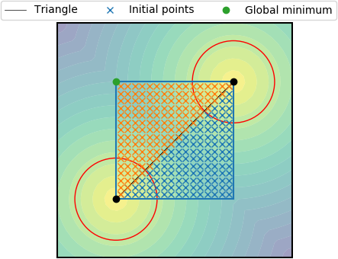
Fig. 3. The algorithm divides the room into triangles and in each calculates local optima (farthest points) from already determined control points. Subsequently, the farthest point is selected from this set of local optima and determined as the global minimum for the given iteration – the green point. At each iteration, a new background contour is calculated, which displays the distance from the control points in color.
- Experiments
In order to work and improve our algorithms for both purposes of measuring noise intensity, we have prepared experiments to verify and test the algorithm. We performed the simulated experiments in a small room with an area of 16 m² (Fig. 4), then in a larger room with an area of 36 m² (Fig. 5), and finally in a large room with an area of about 235 m² (Fig. 6).
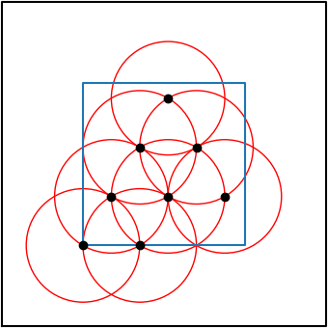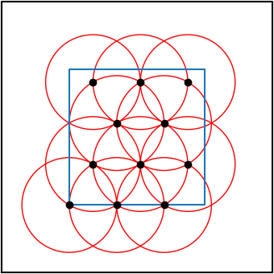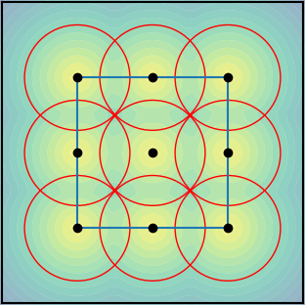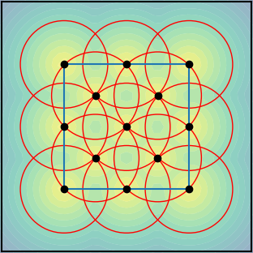
Fig. 4. The first top four images show the first algorithm that determines the control points for long-term stationary noise. The algorithm gradually adds control points where the intersection of the 0.7 m boundary with the other boundaries (red circles) occurs. An algorithm created the lower quartet of the image for regular short-term noise. The algorithm focuses on covering the area as much as possible in each iteration.

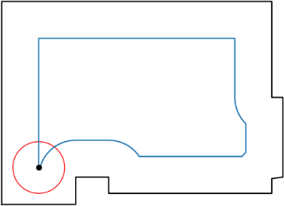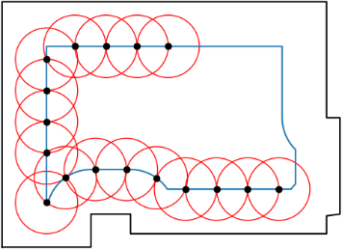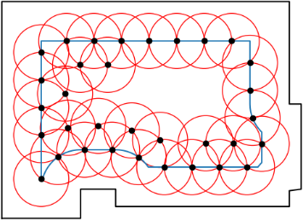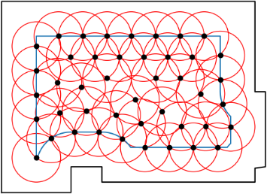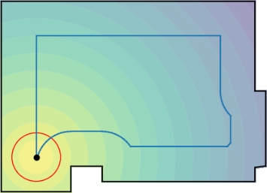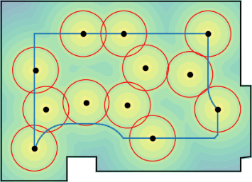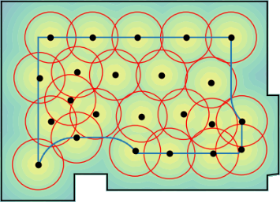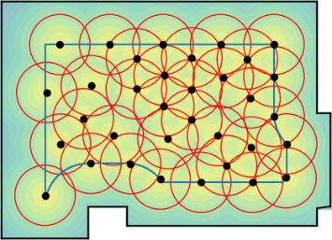
Fig. 5. The room is characterized by a more complex area where control points may occur. The results of the first algorithm are shown in the upper part. The figures show how the algorithm first determines the border control points in the marked area and then passes into the inner area of the room. The second algorithm created a network of control points, focusing on successively spaced control points throughout the area, as can be seen from the bottom figures.
- Rooms
In the first experiment, we verified the basic accuracy of calculations and determination of control points in a simple room layout for both algorithms. The room had a size of 4.0×4.0 m. Each experiment is divided into two simulations one for long-term and one for short-term noise. The simulations for the first experiment are shown in Fig. 4.
The second experiment focused on a simulation of a more diverse room. The dimensions of the real room were measured and incorporated into the simulation. The results of the control point calculation for both algorithms are recorded in Fig. 5.
The third experiment was focused on verifying the robustness of algorithms in more demanding conditions. An extensive segmented room was created, where the algorithms determined the control points (Fig. 6).
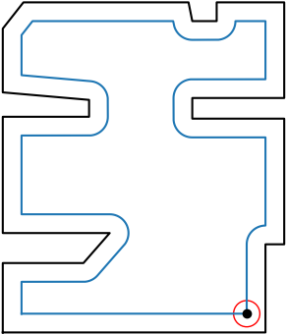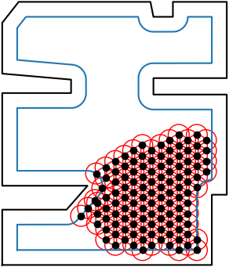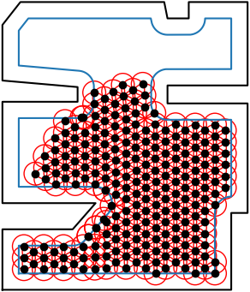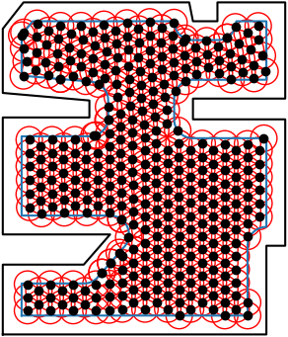
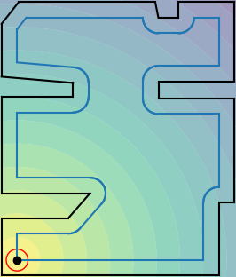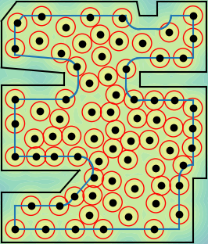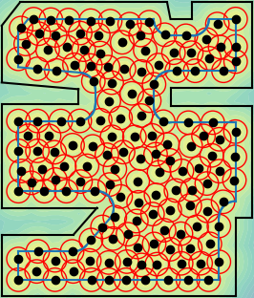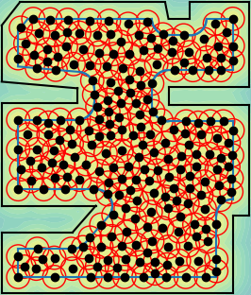
Fig. 6. To test both algorithms in demanding conditions, we created an intricately articulated and large room. Both algorithms proceeded as expected in determining the control points. The results show that the algorithm for long-term stationary noise determined significantly more control points than the algorithm for regular short-term noise.
- Control points analysis
An overview of the number of control points from both algorithms from individual experiments can be seen in Table 1. Surprisingly, in the first experiment, the algorithm for long-term stationary noise found two control points less than the algorithm created for regular short-term noise. This anomaly occurred only in the first experiment, where it was an elementary room without a fragmented floor plan. Further testing has shown that the algorithm for finding the maximum number of control points in the measuring area is not optimal and may not find the maximum number of control points for small rooms.
In the second experiment, the algorithm for long-term stationary noise discovered more control points than the second. In the third experiment, the algorithm for long-term stationary noise determined 360 control points in the final result. The algorithm for a regular short-term noise identified 224 control points. The difference in the number of control points for larger rooms show that the first algorithm is indeed more suitable for long-term noise.
Table 1. The total number of control points and computation time for the long-term stationary noise (column A) and recurring short-term noise (column B).
 | Number of control points |  | Computation time [min]
Room | A | B | A | B
Sq. room (Fig. 4) | 11 | 13 | 0.05 | 0.50
Real room (Fig 5) | 44 | 33 | 0.50 | 4.13
Large room (Fig 6) | 360 | 224 | 6.20 | 245.82
- Estimating the measurement time
The algorithms are different not only according to the purpose but also the time they need to determine the control points, so in all experiments, we recorded the time needed to determine all the control points. For this reason, we created a table that clearly shows the times for each room using both algorithms (Tab. 1).
The results of the table show that the algorithm for the first purpose calculates all control points much faster than the algorithm for regular short-term noise. In the third experiment, the most apparent difference in the time calculation of control points was between the two algorithms. In real measurements, however, this difference is not decisive. On the contrary, when measuring long-term stationary noise, a faster determination of other control points is needed—changing the measuring point sets immediately after recording the noise level at that point. For regular short-term noise, the algorithm has enough time to calculate. The change of the measuring point is not known, and the noise level at the given control point is expected to be exceeded. While waiting for the noise level to be exceeded, the algorithm can determine next control points based on the dimensions of the room. Optionally, the algorithms can compute control points offline before the measurement based on the floor plan measured either manually or automatically using Lidar.
- Conclusion
This paper aimed to create algorithms for two specific purposes of noise measurement. The first algorithm was developed to determine control points for long-term stationary noise, and it finds the maximum number of control points in the room. The second algorithm was created to determine control points for regular short-term noise. For this purpose, the program does not know the number of iterations of the measurement. Therefore, it looked for the location of the next control point in the measuring area to cover as large an area as possible.
During the experiments, we tested both algorithms in different rooms, from simple floor plans to large rugged rooms. The simulations showed that the proposed repeatable algorithms meet the specified conditions by the standard.
In the next phase, we would like to work on real testing of our algorithms using a robotic unit that initially measures the floor plan by simultaneous localization and mapping. The constructed map is used for the computation of control points, and the robotic platform performs measurement at these points afterwards.
- AcknowledgmentS
This work was supported by the Grant Agency of the Czech Technical University in Prague, Grant No. SGS20/070/OHK3/1T/13.
References
- C. S. Institute: 1996-2 Acoustics — Description, measurement and assessment of environmental noise — Part 2: Determination of sound pressure levels, Czech Standards Institute, 2018
- I. O. for Standardization: 1996-2:2017 Acoustics — Description, measurement and assessment of environmental noise — Part 2: Determination of sound pressure levels, International Organization for Standardization (ISO), Geneva, Switzerland, 2017
- Buratti, C.: Indoor noise reduction index with open window, Applied Acoustics, 2002, pp. 431-451.
- Guarnaccia, C.; Quartieri, J.; & Ruggiero, A.: Acoustical noise study of a factory: Indoor and outdoor simulations integration procedure, International Journal of Mechanics, 2014, pp 298-306.
- Pujol, S., Berthillier, M., Defrance, J., Lardiès, J., Petit, R., Houot, H., ... & Mauny, F.: Urban ambient out door and inddor noise exposure at home: A population-based study on schoolchildren, Applied Acoustics, 2012, pp 741-750.
- Zannin, P. H. T., & Ferraz, F.: Assessment of indoor and outdoor noise pollution at a university hospital based on acoustic measurements and noise mapping, Open Journal of Acoustics, 2016, pp 71-85.
- Bonomolo, M., Ribino, P., Lodato, C., & Vitale, G.: Post Occupancy Evaluation and Environmental Parameters Monitoring by a Humanoid Robot, 2019 IEEE International Conference on Environment and Electrical Engineering and 2019 IEEE Industrial and Commercial Power Systems Europe (EEEIC/I&CPS Europe), 2019, pp 1-6.

