The Problem of Residual Compensation Effect
Michał Bartyś
Institute of Automatic Control and Robotics, Warsaw University of Technology, Warsaw, Poland
e-mail: michal.bartys@pw.edu.pl, phone: +48 501-697-545

Abstract – This paper discusses the problem of the residual compensation effect. The residual compensation effect referred to as the fault compensation effect, is an underrated issue of a model-based diagnostics. In part, this is justified due to the relatively low probability of such an effect. However, there is a belief that the inability to isolate faults in case of the residual compensation effect is the evident drawback of the model-based diagnostics. This paper shows that under some conditions, the problem of fault compensation could be overcome. In this connection, the necessary and sufficient conditions of fault compensation effect for tri-valued residuals were formulated. Both conditions are explained in the example of the diagnosing of a simple single buffer tank system in open and closed-loop arrangements. In this regard, it was shown the complete disutility of a bi-valued residual evaluation frequently used for fault isolation. In contrast, the advantages of a tri-valued residual evaluation were outlined. This paper also brings a series of practical conclusions allowing for a better understanding of the residual compensation effect.

Keywords – fault compensation effect, fault isolation, bi-valued residuals, tri-valued residuals, diagnostics of processes, simulation model, fault distinguishability
- Introduction
The model-based diagnostics of industrial processes intensively make use of residuals expressing how much observations (measurements) and outputs of a diagnosed system differ from the reference models. Fig. 1 depicts the general block scheme of the model-based diagnostics. It generally consists of three consecutive phases: detection, isolation, and identification of faults. Frequently, the fault identification is not of concern in industrial applications. Therefore, this phase was omitted in Fig. 1.
To react appropriately on faults, the process operator or fault-tolerant control system demands univocal isolation of faults. However, this is not a trivial task. Any discrepancy r (residual) between model $\hat{V}$ and process $V$ outputs is assumed to be a potential symptom of a fault or faults. The residuals, even in the fault-free state of the diagnosed system, are fluctuating around zero values. It results mainly due to process disturbances, 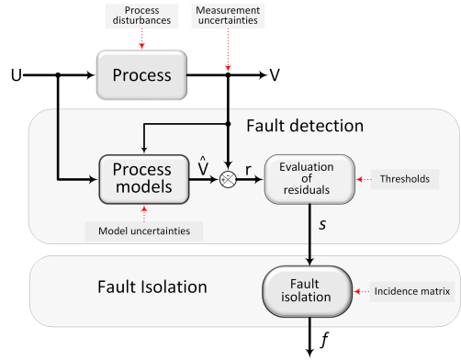
Fig. 1. A block diagram of the basic workflow in model-based fault detection and isolation approach (FDI). Notions: r - residuals, $V$ - process outputs, $\hat{V}$ - model outputs, s – diagnostic signals, f – faults.
uncertainty of measurements and uncertainty of reference models. In practice, the residuals are filtered and discretized through the constant [1] or adaptive thresholding approaches [2]. As a result, the continuous or piecewise continuous residuals are converted into bi- and tri-valued crispy or fuzzy values referred to as diagnostic signals [1, 3, 4]. A set of diagnostic signal values associated with each particular fault creates its specific pattern (signature), which typically takes a form of a column vector. The structure of all fault signatures is referred to as the incidence matrix or structure of residual sets or diagnostic matrix [3, 5, 6].
The signatures allow for distinguishing among the faults, however, under the condition that all signatures are unique. In general, this condition is not always met. Therefore, some faults remain indistinguishable. It is the severe drawback of the Fault Detection and Isolation (FDI) approach. There were many methods developed that increase fault distinguishability. However, it was proven, that in general, this task is unsolvable [4].
- The nominal model of the system
The problem of residual compensation will be characterized based on the example of the model-based diagnosing workflow of a simple open-loop control system shown in Fig. 2. The diagnostic problem is to isolate two single faults: leakage in the tank (fault $f_{1}$) and obliteration of the outlet pipe (fault $f_{2}$) as well as one double fault $\left\{f_{1}∧ f_{2}\right\}$. The double fault represents the state where the leakage and obliteration take place simultaneously. For simplicity, we assume that measurement instruments are infallible. Firstly, according to the scheme shown in Fig. 1, we develop the nominal (reference) model of the process in a fault-free state. In this case, we will use an analytical, phenomenological model of the process. This model will be exploited further for the closed-loop control system.
There are many other models imaginable in this stage, including these, based on heuristic knowledge, fuzzy sets theory, fuzzy neural networks, neural networks, etc. Firstly, we assume the availability of measurement instruments as in Tab. 1, except for optional flow rate meter F₁. In the case of a fault-free state, for incompressible, inviscid liquid, the accumulation of fluid in the tank is equal to the difference between inflow and outflow volumes. Hence:
$F_{0}=A\frac{dL}{dt}+αS\sqrt{2gL}$ 1
where: α is the flow contraction coefficient, S is the cross-sectional area of the outlet pipe, and g is the gravitational constant. Eq. (1) will be further referred to as the nominal model of the process.
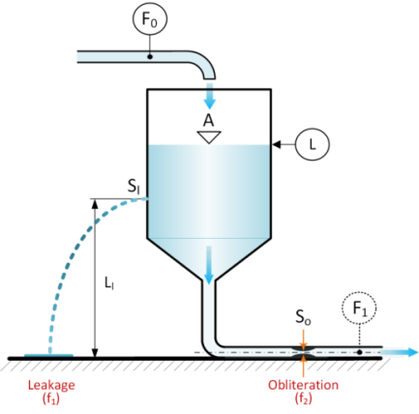
Fig. 2. An illustration to an example of diagnosing of single and double fault in a buffer tank.
Table 1. List of available measurements.
item | symbol | measured quantity
1 | $$F_{0}$$ | liquid inflow rate
2 | L | liquid level relative to the ground
3 | $$F_{1}$$ | liquid outflow rate (option)
- Fault Detection
Generally, fault detection should indicate whether the fault or faults occurred or not. The residuals are assumed as fault indicators. In case of faults, a discrepancy between the nominal model and real output of the process takes place. However, this is true under two essential conditions:
- residuals are sensitive to the faults;
- the residual compensation effect does not take place.
This paper mainly focuses on clarification and discussion of this second issue. To obtain residuals, we assume three faults listed in Tab. 2, and next, we develop the model of the diagnosed system (2) in the so-called inner form [3], i.e., in the way which reflects the impacts of faults.
Table 2. List of faults.
item | symbol | fault
1 | $$f_{1}$$ | leakage from the tank
2 | $$f_{2}$$ | obliteration of the outflow pipe
3 | $$f_{1}∧ f_{2}$$ | leakage and obliteration
$F_{0}^{f}=A\frac{dL}{dt}+αS\sqrt{2gL}+f_{1}αS\sqrt{2g\left(L-L_{l}\right)}-f_{2}αS\sqrt{2gL}$ 
where: α_{l} is the leakage outflow contraction coefficient, S_{l} is a cross-sectional area of the leakage orifice, $f_{1}=S_{l}/S$, $f_{2}=1-S_{o}/S.$
While residual equals ${r=F}_{0}-F_{0}^{f}$, then from Eqs. (1-2) we obtain:
${r=-f}_{1}αS\sqrt{2g\left(L-L_{l}\right)}+f_{2}αS\sqrt{2gL} .$ 
Therefore, the residual r equals zero, in the case when the outputs of the model and process are identical. However, this cannot be interpreted uniquely as a fault-free state of the system, while the residual r may take zero value by the occurrence of faults due to the effect of residual compensation. Obviously, this effect takes place exclusively for multiple faults. From (3), we can easily withdraw a simple condition for which a compensation of both faults takes place.
$\frac{f_{1}}{f_{2}}=\sqrt{\frac{L}{\left(L-L_{l}\right)}} .$ 
It is believed that the probability of fault compensation effect is relatively low. However, this effect is one of the reasons for false-negative fault isolation, and therefore, it should be avoided as far as it is possible. The following observation would be helpful:

The effect of compensation of faults does not take place in case of single faults and for those multiple faults for which residuals are unidirectionally affected.

From this observation, we can withdraw some practical conclusions:

Conclusion 1. Single fault detectors are recommended for usage in the diagnostic systems in order to avoid false fault isolation.

Conclusion 2. To increase fault distinguishability, it makes sense to take into consideration the directions of changes of residuals.

Conclusion 1 sounds slightly unrealistic in nowadays world. Therefore, the question appears on how we can avoid fault compensation effects if they are typical even for elementary processes, as shown in Fig. 1?
There is no right general answer in this matter. However, some productive actions can be undertaken. The excellent solution seems to have an equal number of nominal models as the number of single faults such that each model should be effected exclusively by one fault.
Let us now consider the same system as in Fig. 2. The only difference is that we now will consider the usage of the additional flow rate instrument, i.e., F₁. The nominal models of the process will be the following:
$\left\{\begin{aligned}F_{0}=A\frac{dL}{dt}+F_{1} \\ F_{1}=αS\sqrt{2gL}\end{aligned}\right. ,$ 
while the models in the internal form will be:
$\left\{\begin{aligned}F_{0}^{f}=A\frac{dL}{dt}+F_{1}+f_{1}αS\sqrt{2g\left(L-L_{l}\right)} \\ F_{1}^{f} =αS\sqrt{2gL}-f_{2}αS\sqrt{2gL}\end{aligned}\right.$ 
or
$\left\{\begin{aligned}F_{0}^{f}=F_{0}+f_{1}αS\sqrt{2g\left(L-L_{l}\right)} \\ F_{1}^{f} =F_{1}-f_{2}αS\sqrt{2gL}\end{aligned} .\right.$ 
From (7), we obtain residuals:
$\left\{\begin{aligned}r_{1}={-f}_{1}αS\sqrt{2g\left(L-L_{l}\right)} \\ r_{2}=+f_{2}αS\sqrt{2gL}\end{aligned}\right. .$ 
As can be easily seen from (8), each residual is sensitive exclusively to one fault. It is promising to avoid the fault compensation effect at the expense of additional flowrate measurement instruments. The added value, in this case, is that the double fault is easily isolable. In the case of double fault, both residuals ($r_{1}$ and $r_{2}$) have non zero values and opposite signs. Therefore, this feature enforces significantly fault isolability property.
- Fault Isolation
The primary aim of fault isolation is to indicate the faults that occurred in the process. This phase is frequently called as diagnosing. Diagnosing requires a knowledge of the relation between the faults and residuals. This relation may be precisely known in the case of the application of analytical phenomenological models, for example, in the form of Eqs. (3) and (8). If the analytical models are not known, for example, the GP graphs of the processes [7] may be helpful. The GP graph represents the cause-and-effect relations in the process, combined with the visualization of the qualitative impact of faults on the values of process variables. Fig. 3 depicts the GP graph for the process shown in Fig. 2. This graph applies to Eq. (3) and refers to a situation where flowrates F₀ and F₁ are not available.
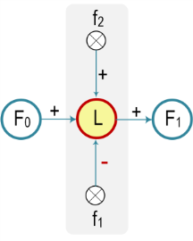
Fig. 3. The GP graph is reflecting the qualitative impact of faults on the values of process variables. A circle colored in yellow depicts the available measurement.

From this graph, it is clear to see that both faults influence bi-directionally on the liquid level. Therefore, both faults may mutually compensate for their impacts. Hence:
Conclusion 3. The fault compensation effect is immediately detectable from the directed graph of the process.

On the other hand, if we apply Eq. (8), then the GP graph will take shape presented in Fig. 4.
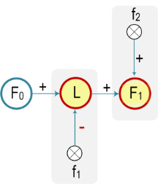
Fig. 4. The GP graph is reflecting the additional measurement F₁.

In this case, the influences of both faults on the graph’s nodes are separated. Therefore, the fault compensation effect simply does not take place when having partial models for each node.

Conclusion 4. Avoidance of fault compensation effect is highly demanding on reliable measurements.

Instead of the GP graph, more useful for fault isolation is the incidence matrix. The incidence matrix reflects the relation between faults and diagnostic signals. The question is why diagnostic signals are being used instead of residuals?
The reason is the demanded robustness of a diagnostic system. Principally, the diagnostic signals are used to introduce some immunity to the diagnosing process. Otherwise, the impact of uncertainties on residuals would seriously degrade the resulting diagnose. In this scope, the residuals are appropriately processed (evaluated). In this paper, we will limit our considerations exclusively to elementary, however practicable, thresholding evaluation of residuals, which introduce some dead zones to residual signals. For the binary assessment of residuals, we will further apply the formula:
$s=\left\{\begin{aligned} 0 ← |r| <T_{h} \\ 1 ← |r| ≥T_{h}\end{aligned}\right. ,$ 
while for tri-valued residuals:
$s=\left\{\begin{aligned} -1 ← r ≤-T_{h} \\ 0 ← |r| <T_{h} \\ +1 ← r ≥T_{h}\end{aligned}\right. ,$ 
where: $T_{h}$- is an arbitrarily chosen nonnegative threshold.
The robustness of fault isolation can be characterized by the rate of false-positive as well as false-negative diagnoses. In this context, the false positive diagnose indicates non-existing fault, while false-negative diagnoses are not able to isolate truly existing faults. As can be seen from (9-10), the introduction of dead zones immunizes diagnostic signals, at the expense of loss of sensitivity to low size faults and elongation of fault isolation time in case of incipient faults.
In this paper, we will discuss both (9) and (10) residual evaluation approaches in the context of fault compensation effect. For example, we will show that fault compensation may be easily identified from the incidence matrix; however, under some conditions. Firstly, please refer to Tab. 3. Here, the incidence matrix entries are bi-valued as in (9). This table is frequently referred to as a binary diagnostic matrix (BDM) [6].
Table 3. Binary diagnostic matrix for residual (2).
 | fault-free | $$f_{1}$$ | $$f_{2}$$ | $$f_{1}∧ f_{2}$$
s | 0 | 1 | 1 | 1

Please note that in Tab. 3, all signatures of all faults are identical. Therefore, in case of failure, we cannot indicate which fault occurred. Moreover, we cannot say anything about hypothetic compensation of fault impacts. This simple example leads to the following conclusion:
Conclusion 5. The binary diagnostic matrix is useless for recognition of a fault compensation effect.

Next, we discuss the case of the tri-valued incidence matrix [8]. This matrix is shown in Tab. 4. Here, the values of reference diagnostic signals of multiple faults are in the set of all possible results of the algebraic sums of all diagnostic signals of single faults constituting multiple faults. For example, diagnostic signal s in Tab. 4 may have three alternative values -1 or 0 or +1.
Table 4. Trinary diagnostic matrix for residual (2).
 | fault-free | $$f_{1}$$ | $$f_{2}$$ | $$f_{1}∧ f_{2}$$
s | 0 | -1 | +1 | -1, 0, +1

Now, we can easily distinguish single faults $f_{1}$ and $f_{2}$. The reason is that quite distinct diagnostic signal values are assigned to both faults. However, both single faults are conditionally indistinguishable from double fault. Moreover, the double fault may not be distinguishable from the fault-free state of the process. It takes place, for example, for diagnostic signal s=0.
There is to mention that tri-valued residuals allow for an indication of possible fault compensation. Based on the observations, we can formulate necessary and sufficient conditions for fault compensation concerning diagnostic signals.
Condition 1. A necessary condition for fault compensation.
The full set of diagnostic signals {-1,0,+1} of at least one entry of multiple fault signature is necessary to indicate the possibility of occurrence of fault compensation effect.
Condition 2. Sufficient condition for fault compensation.
It is sufficient for fault compensation if it holds necessary condition and, moreover, if it exists at least any other entry of signature of the same fault that does not contain 0 value.
Let us now discuss the case of a diagnostic system for which the GP graph is shown in Fig. 4. The appropriate binary and trinary diagnostic matrices are shown respectively in Tabs. 5 and 6.
Table 5. Binary diagnostic matrix for residual (8).
 | fault-free | $$f_{1}$$ | $$f_{2}$$ | $$f_{1}∧ f_{2}$$
s₁ | 0 | 1 | 0 | 1
s₂ | 0 | 0 | 1 | 1

Table 6. Trinary diagnostic matrix for residual (8).
 | fault-free | $$f_{1}$$ | $$f_{2}$$ | $$f_{1}∧ f_{2}$$
s₁ | 0 | -1 | 0 | -1
s₂ | 0 | 0 | +1 | +1

Now, the binary diagnostic matrix allows for uniquely distinguishing all considered faults. In this case, the fault compensation effect cannot occur. Similarly, the application of the trinary diagnostic matrix shown in Tab. 6 allows for uniquely distinguishing of all faults. Here, the fault compensation effect cannot take place because the necessary condition does not hold. It is easy to see the submatrix of the diagnostic matrix shown in Tab. 6, consisting exclusively of signatures of single faults, is diagonal.
Conclusion 6:
The diagonal tri-valued binary diagnostic matrix of single faults should be designed to avoid residual compensation effects due to multiple faults.
The above recommendation is postulated mainly for diagnostic systems intended for the new installations. Implementing this recommendation for diagnostic systems in actually running processes seems unrealistic because it demands additional instrumentation.
- Simulations
The simulations were performed to exemplify the fault compensation effect in a single buffer tank depicted in Fig. 2. The simulation model was developed in a Matlab-Simulink environment. The resulting flowchart of the simulation of the liquid storing process is shown in Fig. 5. The tank model generates an output vector, which includes liquid level signal, liquid inflow and outflow rates, residua, and diagnostic signals. The liquid level in the tank depends on the change in the dynamic accumulation of liquid. This change depends on inlet and outlet liquid rates, leakages, and obliteration of pipe. The level of liquid in each tank can, therefore, be determined by integrating the dynamic liquid accumulation, i.e., by integrating the difference in the flow rate of liquid entering and leaving the tank.
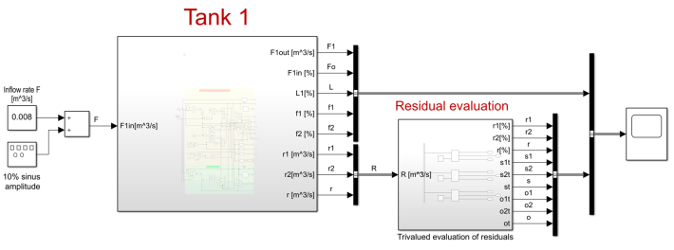
Fig. 5. Simulation diagram of a single buffer tank process.
Due to limited space, we will discuss here only one simulation scenario. Consider two incipient faults: leakage $f_{1}$ and pipe obliteration $f_{2}$. The obliteration starts to grow immediately after the running simulation. The leakage begins to grow at the time instant 0.50∙10⁵ s. The slopes of both faults are slightly different, as shown in Fig. 6. The liquid inflow rate F₀ fluctuates around constant value within ±10% limits. Residuals are tri-valued. The diagnostic signals s, according to (3), as well as s₁ and s₂, according to (8), are calculated based on constant threshold T_{h}=5%. The obtained results are collected in Tab. 7.
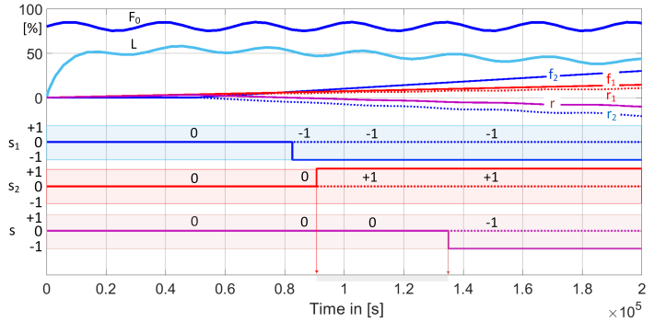
Figure 6: Example of a simulation of a double fault. Notation: F₀ - liquid inflow rate - dark blue line; L – liquid level - blue line; f₁ – leakage fault - red line; f₂ – obliteration fault –blue line; r1– dotted red line; r2 – dotted blue line; r – purple line; diagnostic signals: s₁ – blue; s₂ – red; s – purple.

Discussion: Tab. 8 summarizes the obtained diagnoses from simulations. Diagnose D1 is based on the tri-valued diagnostic matrix shown in Tab. 4, while diagnose D2 is based on the tri-valued diagnostic matrix shown in Tab. 6.
Table 7. Diagnostic signals values.
time [s∙10⁵] | 0.00  0.82 | 0.82  0.90 | 0.90  1.35 | 1.35  2.00
s | 0 | 0 | 0 | -1
s₁ | 0 | -1 | -1 | -1
s₂ | 0 | 0 | +1 | +1
Interval of the fault compensation effect
0.85..1.35∙10⁵ s
Table 8. Obtained diagnoses.
time [s∙10⁵] | 0.00  0.82 | 0.82  0.90 | 0.90  1.35 | 1.35  2.00
D1 | $$∅$$  $$f_{1}∧ f_{2}$$ | $$∅,$$  $$f_{1}∧ f_{2}$$ | $$∅,$$  $$f_{1}∧ f_{2}$$ | $$f_{1},$$  $$f_{1}∧ f_{2}$$
D2 | $$∅$$ | $$f_{1}$$ | $$f_{1}∧ f_{2}$$ | $$f_{1}∧ f_{2}$$
isolates and correctly distinguishes all faults. In turn, diagnose D1 is ambiguous, i.e., delivers much less usable information, in part due to the fault compensation effect.
- FAULT MASKING EFFECT
As long as the process value tracks the setpoint value within some predefined limits, either process operator or alarm system does not have substantial reasons to react. In the closed-loop systems, the effects of faults are compensated by controller action as long as the system is controllable. Therefore, the fault-masking effect is frequently understood as an effect of the invisibility of faults by process operators or alarm systems. In other words, in a steady-state, the difference between the setpoint and process value is nor sensitive nor indicative of faults. Here, the question arises: do the model-based fault diagnostics discussed earlier for the open control system is still valid if we close the loop?
To answer this question, we close the loop of the system shown in Fig. 2. The modified control system is shown in Fig. 7.
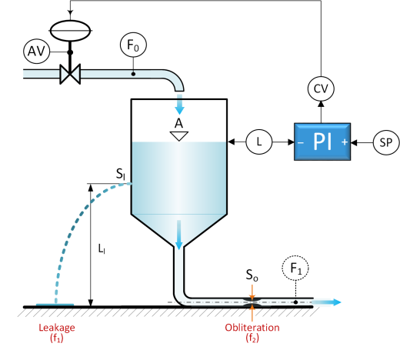
Fig. 7. A closed-loop liquid level control system. Notions: SP - setpoint; CV - control valve; PI – proportional and integral controller; AV - positioner feedback signal.
The liquid inflow rate into the buffer tank is controlled by a control valve driven by a PI controller. The PI controller, employing an actuator (control valve), adjusts the liquid inflow rate into the tank to keep the setpoint value. Thus, in case of leakage, the controller simply increases the inflow rate to compensate for additional demand for liquid.
Let us now develop the GP graph for the closed-loop system. In the graph, shown in Fig. 8, we introduce an additional node reflecting actuator fault denoted as f₃ and nodes and arcs representing the PI controller in the loop. The control valve has an output AV signaling the position of the control valve stem. For simplicity, we also assume the infallibility of the PI controller.
As it is to see in Fig. 8, all faults are associated with its observable nodes. Hence, the trinary diagnostic matrix of single faults takes the diagonal shape, and in consequence, all single and multiple faults are isolable. Hence, the residual compensation effect in case of multiple faults does not take place.

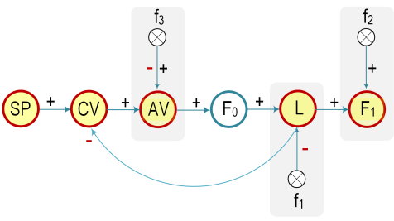
Fig. 8. The GP graph of the closed-loop system reflecting the qualitative impact of faults on the values of process variables.

For simplicity, we assume here a trivial static model of an actuator. The nominal model of the actuator is AV=CV. The actuator fault manifests in a discrepancy between AV and CV values. Assume additive actuator fault. Hence, the model of the actuator in an internal form equals:
$AV=CV+f_{3}→$ $r_{3}=f_{3} .$ 
Fig. 9 depicts the result of a simulation of a triple fault, i.e., slowly increasing obliteration $f_{2}$ starting at the time instant 0, slowly increasing leakage $f_{1}$ starting at the time instant 5∙10⁴ s and abrupt actuator fault $f_{3}$ appearing at the time instant 10∙10⁴ s. Signal s₃ represents the diagnostic signal of residual r₃.

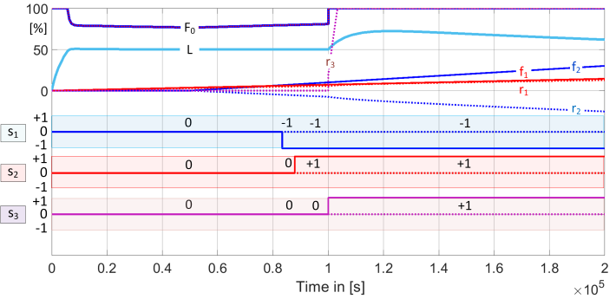
Figure 9: Example of a simulation of a triple fault. Notations: f₃ – actuator fault - purple line; r₃ – purple dotted line; s₃ – diagnostic signal – purple line. Remaining notions, as in Fig. 6.

The summary of isolated faults is presented in Tab. 9. As can be seen, closing the loop does not degrade the diagnostic properties of the system as far as the conditions 1 and 2 hold.
Table 9. Obtained diagnoses.
time [s∙10⁵] | 0.00  0.82 | 0.82  0.85 | 0.85  1.00 | 1.00  2.00
D | $$∅$$ | $$f_{1}$$ | $$f_{1}∧ f_{2}$$ | $$f_{1}∧ f_{2}∧ f_{3}$$
- FINAL REMARKS
Residual compensation effect due to multiple faults is a common problem for all model-based FDI diagnostic approaches. This paper discusses and zooms this particular problem.
The sufficient and necessary conditions for compensation of tri-valued residuals were formulated.
In this regard, some practical hints were proposed.
The primary weakness of the presented discussion is the adoption of assumptions regarding the infallibility of measurement instruments. This assumption is only in part justified as the intensity of failures of functionally safe instrumentation is significantly lower than this of actuators and technological equipment.
Further research will be concerned with developing a theoretical framework encompassing all aspects of fault compensation effects signaled in this paper.
- AcknowledgmentS
I would like to express my gratitude to the Institute of Automatic Control and Robotics of the Warsaw University of Technology for the financial support of this paper.
References
- Korbicz, J.; Kościelny, J.M.; Kowalczuk, Z.; Cholewa, W.: Fault Diagnosis. Models. Artificial Intelligence. Applications. Springer 2004.
- Patan, K., Korbicz, J.: Nonlinear model predictive control of a boiler unit: A fault-tolerant control study, International Journal of Applied Mathematics and Computer Science, Vol. 22, No. 1, 2012, pp. 225-237.
- Gertler, J.: Fault Detection and Diagnosis in Engineering Systems. Marcel Dekker, Inc. New York, 1998.
- Bartyś, M.: Chosen Issues of Fault Isolation. Polish Scientific Publishers, PWN, 2014.
- Blanke, M., Kinnaert, M., Lunze, J., Staroswiecki, M.: Diagnosis and Fault-Tolerant Control. Springer, New York, NY, USA, 2015.
- Kościelny, J. M.: Process Diagnostics Methodology, in: Korbicz, J.; Kościelny, J.M.; Kowalczuk, Z.; Cholewa, W. (eds.): Fault Diagnosis. Models. Artificial Intelligence. Applications. Springer 2004, pp. 59-117.
- Takeda, K., Shibata, B., Tsuge, Y., Matsuyama, H.: The improvement of fault diagnosis algorithm using a signed directed graph, IFAC Symposium Safeprocess, Espoo, Finland, 13-16 June 1994, Vol. 1, pp. 368–373.
- Kościelny, J.M., Bartyś, M., Grudziak, Z.: Tri-valued evaluation of residuals as a method of addressing the problem of fault compensation effect, In Korbicz J., Patan K., Luzar M. (eds.) Advances in Diagnostics of Processes and Systems, Springer, Vol. 313, 2021 (in printing).

