Augmented Reality life-size flight panel for checklist training

Simone Keller Füchter, PhD
Estácio de Santa Catarina University
Florianópolis, Brazil
simonekf.2011@gmail.com
George Salazar
NASA, Johnson Space Center
Houston,Texas
george.a.salazar@nasa.gov
Mario Sergio S
Estácio de Santa Catarina University
Florianópolis, Brazil
mariosergio201823@gmail.com

Abstract - A pre-flight checklist requires in-depth technical knowledge of the aircraft and its dashboard, avionics, instruments, functions, and cabin layout. The student in training to be a pilot or advanced pilot, to obtain an updated certification, must know very thoroughly each instrument and its position on the flight panel. Every second spent searching for the location of an instrument, switch or indicator can waste time completing the checklist, resulting in a poor start-up procedure and possibly a safety hazard. This paper reports preliminary findings of using augmented reality (AR) technology in a training setting. The objective of this research was to obtain preliminary data to determine if the use of AR as a human interface for training can help pilots improve their skills and help them learn new flight panel layouts of different aircraft more efficiently and effectively than traditional training methods. For this research, the methodology used was Human-Centered Design (HCD) which is a multidisciplinary process that involves many actors who collaborate on design skills, including people who belong to this process such as flight instructors, students, and pilots. A mobile / tablet application prototype was created for the user to have in their pocket, a rich experience with enough detail of a flight panel of a Cessna150, an aircraft used in training flights at the Santa Catarina Aero club. The tests were applied in Brazil and the results showed a good response and acceptance from the users from the users from the users.
Keywords— Augmented Reality, Virtual Training, Flight Panel

Introduction
There are many materials used for pilot training, concerning the equipment according to each aircraft. Traditionally, the aircraft manual has been an important source of information on each part of its structure, as well as on mechanical, electronic, and digital components. The operating manual is still the main learning resource, but in addition to this document, many multimedia resources have been added for better visualization of certain tasks and commands during the panel checklist. We also have printed books as a good knowledge resource that help students aspiring to be private pilots, also known as PP. This category of pilot is a certification that allows the pilot fly an airplane and carry baggage and passengers althought not for payment or hire.[1]
Videos, photographs, printed posters, flight simulators, virtual reality glasses help to learn [2] and memorize the components of the panels. Each one has its advantages and disadvantages, for example, the simulator is quite complete and close to reality, but it is not available 24 hours a day for everyone and its cost per hour of use is relatively high since it involves sophisticated equipment. The videos show a lot of detail, but they do not have interactivity and to find the information that you are looking for, sometimes it is necessary to watch a long video to be able to visualize a specific procedure. Software such as Microsoft's Flight Simulator [3], X-Plane [4] among others, have a wide base of information and procedures and high-quality graphics. However, the purpose of this work is to create a prototype app for a smartphone that is easy to use, specifically focused on familiarizing the pilot with the panel and the respective checklists so that his learning and memorization of a new aircraft in his training can be faster, bringing greater savings and above all safety for the flight. Checklists are a critical part of preparing preparing for flight.Apps like the one that is presented here can be used in any place, without computers, screen, joysticks or any other hardware, but just a smartphone. It can be used before the pilot goes to a flight simulator, for example. This app does not pretend to be kind of a flight simulator, but a specific and cheap tool to help pilots or students to memorize the flight panel components and study them day by day, at home, open spaces or even rooms without an internet connection. This is the main objective of thiswork: try to represent with realism the details of the flight panel, without computers in a cost-effective and efficient way using readily-available technology.

Methodology
The methodology used for this research with the AR training is Human-Centered Design (HCD) which is a multidisciplinary process that involves many stakeholders who collaborate on design skills, including people who belong to this process [5] as flight instructors, pilots and students. Key to the importance of HCD is the iterative process of continuous test and evaluation of the system that can flesh out problems with the AR application related to the aircraft the user is learning or problems with the aircraft human interface.
HCD is a key component of the Human-Systems Integration (HSI) that is defined as an interdisciplinary technical and management processes that integrate human considerations within and across all system elements [6]

For this study, a prototype of a mobile app app - in Augmented Reality was built with the Cessna150 aircraft panel, used for the training of new private pilots in several flying clubs in Brazil and specifically in the Santa Catarina Aeroclub. This provides a pilot an opportunity to familiarize himself with the panel of a new plane that will fly will be able to access on his smartphone, at any time, anywhere, and see the panel in a very realistic way. Also, and more importantly, the pilot can use the main checklist procedures, in a 3D view, which makes possible a better understanding of certain movements of push/pull, rotate, and others.

AUGMENTED REALITY
Augmented Reality is a technology that overlays virtual components in a real-world environment while users have a device to watch through; where virtual objects are added to the real world in real-time during the user experience [7]. With AR, the pilot can see a virtual flight panel in front of him, using his smartphone, the user can visualize and study each component before going to a real and physical aircraft.
AR along with a Smartphone provides a useful tool for training where the professional can train in such as a manufactory [8], a garage, or a hangar. Done correctly, AR technology can complete with the real environment with respect to creating virtual objects that mimics real time applications[9].
The future of AR depends on huge innovations in all fields [10] and this paper presents a new way of learning and training aircrafts checklist panel.

The Prototype

In this paper, a life-size prototype was created and tested by flight instructors, pilots, and students with the visualization of a virtual flight panel using Augmented Reality in their smartphones or tablets.
Bringing together the information from the manual, and the experience of the instructors and pilots who were studying to use different aircraft, the proofs of concept evaluations were created (Fig.1). A description follows.

Fig. 1. Proofs of Concept

Preliminary Proof of Concept
The prototype was built in the Unity 3D platform using Vuforia as the Augmented Reality technology. It was used as a printed marker in a banner size A0 as we can see in the Fig. 2.

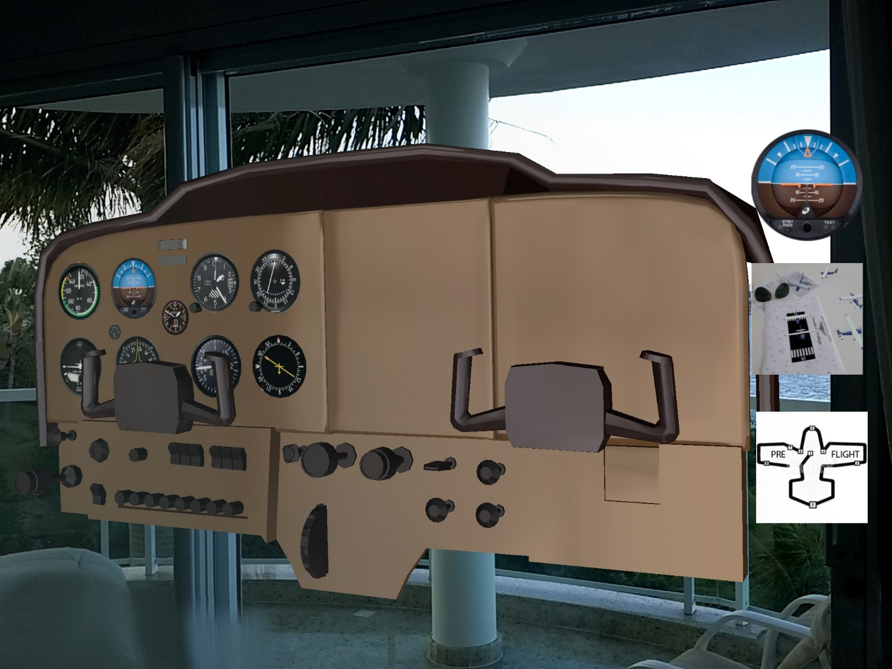
Fig. 2 : A life-size panel that can be viewed at home using a smartphone and a Banner printed marker.

Another option of the marker was used printed in a small paper as we can see in Fig. 3. During this test, it was found that the use of a small marker can also be an excellent tool, as it shows a 3D panel that fits in the palm and is very easy to visualize all the components since when approaching they are very accessible and visible objects.

After the first test, a small “pocket” marker was printed, as we can see in Fig. 3.

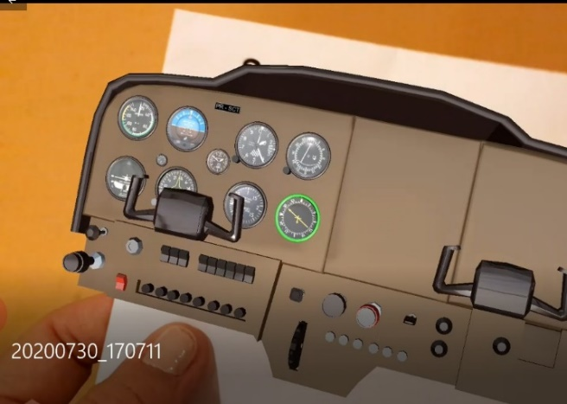
Fig. 3. A small size “pocket” panel to be visualized in any place, anywhere, anytime in an ubiquity approach.

This app was developed, after meetings with instructors and practice flights with students. The assessment was made based on how pilots perform a checklist before departure in aircraft was noted.A sketch was presented with the first placement of instruments and buttons. The size of the panel to be presented and the quality of the generated 3D image was tested. The result had good aesthetic value and high definition but still had little interactivity. After the first phase, an increment was developed where animations were created and it was decided to have in the first menu item, the idea of presenting each item in the manual according to the order in which it appears from left to right. The manual was followed. For each instrument or button that is displayed, a green highlight appears, as shown in Fig. 4.

This step was not planned with this type of indication, but with the feedback given in the meetings and discussions, it was understood that the first step in the study of the checklist is not to start the checklist steps. It was more interesting to present all the instruments and buttons first, and just after that, starting with the checklist, using animations of objects and instruments.
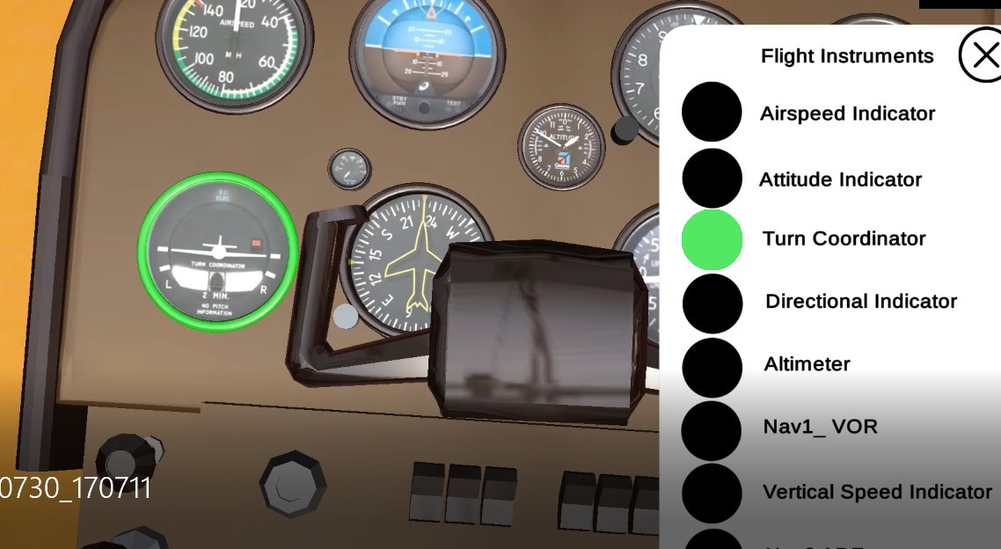
Fig. 4. Each instrument and controls are presented to the user

Improved Proof of Concept

The Prototype, which ended up acquiring an unexpected new feature, described above previously, now has the item in the menu where it is possible to understand not only the names and functions of the buttons but also, what kind of movement it performs. If it is a turn, in this case, it is evidenced in three dimensions if it is 45 or 90 degrees, if it is pushed/pull-type, on/off button and mainly it is possible to closely visualize the movement of the mixture control -, which consists of a button and a lever that must be pressed at the same time.
So, in this second proof of concept, the goal was to demonstrate the panel in a better way than the pictures in the aircraft manual presents where is difficult to realize the controls design, format, and movements as we can see in Fig. 5. An Aircraft Manual shows a 2D image, but we cannot perfeclty visualize the mixture control and understand wheter it must be a button to rotate, pus/pull or press.

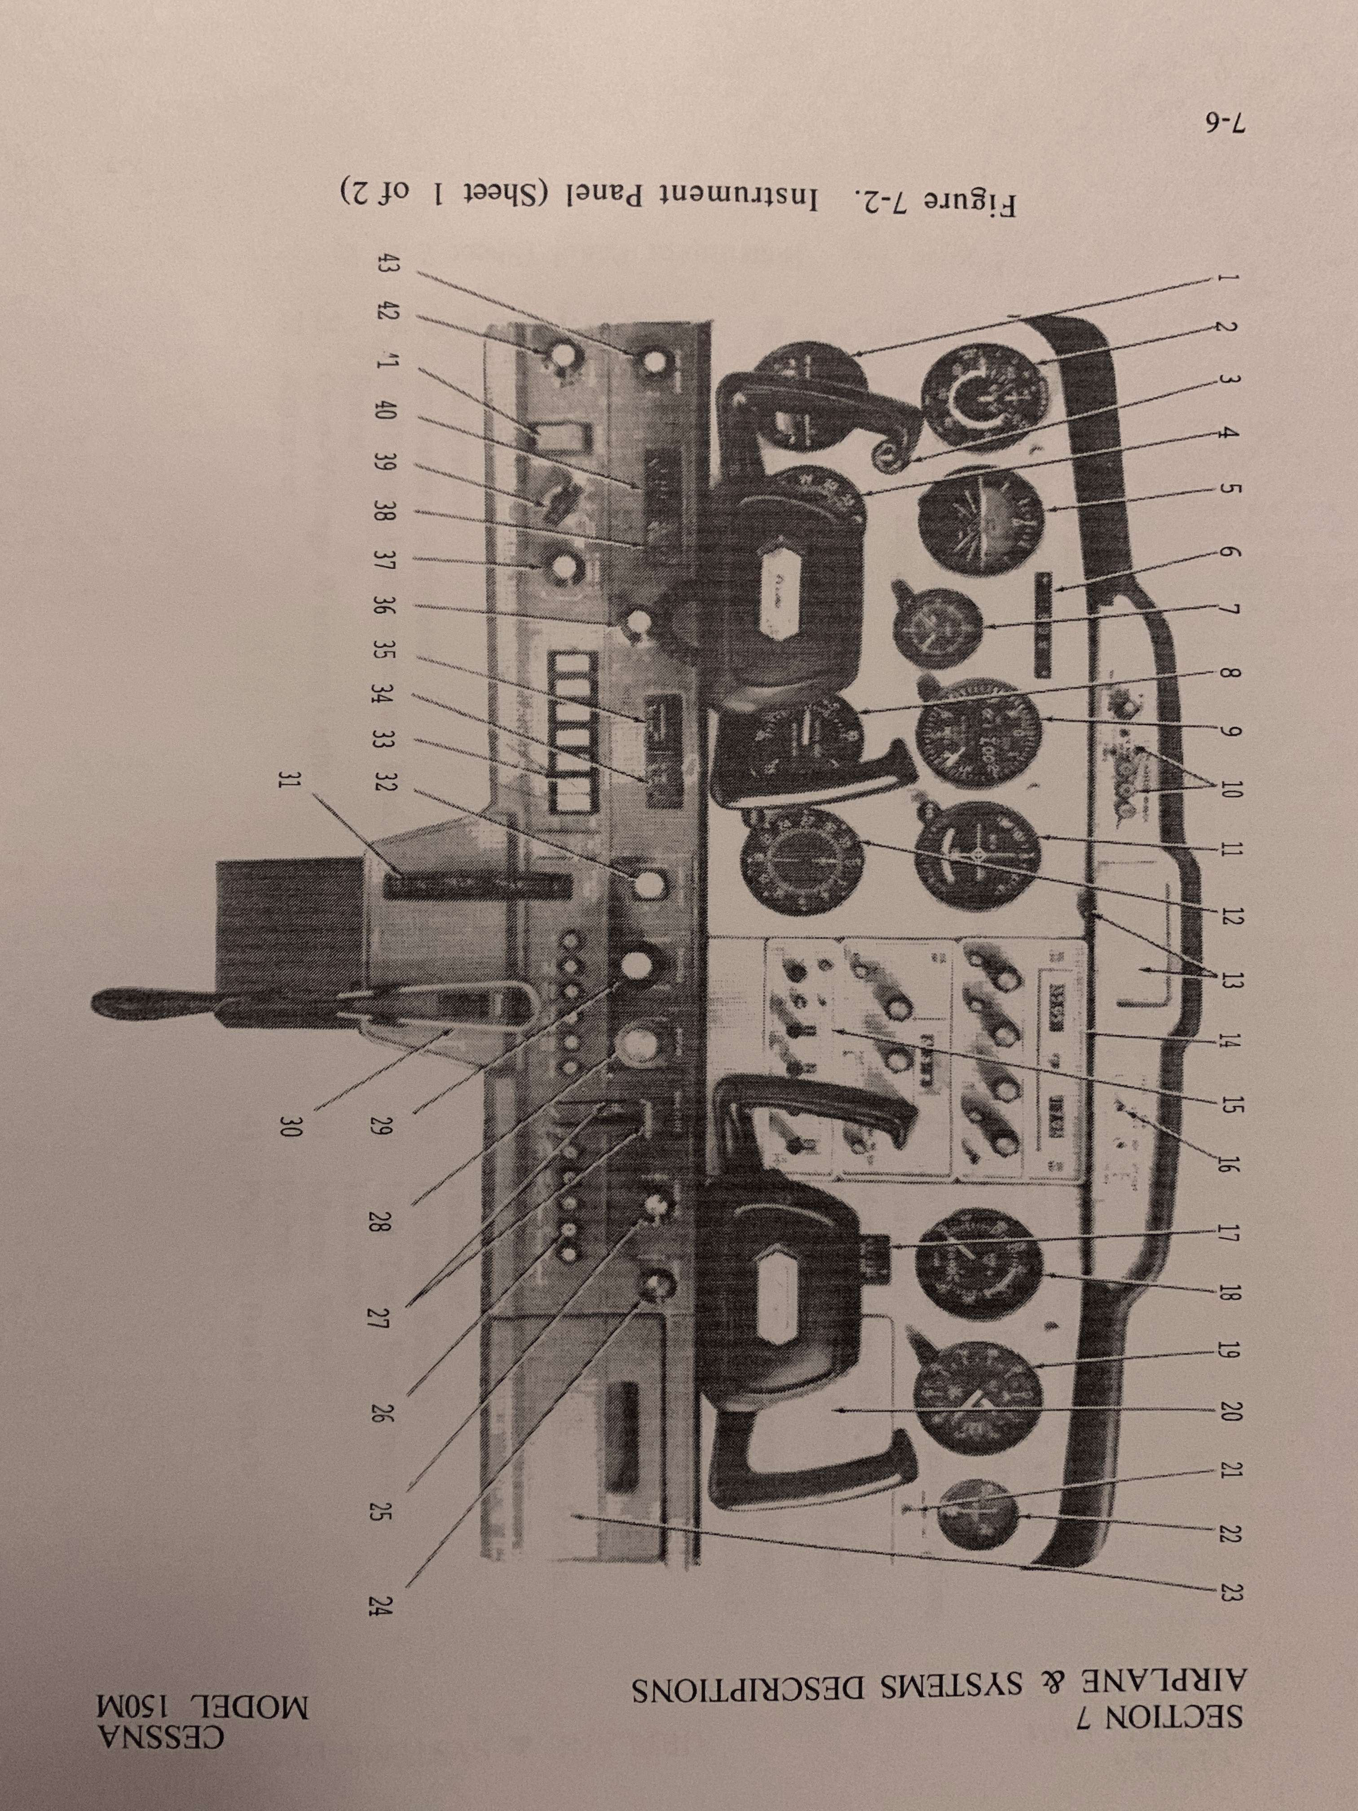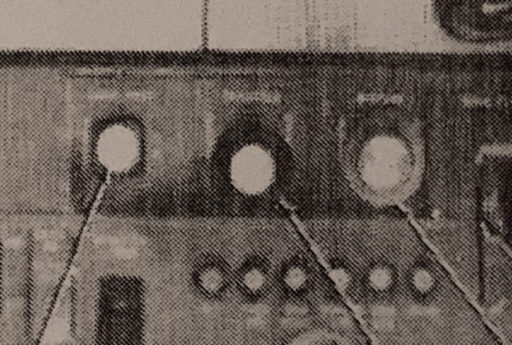
Fig. 5. Difficulty to visualize if the button must be pusshed/pulled or rotated. Cred: Cessna 150 aircraft manual.

So, the goal was to demonstrate in high definition, including animation and interaction as we can see in Fig 6.
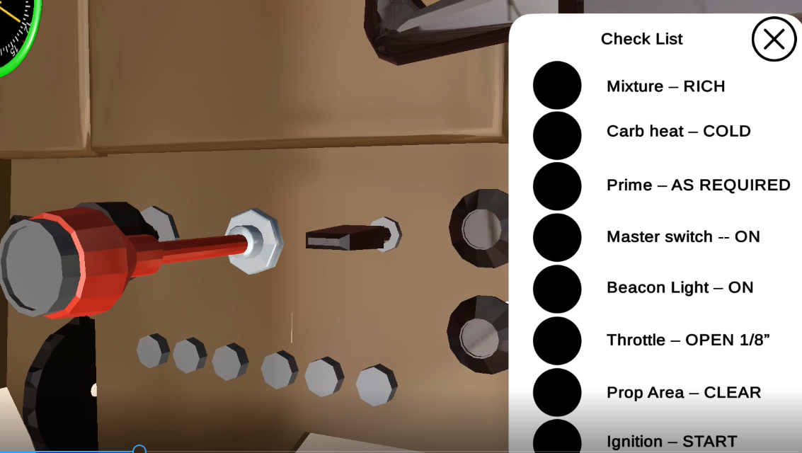
Fig. 6. In an Augmented Reality App is possible to visualize that Mixture control is not a button, but a lever. And the animation shows clearly how to execute the procedure.

This app is very specific to a checklist approach and the panel components.Therefore, it is different from other aplications like X-plane. The focus in this app includes a spoken explanation about each instrument. The focus of this app includes a didactical explanation for each instrument.
The Cessna 150 Starting Engine checklist [11] used can be seen in Fig. 7.
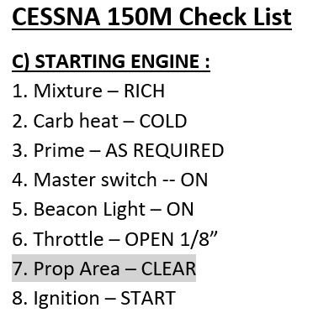
Fig. 7. Check list items used in this experience. Credits: Cessna150 Aircraft Manual

Enhanced Proof of concept

In this phase, greater interaction with the user was sought, where the same checklist is presented, and the user must perform the movements of the lower control panel.
It will only be possible to start the aircraft (start the engine) in this AR simulation if all the buttons have been executed with the correct movement and in the correct order. At the end of this step, the engine is started, and the respective audio confirms the complete verification of the checklist in addition to a message. In discussion with those involved, it was understood that these features would bring gamification to this app, as the pilot feels challenged “to hit" the movements and finish the checklist perfectly, and as a reward, the engine will start. This stage is still under development, but its concept and technologies have already been finalized.
We were involved with the flight instructors, pilots, and students.

V. The experience

The prototype was tested with students, pilots, instructors (Fig. 8 and Fig. 9). The experience involved some steps:

- Explanation about the objectives of his study
- Fill out participant consent
- Read the orientation about how to use the app
- Use the app in front of a banner as a marker for the augmented reality, the user is stand or seated and can move in front of the panel.
- Use the app with a Banner Marker in an A0 size and with a little marker printed in half of an A4 page. In the first case, the user can see the AR panel in a life-size. In the second case, the user can move the little marker using his hands and manipulate the panel position so that he can visualize it comfortably.
- Fill out a questionnaire to reflect and share their points of view
The tests were with instructors (Fig. 7) also involved students (Fig. 8) that are preparing to get the private pilot license - PP.

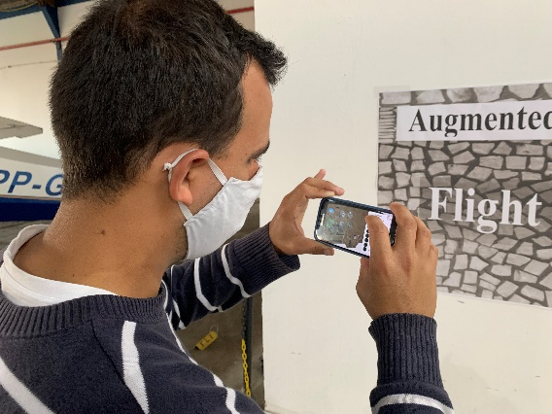
Fig. 9. Student tests the AR app.
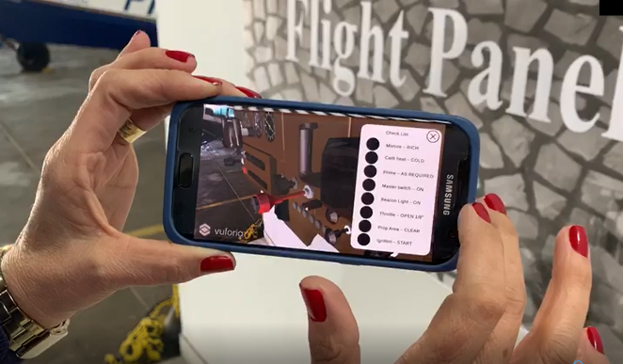
Fig. 8. Flight instructor tests the AR app.

results
The results showed that the virtual 3D model can be very realistic and useful to the pilot with the feature of simulating failures in the instruments, to check if the pilot paid attention to flight indicators, or if the aircraft has deficiencies in the human interface design that should be corrected or controlled

during the flight. The prototype has animated controls and pieces that promote an interactive and more complex task in different situations. This app can help the pilot to be more confident, faster, and secure when flying. Spending less time in the checklist in a real aircraft or a flight simulator, will decrease the costs of the process and increase safety with AR training. Also, AR improves their situational awareness (S–A) - perceive, comprehend, and project future actions in a scenario that SA and mental models of the system are important in minimizing human error. Table I provides information and comments that allow us to conclude how useful this application can be for pilots, students and even for companies that need to improve the training resources.

Table i. uSER´S cOMMENTS
Profile/ Function | Some Comments after experiment the App
 | Comments | pros | cons
Flight instructor coordinator | “The app has great potential not only for new students studying to get their private pilot license, but for experienced pilots when they go to upgrade and get their jet license, for example.” | Easy,can be replicated to other airplanes, high definition | Check list could have all items, be more complete
Flight instructors | “ Cool. We can see in details.”  “ It is a good way to learn about the instruments and controls. Good to memorize.” | Strong learning and training tool;  High definition image | The prototype is just for Android. Various instructors use iPhone
pilots | “There are illustrations in the manuals that do not allow to understand the real movement that is made when activating a certain switch, lever, button, or selector. With Augmented Reality it is possible to visualize as if the panel were really in front of us and the pieces were easy to visualize.”  “It would be great if I had a App like this one, when I was preparing myself to be a pilot and upgrading my licences and airplanes.” | Useful,  Detailed,  Easy, | It could include more procedures
students | “I found it very realistic and I liked the part where I can have it in my house, where I can use the virtual panel whenever I want”  “Show. I can study at home and see in details the panel. When I will use this airplane, ( I´m a new student) it will be friendly for me”  “Nowadays, I´m learning to fly in an Aeroboeiro, I would like to have one of that also for this aeroplane” | Cool,  Portable,  Useful, | The prototype is just for Android. Various students use iPhone;  Icon to click is too small

Conclusion
This study is preliminary and more students, pilots, and instructors will be invited to participate in future tests of the system. Flight engineers and physicians also will be invited to participate to increase diversity in the evaluation of the system as part of the Human-Centered Design method. It is important to note that this application goes beyond the data and information that we can find in the aircraft manual and procedures. It is also important that we improve the app so that it can capture and pass the “knowledge and experience” from experienced pilots, instructors, and all stakeholders on to novice pilots to promote a mature experience-improving security, better quality flights, good tolls, and methods to teach others and transfer the “knowledge and experience” of flight.

This study can be useful to the aircraft industries and other professions such as the medical industry where medical practitioners can receive more information to support the human cognitive and health field-such as medical operation procedures. In essence, this AR method is independent of the field of application.

ACKNOWLEDGMENT

S.K.F thanks for the Aeroclub of Santa Catarina, instructors Claudia Thofehrn and Thiago Bortholotti, pilots, and students.

References

[1] I. N. Gleim and Garrett W. Gleim, “Private Pilot FAA Knowledge Test”1st ed., pp 2. University Station, 2011.
[2] J. Tustain, “ Tudo sobre realidade virtual & fotografia 3600 . São Paulo Editora Senac, 2019.
[3] Microsoft. "Microsoft Flight Simulator." Xbox. Xbox.com/games/microsoft-flight-simulator (accessed Sept. 18, 2020).
[4] Laminar Research. "X-Plane 11." X-Plane. x-plane.com (accessed Sept. 18, 2020).
[5]International Standards Organization (ISO) 13407. Human-Centered Design Processes for Interactive Systems.
[6] J.S Martinez et al. “Implementation of human-system integration workshop at NASA for human spaceflight,” 70th International Astronautical Congress IAC Washington D.C., October 2019
[7] Milgram P., Kishino F. A taxonomy of mixed reality visual displays. IEICE Trans. Inform. Syst. 77 (1994)1321–1329.
[8] S. Keller Füchter and M.Sergio Schlichting, “ Utilização da realidade virtual voltada para o treinamento industrial. Revista científica multidisciplinar núcleo do conhecimento. Ano 03, ed. 10, vol. 07, pp. 113-120 may, 2019.
[9] C. KIRNER, and R. TORI, “Introdução à realidade virtual, realidade misturada e hiper-realidade. Realidade Virtual: Conceitos, Tecnologia e Tendências”. 1 ed. Sã Paulo, SENAC, 2004, v. 1.
[10] P. Cipresso, I. A. Giglioli, M. A. Raya, G. Riva The Past, Present, and Future of Virtual and Augmented Reality Research. Front Psychol, 2018
[11] Cessna Pilot´s Operating Handbook. 150 commuter Cessna Model 150M, 1977

