XXI IMEKO World Congress “Measurement in Research and Industry”

August 30 − September 4, 2015, Prague, Czech Republic

Evaluating a Tool for Mapping Study Approaches and Preferred Learning Preferences: A Pilot Study

E D Fitkov-Norris ¹, A Yeghiazarian ²

¹Kingston University, Kingston-upon-Thames, UK, e.fitkov-norris@kingston.ac.uk
¹Kingston University, Kingston-upon-Thames, UK, a.yeghiazarian@kingston.ac.uk

Abstract − This article introduced a new conceptual framework of student learning that takes into account recent developments from neuroscience, in order to describe the complex interactions between the learners’ environment and the subconscious and conscious information processing required, enabling them to learn more effectively. The validity of a tool for assessing learners’ approach for consciously processing information: Visually, Auditory, Read/Write or Kinaesthetic (VARK) was tested using exploratory factor analysis and good mapping was found between visual, read/write and auditory items. The kinaesthetic learning modality is harder to capture reliably. Given these promising results, it is recommended that the tool be evaluated with a larger sample size, before adopting it as an instrument as learning support tool and in further research.
Keywords: study preferences, VARK, exploratory factor analysis, study approaches framework

1. Introduction
Learning is an essential part of life and as the acquisition and development of new skills is becoming a requirements at all stages in life, scholars are continuing their attempts to identify the factors that affect student learning and subsequent academic performance. A large number of models and instruments have been developed to simulate the stages of the learning process or assess the way in which people learn, with the objective of identifying the optimal study strategies students could employ at the point of interaction with their learning environment [1,2]. While learning can happen in many different contexts, researches are particularly interested by the complex interactions that arise in formal learning situations such as classrooms, where exogenous variables can be controlled.
Past research has indicated that in the context of higher education, both the lecturer style and mode of delivery of the material (visual, auditory, read/write and kinaesthetic) have a significant impact on the way in which students approach learning [1,3]. In particular, empirical evidence suggests that aligning the mode of material delivery to the students preferred learning style can increase the students satisfaction and impact positively on their academic performance [1]. Recent evidence from neuroscience supports these findings by showing that visual learners’ have to convert words into pictures before they can learn them and vice versa [4]. Furthermore, numerous studies suggest that students’ study strategies and habits can play a significant role in predicting academic performance [5,6]. In light of this new evidence, a new conceptual framework has been proposed recently, explicitly identifying the relationship between students preferred mode of learning (visual, auditory, read/write, kinaesthetic) and the study strategies and habits they adopt to mange their learning [7].
This article presents results from a pilot study which attempted to evaluate students’ study approaches as visual, auditory, read/write and kinaesthetic. In particular, the article evaluates the construct validity of the questionnaire used to elicit learners’ study approaches and assesses its suitability as a measuring instrument. The article is organised as follows: the next section provides an overview of the proposed conceptual framework linking preferred learning modality and study approaches. Section 3 discusses the methodology used to assess the questionnaire validity and reports the results from the analysis. Finally, implications from the research findings are discussed and suggestions made for further research.

2. Framework linking preferred learning preference and study approaches
Many instruments and models have been designed to assess and describe the approach taken by students when studying [8], although the terms used by academics to reflect the different elements involved in the learning process are not always well defined [9]. Learning preferences relate to the learner’s preference for one method of teaching over another [10] and reflect the way in which a learner prefers to receive information. There are four ways for conveying and absorbing information: Visual (via pictures and diagrams), Auditory (by hearing), Read/write (by text) and Kinaesthetic (by doing). The preferences of students for using combinations of information input pathways are measured using VARK type questionnaires [11]. Recent developments from neuroscience show that visual learners convert words into images in their brains, before processing the information further [4]. Conversely, read/write learners convert images into text before processing the information further. This finding has significant implications as it suggests that the optimal approach a learner adopts would be context sensitive and depend on the type of information presented to them. If information is presented to a learner in a format other than the one they prefer, they have to carry out an additional step of processing that information into a suitable format before they can learn it. This may entail the conversion of textual lecture notes into diagrams, for example, if a learner is visual. However, no conversion is required, if the same learner is presented with a diagram.
In addition to these insights into information processing, fMRI (functional Magnetic Resonance Imaging) brain scanning provide further insight into how people make decisions, and in particular, the way in which students react when finding themselves in a context that may or may not be familiar to them. Research shows that their behaviour is governed by the interactions of two systems in the brain: the reflective C-system and the reflexive X-system. [12,13]. The reflective C-system is used in situations, which are unfamiliar, and provides sequential and effortful assessment for particular choice of course of action. The reflexive X-system is used in familiar situations, where actions are automatic and relatively effortless and uses parallel processing. In the context of learning, this can be translated as a student who is attending a lecture for the first time and not sure how to handle the situation, versus a student who has attended lectures in the past and “knows” automatically what to do. Students who consistently use the same study strategies could benefit in the long run by gradually strengthening their decision pathways and shifting from using their reflective to using their more efficient and less effortful reflexive system. In addition, the repeated actions lead to situational familiarity which is in turn more likely to trigger the same habitual behavioural response [13], further reinforcing the habituation of that particular behaviour. This reinforcing feedback loop may explain how students could be trapped in using inefficient study habits and strategies, even when they make a conscious effort to study hard or work efficiently [9].
The terms study habits and study strategies are used interchangeably in the academic literature and their definitions have evolved over time to encompass a number of different sub-constructs and aspects of study habits, covering different cognitive, affective and behavioural activities [2]. The cognitive factors reflect the approach and techniques used by students to draw inferences from the information. This may include deep, strategic and surface approaches to learning [2]. The affective components link to students’ emotions and measure the students motivation and anxiety and their propensity to avoid procrastination [5]. Lastly, behavioural factors include study related behaviours such as note taking, highlighting, and reviewing [6]. The majority of study habits and strategy instruments use a combination of some, if not all of these sub scales [2,8], although only one inventory attempts to capture information about the learners cognitive preferences as well as their information processing preference [1].
As pointed out, the context sensitivity of optimal study strategy would be dependent on both individual’s particular information processing preference mode as well as the mode in which information presented to them and this is reflected in the conceptual framework in Figure 1. The structure highlights the additional information-processing step that is carried out subconsciously by learners when presented with information in a mode other than their primary VARK preference. It also shows the impact of study habits on conscious information processing that learners carry out as part of their learning activities. These may involve actions such as detailed note taking, underlining, revision and group discussion or other learning strategies adopted by individual students.
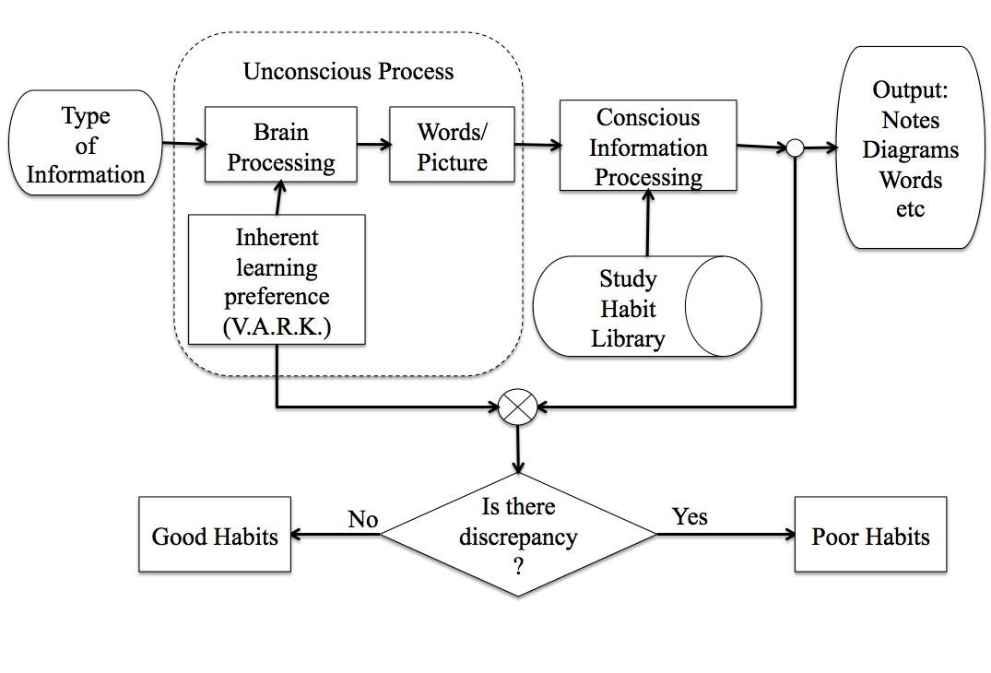

Fig. 1 – Conceptual framework linking information processing and study approaches.
The student’s inherent preferred mode of learning and the output produced as a result of their conscious study efforts is compared and if a discrepancy is found, this is indicative of potentially poor study habits. The diagram focuses on the behavioural aspects of study habits and strategies, and does not show the complexity added by affective and cognitive dimensions of study habits and strategies, such as student motivation and higher order cognitive processes involved in learning. The complex interrelationship between learning approaches and information processing may account for some of the variation in the success of students’ learning strategies Adopting a study strategy that is not optimal (such as for example, a visual learner reading their lecture notes over and over again, without summarizing them into diagrams) could result in very inefficient and effortful learning experience and ultimately lead to learner’s discouragement and increased anxiety. While the higher educational system has been deigned to instil good study habits and encourage students to become independent learners, to the best of our knowledge, no study strategy instrument assesses the fit between the student preference for seeing a particular type of information and their approach to handling this type of information. Of course, if a learner is multi-modal the impact of this potential discrepancy between actual and optimal behaviour is small. However, learners with strong single preference will potentially be most at risk and this is borne by findings that learners with a single strong modal learning preference are at a much higher risk of academic failure, compared to their peers with more balanced preferences [14]. While one could expect that with experience, learners would become better able to identify intuitively the optimal strategies for information pre-processing to enable them to learn most effectively, the affective emotional factors (such as anxiety and frustration) may affect the learner motivation to reflect critically on their learning approach.

3. Validation of the Mapping of Study Approaches to VARK modalities

3.1. Methodology
Well known instruments exist for eliciting individual’s preferred information processing approaches such as the VARK learning modality preferences questionnaire [11]. The questionnaire assesses learner’s unconscious preference for visual, auditory, read/write or kinaesthetic information processing and the questionnaire’s construct validity has been confirmed using exploratory factor analysis and Rasch analysis [15,16]. However, no instrument has even been designed to map the approach the students take consciously when attempting to study. A questionnaire by Nonis and Hudson [6] was specifically designed as part of this study to measure the students study approach in two different contexts: in the classroom and when revising. The objective of the questionnaire is to elicit the actual information processing approach the students adopt when taking notes and listen in class and also the approach they take when preparing notes for revision. A modified version of the Nonis and Hudson [6] questionnaire will be used to map the conscious actions learners take to study onto the VARK learning modalities. The validity of the questionnaire was validated using binary exploratory factor analysis with tetrachoric correlations using R and SPSS.

3.2 Results and Discussion
A pilot questionnaire was administered to 65 PG students. 14 students did not complete the questionnaire fully and their results were removed, giving a sample size of 51. 41% of the sample was male and the average age of the students was 26 years. The majority of students were studying for art, business or architecture degree (88%) and 94% had lived in the UK for less than 2 years. As the majority of data items were binary, tetrachoric correlations were used in the exploratory factor analysis. The exploratory factor analysis confirmed that the study approaches questionnaire measured 4 subscales explaining 65% of the total variance (Table 1). The solution with 3 factors had poorer fit as reflected by its higher BIC value (1814.24 as opposed to 1770.2). Only loadings greater that 0.5 were interpreted to mitigate the impact of the relatively small sample size.
The first factor loaded highly on Visual questions and also had high negative correlation with Read/write preference. The second factor correlated highly with read/write questions, while the third factor correlated highly with auditory items. The final factor did not correlate with a particular preference but had high loadings from Auditory, Visual and Read/Write items (with the read/write being negatively correlated to the other two). This factor appears to relate to good study approaches from all types of learners rather than elicit just one information preference. In addition, the practice of summarizing concepts by drawing picture and diagrams was loading highly on both the visual factor and also on the factor summarizing good study approaches suggesting that this item did not load on a single factor Finally, only one kinaesthetic preference question had sufficiently high loading to be included in the results and it did this on the read/write factor, which is perhaps not surprising, given that writing is a kinaesthetic activity and this highlights the difficulty of attempting to capture this particular learning preference.

Table 1. Factors with Loadings > 0.5.
Question | Factor 1 Visual | Factor 2  Read/  Write | Factor 3 Auditory | Factor 4 Mixed
- When revising: I re-write/re-draw my notes (V) | .838 |  |  | .  .677
- When taking notes in class I: Write down every word the lecturer says (R) | -.655 |  |  | .  .677
- When taking notes in class I: Summarise concepts by drawing pictures and diagrams (V) | .513 |  |  | .  .677
- When in class I understand better when I: Read the slides (R) |  | .636 |  | .  .677
- When revising: I read through the notes taken in class (R) |  | .633 |  | .  .677
- When in class I understand better when I: Do in-class exercises (K) |  | .580 |  | .  .677
- When revising: I read the notes aloud to myself or others (A) |  |  | .710 | .  .677
- When revising: I talk to others and discuss the material in my notes (A) |  |  | .707 | .  .677
- When in class I understand better when I: Listen carefully to lecturer (A) |  |  |  | .772
- When taking notes in class I: Write down everything displayed on the lecture slides (R) |  |  |  | -.765

The exploratory factor analysis results show that the adapted instrument mapped the Visual, Read write and Auditory learning modalities reasonably well with majority of questions loading highly on the relevant factor. However, on two occasions Read/Write questions showed strong negative correlation to several visual and an Auditory question. This seems to suggest that the processing visual, auditory and read/write information is not complementary and this is in line with the findings by Kraemer et al [4] that visual individuals have to convert text into images and visa versa. These findings also seem to provide some empirical evidence that similarly, auditory information is processed differently form read/write information. This findings needs to be examined further before any conclusions can be drawn. Finally, the proposed questionnaire did not map the kinaesthetic dimension of the learning modalities to a single factor and this suggest that this particular preference is rather difficult to capture. The questionnaire also elicited a final dimension of a set of questions that appear to reflect good study practice such a listening carefully to the lecturer and summarizing concepts by drawing diagrams rather than a specific information processing approach. This is confirmed further by the fact that the visual technique of summarizing concepts by using diagrams is the only question that exhibited cross – loading across two factors.

4. Conclusions
This article introduced a new conceptual framework on learning that takes into account recent developments from neuroscience to describe the complex interactions between the learners’ environment and the subconscious and conscious information processing required, enabling them to learn more effectively. The validity of a tool for assessing learners’ approach for consciously processing information was tested using exploratory factor analysis and good mapping was found between visual, read/write and auditory items. The kinaesthetic learning modality is harder to capture reliably. The results suggest that the conscious information processing approach taken by learners vary, with across learners with different preferences and it is therefore suggested that this research is conducted with a larger sample size in order to validate these empirical findings further.

References
[1] R. Dunn, Learning Style: State of the Science. Theor Pract. vol 23, nº. 1, pp 10–9., 1984.
[2] N. Entwistle and V. McCune The conceptual bases of study strategy inventories. Educ Psychol Rev. vol. 16, nº. 4, pp. 325–45, 2004.
[3] J. Biggs and C. Tang, Teaching for Quality Learning at University. Fourth Edition. McGraw-Hill International; 2011.
[4] D. Kraemer, R. Hamilton, S. Messing, J. DeSantis and S. Thompson-Schill, Cognitive style, cortical stimulation, and the conversion hypothesis. Front Hum Neurosci., vol. 8 2014.
[5] M. Credé, S. Roch and U. Kieszczynka. Class Attendance in College: A Meta-Analytic Review of the Relationship of Class Attendance With Grades and Student Characteristics. Rev Educ Res. vol. 80, nº.2, pp. 272–95, 2010.
[6] S. Nonis and G. Hudson, Performance of College Students: Impact of Study Time and Study Habits. J Educ Bus. vil. 85, nº.4, pp. 229–38, 2010.
[7] E. Fitkov-Norris and A. Yeghiazarian, Measuring the Relationship between Study Habits and Preferred Learning Style in Higher Educations. Frontiers in Education Conference, Madrid. pp. 1–4, 2014.
[8] F. Coffield, D. Moseley, and K. Ecclestone, Learning Styles and Pedagogy in Post-16 Learning. Learning and Skills Research Centre; p. 173, 2004.
[9] E. Fitkov-Norris and A. Yeghiazarian, Measuring study habits in higher education: the way forward? Rossi GB, Crenna F, Belotti V, editors. J Phys: Conf Ser. Genoa, nº. 459, 2013.
[10] C. McLoughlin , The implications of the research literature on learning styles for the design of instructional material. Aust J Educ Tech. vol. 15, nº.3, pp 222–41, 1999.
[11] N. Fleming, VARK: a Guide to Learning Styles. The VARK Questionnaire. 2001.
[12] M. Lieberman, R. Gaunt, D. Gilbert and Y. Trope, Reflexion and reflection: A social cognitive neuroscience approach to attributional inference. Adv Exp Soc Psychol. vol. 34, pp. 199–249, 2002.
[13] C. Klöckner and E. Matthies E. How habits interfere with norm-directed behaviour: A normative decision-making model for travel mode choice. J Environ Psychol. , vol 24, nº.3, pp 319–27, 2004.
[14] G. Eudoxie, Learning Styles among Students in an Advanced Soil Management Class: Impact on Students' Performance. J Nat Resour Life Sci Educ. vol 40, pp. 137–43, 2011.
[15] W Leite, M. Svinicki and Y. Shi. Attempted Validation of the Scores of the VARK: Learning Styles Inventory With Multitrait-Multimethod Confirmatory Factor Analysis Models. Educ Psychol Meas. vol. 70, nº.2, pp. 323–39, 2010.
[16] E. Fitkov-Norris and A. Yeghiazarian, Validation of VARK learning modalities questionnaire using Rasch analysis. J Phys: Conf Ser. Madeira, nº. , 588; 2014. pp. 1–6, 2014.

