Major points of extension

- 4. CONSTRUNTION OF XRF XPS SURFACE ANALYSIS SYSTEM
In Figure 4, the view of the combined XRF XPS surface analysis system is replaced the design diagram with the actual system diagram. Each component of the surface layer system is indicated on the figure.

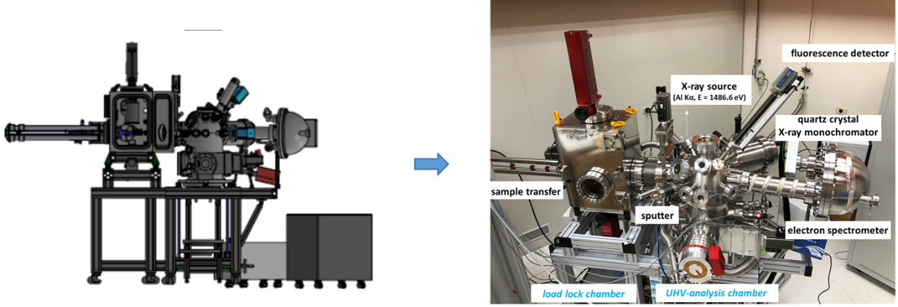

- 4. CONSTRUNTION OF XRF XPS SURFACE ANALYSIS SYSTEM
The step resolutions of the five axes of the UHV 5-axis manipulator have been addressed respectively.” For the 5-axis manipulator, 2 of the axes are linear motors moving along the vertical (axis ②) and horizontal (axis ④) directions with the step resolution of 0.000061 mm and 0.0001 mm respectively to adjust the position of the Si-sphere to the center of the chamber. The other three axes are composed of rotating motors. The motor at the lowest (axis ⑤)is to rotate around the center of the UHV analysis chamber with the step resolution of 0.0001° to change the angle of incidence on the Si-sphere. The upper two motors rotate around with center of the Si-sphere to measure the element distribution on the Si-sphere. The step resolutions of horizontal axis ① and vertical axis ③ are 0.00014° and 0.0001° respectively.”
In Figure 5, the actual diagram of the 5-axis manipulator is added.
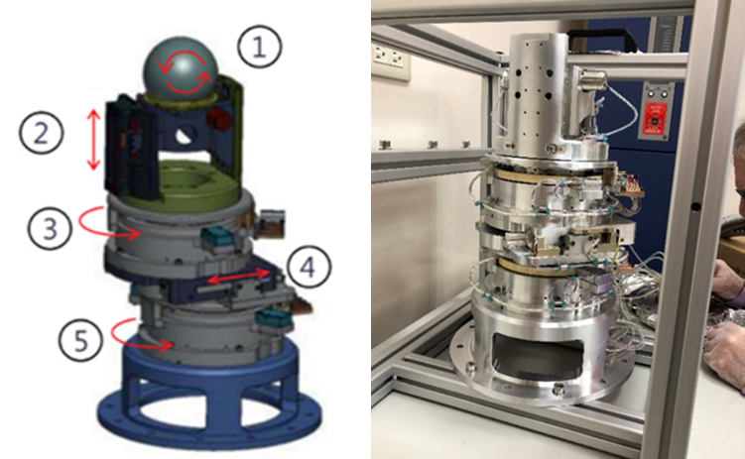

- 4. CONSTRUNTION OF XRF XPS SURFACE ANALYSIS SYSTEM123
We have added a paragraph about vacuum system design:
“When the measurement is proceeded, the chambers should keep in ultra-high
vacuum environment with the pressure of the loadlock chamber of 10⁻⁷ mbar and
UHV analysis chamber (main chamber) of 10⁻⁹ mbar. The design of vacuum
system is showed in Figure 6: The load lock chamber and a main chamber are
connected by a gate-valve. The turbo molecular pumps are mounted on both
chambers and connected to a root pump. An ionization gauge and Pirani gauge
are used to monitor the pressure in both chambers. As a buffer of the main
chamber, the load lock chamber supposed to be evacuated and re-filled usually.
An angled valve with soft pump is used to avoid the diffusion of dust and
particles in the load lock chamber. The load lock chamber will be filled with
nitrogen before open the chamber. Moreover, in order to avoid the window on
the chamber being damaged by the high pressure of nitrogen, a buffer volume is
connected between the source of nitrogen and the load lock chamber. For
keeping the pressure of the main chamber of 10⁻⁹ mbar, except turbo molecular
pump, an ion pump is also used. And a residual gas analyser (RGA) is used to
analyze the residual pressure in the main chamber. ”
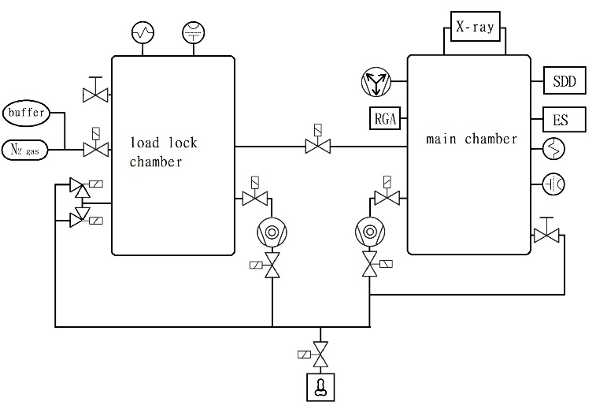
Figure 6 The vacuum system design of the combined XRF XPS surface analysis system.

