1. Introduction
Experimental Evaluation of a PTB Force-Balanced Piston Gauge
Ahmed S. Hashad^{1,a,†}, Wladimir Sabuga², Sven Ehlers², Thomas Bock³
¹National Institute for Standards (NIS), Giza, Egypt, ª Guest researcher at PTB
(Tel : +49-531-5923172; E-mail: ahmed_hashad84@hotmail.com)
²Physikalisch-Technische Bundesanstalt (PTB), Braunschweig, Germany
(Tel : +49-531-5923230, +49-531-5923138; E-mails: wladimir.sabuga@ptb.de, sven.ehlers@ptb.de)
³PTB, Berlin, Germany
(Tel : +49-30-34817354; E-mail: thomas.bock@ptb.de)

Abstract: Experimental methods using different pressure standards were applied to verify theoretical results obtained for the effective area of the piston-cylinder assembly (PCA) and the pressures measured with a Force-Balanced Piston Gauge (FPG). The theoretical effective area was based on PCA's dimensional properties defined by diameter, straightness and roundness measurements on the piston and cylinder, derived by gas flow modelling using principles of the Rarefied Gas Dynamics, and presented by two values, one obtained for absolute and the other for gauge pressure operation modes of the FPG, both having a relative standard uncertainty of 5⋅10⁻⁶. The experimental methods were selected aimed at covering the whole operating pressure range of the FPG from 3 Pa to 15 kPa. Comparisons of the FPG with three different PTB pressure standards operated in different pressure ranges were performed using the cross-float method or by a direct comparison of the generated pressures. First, a Ruska pressure balance traceable to PTB primary pressure standards was applied to determine the FPG effective area in the range of 2 kPa to 15 kPa. Second, the FPG was compared with a mercury manometer, being a primary standard, in the pressure range of 1 kPa to 15 kPa. Third, the FPG pressures from 3 Pa up to 300 Pa were compared with pressures of a static expansion system (SES), being PTB primary vacuum standard. The two first comparisons against the pressure balance and the mercury manometer were performed in absolute and gauge pressure modes. The measurements against the SES were done in absolute pressure mode only. The experimental results obtained at pressures above 1 kPa were used to calculate the PCA effective area, which was compared with the theoretical one. Below 1 kPa, the FPG pressures were compared with those of the reference standards. For the theoretical and experimental effective area as well as for pressures generated by the FPG and the reference standards, all the results demonstrated full agreement within their uncertainties. Herewith, the FPG characterised as primary pressure standard is validated experimentally and can now be used for pressure measurements and calibrations in the pressure range from about 3 Pa to 15 kPa.

Keywords: FPG, cross floating, effective area, pressure standard, experimental verification.

Force-balanced piston gauges (FPG) present an important class of piston gauges, which enable pressure measurements from few pascals to tens of kilopascals. In these instruments, the force of the pressures acting on the piston of a piston-cylinder assembly (PCA) is measured by a high-accuracy balance. Knowing this force and the effective area ($A$) of the PCA, the difference of the pressures above and below the piston can be calculated. At PTB, a force-balanced piston gauge manufactured by Fluke Calibration, USA under the name FPG8601 [1] was characterized as a primary pressure standard [2, 3] by determining $A$ of its PCA from PCA's dimensional properties. Then, three experiments were performed to validate the PCA’s effective area and pressures measured by the FPG using pressure comparisons against three different pressure standards. These standards have various operation principles and pressure ranges as explained at length.
† Ahmed S. Hashad is the presenter of this paper.

2. Experiments
2.1 Effective area determination
The FPG was calibrated against a Ruska pressure balance, model 2465A (gas piston gauge), equipped with a PCA, serial no. TL1568, to determine the effective area of the FPG by the cross-float method. The Ruska PCA has an effective area equal to 3.35666 × (1 ± 5.8⋅10⁻⁶) cm² (all uncertainties in this paper are given for $k$ = 1, unless otherwise specified). The effective area of this Ruska PCA is traceable to the state-of-the-art pressure balance used in the experiments on the redetermination of the Boltzmann constant [4, 5] and being German national pressure standard in the range 180 kPa to 7.5 MPa of absolute pressure. Both instruments were connected by the setup shown in Fig. 1. A very low-pressure controller (VLPC) produced by Fluke Calibration was used to stabilize FPG's measurement and lubrication pressures. A stainless-steel mass set of class E₂ was used to characterize FPG's balance. A 10 torr capacitance diaphragm gauge (CDG) was placed in the measurement line to indicate the pressure difference between both instruments as shown in the Fig. 1. The pressures of both instruments were controlled to keep the pressure difference measured with the CDG as close to zero as possible. The measurements were performed in gauge and absolute modes in pressure ranges of 3 kPa to 15 kPa and of 2 kPa to 15 kPa, respectively.
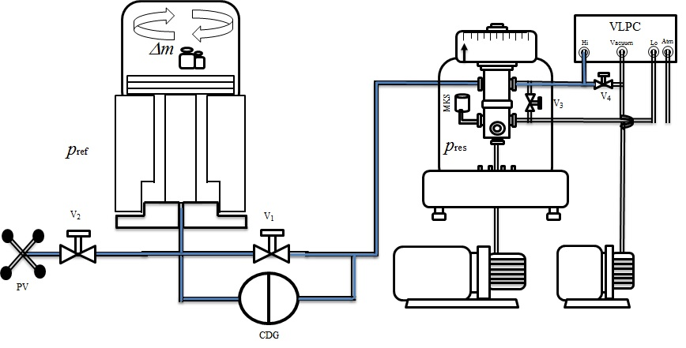 | 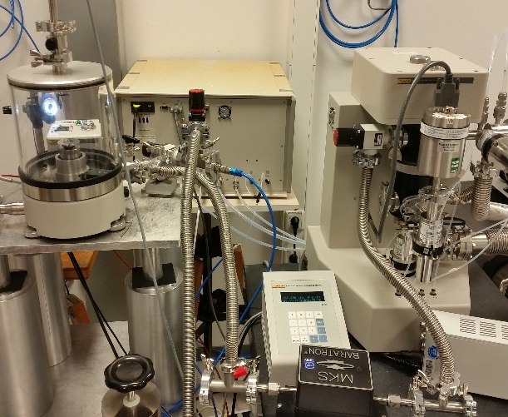
Fig. 1 Experimental setup for cross floating between FPG and Ruska pressure balance.
During the measurement, valve V₁, separating both instruments, was closed and valve V₂ was opened. The pressure of FPG was generated by VLPC at the target
pressure, and the variable pressure volume (PV) was used to generate the target pressure within the Ruska pressure balance. Then, the VLPC was used for a fine pressure adjustment within FPG to reach a nearly zero indication of the CDG. After that, valve V₁ was opened and V₂ closed to allow for a direct cross-float between the FPG and Ruska pressure balance.
From the experimental results, the effective area was calculated by means of Eq. (1),
$$A=\frac{F_{lc}}{(p_{ref}-p_{res})∙[1+(α+β)∙(t-20)]} ,$$ | (1)
in which p_{ref} is the pressure of the reference standard, p_{res} is the residual pressure in the lower side of the FPG PCA, equal to zero in gauge mode, α + β is the thermal expansion coefficient of the FPG PCA and F_{lc} is the force measured by the balance and corrected for buoyancy and lubrication pressure change effects according to [6],
$$F_{lc}=\frac{m_{cal}∙\left(1-\frac{ρ_{lub}}{ρ_{m}}\right)∙g}{N_{cal}}\left(N+δN_{1}+δN_{2}+δN_{3}\right).$$ | (2)
Here, m_{cal} is the true mass of the internal reference mass used for balance's internal calibration, N_{cal} is the reading of the balance when m_{cal} is loaded, N is the balance indication due to the pressure difference, δN₁ is the indication correction due to the lubricant gas pressure variation, δN₂ is the indication correction due to the drag force change and δN₃ is the indication correction due to the atmospheric pressure variation.
The Ruska reference pressure ($p_{R.ref}$) was calculated by means of Eq. (3), where g is the local gravity acceleration, m_{i} and ρ_{i} are the masses and their densities, respectively, ρ_{amb} is the density of the ambient gas, V is piston’s additional volume which is required as a correction due to the buoyancy produced by the pressure-transmitting medium with density ρ_{l}, A_{r0} is the effective area of the Ruska PCA, α_{r} + β_{r} is the thermal expansion coefficient of the Ruska PCA, p_{R.rest} is the residual pressure in the Ruska bell jar and h is the height difference between the reference levels of the pressure balance and the FPG,
$$p_{R.ref}=\frac{g∙\left[m_{i}∙\left(1-\frac{ρ_{amb}}{ρ_{i}}\right)+V(ρ_{l}-ρ_{amb})\right]}{A_{r0}∙\left[1+\left(α_{r}+β_{r}\right)∙\left(t-20\right)\right]}+p_{R.rest}+g∙h∙\left(ρ_{l}-ρ_{amb}\right).$$ | (3)
2.2 FPG vs. mercury manometer
In this experiment, the FPG was calibrated against the PTB mercury manometer (HgM), model 1025B of the Schwien Engineering company, USA, which was modified at PTB and metrologically characterized as described in [7]. The design of this instrument is shown in Fig. 2.
Fig. 2 PTB mercury manometer (HgM).
The manometer comprises two vessels filled with mercury and connected by a flexible tube (A) with the ability to change the height position of one of the vessels mechanically. The height change of the movable vessel is measured by a laser interferometer (B). The height levels of the mercury's free surface in the vessels is
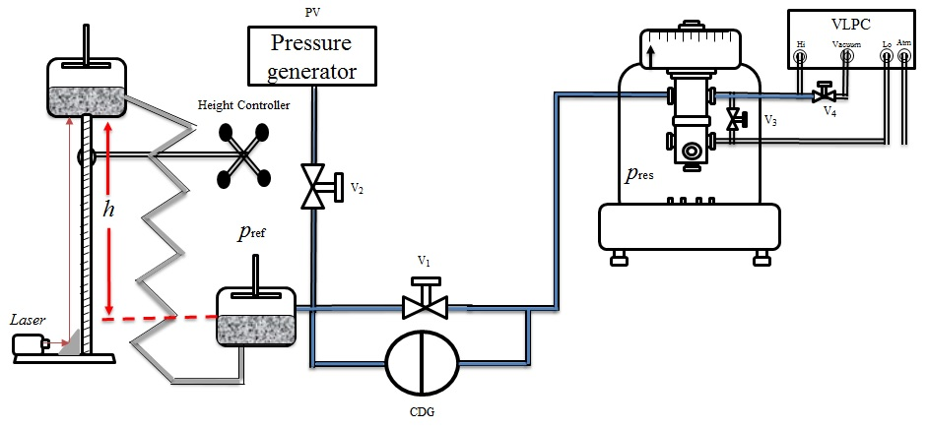 | 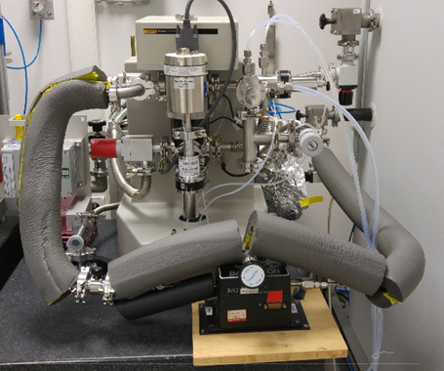
Fig. 3 Experimental setup for cross floating between FPG and HgM in gauge pressure mode.
controlled by capacitance measurements (C1 and C2).
In the experiments, the FPG was connected with the HgM directly, as Fig. 3 shows this for measurements in gauge mode.
Between the two instruments, a CDG was placed to measure the pressure difference when changing the pressure in each of them. All connections were thermally isolated to minimize the effect of ambient temperature changes, even though all measurements were performed in an air-conditioned environment having temperature stability within 0.3 K. The measurements were carried in the pressure range 100 Pa to 15 kPa in the gauge and between 1 kPa to 15 kPa in the absolute mode.
In the gauge pressure mode, the VLPC was used to control the FPG’s pressure at optimal stability level. At the beginning, zero pressures were set in both instruments, and both instruments were zeroed. After zeroing, pressures in both instruments were generated separately. When generating the pressures, valve V₁ separating both instruments stayed closed and valve V₂ was open, allowing connection of the HgM with its pressure generator. Thus, the target pressure was generated by VLPC within the FPG and by the pressure generator within the HgM. The height of the movable vessel was adjusted to achieve equality of capacitances C1 and C2, see Fig.2. Then, valve V₂ was closed and, using the VLPC for a fine adjustment of pressure in the FPG, a nearly zero indication of the CDG was reached. After that, bypath valve V₁ was opened to have a direct connection and a pressure equilibrium between both systems. When the equilibrium was achieved and all relevant indications became stable, their values and all conditions were recorded.
In the absolute pressure mode, the VLPC was replaced by a finely opening needle valve (V₄) in combination with a turbopump behind it, see Fig. 4. Thanks to the lubrication pressure being equal to 40 kPa, the measurement pressure inside the FPG was achieved by changing the opening of valve V₄.
The HgM pressure was calculated by means of Eq. (4),
$$p_{HgM}=g∙h_{Hg}∙ρ_{Hg}+p_{M.rest}-g∙l∙ρ_{l},$$ | (4)
in which $h_{Hg}$ is the height difference between the mercury levels in the two vessels, l is the height difference between the reference level of the HgM and the mercury surface in the lower vessel, $ρ_{Hg}$ is the density of mercury, $ρ_{l}$ is the density of the pressure-transmitting gas and $p_{M.rest}$ is the residual pressure in the upper vessel of the HgM.
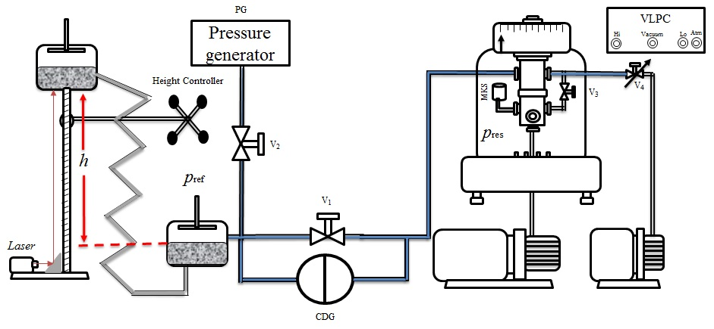
Fig. 4 Experimental setup for cross floating between FPG and HgM in absolute mode.
The FPG pressure was calculated by means of Eq. (5) with two additional components containing the height difference (h) between the pressure reference levels of the FPG and HgM, and the residual pressure $p_{res.}$ on the reference side of FPG, which appears only in the absolute pressure mode,
$$p_{FPG}=\frac{F_{lc}}{A∙[1+(α+β)∙(t-20)]}+p_{res.}-g∙h∙ρ_{l}.$$ | (5)
2.3 FPG vs. static expansion system
The static expansion system SES (Vacuum 40 293-304) [8] is a primary vacuum standard consisting of two stages of expansions starting with small volumes Vol.1 and Vol.2, intermediate volumes Vol.4 and Vol.5, and, at the end, calibration vessel Vol.6, which has a nominal volume of 100 liter (Fig. 5).
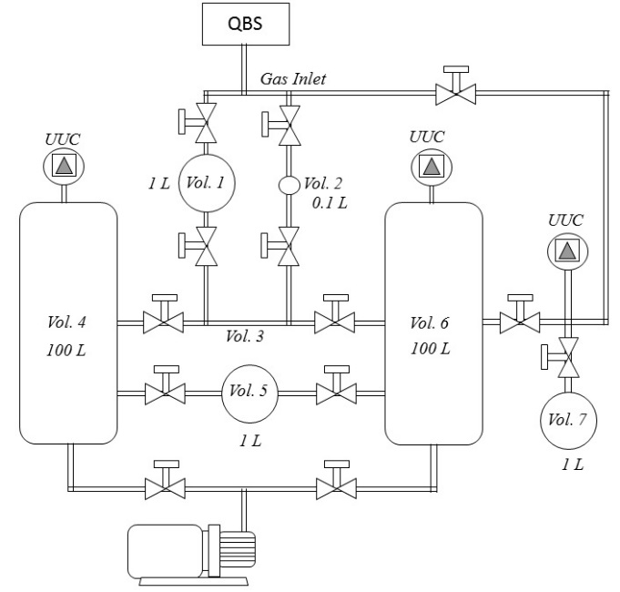
Fig. 5 Design of SES.
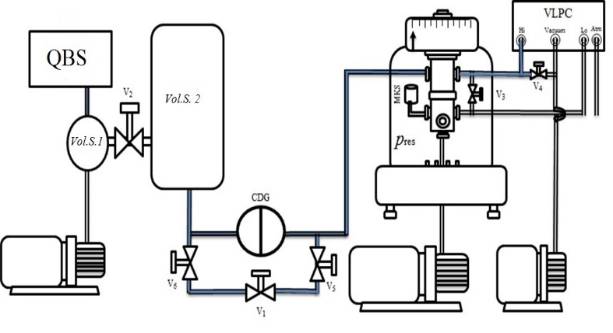 | 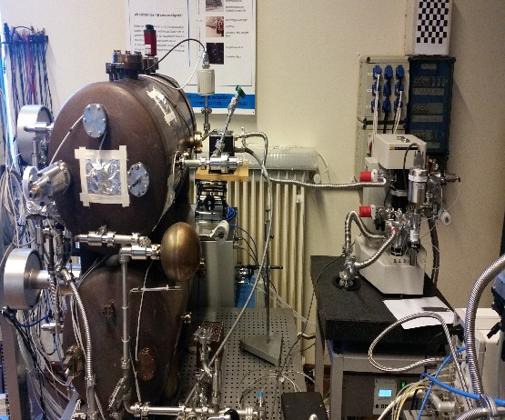
Fig. 6 Experimental setup for comparison between FPG and SES.
UUC is the unit under calibration. This set of volumes enables realization of the expansion ratios f_{i}, which are presented in Table 1.
Table 1 Expansion ratios of SES.
Symbol | Expansion ratio | f
f₁ | $$\frac{Vol. 1}{Vol.1+Vol.3+Vol.6}$$ | 9.1732⋅10⁻³
f₂ | $$\frac{Vol. 2}{Vol.2+Vol.3+Vol.6}$$ | 7.4231⋅10⁻⁴
f₃ | $$\frac{Vol. 1}{Vol.1+Vol.3+Vol.4+Vol.5}$$ | 9.1978⋅10⁻³
f₄ | $$\frac{Vol. 2}{Vol.2+Vol.3+Vol.4+Vol.5}$$ | 7.4378⋅10⁻⁴
f₅ | $$\frac{Vol. 5}{Vol.5+Vol.6}$$ | 9.170⋅10⁻³

A Quartz Bourdon Spiral (QBS) is used to control and measure the initial pressure value p_{fill} when filling the first volume with the nitrogen gas in a range between 1 kPa to 100 kPa. The final pressures produced by SES (p_{S.ref}) in the range of 10 mPa and 1 kPa can be calculated with the mean of Eq. (6),
$$p_{S.ref}=\frac{{f'}_{i}∙p_{fill}∙T_{1}}{T_{0}∙\left(1+\left({p_{fill}∙B}/{\left(R∙T_{0}\right)}\right)\right)},$$ | (6)
where ${f'}_{i}$ is the corrected expansion ratio taking the additional volume of the UUC into account. T₀ is the initial temperature before and T₁ is the final temperature after the expansion. B is the virial coefficient and R is the gas constant.
The SES was used to verify the FPG in the low pressure range from 3 Pa up to 300 Pa. Because of the humidity of nitrogen used inside the FPG and to keep the expansion volume Vol.6 defined, a CDG was always separating both systems, and its readings were taken into consideration in the comparison results.
Fig. 6 shows the experimental setup for the comparison of the FPG with the SES in absolute pressure mode, where the SES is simply sketched with only two volumes. The VLPC was used to control the pressure of the FPG in order to keep the differential pressure measured by the CDG as close to zero as possible.
At the beginning, the QBS was used to set the pressure in Vol.S.1. Then, valves V₂ and V₆ were opened to expand the gas into the bigger volume Vol.S.2 and the tubes connected to the left side of the CDG before V₁. The total volume was measured precisely. The pressure value of SES was calculated according to Eq. 6.
3. Results
Results of the effective area determination from the FPG calibration against the Ruska pressure balance, described in section 2.1, are presented in Table 2 and Fig. 7 for both, gauge and absolute pressure operation modes. In Fig. 7, these experimental results are shown together with the results of the theoretical determination based on dimensional properties of the PCA under application of methods of the rarefied gas dynamics (RGD). There, also the effective area reported by the manufacturer is shown. All experimental and theoretical effective areas agree well with each other on the level of the experimental standard uncertainties.
Table 2 Experimental effective area A and its standard uncertainty u(A) (k = 1) of FPG at nominal pressures p, in gauge and absolute mode
p /  kPa | Gauge mode |  | Absolute mode
p /  kPa | A / cm² | u(A) / cm² | A / cm² | u(A) / cm²
2 |  |  | 9.80592 | 4.8⋅10⁻⁴
3 | 9.80624 | 2.6⋅10⁻⁴ | 9.80601 | 2.5⋅10⁻⁴
5 | 9.80620 | 1.6⋅10⁻⁴ | 9.80600 | 1.8⋅10⁻⁴
6 | 9.80611 | 8.8⋅10⁻⁵ | 9.80602 | 1.8⋅10⁻⁴
8 | 9.80607 | 1.1⋅10⁻⁴ | 9.80601 | 1.5⋅10⁻⁴
10 | 9.80614 | 8.3⋅10⁻⁵ | 9.80601 | 9.4⋅10⁻⁵
11 | 9.80617 | 7.5⋅10⁻⁵ | 9.80606 | 1.0⋅10⁻⁴
13 | 9.80613 | 7.2⋅10⁻⁵ | 9.80598 | 9.4⋅10⁻⁵
15 | 9.80610 | 8.0⋅10⁻⁵ | 9.80599 | 8.7⋅10⁻⁵

Results of pressure comparison between the FPG and the HgM are presented for gauge and absolute mode in Figs. 8 and 9, respectively.
The pressure differences measured in gauge mode scatter stronger than in absolute mode, because the gauge pressure measurements were affected by instability of the atmospheric pressure. Due to considerably different time constants of the FPG and the HgM, temporal reactions of the two instruments on the ambient pressure variations are essentially different leading to the pressure differences observed in the experiment. In addition, the big volume of the tubes connecting the FPG with the HgM caused some difficulties for the pressure control during the measurements. Despite of this, almost all pressure differences are covered by the expended uncertainty (k = 2) of the HgM.
Contrariwise, in absolute pressure mode, the measurements were free of ambient pressure effect, and
Fig. 7 Experimental (Exper.), RGD calculated (Theor.) and manufacturer's (Manuf.) effective areas of FPG in absolute (abs.) and gauge (gauge) mode.
Fig. 8 Differences of pressures measured with FPG and HgM in gauge mode.
the results are characterized by much lower scatter of the pressure differences, see Fig. 9. The differences of pressures measured with the FPG and the HgM are much smaller than the expanded uncertainty of the HgM, which demonstrate a full consistency of the two pressure standards.
In the lowest pressure range of the FPG operation, from 3 Pa to 300 Pa it was verified by the comparison preformed against SES in the absolute pressure mode.
Fig. 9 Differences of pressures measured with FPG and HgM in absolute mode.
The results of this comparison in terms of pressure differences and their uncertainties between the two pressure standards are shown in Fig. 10.
Fig. 10 Differences of pressures measured with FPG and SES in absolute mode.
Above 30 Pa, the pressure differences agree with the expanded uncertainty (k = 2) of the SES. At lower pressures, the scatter of the pressure differences is bigger than the uncertainty of the SES, but still allows making a conclusion about consistency of the standards on the level of 10 mPa.
4. CONCLUSION
For the theoretical and experimental effective area as well as for pressures generated by the FPG and the 3
reference standards based on different operation principles – the pressure balance, the mercury manometer and the static expansion system – all the results demonstrate full agreement within the expanded uncertainties (k = 2) of these standards. Herewith, the FPG already characterized as primary pressure standard is validated experimentally with a support of the FPG standard uncertainty currently estimated as 10 mPa + 6⋅10⁻⁶×p for the pressure range from about 3 Pa to 15 kPa.
5. ACKNOWLEDGMENTS
The first author wishes to thank the Egyptian study mission for their support and funding of his scientific mission at PTB. This research was carried out within the EMPIR jointly funded by the EMPIR participating countries within EURAMET and the European Union.
References
[1] P. Delajoud, M. Girard, "A force balanced piston gauge for very low gauge and absolute pressure", Proc. Metrol. 2001, 22-25 Oct. 2001, St. Louis, France.
[2] A. Hashad, S. Ehlers, O. Jusko, W. Sabuga, "Characterization of a force-balanced piston gauge as a primary pressure standard", Measurement, Vol. 131, pp. 723-729, 2019.
[3] S.Naris, N. Vasileiadis, D. Valougeorgis, A. Hashad, W. Sabuga, "Computation of the effective area and associated uncertainties of non-rotating piston gauges FPG and FRS", Metrologia, Vol. 56, pp.1-10, 2019.
[4] W. Sabuga, T. Priruenrom, R. Haines, M. Bair, "Design and evaluation of pressure balances with 1⋅10⁻⁶ uncertainty for the Boltzmann constant project", PTB-Mitteilungen, Vol. 121, pp. 256-259, 2011.
[5] T. Zandt, W. Sabuga, C. Gaiser, B. Fellmuth, "Measurement of pressures up to 7 MPa applying pressure balances for dielectric-constant gas thermometry", Metrologia, Vol. 52, pp. S305–S313, 2015.
[6] FPG8601™/VLPC™, Operation and Maintenance Manual, DH Instruments, a Fluke Company, 2007.
[7] J. Jäger, "Use of a precision mercury manometer with capacitance sensing of the menisci", Metrologia, Vol. 30, pp.553-558, 1993/94.
[8] T. Bock, H. Ahrendt, and K. Jousten, "Reduction of the uncertainty of the PTB vacuum pressure scale by a new large area non-rotating piston gauge", Metrologia, Vol. 46, No. 5, pp. 389–396, 2009.

