Non-destructive pole-figure measurements on workshop-made silver reference models of archaic objects
Máté Sepsi, Márton Benke, Valéria Mertinger
Institute of Physical Metallurgy, Metal Forming and Nanotechnology, University of Miskolc, Miskolc-Egyetemváros H3515 Hungary
ABSTRACT
Based on the knowledge of crystallographic texture, the parameters of the metal-forming heat treatment of metallic objects can be reconstructed well when conventional technologies (e.g. rolling, deep drawing, etc.) are applied. The characterisation of texture has been possible only by using destructive techniques, apart from neutron diffraction. Recently, a non-destructive texture measurement method has been developed for centreless diffractometers, providing a new dimension to the examination of archaic objects. In the present study, two types of Stresstech G3R centreless diffractometer were used with this new method, which proved it to be applicable to both the tabletop and robotic arm-assisted versions of the diffractometer. Although the texture of archaic objects can be revealed using this method, the production of these objects cannot be directly deduced from the results, since their manufacturing steps are not identical to the metal-forming operations applied today. In this study, workshop-made silver reference samples were produced with the help of three silversmiths. Wrinkling, metal spinning and intermediate annealing were applied to the rolled silver sheet with the aim of making real-sized silver cups. The workshop-made reference cups were then subjected to non-destructive texture examinations. The results reveal the textures developed during the conventional manufacturing steps of silver cups. The obtained information greatly assists future research in understanding the pole figures of archaic objects and the reconstruction of their manufacturing technology.

Section: RESEARCH PAPER
Keywords: non-invasive; non-destructive crystallographic texture; X-ray diffraction; archaic silver model object
Citation: Thomas Bruns, Dirk Röske, Paul P. L. Regtien, Francisco Alegria , Template for an Acta IMEKO paper, Acta IMEKO, vol. A, no. B, article C, Month Year, identifier: IMEKO-ACTA-A (Year)-B-C
Section Editor: name, affiliation
Received month day, year; In final form month day, year; Published Month Year
Copyright: This is an open-access article distributed under the terms of the Creative Commons Attribution 3.0 License, which permits unrestricted use, distribution, and reproduction in any medium, provided the original author and source are credited.
Funding: [Optional, if applicable] The present paper was supported through the National Research, Development and Innovation Office – NKFIH K119566 project and the EFOP-3.6.1-16-00011 ‘Younger and Renewing University – Innovative Knowledge City – institutional development of the University of Miskolc aiming at intelligent specialisation’ project, implemented in the framework of the Szechenyi 2020 programme. The realisation of this project is supported by the European Union, co-financed by the European Social Fund. This work was supported by the Janos Bolyai Research Scholarship of the Hungarian Academy of Sciences. The authors are very grateful to Tamás Zoltán, Miklós Varga, István Kéry, silversmith experts, for their contribution to the production of the reconstructed objects.
Corresponding author: Paul P. L. Regtien, e-mail: paul@regtien.net

- Introduction
Crystalline metallic materials are typically polycrystalline. The orientation of the polycrystals can be random (isotropic) or oriented (anisotropic). Crystallographic anisotropy (often called crystallographic texture or texture) can be caused by many effects, such as unidirectional crystallisation with controlled cooling [1]-[5]. In this case, the deviation of the crystals from the random orientation distribution is caused by the directionality of heat dissipation. In the case of complex-shaped objects, the crystallisation texture can also be very complex. Furthermore, this texture is non-stable because, in most cases, it is modified during the subsequent stages of processing. In contrast, plastic deformation, especially the cold forming process, produces a characteristic crystalline arrangement and texture. However, notable changes are caused by annealing, which follows the forming process. One of the great challenges for today's engineers is to influence and design the texture of metals using appropriate technology. The nature of the existing texture is clearly dependent on the metal crystalline lattice, thus on the nature and degree of plastic deformation. Depending on the temperature of the heat treatment, so-called recrystallisation processes can also cause characteristic changes in the texture of a given type of alloy. The recrystallised texture is generally dependent on the crystal lattice and material properties, but several process parameters cause typical modifications. Measuring, controlling and designing crystallographic texture is a very well-known technique in the industry, as texture formation can be controlled well by the applied technological processes [6]-[10].
The most common representation of texture is the pole figure, which is a two-dimensional stereographic projection in which the positions and intensities of specific crystallographic orientations are plotted in relation to the specimen geometry. Stereographic projection is a two-dimensional projection of a three-dimensional crystal such that the angular relationships between different planes, different directions, and between crystalline planes and directions in the crystal can be easily identified from the projection. Thus, a stereographic projection is an ‘angle-true’ projection in just the same way as a geographic atlas is a two-dimensional ‘area-true’ projection of a three-dimensional globe. The conventional techniques for measuring crystallographic texture are based on neutrons [11], X-ray [1]-[3] or electron backscatter diffraction [1]-]3], which involve the determination of several pole figures and ODFs (orientation distribution function) for the investigated materials. The main difference between these methods is the size of the examined volume and, thus, the number of crystals involved in the examination.
Based on reverse engineering theory, we assume that the characterisation of the texture can be used to reconstruct the applied technological operation for archaic objects. This logical theory has not been widely used in archaeometry because texture characterisation, apart from neutron diffraction, could only be used in a way that was destructive until last year [12]-[14].
Neutron diffraction is an excellent test method, especially for tomography. There is no other method that provides as much information about the inside of objects without causing destruction. Therefore, it is also particularly popular in the field of archaeometry [15]-[17]. When examining metal objects, internal defects often provide information about the manufacturing technology [18]-[20]. Examination of bronze coins is widespread mainly due to the small layer thickness and size of the coins, which allows multiple coins to be illuminated simultaneously. It is also easy to detect compositional inhomogeneity, which can also be a useful tool in originality (genuine or fake) testing. Kockelmann [22] examined 16th-century silver/copper coins from the Vienna Museum with neutron diffraction to determine whether they were original or fake. The rolling texture of the tested coins was the original coin in the silver and copper phase, while the fake coins differed not only in their composition but also in their texture, as they were produced primarily by casting.
The problem with using neutrons is that they have limited access to the source and that they also activate the object. Furthermore, especially in the case of silver, an isotope with a long half-life is formed. [20]. In other cases, isotopes can be very useful when used to determine the location of a metal ore [23]. Despite the limitations of the neutron source, neutron texture studies have been performed on archaic finds. In the case of bronze axes and other objects, neutron texture studies have provided additional information about the age of manufacturing based on the different characteristic forming methods of different ages [24]-[27]. The texture formed by different manufacturing steps, such as shaping and heat treatment, can also be distinguished [28]. In 2007, Artioli [29] studied 20 copper axes from the Neolithic to the early Bronze Age from different sites using neutron diffraction. Based on this work, the axes can be divided into the following groups in terms of production: cold forming and subsequent annealing, pure annealed, cast and very slow cooling during casting. With the synthesis of ODF (showing the orientation of every unit cell within the examined volume), details (which had been preserved for more than five thousand years) were identified, such as that the cold forming had taken place in one or two directions and that it had been applied before the annealing heat treatment or directly after casting. In contrast, there are few test results relating to the texture of gold [30]. Due to the previously mentioned activation problem, there are even less examples relating to the examination of the texture of silver [22], [31].
The undoubted advantage of the X-ray diffraction test method over the neutron source is that the devices are easily accessible, and there are even mobile devices available on the market; there is also no activation problem. Conventional diffractometers, however, are only capable of accommodating small samples. Parallel beam devices are alone in being capable of examining smaller objects. An example of X-ray diffraction is found for small objects where parallel beam alignment with the Göbel mirror can be a solution [32]. Chiari et al. [33] used a mobile XRF-XRD (X-ray fluorescence spectrometry combined with X-ray diffraction) device to determine the age and production steps of museum objects with similar considerations. Their article highlights the mobility of their X-ray diffraction equipment and its benefits, as well as the growing requirement for non-destructive testing using these mobile devices in situ. Our experience is similar in the field of archaeometry, namely that the laboratory testing of objects is often very difficult, and museums prefer on-site measurements primarily because moving and monitoring high-value objects requires armed security personnel. Because of this need, transportable equipment may have advantages over neutron diffraction, in which the neutron source is stationary, operates with long exposure times and activates the objects.
In the last two years, a new non-destructive pole-figure measurement method for centreless X-ray portable diffractometers in modified CHI mode has been developed and patented [12] (modified CHI mode refers to the position and tilting of the X-ray source relative to the sample). The maths of the method, comparison of the centreless measurements with the conventional ones and validation process on rolled aluminium sheets have been presented in detail in our earlier paper [13]. The method has been further developed over the past year, and it has been demonstrated that it is also possible to construct a semi-full pole figure from data originally acquired during the residual stress measurement (reverse modified CHI mode) [14]. A special version of centreless diffractometers is robot armed, which is also available on the market. In the case of a texture measurement, this configuration means that the object does not have to be rotated, even on a rotation table, because the measuring head performs all the necessary movements. A further advantage is that the beam path of conventional diffractometers can be achieved (CHI mode) by using a measuring arm originally developed for the measurement of retained austenite, and due to the centreless configuration, sampling is still not necessary. This further expands the freedom of measurement, which is especially advantageous when examining unique archaic objects. In this paper, the model objects were also measured using a robot diffractometer in modified CHI mode, and this measurement setup has also been validated.
A collection of archaic objects, the Seuso Treasure [34], was first subjected to an onsite residual stress measurement in the Hungarian National Museum to identify the production technique. It then became clear that by measuring a pole figure, we could get considerably more relevant information. The stress measurement data was subjected to describe the anisotropy (specific section of the pole figure) of the perfume box [35]. After developing the method, we measured each piece of the Seuso Treasure and determined incomplete pole figures. The pole figures obtained are not similar to the pole figures of metal produced by any of the known industrial metal-forming technologies; therefore, model silver objects were produced by well-known silversmiths, Tamás Zoltán, Miklós Varga and István Kéry. They have a lifetime’s experience, especially working on silver. They applied two different methods, metal spinning and wrinkling, to produce silver cups, and the pole figures were determined from the model objects. In the present study, the production of the model objects and their non-destructive pole figures are presented. The measured and calculated pole figures of the model objects, which have been subjected to well-documented production methods, will help to interpret pole figures of archaic silver objects where the production technology is not yet clearly described.
- Preparation of workshop-made silver reference model objects
  - Wrinkling cup
Since silver has excellent formability, most metal-forming techniques can be applied to it. However, our metal-forming experience based on modern industrial techniques does not necessarily help us understand the production technology of archaic objects. Fortunately, silver and coppersmiths continue to use techniques now that are suspected to have been used in the production of archaic objects. Following the silversmiths’ suggestion, as a first step, two model cups were produced using wrinkling and metal spinning techniques. In both cases, pure 2 mm-thick silver sheets were used for the model objects with dimensions of 120 x 120 mm. First, the silversmith annealed the sheets using a gas jet, rolled them on a hand-driven rolling mill and cut a disk with scissors (Figure 1). The wrinkling process was the following: the base of the cup was marked off on a wooden mould with a steel hammer, in the same way as the wrinkles on the cylinder. After creating contours and wrinkles, the wrinkles were shrunk and hammered from the bottom to the top in overlapping circles (Figure 2).
After hammering, the hardened silver was annealed again using a gas jet and cleaned with a hot borax solution, and the creation and shrinking of the wrinkles and the annealing was repeated twice more to decrease the angle between the cylinder and base of the cup. The final hammering was performed on a metal anvil (Figure 3). In the last two pictures of Figure 3, the finished wrinkled silver cup and the initial sheet can be seen.
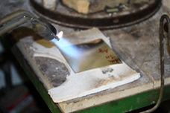 | 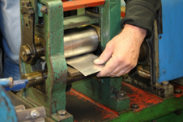
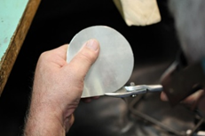
Figure 1. Annealing, rolling and cutting the initial silver sheet.
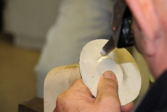 | 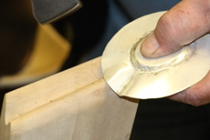
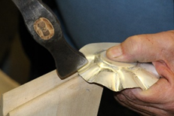 | 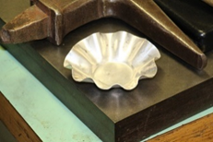
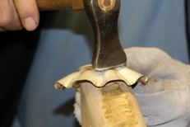 | 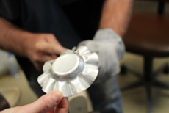
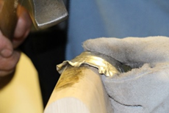 | 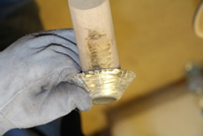
Figure 2. Initial steps of preparing a wrinkling cup. Creating contours and wrinkles and the hammering of the wrinkles.
  - Metal spinning cup
The other silver model cup was produced by metal spinning. The initial material was the same as in the previous case, a circle-like disk from a rolled and annealed sheet. Generally, metal spinning is performed on a turning-like machine. To mould the disk, it is pressed against a formed block on the driver by a tool called a ‘spoon’ while the disk is spinning. In our case, the spoon was a round-ended steel bar, which pressed the disk from the middle to the edge on the formed block. During the metal spinning process, intermediate annealing was applied because of the extended hardening process of silver. The method for annealing was the same as that used during the wrinkling procedure. Before removing the prepared cup, the bottom, which was conical, was smoothed using a flat steel tool (Figure 4). The figure clearly shows that the rim of the cup is heavily wrinkled. This is because the machining pad was originally not optimised for metal spinning. This wrinkled rim was cut off with a lathe knife to prevent interference during further examinations.
The initial sheet with the rolling direction (RD) indicated and the model objects prepared by metal spinning and wrinkling can be seen in Figure 5. The blue numbered dots mark the measured locations of the subsequent pole-figure measurements.
- Pole-figure measurements
The new, reverse modified CHI method was introduced in [13], [14] using a Stresstech G3R-type centreless diffractometer with a CrKα source, operating with 30 kV tube voltage and 9 mA tube current. The χ values used were -59° + 59°, with 5° increments, and ϕ was chosen as -90…+ 90°, with 5° increments. A Stresstech XStress Robot centreless diffractometer was also used to extend the theta limitation and verify the setup. CrKα radiation was used at 30 kV and 9 mA. The measurements were performed using both the {222} and the {311} silver plane systems, and defocus correction was carried out on the Ag powder. The absorption-corrected pole figures were plotted by Origin software. The tests were performed on the initial metal sheet (Figure 5) at two locations on the cylinder of the metal spinning cup (lower cylinder - No. 1 and upper cylinder - No. 2) and at three locations on the wrinkling cup (bottom - No. 1, lower cylinder - No. 2 and upper cylinder - No. 3). Figure 6 shows the {222} and {311} pole figures of the objects, where the texture number increases from blue to green to red, and Figure 7 shows the measurements.

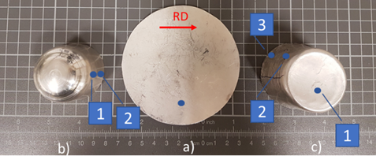
Figure 5. a) The initial sheet and the reference objects: b) metal spinning cup, c) wrinkling cup. Blue numbered dots mark the pole-figure measured points, while the red arrow indicates the rolling direction (RD).
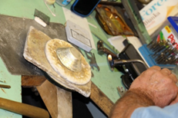 | 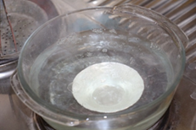
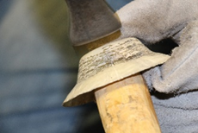 | 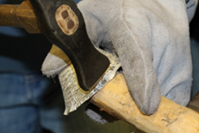
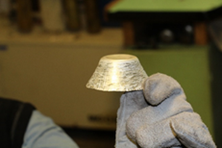 | 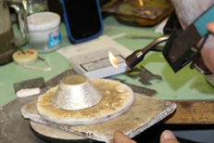
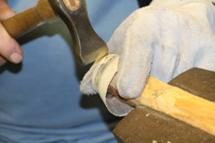 | 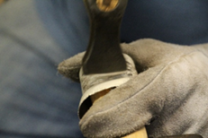
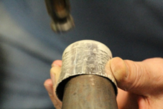 | 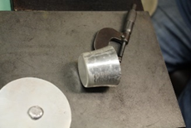
Figure 3. Subsequent steps for preparing the wrinkling cup. Annealing twice, cleaning and hammering from the bottom to the top.
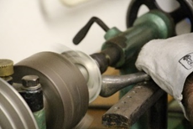 |  | 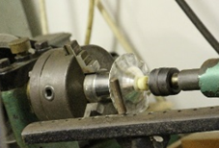
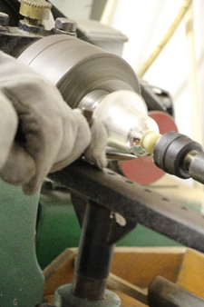 | 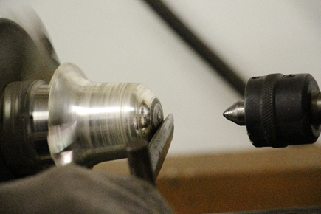
Figure 4. Preparing a silver cup by metal spinning.
The initial sheet’s {222} pole figure shows a characteristic texture. The same character and the homogeneous distribution of {311} can also be seen on the bottom of the wrinkling cup, but there is only a slight angular rotation between the two poles because the test site and the starting point of the pole figure are randomly selected. This is, of course, an expected result, as the operation, in contrast to the metal spinning, has left the base of the vessel almost unaffected. It is important to remember that during the operation, the annealing process was carried out twice, which was necessary to further deform the object, but it did not result in recrystallisation. Recrystallisation is a diffusion-controlled process that can completely eliminate the effect of the previous deformation in the crystal structure if the process is fully completed. The lower part of the cylinder further enhances the shaping character, while the upper part shows a homogeneous character, which may be the result of strong multiple hammering alone or combined with softening. The rate of recrystallisation is proportional to the degree of shaping, so that recrystallisation begins at the top of the cup because of the intermediate softening.
The metal spinning cup’s pole figure shows an image of a completely different character. The pole figure of {222} is reminiscent of a fibre texture at both the bottom and the top of the cylinder. The difference between the two textures may indicate the same shaping behaviour at different degrees. The metal spinning vessel received an intermediate annealing during the forming of the metal.
Comparing the results of the two measurement methods, we can conclude that the pole figures obtained with the robot diffractometer and the G3R diffractometer are identical.

{222} | {311} | {222} | {311}
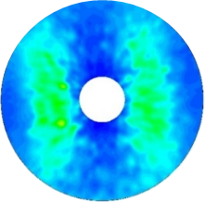 | 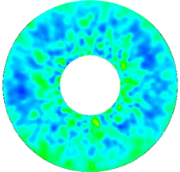 | 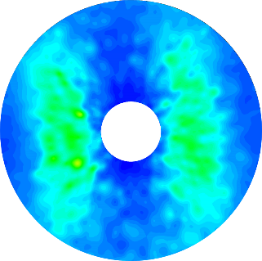 | 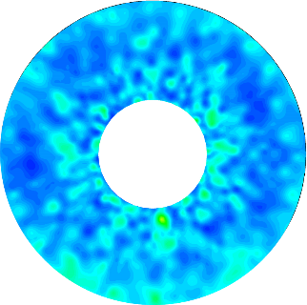
G3R |  | Robot diffractometer
Initial silver sheet
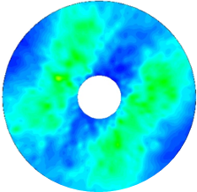 | 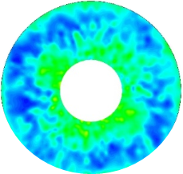 | 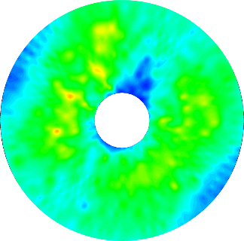 | 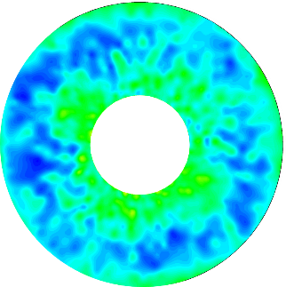
G3R |  | Robot diffractometer
Bottom of the wrinkling cup
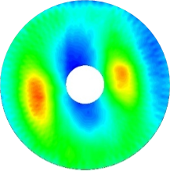 | 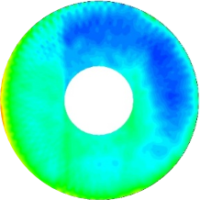 | 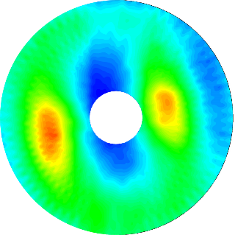 | 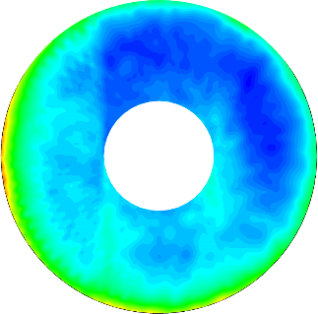
G3R |  | Robot diffractometer
Lower cylinder of the wrinkling cup
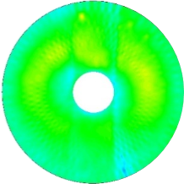 | 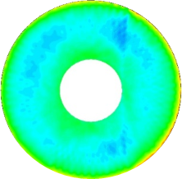 | 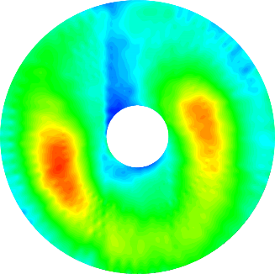 | 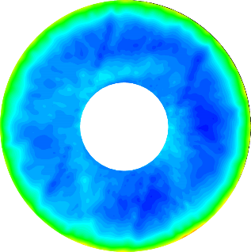
G3R |  | Robot diffractometer
Upper cylinder of the wrinkling cup
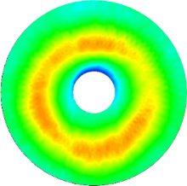 | 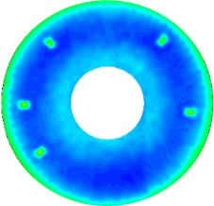 | 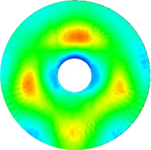 | 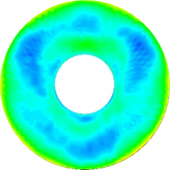
G3R |  | G3R
Lower cylinder of the metal spinning cup |  | Upper cylinder of the metal spinning cup.
Figure 6. Pole figures determined by the G3R and the robot diffractometers in modified PSI mode at different locations on the model objects.
- Summary
Silver reference cups were produced using metal-spinning and wrinkling techniques by silversmiths. The pole figures were measured with two types of non-invasive X-ray diffractometer setups in reverse modified CHI mode.
It was concluded that the non-destructive pole-figure method is an efficient way to distinguish between metal objects formed in different ways. The specific forming modes result in specific pole figures. By producing and examining a sufficient number of reference materials, the mode of production of archaic objects can also be reconstructed.
The pole figures obtained by the robot diffractometer are identical to the figures of the previously validated G3R diffractometer. However, further analyses on other materials are necessary if the robot diffractometer can be considered as validated in modified CHI mode for general texture analysis.
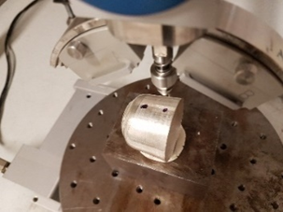 | 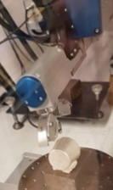
a) | b)
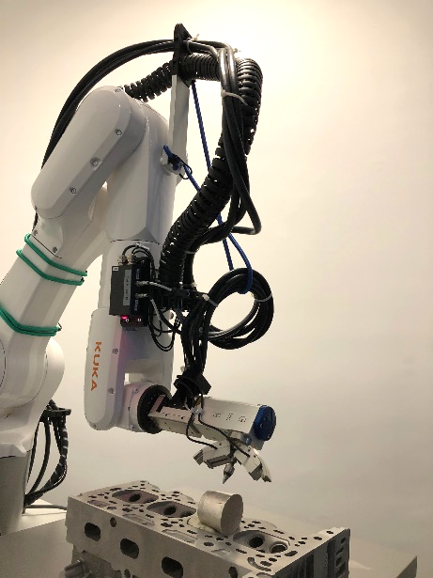
c)
Figure 7. Pole-figure measurement in modified CHI mode of a) metal spinning and b) wrinkling cup by centreless X-ray diffractometer and c) in CHI mode of wrinkling cup by robot-armed centreless X-ray diffractometer.
Acknowledgement
The present paper was supported through the National Research, Development and Innovation Office – NKFIH K119566 project and the EFOP-3.6.1-16-00011 ‘Younger and Renewing University – Innovative Knowledge City – institutional development of the University of Miskolc aiming at intelligent specialisation’ project, implemented in the framework of the Szechenyi 2020 programme. The realisation of this project is supported by the European Union, co-financed by the European Social Fund. This work was supported by the Janos Bolyai Research Scholarship of the Hungarian Academy of Sciences. The authors are very grateful to Tamás Zoltán, Miklós Varga, István Kéry, silversmith experts, for their contribution in the production of the reconstruction reference material. Many thanks to Mária Tóth Totyi, who contributed her constructive ideas to the development of the measurement methods.
References
- S. Suwas, R. Ray Kumar, Crystallographic Texture of Materials, Springer-Verlag, London, 2014, ISBN 978-1-4471-6314-5.
- O. Engler, V. Randle, Introduction to Texture Analysis – Macrotexture, Microtexture and Orientation Mapping, CRC Press, 2010.
- U. F. Kocks, C. N. Tomé, H.-R. Wenk, Texture and Anisotropy, Cambridge University Press, Cambridge, 1998, ISBN 0-521-46516-8.
- H.-J. Bunge, Texture Analysis in Materials Science, Butterworth & Co, London, 1982, ISBN 0-408-10642-5.
- A. Rollet, F. Humphreys, M. Hatherly, Recrystallization and Related Annealing Phenomena, 3rd edition, Elsevier, 2017.
- H. Li, D. Wei, H. Zhang, H. Yang, H. Liu, S. Liu, Z. Chu, D. Zhang, Texture evolution and controlling of high-strength titanium alloy tube in cold pilgering for properties tailoring, Journal of Materials Processing Tech. 278 (2020) 116520.
- D. Liu, Z. Liu, E. Wang, Improving single pass reduction during cold rolling by controlling initial texture of AZ31 magnesium alloy sheet, Trans. Nonferrous Met. Soc. China 28 (2018) pp. 244-250.
- O. Engler, J. Aegerter, D. Calmer, Control of texture and earing in aluminium alloy AA 8011A-H14 closure stock, Materials Science & Engineering A775 (2020) 138965.
- B. Song, Q. Yang, T. Zhou, L. Chai, N. Guo, T. Liu, S. Guo, R. Xin, Texture control by {10-12} twinning to improve the formability of Mg alloys: a review, Journal of Materials Science & Technology 35 (2019) pp. 2269-2282.
- T. Ishimoto, K. Hagihara, K. Hisamoto, S.-H. Sun, T. Nakano, Crystallographic texture control of beta-type Ti–15Mo–5Zr–3Al alloy by selective laser melting for the development of novel implants with a biocompatible low Young's modulus, Scripta Materialia 132 (2017) pp. 34-38.
- W. Kockelmann, A. Kirfel, S. Siano, C. D. Frost, Illuminating the past: the neutron as a tool in archaeology, Phys. Educ. 39 (2004) p. 155.
- M. Benke, V. Mertinger, M. Sepsi, V. Karpati, Measuring Methods for Centerless X-ray Diffractometers to Obtain Pole Figures and their Cuts in Ω and Modified Ψ Modes, Hungarian patent P1600500.
- M. Sepsi, V. Mertinger, M. Benke, Sample cutting-free pole figure measuring method for centreless diffractometers in modified X mode, Mat. Char. 151 (2019) pp. 351-357,
- V. Mertinger, M. Sepsi, M. Benke, Non-destructive texture measurement methods for centreless X-ray diffractometers in reverse modified (CHI) mode, J. Phys.: Conf. Ser. 1270 012012, 2019 Proc. of 7th International Conference on Recrystallization and Grain Growth, Ghent, Belgium, 2019.
- W. Kockelmann, A. Kirfel, Non-destructive phase analysis of archaeological ceramics using TOF neutron diffraction, J. Archaeol. Sci. 28 (2001) pp. 213-222.
- R. Coppola, A. Lapp, M. Magnani, M. Valli, Small angle neutron scattering investigation of microporosity in marbles, Appl. Phys. A 74 (2002) pp. S1066-S1068.
- D. Barilaro, V. Crupi, D. Majolino, V. Venuti, G. Barone, G. Tigano, S. Imberti, W. Kockelmann, A non-invasive analysis of ‘proto-majolica’ pottery from southern Italy by TOF neutron diffraction, J. Phys.: Condens. Matter 20 (2008) 104254.
- F. Salvemini, S. R. Olsen, V. Luzin, U. Garbe, J. Davis, T. Knowles, K. Sheedy, Neutron tomographic analysis: material characterization of silver and electrum coins from the 6th and 5th centuries BCE, Materials Characterization 118 (2016) pp. 175-185.
- F. Salvemini, S. R. Olsen, V. Luzin, U. Garbe, J. Davis, T. Knowles, K. Sheedy, Neutron tomographic analysis: material characterization of silver and electrum coins from the 6th and 5th centuries BCE, Materials Characterization 118 (2016) pp. 175-185.
- E. H. Lehmann, E. Deschler-Erb, A. Ford, Neutron tomography as a valuable tool for the non-destructive analysis of historical bronze sculptures, Archaeometry 52 (2010) pp. 272-285.
- M. Griesser, R. Traum, K. Vondrovec, P. Vontobel, E. H. Lehmann, Application of x-ray and neutron tomography to study antique Greek bronze coins with a high lead content, IOP Conf. Ser.: Mater. Sci. Eng. 37 (2012) 012011.
- W. Kockelmann, Neutron diffraction studies of archaeological objects on ROTAX, Physica B: Condensed Matter. 350 (2004) 10.1016/j.physb.2004.03.156.
- G. Davis, D. B. Gore, K. A. Sheedy, F. Albarede, Separating silver sources of archaic Athenian coinage by comprehensive compositional analyses, Journal of Archaeological Science 114 (2020) 105068.
- R. Arletti, L. Cartechini, R. Rinaldi, S. Giovannini, W. Kockelmann, A. Cardarelli, Texture analysis of bronze age axes by neutron diffraction, Appl. Phys. A 90 (2008) pp. 9-14.
- L. Cartechini, R. Rinaldi, W. Kockelmann, S. Bonamore, D. Manconi, I. Borgia, P. Rocchi, B. Brunetti, A. Sgamellotti, Non-destructive characterization of compositional and textural properties of Etruscan bronzes: a multi-method approach, Appl. Phys. A 83 (2006) pp. 631-636.
- S. Siano, L. Bartoli, W. Kockelmann, M. Zoppi, M. Miccio, Neutron metallography of archaeological bronzes, Physica B 350 (2004) pp. 123-126.
- S. Siano, L. Bartoli, J. R. Santisteban, W. Kockelmann, M. R. Daymond, M. Miccio, G. D. Marinis, Non-destructive investigation of bronze artefacts from the Marches National Museum of Archaeology using neutron diffraction, Archaeometry 48 (2006) pp. 77-96.
- E. Pantos, W. Kockelmann, L. C. Chapon, L. Lutterotti, S. L. Bennet, M. J. Tobin, J. F. W. Mosselmans, T. Pradell, N. Salvado, S. Butı́, R. Garner, A. J. N. W. Prag, Neutron and X-ray characterisation of the metallurgical properties of a 7th century BC Corinthian-type bronze helmet, Nuclear Instruments and Methods in Physics Research B 239 (2005) pp. 16-26.
- G. Artioli, Crystallographic texture analysis of archaeological metals: interpretation of manufacturing techniques, Applied Physics A. 89 (2004) pp. 899-908.
- F. E. Wagner, R. Gebhard, W. Gan, M. Hofmann, The metallurgical texture of gold artefacts found at the Bronze Age rampart of Bernstorf (Bavaria) studied by neutron diffraction, Journal of Archaeological Science: Reports 20 (2018) pp. 338-346.
- Y. Xie, L. Lutterotti, H. R. Wenk, F. Kovacs, Texture analysis of ancient coins with TOF neutron diffraction, Journal of Materials Science 39 (2004) pp. 3329-3337.
- A. Duran, L. Herrera, M. Jimenez de Haro, A. Justo, J. Perez-Rodriguez, Nondestructive analysis of cultural heritage artefacts from Andalusia, Spain, by X-ray diffraction with Göbel mirrors, Talanta 76 (2008) pp. 183-188.
- G. S. Chiari, Non-conventional applications of a noninvasive portable X-ray diffraction/fluorescence instrument, Appl. Phys. A (2016) 122: 990.
- M. M. Mango, A. Bennett, The Sevso Treasure, Thomson-Shore, Dexter, 1994, ISBN 10-1887829121.
- M. Sepsi, V. Mertinger, M. Benke, Utilization of spatial resolved qualitative texture assessment method on an object of the Seuso Treasure, IOP Conf. Ser.: Mater. Sci. Eng 375 (2018) 012036.

