Integrated approach for non-invasive diagnostic investigation at the Bishop’s Palace of Frascati

Luisa Caneve1, Francesco Colao2, Massimiliano Guarneri3, Marialuisa Mongelli4,

Valeria Spizzichino5, Massimo Francucci 6

1 ENEA, Via Enrico Fermi 45, 00044 Frascati (Rome), [luisa.caneve@enea.it](mailto:luisa.caneve@enea.it)

2 ENEA, Via Enrico Fermi 45, 00044 Frascati (Rome), francesco.colao@enea.it

3 ENEA, Via Enrico Fermi 45, 00044 Frascati (Rome), massimiliano.guarneri@enea.it

4ENEA, Lungotevere Thaon di Revel 76, 00196 Rome, [marialuisa.mongelli@enea.it](mailto:marialuisa.mongelli@enea.it)

5 ENEA, Via Enrico Fermi 45, 00044 Frascati (Rome), [valeria.spizzichino@enea.it](mailto:valeria.spizzichino@enea.it)

6 ENEA, Via Enrico Fermi 45, 00044 Frascati (Rome), massimo.francucci@enea.it

*Abstract* – Artistic surfaces at the Bishop’s Palace of Frascati have been investigated by an integrated approach involving different non-invasive technologies. Information on previous restoration actions are reported in this paper.

1. Introduction

In the frame of the ADAMO project (Analysis, Diagnostic and Monitoring for the Cultural heritage conservation and restoration), financed by Lazio Region for Technological Cultural District (DTC Lazio), a campaign of measurements has been developed at the Bishop’s Palace of Frascati, ancient fortress of the town near Rome, in the past, and domicile of Episcopal Tuscolana Diocese nowadays. The measurementshave been performed, in order to check the state of the previous restoration work. Following the requests of the holder of the Palace, particular attention has been devoted, in this study, to the investigation of the so called “*stufetta*” room at the ground floor of the Palace (Fig.1), and the “*Landscape room*”, adorned with framed views of garden, at the first floor. An integrated investigation approach has been adopted involving different technologies and instruments with the common characteristic to be non-invasive at all. A LIF (Laser Induced Fluorescence) system developed at Diagnostic and Metrology Laboratory of ENEA, already applied as diagnostic tool in Cultural Heritage investigations, has been used. Thanks to its unique properties of being a non-destructive and non-invasive remote technique, with no sampling requirements, based on transportable or portable instruments that can provide first results in real time, LIF is a suitable tool also for the characterization of valuable and unmovable targets [1,2]. LIF technique has been already successfully applied in archaeological sites, making available useful information to the restorers [3,4]. The validity of the technique as diagnostic tool for artworks of different materials, like paintings, wood and stone, has been also demonstrated [5,6,7]. The LIF instrument is able to acquire fluorescence spectra and generate multispectral images for obtaining component materials maps of the investigated surface, useful for the identification and the characterization of materials of interest. This technology worked, in this study, in synergy with other non-invasive techniques, suitable for localizing the bio-deteriorated areas and the added restoration materials as well as to focus some details to support and integrate the experimental results. In particular, *SfM* (Structure from Motion) technique [8] was used to obtain the 3D photogrammetric reconstruction of the painted vault of the “stufetta” and the RGB-ITR 3D laser scanner prototype was used for digitalizing the “Landscape Room”. This 3D laser scanner has been already used for remote diagnostic of cultural heritage [9,10]. The obtained results highlighted the localized presence on the surface of different materials, due to retouching or consolidating processes, also in areas where significative differences are not appreciable by naked eye. Deterioration phenomena, mainly due to environmental humidity, have been in addition localized by the systems also in some points where they were not clearly evident, suggesting the possibility of damage early detection. The combined use of the different instruments offered several advantages. In particular, the possibility to overlap the LIF spectral maps to the 3D photogrammetric model, obtained in a short medium range of distance, and to the 3D laser colored model obtained by RGB-ITR scanner, also in case of low light conditions, allowed to perfectly localize, also at great distances, the points on the surface submitted to degradation actions. The available techniques for the bio-degradation characterization and monitoring [11,12] can be supported by the presented approach. Moreover, the ability of measuring in situ, remotely, besides to assure the complete non-invasiveness, eliminates the use of scaffolds, reducing the time and the cost of the analysis. The results of the proposed integrated approach can be of great usefulness for the site conservation 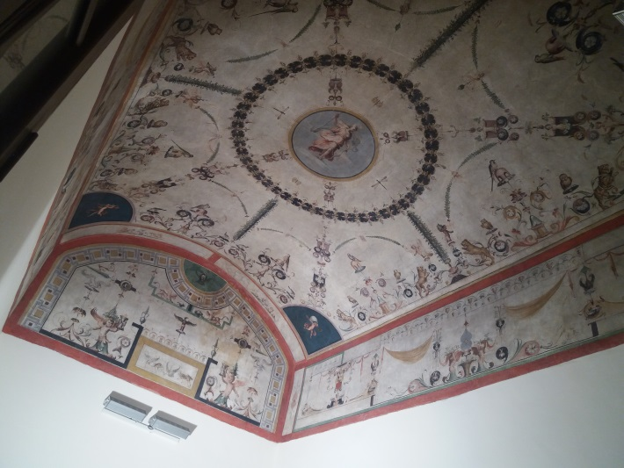

*Fig. 1. Stufetta vault at the Bishop’s Palace of Frascati.*

helping in monitoring the degradation processes and identifying the most correct restoration process in very rapid time.

1. EXPERIMENTAL
2. LIF system

The system applied in this work for fluorescence measurements is the ENEA prototype LIF line scanning system, in which a cylindrical lens in the optical path modifies the shape of the laser beam on the target from a point to a line. This system, shown in Fig.2 during the measurements at the Palace, is described in detail in previous published papers [13,14]. The improvement of the optical system together with the new rotating mechanical assembly induce the considerable reduction of the scan time, 1.5×5m2 scanned in less than 2 minute at 25 m, respect to previous developed similar systems [15], making this instrument particularly suitable for large areas analysis. The handling of motorized optics by software permits the laser beam, working in this case at the wavelength of 266 nm, with a repetition rate of 20 Hz, pulse duration of 10 ns and energy of 1.2 mJ, to carry out a scan of the surface. The whole fluorescence spectrum in the 270-900 nm range for every examined point and fluorescence images of the scanned surface are generated by the system. Fluorescence images can be elaborated and reconstructed in false colour by using the three most intense detected bands, corresponding to the main features, as Red, Green and Blue channels (RGB), respectively. The LIF measurements have been performed in this case at a distance from the target of about 3 meters.

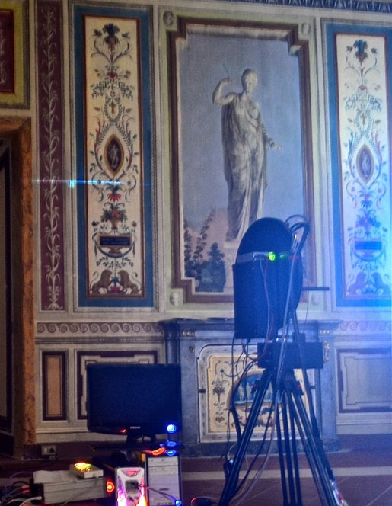

Fig. 2. LIF system operating at the Bishop’s Palace of Frascati. Laser beam line visible on the left wall.

1. Photogrammetry

The photogrammetric scanning of the stufetta tunnel vault was carried out by Nikon D60 reflex digital camera with a resolution of 10.2 MPixel. 2D digital images were remotely post-processed by Photoscan Pro, via Internet, through IT@CHA virtual lab, completely dedicated to cultural heritage applications. IT@CHA was developed for accessing, via web, to graphic codes, processing digital images and producing 3D spatial data by hardware/software capabilities of the High Performance Computing (HPC) ENEA ICT Infrastructure named CRESCO, (Research Computational Centre on Complex Systems) distributed over 6 geographical sites in Italy. In addition the CRESCO system allows to handle heavy jobs for 3D reconstructions by providing facilities in computing, storage resources and 3D data rendering tools [16].

1. RGB-ITR 3D laser scanner

The RGB-ITR (Red Green and Blue – Imaging Topological Radar) is a LIDAR scanner based on the amplitude modulation of laser beams and lock-in technique for both colour and structure information 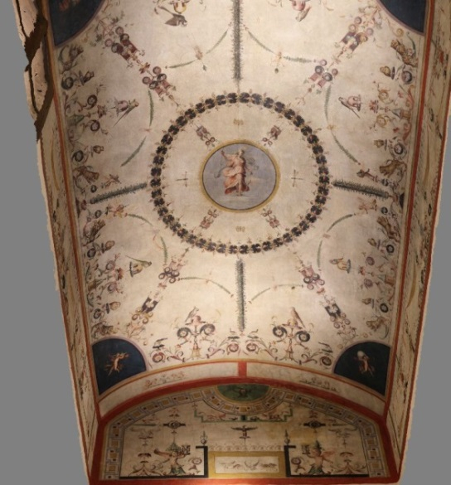

*Fig. 3. 3D photogrammetric reconstruction of the stufetta tunnel vault.*

estimation [17]. This instrument can work during 24 hours without the influence by external factors, like the variability of the ambient light factors. Differently from other laser scanners, the RGB-ITR system drives the beam on the surface drawing a TV-like raster, which ensures the same resolution on the lateral walls and the top. The entire digitalization was performed placing the scanner in the middle of the room and rotating the optical head when the entire field of view was punctually covered by the laser beams. Also if in this particular case the laser scanner operated approximately at a distance of 5m, the instrument can operate up to 35m. The resulting spot size of the three super-imposed laser beams was 0.3mm, while the spatial resolution was set at 0.5 mm as a good compromise between the scanning time and the image resolution. During the acquisition phase a linear calibration procedure was completed: it consists in illuminating by the laser beams a calibrated white target at several distances; the resulting curves are used during the post-process phase for normalizing the colour channels values. The Landscape Room, with a size of about 10x10x3 m3, was digitalized in 4 days without the influence by ambient light, the sun during the day and the artificial lights during the night.

1. RESULTS

More than one hundred 2D digital images of 8MB each, with zoom and focus held constant, were taken by the photogrammetric scanning in the stufetta tunnel vault. The post processing phase released a full 3D reconstruction as it is shown in Fig.3. The 3D real scaled model allows to focus some details to support and 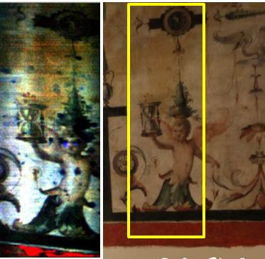

*Fig.4. False colour LIF image, reconstructed at 300,400,500 nm, on the left; photogrammetric image*

*with measured area in the yellow, on the right.*

integrate the other NDTs measures and experimental results [18]. In Fig.4, the false colour LIF image, reconstructed at 300, 400 and 500 nm, is reported on the left. The relative photogrammetric image, with the measured area highlighted in the yellow line, is reported as reference on the right. As can be observed, some details not appreciable by naked eye have been put in evidence. In particular, the presence of a different material has been revealed in correspondence with the eyes of the angel, in blue in the LIF false colour image. By analysing the LIF spectra resulting from these points, it can be observed a narrow intense emission band at 380 nm (Fig.5, lower spectrum), ascribable to the presence of restoration materials probably containing zinc oxide, as suggested by the database developed in laboratory for cultural heritage in similar experimental conditions. Also in the chest some details have been put in evidence by the fluorescence images, but the relative spectra are composed by different emission bands, making probable a different composed restoration material, with low concentration of zinc oxide, to be present. Such material has been found also in other parts of the analysed surface.

The presence of bio-deterioration has been also detected by the measurements. A grid of cell size equal to 0.05 meter was defined in the lunette above the angel in the photogrammetric model to monitor the areas affected by humidity over time (Fig.6). LIF measurements allowed to detect the presence of bio-deterioration, not only in those areas where it is visible by naked eye, but also in some areas where it is not visible absolutely. LIF spectrum associated to such degradation is characterized by the emission band at 550 nm (Fig.5, upper spectrum) that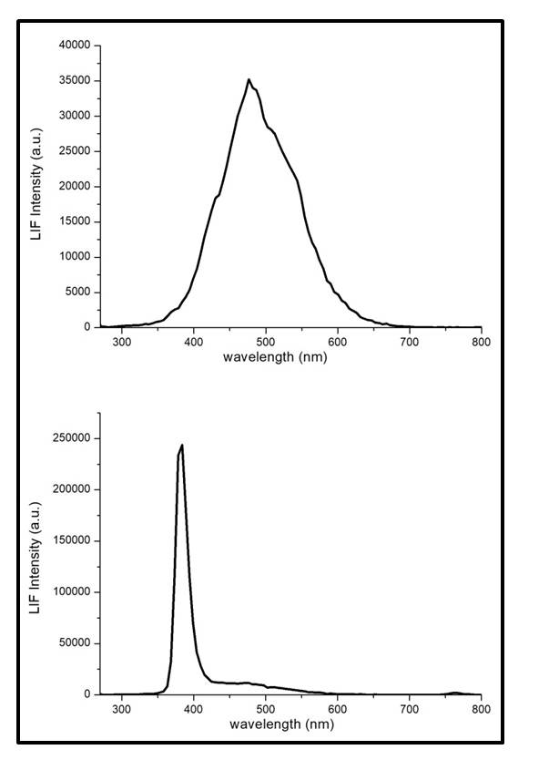

*Fig.5. LIF spectra related to areas with presence of bio-deterioration (upper spectrum) and restoration material (lower spectrum).*

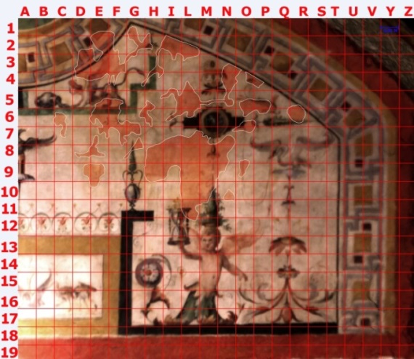

Fig.6. Photogrammetric real scaled 1:1 details of the lunette.

results absent in the LIF spectra collected by the non-deteriorated areas. This result, allowing the discrimination between deteriorated and non-deteriorated area also when the biodegradation is not visible, suggests the possibility of a preventive monitoring to reduce the eventual induced damage. The Landscape Room has been also investigated. As for the tunnel vault, the laser induced fluorescence maps were referenced to the 3D model. In this case, the RGB-ITR laser scanner has been used (Fig.7). The partial 3D model reconstruction of the room is reported in Fig.8. In this case, the LIF system didn’t detect any degradation or restoration evidence on the painted walls and the emission bands in all the 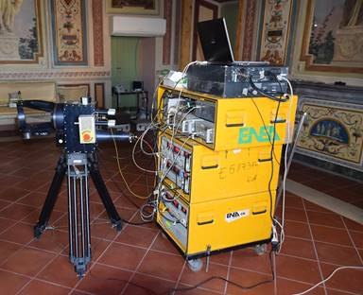

Fig.7. RGB-ITR operating in the Landscape Room.

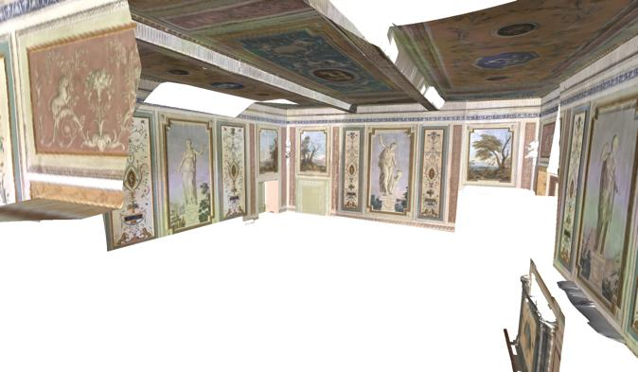

Fig.8. Partial 3D model reconstruction of the Landscape room obtained by the RGB-ITR scanner.

collected spectra could be ascribed to cellulose, due to the substrate mainly composed of textile. In Fig.9, the false color LIF image of a detail on the painted left wall is shown next to the RGB-ITR image, as an example. Differently, by analyzing the painted wooden fire screen in the room, the LIF results highlighted the discontinuity of the surface materials. In Fig.10, beside the RGB-ITR image on the left, 380/450 nm fluorescence image of area, in the yellow line on the left side of the figure, is reported on the right. As can be observed, added materials, probably due to restoration actions and/or degradation processes, have been localized also in this case by LIF analysis even if they are not visible by naked eye in some points. Moreover, a post processing analysis of the RGB-ITR 3D models has been developed in order to carry out the circumscription of the areas of interest and to evaluate the eventual modifications respect to images collected in previous periods. The monitoring of the degradation processes could be provided in this way by repeating the measurements at different times.

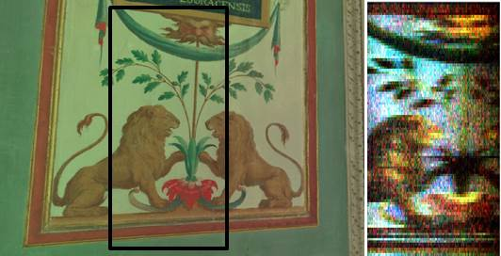

*Fig.9. RGB-ITR image, with measured area in black, on the left; false colour LIF image, reconstructed at 300,400,500 nm, on the right.*

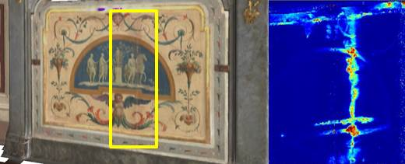

Fig.10. Fire screen RGB-ITR image (left); 380/450 nm LIF image of the analysed area, in the yellow line, (right).

1. CONCLUSIONS

The validity of the integrated approach developed in this work as non-invasive diagnostic tool has been demonstrated by the obtained results. The capability to localize areas where bio-deterioration processes are growing and where restoration materials have been applied in previous conservation actions has been verified. The collected data attested the good quality, in some cases, of the restoration actions performed during the previous years at the Bishop’s Palace. Used materials and techniques proved to be perfectly suitable for some retouches and integrations. However, degradation processes due to the environmental humidity have been highlighted by the investigation. The possibility of a preventive monitoring by the application of the presented approach to reduce the eventual induced damage has been put in light.

Acknowledgment

The activities of this work have been supported by the ADAMO project (Analysis, Diagnostic and Monitoring for the Cultural heritage conservation and restoration), financed by Lazio Region for Technological Cultural District (DTC Lazio). The authors would like to thank Episcopal Tuscolana Diocese for the support and the hospitality and the ENEA colleagues Marco Pistilli, Marcello Nuvoli and Massimiliano Ciaffi for the fundamental logistic support.

References

1. J. Hällström, R. Grönlund, A. Johansson, S. Svanberg, L. Palombi, D. Lognoli, V. Raimondi, G. Cecchi, C. Conti, “Documentation of soiled and biodeteriorated facades: A case study on the Coliseum, Roma, using hyperspectral imaging fluorescence lidars”, J. Cult. Herit., vol.10, 2009, pp.106–115.
2. D. Comelli, N.Björsell, A.Nevin, G. Valentini, I. Osticioli, E. M. Castellucci, L. Toniolo, D. Gulotta, R. Cubeddu, “Insights into Masolino’s wall paintings in Castiglione Olona: Advanced reflectance and fluorescence imaging analysis” J. Cult. Herit., vol.12, 2011, pp.11–18.
3. R. Fantoni, L. Caneve, F. Colao, L. Fiorani, A. Palucci, R. Dell’Erba, V. Fassina, “Laser induced fluorescence study of medieval frescoes by Giusto de’ Menabuoi”, J. Cult. Herit., vol.14, No.3, 2013, pp.S59–S65.
4. L. Pantani, G. Ballerini, G. Cecchi, H. Edner, D. Lognoli, T. Johansson, V. Raimondi, S. Svanberg, P. Tiano, L. Tomaselli, P. Weibring, “Experiments on stony monument monitoring by laser-induced fluorescence”, J. Cult. Herit., vol.1, 2000, pp.S345-S348.
5. D. Anglos, M. Solomidou, I. Zergioti, V. Zaffiropulos, T.G. Papazoglou, C. Fotakis, “Laser-induced fluorescence in artwork diagnostics: an application in pigment analysis”, Appl. Spectros., vol.50, 1996, pp.1331-1334.
6. L. Caneve, V. Spizzichino, E Antonelli, L. Bertani, “Study of ancient egyptians artefatcs by non-destructive laser based techniques”, Proc. of MetroArchaeo2018, Cassino October 22-24, pp. 374-378.
7. R. Grönlund, J. Hällström, A. Johansson, K. Barup, S. Svanberg, “Remote multicolour excitation laser-induced fluorescence imaging”, Laser Chem., vol. 2006, Article ID 57934, 6 pages.
8. M. Mongelli, I. Bellagamba, G. Bracco, S. Migliori, A. Perozziello, S. Pierattini, A. Quintiliani, B. Mazzei, “3D photogrammetric reconstruction by “Structure from Motion” as a monitoring technique for safety, conservation and improvement of the fruition of cultural heritage”, Proc. of MetroArchaeo2017, Lecce October 23-25, pp.228-233.
9. R. Fantoni, S. Almaviva, L. Caneve, M. Caponero, F. Colao, M. Ferri De Collibus, L. Fiorani, G. Fornetti, M. Francucci, M. Guarneri, V. Lazic, A. Palucci, V. Spizzichino “Laser scanners for remote diagnostic and virtual fruition of cultural heritage”, Opt. Quant. Electron., vol.49:120, 2017, 21 pages, DOI 10.1007/s11082-017-0952-4.
10. M. Guarneri, M. Ferri de Collibus, G. Fornetti, M. Francucci, M. Nuvoli, R. Ricci, “Remote colorimetric and structural diagnosis by RGB-ITR color laser scanner prototype”, Advances in Optical Technologies, Hindawi Publishing Corporation, Volume 2012, Article ID 512902, 6 pages, doi:10.1155/2012/512902.
11. A. Mihajlovski, D. Seyer, H. Benamara, F. Bousta, P. Di Martini, “An overview of techniques for the characterization and quantification of microbial colonization on stone monuments”, Ann. Microbiol., vol.65, 2015, pp.1243-1255.
12. K. Sterflinger, G. Piñar, “Microbial deterioration of cultural heritage and works of art – tilting and windmills?”, vol.97, 2013, pp.9637-9646.
13. L. Caneve, F. Colao, R. Fantoni, L. Fiorani, “Scanning lidar fluorosensor for remote diagnostic of surfaces”, Nucl. Instr. Meth. Phys. Res. A, vol. 720, 2013, pp.164-167.
14. L. Fiorani, L. Caneve, F. Colao, R. Fantoni, P. Ortiz, M.A. Gomez, M.A. Vazquez. ‘‘Real-Time Diagnosis of Historical Artworks by Laser-Induced

Fluorescence’’. Adv. Mater. Res., 2010, Vol.133-134, pp. 253–258.

1. L. Caneve, F. Colao, L. Fiorani, R. Fantoni, L. Fornarini, “Laser Induced Fluorescence analysis of acrylic resins used in conservation of cultural heritage”, 2008, Proc. of the 2nd Int. Topical Meeting on Optical Sensing and Artificial Vision-OSAV’2008, St. Petersburg, pp.57-63.
2. G. Ponti et al., “The role of medium size facilities in the HPC ecosystem: the case of the new cresco4 cluster integrated in the ENEAGRID infrastructure”, Proc. of International Conference on High Performance Computing and Simulation, HPCS 2014, art. no. 6903807, pp. 1030-1033.
3. L. Caneve, M. Guarneri, A. Lai, V. Spizzichino, S. Ceccarelli, B. Mazzei, “Non-Destructive laser based techniques for biodegradation analysis in cultural heritage”, NDT&E International, vol. 104, June 2019, pp. 108-113.
4. M. Mongelli, I. Bellagamba, A. Perozziello, S. Pierattini, S. Migliori, A. Quintiliani, G. Bracco, A. Tatì, P. Calicchia, “Photogrammetric survey to support Non Destructive Tests at St. Alexander Catacombs in Rome”, Proc. of MetroArcheo2018, Cassino October 22-24, pp.308-313.