Metrological characterisation of a textile temperature sensor in archaeology
Andrea Zanobini
Department of Information Engineering, Via Santa Marta, 3 Florence, Italy
University of Florence, Italy. Email: andrea.zanobini@unifi.it
ABSTRACT
This paper presents the study of a new generation textile temperature sensor in two different heated ovens. The first chamber was used to evaluate temperature and the second was used to evaluate both temperature and humidity. Data acquisition systems based on LabVIEW and Agilent were developed using thermocouples and Pt100 sensors. The results show many metrological characteristics that prove that the sensor is a resistance temperature detector.

Section: RESEARCH PAPER
Keywords: RTD, temperature sensor, textile industry, smart textiles, wearable systems, textile sensors, yarn, pressure sensor
Citation:
Editor: Paolo Carbone, University of Perugia, Italy
Received; In final form; Published
Copyright: © 4IMEKO. This is an open-access article distributed under the terms of the Creative Commons Attribution 3.0 License, which permits unrestricted use, distribution, and reproduction in any medium, provided the original author and source are credited
Funding: This work was supported by Measurement Science Consultancy, The Netherlands
Corresponding author: Paul P.L. Regtien, e-mail: paul@regtien.net

- INTRODUCTION

‘Temperature and relative humidity are essential elements in museums and in collections care. Get the conditions wrong and items could be found ruined. Mould, pests, deterioration, and warping are just a few of the problems that can happen if these elements are not stable and controlled.’ [1]

- Humidity

All organic materials degrade in humid conditions. Plants and animals contain a high proportion of water, so it is unsurprising that their products also retain moisture. When materials absorb and retain moisture, they are described as hygroscopic. Such materials can and will absorb or give off moisture until they reach a state of equilibrium with the air that surrounds them. These materials include: wood, paper, cotton, linen, wool, silk, parchment, leather, fur, feathers, ivory, bone and horn. When the surrounding air is very dry, organic materials will give off some of their moisture. They become brittle and may shrink, warp, split or crack. When the surrounding air is damp, the materials will absorb some of the moisture from the air. They may swell, cockle, warp, change shape or lose strength. Dampness can also cause mould and fungal growth on organic materials. Inorganic materials such as glass, ceramics, metals and minerals are also affected by high or low humidity. Materials that have a natural salt content may suffer from efflorescence when the air is dry. The salts in deteriorated glass, porous ceramics and some geological material are carried to the surface by moisture (which may have entered the pores during a period of higher humidity). The moisture evaporates, and the salts crystallise on the surface. Other effects on inorganic materials include: corrosion in metals, fading in dyes and pigments and pyrite decay in geological materials. If the humidity of the air changes frequently, hygroscopic materials will swell and shrink repeatedly. This causes internal stress and damage. This is particularly a problem in composite objects made up of materials with different rates of shrinkage. The expansion of one material may force changes in the dimensions of another, causing considerable tension and eventually damage. Such damage can be observed in items like skins on drums and paintings on wooden panels. Moisture can also start or speed up the damaging effect of air pollutants and other harmful substances on many museum items.

- Temperature
Objects themselves are rarely directly affected by temperature. Fluctuating heat, however, can damage or compromise items in indirect ways. Uncontrolled temperatures can cause changes in humidity, damaging sensitive objects through fluctuations in relative humidity (RH). This is the main reason for controlling temperature. Other reasons have to do with the way that temperature changes can speed up chemical processes and biological activity, making certain materials expand and contract. This is particularly damaging for composite materials with parts that expand at different rates. Additionally, high or low temperatures can affect the comfort of people working with or visiting collection items.

Moreover, temperature and humidity affect each other. The humidity of the air depends on the temperature. While one cubic metre of air holds 10 g of water at 10 °C, the same volume can hold over 30 g when the air is heated to 30 °C. Measuring absolute humidity – the number of grammes of moisture in the air – doesn't mean much when monitoring a museum's environment. 10 g of water feels damp at 10 °C but will seem dry at 30 °C.
Instead, the environment in museums is measured in terms of relative humidity (RH). This is expressed as a percentage of the maximum amount of water the air can hold at that temperature. For example:
- At 10 °C, 10 g of water is the maximum amount the air can hold, so the RH is 100 %.
- At 30 °C, 10 g is about one-third of the maximum amount, therefore the RH is approximately 33 %.
When the temperature changes, for instance after the sun has set, so does the RH. This principle is one of the most important factors in environmental control in a museum.

- Environmental recommendations
The recommended temperature for museum items is 16 to 20 °C. Moderate fluctuations of temperature between 10 and 20 °C are unlikely to adversely affect museum items. Rooms below 16 °C become too uncomfortable for visitors, while anything below 10 °C can cause condensation and affect RH. Temperatures above 20 °C will be too hot for guests and can accelerate degradation in museum objects. Museum stores can be cooler than 16 °C as they are not frequented by visitors. It is important to remember that items will need to acclimatise gradually between storage and display. Relative humidity should not drop below 40 % or rise above 70 %. Relative humidity below 40 % can cause sensitive items to become dry and brittle. The maximum level is determined by the point where fungal growth begins, which is at an RH of at least 70 %. Reducing the fluctuation of RH is also important. But these are just broad recommendations. Some items and materials require more specifically controlled levels of relative humidity. For more information, read our guide to items and their ideal conditions. In a naturally ventilated building in sound condition, indoor conditions will respond to outdoor conditions. There are, however, mitigating factors that can affect the temperature and humidity inside a building, room or display case.

- Continuous monitoring with sensors
As so many factors can affect the temperature and humidity in a museum, the environment must be regularly monitored to keep track of fluctuations. After 12 months of monitoring, it is possible to develop a good idea of the changing environmental conditions in a museum. The information gained from monitoring can be used to decide where and how to display sensitive items in collections and to determine investments in control equipment when necessary. When continually monitoring a museum, particular attention must be paid to regular, frequent fluctuations, which can cause significant damage to museum items. The changes take place slowly enough for the objects to adjust but fast enough to cause frequent movement, stress and fatigue in the material. Occasional very rapid fluctuations, within one or two hours, will have a less damaging effect on items. Very gradual fluctuations will give the items enough time to acclimatise slowly.
Some types of items are more affected by fluctuations than others. When transporting items to an area with different environmental conditions, items must be kept well packed and wrapped in acid-free tissue and a box or blanket. This will ensure that acclimatisation to the new conditions can take place gradually. Maintaining stable humidity and temperature in a museum can use up a lot of energy. This is expensive and can also increase a building's negative environmental impact. Although maintaining stability is essential for the care of museums, some strategies can be put in place to increase energy efficiency. A slightly more flexible approach to environmental control is to be taken, and it is important to look for ways to reduce artificial means of altering temperature and humidity. This may mean allowing a greater range of desired RH and temperature, but it can reduce carbon footprint.

- TEXTILE SENSORS

Fabric-based wearable devices help achieve high levels of pervasive and distributed sensing and computing in social, environmental or industrial contexts, with little or no user intervention. In this paper, we study the metrological characterisation of these devices, which provide high
sensitivity and high spatial resolution and are easy to manufacture. They do not disturb the wearer, which is a critical factor in complex and hazardous workplaces such as the military, rescue units and fire stations. Furthermore, these soft sensors can easily be incorporated into automotive applications or used in educational laboratories and professional trainings to introduce smart textiles, piezoresistive materials, nano-composites or signal and image processing concepts.
Wearable computing refers to the concept of a computer that could be worn on the body. Due to their ability to easily reach a wide audience in both consumer segments and professional markets and driven by the use of several key enabling technologies such as low cost sensors, miniaturised electronics and the development of cloud-based IoT services, wearables are becoming a pervasive and cost-effective technology. Common wearables are made of materials with electrical and mechanical characteristics that can restrict their use. Textiles embedded with electronics are usually more flexible and stretchable and are manufactured in a much simpler way. Furthermore they do not disturb the wearer, which is a critical factor in complex and hazardous workplaces (e.g. the military, rescue units or fire stations). Smart textiles are textile fabrics that incorporate non-textile elements to sense, compute, actuate or adapt to given situations [2]–[4]. Different transduction strategies have been demonstrated for smart textiles exploiting the capability to sense
for force, pressure, strain or thermal fields, but a promising class of smart textiles is piezo-resistive textile sensors made from carbon nanotubes or carbon black-based nano-composites, since they provide the best trade-off between the device’s electrical and mechanical properties and the production costs. This paper presents the findings of the metrological characterisation of piezo-resistive fabric-based cost-effective sensors with high sensitivity and spatial resolution that are suitable to be used in wearable computing to measure pressure and thermal fields. The textile compounds used in this study were developed by Plug&Wear (Plug&Wear srl, IT, www.plugandwear.com). This textile technology has been validated in a few previous works and in a wide variety of applications such as monitoring vital functions.
Textile sensors are the future. They are fabrics that feature electronics and have interconnections woven into them [2], [3] allowing for physical flexibility. They have been used for typical and robot-assisted non-invasive endoscopy capsule positioning [5], [6], rehabilitation studies and gaming and sport activities [8] as well as to develop a multimodal sensing framework to support the development of social skills [9] and to enhance human–robot interaction in a smart environment [10], [11].
This paper is organised as follows: in Section 2, the design of the conductive layers and the design of the electrodes for the textile matrix pressure sensors are introduced. In Sections 3 and 4, a metrological investigation of sensor characteristics is presented, highlighting the effectiveness of the sensors and their capabilities in the presence of pressure and an external thermal field.
Piezo-resistive sensors can be made in sizes that cannot be achieved with other existing electronic manufacturing. Conductive fibres are the key elements for building these sensors [4]. The soft sensor
investigated in this work is able to sense pressure or an external thermal field and is a resistance temperature detector (RTD) [5], according to the builder.
Piezoresistive textile soft sensors are made from layers of knitted textile fabric that are sewn to form one unit, with the piezoresistive nano-material in the innermost layer [7]. Knitted power supply lines and data buses are fabricated by alternating conductive and not conductive yarns on the textile sheets, which are in direct contact with the sensitive layer. The pressure sensing element, or sensel, is at the intersection of two
conductive lines in different layers. Data buses are interfaced through conventional connectors to external cables that connect to an Arduino MEGA 2560 r31 through a custom breakout board [2], [3]. Software developed in LabVIEW displays and processes the acquired signals. Exploiting the variation of the resistivity of some material at different temperatures, an innovative all-fabric single-layer (RTD) sensor is presented. Using this layered architecture, three types of fabric-based sensors that differ based on the conductive materials of the fabric will be considered:
Fabric A - Conductive lines are made of copper wire (100 _m in width) and insulating material is coated copper wire (112 _m in width);
Fabric B - Fabric is made of polyester yarns alternated with yarns of fibres metallised with silver;
RTD Fabric - All-fabric single-layer RTD sensor. It exhibits very low thermal inertia and hysteresis.
The mechanical properties of textile fabrics depend on their manufacturing and the material of the yarns. In knitted fabrics, loops can be easily stretched in different directions, and the fabric overall is highly stretchable within the constraints of the material the yarns are made of. In particular, replacing metal yarn with silver- or carbon black-coated polyester threads leads to a more elastic and stretchable textile matrix and significantly reduces the thickness of the compound of the sensor, thus increasing its capacity to adapt its shape to the human body for wearable applications.

The purpose of this study is to determine whether the sensor is an RTD by calculating the linearity of the textile sensor [5] and searching for a mathematical function similar to the theoretical model ρ(T)=ρ0∙[1+αT-T0]]. By using $R=ρ∙L/S$, it is possible to use the resistive model $R\left(T\right)=R_{0}∙[1+α\left(T-T_{0}\right)]$. First, the study examined the behaviour of temperature in an internal science oven situated in a reliability laboratory at the Analytical CETACE test laboratory in Scandicci (Firenze, Italy). Next, the behaviour of temperature and humidity was analysed in the second oven chamber. This document proposes to characterise the textile [7] temperature sensor made by Plug&Wear Srl (Firenze, Italy). The temperature experiment [8] was divided into four stages. In the first step, all contact resistances were avoided, and the sensor was placed on an insulating material. The second step was aimed at implementing a measurement system by developing a specific software through LabVIEW. The third step consisted of data acquisition, and finally, the study results were determined. Temperature acquisition was performed with an Agilent software. The humidity experiment required the same stages. To measure temperature during both experiments, thermocouples and one Pt100 [9], [10] were supported by the sensor, but data elaboration was performed using the Pt100 because of its high accuracy. Data were collected for linearity, hysteresis, sensibility, output range and input range.

- METHODOLOGY

A. Resistance settings
Resistance was measured using the 4-wire method and a digital multimeter HP-34401A [11]. Resistance acquisition was performed using an application of LabVIEW [12], as shown in Figure 1. To connect the multimeter to a PC, a National Instruments GPB-USB-NHI was used.

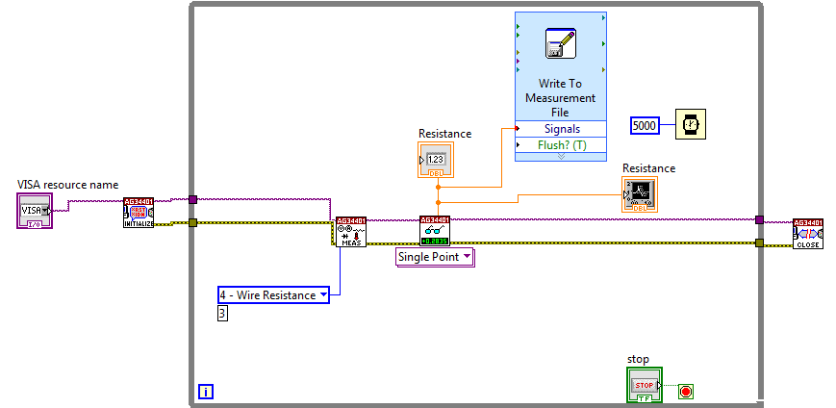

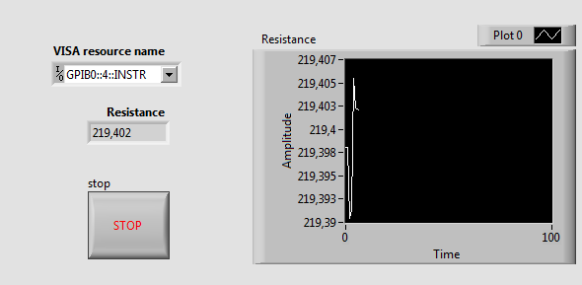

Fig.1. Code created in LabVIEW with 34401A drivers and front panel.

B. Temperature settings
Temperature was measured with an Agilent 34970A data acquisition [13], [14] using a Pt100, as shown in Figure 2. Temperature acquisition was performed using the Agilent Benchlink Data Logger software. To interface a PC and the data acquisition, an Agilent USB/GPIB was employed.

C. First experiment and analysis method
Data were collected every 5 seconds throughout the testing period, both for temperature and for resistance. Results were reworked using Excel. The experiment setup is shown in Figure 3. All the measurements were taken after allowing the instruments to warm up for about 30 minutes. The temperature was increased quickly [15] from −10 °C to 103 °C using a WEISS SB11500 chamber.

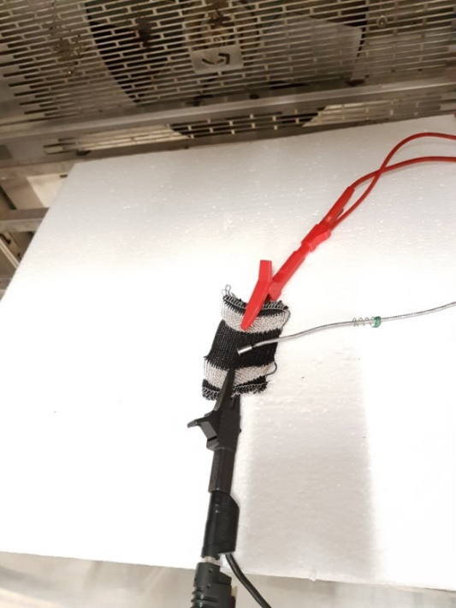

Fig.2. Temperature sensor and Pt100.

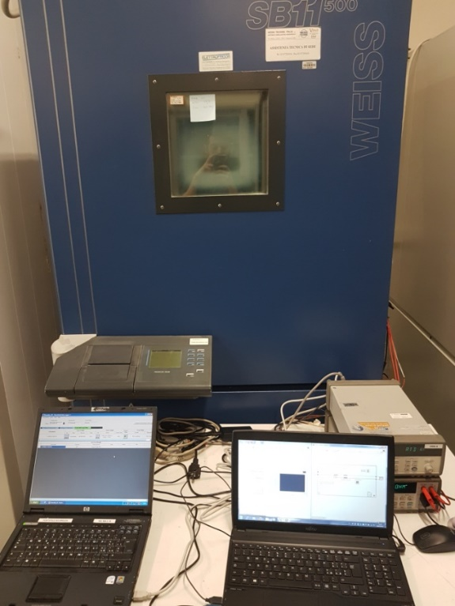

Fig.3. First experiment setup.

D. Second experiment and analysis method
The temperature was increased by steps of 5 degrees centigrade from -10 °C to 80 °C using a Challenge 1200 ACS chamber, as shown in Figure 4. Data were collected cyclically every 5 seconds once the temperature was exactly at the set point for a period of 15 minutes. The results were reworked using Excel. The Pt100 was positioned 5 millimetres from the sensor, as observable in Figure 5. All the measurements were taken after allowing each instrument to warm up for about 30 minutes.

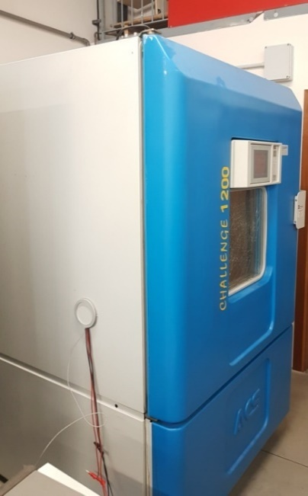

Fig.4. Challenge 1200 ACS oven chamber.

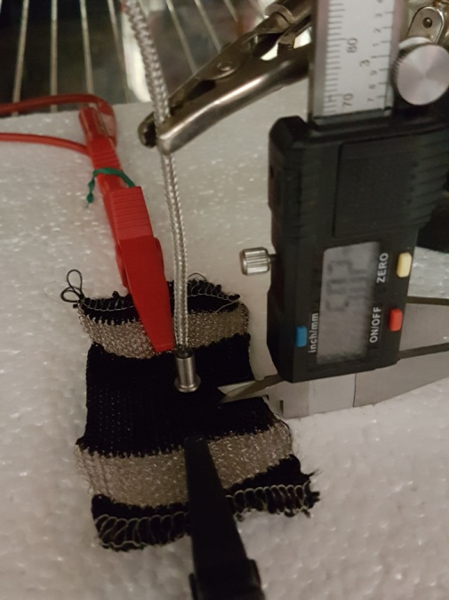

Fig.5. Pt 100 positioned 5mm from sensor

E. Third experiment and analysis method
Humidity [16] was analysed by setting the temperature at 30 °C and varying the humidity from 30 % to 90 %, dividing the range into 4 steps. At the set point, data was collected every 5 seconds for a period of 30 minutes using the same tools and automated acquisition system as in the previous experiments. Humidity was studied in a Challenge 1200 ACS oven chamber. The results were reworked using Excel.

IV. DATA ANALYSIS

A. First experiment data
The aim of this study was to determine how the sensor responds to a rapid change in temperature. As seen in Figure 6, resistance variation seems linear, but the resistance values are not correct because of a quick temperature overview. Data have never stabilised.

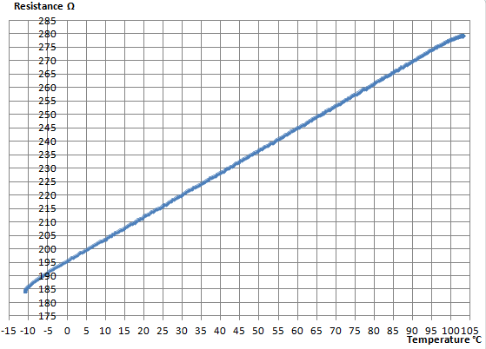
Fig.6. Preliminary graph of resistance as a function of temperature, with all sampled points in blue.

B. Second experiment data
This study was done to obtain a function and more accurate data than the previous study by increasing the sampling density. Due to sensor linearity, sampling was done every 5 degrees centigrade in 19 steps. The results are shown in Figure 7. Data were analysed using the statistical method of linear regression and an additional Excel tool.

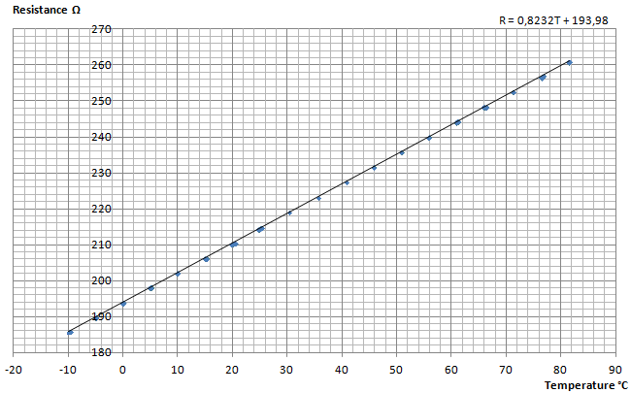
Fig.7. Final graph of resistance as a function of temperature, with all sampled points in blue and the linear regression line in black.

R=0.8232T + 193.98 characterises the sensor. Sensor sensitivity [17] is defined as S=dydxdydx and so is equal to 0.8232[Ω/°C]. Because of this result, the uncertainty of the measurement was calculated to understand its effect on the resistance values. Type A uncertainty [18] was evaluated by statistical method due to the result of repeated measurements of resistance at the same temperature and is equal to$u_{A}=s/{\sqrt{n}}$, where s = standard deviation and n = samples acquired. Type B uncertainty was evaluated using information obtained from the manufacturer’s manual and is equal to $u_{B}=a/{\sqrt{3}}$, where $a$ = the accuracy of the instrument. Total uncertainty is calculated as $u_{T}=\sqrt{{u_{A}}^{2}+{u_{B}}^{2}}$. All of the results are shown in Table I and Figure 8.

TABLE I
RESULTS OF RESISTANCE MEASUREMENT

T [°C] | R [Ω] | u [Ω] | T [°C] | R [Ω] | u [Ω]
−10 | 185,88 | ±0,02 | 35,7 | 223,24 | ±0,02
−5 | 189,74 | ±0,02 | 40,7 | 227,46 | ±0,02
0 | 193,88 | ±0,02 | 45,7 | 231,67 | ±0,02
5 | 198,06 | ±0,02 | 50,8 | 235,84 | ±0,02
10 | 202,14 | ±0,02 | 55,8 | 240,01 | ±0,02
15,3 | 206,24 | ±0,02 | 60,9 | 244,23 | ±0,02
20,3 | 210,32 | ±0,02 | 66 | 248,38 | ±0,02
25,3 | 214,84 | ±0,02 | 71,2 | 252,60 | ±0,02
30,3 | 219,06 | ±0,02 | 76,5 | 256,91 | ±0,02
81,5 | 260,96 | ±0,02

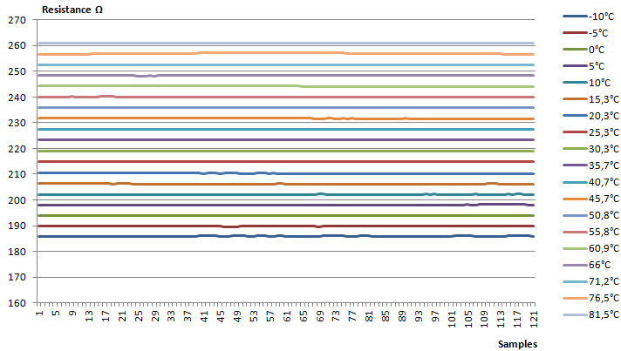

Fig.8. Chart of all the resistance samples at the same temperature

C. Third experiment data
The objective of this investigation was to evaluate the impact of humidity [19] on resistance value. As with the prior measurements, uncertainty was calculated as shown in Table II. Figure 9 shows the results.
TABLE II
RESISTANCE MEASUREMENT WITH HUMIDITY EFFECTS

Resistance [Ω] | Humidity % | Uncertainty[Ω]
219,37 | 30 | ±0,02
219,36 | 50 | ±0,02
219,36 | 70 | ±0,02
219,50 | 90 | ±0,02

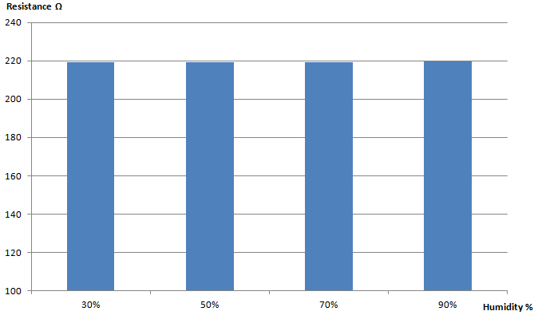
Fig.9. Histogram representing a non-significant variation of resistance depending on humidity.

V. CONCLUSIONS

The experiments produced the following metrological characteristics: linearity, sensitivity equal to 0.8232 [Ω/°C], measurement range from −10 °C to 81.5 °C, operating range from (185.88 ±0.02) Ω to (260.96 ±0.02) Ω, non-significant hysteresis. No significant variation of resistance values was obtained by introducing the factor of humidity. During the first experiment, the feasibility and repeatability of the method were demonstrated. During the second and third experiments, the reproducibility of the method was shown. The aim of this investigation was also to create a function able to take resistance values and turn them into temperature values, as shown in Figure 10. The final function is T=1.214R – 235.62, an important result.

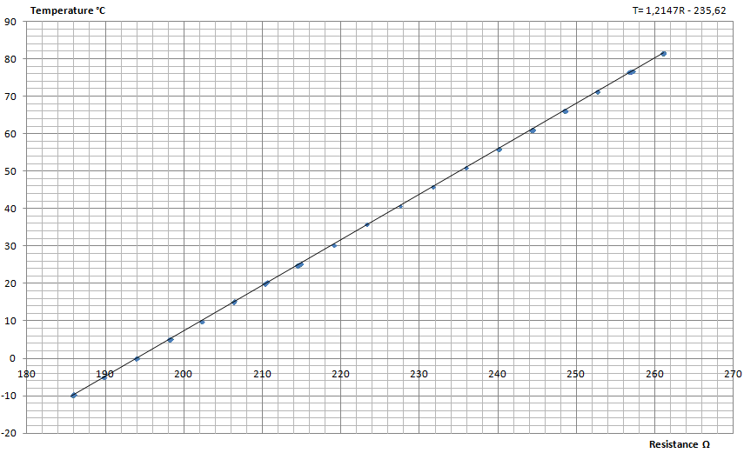

Fig.10. Final graph of temperature as a function of resistance, with all sampled points in blue and the linear regression line in black.

Questions could be raised regarding hysteresis due to the acquisition method. Data were acquired during the phase in which the WEISS SB11500 chamber was cooling to -10 °C. However, dense sampling was not done in certain steps. Resistance values in descent are very similar to those that would be found using the function obtained during the second experiment. It can be suggested that additional hysteresis studies should be done in the future. Recently, important studies on temperature effects in archaeology have been performed in our research group (the measurements and reliability laboratory of the Information Engineering Department, University of Florence). During the test for relative humidity at 90 %, the Challenge 1200 ACS oven chamber had problems maintaining the temperature at 30 °C. Therefore, since the sensor is very sensitive to even small changes in temperature, it has been deduced that the increase of approximately 0.13 Ω in resistance values is due to this factor. It would be interesting to increase the measurement and operating range to reach the edge temperatures of the oven chambers. Also, all of the functions could be refined by making a broad sampling degree by degree. Many studies have focused on this sensor with regard to pilling, aging, textile strain, salt fog testing, chemical swear and many other topics. Several future uses for textile sensors could be suggested to add to the one analysed in this paper, such as implementation in biomedical systems for measuring body temperature in infants or measuring the temperature of a surface or tube, especially in very tight spaces that cannot be accessed by thermal imaging cameras.

Acknowledgment
The authors would like to thank Ing. Lorenzo Quartini for his important contribution to the first draft of this article.

References

- Museums Galleries Scotland, Temperature and humidity in museums, https://www.museumsgalleriesscotland.org.uk/advice/collections/temperature-and-humidity-in-museums/
- M. Stoppa, A. Chiolerio, Wearable electronics and smart textiles: a critical review, Sensors 14(7) (2014) pp. 11957-11992.
- R. Zeitler, A new optical sensor for measuring the velocity of webs by correlation techniques, IEEE Transaction on Instrumentation and Measurement 47(1) (1998) pp. 289-292.
- L. Capineri, Resistive sensors with smart textiles for wearable technology: from fabrication processes to integration with electronics, Procedia Engineering 87 (2014) pp. 724-727.
- A. Chen, J. Zu, B. Li, Temperature compensation for hot-film crosswind sensors, IEEE Instrumentation and Measurement Technology Conference, Ottawa, Canada, May 19-21, 1997, vol. 2, pp. 1086-1088 .
- A. Song, Y. Han, H. Hu, J. Li, A novel texture sensor for fabric texture measurement and classification, IEEE Transaction on Instrumentation and Measurement, 63(7) (2014) pp. 1739-1747.
- P. Godts, D. Dupont, D. Leclercq, Direct measurement of the latent heat of evaporation by flowmetric method, IEEE Transaction on Instrumentation and Measurement 54(6) (2005) pp. 2364-2369.
- V. H. Carvalho, P. J. Cardoso, M. S. Belsley, R. M. Vasconcelos, F. O. Soares, Yarn hairiness characterization using two orthogonal directions, IEEE Transaction on Instrumentation and Measurement 58(3) (2009) pp. 594-601.
- W. Nawrocki, Measurement Systems and Sensors, Artech House, London, 2016, ISBN 13: 978-160807-932-2.
- M. Arai, K. Yamazaw, High-temperature furnace controlled by a platinum resistance thermometer, SICE 2004 Annual Conference 2, Place, Country, 2004, pp. 1172-1175.
- Agilent Technologies\HP, HP 34401A multimeter, (2000).
- L. Wen, J. X. Jin, X. Y. Chen, and L. Jiang, A universal LabVIEW-based HTS device measurement and control platform and verified through a SMES system, IEEE Transaction on Applied Superconductivity 24(5) (2014) pp. 1-5.
- Agilent Technologies, Agilent 34970A data acquisition/switch unit family product overview 34970A 34972A, (2010).
- B. Saggin, M. Tarabini, G. Lanfranchi, A device for the skin–contact thermal resistance measurement, IEEE Transaction on Instrumentation and Measurement 61(2) (2012) pp. 489-495.
- D. Ha, K. Woo, S. Meninger, T. Xanthopoulos, E. Crain, D. Ham, Time-domain CMOS temperature sensors with dual delay-locked loops for microprocessor thermal monitoring, IEEE Transaction on Very Large Integration (VLSI) Systems 20(9) (2012) pp. 1590-1601.
- M. D. Husain, O. Atalay, R. Kennon, Effect of strain and humidity on the performance of temperature sensing fabric, International Journal of Textile Science 2(4) (2013) pp. 105-112.
- A. Martinez-Ríos, G. Anzueto-Sanchez, R. Selvas-Aguilar, A. A. C. Guzman, D. Toral-Acosta, V. Guzman-Ramos, V. M. Duran-Ramirez, J. A. Guerrero-Viramontes, C. A. Calles-Arriaga, High sensitivity fiber laser temperature sensor, IEEE Sensor Journal 15(4) (2015) pp. 2399-2402.
- J. R. Taylor, An Introduction to Error Analysis: The Study of Uncertainties in Physical Measurements, University Science Books, Sausalito, California, 1997, ISBN 978-0-935702-42-2.
- R. Bhunjun, R. W. Vogt, Sensor system for contactless and online moisture measurements, IEEE Transaction on Instrumentation and Measurement 50(11) (2010) pp. 3034-3040.
- A. Proietti, F. Leccese, M. Caciotta, F. Morresi, U. Santamaria, C. Malomo, A new dust sensor for cultural heritage applications based on image processing, Sensors 14(6) (2014) pp. 9813-9832. DOI: 10.3390/s140609813.
- L. Maiolo, F. Maita, A. Castiello, A. Minotti, A. Pecora, Highly wearable wireless wristband for monitoring pilot cardiac activity and muscle fine movements, 4th IEEE International Workshop on Metrology for AeroSpace, MetroAeroSpace 2017 - Proceedings, Place, Country, 2017, art. no. 7999578, pp. 271-275.
DOI: 0.1109/MetroAeroSpace.2017.7999578
- G. Mattana, T. Kinkeldei, D. Leuenberger, C. Ataman, J. J. Ruan, F. Molina-Lopez, A. Vásquez, Woven temperature and humidity sensors on flexible plastic substrates for e-textile applications, IEEE Sensors Journal 13(10) (2013) pp. 3901-3909.
- L. M. Castano, A. B. Flatau, Smart fabric sensors and e-textile technologies: a review, Smart Materials and Structures 23(5) (2014) p. 053001.

