Projected Fringes Profilometry for Cultural Heritage Studies
Giuseppe Schirripa Spagnolo¹, Lorenzo Cozzella¹, Fabio Leccese²
¹ Università degli Studi Roma Tre, Dipartimento di Matematica e Fisica
² Università degli Studi Roma Tre, Dipartimento di Scienze

Abstract – The use of projected fringes for the measurement of surface profile is a well-developed technique. In this paper, we present a surface profile measurement method for micro-components based on the combination of digital fringe projection, phase stepping, temporal phase unwrapping, and digital image acquisition. In this paper, a cost-effective machine is proposed. In particular, the paper describes the hardware and software realization. A simple procedure is described, which enables calibration of the optical set-up for subsequent quantitative measurement of micro-components of unknown shapes. In this paper, some examples are presented to demonstrate the potentiality of the system in measurement of microscopic surface profile.
- Introduction
The survey of the surface profile by means of non-contact optical systems is the subject of extensive studies [1-6], given its importance in many fields ranging from quality control to medicine, from robotics to solid modeling. In the field of conservation of cultural heritage, both the determination of surface finish (surface texture) and its variations over time are of particular importance. In fact, to establish the actual vulnerability of cultural assets, one of the most important parameters to determine is the loss of material or, more generally, the determination of microstructural changes in the exposed surface (currently, for these determinations, indirect methods are used). Therefore, the objective of the present research is to develop a no-contact optoelectronic system capable of analyzing, at high resolution, the surface profile of artistic finds. The basic methodology to be used for the development of the system is the one known as grating projection or structured light [7,8]. This method, supported by optoelectronic signal processing techniques, will allow the development of a system characterized by high precision, small footprint and relative low production cost.
- The range-finder
Projected fringe profilometry is one of the most effective methods to measure the 2.5D surface profiles of rough engineering surfaces [9]. The fringe can be generated by projecting parallel light through optical grating slides with various projecting patterns, such as sinusoidal-like modulation. The traditional phase shifting method, which involves physically moving a grating or a reference mirror has two problems, namely inefficiency due to mechanical movement, and unavoidable phase shifting errors incurred during the phase shifting process. Therefore, a digital micro-mirror device (DMD) was further proposed to generate flexible structured-light patterns with highly precise phase shifting.
This paper presents a surface profile measurement method for micro-components based on the fringe projection, phase-shifting technique, and temporal phase unwrapping. Linear sinusoidal fringe patterns are projected on a micro-component surface by a digital fringe projector. The system projected an area of fine sinusoidal fringes on a micro-component surface. The projected sinusoidal fringes will be deformed by the surface height variations of the micro-component. By detecting the deformed sinusoidal fringes and in combination with phase stepping and temporal phase unwrapping, high-precision 2.5D measurement of micro-component can be efficiently acquired.
The system is built with commercially available instrumentation. It is shown in Figure 1 and consists of four main modules: the digital fringe projector (developed using a Digital Light Projector - DLP); CCD camera, micro-stepping movable table and a personal computer as processing unit.

Fig. 1. Set up of the measurement system.
The DLP is a commercial available video projector based on DMD technology. An advantage with this is that fringes can be phase-stepped without miscalibration. Hence, a generic N-bucket phase shifting algorithm, without self-calibrating properties, is suitable for the phase calculation. As camera, it is used a common b/w CCD with 1200 x 1600 pixels resolution.
Structured light with sinusoidal fringes is projected onto the object surface. Due to the depth variation of the surface the structured light is phase-modulated, leading to a deformed spatial carrier fringe pattern in which the topographic information of the object surface has been encoded.
The optical geometry of the phase measuring techniques is shown in Figure 2.

Fig. 2. Optical geometry for fringe projection.
When a sinusoidal fringe pattern is projected onto a 3-D object, the surface height of it is mapped to a phase function of the deformed intensity fringe pattern, and can be resolved by [10]:
(1)
where (x, y) is the spatial coordinate, h(x, y) is the local height variation, P₀ is the period of sinusoidal grating in the reference plane, θ is the angle between the axis of projection and the reference plane, Δφ is the phase difference relative to the height change. The relationship between the phase distribution and the range image of a 2.5D object surface is determined by optical sensitivity that depends on the geometry of system design and system parameters. Such the equation (1) relation can be simply expressed as:
(2)
where K represents the fringe sensitivity depending on the optical geometry.
As described in equation (2), the phase-shifting difference is regarded as being proportional to the depth of 3D shape of an object surface. However, due to the nonlinearity errors, the image distortion of the digital fringe projection (DMD and its lens set) and the image acquisition (CCD camera and its lens set), the linearity of the phase shift with regard to the depth of the object surface, in fact, does not exist [11,12]. The nonlinearity errors of both the fringe projection and the image acquisition can greatly affect the accuracy of 3D shape measurement. To minimize these errors, the system parameters used in the digital fringe projection (DFP) for 3D surface profilometry must be systematically modeled and calibrated, with the measurement errors in the measurement space mapped out and compensated for.
For the absolute phase calculation, it is possible to use the FFT algorithm [13-15] or phase-shifting technique [16].
The phase-shifting fringe analysis method has been well described in [10, 13, 16]. In short, we presume that N frames of sinusoidal fringe patterns are cast in sequence on the object surface by the projector, with a constant phase increment 2π/N between consecutive frames. Then the n’th distorted fringe pattern captured by the CCD camera can be represented as
(3)
where n = 0, 1, ... , N-1 is an integer-valued vector; x and y are the coordinates of the point in the distorted fringe pattern; In(x, y), a(x, y), and b(x, y) denote the recorded intensity, the background intensity, and the local contrast variation at the point (x, y), respectively; and Δϕ(x, y) denotes the phase in which the depth information of object surface is included. The values of wrapped phases can be calculated by [11]
(4)
Since phase calculation by the computer gives principal values ranging from −π to +π, the phase distribution is wrapped into this range and, consequently, has discontinuities with 2π-phase jumps for variations larger than 2π. In general, a phase unwrapping technique is required to identify phase reversal in the fringe pattern. With the use of computer-generated fringe patterns, however, the phase in the projected fringe pattern can be easily programmed. Therefore, temporal phase unwrapping technique can be used for analysing phase maps [17,18]. The basic idea is to vary the pitch of the fringes over time. A sequence of phase maps is recorded, forming a three-dimensional phase distribution. The phase at each pixel is then unwrapped along the time axis. The method is simple and robust. Furthermore, the technique also has the advantage that aberrations in the system are automatically cancelled so that high-accuracy measurements can be made without the need for calibration with a flat reference surface.
- EXPERIMENTAL RESULTS AND DISCUSSION
First, some validation experiments have been made. Figure 3 shows the recovered 2.5D plot of a specimen of metallic step, with 50 μm in height, produced by means of grinding machine. A comparison between conventional direct contact measurement and optical results shows that the maximum discrepancy is about 2 μm.

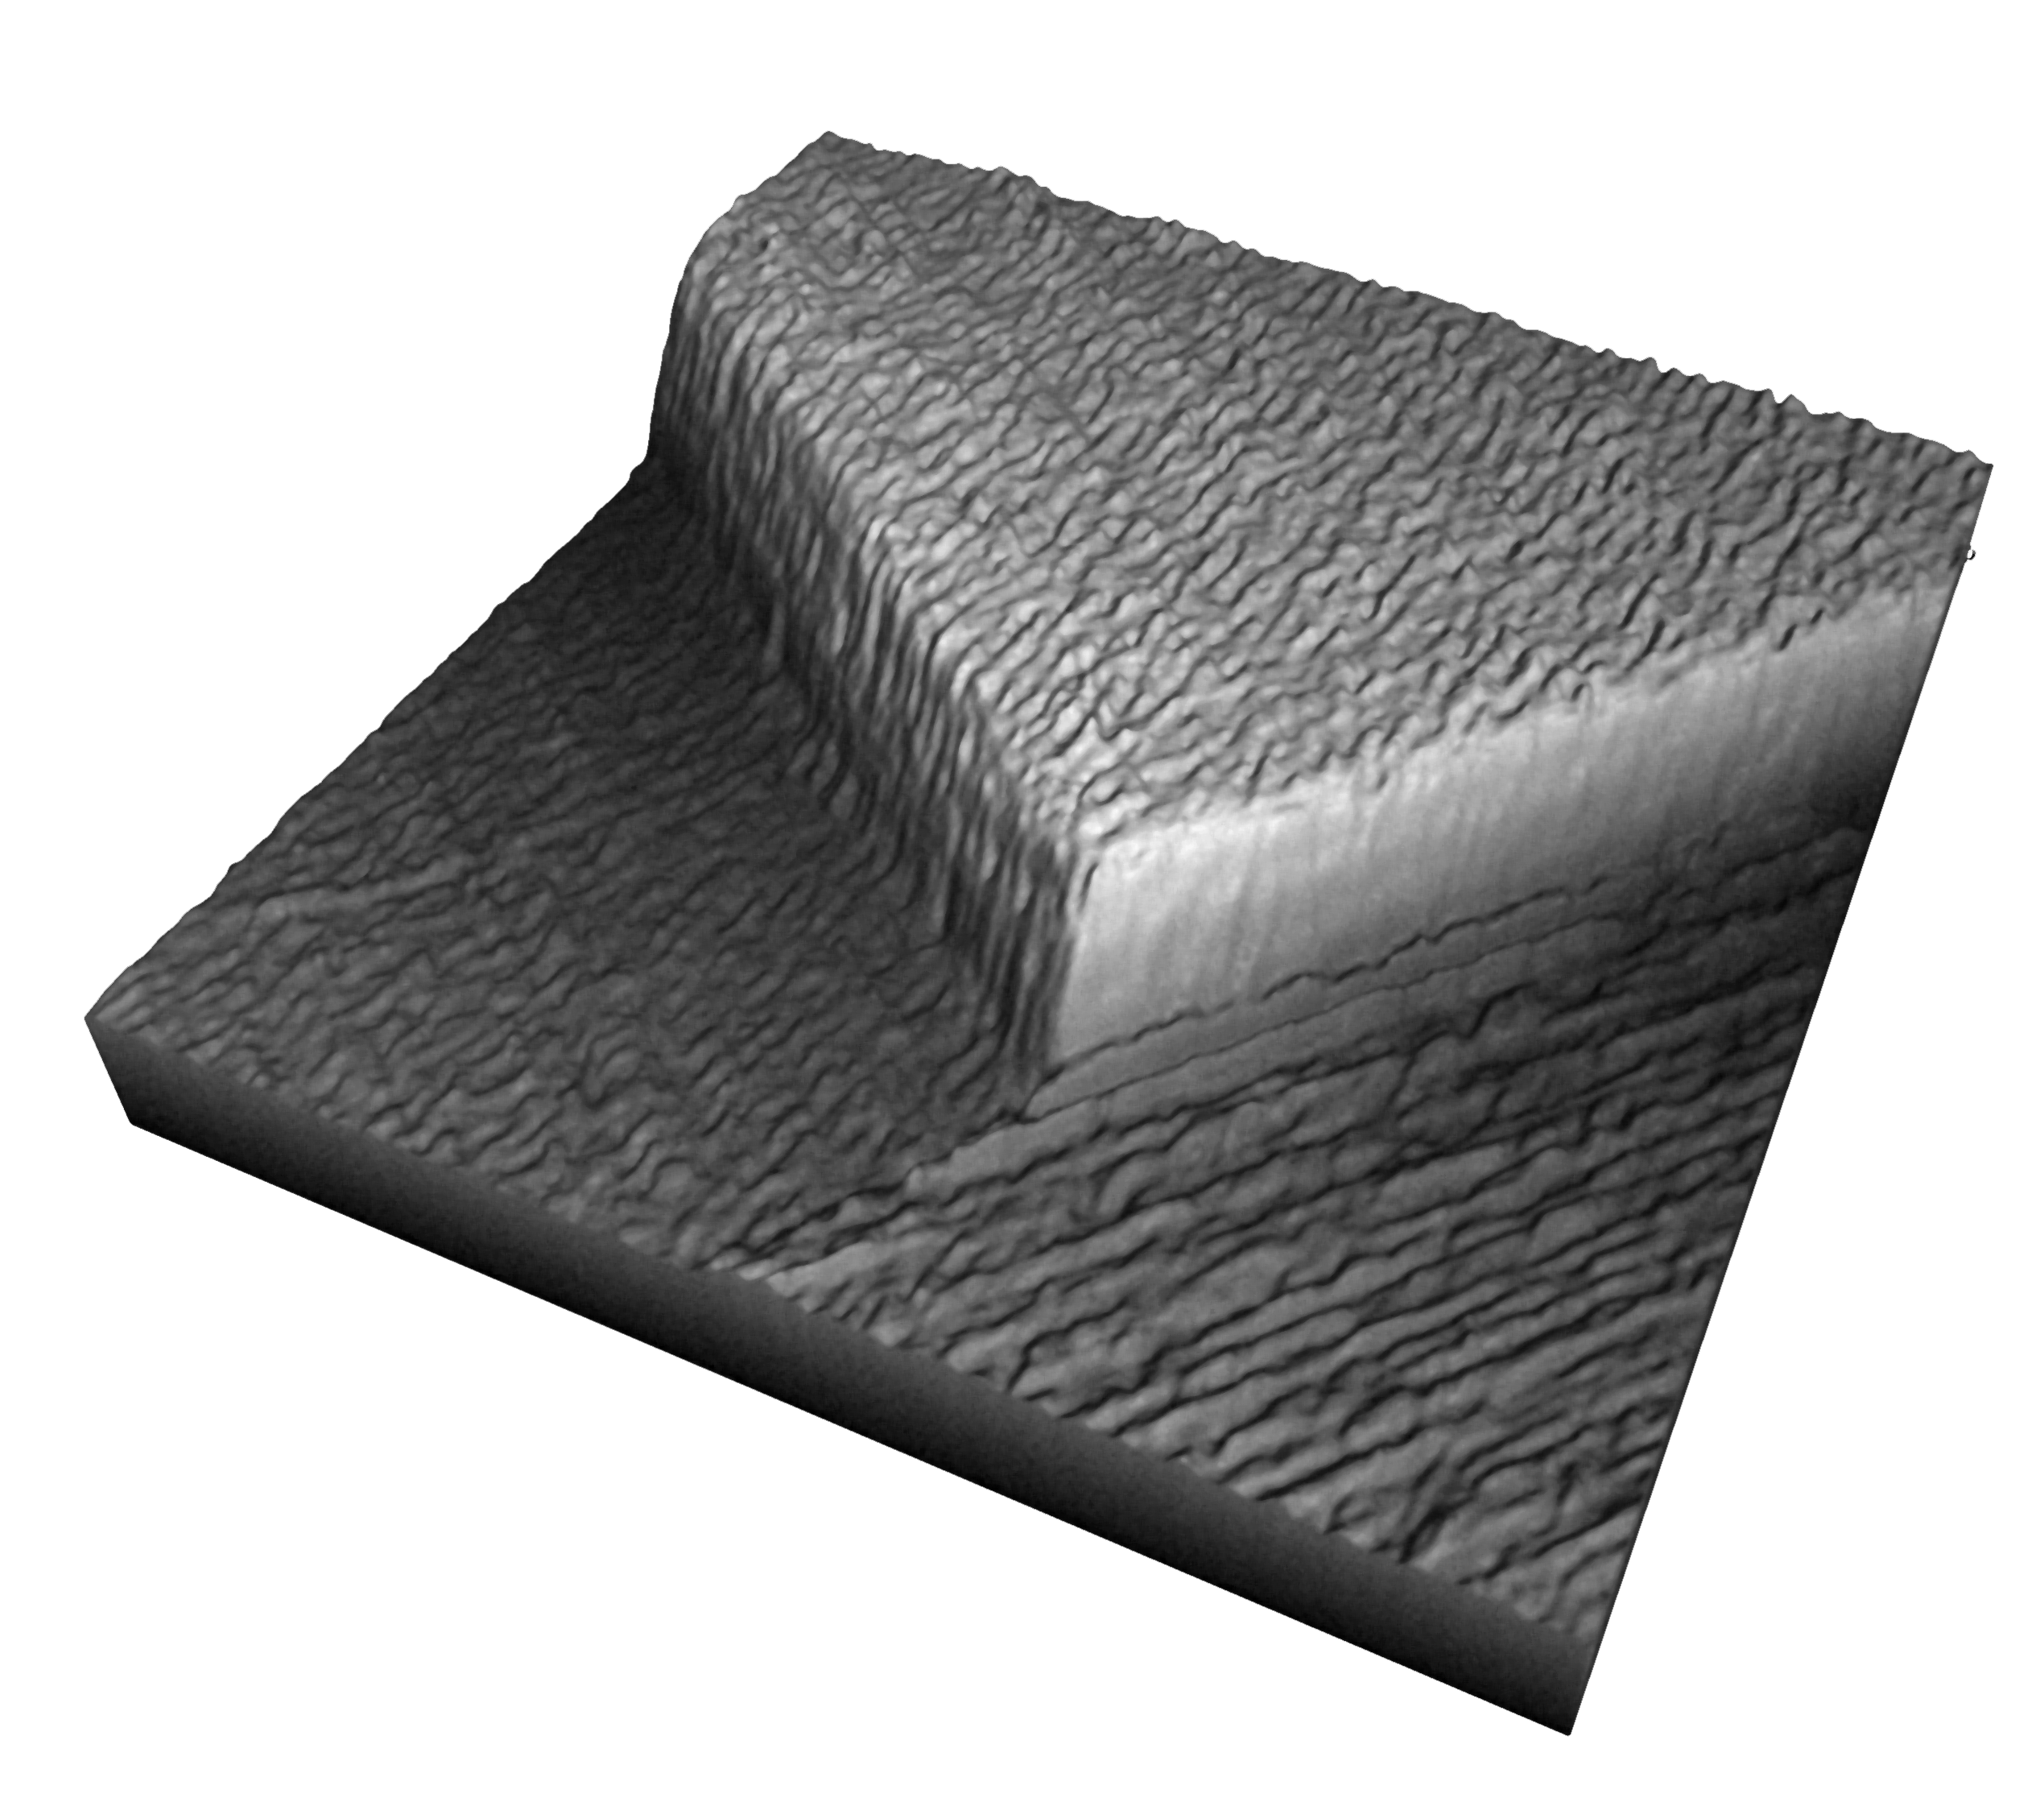
Fig. 3. Three-dimensional reconstruction of specimen with 50 μm calibrated steps.

Subsequently, we have performed a test on a coin. Figure 4 shows the recovered 2.5D plot of an Italian 10 Lire coin, used before 2000.

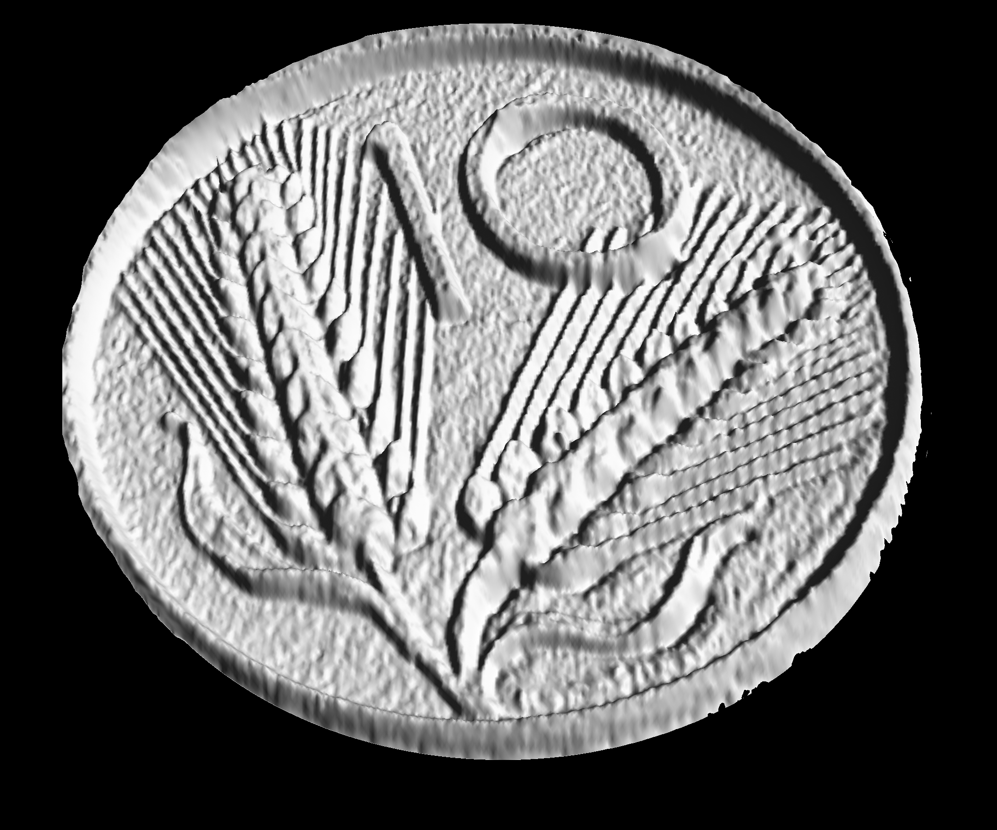
Fig. 4. Recovered 3D plot of a coin: “10 Italian lire”.
The system resolution depends on the grating period in the reference plane (P0), and the projection angle (θ). In our system, the phase values can be measured with a resolution of about π/50. Therefore, starting from Equation (1), surface profile measurements with a resolution better than 2 μm are possible.
The sensitivity can be readily modified by changing the grating pitch (P₀) or the illumination angle (θ).

- pipeline for 3D color model
For a correct and accurate acquisition of the surface, it is essential that the color characteristics are also acquired.
A typical 3D data elaboration pipeline, to obtain a complete 3D model of the acquired object from the raw data, consists of the following main steps:

- Acquisition of 2D color information [19, 20];
- 3D geometric data acquisition;
- Data integration;
- Model conversion.

To try the usability of the proposed technique in the construction of a virtual gallery of ancient artifacts, we have digitized some ancient Roman coins.
Figure 5 shows the steps of the data processing pipeline, used to obtain a complete 3D model of the Roman sestertius of Agrippina Senior, who was born in 15 B.C. and died in exile in A.D 33. This commemorative coin, bearing her name and portrait was struck by her son, the emperor Caligula (A.D. 37 – 41).
Figures 5(a) show the color photos of the coins (obverse and reverse). Figures 5(b) show shared view of the geometry with surface details. Figures 5(c) show the color rendering of the coin.

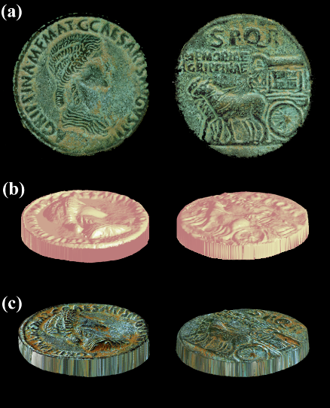
Fig. 5. Ancient Roman coin (A.D. 37 – 41).
(a) Photograph of the coin: obverse and reverse; (b) Shaded Rendering of the coin geometry; (c) Rendering of the coin shape and color model.
- Conclusion
Projected fringes for the measurement of surface profile is extensively used in 2.5D optical metrology. However, low-cost commercially-available projectors are susceptible to gamma non-linearity, lack of depth of field, system vibration and noise, which distorts the fringe patterns and introduces significant errors in the phase measurements. In this work, we have presented a simple optical method that can be applied to measurement of micro-surface profiles. In the proposed setup, the number of phase shifts applied in the projected grating can be changed via the user interface, according to the required accuracy.
The proposed device has the potential of the traditional fringe projection technique with more versatility, offering the freedom to choose and control the fringe period. Experiments from real sample have shown that the 2.5D profiling measured, by the proposed system, are efficient and effective. Finally, the method relies on very simple and cheap equipment.
The proposed system using only consumer technology (a video projector and a digital camera), its realization can be carried out with less than $ 500.
In other words, with less than $ 750 is possible to realize a system with precision and accuracy comparable to much more complex and expensive systems (>$ 5000).

References
- G. Sansoni, M. Trebeschi, F. Docchio, “State-of-The-Art and Applications of 3D Imaging Sensors in Industry, Cultural Heritage, Medicine, and Criminal Investigation”, Sensors, vol.9, No.1, January 2009, pp. 568-601; https://doi.org/10.3390/s90100568
- G. Sansoni, P. Bellandia, F. Leonia, F. Docchio, “Optoranger: A 3D pattern matching method for bin picking applications”, Optics and Lasers in Engineering, vol.54, March 2014, pp. 222-231, https://doi.org/10.1016/j.optlaseng.2013.07.014
- G. Schirripa Spagnolo, L. Cozzella, C. Simonetti, “IR Fringe Projection for 3D Face Recognition”, AIP Conference Proceedings, vol.1236, May 2010, pp.383-388, https://doi.org/10.1063/1.3426146
- G. Schirripa Spagnolo, L. Cozzella, C. Simonetti, “Linear conoscopic holography as aid for forensic handwriting expert”, Optik, vol.124(15), 2013, pp. 2155-2160, https://doi.org/10.1016/j.ijleo.2012.06.097
- G. Schirripa Spagnolo, L. Cozzella, F. Leccese, “Viability of an optoelectronic system for real time roughness measurement”, Measurement, vol.58, December 2014, pp. 537-543, https://doi.org/10.1016/j.measurement.2014.09.018
- G. Sansoni, P. Bellandi, F. Docchio, “Design and development of a 3D system for the measurement of tube eccentricity”, Meas. Sci. Technol., vol.22, No.7, June 2011, https://doi.org/10.1088/0957-0233/22/7/075302
- J. Salvi, S. Fernandez, T. Pribanic, Xavier Llado, “A state of the art in structured light patterns for surface profilometry”, Pattern Recognition, vol.43, No.8, August 2010, pp. 2666-2680, https://doi.org/10.1016/j.patcog.2010.03.004
- S. Zhang, “High-speed 3D shape measurement with structured light methods: A review”, Optics and Lasers in Engineering, vol.106, July 2018, pp. 119-131, https://doi.org/10.1016/j.optlaseng.2018.02.017
- S. Zhang, Handbook of 3D Machine Vision: Optical Metrology and Imaging, CRC Press, Boca Raton, Fl (USA), 2013, https://doi.org/10.1201/b13856
- V. Srinivasan, H. C. Liu, and M. Halioua, ‘‘Automated phase measuring profilometry of 3-D diffuse object,’’ Appl. Opt., vol.23, No.18, pp. 3105–3108, 1984, https://doi.org/10.1364/AO.23.003105
- P.S. Huang, Q. Hu, and F.P. Chiang, “Error compensation for a 3D shape measurement system”, Opt. Eng., vol. 42, No.2, pp. 482–486, February 2003, https://doi.org/10.1117/1.1531636.
- L.C. Chen , C.C. Liao, “Calibration of 3D surface profilometry using digital fringe projection,” Meas. Sci. Technol., vol. 16, No.8, pp. 1554–1566, June 2005, https://doi.org/10.1088/0957-0233/16/8/003
- M. Takeda, K. Mutoh, “Fourier transform profilometry for the automatic measurement of 3-D object shaped,” Appl. Opt., vol.22, No.24, pp. 3977–3982, 1983, https://doi.org/10.1364/AO.22.003977
- E. Zappa, G. Busca, “Static and dynamic features of Fourier transform profilometry: A review”, Optics and Lasers in Engineering, vol.50, No.8, August 2012, pp. 1140-1151, https://doi.org/10.1016/j.optlaseng.2012.03.008
- G. Schirripa Spagnolo, L. Cozzella, F. Leccese, “Phase correlation functions: FFT vs. FHT”, ACTA IMEKO, vol.8, No.1, 2019, pp. 87-92, http://dx.doi.org/10.21014/acta_imeko.v8i1.604
- C. Zuo, S. Feng , L. Huang , T.Tao , W. Yin, Q. Chen, “Phase shifting algorithms for fringe projection profilometry: A review”, Optics and Lasers in Engineering, vol.109, 2018, pp. 23-59, https://doi.org/10.1016/j.optlaseng.2018.04.019
- H. O. Saldner and J. M. Huntley, “Temporal phase unwrapping: application to surface profiling of discontinuous objects,” Appl. Opt., vol. 36(13), pp. 2270-2275, 1997. https://doi.org/10.1364/AO.36.002770
- C. Zuo, L. Huang, M. Zhang, Q. Chen, A. Asundi, “Temporal phase unwrapping algorithms for fringe projection profilometry: A comparative review, Optics and Lasers in Engineering”, vol.85, 2016, pp. 84-103, https://doi.org/10.1016/j.optlaseng.2016.04.022
- K.E. Torrance and E.M. Sparrow, “Theory for Off-specular Reflection from Roughened Surfaces”, J.OSA, vol.57, No. 9, 1967, pp.1l05-11l4, https://doi.org/10.1364/JOSA.57.001105
- G. Schirripa Spagnolo, B. Calabrese, G. Ferrari, “Color Separation to Facilitate Handwriting Examination”, 5th International Symposium on Communications Control and Signal Processing, ISCCSP 2012; Rome; Italy; May 2012, https://doi.org/ 10.1109/ISCCSP.2012.6217832

