Image and laser scanner survey archive for Cultural Heritage 3D-modeling and changing analysis.
Gabriella Caroti¹, Isabel Martínez-Espejo Zaragoza¹, Andrea Piemonte¹
¹Civil and Industrial Engineering Department (DICI)/University of Pisa, Largo Lucio Lazzarino 1, 56122 Pisa, Italy
ABSTRACT
Cultural Heritage studies often require to perform analyses on buildings which have undergone several changes and alterations during their lifetime. This often implies loss of architectural elements or construction of new elements, in turn disrupting the perception of the former buildings. The recovery of lost elements or structures through virtual reconstructions is of paramount importance in both scientific and cultural applications. In this case, novel procedures in surveying and photogrammetric processing offer a powerful tool, allowing to extract geometric information from historical documentation such as archive images, historical photogrammetry (HP) or historical terrestrial laser scanner (HTLS). This paper elaborates on the methodology used for integration of a metric 3-D model with information present in archive surveys of lost architectural volumes. The methodology implies the availability of historical plans representing the survey object at scales consistent with UAV surveys and featuring shared elements. The methodology used to frame these plans in the reference system of the UAV survey for an open source GIS environment is also described, as well as the accuracy checks. Finally, the procedure followed for the virtual reconstruction of the Fortezza in BIM environment, granting fruition of the model derived by integration of historic and current data, is described. The methodology was applied to two case studies: a portion of the Pisa medieval walls of and in the Fortezza Vecchia site in Livorno.
Section: RESEARCH PAPER
Keywords: Cultural Heritage, Photogrammetry, Laser scanner, BIM
Citation:Thomas Bruns, Dirk Röske, Paul P.L. Regtien, Francisco Alegria, Template for an IMEKO event paper, Acta IMEKO, vol. 3, no. 1, article 1, January 2014, identifier: IMEKO-ACTA-03 (2014)-01-01
Editor: Paolo Carbone, University of Perugia, Italy
Receivedmonthday, year; In final formmonth day, year; PublishedJanuary2014
Copyright: © 2014IMEKO. This is an open-access article distributed under the terms of the Creative Commons Attribution 3.0 License, which permits unrestricted use, distribution, and reproduction in any medium, provided the original author and source are credited
Funding: This work was partially funded by PRA 2017/12 University of Pisa Project
Corresponding author: Isabel Martínez-Espejo Zaragoza, e-mail: isabel.zaragoza@unipi.it

- Introduction
Surveying and documenting cultural heritage is essential for its protection and sustainable management [1].
In the last decades, new instruments and innovative surveying methodologies provided cultural heritage with data and views at the same time innovative, simplified, user-friendly and challenging for researchers.
Anyway, in addition to methodological and technical issues, any intervention on a cultural heritage object requires its full knowledge, including its original concept, the timeline of any modification, its current conditions, the causes of the decay and their historical contextualization, etc.
In this perspective, surveys provide a valuable support in the investigation of historical – bibliographical, documental and iconographical – sources, lending actual consistency for geometry, materials and build.
Photogrammetry methodologies play a prominent role due to the availability of a vast array of photographical images, both historical and present, of cultural heritage.
Such an array is of foremost importance, as it provides valuable information in preliminary investigation, e.g. past, hardly trackable interventions on a building or its current conditions [2].
The use of Historical Photogrammetry (HP) in cultural heritage investigations is well shown by the relevant research lines pursued by several Authors in order to assess what additional information can be provided by referring these images to new 3-D survey models and what potential this kind of operation offers [3,4,5,6,7,8].
Laser scanning, both terrestrial and airborne, is possibly the most important surveying technology developed over the last 20 years. In this time span, its use as a means of producing dense point clouds for documenting, mapping and multi-scale viewing purposes has evolved from alternative to traditional methodologies of direct surveying [9,10,11,12] and classical photogrammetry into a surveying methodology capable of integration with other geomatics offerings.
Use of laser scanning for over 20 years in cultural heritage surveying and documenting has in turn led to a large archive of real-scale dense point clouds, which allow to perform multi-temporal comparisons and investigations and provide support architectural research and historical cataloguing.
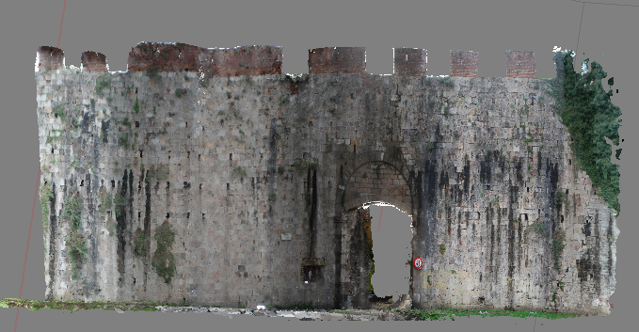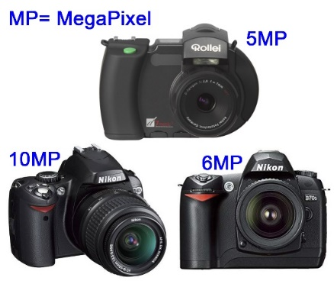
Figure 1. Photogrammetric Point Cloud from historic images (up) and, cameras used for collecting historic images (down).
As for HP, data processing methodologies for Historical Terrestrial Laser Scanning (HTLS) also present some difficulties. Firstly, HTLS data usually come in proprietary formats, not readily convertible to current standards. Besides, several HTLS data sets only provide 3-D coordinates and reflectance values, therefore lacking any colour information, which can pose additional problems in the manual input of registering points in case of failure of cloud matching algorithms, due e.g. to insufficient overlap between adjacent scans. This could further complicate the detection of tie points for the orientation of historical images.
Finally, density and precision of HTLS clouds reflect the technological limitations of relevant time periods.
The current job is targeted to define a methodology for recovery of HTLS and HP data for the generation of 3-D models of the survey objects as support in multi-temporal investigations on the geometry of objects subjected over time to alterations, modifications, changes of use destination etc.
The investigation focused on two case studies: a section of the medieval urban walls by Porta San Zeno (St. Zeno Gate) in Pisa and the Fortezza Vecchia (Old Fortress) site in Livorno, Italy. Porta San Zeno underwent major restoration and improvement activities starting in 2012: preliminary surveys, however, started in 2010 and provided historical TLS, photogrammetry and photographic data used for the present investigation along those collected in more recent times reporting the results of restoration and improvement interventions. Fortezza Vecchia suffered several volume losses both during and after World War II, upon restoration interventions. In this case, archive images have been used for metric 3-D reconstruction of Palazzo di Cosimo De’ Medici.
- MATERIALS
  - Pisa urban walls
Porta San Zeno, one of the medieval gates that provided access to the city, is located near the namesake church. Its current setting dates back to 1935, when it was reopened, in order to alleviate urban vehicular traffic by providing a route towards SS12 and SP2 (Via del Brennero and Via Calcesana). The defensive complex includes a round arch, complemented by a lowered arch curtain built in Verruca stone, following the Pisa custom, and supported by rectangular pillars, also in Verruca stone, topped with plain capitals. In the intrados, the stone rings, which originally provided support for the gates’ hinges, are still visible.
The face in which the arch is set is made of Asciano breccia, neatly cut in rectangular ashlars. It has been built between 1156 and 1158, as a closure for a wall section joining along the north-east direction two existing sections by St. Zeno abbey.
The wall section including the Gate was later involved in the reinforcement of urban defences following the defeat suffered by Pisa in the battle of the Meloria in 1284, which provided widening and the excavation of a moat along its outer side.
The section of urban walls between the Gates of Lucca and St. Zeno has kept its respect bracket, both inwards and outwards, ever since having been built [13].
    - 2010 survey campaign
In 2010, ASTRO laboratory carried out a surveying campaign in order to document the status quo of the walls section around the gate. The surveys exploited two different techniques: a TLS survey, by means of a Riegl LMS-Z420i laser scanner, and a photogrammetric survey, by means of both a semi-metric Rollei d7 digital camera and an amateur digital Nikon D40X camera (Figure 1, up).
The Riegl LMS-Z420i laser scanner automatically associates laser scans with the “high-resolution” images collected by a calibrated camera installed in a dedicated socket on top of the device. Its precision is 10mm up to a 50m range (1σ @ 50m range under Riegl’s test conditions). The integrated camera used in the survey is a Nikon D70 (Figure 1, down) digital camera fitted with a fixed focus (f=20mm) lens, whose other features include a 6.1 MP, 23.7 x 15.6 mm sensor and a 2000x3008 px image size.
Features of the cameras used in the photogrammetry survey include, as regards the Rollei d7, a fixed focus (f=7mm, 1:2.8) lens, equivalent to 28mm for a 35mm camera, with a 5MP, 8.8 x 6.6mm sensor and a 2552 x 1920 px image size; for the Nikon D40X, a variable focus (f=18-55mm) lens, with a 10.2MP, 23.6 x 15.8mm sensor and a 3872 x 2592 px image size.
These images were aimed at photographic straightening, and therefore have no or very poor mutual overlap. Since no photogrammetric modelling was planned, focal length is also inconsistent between images collected with the Nikon D40X camera. In addition, the Nikon D70 also collected some context images of the Arch, as supporting documentation.

    - 2019 survey campaign
The 2019 survey campaign carried out by ASTRO laboratory integrated TLS with SfM- and MVS-based photogrammetry.
The instrument used for the TLS survey is a Leica C10 ScanStation, with sub-centimetre precision and on-board camera.
Photographs were collected by a Nikon D750 digital camera (Figure 2, down), fitted with a fixed focus (f=50mm) lens, at an average range of about 10m, resulting in a GSD of about 1.2 mm.
A topographical survey, performed with a Leica TCRP 1201+ total station, provided the coordinates of the Ground Control Points (GCPs) and therefore a shared reference system for TLS and photogrammetry, as well as the ability to scale the latter.
  - Fortezza Vecchia
Fortezza Vecchia in Livorno, Tuscany, is the last of an array of fortifications designed by architects Giuliano and Antonio da Sangallo between 1488 and 1519, with which they experimented and improved on the modern outline of fortifications with corner bastions. The Fortezza Vecchia complex included a pre-existing fortification, known as Quadratura dei Pisani, built around the second half of XIV century to strengthen an existing medieval keep. Pre-existing structures, as well as the site itself, surrounded by the sea, deeply affected the building process, resulting in several anomalies and departures from the ideal regular form pursued by Renaissance military architecture [14].
    - Archive documentation
Historic documents referring to Fortezza Vecchia include a set of plans dating from 1669 to 1676 [15], showing interior layout and the design of public and residential spaces. A further set of plans, dating from XVIII to XIX century tracks multiple changes in the intended use of the complex after its termination as military fortress [16].
Photographs predating WWII show the size of the complex and the huge barracks located in the large squares of the fortress. Early XX century images mostly show global views of the complex.
On the other hand, both the XVIII-XIX century plans and the XX century images record an ongoing building choke due to lack of space.
    - Current survey
The status quo reference survey was made available by the North Tyrrhenian Sea Port System Authority within the framework of the PRA research project 2017 “Tuscany’s renaissance architectures: case studies between historical investigation, survey and structural analysis”, funded by the University of Pisa.
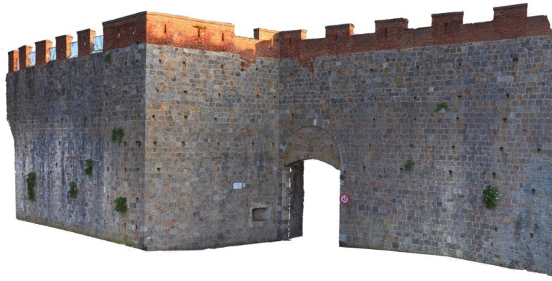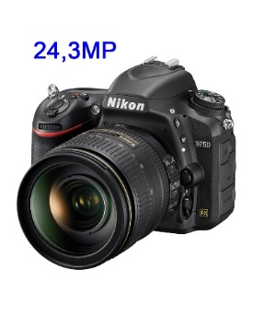
Figure 2. Up, Photogrammetric model from 2019 survey. Down, Nikon D750 camera.
This survey of the fortress was based on UAV-borne imagery, which allowed the reconstruction of exteriors 3-D model. Besides, UAV-borne imagery allows to detect homologous points for orientation of archive images based on unchanged architectural details.
A fixed focus (f=20mm – 35mm format equivalent) camera with a 12.4 MP (image size 4000x3000px) 1/2.3" CMOS sensor, fitted on board a DJI FC330 UAV, was used to collect a total of 110 images, divided in two sets at 40m and 60m respectively flight levels relative to the top of the walls.
- METHODS AND RESULTS
  - Pisa urban walls
The data sets described above yielded two models. In the first case, all the images collected by the cameras in the 2010 survey were processed using SfM and MVS to generate a 3-D photogrammetric model (Figure 1, up). Orientation has been successfully performed on 77 out of 92 images collected with the three cameras. Photogram alignment for this model presented some problems, due to both different image resolution and quality and insufficient overlap, since the photographs targeted photoplan production. In addition, variable focal length, pixel size and image size entail the project having poorly defined sections, with minor morphological issues. For these reasons, manual input of about 35 tie points was required in order to assist the photogrammetry software in correctly matching homologous points. The precision of the resulting model is of a few cm.
TLS provided the coordinates of some Ground Control Points (GCPs) used in photogrammetry processing (8 points). Selecting 10 control points for alignment checking yielded a mean error of 2.8 pixels / 5cm.
This model represents the survey object prior to any restoration intervention, showing the volumes and the decay.
The 2019 survey generated a further, high-precision photogrammetry model, representing the survey object after the restoration (Figure 2, up).
The comparison between these models yields a noteworthy documentation, which allows to analyse variations in volumes and geometry, the consistence of the restoration and the extant structural decay.
The 2010 model allows to observe several pathologies, such as the lack of crowning on the majority of the battlement, geometric disruptions and fractures, as well as the presence of biotic film and shrubs growing on the walls, breaking up the building materials and affecting the optimal structural conditions.
On the other hand, the 2019 model allows to keep track of geometrical changes intervened over time, such as integration of volumes, which have modified the previous shapes, and the addition of external elements allowing for safe pedestrian practicability. The removal of biotic film and the restoration of fractures can also be observed, along with the ongoing growth of shrubs and other plants continuing their disruptive action on joints.
The two clouds have been compared in order to visually detect the morphological changes occurred over time (Figure 3).
  - Fortezza Vecchia
After the Second World War, Palazzo di Cosimo was razed in some areas, while in others the walls suffered partial damages. A virtual reconstruction of the building using Buildings Information Modelling (BIM) software, in this case Revit, provided support to study and manage the historical documentation. The reference period for reconstruction is early 20th century, before the war and the partial destruction of the building. Available historical archive photographs, which represent the building before the destruction of the war, date back to this period.
The virtual reconstruction is based on three key elements: the ancient plants designed in the 18th century, the photographs taken between the late 1800s and early 1900s and the 3D model of the current situation obtained by photogrammetric processing of airborne imagery.
    - Measures obtainable from historical plans
The historic plants of the 18th century were scanned at a resolution of 300 dpi, which corresponds to a pixel size of about 2cm (Figure 4).
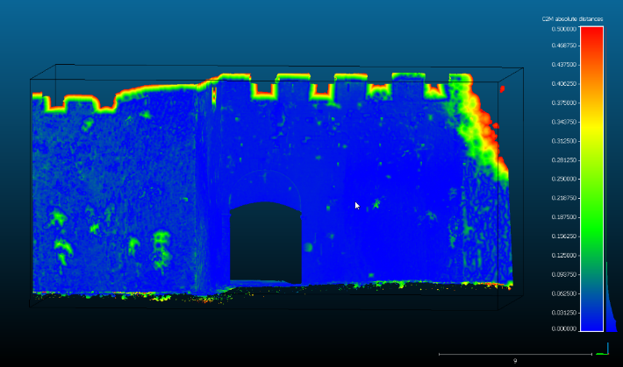
Figure 3. Comparison between 2010 and 2019 photogrammetry models.
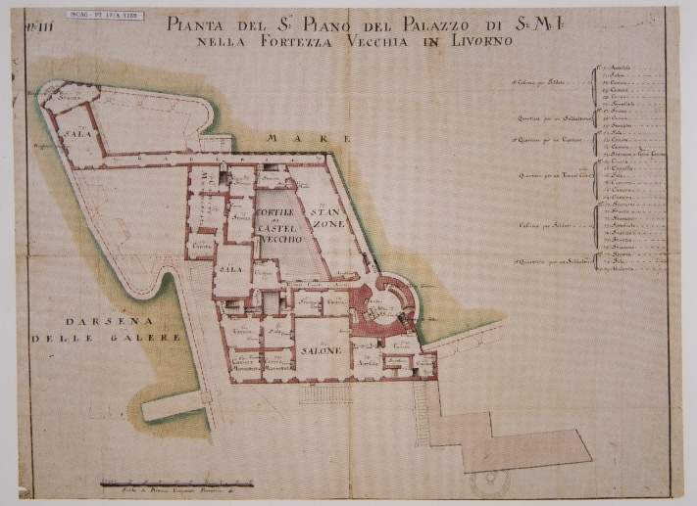
Figure 4. Palazzo di Cosimo XVIII century plan.
In order to be able to use these scans in the definition of the 3-D model, it was necessary to georeference it and to minimize as far as possible the survey and support deformation errors.
Georeferencing of the historical plant image was performed in the QGIS environment using a first-degree polynomial geometric transformation, upon which it was resampled using the nearest neighbour algorithm.
For transformation parameters evaluation, ten recognizable points were identified both on the paper plan and in the orthophotograph obtained from the photogrammetric survey (Figure 5).
Six of these points were used as GCPs to calculate the transformation parameters, and four were used as Check Points (CPs).
The residuals on the GCPs, providing accuracy indications, were on average 42 pixels, while the residuals on the CPs, providing precision indications, were on average equal to 45 pixels. These results agree as regards magnitude order, and the solution provided is acceptable for the transformation. The pixel size in metric units is equal to about 2 cm, resulting in 84cm accuracy and 90cm precision.
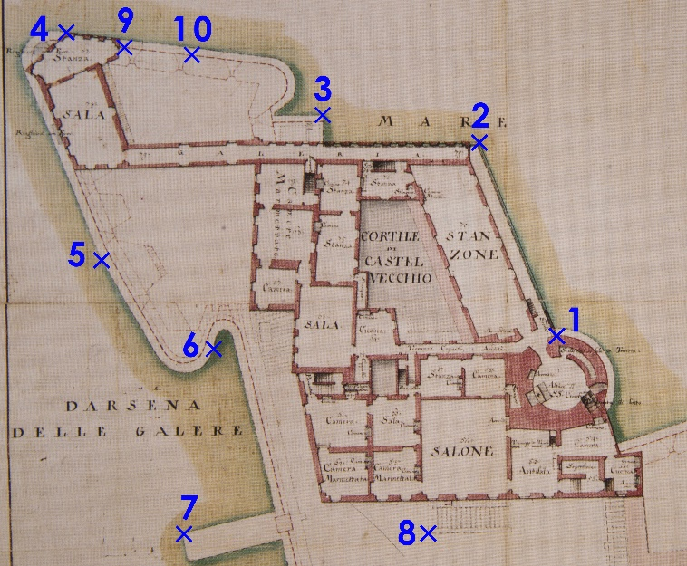
Figure 5. GCPs and CPs on XVIII century plan.
Considering the type of historical plant, its state of conservation, the deformations that the support may have had over time, as well as the graphical and metrical accuracy of archive surveys, the Authors believe that the achieved results of the transformation was adequate for the subsequent work of integration and verification of the data obtained from the photogrammetric processing of the historical archive images.
    - 3D points definition through historical images
In this case, images have not been collected by means of digital cameras with known features: instead, analogue archive images have been used.
Processing of analogue photographs, mostly older ones, is more complex than digital ones, due to archive quality as well as digitization and technical equipment issues. Anyway, even bigger problems reside in material coming from different sources, with uncertain origin, low image quality, complete lack of information on the camera parameters and the presence of deformations on the original image [4].
Use of archive images, lacking important requirements for correct photogrammetric processing, while failing to grant homogeneous geometric precision as well as the ability to generate complete 3-D models, allows nonetheless, in the case of Fortezza Vecchia, to reconstruct lost volumes. For this purpose, anyway, beyond strictly following geomatics survey guidelines, an in-depth historic-architectural investigation of the study object is required for full comprehension and better exploitation of any available source.
While photogrammetric processing of these images did not allow for automated point cloud generation, it did however provide geometric reference for subsequent processing. Some points can be measured in separate images and subsequently calculated by ray intersection, using the results of the orientation by bundle adjustment. Although seemingly straightforward, this step in fact poses some practical issues. Due to differences in image scale, radiometric and geometric resolution, shooting position, lighting conditions etc., it is often quite difficult to detect the same point in two different images. Coordinate precision for the resulting points is related to the lower precision of pairs of image coordinates and the conditions of ray intersections [17].
The photogrammetry project includes the status quo set of UAV-borne images and five archive images dating to the 1930s. As already stated, the different features of the archive images and their shooting geometry, as well as major scene modifications, have prevented automatic detection of tie points, which have therefore been detected manually. This operation provided the following steps:
1) selection of areas which did not undergo changes or major restorations since the 1930s, based on historic researches;
2) within these areas, surveying of architectural elements in order to keep sighting errors on images as low as possible;
3) picking out points providing the most homogeneous layout on both images and 3-D model.
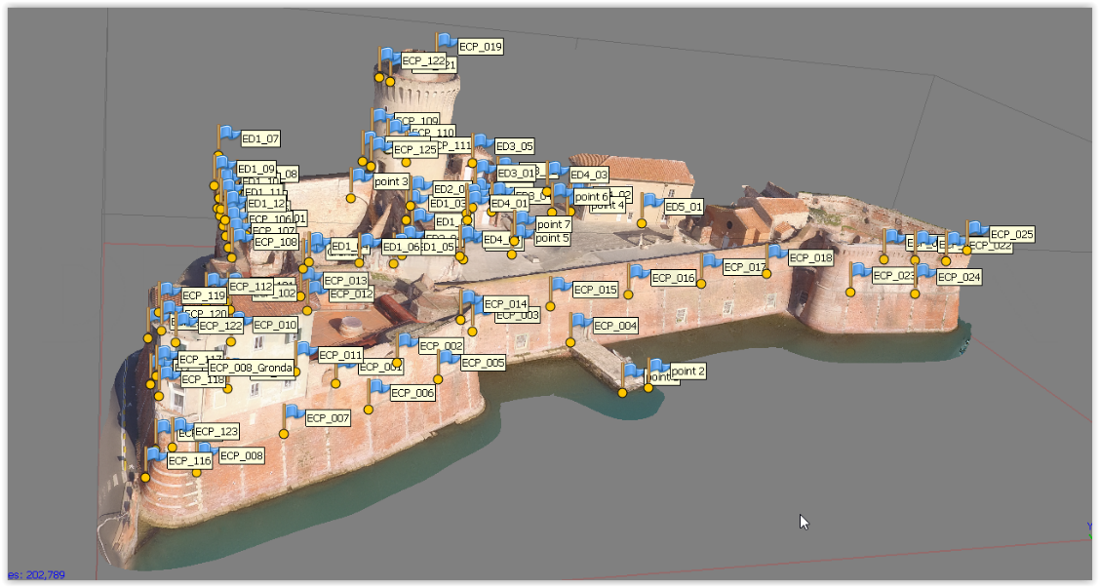
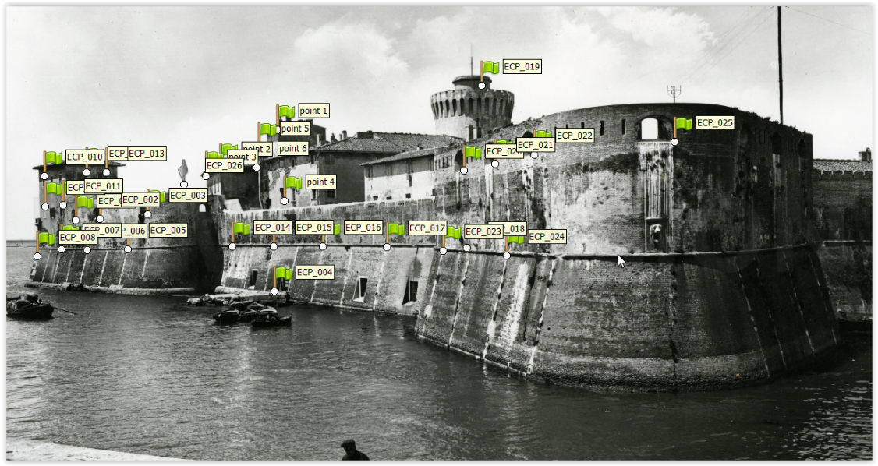
Figure 6. Tie point on 3D model (up) and on archive image (down).
A total of 52 points, one half of which detected on images collected along the North to South direction and the other half on images collected in the East to West direction, was selected and sighted (Figure 6, up). Such high amounts of points for bundle adjustment were required in order to keep sighting errors due to the poor resolution of archive images as low as possible.
Further 20 control points were selected for alignment checking, resulting in a mean error of 1.3 pixels / 12cm.
Integration of the UAV-derived 3-D model of the Fortress with on-site analysis allowed to outline the main walls of some buildings, such as those bounding the Cortile del Castello Vecchio, while other areas, particularly on its W and S sides, were not so well-defined.
Identification of the points upon orientation of archive images (Figure 6, down) in the UAV-derived 3-D model yielded the external outline of the S and W perimeter walls, as well as most eaves and some window sills.
The easiest way to obtain the vertical walls 3D model would have been using photogrammetry starting from ancient photos. A similar method was used in modelling Porta San Zeno. However, as previously stated, these images did not automatically allow to obtain a dense point cloud, due to image quality and resolution. Considering that the orientation parameters of these images are known, it was instead possible to use them to obtain the 3D coordinates of significant points (windows, doors, wall heights, etc.).
These 3D coordinates have then been exported in CAD environment, and subsequently to Revit.
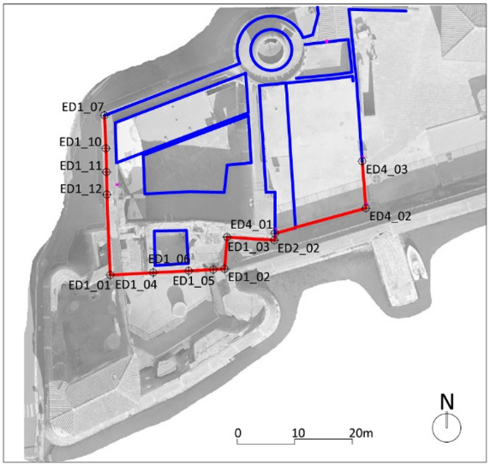
Figure 7. UAV-borne orthophotograph overlaid with plan of Palazzo di Cosimo de’ Medici.
Historical photogrammetry, therefore, allows above all to obtain metric information unavailable in other graphic archive documentation. These findings allowed to provide a 2-D outline for the entire complex, which is in turn essential for subsequent 3-D reconstruction. Calculated elevations of lost buildings, along with numerical information on historical documents, provides an useful support for possible reconstruction of the interior, also taking advantage of extant building portions (Figure 7).
    - 3D virtual reconstruction
Palazzo di Cosimo de’ Medici has been partially reconstructed using Autodesk’s Revit BIM software. For this purpose, the first step provided using Autodesk’s ReCap software to export the point cloud of the status quo model in Revit. A local reference system is also created, as per Revit requirements, starting from the WGS84 reference system of the photogrammetry model. This step provides use of Autodesk’s AutoCAD software to trace the plans of the three levels of the building, previously processed in QGIS, as stated in 3.2.1. Subsequently, in Revit, the point cloud model provides the basis to reconstruct the first level of the building, corresponding to the ground level plan of the Palazzo. In order to retrieve the elevation information for the other levels, horizontal sections of the point cloud are checked against 3-D points detected on historic images. Upon calculation of the height of the different levels, these are defined in Revit and the matching plans are imported. This information is fed into Revit to reconstruct the walls.
The following step involves windows and roofs. While 2-D positions of the windows are extracted from historical plans, assessing their height requires photogrammetry information. In Revit, different window families and sizes are then defined for each window type. Reconstruction of the roofs provides defining the slope by detecting relevant points on historical images, which also supply a visual clue as regards the roof type, e.g. gable or hip roofs.
BIM modelling also provides definition of the building materials: in this case, the poor quality of the historic images prevented retrieving this information. However, future integrations covering this part are provided, also involving different expertise areas such as archaeology and architecture history.
Any ambiguous or hardly readable information were filtered out of the modelling process, only using sources effectively clearing a given reliability threshold in the generation of the BIM model.
- CONCLUSIONS
Methodologies and examples shown in this paper show that, as regards management of architectural heritage, HBIM plays a similar role as GIS for land management, i.e. a tool for handling heterogeneous data and, above all, databases featuring georeferencing as unifying factor.
In both the cases presented, and particularly for the reconstruction of lost architectural volumes in Fortezza Vecchia in Livorno, it is apparent that generation of the 3-D model and its placement in the status quo layout has been possible only thanks to the integration of information coming from mixed sources.
In particular, TLS is a well-established surveying methodology, whose results provide an effective means of representation of historical and architectural heritage. A simple comparison between TLS surveys carried out with a 9-years interval highlights the powerful evolution this technology has underwent in this time span.
The new approach to photogrammetry, based on SfM and MVS algorithms has brought over a major change in the geomatics survey routine, allowing to collect high-density colour 3-D point clouds, quite similar in size to those coming from TLS. It is however obvious that the achievement of such results requires following strict rules in planning and performing the photographic shoots.
Historic images, either predating any change or from archives, have proved to supply a major information source, either for 3-D reconstruction of lost architectural volumes or achievement of a fuller understanding of the period-related status quo. Usually, photogrammetric processing of these images, particularly those with lower quality and poorer geometry, do not achieve automatic generation of point clouds of the survey objects: even when this is possible, however, homogeneous geometric accuracy is not ensured. As regards Fortezza Vecchia, further processing has yielded geometric information which, although not always sufficient for a full 3-D reconstruction, provide anyway some references for subsequent integration of other iconography. For Porta San Zeno, with a more consistent, natively digital image set, a 3-D model has been generated, providing a more detailed documentation of the pre-restoration status quo. In both cases, the methodology for fuller object documentation shows great potential.
Most interesting is the use of typical GIS tools for the homogenization of reference systems, in particular as regards the ability to provide diverse images, including historic ones, with georeferencing information by means of tools and algorithms available in open source GIS environments.
Generation of the final model provides processing the above data in HBIM environment, which also allows multitemporal structure analysis.
3-D survey products are in ever rising demand among managers of built heritage. In this context, the ability to recover any data surveyed in the past in view of the generation of 3-D models is of the highest importance. The final models can be integrated, by means of photogrammetric tie points, in the status quo model, for possible fruition on VR/AR platforms.
AcknowledgementS
Financial support from the University of Pisa under programme PRA 2017, project “Architetture toscane rinascimentali: casi studio fra indagine storica, rilievo e analisi strutturale” is gratefully acknowledged.
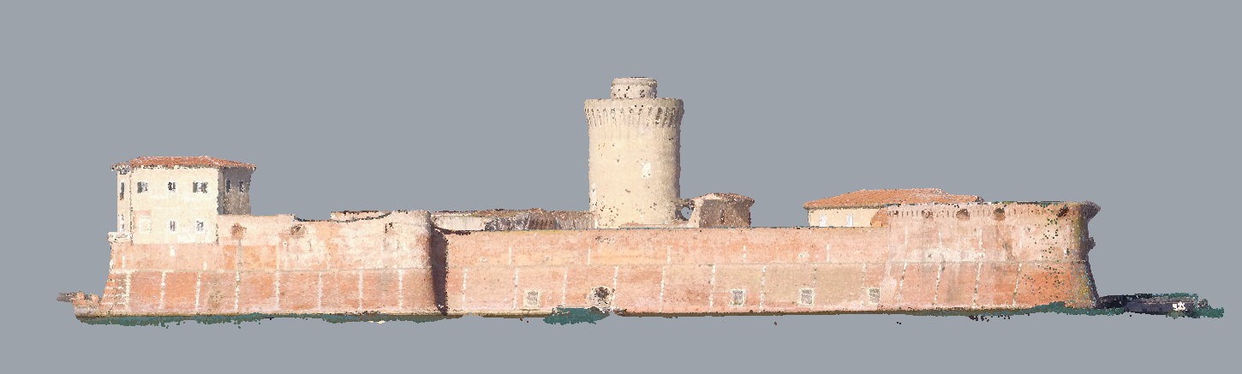
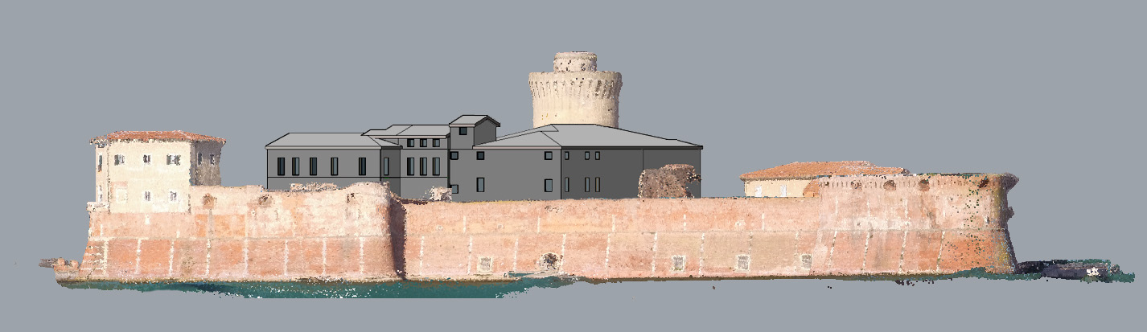
Figure 9. Virtual 3D model with and without Palazzo di Cosimo reconstruction.
The collaboration of the Port System Authority of the Northern Tyrrhenian Sea is gratefully acknowledged.
References
- Means, B.K.: 3D Recording, Documentation and Management of Cultural Heritage. Hist. Archaeol. 51, 582–583 (2017). https://doi.org/10.1007/s41636-017-0055-x.
- Grussenmeyer, P., Al Khalil, O.: From metric image archives to point cloud reconstruction: case study of the great mosque of Aleppo in Syria. ISPRS - Int. Arch. Photogramm. Remote Sens. Spat. Inf. Sci. XLII-2/W5, 295–301 (2017). https://doi.org/10.5194/isprs-archives-XLII-2-W5-295-2017.
- Bevilacqua, M.G., Caroti, G., Martínez-Espejo Zaragoza, I., Piemonte, A.: Orientation of archive images on 3D digital models of painted vaults: an interesting tool for restorers. Appl. Geomatics. 10, 385–398 (2018). https://doi.org/10.1007/s12518-018-0212-8.
- Bevilacqua, M.G., Caroti, G., Piemonte, A., Ulivieri, D.: Reconstruction of lost architectural volumes by integration of photogrammetry from archive imagery with 3D models of the status quo. ISPRS - Int. Arch. Photogramm. Remote Sens. Spat. Inf. Sci. XLII-2/W9, 119–125 (2019). https://doi.org/10.5194/isprs-archives-XLII-2-W9-119-2019.
- Bitelli, G., Dellapasqua, M., Girelli, V.A., Sbaraglia, S., Tinia, M.A.: Historical photogrammetry and terrestrial laser scanning for the 3D virtual reconstruction of destroyed structures: a case study in Italy. ISPRS - Int. Arch. Photogramm. Remote Sens. Spat. Inf. Sci. XLII-5/W1, 113–119 (2017). https://doi.org/10.5194/isprs-archives-XLII-5-W1-113-2017.
- Bitelli, G., Girelli, V., Marziali, M., Zanutta, A.: Use of Historical Images for the Documentation and the Metrical Study of Cultural Heritage by Means of Digital Photogrammetric Techniques. ISPRS Arch. XXXVI-5/C5, 6 (2007).
- Grun, A., Remondino, F., Zhang, L.: Photogrammetric Reconstruction of the Great Buddha of Bamiyan, Afghanistan. Photogramm. Rec. 19, 177–199 (2004). https://doi.org/10.1111/j.0031-868X.2004.00278.x.
- Maiwald, F., Vietze, T., Schneider, D., Henze, F., Münster, S., Niebling, F.: Photogrammetric analysis of historical image repositories for virtual reconstruction i nthe field of digital humanities. ISPRS - Int. Arch. Photogramm. Remote Sens. Spat. Inf. Sci. XLII-2/W3, 447–452 (2017). https://doi.org/10.5194/isprs-archives-XLII-2-W3-447-2017.
- Cardaci, A., Roberti, G.M., Versaci, A.: From the continuos to the discrete model: a laser scanning application to conservation projects. ISPRS - Int. Arch. Photogramm. Remote Sens. Spat. Inf. Sci. XXXVIII-5/, 437–444 (2012). https://doi.org/10.5194/isprsarchives-XXXVIII-5-W16-437-2011.
- Caroti, G., Martínez-Espejo Zaragoza, I., Piemonte, A.: Range and image based modelling: a way for frescoed vault texturing optimization. ISPRS - Int. Arch. Photogramm. Remote Sens. Spat. Inf. Sci. XL-5/W4, 285–290 (2015). https://doi.org/10.5194/isprsarchives-XL-5-W4-285-2015.
- Bevilacqua, M., Caroti, G., Martínez-Espejo Zaragoza, I., Piemonte, A.: Frescoed Vaults: Accuracy Controlled Simplified Methodology for Planar Development of Three-Dimensional Textured Models. Remote Sens. 8, 239 (2016). https://doi.org/10.3390/rs8030239.
- Spreafico, M.C., Perotti, L., Cervi, F., Bacenetti, M., Bitelli, G., Girelli, V.A., Mandanici, E., Tini, M.A., Borgatti, L.: Terrestrial Remote Sensing techniques to complement conventional geomechanical surveys for the assessment of landslide hazard: The San Leo case study (Italy). Eur. J. Remote Sens. 48, 639–660 (2015). https://doi.org/10.5721/EuJRS20154835.
- Zampieri, A.: Le mura di Pisa. Percorsi. (2014).
- Ulivieri, D.: Fortezza Vecchia in Livorno. Nexus Netw. J. 16, 675–697 (2014). https://doi.org/10.1007/s00004-014-0203-y.
- VV.AA.: Livorno: progetto e storia di una città tra il 1500 e il 1600. (1980).
- Piancastelli, G., Nencini, P.: La fortezza vecchia: difesa e simbolo della città di Livorno. (1995).
- Wiedemann, A., Hemmleb, M., Albertz, J.: Reconstruction of historical buildings based on images from the Meydenbauer archives. Int. Arch. Photogramm. Remote Sens. XXXIII-P, 887–893 (2000).

