Historical data of laser scanning and photogrammetry for the knowledge and memory plan of Cultural Heritage
Gabriella Caroti¹, Isabel Martínez-Espejo Zaragoza¹, Andrea Piemonte¹
¹ Civil and Industrial Engineering Department (DICI), A.S.T.R.O. Laboratory, University of Pisa
Largo Lucio Lazzarino 1, 56122 Pisa, Italy, gabriella.caroti@unipi.it

Abstract – Cultural Heritage studies often require to perform analyses on buildings which have undergone several changes and alterations during their lifetime. This often implies loss of architectural elements or construction of new elements, in turn disrupting the perception of the former buildings. The recovery of lost elements or structures through virtual reconstructions is of paramount importance in both scientific and cultural applications. In this case, novel procedures in surveying and photogrammetric processing offer a powerful tool, allowing to extract geometric information from historical documentation such as archive images, historical photogrammetry (HP) or historical terrestrial laser scanner (HTLS). This contribution presents a methodology based on HTLS and HP data and aimed at the generation of 3-D models for multi-temporal geometric analysis of modified objects. The methodology was applied to two case studies: a portion of the Pisa medieval walls of and in the Fortezza Vecchia site in Livorno.
- Introduction
Surveying and documenting cultural heritage is essential for its protection and sustainable management [1].
In the last decades, new instruments and innovative surveying methodologies provided cultural heritage with data and views at the same time innovative, simplified, user-friendly and challenging for researchers.
In addition to methodological and technical issues, any intervention on a cultural heritage object requires anyway its full knowledge, including its original concept, the timeline of any modification, its current conditions, the causes of the decay and their historical contextualization etc.
In this perspective, surveys provide a valuable support in the investigation of historical – bibliographical, documental and iconographical – sources, lending actual consistency for geometry, materials and build.
Photogrammetry methodologies play a prominent role due to the availability of a vast array of photographical images, both historical and present, of cultural heritage.
Such an array is of foremost importance, as it provides valuable information in preliminary investigation, e.g. past, hardly trackable interventions on a building or its current conditions [2].
The use of Historical Photogrammetry (HP) in cultural heritage investigations is well shown by the relevant research lines pursued by several Authors in order to assess what additional information can be provided by referring these images to new 3-D survey models and what potential this kind of operation offers [3,4,5,6,7,8].
Laser scanning, both terrestrial and airborne, is possibly the most important surveying technology developed over the last 20 years. In this time span, its use as a means of producing dense point clouds for documenting, mapping and multi-scale viewing purposes has evolved from alternative to traditional methodologies of direct surveying [9,10,11,12] and classical photogrammetry into a surveying methodology capable of integration with other geomatics offerings.
Use of laser scanning for over 20 years in cultural heritage surveying and documenting has in turn led to a large archive of real-scale dense point clouds, which allow to perform multi-temporal comparisons and investigations and provide support architectural research and historical cataloguing.
As for HP, data processing methodologies for Historical Terrestrial Laser Scanning (HTLS) also present some difficulties. Firstly, HTLS data usually come in proprietary formats, not readily convertible to current standards. Besides, several HTLS data sets only provide 3-D coordinates and reflectance values, therefore lacking any colour information, which can pose additional problems in the manual input of registering points in case of failure of cloud matching algorithms, due e.g. to insufficient overlap between adjacent scans. This could further complicate the detection of tie points for the orientation of historical images.
Finally, density and precision of HTLS clouds reflect the technological limitations of relevant time periods.
The current job is targeted to the methodology for recovery of HTLS and HP data for the generation of 3-D models of the survey objects as support in multi-temporal investigations on the geometry of objects subjected over time to alterations, modifications, changes of use destination etc.
The investigation focused on two case studies: a section of the medieval urban walls by Porta San Zeno (St. Zeno Gate) in Pisa e the Fortezza Vecchia (Old Fortress) site in Livorno, Italy. St. Zeno Gate underwent major restoration and improvement activities starting in 2012: preliminary surveys, however, started in 2010 and provided historical TLS, photogrammetry and photographic data used for the present investigation along those collected in more recent times reporting the results of restoration and improvement interventions. Fortezza Vecchia suffered several volume losses both during and after World War II, upon restoration interventions. In this case, archive images have been used for metric 3-D reconstruction of Palazzo di Cosimo De’ Medici.

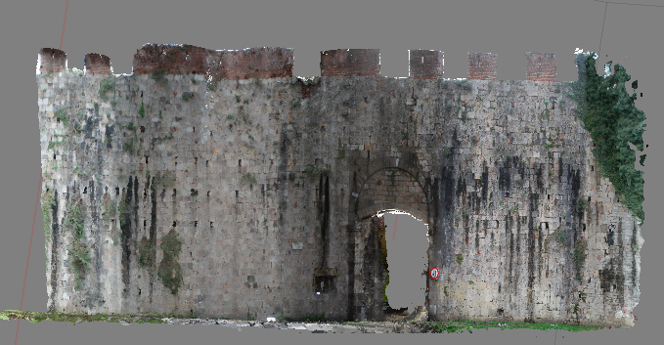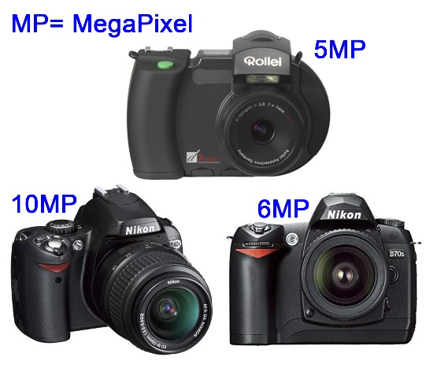
Fig. 1. Photogrammetric Point Cloud from historic images (l) and, cameras used for collecting historic images (r).

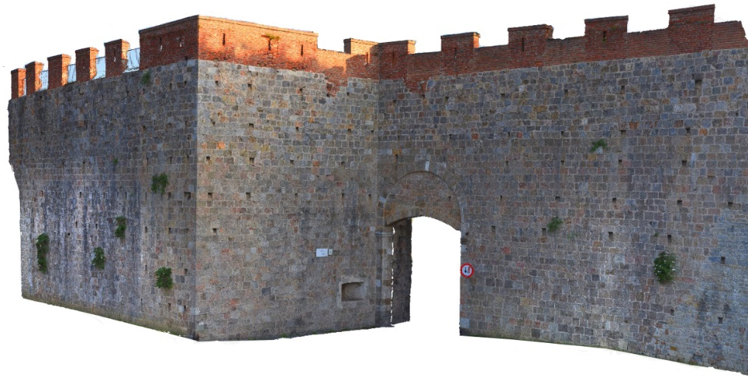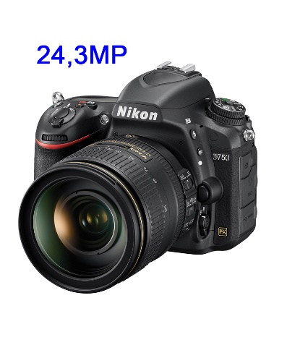
Fig. 2. Left, Photogrammetric model from 2019 survey. Right, Nikon D750 camera.

- Materials
  - Pisa urban walls
St. Zeno Gate, one of the medieval gates that provided access to the city, is located near the namesake church. Its current setting dates back to 1935, when it was reopened, in order to alleviate urban vehicular traffic by providing a route towards SS12 and SP2 (Via del Brennero and Via Calcesana). The defensive complex includes a round arch, complemented by a lowered arch curtain built in Verruca stone, following the Pisa custom, and supported by rectangular pillars, also in Verruca stone, topped with plain capitals. In the intrados, the stone rings, which originally provided support for the gates’ hinges, are still visible.
The face in which the arch is set is made of Asciano breccia, neatly cut in rectangular ashlars. It has been built between 1156 and 1158, as a closure for a wall section joining along the north-east direction two existing sections by St. Zeno abbey.
The wall section including St. Zeno Gate was later involved in the reinforcement of urban defences following the defeat suffered by Pisa in the battle of the Meloria in 1284, which provided widening and the excavation of a moat along its outer side.
The section of urban walls between the Gates of Lucca and St. Zeno has kept its respect bracket, both inwards and outwards, ever since having been built [13].
2010 survey campaign
In 2010, ASTRO laboratory carried out a surveying campaign in order to document the status quo of the walls section around the St. Zeno Arch. The surveys exploit two different techniques: a TLS survey, by means of a Riegl LMS-Z420i laser scanner, and a photogrammetric survey, by means of both a semi-metric Rollei d7 digital camera and an amateur digital Nikon D40X camera (fig. 1, right).
The Riegl LMS-Z420i laser scanner automatically associates laser scans with the “high-resolution” images collected by a calibrated camera installed in a dedicated socket on top of the device. Its precision is 10mm up to a 50m range (1σ @ 50m range under Riegl’s test conditions). The integrated camera used in the survey is a Nikon D70 (fig. 1, right), digital camera fitted with a fixed focus lens (f=20mm), whose other features include a 6.1 MP, 23.7 x 15.6 mm sensor and a 2000x3008 px image size.
Features of the cameras used in the photogrammetry survey include, as regards the Rollei d7, a fixed focus (f=7mm, 1:2.8) lens, equivalent to 28mm for a 35mm camera, with a 5MP, 8.8 x 6.6mm sensor and a 2552 x 1920 px image size, and, for the Nikon D40X, a variable focus (f=18-55mm) lens, with a 10.2MP, 23.6 x 15.8mm sensor and a 38472 x 2592 px image size.
These images were aimed at photographic straightening, and therefore have no or very poor mutual overlap. Since no photogrammetric modelling was planned, focal length is also inconsistent between images collected with the Nikon D40X camera. In addition, the Nikon D70 also collected some context images of the Arch, as supporting documentation.
2019 survey campaign
The 2019 survey campaign carried out by ASTRO laboratory integrated TLS with SfM- and MVS-based photogrammetry.
The instrument used for the TLS survey is a Leica C10 ScanStation, with sub-centimetre precision and on-board camera.
Photographs were collected by a Nikon D750 digital camera (fig. 2, right), fitted with a fixed focus lens (f=50mm), at an average range of about 10m, which resulted in a GSD of about 1.2 mm.
A topographical survey, performed with a Leica TCRP 1201+ total station, provided the coordinates of the Ground Control Points (GCPs) and therefore a common reference system to TLS and photogrammetry, as well as the ability to scale the latter.
B. Fortezza Vecchia
Fortezza Vecchia in Livorno, Tuscany, is the last of an array of fortifications designed by Giuliano and Antonio da Sangallo in the 1488 to 1519 period, with which the two architects experimented and improved on the modern outline of fortifications with corner bastions. The Fortezza Vecchia complex included a preexisting fortification, known as Quadratura dei Pisani, built around the second half of XIV century to strenghten an existing medieval keep. Prexisting structures, as well as the site itself, surrounded by the sea, deeply affected the building process, resulting in several anomalies and departures from the ideal regular form pursued by Renaissance military architecture [14].
Archive documentation
Historic documents referring to Fortezza Vecchia include a set of plans dating from 1669 to 1676 [15], showing interior layout and the design of public and residential spaces. A further set of plans, dating from XVIII to XIX century tracks multiple changes in the intended use of the complex after its termination as military fortress [16].
Photographs predating WWII show the size of the complex and the huge barracks found in the large squares of the fortress. Early XX century images show mostly global views of the complex.
On the other hand, both the XVIII-XIX century plans and the XX century images record an ongoing building choke due to lack of space.
Current survey
The survey of the fortress was based on UAV-borne imagery, which allowed reconstruction 3-D model of the exteriors. Besides, UAV- borne imagery allows to detect homologous points for orientation of archive images based on unchanged architectural details.
A fixed focus (f=20mm – 35mm format equivalent) camera with a 12.4 MP (image size 4000x3000px) 1/2.3" CMOS sensor, fitted on board a DJI FC330 UAV, was used to collect a total of 110 images, divided in two sets with 40m and 60m respectively flight levels relative to the top of the walls.
III. Methods and Results
- Pisa urban walls
The data sets described above yielded two models. In the first case, all the images collected by the cameras in the 2010 survey were processed using SfM and MVS to generate a 3-D photogrammetric model (fig. 1, left). Orientation has been successfully performed on 77 out of 92 images collected with the three cameras. Photogram alignment for this model presented some problems, due to both different image resolution and quality and insufficient overlap, since the photographs were aimed at photoplan production. In addition, variable focal length, pixel size and image size entail the project having poorly-defined sections, with minor morphological issues. For these reasons, manual input of about 35 tie points was required in order to assist the photogrammetry software in detecting proper correspondence between homologous points. The precision of the resulting model is of a few cm.
TLS provided the coordinates of some Ground Control Points for use in photogrammetry processing (8 points). Selecting 10 control points for alignment checking yielded a mean error of 2.8 pixels / 5cm.
This model represents the survey object prior to any restoration intervention, showing the volumes and the decay.
The 2019 survey generated a further, high-precision photogrammetry model, representing the survey object after the restoration (fig. 2, left).
The comparison between these models yields a noteworthy documentation, which allows to analyse variations in volumes and geometry, the consistence of the restoration and the extant structural decay.
The 2010 model allows to observe several pathologies, such as the lack of crowning on the majority of the battlement, geometric disruptions and fractures, as well as the presence of biotic film and shrubs growing on the walls, breaking up the building materials and affecting the optimal structural conditions.
On the other hand, the 2019 model allows to keep track of geometrical changes intervened over time, such as integration of volumes, which have modified the previous shapes, and the addition of external elements allowing for safe pedestrian practicability. The removal of biotic film and the restoration of fractures can also be observed, along with the ongoing growth of shrubs and other plants continuing their disruptive action on joints.
The two clouds have been compared in order to visually detect the morphological changes occurred over time (fig. 3).

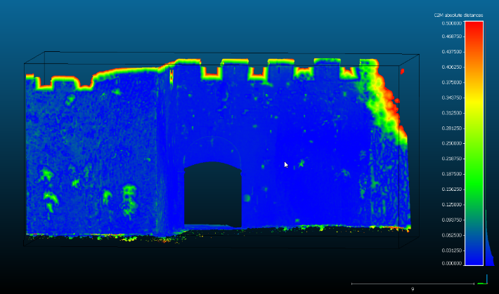
Fig. 3. Comparison between 2010 and 2019 photogrammetry models
B. Fortezza Vecchia
In this case, images have not been collected by means of digital cameras with known features: instead, analog archive images have been used.
Processing of analog photographs, mostly older ones, is more complex than digital ones, due to archive quality as well as digitization and technical equipment issues. Anyway, even bigger problems reside in material coming from different sources, with uncertain origin, low image quality, complete lack of information on the camera parameters and the presence of deformations on the original image [17].
Use of archive images, lacking important requirements for correct photogrammetric processing, while failing to grant homogeneous geometric precision as well as the ability to generate complete 3-D models, allows nonetheless, in the case of Fortezza Vecchia, to reconstruct lost volumes. For this purpose, anyway, beyond adhering to geomatics survey guidelines, an in-depth historic-architectural investigation of the study object is required for full comprehension and better exploitation of any available source.
While photogrammetric processing of these images did not allow for automated point cloud generation, it did however provide geometric reference for subsequent processing. Some points can be measured in separate images and subsequently calculated by ray intersection, using the results of the orientation by bundle adjustment. Although seemingly straightforward, this step in fact poses some practical issues. Due to differences in image scales, radiometric and geometric resolution, shooting position, lighting conditions etc. it is often quite difficult to detect the same point in two different images. Coordinate precision for the resulting points is related to the lower precision of pairs of image coordinates and the conditions of ray intersections [18].
The photogrammetry project includes the status quo set of UAV-borne images and 5 archive images dating to the 1930s. As already stated, the different features of the archive images and their shooting geometry, as well as major scene modifications, have prevented automatic detection of tie points, which have therefore been detected manually. This operation provided the following steps: 1) Selection of areas which did not undergo changes or major restorations since the 1930s, based on historic researches; 2) Within these areas, surveying of architectural elements in order to keep sighting errors on images as low as possible; 3) Picking out points providing the most homogeneous layout on both images and 3-D model.
A total of 52 points, one half of which detected on images collected along the North to South direction and the other half on images collected in the East to West direction, has been selected and sighted (fig. 4). Such high numbers of points for bundle adjustment were required in order to keep sighting errors due to the poor resolution of archive images as low as possible.
Further 20 control points have been selected for alignment checking, which resulted in a mean error of 1.3 pixels / 12cm.
Integration of the UAV-derived 3-D model of the Fortress with on-site analysis allows to outline the main walls of some buildings, such as those bounding the Cortile del Castello Vecchio, while other areas, particularly on its W and S sides, are not so well-defined.
Identification of the points upon orientation of archive images (fig. 5) in the UAV-derived 3-D model yields the external outline of the S and W perimeter walls, as well as most eaves and some window sills.

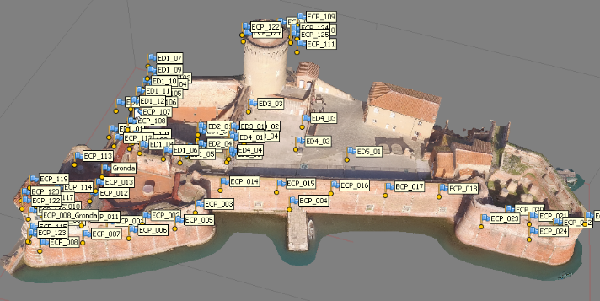 Fig. 4. 3D model of the Fortezza Vecchia with Tie Points.

These findings allowed to provide a 2-D outline for the entire complex, which is in turn essential for subsequent 3-D reconstruction. Calculated elevations of lost buildings, along with numerical information on historical documents, provides a useful support for possible reconstruction of the interior, also taking advantage of extant building portions (fig. 6).
IV. Conclusions
TLS is a well-established surveying methodology, whose results provide an effective means of representation of historical and architectural heritage. A simple comparison between TLS surveys carried out with a 9-years interval highlights the powerful evolution this technology has underwent in this time span.
The new approach to photogrammetry, based on SfM and MVS algorithms has brought over a major change in the geomatics survey routine, allowing to collect high-density colour 3-D point clouds, quite similar in size to those coming from TLS. It is however obvious that the achievement of such results requires following strict rules in planning and performing the photographic shoots.
Historic images, either predating any change or from archives, have proved to supply a major information source for 3-D reconstruction of lost architectural volumes or achieving a fuller understanding of the status quo of the time which the related historic images belong to. Usually, photogrammetric processing of these images, particularly those with lower quality and poorer geometry, cannot achieve automatic generation of point clouds of the survey objects: even when this is possible, however, homogeneous geometric accuracy is not ensured. As regards the fortress, further processing has yielded geometric information which, although not always sufficient for a full 3-D reconstruction, provide anyway some references for subsequent integration of other iconography. For the St. Zeno Gate, with a more consistent, natively digital image set, a 3-D model has been generated, providing a more detailed documentation of the pre-restoration status quo. In both cases, the methodology for fuller object documentation shows great potential.
3-D survey products are in ever rising demand among managers of built heritage. In this context, the ability to recover any data surveyed in the past in view of the generation of 3-D models is of the highest importance. The final models can be integrated, by means of photogrammetric tie points, in the status quo model, for possible fruition on VR/AR platforms.

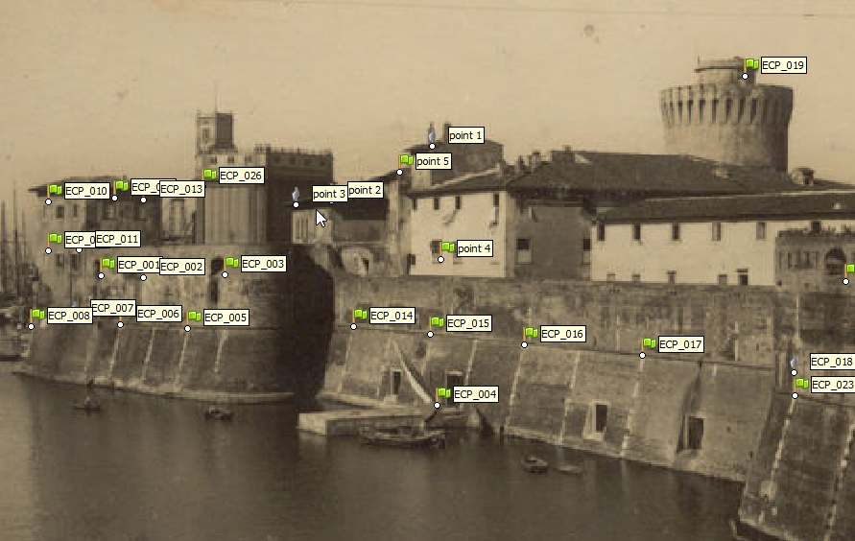 | 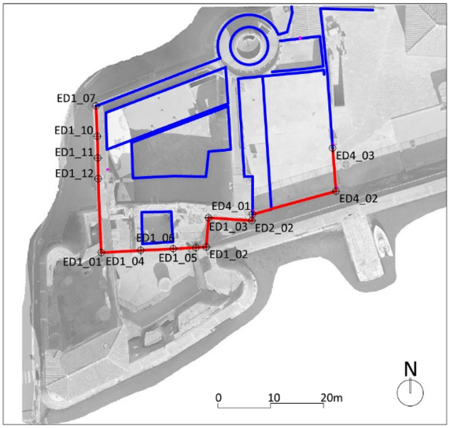
Fig. 5. Archive image with Tie Points |  | Fig. 6. UAV-borne orthophotograph overlaid with plan of Palazzo di Cosimo de’ Medici.

References
- E. Stylianidis, F. Remondino, “3D Recording, Documentation and Management of Cultural Heritage” Whittles Publishing, Dunbeath, 2016.
- P. Grussenmeyer, O. Al Khalil, “From metric image archives to point cloud reconstruction: case study of the great mosque of Aleppo in Syria”, Int. Arch. Photogramm. Remote Sens. Spatial Inf. Sci., XLII-2/W5, 2017, pp. 295-301, https://doi.org/10.5194/isprs-archives-XLII-2-W5-295-2017.
- M.G. Bevilacqua, G. Caroti, I. Martínez-Espejo Zaragoza, A. Piemonte, “Orientation of archive images on 3D digital models of painted vaults: an interesting tool for restorers”, Applied Geomatics, 10 (4), 2018, pp. 385-398 https://doi.org/10.1007/s12518-018-0212-8.
- M.G. Bevilacqua, G. Caroti, A. Piemonte, D. Ulivieri, “Reconstruction of lost architectural volumes by integration of photogrammetry from archive imagery with 3-D models of the status quo”, ISPRS Annals of the Photogrammetry, Remote Sensing and Spatial Information Sciences, 42 (2/W9), 2019, pp. 119-125. https://doi.org/10.5194/isprs-archives-XLII-2-W9-119-2019)
- G. Bitelli, M. Dellapasqua, V. A. Girelli, S. Sbaraglia, M. A. Tinia, “Historical photogrammetry and terrestrial laser scanning for the 3D virtual reconstruction of destroyed structures: A case study in Italy”, Int. Arch. Photogramm. Remote Sens. Spatial Inf. Sci., XLII-5/W1, 2017, pp. 113-119, https://doi.org/10.5194/isprs-archives-XLII-5-W1-113-2017.
- G. Bitelli, V.A. Girelli, M. Marziali, A. Zanutta, “Use of historical images for the documentation and the metrical study of Cultural Heritage by means of digital photogrammetric techniques”, Int. Arch. Photogramm. Remote Sens., XXXVI-5/C53, 2007, pp. 141-146.
- A. Gruen, F. Remondino, L. Zhang, “Photogrammetric Reconstruction of the Great Buddha of Bamiyan, Afghanistan”, The Photogrammetric Record, 19, 2004, pp. 177–199.
- F. Maiwald, T. Vietze, D. Schneider, F. Henze, S. Münster, F. Niebling, “Photogrammetric Analysis of Historical Image Repositories for Virtual Reconstruction in the Field of Digital Humanities”, Int. Arch. Photogramm. Remote Sens. Spatial Inf. Sci., XLII-2/W3, 2017, pp. 447-452.
- A. Cardaci, G. M. Roberti, A. Versaci, “From the continuos to the discrete model: a laser scanning application to conservation projects” Int. Arch. Photogramm. Remote Sens. Spatial Inf. Sci., XXXVIII-5/W16, 2011, pp. 437-444, DOI: 10.5194/isprsarchives-XXXVIII-5-W16-437-2011.
- G. Caroti, I. Martínez-Espejo Zaragoza, A. Piemonte, “Range and image based modelling: A way for frescoed vault texturing optimization”, Int. Arch. Photogramm. Remote Sens. Spatial Inf. Sci., 40 (5W4), 2015 pp. 285-290, DOI: 10.5194/isprsarchives-XL-5-W4-285-2015.
- M. G. Bevilacqua, G. Caroti, I. Martínez-Espejo Zaragoza, A. Piemonte, “Frescoed vaults: Accuracy controlled simplified methodology for planar development of three-dimensional textured models”, Remote Sensing, 8 (3), art. no. 239, 2016, DOI: 10.3390/rs8030239.
- M.C. Spreafico, L. Perotti, F. Cervi, M. Bacenetti, G. Bitelli, V.A. Girelli, E. Mandanici, M.A. Tini, L. Borgatti, “Terrestrial Remote Sensing techniques to complement conventional geomechanical surveys for the assessment of landslide hazard: The San Leo case study (Italy)”, European Journal of Remote Sensing, 48, 2015, pp. 639-660, https://doi.org/10.5721/EuJRS20154835.
[13] A. Zampieri, (ed.), “Le mura di Pisa. Percorsi”, Forti Holding S.p.A. / Ecofor Service S.p.A. 2014
[14] D. Ulivieri, “Fortezza Vecchia in Livorno”, Nexus Netw. J. 2014, vol.16, pp. 675–697. https://doi.org/10.1007/s00004-014-0203-y
[15] AAVV, “Livorno: progetto e storia di una città tra il 1500 e il 1600”, Pisa, 1980.
[16] G. Piancastelli Politi, “La Fortezza Vecchia. Difesa e simbolo della citta` di Livorno”, Milano, 1995.
[17] M. G. Bevilacqua, G. Caroti, A. Piemonte, and D. Ulivieri, “Reconstruction of lost architectural volumes by integration of photogrammetry from archive imagery with 3-D models of the status quo”, Int. Arch. Photogramm. Remote Sens. Spatial Inf. Sci., XLII-2/W9, 2019, pp. 119-125. https://doi.org/10.5194/isprs-archives-XLII-2-W9-119-2019
[18] A. Wiedemann, M. Hemmleb, J. Albertz, “Reconstruction of Historical Buildings based on Images from the Meydenbauer”, Archives. Int. Arch. Photogramm. Remote Sensing. 2000, vol.33, pp. 887–893.

