Digital survey and 3D Modelling pipelines on structural shape for instability monitoring in historical buildings. A strategy of versatile mesh models for ruined and Endangered Heritage.
Sandro Parrinello¹, Raffaella De Marco¹
¹DICAR – Department of Civil Engineering and Architecture, University of Pavia, via Ferrata 3, 27100 Pavia, Italy
ABSTRACT
Cultural Heritage and its variety of Built Heritage is increasing a scientific cognitive approach from European Committees, related to the difficulties of its protection and management. This is primarily due to the lack of emergency protocols of structural knowledge and documentation on architecture and its ruins, in particular for the goals of protection and intervention on an Endangered Heritage affected by mechanical instabilities.
Considerations on a fast and reliable structural documentation pipeline applied to Historical Built Heritage, as in the case study of the Church of the Annunciation in Pokcha (Russia), review the declination of integrated products of 3D survey into Reality-Based Models. This practice enhances the possibility of systematizing data through methodological phases and controlling the quality of numerical components into 3D polygonal meshes, with millimetric levels of details and triangulated from the integration of Terrestrial Laser Scanner and UAV survey data. These models are intended in the capacity of their shape to preserve morphological qualities about structural behaviour, thus to highlight some considerations on deformation and instabilities of the architectural system, and to fit it into computational platforms of analysis, for information on tensional behaviour and emergency risks.

Section: RESEARCH PAPER
Keywords: Journal; template; IMEKO; Microsoft Word
Citation:Thomas Bruns, Dirk Röske, Paul P.L. Regtien, Francisco Alegria, Template for an IMEKO event paper, Acta IMEKO, vol. 3, no. 1, article 1, January 2014, identifier: IMEKO-ACTA-03 (2014)-01-01
Editor: Paolo Carbone, University of Perugia, Italy
Receivedmonthday, year; In final formmonth day, year; PublishedJanuary2014
Copyright: © 2014IMEKO. This is an open-access article distributed under the terms of the Creative Commons Attribution 3.0 License, which permits unrestricted use, distribution, and reproduction in any medium, provided the original author and source are credited
Funding: This project has received funding from the European Union’s Horizon 2020 research and innovation programme under the Marie Skłodowska-Curie grant agreement No 821870.
Corresponding author: Raffaella De Marco, e-mail: raffaella.demarco@unipv.it

- Introduction: the documentation of endangered heritage
The analysis of Cultural Heritage, in parallel to the development of communitarian guidelines for its protection [1], is determining a growing scientific cognitive approach to European and Worldwide sites [2]. The variety of Built Heritage, including from localized historical buildings and monuments to extensive targets of historical centers, sites and territorial landscapes, intends a wider field of knowledge and intervention in terms of both structure, policy and extension. This justifies the difficulty of its protection and preservation, assisting to a fragmented reality of separated protocols of documentation, directly derived into computation and administrative actions. Thus, the difficulties in the sharing of information and data integration are influencing and slowing the entire approach to a current intervention program focused on the preservation of integrity and security of historical buildings, in particular regarding the so-called “Endangered Heritage” (World Heritage Convention, List of World Heritage in Danger 1972), that class of built heritage particularly affected by proven or potential threats that define a high level of risk for its preservation [3].
Actually, the revision of those sites officially listed as Endangered Heritage has been achieved on conditions of relevance and correspondence to envisaged danger criteria and indicators (as territorial, political or social dangers), but it expresses variable statistics in terms of monitoring parameters and protocols, highlighting a lack in disposing of scientific and technical documentation for Built Heritage dangers and missing in the connection between intervention disposals and “reality-
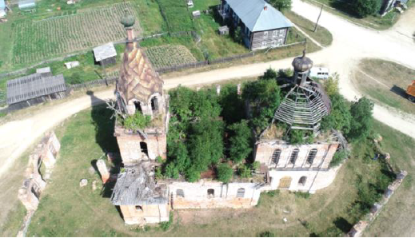
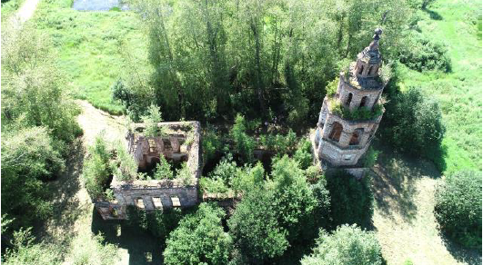
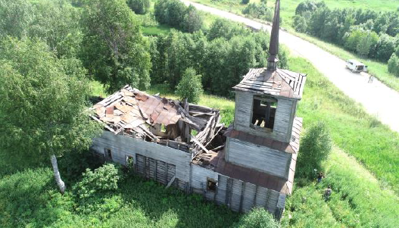
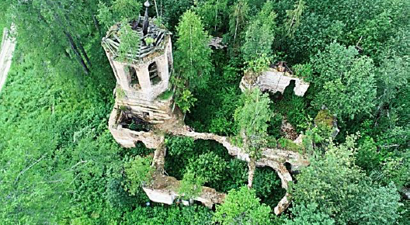
Figure 1. Examples of sites along Upper Kama route characterised by on-going risks of abandonment and decay, proving the basis for a classification as Endangered Heritage: from the top, Church of the Exhaltation of the Holy Cross in Bondjug, Rubezhskaya Church in Usolye, Church of St. Nicholas in Uzhginskay, Church of Paraskeva Friday in Saltanovo.
based” analysis on updated sites. This framework highlights the coexistence of a double type of cognitive emergency on Built Heritage: on the one hand the classification of the site as “endangered” for the stability and integrity of its physical container, on the other the growing request for parameters and specific protocols of analysis for the quantification of the emergency value of the building, conditioning the relative useful efforts and time for its intervention.
Thus, it follows a growing demand in the identification of these sites [4], both geographical and typological, expanding the dissemination and application of proportionate monitoring and knowledge practices, preliminary to intervention on territory [5], with the aim of triggering a growing process of safeguard policies [6].
The attention to safeguarding methodologies for existing heritage is receiving an awareness-raising improvement of research, able to develop new generations of digital products combining a Survey-based phase of digital documentation of Cultural Heritage, necessary for a correct and complete understanding of the characteristics and parameters of units and contexts of Built Heritage, to a Compute-based action of cognitive and interactive models, with the elaboration of 3D digital products for investigations and simulations on shapes and structures.
New representation systems produce new expectations related to digital communication, changing the objectives and constantly renewing the demand in analytical terms of cognitive requirements, also in response to necessities more linked to the computational nature of interaction within the models themselves, now capable of providing quantitative as well as qualitative answers. The difficulties on the development of reliable diagnosis of historical structures can be reconducted to the need of new methods of analysis, that can exploit computation opportunities through methodologies and cognitive practices. These are experimented on the visual and graphic aspects of the documentation of architecture [7] reliably represented in its present configuration of stability and linked to its constructive and safeguarding rules.
- HISTORICAL STRUCTURES, INSTABILITIES AND RELATION TO THE DIGITAL DOCUMENTATION OF STRUCTURAL SHAPE IN ARCHITECTURE
Historical buildings and architectural heritage, traditionally, are founded on and remain linked to their original structural system from the construction phase to even later periods, experimenting in a singular and individual way a series of modifying episodes and interventions of integration, in particular for changing functions. The demolition of bearing systems and elevations, the reconfiguration of horizontal levels and vaults, the construction of expansion blocks thus become actions ‘of’ and ‘on’ the architectural structure. These actions contribute to enrich the mechanical information necessary for the work of structural professionals, who both receive data and suggestions coming from the formal context of the 'real structure' and also elaborate new reflections from data to the mechanical phenomena influencing the built system, required to be 'virtualized' in the documentation drawings and products to plan actions of intervention and consolidation.
The consideration of structural diagnosis applied to historical Built Heritage, as capacity of knowledge of stress behaviours and prevision of damage mechanisms, remarks a central role in the development of documentation protocols for the safeguard of architectural systems. The review of risks, on-going kinematics and priorities of stability on endangered buildings [8] highlights the focus on the character of Robustness, as strength of architecture and its elements to withstand a level of stress derived from the combined action of degradation and function alteration of both materials and environments [9]. Thus, considering the deep impact that stress-alteration phenomena have on the geometrical and material aspects of buildings, it is highlighted how a main qualitative diagnosis can be express from the shape analysis of the structures, as it is exactly in the external border surface of these components that the main deformations and forces show their action, drifts and cracks on the architectural system [10]. Therefore, it becomes possible to center the evaluation of stress instabilities on the target of a 'static morphology' of the structure. This shape reflects the mechanical and stress traces left by the adaptation schemes of the system during its physical history, highlighting stability principles connected to classes and types of resistant geometries.
Nowadays, the analysis of the structural apparatus in historical buildings adopts simplified typological schemes of numerical structures, chosen to be mechanically controllable in more defined levels of regularization and abstraction of the physical structure [11]. The confidence in the standardization of structural verification practices has led to underestimate the ‘experience’ of the building, as that system of events that over time developed stresses and tensions such as to define a specific change in response capacity, in addition to the constitutive inhomogeneity typical of the bearing system. In this sense, the attention to the singularity of shape detail of the historical structures refers to a need for documentation that is at the same time 'comparative', with reference to the archetypes, and 'specific', highlighting the variants of formal detail reliably observed on the built system.
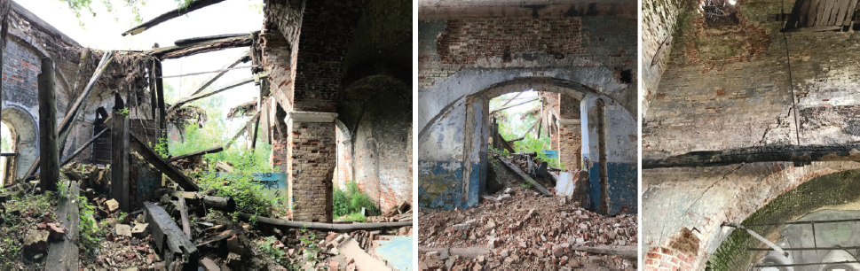
Figure 2. The state of neglect and the lack of conservation present critical situations of widespread instability phenomena on the masonry systems, clearly exposing the structure and the damage effects on its apparatuses. Robustness instabilities in the structural complex of the Church of the Transfiguration, Pyskor, defining increasing frameworks of damage that are going to destroy and disappear these buildings without specific lines of intervention.
If on the one hand the knowledge of the main bearing profiles and mechanical qualities of the building materials has so far satisfied the needs of computation, the testing of intervention procedures and solutions on existing components and their instability performance is gradually highlighting the need to implement the detail of shape in these models for simulations of greater reliability and precision, in particular on irregular structural systems [12]. At the same time, digital documentation has developed into morphometric 3D databases with enhanced density and precision of information, so as to direct the process of acquiring the measurement itself towards a spatial discretization increasingly closer to the continuous form [13]. The relationships between shape and mechanics of structural systems can thus find new descriptive products through reality-based digital documentation methods, which acquire reliable and implementable geometric data. From the products of the digital survey, such as point clouds and morpho-metric databases acquired on site, the visual perception of the structural systems is translated into an archive of 3D data, where in addition to the spatial dimensions, information content and thematic frameworks can be queried and extracted from the architectural shape to its mechanical interpretation in quantitative terms.
It is from this context that the desire for 'digital' and 'reliable' products derives, capable of guaranteeing a direct and concrete approach to the structural system of buildings, which can be developed with an 'organic' and 'repeatable' but also specifically 'declinable' method on the particular morphological configuration, preserved or in ruins. Therefore, the recurring theme of the ‘drawing’ for the ‘documentation’ highlights how on-site measurement and monitoring practices are called to review not only the specific acquisition and integration standards, but also their spatial representation and their processing into Models. The theme of 3D models configures a way of deriving and indexing information from investigation on historical structures, and a possibility of interconnecting metadata and databases among them, moving to systematized data through methodological phases and 3D products. Thus, the model, whose numerical component determines and characterizes every aspect of its reliability, can become a tool for the management of the asset in terms of computing and analysis of Robustness information.
These considerations are encouraging, both methodologically and contextually, the structuring of project ideas aimed at defining strategies of integration of data for the development and promotion of Structural Reality-Based Models on architectural heritage. On a scientific level, the experimentation of Reality-Based models for structural diagnosis will develop a multidisciplinary and implementable methodology, capable of preparing a standardized product, the polygonal mesh model, in different levels of details and integration for the management of the existing Built Heritage. These species of models are intended for the intervention both in "emergency" and in "long term", in the calibration of its procedural computing, and in a both aware-scientific and practical-operational direction, in the capacity of its shape to decline into morphological and computational platforms of analysis. The methodological process aims to be as far as possible fast, extendable and replicable, to facilitate interchange and make possible a complete knowledge and management capacity through 3D models of the built assets that are in a state of emergency.
- AN EXPERIMENTAL CASE STUDY: THE CHURCH OF THE ANNUNCIATION IN POKCHA (RUSSIA)
  - The site and its historical-structural characterisation
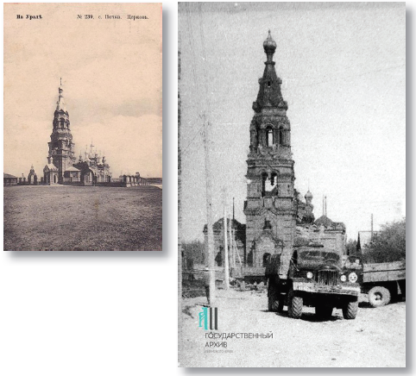
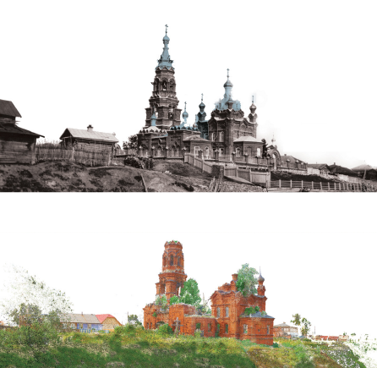
Figure 3. The complex of Blagoveshchenskaya Church in Pokcha: from the original architectural structure of the church before the revolution and in 1956, till the actual ruined shape in 2018.
The constructive features of built structures have witnessed technological and material traditions towards close continents, as Europe and Asia, where the stylistic influences and source availability of elements have performed a resilience in maintaining specific characters of architectural shape. In particular, built sites and monuments along the European Cultural Heritage Routes, whose architectural values are strongly permeated by structural typologies, represent an exemplary case of this phenomenon, where materials and traditional shapes have been integrated in the definition of structures and elements of complexes. Thus, architectural structures have acquired their own identity, characterization and specificity over time, evolving spatial distributions and constructive apparatuses in their historical development and change of functions. Resilient structures combine a wide framework of morphological and static relationships that are reflected in their own state of conservation, and that influence the robustness approach to their restoration and preservation regarding their security and stability.
The case of Upper Kama, in Russia, already interested by international research experience on the digital documentation of the complexes, identifies an emblematic example of Cultural Heritage Route on the role of coexistence between historical structures and wider phenomena of instability caused by the functional experience of the building, reflecting a complex framework of diagnosis on the safety and integrity of the various built sites. In these terms, Upper Kama sites collect a catalogue of architectural characters, stylistic varieties, constructive solutions and a multiplicity of building materials, with related pathologies of degradation and conservation, such as to define a rich morphological abacus of technological modules and elements of its structures [14].
The Upper Kama region, developed around the Kama River basin, extends north of Perm Krai for about 7,000 sq km, west of the Ural Mountains in European Russia. Mineral resources and the role of commercial crossroads of the imperial period led Upper Kama to an intense cultural and architectural development between the 15th century, with the first industrial settlements, and the 18th century, till to the rapid decline with the Russian Revolution of October (1917). The discovery of local salt pans by merchant families, such as the Stroganovs or the Golitsyns, has decreed the development of urban settlements characterized by monumental Orthodox complexes, churches, bell towers and family chapels, that show continental solution and technological features in their built structures [15].
The settlement characterisation, more stabilized by commercial requirements respect to the villages of the Russian countryside, has determined a global phenomenon of transformation of the built structural systems from the typical wooden architecture to constructive solutions in brick and stone masonry. The tradition of the main structures has maintained many technological features from western culture declined in local styles and forms, in which traditional materials and constructive techniques are integrated. Therefore, these architectural structures have acquired their own identity, characterization and specificity over time, evolving with spatial compartments and constructive systems through the various events that have defined their history, and combining morphological and static relationships with each other.
The Upper Kama sites are characterized by monumental and often isolated religious architecture, originally belonging to larger ceremonial complexes or dedicated to the pilgrimage of relics. This aspect has influenced the morphological configuration of the structural project of the sites, with the design of plans with multiple aisles divided between architectural blocks such as the narthex, bell tower, vestibule and the main built block, and also with other aggregate built blocks in correspondence of side-chapels and expansions. With the Soviet period, the request for conversion of the territory for infrastructural purposes and for energy or food production defined a decline in the role exercised by these religious sites in the Upper Kama cultural basin. The consequent intervention and changing of the architectural structures, forcibly adapted to the new needs of energy infrastructures or industries, ended
with a prevalent abandonment, till to reach the conditions of ruin and collapse.
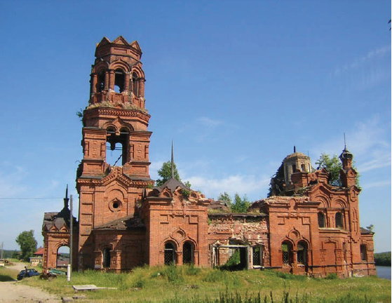
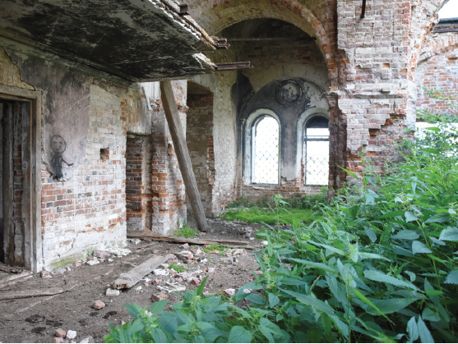
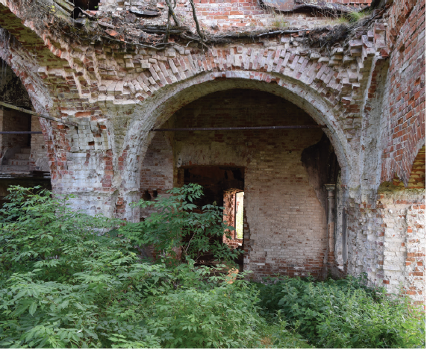
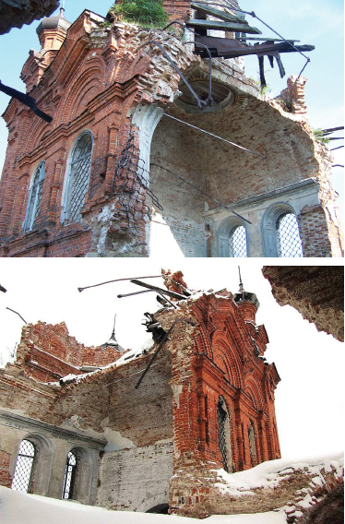
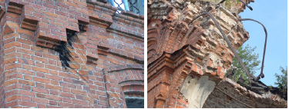
Figure 4. Photographic gallery of the Blagoveshchenskaya Church in Pokcha. On the left, the state of conservation in 2018, on the overall structural system and in the specific static units that characterise the statics of the entire complex. On the right, state of evolution in the damage on the main vault, from 2006 to 2019, with a fast increase due to the lack of intervention. Below, details of the constructive system that influence the robustness evaluation of the complex: signs of intervention for the functional conversion in power central, stratigraphic technology of masonry walls and distribution of steal structure inside the masonry.
The case of Blagoveshchenskaya Church, or Church of the Annunciation in the village of Pokcha consolidates a central historical-architectural phase characteristic of Cherdyn district, synthesizing the value of historical evolutionary urban events in the stratification of its structures and walls, today abandoned in a state of ruin [16].
The original wooden complex was replaced in 1785 with a new one in stone and brick masonry, subdivided in multiple environments: the main body, with a quadrilateral planimetry, constituting a nucleus for the refectory, the chapels of St. George (southern) and St. Nicholas (northern), the bell tower and the entrance narthex. In 1910, a reconstruction intervention has modified structurally and morphologically large portions, in particular the bell tower, entirely replaced, and the eastern section of the central vault and the altar, reconstructed with the insertion of a 5-headed chapter; the interiors in plastered stone, with paintings and ornaments from 1870, are preserved instead. The general coat of the building with an additional red brick facing contributes to the strengthening of the external envelope and gives the possibility of inserting additional devices of tension resistance into the stratified walls.
The history of the site goes through restoration works attempted from 1920, until the complete abandonment in 1940 and the re-conversion into a power central: the energy issues linked to the new function led in the 90s to the partial collapse of the main pavilion vault and of the bell tower roof, after repeated flashes attracted by the electrical system. As result of the extensive damage, the church was excluded from the list of architectural monuments of interest, precluding any new intervention and restoration initiative, and leaving the site to its collapse.
  - The current state of structural ruins
In 2018 the architectural complex was found in an evident state of neglected conservation. The wooden roofs are almost entirely destroyed, and the main structural building is also damaged in several portions, particularly in the main block of the vaulted system of the church.
The vaulted structural system of the spans, loading on pillars and based on a scheme of counter-balances guaranteed between vault-vault and vault-support, is distorted by the collapse of the individual vaults, where it is possible to observe the brick technique of the section (compatible with vaulted ceilings) and the remains of the lead sheets covering the extrados. The large central pavilion vault is preserved for less than half of its span, and allows to appreciate the head brick structure, left visible along the detachment edge. Its ruins, both by brick vaults and wooden roof, collapsed occupying the central environment of the nave. The debris have submerged part of the loading pilasters of the vaults, which cannot be inspected in their ground basement, and have been covered by soil and vegetation creating a natural hill that reduces the access to the narthex and apse rooms, as well as being the cause of degradation of the preserved supports. The connection with the bell tower, once allowed by the central nave through the gallery and the refectory, has been demolished and prevents from the direct documentation of the state of conservation of the elevated structures.
Following the collapse of the roof, the complex is deprived of the main factors of protection from atmospheric agents, in particularly during the winter season, and it is therefore subjected to a rapid degradation of the remaining portions, affected each year by localized collapses. The site is also totally devoid of control services for the access of people and animals, who often occupy it and damage the spaces and their structures. In particular, the narthex environments are deteriorated by the frequent presence of herds in transhumance, housed by the shepherds inside the church during the summer season.
  - Objectives and targets of the documentation process
The objective of the documentation of the Blagoveshchenskaya Church, in addition to the wider mapping and reconnaissance approach of emergence sites in the Upper Kama area, is to encourage a rapid but reliable diagnosis of the emergencies of structural crisis present in the architectural system. This is intended to direct the organization of possible intervention operations in a more targeted way, and to safely preserve and promote the historical ruins. The local administration is gradually recognizing the historical and cultural value of these sites along the Kama, but the conditions of extended ruins of these site present a clear disadvantage for the commitment, both technical and economic, in implementing their conservation projects. Thus, despite extensive damage, the permanence of the ruins testifies the construction and mechanical quality of their structures with an high static performance, and enhances the result of an architectural tradition of excellence that is also an heritage identity of the region. In this sense, fast survey and quantification methods to recognize and evaluate the preserved structural systems and the corresponding lability can constitute a preliminary tool of excellence to correctly orient the qualitative and quantitative planning of the intervention, and to interrupt the exponential cycle of damage.
The documentation of the current state of conservation of the structure of the Blagoveshchenskaya Church has thus highlighted the need to experiment opportunities of structural diagnosis within 3D digital survey, with specific integrated approaches for the acquisition and modelling of the structural shape, to ensure a descriptive quality of its resistant architectural structure through the data collected with a practicable and fast survey in site, contained in terms of both time and instrumental application. With the aim of better understanding its conservation and the instability phenomena of its ruins, as originally designed and actually preserved, the knowledge request has been centred on the shape alteration of the structural ruins as globally and reliably documented, analysing their degree of safety and intervention for their recovery in relation to the unit system and the overall mechanical scheme.
- STRATEGIES OF ANALYSIS FOR THE DIGITATION OF THE RUINED SHAPE
The documentation of the state of conservation of Blagoveshchenskaya Church in 2018 has highlighted the need to experiment integrated approaches of for the reality-based acquisition of the survived ruins to understand the instabilities of preservation in the architectural ruin, centring the analysis on the main structures of the building and on their security for the recovery intervention [17].
The morphological analysis of masonry structures was organized and simplified during the digital measurement and acquisition processes, organizing a decomposition of the spatial constructive units that semantized the architectural apparatuses of environments, linking them to the global volumetric macrosystem at the end of the digitization process. Furthermore, the internal inspection of the masonry sections, in their fracture or collapsed portions, has allowed the cognitive integration of the structural envelope, reliably reconstructed in its shape as skin of the architectural structure [18].
The ruin shape, central element of the cognitive process of analysis, has thus become a basis of direct knowledge supported by the repertoire of historical-constructive analysis data, with the dual purpose of completing the technical stratigraphic knowledge framework and revising it with an integrated action, both instrumental and disciplinary, on the behavioural diagnosis of structural components. The ruined complex of Blagoveshchenskaya Church, for reasons attributable to the collapse of structures and the lack of site regulation, is now deprived of the original spatial design characterising the wall system. The absence of main masonry portions deprives the analysis of the current structure from defined schemes of interpretation of architectural instabilities, and it brings the specific evaluation of the reality-based digital shape as necessary step for a reliable diagnosis of static robustness [19].
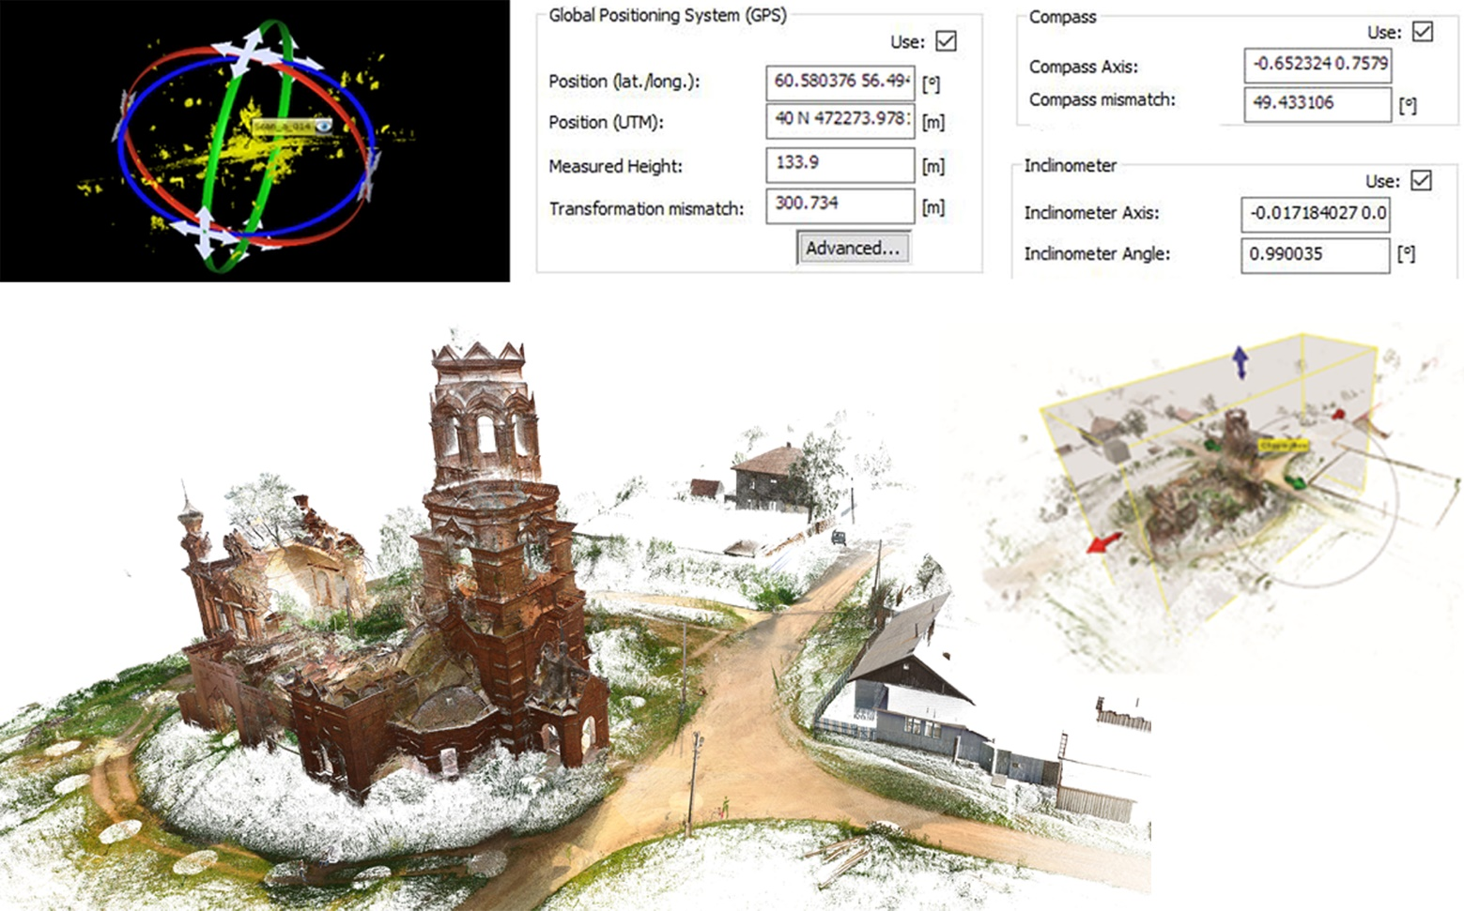
Figure 5. Morphometric database from Terrestrial Laser Scanner acquisition campaign on-site: the single scans, completed by GPS, compass and inclinometer information, have been referenced and registered controlling the overall alignment, to certify the final point cloud.

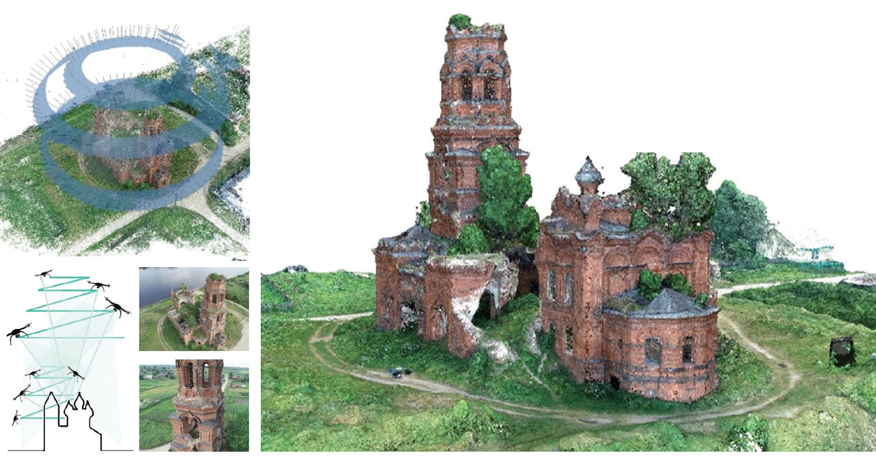
Figure 6. Morphometric database from photogrammetric drone UAV from the on-site acquisition campaign: the photos have been georeferenced and aligned to define the main point cloud on the architectural complex and the surrounding landscape.

The historical-architectural complex of the Blagoveshchenskaya Church in Pokcha has been subject to an integrated extensive range-based and image-based documentation campaign. The documentary approach highlighted the need for a renewed attention to the methodologies of acquisition and representation of the morphological properties of the complex, in particular in terms of correspondence and integration of the information collected on the current and original block. The dimensions of the structures have oriented the morphometric digitization strategy to the use of multi-instrumental close-range measuring systems, such as to guarantee a global coverage and a formal detail resolution appreciably compared to the complexity of the characteristics and architectural geometry of the surfaces and to the structural deformation of the masonries. At the same time, the colorimetric information was a key support in the diagnostics of the structures, evaluating how many pathologies and signs of influence on the mechanical resistance were described through tonal variations of the colours on the surfaces, mainly in brick or plastered and affected to plant infiltration.
The on-site campaign was organized on a double acquisition level, static from the ground with Terrestrial Laser Scanner (TLS) and aerial with drones for photogrammetry (UAV). Both instruments have been applied with a main focus on the total coverage of the morphological data: the elevation of the units of the structure (more than 15 meters with complex conformations of the roofs) and their difficult accessibility have necessarily oriented the goal of digitization of the 'complete form' on the integration of TLS and UAV spatial data in a single 360° database of point clouds. For this reason, it has not been possible to entrust a prevalent role to a certain type of instrumental data, but their integration was promoted. The documentation approach thus highlighted the need for a renewed attention to the methodologies of acquisition and representation of the formal properties of the complex itself, in particular in terms of their correspondence and integration, and encouraged the possibilities offered by digital transposition as an enhanced opportunity for the reconstruction and use of archaeological and architectural data [20].
  - TLS acquisition campaign and products
In the acquisition from TLS FARO Focus S150, the integrated photographic camera was also enabled, ensuring an RGB information quality for each point x, y, z suitable for surface mapping. Each scan, performed in Medium or High mode according to the distance of the shooting range from the object, has provided an additional acquisition time of 4.00’ to allow the shooting of 16 frames for each camera location (coverage of 360°x320°, as for the scan angle). Before each photographic shot, the instrument was set with an average balance of colour and lighting for the shot, considering only the horizontal level for the balance of light conditions in the outdoor scans or the entire panoramic space for the interior scans. These measures have significantly influenced the acquisition campaign, duplicating the scanning times, but they have been still advantageous for the documentation purposes compared to a parallel photographic campaign from the ground, requiring further actions to integrate the photographic material into the spatial database. A number of 73 TLS scans have been realized to collect all external surfaces and to spatially connect the complex distribution of internal environments. The quality of scans has been performed at almost 2 mm of laser spot spacing till 5m height, and of almost 5 mm in the upper surfaces. The quality of TLS acquisition for the bell tower and the central dome has been favoured by the presence of the inner natural hill over the ruins of the roof, permitting a higher level of instrument position from the ground. The TLS metric survey from the ground guaranteed a coverage of 80% of the morphological data on the structure.
  - UAV acquisition campaign
In parallel, an aerial photogrammetric acquisition was developed from UAV DJI Phantom 4 Pro, with a flight plan focused on the point of interest of the architectural complex. The UAV photogrammetric campaign has been organized with a flight plan mission set from the central top of the complex at a level of 50 m from the ground in the mode “point of interest”. Within this procedure, a photogrammetric campaign has been conducted through the aerial camera with a conical acquisition around the monumental complex, descending to a height of 10 meters above ground and developing 329 shots in 10 minutes of flight. The guaranteed camera angle and the adjustable inclination of the gimbal have allowed a total coverage of the top surfaces, with a quality of photographic data suitable for the clear photogrammetric reconstruction of the edges of the components (21 MPixel). In addition, specific flight plans for the tower blocks and the central vault were planned with greater photographic detail thanks to the close distance of shooting. The GPS coordinates defined by the UAV for each shot have better addressed the alignment algorithms, simplifying the alignment of the photogrammetric Structure from Motion reconstruction. This has given the opportunity to conceive a wide area of overlapping between TLS and UAV resulting point clouds, both on vertical and horizontal built surfaces, in order to optimize their referencing in an integrated sparse database of morpho-metric characters.
  - Post processing data and products
From the joint processing of the collected archives, drawings, sections and plans of useful reference were produced for the overall knowledge of the architectural complex and as guidance for the intensive mapping of the pathologies of degradation and instability, documented in the photographic repertoire. The two-dimensional representation, however, has difficultly described the quality of distribution and volumetric development of the main structural apparatus, made even more complex in the interpretation by the ruined character of the site, and therefore by the loss of many of the main shapes conventionally identifiable for the classification of the apparatus (intrados of the vaults, opening profiles and local collapses, integrity of the elevation structures).
Also, the attempt of processing for elevation maps, as standard analysis of deformation mechanisms by the point cloud displacement from a reference plane [21], did not satisfy the need for knowledge on the deformation of the structural surfaces. The high surface processing of the structural envelope, due internally to the collapse conditions and externally to the decorative brick structure, has returned difficult-to-read color maps, where the excessive fragmentation of the level indicators has failed to guarantee an overall picture of interpretation of plastic deformations.
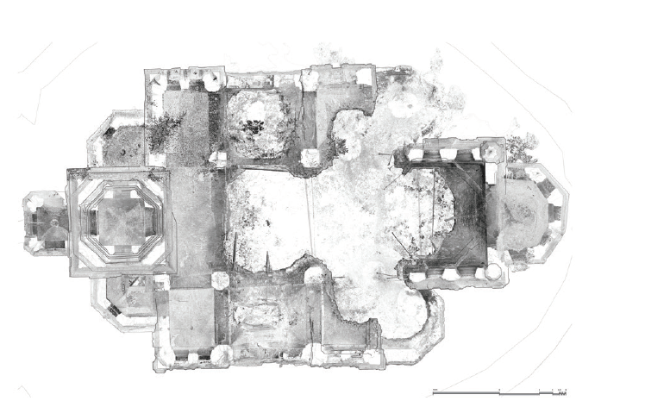
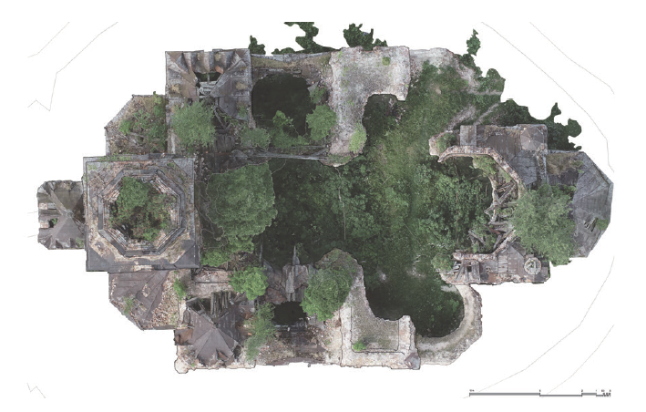
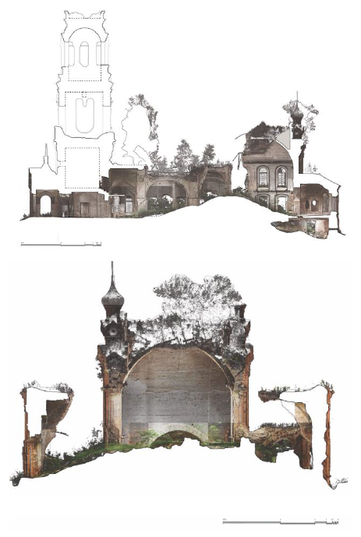
Figure 7. Drawings and elaborates for the 2D description of the main structural system of the church. It is highlighted the presence of noise data on elements such as vegetation and collapsed ruins.
- OPPORTUNITIES OF 3D INTEGRATED MODELLING FOR THE DIAGNOSIS OF STRUCTURAL SHAPE
The aim for the structural representation has been focused on the development of a continuous mesh modelling protocol, enriched with reality-based qualities, achieved as the objective of digital survey for the detailed and unperfect shape as it is conformed by the instability and mechanical features. These shapes, controlled and certified within the envelope of the structural object, necessarily introduce a need to manage the polygonal geometric mesh that defines them, whose processes are however rewarded by the representation of a morphological detail that is itself a source of diagnostic reflections on the mechanisms of analysis systems [22] [23].
The obtained 3D models, in this sense, not only pursue the necessary analysis of deviation between static surfaces, but they consolidate a certified practice that defines them both as outputs, directly applicable for the quality of structural instabilities, and as input data for further implementations, in particular on computational platforms. In this way, a digital data processing is established which exponentially leads to the exploitation of the potential of the three-dimensional discrete database, the point cloud, to the continuous 3D object defined by vertex and edges also for quantifiable evaluations, the model. The application opportunities, from FEM platforms to Information Systems, enhancing the virtual fruition, can thus give the background to involve the models through common languages, adapting them appropriately [24] [25].
The developed research on reality-based mesh models has allowed to accurately delineate the causes and effects produced by the structural survey in the digitisation and modelling processes on morpho-metric data, validating the compatibility and correspondence of the produced models with the multi-instrumental comparison of the measurement practices normally applied in the structural field. The integration of the products of digital survey protocols applied on the site [26], from both terrestrial and aerial metric and image acquisition tools, was complementary completed through the differentiated visual stations, able to guarantee information on exterior and interior parameters, as well as monitoring data on the roof components and elevation units. Focusing on the central pavilion vault, half-destroyed during the electrical accident, the documentation, finalized to the restitution of a complete structural shape, has involved the detection both of the vault from the intrados, visible also in its constructive thickness, and also of the extrados levels, occupied by the ruins of the octagonal masonry tholobate at the base of the wooden roof.
  - Modelling pipeline
The pipeline for 3D Reality-based modelling was assessed within the research objectives on the diagnosis of stability of the Blagoveshchenskaya Church in Pokcha. This choice was oriented both for a spatial configuration of the complex's devices, articulated on several levels and environments, and for a correspondence of the real state of ruin of the building, which highlighted different critic issues to be transposed automatically in a digitized model shape through a NURBS or parametric modelling. First, the data collected from TLS and UAV acquisition campaigns have been tested in a compatible procedure for the integration of the processed point clouds, also supported by common format extensions for their inclusion in the modelling platforms. During this phase, some issues have occurred in the specific management of vertex and polygons objects.
Corrections and uniformities of normal vertex data.
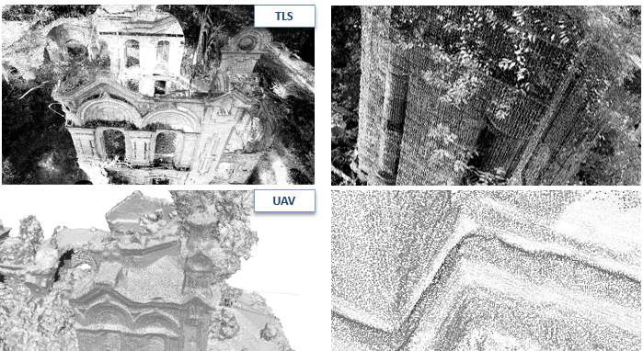
Figure 8. Quality of processed morpho-metric data from TLS and UAV on the external surfaces of the masonry structure. The point cloud from UAV acquisition shows a resolution and density of data comparable with the TLS one, supported by the higher level and resolution of camera shooting.
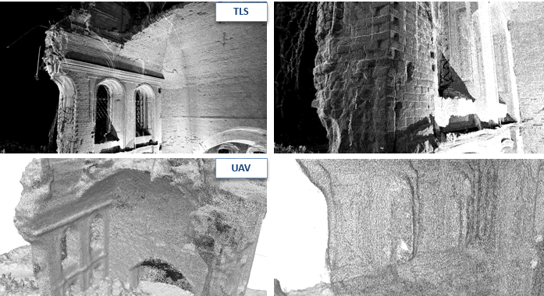
Figure 9. Quality of processed morpho-metric data from TLS and UAV on the internal surfaces of the masonry structure. The point cloud from UAV acquisition shows a worse resolution in the discrete definition of main profiles, geometries and surfaces, due to the corner and shadow shooting.

The first aspect concerned the difficulty of transferring the “vertex normal” information for each point of the photogrammetric cloud acquired by UAV on the mesh modelling platforms. The compatible formats (mainly .ptx and .pts) for the reverse modelling provided a different ASCII code in the UAV photogrammetric processing environment, and the normal information has been corrupted within the different matrixes of conversion. After different attempts of comparison on multiple modelling platforms, among those suitable for the managing of architectural scale data, an additional phase of re-calculation of normal vertex in the UAV point cloud was chosen, performed directly in the modelling environment, so as to correctly orient the mesh triangulation and to avoid anomalies of flipped polygon regions that are not suitable for the whole mesh management. Due to the high density of points and their unstructured distribution, also complicated by the geometric articulation of the complex, the automatic normal calculation tools have failed to guarantee a uniform and coherent result, fragmenting the orientation of the points and, consequently, the features of the triangulated mesh. To solve this issue, a single step triangulation process on TLS and UAV integrated point cloud has been performed, so that the normal vertex data defined in the TLS point cloud has been able to mediate the orientation of the whole mesh surface.

Filtering and selection of source data for the integration procedure.
The second aspect concerned the different point spacing interval of the individual point clouds (on average 1-3 mm from TLS, and 5-10 mm from UAV) and its influence in the triangulation of an overall polygonal mesh, where a uniform reading of structural irregularities was ensured. The two discontinuous datasets have been refined with overall filtering performed on the point clouds and checked on the final mesh, considering an average length of edges of 5 mm to define a final model compatible with the main standards of deformation analysis in structural diagnosis. This range did not compromise the relative dimensions of structural damages quantifiable as a whole, related to the geometry of the construction materials (mainly bricks and metal chains, of larger specific dimensions) and to the tolerance threshold set for the analysis (5 mm, compatibly also with the standards for elastic safety assessments).

The finalization of the integrated 3D survey database on Pokcha complex has defined a virtual system of the preserved shape, directing the attention on the metric-spatial correspondence of information obtained from TLS database and UAV photogrammetry, calibrated at the different reliability of space reconstruction also from the characteristic of the instruments applied in the acquisition phase. In particular, a morphological reference and registration has been developed on the scale of each structural unit of the built complex: for the pavilion vault, the two type of data have been aligned on perimetrical boundaries and façades, considering the deviation accuracy of discreate surfaces and target control points. Then, a segmentation of the overlapped point cloud has been provided, deleting the overlapped areas of points and maintaining the TLS quality of data on the intrados surfaces and both TLS and UAV on the coverage surfaces.
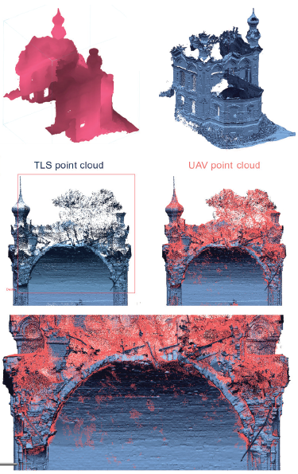
Figure 10. Allignment and integration of multi-instrumental point clouds for the static unit of the central pavillon vault.
At the end, the set of points has been subjected to standard filtering procedures, both automatic and manual, aimed at cleaning all spatial information not belonging to the envelope of the structural surface, in particular constituted by the infiltrated vegetation both at the base and at the top of the ruins. Further attention was paid to the window openings, manually cleaned for a complete reconstruction of the wall thickness. The triangulation phase of the final integrated database has highlighted some portions of missing morphological information, due to building masonry areas covered by vegetation during the survey campaign (removed in the point cloud with the filtering process). These parts have been integrated with a fitting of mesh holes according the geometric primitives derived from the mesh model. The mesh model obtained by triangulating and remeshing the surfaces verified the expected target of morphological detail, conserving both the main structural profiles and the specific geometry qualities of the masonry elements, on the surface and on the edges along the collapsed region.
  - NURBS comparison and deviation analysis
The study on structural instabilities has been focused on the vaulted unit in the central span, with the aim of comparing the specific imperfect geometry of the vault (affected by mechanical deformations) with a reliable reconstruction of its constructive shape from the in-site dimensions of the ruins. From the final mesh model, section planes have been set with an established pitch of 30 cm along all the surfaces of the unit (vault and vertical walls), extracting 3D sketch profiles adhering to the specific morphological surface and importing them into a NURBS modelling environment. By extrusion, the structural volumes of the pavilion vault have been geometrically reconstructed, according to the regular project profiles, and imported into the reverse modelling environment to make a comparison with the irregular mesh surface.
The comparison between the NURBS and mesh models of the vault has been derived considering the query tool of deviation available on the platform, computing the detachment between the models’ surfaces. The deviation comparison (made possible by the same coordinate system maintained between the models) showed an overall failure phenomenon that characterizes the entire system of the resistant unit, possibly attributable to the accidental impact that caused its collapse. Within it, some specific portions affected by instability phenomena are recognizable, as their colour map from the deviation computing is characterised by a colour scale from the green to the red, highlighting their on-course kinematic deformation that is increasing over time. These areas are located both on the vault and on the supporting walls, within deformations that are in the scale of the centimetre and that are affecting the main loaded parts of the vaulted system. In this way, their mapping in intended to direct the intervention practices towards targeted consolidation actions for the safety of ruined structures and their conservation.
- Conclusions
The modelling action performed on the Church of the Annunciation in Pokcha has followed an integration approach of morphometric data from different instrumental point clouds, experimenting an overall mesh triangulation strategy finalized to the generation of a Reality-Based model capable of preserving the structural irregularity through the mediation of numerical polygonal surfaces. Particular methodological considerations have been developed for the mesh triangulation of the integrated TLS and UAV sparse database. In order to perform an HD Mesh Construction, a correct correspondence of points normal was necessary, and it required the processing of UAV point cloud in order to support the optimization of poly-faces orientation in the mesh. Other processes of filtering of the point cloud, in particular regarding the presence of openings’ grids and extensive vegetation, have been implemented to better expose the surface of the structural domain under the decay and nature levels of the ruin site.
The need for a formal approach to the re-drawing analysis and intervention on Endangered Historical Sites has directed the operational experimentation of morphological-structural representation on two research targets:
- The planning of a documentary strategy able to acquire the totality and particularity of the architectural detail, in all its typological variants (masonry, metal parts, wall coverings) and collocation (main environments, underground, in elevation, coverage levels).
- The convenience of transferring these detailed systems into suitable morpho-metric products, capable of experiencing information and analytical opportunities of historical masonries through graphic representation.
This objective directs methodologies and products to prefer a three-dimensional approach to documentation and visualization of the building, directly from data of digital survey. The interactive orbitational approach and the parametric comparison thus become the means dedicated to qualitative and quantitative structural assessments, aware of the interactions that the historical architecture can establish between its individual preserved components and, referring to restoration, with its intervention design.
The presented study case defines a primary phase of research directed to the generation of an overall model of Blagoveshchenskaya Church. Thus, this strategy will support the decomposition and meshing for "structural cells" of the entire complex, defined for minimal spatially identifiable and statically defined units in which the architectural system of the ruin can be subdivided. In this way, the semantized structure will permit an easier management in the possibility of analysis of his deformed shape and considering the direction of computing of reliable mesh models into structural simulation platforms for the monitoring of evolving damages in endangered heritage.
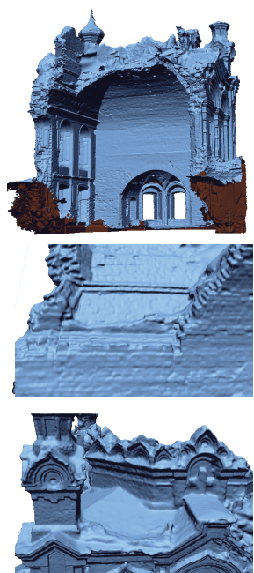
Figure 10. Final reality-based mesh models after the processing of triangulation and optimization of the HD mesh. The mesh has preserved the specific detail of structural shape of the structural unit.
The type of morpho-metric data represented by high-poly mesh models, due to its complex nature in terms of compatibility and format size, is today affected by the continuous developments in the field of Big Data management on 3D databases of architectural systems and urban aggregates. These possibilities of simplification and fast processing in the manipulation of digital metric data, combined with the experimentation directions of the Reverse Modeling procedures on the historical architectural heritage, aim to revise the documentation protocols in a field of application of representative systems for structural diagnostics, till to aspire to technical-professional guidelines. Despite the national lability, the lines applied in the digital documentation demonstrate an attempt to adapt to the provisions of the Digital Agenda 2020 of the European Commission (also included in the Agenda Culture 2030), regarding the Digitation of Cultural Heritage initiatives for the planning of intervention, restoration and conservation. The possibility of experimenting first virtually, in a simulated but reliable space, the methods and effects of a subsequent physical implementation of the intervention on the real heritage emphasizes the opportunities for digital preservation and eGovernance, expanding the ideas of innovation on the type and quality of structural survey products in terms of Curation of digital assests and advanced digitization. The action of 'structural' documentation, such as knowledge of stress behaviors and prediction of damage mechanisms of buildings, can thus also be identified within the European guidelines for heritage at risk by insisting on the character of Robustness.

Acknowledgement
The editorial authorship is recognised to Sandro Parrinello for sections 1, 3 and conclusions, Raffaella De Marco for sections 2, 4 and 5.0
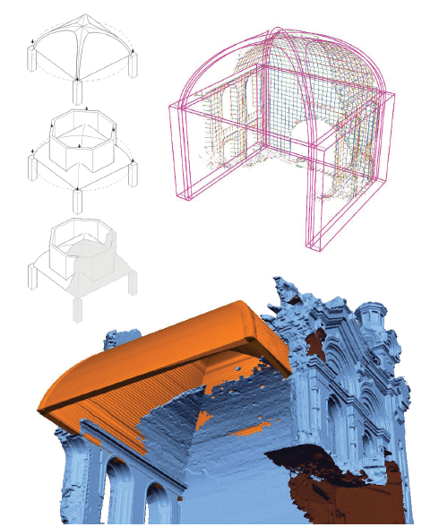
Figure 11. NURBS modelling of the pavilion vault from the sections extracted by the mesh surface. The geometric vault is referenced to the mesh model, and it has been imported in the same workspace.
The documentation of Upper Kama Region is part of a wider program of activities carried out, since 2013, by DAda-LAB - University of Pavia (coordinator prof. S. Parrinello) and Perm National Research Polytechnic University (coordinator prof. S. Maximova). The digital survey campaigns in 2018 and 2019 have been conducted by Parrinello S., Picchio F., De Marco R., Dell’Amico A. Part of the architectural survey documentation data have been processed inside the activities of the course of “Architectural survey & restoration” (prof. S. Parrinello, prof. G. Minutoli) of the Double Degree Italian Chinese course in Building Engineering and Architecture of University of Pavia.
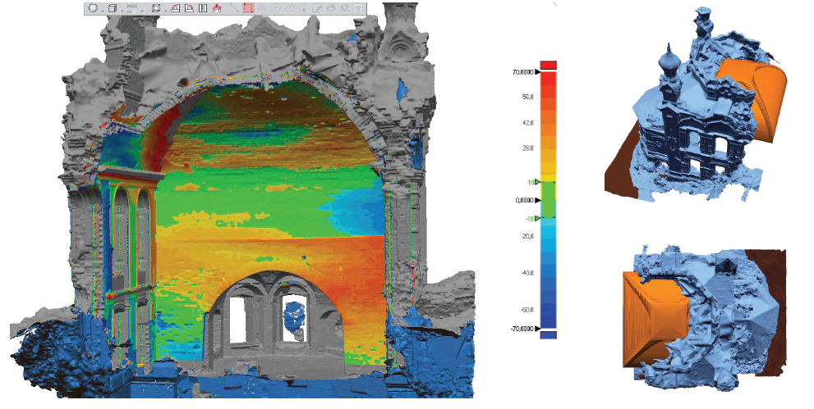
Figure 12. Deviation computing on the shape features between the models of the pavilion vault, from the HD mesh and from the NURB modelling. The color map defines a quantitative reading of the deformed portions from the static configuration, highlighting the kinematic mechanisms that are affecting the vault. From the comparison it has been possible to identify the portions of instability, and to derive diagnostic considerations in relation to the overall static schemes of the entire architectural complex.
The activities of survey, documentation and modelling of Blagoveshchenskaya Church belong to the EU project PROMETHEUS. PROMETHEUS project is funded by the EU program Horizon 2020-R&I-RISE-Research & Innovation Staff Exchange Marie Skłodowska-Curie. It sees the collaboration between three Universities (University of Pavia, Italy, Polytechnic University of Valencia, Spain, Perm National Research Polytechnic University Perm National Polytechnic University Research, Russia) and two companies (EBIME, Spain, SISMA, Italy).
This project has received funding from the European Union’s Horizon 2020 research and innovation programme under the Marie Skłodowska-Curie grant agreement No 821870.
References
- JP – EU, “Guidelines on Cultural Heritage. Technical tools for Heritage Conservation and Management” September 2012, JP - EU/CoE Support to the Promotion of Cultural Diversity (PCDK).
- United Nations Educational, Scientific and Cultural Organization, “Operational Guidelines for the Implementation of the World Heritage Convention”, WHC.17/01, UNESCO World Heritage Centre, Paris, France, 2017.
- UNESCO, “Recueil de décisions importantes sur la conservation des biens du patrimoine culturel inscrits sur la Liste du patrimoine mondial en péril de l’UNESCO”, WHC-09/33.COM/9, Paris, 2009.
- K. Rao, A new paradigm for the identification, nomination and inscription of properties on the World Heritage List, International Journal of Heritage Studies, 16:3, 2010, 161-172.
- L. Toniolo, M. Boriani, G. Guidi (eds), Built Heritage: Monitoring Conservation Management, Springer, Cham, Switzerland, 2015, ISBN 978-3-319-08533-3
- E. Psychogiopoulou, Cultural Heritage and the EU: Legal Competences, Instrumental Policies, and the Search for a European Dimension, in: A. Jakubowski, K. Hausler, F. Fiorentini (eds), Cultural Heritage in the European Union. A Critical Inquiry into Law and Policy, Brill Nijhoff, Netherlands, 2019, ISBN: 978-90-04-36534-6, 57-78.
- S. Parrinello, R. De Marco, From the city to the stone: digital survey for the establishment of structural behaviours in historical architecture, in: R. Salerno, Drawing as (in)tangible representation, Gangemi Editore, Roma, Italy, 2018, ISBN 978-88-492-3651-4, 747-754.
- B. M. Feilden, J. Jokilehto, Management Guidelines for World Cultural Heritage Sites, ICCROM, Rome, Italy, 1998.
- M. Bruneau, S. E. Chang, R. T. Eguchi, G. C. Lee, T. D. O’Rourke, A. M. Reinhorn, M. Shinozuka, K. Tierney, W. A. Wallace, D. von Winterfeldt, A Framework to Quantitatively Assess and Enhance the Seismic Resilience of Communities, Earthquake Spectra, Vol. 19, No. 4, 2003, 733-752.
- A. Giuffrè, C.F. Carocci, Statics and dynamics of historical masonry buildings. In: International Workshop on Structural Restoration of Historical Buildings in Old City Centers, Heraclion, Crete, 1994.
- A. M. D’Altri, G. Milani, S. de Miranda, G. Castellazzi, V. Sarhosis, Stability Analysis of Leaning Historic Masonry Structures. Automation in Construction Volume 92, August 2018, 199-213
- F. Parisi, N. Augenti, Earthquake damages to cultural heritage constructions and simplified assessment of artworks. Engineering Failure Analysis 34, 2013, 735–760
- S. Parrinello, F. Picchio, P. Becherini, R. De Marco, The Drawn Landscape in 3D Databases: The Management of Complexity and Representation in the Historical City. In: 7th Annual International Conference on urban Studies & Planning. ATINER’S CONFERENCE PAPER SERIES, 2018, 3-26, Athens: Athens Institute for Education and Research.
- W. C. Brumfield, Landmarks of Russian architecture. Amsterdam, Gordon e Breach, 1997.
- E. N. Shumilov, Orthodox Churches and Temples of Common Faith in Perm Krai: short historical guide. Perm, 2003.
- Monuments of architecture, history, art of Cherdyn and Cherdyn Region. V.2. Cherdyn, 1997.
- A. Guarnieri, F. Pirotti, M. Pontin, A. Vettore, Combined 3D Surveying Techniques for Structural Analysis Applications, Proc. of International Symposium on Photogrammetry and Remote Sensing (ISPRS), 2005, vol. XXXVI-5/W1, 22-24.
- S. Parrinello, F. Picchio, R. De Marco, New generations of Digital Databases for the development of Architectural Urban Risk Management”. In: C. Gambardella, Le Vie dei Mercanti XV Forum Internazionale World Heritage and Disaster. Fabbrica della Conoscenza, vol. 71, 2017, ISBN: 978-88-6542-582-4, 1-10.
- M. Tsakiri, D. Lichti, N. Pfeifer, Terrestrial Laser Scanning for Deformation Monitoring. In Proceedings of 3rd IAG/12th FIG Symp., 2006, Baden
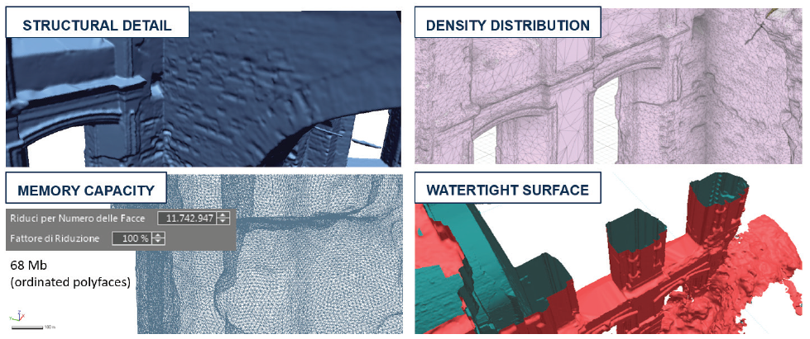
Figure 13. Properties of the final HD mesh model developed, suitable for compatible computing analysis in FEA workflows.
- A. Guarnieri, N. Milan, A. Vettore, Monitoring Of Complex Structure For Structural Control Using Terrestrial Laser Scanning (Tls) And Photogrammetry. International Journal of Architectural Heritage 7(1), 2013, 54-67.
- S. Bertocci, G. Minutoli, G. Pancani, 3D survey and instability’s analysis of Romena parish. DisegnareCON 8(14), 2015, 1-20
- R. De Marco. Shapes and Models: the Survey for the study of Structures in Historical Buildings. In: K. Williams, M. G. Bevilacqua. Nexus 2018 Architecture and Mathematics - Conference Book. Kim Williams Books, Pisa, Italy, 2018, ISBN 978-88-88479-47-7, 289-292.
- L. De Luca, P. Veron, M. Florenzano, Michele. Reverse-engineering of architectural buildings based on an hybrid modeling approach. Computers& Graphics, Volume 30, Issue 2, 2006, 160–176.
- G. Castellazzi, A. M. D’Altri, S. de Miranda, F. Ubertini, An innovative numerical modeling strategy for the structural analysis of historical monumental buildings”. Engineering Structures Volume 132, 2017, 229-248.
- M. Centofanti, S. Brusaporci, Architectural 3D modeling in historical buildings knowledge and restoration processes. In: C. Gambardella, Le vie dei mercanti, X Forum Internazionale di Studi, More or Less. Fabbrica della Conoscenza, vol. 16, 2012, ISBN 978-88-6542-129-1, 331-340.
- S. Parrinello, R. De Marco. From survey to the model: the graphic transposition of an earthquake. Disegnare Idee Immagini, 2018, vol. 57, 70-81.

