Intercalibration of hyperspectral and multispectral systems for Laser Induced Fluorescence imaging
Maria Federica Caso, Luisa Caneve, Valeria Spizzichino
ENEA – Italian National Agency for New Technologies, Energy and Sustainable Economic Development – Via Enrico Fermi 45, 00044 Frascati, Rome, Italy
mariafederica.caso@enea.it, luisa.caneve@enea.it and valeria.spizzichino@enea.it

Abstract – Laser Induced Fluorescence (LIF) is a well-recognized spectroscopic technique for non-destructive surface chemical analysis. It is particularly suitable for in situ analysis on delicate targets as artworks, because it does not need any sample preparation nor contact, working remotely also where only optical access is available. Hyperspectral systems have the advantage to provide whole spectra of the analysed point, and thanks to motorized optics can produce fluorescence images and map of surfaces. Since the early 2000s ENEA has developed hyperspectral LIF scanning systems. To shorten significantly analysis time, overall on very large CH surfaces as building facades, ENEA DIM Laboratory has developed an imaging multispectral LIF system. Here we present intercalibration, data analysis and software to automatically correct such imaging data and take into account filter’s bandpass and optical efficiencies with respect to systems based on the use of spectrometers, avoiding lack of selectivity and accuracy due to the absence of whole spectra.
- Introduction
In the cultural heritage field the diagnostic laser-based instruments are largely used, in particular the LIF (Laser Induced Fluorescence) spectroscopic technique [1]. LIF spectroscopy detects the UV-vis radiations emitted by luminescent molecules on target surface caused by allowed electronic transitions stimulated by UV laser. This technique is non-destructive and non-invasive, does not cause modifications or degradations of chemical structure of targets and for this reason is particularly recommended for fragile and delicate artworks. Furthermore, LIF instruments can work remotely from the targets and transportable instruments for in situ analysis can be designed.
Since the early 2000s ENEA has developed LIF prototypes with hyperspectral scanning systems, capable of both fluorescence and reflectance imaging, that return spatial and spectral information of an object. Recently an imaging multispectral LIF system was designed to permit the rapid acquisition of fluorescence maps of large surfaces (up to 100 m²). It would be particularly suitable for facades and sculptural groups. This system allowed
Fig. 1. Fluorescence spectra of the reference solutions.

faster acquisitions and can provide the first results in real time. The system is studied to be equipped with a custom software for the automatic recognition of specific classes of materials.
In this work we will discuss the intercalibration, the data analysis and an algorithm to automatically take into account the filter’s band passes and optical efficiencies, and to overcome the absence of whole spectra with respect to systems based on the use of spectrometers, avoiding lack of selectivity and accuracy, in order to make these two configurations as much as possible comparable.
- Instrumentation
This paper is focused on two specific instruments developed at the ENEA DIM Laboratory, a punctual scanning system (Lifart) and an imaging LIF system (called Forlab), whose detailed technical features are already been described [2]. Briefly, the punctual scanning system works remotely up to 10 m distance from the target, using a diode pumped solid state laser emitting in the UV at 266 nm. A coaxial optical design is used to transmit the exciting radiation and to receive the fluorescence signals from the investigated target. The point scanning is obtained actuating the last mirror with two rotating servo controls operating at high accuracy. Practical aperture of the scanning is limited by the mounting assembly to approximately +/-45° in both the horizontal and vertical axes. The fluorescence radiation is focused at the entrance
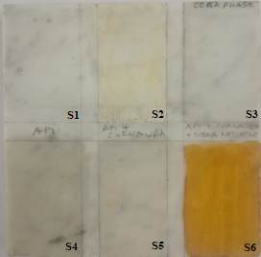
Fig. 2. Reference marble tile.

of a fiber optic linked to a compact QE-Pro spectrometer from Ocean Optics, allowing a hyperspectral imaging in the range of 250–900 nm with a 2.5 nm bandwidth.
The second apparatus used is a multispectral system allowing for the rapid collection of large images on several different spectral. The system is based on the use of motorized delivering optics to scan the whole surface to be analysed with a UV (excimer KrF laser at 248 nm) laser spot. Instead, the collecting subsystem connected to an ICCD (Andor iStar) with large field of view is fixed. The laser source is characterized by a high pulse repetition rate that allow (up to 500 Hz) allowing for the lowering of the acquisition time. A filter wheel is mounted in front of the ICCD in order to detect fluorescence images at 8 preselected spectral bands (Table 1).
Table 1. Forlab filters features.
Center wavelenght | Transmission band
290 nm | T_{avg} > 75% 277.5 – 302.5 nm
315 nm | T_{avg} > 75% 307.5 – 322.5 nm
340 nm | T_{avg} > 75% 327 – 353 nm
376 nm | T_{avg} > 95% 366 – 386 nm
415 nm | T_{avg} > 90% 410 – 420 nm
445 nm | T_{avg} > 93% 435 – 455 nm
480 nm | T_{avg} > 92% 471.5 – 488.5 nm
530 nm | T_{avg} > 93% 521 – 539 nm

Practically, both systems are able to acquire, with the laser switched on or off, punctual fluorescence and reflectance spectra, respectively. Fluorescence data can be processed to obtain fluorescence images and false colour images useful for a material mapping. Active reflectance measurements are based on elastic back-scattering of the incident light collected from the analysed surface at the daylight or under a specific white light source.
- Materials
In this work several different materials, lab samples and real objects of art have been used to calibrate and to test the instruments in order to evaluate correction methods
Fig. 3. Fluorescence spectra of sections S1, S2 and S4 of marble tile.

and algorithms. For the intercalibration of the two instruments, materials characterized by known fluorescence spectra, which cover the entire range between 270 and 700 nm, have been selected. In particular, solutions of phenylalanine (0.1 M), 4,6-diamidino-2-phenylindole (DAPI, 5 mg/ml) and a mix of aminoacids (tyrosine 0.017 M, tryptophan 0.018 M and phenylalanine 0.1 M) have been prepared and their fluorescence spectra excited at 266 nm are presented in Figure 1.
Furthermore, a reference model simulating some real case studies was selected, mimicking a sample that can be encountered during on field campaign. The sample was a Carrara marble tile (Figure 2) divided into six sections:

S1) Marble
S2) Carnauba wax (vegetable wax)
S3) Phase wax (industrial wax)
S4) Beeswax
S5) Beeswax and Carnauba wax mixture
S6) Beeswax and Carnauba wax mixed with Sienna pigment.

Also in this case, these materials were chosen because of their fluorescence spectra that cover the whole wavelength range of interest. In Figure 3 the fluorescence spectra relative to sections S1, S2 and S4 obtained with an excitation at 266 nm are presented. Moreover, these materials have been largely used as coatings in sculpture and architecture since antiquity and Sienna and ochre were frequently applied to give a chiaroscuro effect to artefacts.
Subsequently, another sample prepared in laboratory, an earthenware tile, has been used to test the obtained intercalibration. This sample was treated with a mortar composed by lime and pozzolan and a pigment using buon fresco or mezzo fresco techniques (depending on the areas), and finally covered with a modern surface coating. In particular four different areas have been taken into account:

- white lead and Rhodorsil RC-80
- vine black and Rhodorsil RC-80
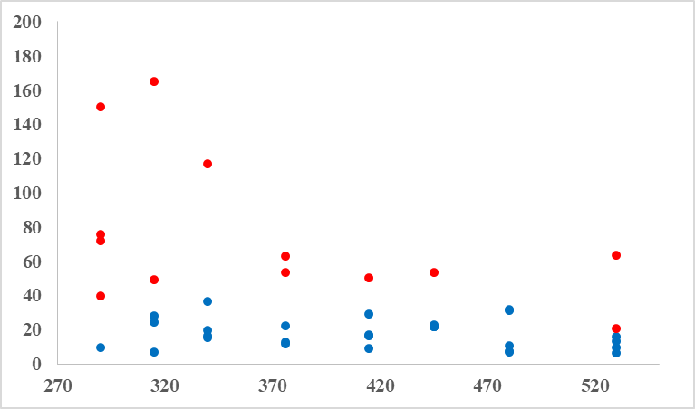
Fig. 4. Calibration values for every sample: in blue the considered values, in red the discarded ones.

- green earth and Paraloid B72
- yellow ochre and Rhodorsil RC-80.

The calibration has been also tested on a real ancient artwork. In particular, a previous study [3] on ancient Egyptian artefacts was chosen to validate the calculous on a third different material (wood). The analysis of fluorescence spectra of the casket and the sarcophagus of Peftjauyauyaset (XXVI din. -VII-VI sec. a.C.) from the Archaeological Museum of Milan was chosen for the discontinuity of the artefacts surface: in fact, the spectra revealed the presence of not-homogeneous materials applied in previous restoration actions. Furthermore, the fully decorated surfaces provide an amplified chiaroscuro contrast and improves the image quality when the calibration is applied to the Forlab results.
- Results and discussion
A. System intercalibration
The reference solutions and the marble tile described in section III were utilized for the calibration. Fluorescence data were registered by both Lifart (whole spectra) and Forlab instruments (eight filters at 445, 376, 340, 315, 290, 415, 532 and 480 nm) and analysed. In particular, fluorescence analyses were carried out on drops of the solutions placed on an aluminium surface, and a small square of the marble tile in the centre of every section was chosen and punctual and Forlab spectral data registered in this area were mediated.
Afterwards, recorded data were processed to obtain intercalibration values as much as possible independent of experimental measurement conditions. First at all, for Forlab data the transmission bands of the filters (reported in Table 1) had to be considered. After this correction, for both the instruments data were normalized with the integral on the whole range (sum of intensity values corresponding at the 8 filters for Forlab). Later on, to compare Forlab and Lifart data, only spectral data from punctual system mediated over the bandpass of the filters used in Forlab were considered.
Fig. 5. Black: LIFART fluorescence spectra of B and C; blue: FORLAB data not calibrated; red: FORLAB data calibrated.

Sections 1, 2 and 4 of marble tile were preferred because the high reproducibility of measurements and higher fluorescence intensity respect to the others. The calibration ratios obtained starting from the reference solutions and sections S1, 2 and 4 of the tile are presented in Table 2. Highlighted values in Table 2 were those considered reliable because correspondent to higher signal to noise ratios, as verifiable in Figure 1 and 3, and used for the calculations of final ratios. Unfortunately for filter 290 just one value was considered because only phenylalanine presented a peak in 270-340 nm wavelength range.
Table 2. Calibration values for every sample.
FORLAB filters (nm) | S1 | S2 | S4
290 | 71,79 | 150,25 | 39,52
315 | 49,09 | 165,13 | 24,51
340 | 19,41 | 117,02 | 36,74
376 | 12,88 | 62,79 | 22,12
415 | 16,59 | 29,05 | 16,75
445 | 22,86 | 21,84 | 21,71
480 | 6,90 | 10,67 | 7,62
530 | 9,30 | 15,79 | 6,35
FORLAB filters (nm) | DAPI | Amino  acids | Phenyl  alanine
290 | 2459,86 | 75,77 | 9,32
315 | 2664,24 | 28,11 | 7,17
340 | 3709,70 | 15,58 | 16,33
376 | 2013,75 | 11,54 | 53,38
415 | 410,70 | 8,96 | 50,10
445 | 299,98 | 21,88 | 53,38
480 | 31,45 | 31,88 | 27,36
530 | 13,24 | 63,52 | 20,83

A confirmation is done by results resumed in Figure 4. In fact, blue points indicate the highlighted values and red
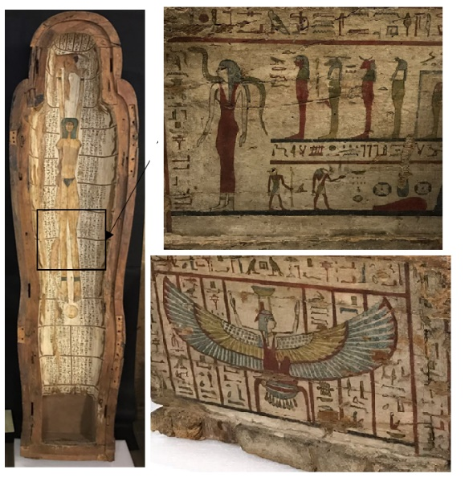
Fig. 6. Upper valve of the sarcophagus, long and short side of the casket.

ones the neglected in the calibration ratios calculous, that are far from the blue ratios and very incoherent.
The final calibration ratios obtained mediating the highlighted values and the standard deviations are presented in Table 3.
Table 3. Calibration ratios for every Forlab filters.
FORLAB filters (nm) | Calibration ratios | Standard deviation
290 | 9,32 | /
315 | 19,93 | 11,2
340 | 22,01 | 10,0
376 | 15,51 | 5,8
415 | 17,84 | 8,3
445 | 22,07 | 0,5
480 | 19,31 | 12,1
530 | 11,17 | 4,2

B. Application of calibration ratios to a laboratory sample
The calibration ratios were applied to the four sections of the earthenware tile described before. As the previews tile, a small square in the centre of every section was selected and the corresponding punctual and Forlab spectral data of this area were averaged. The Forlab data were corrected by the calibration ratios and plotted with the punctual spectra (Figure 5)
The calibrated values presented a minor intensity respect to the punctual spectra, but the peaks and bands showed the same shapes and trends. As expected, values at 290 and 315 nm had a higher intensity in relation to the others.

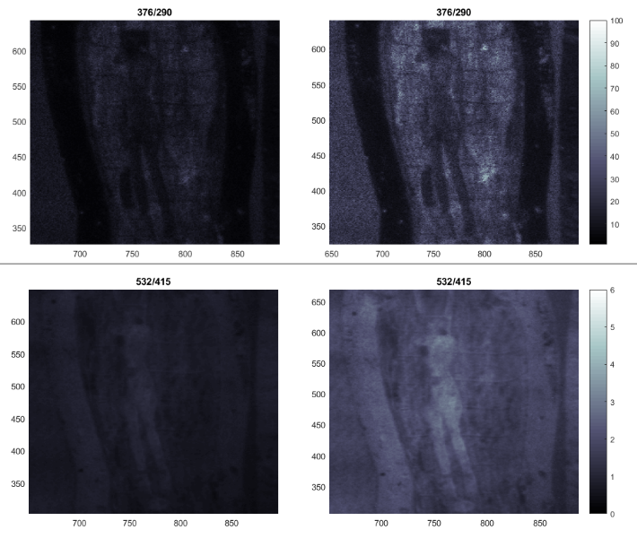
Fig. 7. Application of calibration ratios to FORLAB fluorescence ratios 376/290 and 532/415. Left: without calibration. Right: with calibration

C. Application of calibration ratios to a real case
The calibration ratios were applied to a previous study of DIM laboratory [3] on the Egyptian casket and sarcophagus described in section III. The purpose of this paper is not to reply or revise the already published results, but to improve the quality of the images and the identification of unknown substances.
The processed data of the previous article allowed to attest the discontinuity of surface materials and the individuation of the modern coatings applied in a not documented restoration action. The ratio between the fluorescence spectra acquired from FORLAB with different filters put in evidence some retouches not visible by naked eye, and the punctual scanning system analysis of these individuated portions permitted to recognize zinc oxide, acrylic paint and more.
Very interesting results were obtained by the analysis of the interior part of the upper valve of the sarcophagus (Figure 6), where the presence of canvas under the paints and acrylic coating was revealed on the legs of the goddess Nut.
The application of calibration ratios to two different FORLAB fluorescence ratios permitted to obtain more contrast and definition of the images (Figure 7), confirming the published results. The discontinuity of the surface materials was evident also on the long and the short sides of the casket (Figure 6). In fact, the FORLAB processed data, confirmed by LIFART analysis, showed the presence of acrylic consolidation material applied in several restorations over time.
The calibration ratios considerably improved the quality of FORLAB 376/290 ratio images (Figure 8), making some fissures and several restorations stand out in the casket, particularly on the short side, in correspondence of the winged goddess Nefti.
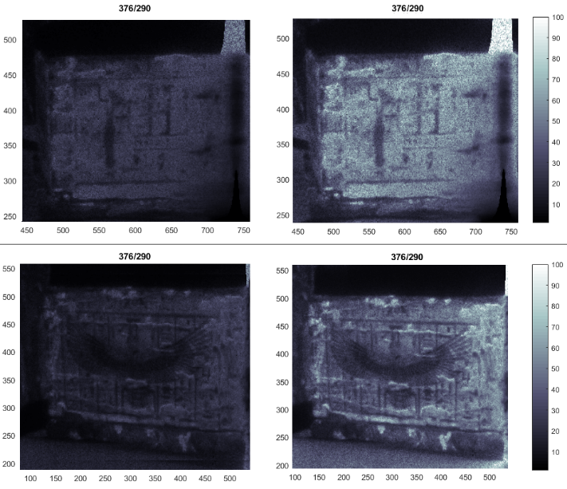
Fig. 8. Application of calibration ratios to FORLAB fluorescence ratio 376/290 of casket sides. Left: without calibration. Right: with calibration

- Conclusions
LIF spectroscopic technique is largely used in the field of cultural heritage for ease of use and non-destructive analysis. ENEA DIM Laboratory perfected an hyperspectral and a multispectral LIF scanning systems, that needed to be calibrated to correct the imaging data and avoid the lack of selectivity due to the use of filters, causing the absence of the whole spectra.
Some reference solutions and a Carrara marble tile treated with different coatings was employed to develop calibration rates for the FORLAB system, that were applied on the fluorescence spectra of a earthenware tile covered with pigments and modern protective paints. The encouraging results, still perfectible, led to give higher quality Forlab images with improved chiaroscuro contrast and accuracy in fluorescence measurements.

AKNOWLEDGEMENTS
The Authors would like to thank ADAMO regional project in the frame of DTC (Technological District for Cultural Heritage) Lazio Det.reg. G08622 and E. Antonelli and the Consorzio Croma laboratory for the collaboration and the maximum availability for measurements.
References
- C.Fotakis, D.Anglos, V.Zafiropulos, S.Georgiou, V.Tornari. “Lasers in the Preservation of Cultural Heritage: Principles and Applications”, 1st edition, CRC Press, Boca Raton, 2006.
- F.Colao, R.Fantoni, L.Fiorani, A.Palucci, I.Gomoiu, “Compact scanning lidar fluorosensor for investigationsof biodegradation on ancient painted surfaces”, J. Optoelectron Adv. Mater., vol.7, No.6, 2005, pp. 3197–3208; V.Spizzichino, L.Caneve, F.Colao, “Stand-Off Device for Plastic Debris Recognition in Post-Blast Scenarios”. Challenges, vol.7, No.2, 2016, p. 23.
- L.Caneve, V.Spizzichino, E.Antonelli, L.Bertani, “Study of ancient Egyptian artefacts by non-destructive laser based techniques,” Proc. of IEEE International Conference on Metrology for Archaeology and Cultural Heritage, Cassino, Italy, 2018.

