Comparison and integration of techniques for the study and valorisation of the Corsini Throne in Corsini Gallery in Roma
Marialuisa Mongelli,¹ Giulia Chellini,² Silvio Migliori,³ Antonio Perozziello,⁴ Samuele Pierattini,⁵ Marco Puccini,⁶ Alessandro Cosma⁷
1 ENEA - High Performance Computing Laboratory, Lungotevere Thaon di Revel 76, 00196 Rome, Italy
2 ENEA - Diagnostic and Metrology Laboratory, Via Enrico Fermi 45, 00044 Frascati, Rome, Italy
3 ENEA - High Performance Computing Laboratory, Lungotevere Thaon di Revel 76, 00196 Rome, Italy
4 ENEA - Diagnostic and Metrology Laboratory, Via Enrico Fermi 45, 00044 Frascati, Rome, Italy
5 ENEA - High Performance Computing Laboratory, Via Madonna del Piano 10, 50019 Sesto Fiorentino, Florence, Italy
6 ENEA - High Performance Computing Laboratory, Lungotevere Thaon di Revel 76, 00196 Rome, Italy
7 Corsini Barberini National Gallery, Via della Lungara 10, 00165 Rome, Italy
ABSTRACT
In recent years, the application of digital technologies for the enhancement and use of cultural heritage items has grown considerably. Multimedia, virtual and augmented reality and 3D reconstructions make it possible to bring the general public closer to an understanding of something that no longer exists or that is from a distant time. But digital tools can serve more than educational purposes. To date, digitisation has become above all an essential tool in most cultural heritage projects involving conservation, restoration, documentation and research.
In this paper, we present a process that integrates different technologies for cultural heritage purposes, from the 3D reconstruction of an artefact to its exhibition using a web application combined with semantic representation of metadata following FAIR principles. This process began with the investigation of an integrated approach involving the non-invasive technologies of photogrammetry and structured light scanning during the development of the WeACT3 Project (Acting Together – Technology for Art, Culture, Tourism and Territory) jointly signed by the CIVITA Association, of which ENEA is an honorary member, and the National Barberini and Corsini Galleries, collaborating in a partnership of several national and international enterprises. The above-mentioned technologies were used to build a 3D model of the Corsini Throne, which is preserved at the Corsini Gallery in Rome.
Following this, over the last year, the information and communications technology division of ENEA played an important role within EcoDigit, a project financed by the Lazio Regionto create a digital ecosystem for the fruition and enhancement of cultural heritage and cultural activities. Our model, along with others, was used as a test case.
The result is an automated web tool prototype that is able to display 3D models along with correlated scientific information (e.g. relevant studies and articles) to assist research activities and knowledge sharing.

Section: RESEARCH PAPER
Keywords: 3D Reconstruction; 3D matching; structured light scans; photogrammetry; structure from motion technique; technology transfer
Citation:
Editor:
Receivedmonthday, year; In final formmonth day, year; PublishedJanuary2014
Copyright: © 2014IMEKO. This is an open-access article distributed under the terms of the Creative Commons Attribution 3.0 License, which permits unrestricted use, distribution, and reproduction in any medium, provided the original author and source are credited
Funding: This work was supported by Measurement Science Consultancy, The Netherlands
Corresponding author: Marialuisa Mongelli, e-mail: marialuisa.mongelli@enea.it

- Introduction
Following upon the paper presented at 2019 IMEKO TC-4 International Conference on Metrology for Archaeology and Cultural Heritage [1], this work takes into account the developments made through participation in the EcoDigit project, which aims to create a digital ecosystem for the cultural heritage of the Lazio Region [2].
The EcoDigit project is one of the initiatives of the Centre of Excellence of the Technological District for Cultural Heritage and Activities (DTC) of Lazio, which aims to aggregate and integrate expertise in the field of technologies for cultural heritage and activities.

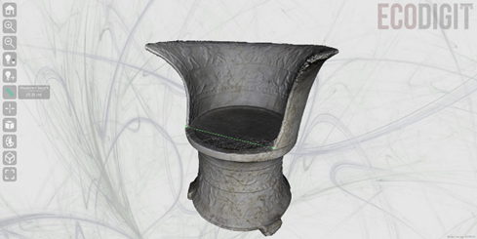

Figure 1. The visualisation tool based on 3DHOP.

The project focused on the design of a middleware platform to facilitate the integration of new data sources and enable the publication and reuse of services for the enhancement and enjoyment of the cultural heritage of Lazio. The results demonstrate the opportunities for sharing and enhancing cultural heritage provided by 3D models that can be extended and linked with studies and other information in a simple way. By adding metadata to the knowledge graph, it is possible to create linked information that can be queried and shown with the viewer in the same web environment, allowing the academic, the researcher and/or the simple user to access resources and carry on with their studies. The Corsini Throne was found between 1732 and 1734 during excavations prior to laying the foundation of the Corsini family’s chapel in the basilica of S. Giovanni in Laterano.
The decorations and typology of this artefact could be considered typical of Etruscan funerary thrones, which were commonly made with bronze or terracotta. The use of marble and the place of the discovery, on the other hand, show the Roman origins of this piece, making it unique in ancient sculpture.
This, together with the events relating to its discovery, has led to a hypothesis regarding its function and role: that it is a symbol of the royal descent of one of the most important women of the Etruscan Plautii Silvani family, Urgulania, who married M. Plautius Vir Praetorius in around 40 BC. The artefact is, therefore, a Roman copy of an Etruscan throne from the late Republican age (late 5th century BC), intended as proof of Urgulania’s royal lineage [3].
The back of the throne is divided into two parts delimited by a frame of ivy; the upper part shows soldiers, while the lower one depicts scenes of wild boar hunting. Above a plant frieze at the base, figures portray scenes of sacrifice and struggle and a procession, the interpretation of which is still not clear.
The Corsini Throne was investigated using both photogrammetry and a structured light scanner. The use of these two non-invasive technologies enabled the creation of two different 3D reconstructions. These reconstructions can be shared virtually, improving the visibility of the artwork and enriching the museum’s catalogue [4].
Photogrammetric reconstruction is widely used to generate 3D models of both small artworks and monumental complexes of considerable size [5], [6]. Starting with 2D digital images taken by a simple camera, a scaled 3D numerical model is generated using structure from motion

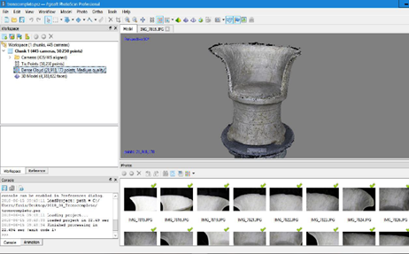
Figure 2. Elaboration of 2D images in Agisoft Photoscan Pro Software.

(SfM) and computer vision algorithms. Photogrammetry is non-invasive, low-cost, contactless, fast and easy to execute [7].
In comparison, structured light scanning is slower due to the greater size of the instrumentation and less immediate because of the use of the scanner; moreover, the software is less intuitive and requires a specialised operator (Figure 1). It quickly creates highly accurate 3D scans and is suitable for projects involving small, delicate or fragile objects. Geometries and colours are captured simultaneously, allowing an exact match of the 3D coordinates and their corresponding colour information.

- Information and communications technology INFRASTRUCTURE AND SERVICES FOR Cultural Heritage ENHANCEMENT
ENEA’s information and communications technology (ICT) infrastructure is a large system of services, software and computing resources for a wide range of use cases, including the emerging field of digital heritage technologies.
In 2019, ENEA supplied its ICT know-how and resources to the EcoDigit project, which aims to design and develop a digital ecosystem for the cultural heritage of the Lazio Region. In particular, ENEA worked to make a reliable, automatic 3D visualisation tool named 3DHOP [8] that would enable semantic interoperability between databases to allow the automatic generation of the visualisation in a web page. With this result, developed by ENEA, 3DHOP has become a module that can be integrated with any type of database structured as described above [9]. Its automatic features, which are based on 3D model metadata, allow for fast deployment of tools like databases, supporting the use of 3D model visualisation.
In particular, 3D models, thanks to their specific properties, provide a starting point for reading and studying the real work of art and monitoring its physical conditions. Metric comparisons between the 3D model and the work can be used to document, measure and study any type of variation that occurs in the physical structure of the artefact.
Photogrammetry makes it possible to repeat the measurements at regular intervals so as to allow the study of changes, thanks to its agile instrumentation, speed of execution and relatively short processing times.

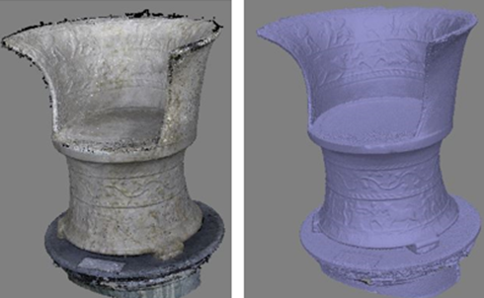

Figure 3. Processing of 2D images for 3D photogrammetric reconstruction: dense cloud and mesh.

Photogrammetric surveys use less expensive instrumentation than other techniques. In addition, the instruments are easier to transport, and the image processing is faster. This makes it possible to check the results almost in real time and, if necessary, to proceed with a new scan.
A 3D model obtained through photogrammetry has a good balance between quality and construction time. Where necessary, it is possible to integrate the photogrammetric results with high resolution scans performed, for example, using a structured light scanner. This can be helpful when it is necessary to highlight details or elements that are not legible at a minuscule resolution.

- PHOTOGRAMMETRIC RECONSTRUCTION BY SfM TECHNIQUE
Photogrammetric scanning was used to produce more than 500 images (5184 x 3456 pixel, 5 MB each) taken with a Nikon D60 digital camera with zoom and focus held constant.
Starting from a set of 2D images, the digitisation process of 3D photogrammetric reconstruction consisted of a sequential semi-automatic procedure.
Post-processing, the images were obtained using the ITACHA virtual platform on ENEAGRID [11]. The 3D reconstruction was elaborated with the commercial software Photoscan Pro (Figure 2) based on computer vision algorithms and supported by SfM and multiple view stereovision techniques.
The software is available by remote access in ENEA’s ICT infrastructure through the fast access to remote objects graphical interface, which makes it possible to use computer graphics tools, to exploit the computational resources offered through HPC CRESCO6 systems and to store images and photogrammetric reconstruction results in the AFS and GPFS ENEA storage areas [12].
After the acquisition of images, the reconstruction procedure using PhotoScan Pro software consisted of the following steps:
a) Matching and alignment;
b) Solving for the camera’s intrinsic and extrinsic orientation parameters;

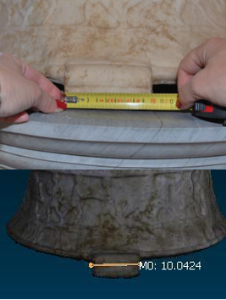

Figure 4. Real measures and scaled model according to real measures (1:1).

c) Reconstructing dense surfaces;
d) Reconstructing polygons;
e) Texture mapping;
f) Surface editing.

Out of 455 images, 435 were successfully aligned and processed in Photoscan. After the alignment phase, the sparse cloud was processed to obtain a dense cloud from which the polygon mesh was built (Figure 3).
Thanks to the use of the hardware and software resources of the ENEA ICT computing infrastructure, it was possible to obtain the 3D reconstruction of the Corsini Throne in about 200 minutes.
Finally, the texture of the 3D model was reconstructed, and the model was also manually scaled according to real measures, creating a correct structure in terms of geometry (Figure 4).
The result is a photorealistic and metrically correct 3D model (Figure 6).
Speed and ease of processing allow photogrammetry to be used as a valid tool for monitoring the conservation status of an artwork: indeed, by comparing 3D models generated at different times, it is possible to monitor any structural changes [13].
- STRUCTURED LIGHT SCANNER
In addition to photogrammetric scanning, the Corsini Throne was also subjected to scanning using structured light.
This non-invasive technology enables the creation of high-resolution 3D data sets.
The structured light system supplied by ENEA is a SmartSCAN by AICON 3D Systems used in combination with Optocat software.
This system uses a high-resolution scan performed by a portable structured light AICON SmartSCAN 5M pixel system (Figure 7) with an M-300 optic to automatically map the texture onto the final mesh. The instrument’s technical features are listed in Table 1. The instrument projects a pattern of light and detects the deformation of this pattern on the object.
The acquired images are processed by Optocat, a software produced by AICON that allows the quality of each scan to be verified in real time and consecutive scans to be merged.

Table 1. AICON SmartSCAN 5M pixel system
Accuracy [μm] | ± 26
Field of view size [mm] | 240 × 200
Measuring depth [mm] | 150
(x,y) resolution limit [μm] | 100
(z) resolution limit [μm] | 5
(z) noise [μm] | ± 11

Optocat uses specific algorithms to automatically align new
scans with preceding ones.
If the scans do not overlap sufficiently, manual alignment through the identification of homologous markers is required.
The pattern deformation induced by the surface of the object is acquired by a camera and exploited to calculate 3D coordinates.
The process of 3D reconstruction by structured light involved a sequence of several steps.
After calibrating the device, we proceeded to scan the object and acquire the images. Due to the dimensions and the particular shape of the object, two separate scan phases were necessary. The first scan covered the seat of the throne, and the second covered its backrest.

Each 3D scan was automatically aligned with the previous one by the Optocat software or, if necessary, by the operator using
manually positioned markers. Due the impossibility of moving and rotating the Corsini Throne, the equipment had to be moved around the throne a total of 360 °.
After aligning these two scans, Optocat elaborated the point cloud and built the mesh.

Figure 6. 3D model of the Corsini Throne with texture.

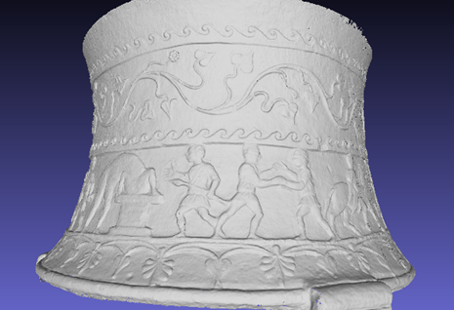

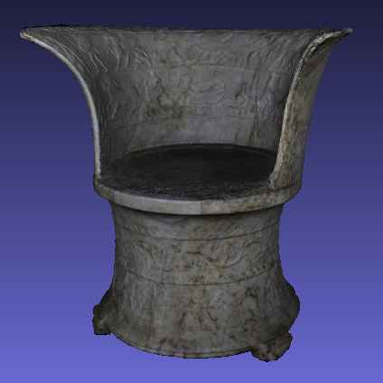

Figure 5. Detail of high-resolution 3D model of Corsini Throne.

This software is able to create colourful textures; the mapping of the high-resolution texture can be realised through the internal images captured by the 3D scanner or with images acquired by external cameras.
The 3D models thus obtained were subjected to a merging process in order to obtain a single and complete model.
In the case of the Corsini Throne, it was preferable to study the object without texture because the texture interfered with the analysis of the bas-relief.

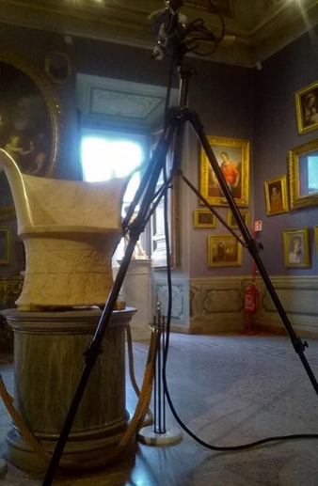

Figure 7. Structured light scanner instrument.

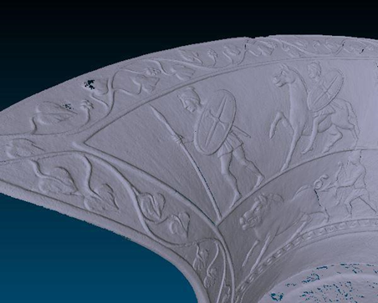

Figure 8. Detail of the high-resolution 3D model.

The result is a very high-resolution model with a greater definition of detail than that obtained through photogrammetry(Figures 5–8). For this reason, exporting the 3D model in PLY format creates an extremely large file that requires advanced computational resources.
Thus, it has been split into two parts, base and back, halving the size. Thanks to this solution, it is possible to manage the two PLY files using even a low-performance PC.

- UNWRAPPING AND INTEGRATION TECHNIQUES
In agreement with the curator of the museum, one of the goals of the structured light survey was to obtain a 3D model that would make it easier to read the bas-reliefs on the back and base of the Corsini Throne.
In fact, the significance of the complex iconography on the base as well as the throne’s function remains unclear, generating questions that continue to fuel scientific debate.

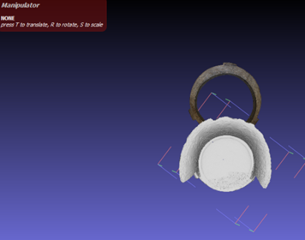
Figure 9. Orientation of the two models in MeshLab using the manipulator tool.

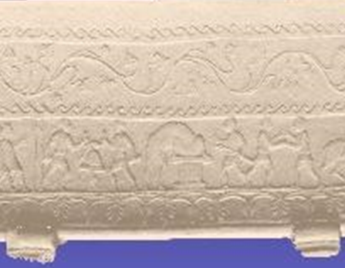
Figure 10. Detail of the relief on the unwrapped Corsini Throne.

Facilitating the narrative reading of the bas-reliefs would make it possible to further enrich the work of the museum and to study this piece in greater depth.
The relief was ‘unrolled’ in MeshLab using the deformation filter and geometric cylindrical unwrapping (Figures 11–12) [14].
This made it possible to observe and study the scenes reproduced at the
base of the throne from a horizontal and consecutive perspective.
The geometry of the model produced through the photogrammetric process does not provide a sufficient level of detail to allow a similar iconographic reading (Figure 10).
For this reason, it was considered useful to generate a single model through the integration of the two techniques.

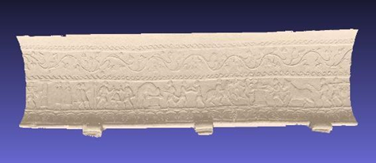

Figure 11. Unrolling of the backrest on the base of the Corsini Throne.

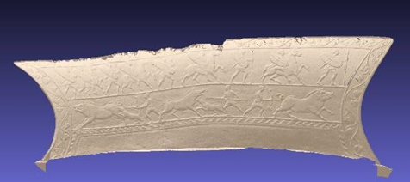

Figure 12. Unrolling of the base of the Corsini Throne.

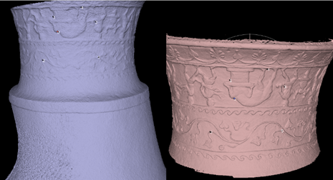

Figure 13. Detail of the high-resolution 3D model.

In so doing, we could obtain a partially high-definition model that was particularly detailed in the area most difficult to study, the base of the Corsini Throne.
At the same time, the file size would be significantly reduced, thus allowing it to be accessed on a PC with lower performance.
The models produced by photogrammetry and structured light were merged within MeshLab [15]. Either the complete 3D photogrammetric model or the structured light model of the base of the throne can be opened in the software. The photogrammetric model, which has smaller dimensions, was complete in order to provide the amount of surface necessary for overlap.
First, we proceeded with the orientation of the two models using the MeshLab manipulator tool for rotation and translation (Figure 9).
Then, in the alignment phase, 5 homologous points were identified on the two models (Figure 13). This allowed a satisfactory overlap (Figure 14). Subsequently, the surface of the photogrammetric model of the base was eliminated because it had become superfluous.
The high-resolution base allows detailed study of the relief.
By combining it, through alignment, with the backrest reproduced using photogrammetry, it was possible to obtain a single model that was used less processing space and was more manipulable. The result (Figure 15) is an exportable model of reduced size that is easy for an average computer to handle.

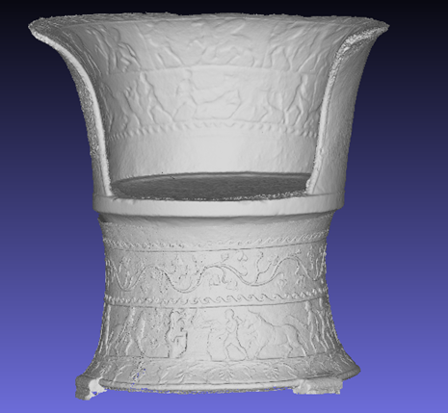

Figure 14. Result of the merging of the two models after alignment.

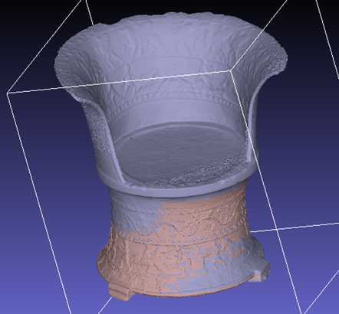

Figure 15. 3D model obtained from the integration of the photogrammetric and structured light scans.

Moreover, a 3D model using smaller files would increase the space available for study materials for those who intend to deepen their knowledge of the artefact.

Finally, a model with these characteristics would be very useful, practical and innovative for educational and dissemination purposes. For example, it would be easily accessible on websites, apps or devices, making 3D exploration available to the general public.

- CONCLUSIONS
The results obtained with two different technologies were compared for 3D shape accuracy, texture quality, digitisation and processing time and finally price.
The results show that the structured light scanner provided the best results with regard to geometric structures.
One of the strengths of photogrammetry is the speed with which information can be acquired and the possibility of using simple 2D photographs (which, however, must be taken in the best way, otherwise geometric information can be lost and the quality of the model will suffer). Only software is required to start the elaboration process. A high-performance PC speeds up the process, but, in the case of more complex images, it is possible in Photoscan to elaborate individual sections and then merge them to obtain a single 3D model.
Photogrammetry offers a very good balance in terms of portability, costs and quality. Photogrammetric models can be successfully used in the divulgation and valorisation of artworks. When integrated within an app or website, they provide a different and more complete level of knowledge than traditional 2D images.
Due to the ICT ENEA infrastructure, it was possible to upgrade 3DHOP to include the new features described above. These make 3DHOP a more interoperable tool, enabling the creation of a more complex microservices architecture to integrate the available tools with other services developed in the same way. This could lead to the creation of more resilient tools for cultural heritage assets managers.
Furthermore, the unrolled Throne could be useful not only for a better visualisation of the figures but also for classification, as researchers and/or automated segmentation recognition algorithms could work from the information provided in the model.

Acknowledgement
A special thanks to the staff of Corsini Gallery and CIVITA Association for their institutional support.
References

- M. Mongelli, G. Chellini, S. Migliori, A. Perozziello, S. Pierattini, M. Puccini, A. Cosma, Photogrammetry and structured light: comparison and integration of techniques in survey of the Corsini Throne at Corsini Gallery in Rome, Proc. of International Conference of Metrology for Archaeology and Cultural Heritage (MetroArcheo2019), Florence, Italy, 4 – 6 December 2019, pp. 166-171.
- http://ecodigit.dtclazio.it/
- M. Torelli, La Sedia Corsini, monumento della genealogia etrusca dei Plautii, in: Mélanges Pierre Lévêques, Vol. 5, Anthropologie et Société. M. M. Mactoux, E. Geny (editors). Université de Franche-Comté, Besançon, 1991, ISBN: 2-251-60429-9, pp. 355-367.
- G. Agugiaro, F. Remondino, G. Girardi, J. von Schwerin, H. Richards-Rissetto, R. De Amicis, A web-based interactive tool for multi-resolution 3D models of a Maya archaeological site, ISPRS – International Archives of the Photogrammetry, Remote Sensing and Spatial Information Sciences XXXVIII-5/W16 (2012).
DOI: 10.5194/isprsarchives-XXXVIII-5-W16-23-2011 5386-5275-6.
- V. Evgenikou, A. Georgopoulos, Investigating 3D reconstruction methods for small artifacts, ISPRS – International Archives of the Photogrammetry, Remote Sensing and Spatial Information Sciences XL-5/W4 (2015) pp. 101-108.
DOI: 10.5194/isprsarchives-XL-5-W4-101-2015.
- A. Scianna, M. La Guardia, Survey and photogrammetric restitution of monumental complexes: issues and solutions—the case of the Manfredonic Castle of Mussomeli, Heritage 2 (2019) pp. 774-786.
DOI: 10.3390/heritage2010050
- M. Mongelli, I. Bellagamba, G. Bracco, S. Migliori, A. Perozziello, S. Pierattini, A. Quintiliani, B. Mazzei, 3D photogrammetric reconstruction by “Structure from Motion” as a monitoring technique for safety, conservation and improvement of the fruition of cultural heritage, Proc. of International Conference of Metrology for Archaeology and Cultural Heritage (MetroArcheo2017), Trento, Italy, 22 – 25 October 2017.
- M. Puccini, M. Mongelli, M. Ceriani, L. Asprino, M. Saccone, A. Budano, D2.3 Proof of Concept del Componente Middleware, Deliverable del DTC della Regione Lazio, 2019.
- L. Asprino, L. Marinucci, A. G. Nuzzolese, V. Presutti, M. Mecella, M. Ceriani, D3.4 Proof-of-Concept, Deliverable del DTC della Regione Lazio, 2019.
- M. Canciani, M. Saccone, D4.3. Ambienti Virtuali per la Fruizione e la Valorizzazione del Patrimonio Culturale, Deliverable Progetto EcoDigit del DTC della Regione Lazio, 2019.
- F. Ambrosino, G. Bracco, A. Colavincenzo, A. Funel, G. Guarnieri, S. Migliori, G. Ponti, Storage architecture and backup strategy of ENEAGRID/CRESCO systems, in: High Performance Computing on CRESCO Infrastructure: Research Activities and Results 2014. F. Ambrosino (editor). ENEA, 2015, ISBN: 978-88-8286-325-8, pp. 181-186.
- F. Iannone, I. Bellagamba, G. Bracco, B. Calosso, G. Giovanetti, S. Migliori, M. Mongelli, A. Perozziello, S. Pierattini, A. Quintiliani, F. Ambrosino, D. Di Mattia, A. Funel, G. Guarnieri, G. Ponti, F. Simoni, M. Steffé, Staging storage sharing system for data handling in a multisite scientific organization, in: Proceedings, April 1, in Proc. Of Communities: CS3 2017 Surf SARA.
- M. Mongelli, I. Bellagamba, G.Bracco, B. Calosso, S.Migliori, A. Perozziello, S. Pierattini, A. Quintiliani, B. Mazzei, Structure-from-Motion (SfM) technique in the Catacombs of Priscilla in Rome Kermes, in: Application of 3D Technology in Cultural Heritage. 2017, pp. 111-116.
- B. Rieck, H. Mara, S. Kromker, Unwrapping highly-detailed 3D meshes of rotationally symmetric man-made objects, ISPRS – Annals of the Photogrammetry, Remote Sensing and Spatial Information Sciences II-5/W1 (2013) pp. 259-264.
- S. Pierattini, M. Mongelli, I. Bellagamba, B. Calosso, L. De Martino, A. Perozziello, D. Visparelli, G. Bracco, A. Quintiliani, S. Migliori, M. Milella, L. Ungaro, Hypothesis of virtual reconstruction for the Sphinxes Frieze at the Trajan’s Forum in Rome, Proc. of International Conference of Metrology for Archaeology and Cultural Heritage (MetroArcheo2018), Cassino, Italy, 22 – 24 October 2018, IEEE Catalogue Number: CFP18O73-USB.

