**Photogrammetry and structured light: comparison and integration of techniques in survey of the Corsini Throne at Corsini Gallery in Rome**

Marialuisa Mongelli1, Giulia Chellini2, Silvio Migliori3, Antonio Perozziello4, Samuele Pierattini5, Marco Puccini6, Alessandro Cosma7

1 ENEA, Lungotevere Thaon de Revel 76, 00196 Rome,[marialuisa.mongelli@enea.it](mailto:marialuisa.mongelli@enea.it)

2ENEA, Via Enrico Fermi 45, 00044 Frascati (Rome), chellini.giulia@gmail.com

3 ENEA, Lungotevere Thaon de Revel 76, 00196 Rome, silvio.migliori@enea.it

4ENEA, Via Enrico Fermi 45, 00044 Frascati (Rome), [antonio.perozziello@enea.it](mailto:antonio.perozziello@enea.it)

5 ENEA, Via Madonna del Piano 10, 50019 Sesto Fiorentino, (Firenze), samuele [pierattini@enea.it](mailto:pierattini@enea.it)

6ENEA, Lungotevere Thaon de Revel 76, 00196 Rome, marco.puccini@enea.it

7 Galleria Nazionale Corsini, Via della Lungara 10, 00165 Roma, alessandro.cosma@beniculturali.it

*Abstract* – The *Corsini Throne* preserved in the Corsini Gallery in Rome has been investigated by an integrated approach involving non-invasive technologies: photogrammetry and structured light.

The advantages and potential of the integration of these two techniques are illustrated in this paper.

**The ENEA R.C. has conducted survey campaign on the *Corsini Throne* preserved at Corsini Gallery in Rome. The activity was developed in the frame of the "WeACT3" Project (Acting Together - Technology for Art, Culture, Tourism and Territory) jointly signed by CIVITA Association, of which ENEA is an honorary member, and the National Barberini and Corsini Galleries, collaborating in a partnership of several national and international enterprises.**

Keywords: 3D Reconstruction, 3D matching, structured light scans, photogrammetry, structure from motion technique, technology transfer.

1. Introduction

The Corsini throne was found between 1732 and 1734, during excavations to realise the foundation of the Corsini’s family chapel in the basilica of S. Giovanni in Laterano.  
The decorations and typology of this  artefact, apparently would leave it to consider typical of Etruscan series of funerary thrones, commonly made with bronze or terracotta.

The use of marble and the place of the discovery, on the other hand, show the Roman origins of this opera that is a unicum in the ancient sculpture production.

This, together with the events relating to the place of discovery, has allowed to hypothesize its function and role: it would in fact be the symbol of the royal descent of the most important women of the Plautii Silvani family, the Etruscan Urgulania, married around at 40 BC by M. Plautius, vir praetorius. The artefact is, therefore, a faithful Roman copy of the late Republican age of a princely Etruscan throne of the late 5th century BC, as proof of the royalty of the Urgula gens [1].

The back of the throne is divided into two parts delimited by a frame with ivy; the upper one shows soldiers while the lower one some scenes of wild boar hunting. Above a plant frieze at the base, develops a figurative band with scenes of sacrifice, of struggle and of procession still of not clear interpretation.

The Corsini Throne has been investigated both by photogrammetry and structured light scanner. The use of these two non-invasive technologies has allowed to create two different 3D reconstructions. That can favour its use in virtual mode, improving the visibility of artwork and enriching the documentation of the museum [2].

The photogrammetric reconstruction is widely used to elaborate 3D reproduction both of small artworks and for monumental complexes of considerable extensions [3] [4]. Starting by 2D digital images, taken by a simple camera, it provides a 3D real scaled numerical model, based on the Structure from Motion (SfM) technique and algorithms of Computer Vision. Is non-invasive, low-cost, contactless, fast, easy to execute [5].

Instead, the survey by structured light is less fast due to the greater size of the instrumentation and less immediate because the use of the scanner; moreover, his software is less intuitive and requires a specialized operator (Fig.1). It provides a fast and high accuracy 3D survey, which is also suitable for projects involving small delicate or fragile objects. Geometries and colours are simultaneously captured, allowing an exact match of the 3D coordinates and their corresponding colour information.

1. 3D PHOTOGRAMMETRIC RECONSTRUCTION BY SfM TECHNIQUE

Photogrammetric scanning has produced more than 500 images (5184 x 3456 pixel, 5 MB each) taken with a Nikon D60 digital camera with zoom and focus held constant.

Starting from a set of 2D images, the digitization process of 3D photogrammetric reconstructions consists of a sequential semi-automatic procedure.

The images post-processing has been obtained using the ITACHA virtual platform, on ENEAGRID [6]. The 3d reconstruction has been elaborated with the commercial software Photoscan Pro (Fig.1) based on algorithms of Computer Vision and supported by SfM and Multiple View Stereovision (MVS) techniques.



Fig. 1. 2D images elaboration in Agisoft Photoscan Pro Software

The software is available by remote access in ENEA’s ICT infrastructure through the so called FARO2 (Fast Access to Remote Objects) graphical interface that allows to use “computer graphics” tools, to exploit the computational resources offered through HPC CRESCO6 systems and to store images and photogrammetric reconstruction results in the AFS and GPFS ENEA storage areas [7].

After acquisition of images, the reconstruction procedure by PhotoScan Pro software consists of the following steps:

1. Matching and Alignment;
2. Solving for camera intrinsic and extrinsic orientation parameters:
3. Dense surface reconstruction;
4. Polygonal model reconstruction;
5. Texture mapping.
6. Editing surface.

435 out of 455 images were successfully aligned and processed in Photoscan. After the alignment phase, the sparse cloud was processed to obtain a dense cloud from which the polygon mesh was built (Fig.2).

Thanks to the use of the hardware and software resources of the ENEA ICT computing infrastructure, it was possible to obtain the 3D reconstruction of the *Corsini Throne* in about 200 minutes.

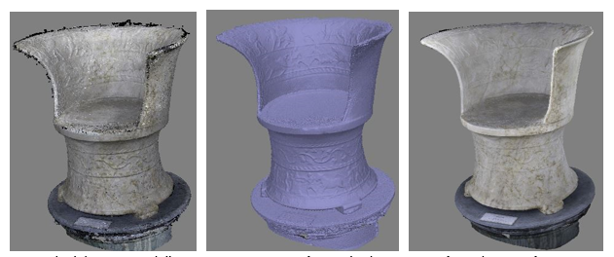

Fig. 2. Processing of 2d images for 3D photogrammetric reconstruction: dense cloud and mesh

Finally, the texture of the 3D model was reconstructed, and the model was also manually scaled according to real measures, giving a correct structure in terms of geometry (Fig.3).

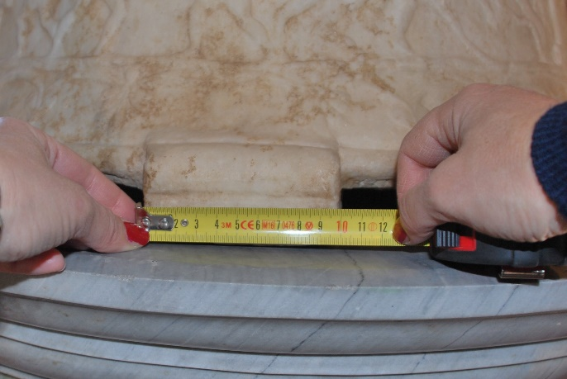

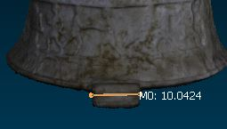

Fig. 3. Real measures and scaled model according to real measures (scale1:1)

The result is a photorealistic and metrically correct 3D model (Fig.4).

Speed and ease of processing allow to use photogrammetry as a valid tool to monitor the conservation status of the artwork: indeed, by the comparison between 3D models generated in different moments it is possible to monitor any structural changes [8].

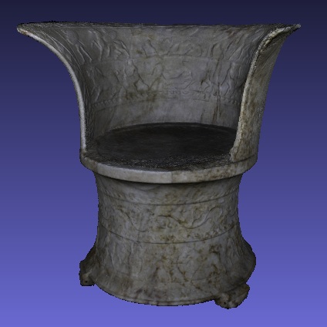

Fig. 4. 3D model of the Corsini Throne with texture

1. STRUCTURED LIGHT SCANNER

In addition to the photogrammetric scanning, the *Corsini Throne* has been subjected to relief through structured light.

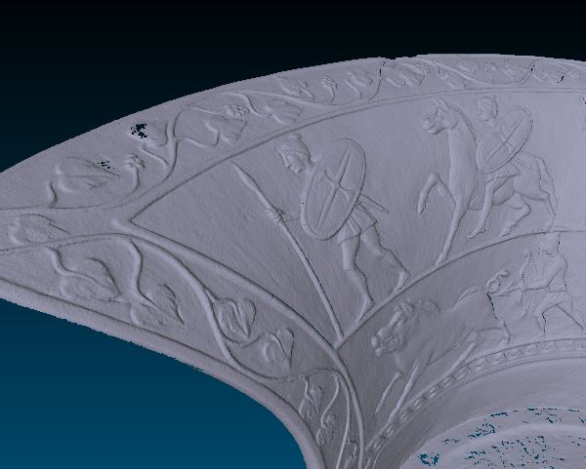

Fig. 5. Detail of high-resolution 3D model

This non-invasive technology allows to create high-resolution, 3D data sets.

Structured light system supplied by ENEA is SMARTSCAN by AICON 3D SYSTEM used in combination with OPTOCAT software.

This system uses a high-resolution scan performed by a portable structured light AICON smartSCAN 5M Pixel system (Fig. 7) with an M-300 optic, to automatically map the texture on the final mesh. The instrument technical features are in TABLE I.

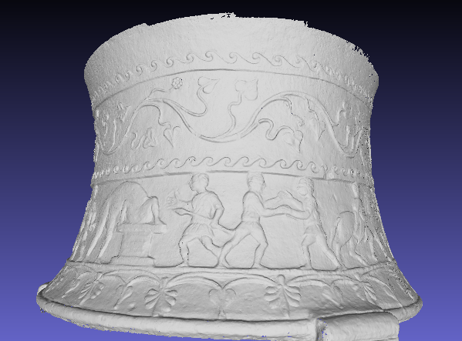

Fig. 6. Detail of high-resolution 3D model of Corsini Throne

The instrument projects a pattern of light and detects the deformation of this pattern on the object.   
The images acquired are processed by OPTOCAT, a software produced by AICON that allows to verify in real time the quality of each scan and to merge consecutive scans.

OPTOCAT uses specific algorithms for automatic alignment of new scan with precedent.  
Whether overlapping scans are not enough, manual alignment trough the identification of homologous markers is required.

Table 1. AICON SmartScan 5M Pixel System

| Accuracy [μm] | ±26 |
| --- | --- |
| Field of view size [mm] | 240x200 |
| Measuring depth [mm] | 150 |
| (x,y) resolution limit [μm] | 100 |
| (z) resolution limit [μm] | 5 |
| (z) noise [μm] | ± 11 |

The pattern deformation induced by the surface of the object is acquired by a camera and exploited to calculate 3d coordinates.  
The process of 3D reconstructions by the structured light involves a sequence of several steps.

After calibrating the device, we proceeded to scan the object and acquire the images.

Due the impossibility of moving and rotating Corsini Throne, the equipment had to be moved around the throne by 360°.

Due the dimension and the paricular shape of the object, it has been necessary to operate with two separate scan phases. The first scan was directed to the seat of the throne, the second to its backrest.

Each 3D scan is aligned with the previous one automatically by Optocat software or, if necessary, by the operator using manually positioned markers.

After aligning these two scans, Optocat started to elaborate the Points Cloud and to build the mesh.

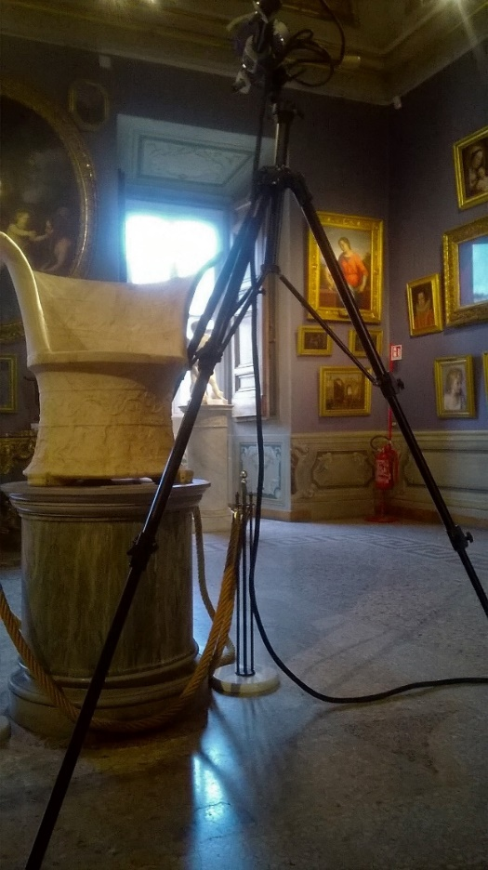

Fig. 7. Structured light scanner instrument.

Then, this software is able to create colorful texture; the mapping of the high-resolution texture can be realised through the internal images of the 3D scanner or with the images acquired by the external cameras.

The 3D models thus obtained were subjected to merge process in order to obtain a single and complete model.

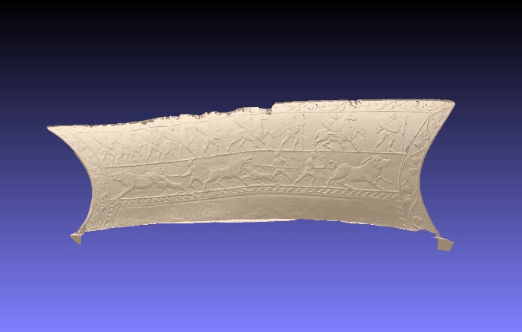

Fig. 8. Unrolling of the backrest on the base of the Corsini Throne

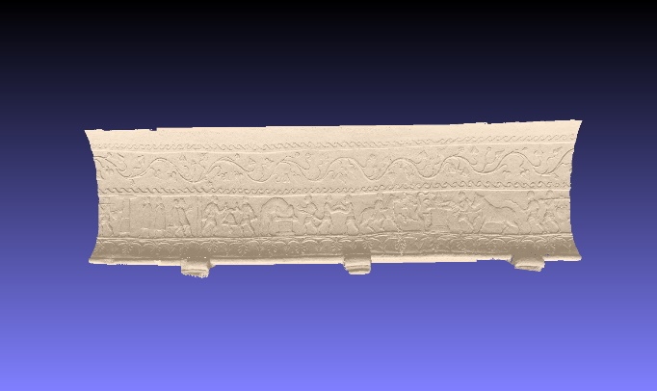

Fig. 9. Unrolling of the base of the Corsini Throne

In the case of the Throne Corsini it was preferred to study the object without texture because it interfered with the analysis of the bas-relief.

The result is a very high-resolution model and with a greater definition of detail than that obtained through photogrammetry (Figg. 5-6). For this reason, the 3D model exported in .ply format is extremely heavy and it is possible to handle it only using  advanced computational resources.

Thus, it has been splitted into two parts: base and back, halving the size. Thanks to this solution it is possible to manage the two .ply files even through a low-performance PC.

1. UNWRAPPING AND INTEGRATION TECHNIQUES

In agreement with the curator of the museum, one of the goal of the survey in structured light was to obtain a 3D model that would make it easier to read the bas-reliefs on the back and base of the Corsini Throne.  
In fact, in addition to its function, the complex iconography on the base still remains to be clarified, a question that still feeds the scientific debate.



Fig. 10. Detail of unwrapping relief Corsini Throne

Facilitating the narrative reading of the bas-reliefs would make it possible to further enrich the documentation of the museum and to study this work in greater depth.  
The relief was "unrolled" in Meshlab using the Deformation Filter and geometrical cylindrical unwrapping (Figg.8-9) [9].

This allows to observe and study the scenes reproduced at the basis of the throne from a horizontal and consecutive perspective.  
The geometry of the model produced through photogrammetry process does not provide a level of detail enough to allow a similar iconographic reading (Fig. 10).

For this reason, it could be useful to generate a single model through the integration of the two techniques.  
In so doing, we would obtain a partially high definition model, particularly detailed around the area most difficult to be studied (base of the Corsini Throne).

At the same time, the file size would be significantly reduced thus allowing to handle it using a pc with lower performance.

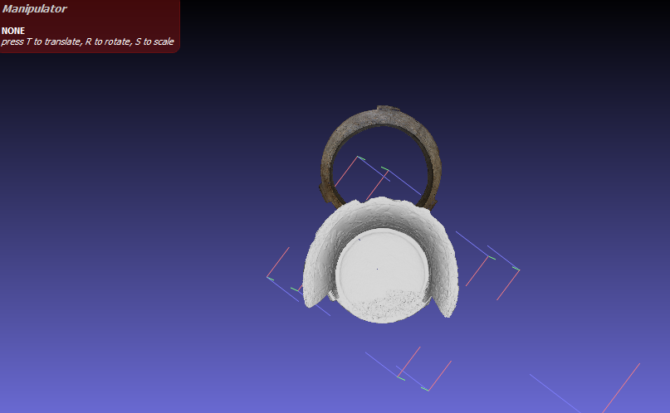

Fig. 11. Orientation of the two models in Meshlab using the Manipulator tool

The models produced by photogrammetry and structured light have been merged within Meshlab [10]. Either the complete 3D photogrammetry model and the model of the only base of the throne, realized in structured light, were opened in the software. The photogrammetric model, of smaller dimensions, was complete in order to provide the amount of surface necessary for the overlap.

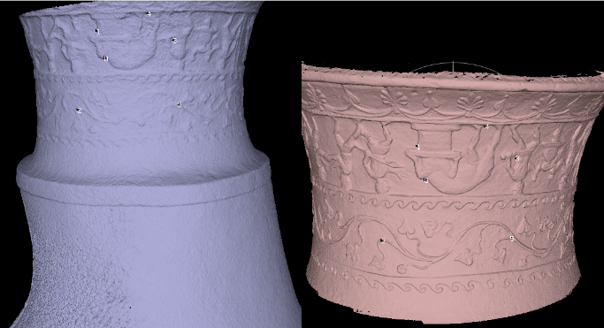

Fig. 12. Identification of homologous points during alignment

Firstly, we proceeded with the orientation of the two models: rotation and translation using the Meshlab manipulator tool (Fig.11).

Then, in the alignment phase, 5 homologous points in common between the two models were identified (Fig.12). This allowed a satisfactory overlap (Fig.13). Subsequently, the surface of the photogrammetric model relative to the base was eliminated because it had become superfluous.

The result is an exportable model, easy to be handled and with reduced size. The high-resolution base allows detailed study of the relief. Combining it, through alignment, with the backrest reproduced in photogrammetry, it is possible to obtain a single model, lighter and more manipulable.

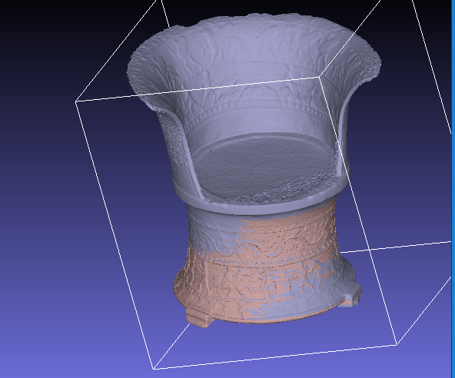

Fig. 13. Result of the merging of the two models after alignment

Moreover, a lighter 3D model would increase the study materials for those who intend to deepen their knowledge of the artefact.

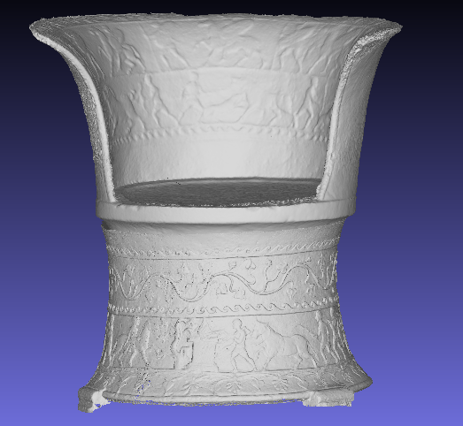

Fig. 14. 3D model obtained from the integration of photogrammetry and structured light

Finally, a model with these characteristics would be very useful, practical and innovative for educational and dissemination purposes. For example, it would be easily accessible on websites, apps or devices allowing 3D exploration even to the general public.

1. CONCLUSIONS

The results obtained with those two different technologies were compared for 3D shape accuracy, texture quality, digitization and processing time and finally price.

The results show that the structured light scanner provided the best results to record geometrical structures.

One of the strengths of photogrammetry is the speed with which informations are acquired and the possibility of using simple 2D photographs (which, however, must be taken in the best way, otherwise the loss of geometric information and the quality of the model). It only requires a software through to start the elaboration process. A high-performance PC speeds up the process but, in the presence of more complex scenes, in Photoscan it is possible to work through autonomous chunks and then proceed to their subsequent merging to obtain a single 3D model.

Photogrammetry is a very good compromise between portability, costs and quality. Photogrammetric models can be successfully used in the divulgation and valorization of artworks. If integrated within an app or website, they provide a different and more complete level of knowledge than traditional 2D images.

Furthermore, the Throne “unrolling” could be useful not only for a better visualization of figures, but for classification also, being an input information for researchers and/or automated segmentation recognition algorithms.

1. REFERENCES

[1] M.Torelli, “La Sedia Corsini, monumento della genealogia etrusca dei Plautii”, in Mélanges Pierre Lévêques, vol.5. Anthropologie et société, Besançon, 1991, pp. 355-367.

[2] M.Mongelli, I.Bellagamba, A.Perozziello, S.Pierattini, S.Migliori, A.Quintiliani, G.Bracco, A.Tatì, P.Calicchia, “Photogrammetric survey to support Non Destructive Tests at St. Alexander Catacombs in Rome”, Proc. of International Conference of Metrology for Archaeology and cultural heritage (MetroArcheo2018), 2018, Italy, ISBN: 978-1-5386-5275-6.

[3] M.Mongelli, G.De Canio, I.Roselli, M.Malena, A.Nacuzi, G.de Felice, 2017, “3D Photogrammetric reconstruction by drone scanning for FE analysis and crack pattern mapping of the Bridge of the Towers”, Proc. of 5th International Conference on Mechanics Of Masonry Structures Strengthened With Composite Materials (MURICO5), 2017, Bologna 28-30 June, Italy, published in Key Engineering Materials, Vol. 747 ISBN: 978-3-0357-1164-6.

[4] I.Roselli, A.Tatì, V.Fioriti, I.Bellagamba, M.Mongelli, M.Barbera, M.Magnani Cianetti, G.De Canio, “Non-destructive tests for structural diagnosis of the so-called Temple of Minerva Medica, Rome”, Proc. of International Conference of Metrology for Archaeology and cultural heritage (MetroArcheo), 2017, Italy.

[5] M.Mongelli, I.Bellagamba, G. Bracco, S. Migliori, A.Perozziello, S.Pierattini, A.Quintiliani, B.Mazzei, “3D photogrammetric reconstruction by “Structure from Motion” as a monitoring technique for safety, conservation and improvement of the fruition of cultural heritage” Proc. of International Conference of Metrology for Archaeology and cultural heritage (MetroArcheo2017), 2017, Italy, ISBN: 978-92-990084-0-9.

[6] F.Ambrosino, G. Bracco, A.Colavincenzo, A.Funel, G.Guarnieri, S.Migliori, G.Ponti, “Storage architecture and backup strategy of ENEAGRID/CRESCO systems. In High Performance Computing on CRESCO infrastructure: research activities and results 2014, ENEA, 2015, pp. 181-186, ISBN: 978-88-8286-325-8.

[7] F.Iannone, I.Bellagamba, G.Bracco, B.Calosso, G. Giovanetti, S. Migliori, M.Mongelli, A. Perozziello, S.Pierattini, A.Quintiliani, F.Ambrosino, D.Di Mattia, A.Funel, G.Guarnieri, G.Ponti, F.Simoni, M.Steffé, 2017, “Staging Storage Sharing System for Data Handling in a Multisite Scientific Organization”. Proceedings, April 1, in Proc. Of Communities: CS3 2017 Surf SARA http://doi.org/10.5281/zenodo.439637.

[8] M.Mongelli, I.Bellagamba, G.Bracco, B.Calosso, S.Migliori, A.Perozziello, S.Pierattini, A.Quintiliani, B.Mazzei, “Structure from Motion (SfM) technique in the Catacombs, of priscilla in Rome”, Kermes, n.107 Application of 3D Technology in cultural heritage, luglio-settembre 2017, pp. 111-116, ISSN 1123-3197.

[9] B.Rieck, H.Mara, S.Kromker, “Unwrapping Highly-Detailed 3D Meshes of Rotationally Symmetric Man-Made Objects” in ISPRS-International Society for Photogrammetry and Remote Sensing, 2013, pp. 259 - 264.

[10]S.Pierattini, M.Mongelli, I.Bellagamba, B.Calosso, L.De Martino, A.Perozziello, D.Visparelli, G.Bracco, A.Quintiliani, S.Migliori, M.Milella, L.Ungaro, “Hypothesis of virtual reconstruction for the Sphinxes Frieze at the Trajan’s Forum in Rome”, Proc. of MetroArcheo 2018, IEEE Catalogue Number: CFP18O73-USB, ISBN: 978-1-5386-5275-6.