Study Upon Specific Absorption Rate: Far Field Source Outside and Subject Inside the Building
Ovidiu Bejenaru¹, Catalin Lazarescu¹, Marius Valerian Paulet¹, Alexandru Salceanu ¹
¹“Gheorghe Asachi” Technical University of Iasi, Romania, ovidiu.bejenaru@ancom.org.ro, lazarescu77@googlemail.com

Abstract – It is well known that the biological and health effects of electromagnetic fields (EMF) are an up to date theme and the associated impact should be taken into consideration. Aiming to estimate these biological effects, an essential item is the accurate estimation of the human exposure to different types of non-ionizing electromagnetic sources. The evaluation of human exposure is performed by determining the currents distributions inside the biological organs or tissues, modeling the different acting mechanisms and understanding the effects developed in living beings by various exposure scenarios. Radiofrequency field absorption in homogenous and heterogeneous biological tissues is computed by using analytical and/or numerical methods. In this paper we have determined by simulations with CST Suite Studio software, the values of specific absorption rate mediates on 10 grams of tissue , SAR Max (10 g), in case of a human body exposure to electromagnetic field generated by a far field source. Here proposed scenario involves the human body located inside the building, in empty room. We have used our previously developed human body 3D model having ellipsoidal cylinder geometry. The determined SAR values have been also compared with those recommended by the International Commission on Non-Ionizing Radiation Protection (ICNIRP) and IEEE Standards for Safety Levels (2005).

Keywords – EMF, Numerical Methods, SAR, Human Exposure, 3D Human Model, CST simulation
- INTRODUCTIOn
Aiming to protect the humans against different electromagnetic field sources, various countries around the world have already proposed and recommended various safety standards and regulations. The actual standards for human exposure characterize, according to selected frequency domain, total different methods and measures for defining the so called basic restrictions: internal induced current density or electric field (up to 100 kHz) respectively localized SAR (from 100 kHz up to 10 GHz) and power density (from 10 GHz to 300 GHz, imposing safety limits.
In a real scenario of exposure from a far field source, the human body could be directly exposed to the electromagnetic (plain) waves generated by emitting antenna, complemented by the waves produced by reflection or scattering from objects presented in the area. Different international protection organizations proposed recommendations for such ”safe” exposure, [1], [2], [3]. As regarding radio-frequency spectrum and even above, an important limit for the incident power density is 1.0 mW/cm2, [3]. This value should guarantee that in any part of the exposed body the basic restriction on the local specific absorption rate SAR (2W/kg averaged over any 10 g of tissue) is never exceeded, [1], [3].
Since the past up today, the computer calculating speed and calculation techniques have been improved significantly and SAR determinations for different types of exposure using numerical methods could be even done for realistic models of the human bodies.
The human body can be 3D modeled, with a geometry more or less detailed, depending on the number of voxels and the electrical characteristics of organs and tissues. It is known that the first basic models of the human body for numerical simulation of the power absorption are the block [4] for frequencies below 600 MHz, the prolate spheroid [5] for frequencies above 10 GHz and the two dimensional multilayered cylinder [6] for frequencies between these. There are significant differences between simplified 3D models with simple geometries and quasi-complete (realistic) voxel models of the human body developed over many years by very powerful software companies, a well-known example being the Hugo model [7]. Also the 3D models of the human body must allow scaling, according to the very wide palette of human physical dimensions [8]. Therefore, the number of voxels needed for a specific accuracy can be extremely high, and “slice by slice” processing of various images could mean a considerable amount of time and resources. A solution might be in such cases the usage of simplified 3D models.
Different 3D electromagnetic simulation software programs offer very accurate and efficient computational solutions for electromagnetic design and analysis. Electromagnetic simulation software allows engineers to investigate the electromagnetic properties of components or whole systems efficiently, computing the field distribution in specific points on smaller or larger volumes, [9], [10], [11].
For a real human being, the values of SAR will vary from those calculated using numerical methods for different simple geometries (spherical, cylindrical and elliptical) of the human bodies. Obviously, for accurately calculating the average SAR at high frequencies, using much more realistic model of the human body is strongly required.
Nevertheless, aiming to start the study of any type of human exposure to non-radiating electromagnetic fields, a simplified intermediary model could be accepted, offering positive outcomes that might be considered in further approaches and developments.
Using numerical simulations provided by CST SUITE STUDIO software, we have determined the specific absorption rate (SAR) on the surface of the proposed 3D human body model in case of exposure to a far field source, when the subject is located inside an empty room, located on the ground floor, the building having concrete walls.
The simplified proposed 3D model used in this study is considered to be a nude model without clothing. It is known from the past studies, that the average SAR is influenced if the subject worn thick clothing. Some researchers have previously investigated this effect, [5], using the multilayered cylindrical model, which differs from the realistic shape of the human body. We have to mention some unsuitable results when the clothing produced loss. On that directions, further investigations have presented accurate procedure for obtaining the power absorption of the multilayered cylindrical model of a man wearing clothing considering the introduced loss, [12].
- Material and Methods
Aiming to quantify the electromagnetic energy absorbed by the human body from different types of electromagnetic sources, the specific absorption rate (SAR) is generally used. Different numerical methods are used for SAR computations but the most intensively used numerical methods applied are FDTD and FIT, [13], [14]. This numerical methods consider the volume of study (the actual human model and the neighboring space) as being composed of a scattered field region and a total field region, each of which consisting of a very large number of cells identified by the indexes $\left(i,j,k\right)$, the field components being defined at fixed locations. Maxwell’s equations in time domain are then discretized by using the finite-difference approximations for time and space derivatives.
The time-stepping system resulting from the discretization of the Maxwell’s equations is solved by imposing the excitation field as a function of time at the proper cells, the initial and boundary conditions. For initial conditions all the components of the electromagnetic field are equal to zero at the original time step.
In this paper, the incident electric field has been supposed to have the characteristics of a plane wave with a time-harmonic behavior. In the presence of a time-harmonic behavior for the excitation field, the local SAR at each cell is given by the equation (1):

$$SAR\left(i,j,k\right)=σ\left(i,j,k\right)\left[E_{x}^{2}\left(i,j,k\right)+E_{y}^{2}\left(i,j,k\right)+E_{z}^{2}\left(i,j,k\right)\right]/ρ\left(i,j,k\right)$$ | (1)

where $σ\left(i,j,k\right)$ and $ρ\left(i,j,k\right)$ are the space dependent conductivity and density of the considered tissue to any $\left(i,j,k\right)$ cell. In equation (1) the peak of the electric field components is considered.
The skin tissue of the human body (mainly due to “skin” effect, but also due to its conductive properties) plays the role of “electromagnetic shield” in protecting the interior organs against microwave exposure. – An argument for the fact that the human body model here proposed is covered with “skin material” from the CST library, with specific electrical properties for different frequencies, influencing the SAR value.
The way SAR varies depending on the electrical properties of the skin at different frequencies can be analyzed using numerical methods; the skin properties (as tissue) could be estimated at analytical level using the Debye equation.
We have also considered the relative complex permittivity $\dot{ε_{r}}$ of the skin (according to Debye dispersion characteristics) with two relaxation time constant $τ_{1}$and $τ_{2}$, like in [15]. Dispersion equation is the following:

$$\dot{ε_{r}}=ε_{r}-j\frac{σ}{ωε_{0}}=ε_{∞}+\frac{ε_{S1}-ε_{∞}}{1+jωτ_{1}}+\frac{ε_{S2}-ε_{∞}}{1+jωτ_{2}}$$ | (2)

where $ε_{r}$ is the relative permittivity and $σ$ is the conductiviy. Here $ε_{∞}$ is the relative permittivity at the highest frequency and $ε_{S1}+ε_{S2}-ε_{∞}$ is the relative permittivity for DC. If these parameters can be estimated by matching the measured data for several specific frequencies, the electrical properties of skin tissue for any frequency could be obtained.
In our study, we have determined the values of specific absorption rate, SAR, for 10 g of specific tissue (spatially averaged utmost value) by using a quasi-simplified homogeneous 3D human model and a 900 MHz far-field source (a representative frequency for GSM mobile communications). The computation background has been provided by Microwave Studio Module, CST SUITE Studio software. This source is considered to be a vertical polarized uniform plane wave with an incident electric field Ez the value being 41.25 V/m, parallel with Oz axis, as presented in Fig. 1. The plane wave of E-polarization irradiates parallel to the model from the minus direction of the y axis. For our research study, we have considered the value for the incident electric field as being the maximum value in accordance with ICNIRP limit for exposure of general public and we have determined the SAR Max (10 g) values distribution on the surface of the 3D model of the human body for this incident electric field.

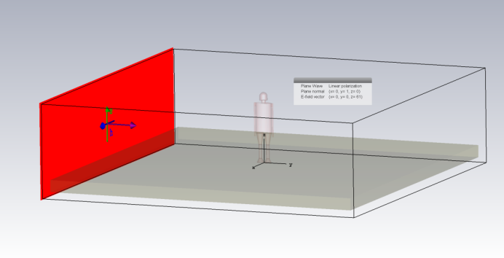
Fig.1 – Direction of the incident plane wave toward the model
For the design of the 3D human body model we have used the CAD interface, from the „Modeling” section, CST software. The developed 3D model has been “built” from circular rotational bodies, excepting the trunk part that has been chosen as being elliptic cylinder, Fig. 2. This design of the body shape is much closer to reality than the variant with circular cross section used in other studies, allowing different evaluations of field distribution and induced currents on the surface of the model. We have done these minor modifications over the shape and dimensions of the human body sections, to provide a more realistic approach. As can be seen in Fig. 2, the height of our model is 175 cm, an average height for a male person in standing position.

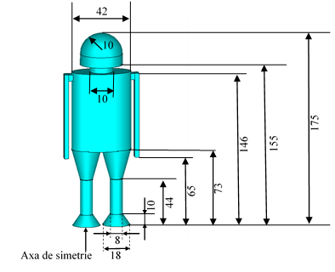
Fig. 2 – Proposed 3D model of human body.
The proposed 3D model of the human body designed and used in this study is an updated version of a simplified 3D model used previous in other studies by authors and others [16], [17], [18].
The origin of Oxyz coordinate axes system has been chosen as it is presented in Fig. 3.
In accordance with our research interests-to determine the SAR Max (10 g) distribution on the surface layer of our 3D model, we used the specific electrical and thermal characteristics of human skin at 900 MHz, as they are provided by CST software -materials library.
Different exposure scenarios have been considered. The SAR values obtained by simulations have been determined in the following situations: when the human body is directly positioned on the ground without having insulated shoes on his feet – namely generic Case A (Fig. 4.a), in the situation of a concrete floor – Case B (Fig. 4.b) and in the cases when the human body is placed inside of a closed concrete room, or inside of a concrete room without or with a window glass on a wall – Case C (Fig. 4.c), Case D (Fig. 4.d), Case E (Fig. 4.e).

Fig. 3 – The origin of Oxyz coordinate axis system
In all studied cases presented above the 3D model of the human body is placed in the middle of the room, his position remaining fixed in all cases.

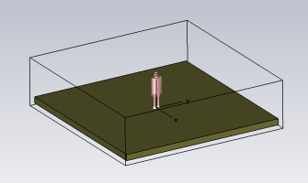 |  | 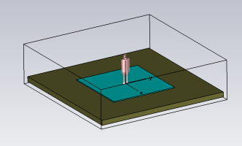
Case A |  | Case B
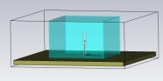 | 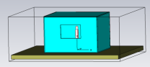 |  | 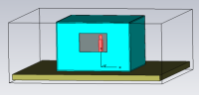
Case C | Case D |  | Case E
Fig. 4 – Different scenarios for the human body model prepared for simulation for determination of SAR Max (10 g) distribution values on the surface of the model
The ground (soil) has also been shaped in the CAD section of CST Studio Suite software. Its rectangular shape has been designed like a parallelepiped with dimensions 800 x 800 x 30 cm according to Ox, Oy, Oz directions. The soil material was considered to be Loamy type (dry), being also loaded from CST library materials. The room walls, the floor and the ceiling have been consider as being done from minimum one year old concrete; this material could be found in CST library. The room has been considered a parallelepiped with dimensions 200 x 200 x 5 cm, Ox, Oy and respectively Oz direction.
The window glass was set to be as lead glass, material for the window glass having been also selected from the CST library material. This material was set for his refractive properties, [19].
In Simulation menu for Background properties, material type has been set as normal and the space is air-filled with well-known properties. For surrounding space frame, we set for the Lower X, Upper X, Lower Y, Upper Y, Lower Z, Upper Z distances the value 15 (in centimeters), applied in all direction. These distances extend the virtual surrounding box of our model. By default, the CST software considers the length for the space surrounding the structure in each direction as being $λ/8$ cm. Other researchers take this space as a quarter of wavelength on each direction around the structure. We extend the space around the structure in each direction with a length equal approximately with $λ/2$, 15 cm.
Boundary has been set “open” with extra space in all directions. The Frequency range has been set according to the frequency used in simulation process. It is important to know that these settings have some influence on the calculation results; that is why we have to choose Fmin and Fmax properly. Increasing the range of this frequency domain can lead to a higher number of meshcells too, so the time for the simulation will be increased accordingly. For a good accuracy in our study we set the interval [0-1.5] GHz for the frequency range in Simulation menu.
Before starting the simulation process for determination of SAR Max (10 g) values, time domain solver has been selected. To avoid the situation when the steady state energy criterion has not been satisfied, we have extended the maximum number of pulses from 20 to 50. In that case, the solver will work correctly for our study and the results will be displayed with acceptable errors. Mesh type is considered to be hexaedral. Source type is selected as a Plane Wave. For better results, the accuracy has been set from -30 dB to -50 dB. We can control the Mesh density for our structure by increasing the number of lines per wavelength. Increasing the numbers of lines per wavelength the number of meshcells will increase accordingly and hardware limitation might be reached.
The simulations will be carried out with the default value 10 lines per wavelength and lower mesh limit will be set by default to 7. These settings offer a good compromise for starting with. Considering the fact that a complete convergence study (number of lines per wavelength has been increased from 10 to 40 for a fine mesh structure) has been previously performed by authors in a recent publication, [20], in the present study we will take in consideration the drawn conclusions regarding the accuracy of the final values of SAR Max (10 g) obtained by simulations.
With all the above settings previously done, the simulation process could start, the SAR values could be determined with good accuracy for each scenario proposed in this paper.
- RESULTS AND DISCUSSIONS
The simulation process for the determination of SAR Max (10 g) values distribution on the surface of the 3D model of the human body was done for different scenarios described above from Case A to Case E with all settings for CST software mentioned in previous chapter.
The distribution of SAR MAX (10 g) values on the surface of the human body model when the 3D model is in one of the exposure situations named Case A, B, C, D, E, for a number of 10 lines per wavelength set for the mesh grid is presented in Fig. 5.

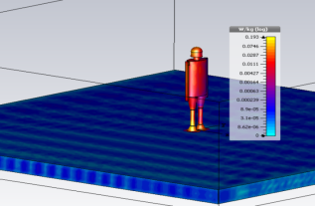 |  | 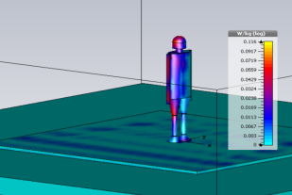
Case A |  | Case B
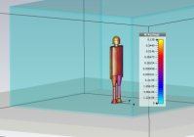 | 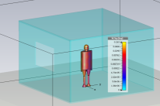 |  | 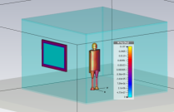
Case C | Case D |  | Case E
Fig. 5 – SAR Max (10 g) distribution on the surface of 3D model of the human body due to an external electric field Ezinc = 41,25 V/m for a frequency f=900 MHz.

How the SAR MAX (10 g) values varies on the different areas of the 3D model of human body surface in different cases of exposure, Case A, B, C, D, E for a number of 10 lines per wavelength set for the mesh grid is presented in Table 1 for head, trunk and limbs regions. We search the maximum values for specific absorption rate mediated on 10 grams of tissue (skin tissue) on the surface of the model on the areas mentioned above with Field at Cursor tool option from CST software interface.

Table 1 – SAR Max (10 g) values on different areas on the surface of the 3D model of the human body for a number of 10 lines per wavelength set for the mesh grid due to an external electric field Ezinc = 41,25 V/m for a frequency f=900 MHz.

Location | SAR Max (10 g) [W/kg]
Location | Case A | Case B | Case C | Case D | Case E
Head | 8.31e-02 | 7.01e-02 | 4.33e-02 | 6.04e-02 | 5.17e-02
Trunk | 2.17e-02 | 2.45e-02 | 1.07e-02 | 1.87e-02 | 1.33e-02
Limbs | 1.71e-01 | 6.45e-02 | 4.80e-02 | 5.59e-02 | 4.73e-02

Also, a good accuracy over the final values of SAR Max (10 g) can be obtain by doing also a convergence study, by increasing the number of lines per wavelength in the mesh section of CST software for a fine mesh grid. Taking in consideration the precedent research made by authors on this convergence study, [20] we can conclude that a variation between the values obtained for a number of 10 lines per wavelength for the mesh grid and 30 lines will exist and the SAR Max (10 g) values can suffer modifications (25- 50%) in different zones of the surface of the investigated human body model.

- conclusions

In the experimental research here presented, we have calculated by simulations the specific absorption rate values, averaged on 10 g of tissue on different areas from the surface of a 3D model of the human body developed by authors. The human body model was exposed to a far-field electromagnetic source with an external electric field Ezinc = 41.25 V/m along Oz axis; the frequency f=900 MHz was chosen as being a specific one from RF mobile communication band. The value for the incident electric field has been chosen as being the maximum value in accordance with ICNIRP limit general public exposure. The study can have relevance in different kind of exposure scenarios.
Using for the human body a 3D elliptical cylindrical geometry, electromagnetic simulations were developed in CST Suite Studio (Microwave module) software, for different scenarios of exposure, case A, B, C, D and E respectively.
While evaluating SAR after simulation process was done, we have noticed the influence of the different body parts over the distribution of SAR MAX (10 g) values on the surface of the human body model.
We have concluded that the here achieved SAR Max (10 g) values obtained by simulation using CST software for this type of far field exposure are considerable lower than the established ICNIRP values (head, trunk and limbs localized SAR) being in decent agreement with IEEE and EU standards.
References
- International Commission on Non-Ionizing Radiation Protection, “Guidelines for Limiting Exposure to Time-Varying Electric, Magnetic, and Electromagnetic Fields (up to 300 GHz)”, Health Physics, vol. 74, 494-521, 1998.
- IEEE, IEEE Standard for Safety Levels with Respect to Human Exposure to Radio Frequency Electromagnetic Fields, 3 kHz to 300 GHz, C95.i2005. New York: Institute of Electrical and Electronics Engineers, 2005.
- European Commettee for Electrotechnical Standardization (CENELEC) Prestandards ENV 50166-2, Human exposure to electromagnetic fields. High frequency (10 kHz to 300 GHz) (January 1995).
- Hagmann, M. J., Ghandi, O. P., et al., Numerical calculations of electromagnetic energy deposition for a realistic model of man. IEEE Trans. Microwave Theory Tech. MTT-27(9): 804-809, 1979.
- Rawlandson, G. I., and Barbeer, P. W., Absorption of higher-frequency RF energy by biological models: Calculations based on geometrical optics, Radio Science 14(6S): 43-50, 1979.
- Massoudi, H., Dourney, C. H., et al., Electromagnetic absorption in multilayered cylindrical models of man, IEEE Trans. Microwave Theory Tech. MTT-27(10): 825-830, 1979.
- M. J. Ackerman, “The visible human project” Proceedings of the IEEE, 86(3), pp. 504–511, 1998.
- M. Caon, “Voxel-based computational models of real human anatomy: a review” Radiat Environ Biophys, 2004.
- ANSYS, https://www.ansys.com
- COMSOL MULTIPHYSICS, https://www.comsol.com/
- CST STUDIO SUITE, https://www.cst.com/
- S. Kuwano and K. Kokubun, Further Study of Microwave Power Absorption in a Multilayered Cylindrical Model of Man, The Journal of microwave power and electromagnetic energy: a publication of the International Microwave Power Institute 32(1):45-9, DOI: 10.1080/08327823.1997.11688322, February 1997
- A. Taflove, Advances in Computational Electrodynamics: The Finite-Difference Time-Domain Method, Norwood, MA: Artech House, 1998.
- Clemens M. and Weiland T., Discrete electromagnetism with the finite integration technique, Progress in Electromagnetism Research, PIER 32, pp. 65-87, 2001.
- C. M. Fuse, J. Y. Chen, et al., The use of the frequency-dependent finite-difference time-domain method for induced curent and SAR calculations for a heterogenous model of human body, IEEE Trans., Vol. AP-14, No. 3, pp. 302-307, 1996.
- Bejenaru O., Lazarescu C., et al., Specific Absorption Rate Evaluation in Case of Exposure of the Human Body to Radiofrequency Electromagnetic Field Generated by Mobile Communications, 2018 International Conference and Exposition on Electrical And Power Engineering (EPE), 2018.
- Laissaoui A., Nekhoul B., et al. On the Rotationally-Cylindrical Model of the Human Body Exposed to ELF Electric Field, Progress In Electromagnetics Research M, Vol. 29, 165-179, 2013.
- Mezoued, S., Nekhoul, B., et al., „Human Exposure to transient electromagnetic field using simplified body models”, Engineering Analysis with Boundary Elements 34, 23-29, 2010
- https://en.wikipedia.org/wiki/Lead_glass
- Bejenaru, O., Lazarescu, C., et al., On the convergence of Specific Absorption Rate Values for Human Exposure to Electromagnetic Fields Produced by Mobile Communcations Systems, ATEE 2019, MARCH 28-30, Bucharest, Romania, 2019.

