Study Upon the Influence of Human Body Torso Stance on the Inductive Coupling
Marius Valerian Paulet¹, Alexandru Salceanu¹, Catalin Lazarescu¹, Ovidiu Bejenaru¹
¹“Gheorghe Asachi” Technical University of Iasi, Romania, mpaulet@tuiasi.ro, asalcean@tuiasi.ro

Abstract –The paper presents a study on the relevance of the relative position of the human trunk to the plane of the supporting pylons of various Overhead High Voltage Power Lines (OhHVPL), from the perspective of currents induced by the generated magnetic field. A homogenous model of the human body that considers the trunk as a cylindrical ellipsoid has been developed in CST Studio software. After necessary theoretical brevity, the results obtained by simulation for the loop currents along the perimeter associated with the large axis of the transversal section of the trunk and that associated with the small axis are presented and commented. The simulations have been performed for 5 relative positions (0º, 30º, 45º, 60º, 90º) of the human trunk with respect to the plane of the network supporting pylons and for three different types of symmetric, double three-phase networks (110 kV and 640 A, 220 kV and 900 A, 400 kV and 1500 A). The obtained results make it possible to formulate recommendations on the reduction of exposure to magnetic fields. Also, more refined approaches might be further prepared to take into account cumulative aspects of short-term human exposure to Extreme Low Frequency (ELF) electrical and magnetic fields.

Keywords – Magnetic Fields, High Voltage Power Lines, Induced currents, CST simulation
- JUSTIFIED CONCERN about ELECTRICAL AND MAGNETIC FIELDS Generated by OHHVPL
The use of electricity, besides the advantages without which it is impossible to imagine human life in the civilized world of the third millennium, raises a number of concerns about possible harmful effects on human health. Most of these concerns are related to the influence that electric, magnetic or electromagnetic fields can have on living matter. From this category, high-voltage aerial power lines play an important role. Here we encounter both voltages of hundred kV (meaning significant electric fields) and currents above 1000 A, generating magnetic fields that should be taken into account.
In Romania, the National Electricity Transmission Network, operated by the National Company "Transelectrica", measures approximately 9000 km of overhead power lines (the overwhelming majority being 400 kV and 220 kV lines) and 81 power stations (respecting approximately the same parity, 38 of 400 kV, 42 of 220 kV and only one of 750 kV). In addition, thousands of kilometers of 110 kV Overhead Power Lines (managed by various distribution companies) should be also considered. Of course, 110 kV represents the theoretical, conventional ”boundary” between medium and high-voltage, but due to the lower height of the supporting pylons and the greater proximity to the inhabited areas, the 110 kV lines must be included, from the point of view of possible harmful effects on health in the same category as the 220 kV, 400 kV or even 750 kV lines.
Values considered non-dangerous, therefore acceptable, for currents induced in the human body by electric fields having frequencies lower than 100 kHz (by capacitive coupling) or by magnetic fields having the same frequency spectrum (by inductive coupling) are known in the literature under the generic name of basic restrictions. These values have mainly been established on the instant, short-term health effects like nerves and muscles excitation.
The human body is electrically non-homogeneous and therefore the values of basic restrictions are expressed in the form of the current density obtained by mediating on a 1 cm² cross-section perpendicular to the flow of current.
A complicated and debatable issue is setting the correspondence between the electric and magnetic fields existing in the surrounding environment (the so-called reference levels) and the currents actually induced in the human body.
Numerous anatomically based human models (often expended on Magnetic Resonance Imaging) have been developed with millimeter resolutions. Using these models together with numerical methods of solving (partial) differential equations (the finite element method or finite difference method), the currents induced in the human body model by the electric and magnetic fields in the immediate vicinity of the human subject can be calculated.
Then we have to compare the value of the current density induced in various organs with the typical value accepted by the standards, [1]: 10 mA/m².
Since coupling mechanisms are fundamentally different, the vast majority of simulation-modeling programs have different modules for low and high frequencies respectively. Moreover, at low frequency there are two different solvers: one (quasi)electrostatic, recommended when the dominant field is the electric one and the other, (quasi)magnetostatic, suitable for the dominant magnetic field occurrence.
Here we have to specify the criterion that determines the nature of the dominant field, since due to different units of measure, V/m and A/m, it is not possible be compared as such. What could be compared are the associated volumetric energy densities, expressed in J/m³:
$W_{B}=\frac{B∙H}{2}=\frac{1}{2}μ_{0}H^{2} and W_{E}=\frac{D∙E}{2}=\frac{1}{2}ε_{0}E^{2}$ (1)
In the case of high voltage power lines, the problem of the nature of the dominant field is of particular importance. We have both very high voltages and very high currents. In the case of the equivalence of the spatial energy densities of the two fields, we obtain the well-known value of the corresponding wave impedance [2] for the value of the ratio between the electric field strength and the magnetic field strength (in free space):
$\frac{1}{2}μ_{0}H^{2}= \frac{1}{2}ε_{0}E^{2}⇒\frac{E\left[V/m\right]}{H\left[A/m\right]}⇒\sqrt{\frac{μ_{0}}{ε_{0}}}=\sqrt{\frac{4π∙{10}^{-7}}{\frac{1000}{36π}{10}^{-12}}}=120π Ω ≃377 Ω$ (2)
If at the point of interest, the E/H ratio is greater than 377 Ω, the dominant field is the electric one, but if this ratio is less than 377 Ω, the dominant field becomes the magnetic one. The electric field strength is proportional with the scalar electrical potential and is higher if electric charges are nearer to the measuring point.
Some approximations, which are very close to reality, should be made, especially for 50/60 Hz frequencies (so-called mains frequency), which fall under the extremely low frequency category.
The most important for the (quasi)electrostatic approach is neglecting the variation with respect to the time of the electric flux density in the Ampere law (written in harmonic mode).
In this way, the influence of the electric field on the current density of conductors in general, especially in the human body can be properly modeled.
$\vec{∇}X\vec{H}=\vec{J}+\frac{∂\vec{D}}{∂t}= σ\vec{E}+ε\frac{∂\vec{E}}{∂t}= σ\vec{E}+jωε\vec{E}= \left(σ+jωε\right)\vec{E}$  
At the mains (industrial) frequency, the displacement current in the human body has a much smaller influence than the conduction current.
For the human body at the 50 Hz frequency, the conductivity σ is about 0.2 S / m and the relative permittivity ε_{r} is approximately 10⁷.
An approximate calculation of the product ωε gives the value:
$ωε=2πfε_{0}ε_{r}=2π∙50∙\frac{1000}{36π}∙{10}^{-12}∙{10}^{7}=\frac{1}{36}≃0.027$ (4)
This value represents about 14% of the predicted value of electrical conductivity, which justifies the lower weight of displacement currents. The main weight in the complex conductivity formula belongs to the conduction component rather than to the displacement one. This finding is also valid at frequencies above 50 Hz, the product ωε does not increase in proportion to the frequency as the permittivity decreases as the frequency increases.
Essentially, the external electric field produces two effects in the human body:
• Establishes a conduction current of the existing charges whose amplitude is determined by the electrical conductivity σ
• Establishes a displacement current, both by forming new charges (bound charges) and by orientating existing dipoles. Permittivity is an expression of the magnitude of polarization processes in dielectric bodies.
It should be noted that in the case of human body, both electric conductivity and permittivity vary in a very wide range, depending both on the nature of the tissue and the frequency of the external field applied.
Additionally, an external field due to Coulomb forces will induce a movement of the charges at the surface of the body. This alternate polarization of superficial charges will cause induced currents, the distribution of which will be determined by both the geometric dimensions of the body and its position relative to the field.
If the magnetic field is dominant (directly proportional to the current), magnetostatic solver is used.
The most important approximation for the (quasi)magnetostatic approach is the neglect of the magnetic flux density variation in the Faraday-Lenz law, the induced voltage being practically zero:
$\vec{∇}X\vec{E}=-\frac{∂\vec{B}}{∂t}≃0$  
The interaction between the external variable magnetic field and human body means the induction of voltages that cause current loops. As the surface intersected by variable magnetic flux is higher, both the induced voltage and consequently, circulating currents have higher values. An indicative formula (deduced from Faraday-Lenz's law) shows that the circular current density (2πR being the length of the path) is directly proportional not only to the radius of the intersected surface but also to the conductivity of the tissue and with the amplitude and frequency of the magnetic flux density.
$J=πRfBσ$ 
Due to the extensive resources of current computing systems, most actual simulation-modeling programs of the electromagnetic fields also have a module that takes into account, even at 50 Hz frequencies, both variations of magnetic flux density and electrical flux density. It should be noted that this option uses computer resources more intensively and is time consuming. In the specific case of the CST EM Studio ® software [3], used in the examples presented in this paper, this solver is called "Fullwave", the name suggesting that both components of an electromagnetic wave are taken into account.
- DIFFERENT RESEARCH TEAMS, COUNTRIES AND APPROACHES BUT CONVERGING CONCLUSIONS
The issue of the electric and magnetic fields generated by OhHVPL concerns the most diverse teams of researchers, spread across countries, with different approaches, but finally convergent conclusions. In the frequency range 50-60 Hz, the biological effects of the electric fields [4] must be treated differently from those of the magnetic fields [5]. A challenging matter is to study the cumulative effects of currents induced by both fields, [6], [7], [8]. Fortunately, the currents induced by the electric field are vertical and those induced by the magnetic field are in the loop. In addition there is a phase shift between them, so that their maximum values could not arithmetically summed up. Complementary, the studies undertaken should be differentiated on the two fundamentally different categories: occupational, when for a limited time, a healthy, trained and protected worker can be found due to some service tasks near the high voltage lines [9], [10] respectively residential, when any person, irrespective of age and health, is located in the vicinity of these lines, which might be placed within the newly-developed residential neighborhoods [11]. Even if 110 kV can be considered as medium voltage [12], the generated fields at soil level are comparable with those emitted by higher voltage networks. One of the problems that called for the attention of researchers is the influence of soil, floor or footwear on the subject (due to different conductivity and permittivity values) in determining the amplitude of induced currents in the human body [13].
- ELIPSOIDAL CYLINDER MODEL OF THE HUMAN BODY FOR THE STUDY OF INDUCTIVE COUPLING
In paper [14], the same group of authors has developed an axis-symmetric rotation 3D model consisting of a hemisphere, 4 cylinders and 4 trunks of cone. From the perspective of the current density induced by quasi-homogeneous electric fields, along the vertical axis of the body, this model provided values not only in accordance with the analytical calculations, but also with the values published in the reference literature.
In paper [15], we have developed a more refined model, closer to the real geometric shapes of the human body. In order to accomplish this target, the trunk has been designed in the shape of an elliptic cylinder, having radius of 28 and 16 cm, respectively. The hands and legs have also been distinctly shaped. This model has proven useful in determining the current density at the body surface and the loop current induced by the horizontal component of the magnetic field generated by OhHVPL. The fact that the origin of the three coordinate axes should be considered outside the human body (modeled with 2 distinct feet) represents a difficulty in determining the vertical induced current.
In the present paper we aimed to study the influence that the relative position of the human body versus the vertical plane determined by the supporting pillars of the network has to the magnitude of induced currents in the body. A special emphasis should be given to loop currents induced by the horizontal component of the magnetic field generated by OhHVPL. We have developed an intermediate model between the two previously presented models, also using the CST Suite Studio, CAD module in the "Modeling" section. More specifically, we kept the trunk as an elliptic cylinder, but, since the vertical axis of human symmetry should coincide with the vertical axis of the coordinate system, the two legs were modeled together in the form of a truncated cone, also elliptic.
- Achieved results and their relevance
We considered 5 representative positions of the human model, namely the angles of the major axis of the elliptic cross section of the trunk and the plane determined by the pillars of the network being of 0º, 30º, 45º, 60º and 90º respectively. Initially, we considered a double 110 kV three-phase network, with a single grounding conductor supported by SN 110252 pylons and maximum effective current of 640 A. We simulated for all 5 relative positions the distribution of current density to the body surface, Fig.1.
Fig.1. Example of the current density on the surface of the model, 45º relative orientation
We have found, as in principle expected, that the relative positions of the human body have an insignificant influence on the surface current density distribution, incidental electric field variations being virtually negligible.
We also simulated the electric current induced along the vertical axis of the human body, Fig.2.

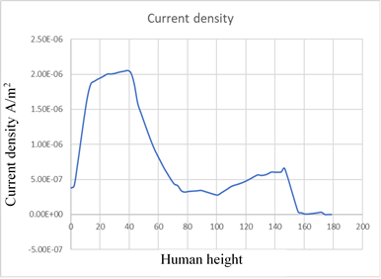
Fig. 2. Induced current density along vertical axis
The simulated values, considering that we used the magnetostatic solver, are about 4 orders of magnitude smaller than the basic restrictions, which makes the small variations due to the relative position practically irrelevant.
It is quite different in the case of loop currents induced in the trunk. We have simulated the loop currents induced along the perimeter corresponding to the large axis of the trunk. Current density values were maximum when the surface intersected by the horizontal component of the magnetic field was the greatest; the angle between the long axis of the trunk and the plane of the pylons is zero.
The minimum value of the current density induced on the same maximum contour is recorded when the long axis of the trunk is perpendicular to the plane of the pillars. Between these two extremes are the intermediate values associated with the angles of 30º, 45º, 60º.
Things should be seen in the symmetric register for the loop currents that close on the contour corresponding to the small axis of the transversal elliptic section of the trunk of the human model. Maximum values are recorded when the small axis is parallel to the plane of the pillars and the minimum when the same axis is perpendicular.
In order to obtain more comparative information on human exposure to magnetic fields generated by OhHVPL, we have resumed the same simulations for two other comparable types of network:
• A 220 kV double three-phase, single grounding conductor, using Pylons type SN 220202, for which we considered the maximum phase current 900 A r.m.s.;
• A 400 kV double three-phase, single grounding conductor, using Pylons type SN 400232, for which we considered the maximum phase current 1500 A r.m.s.
The distribution of the current density in the horizontal plane along the large axis for the maximum coupling is shown in Fig.3.

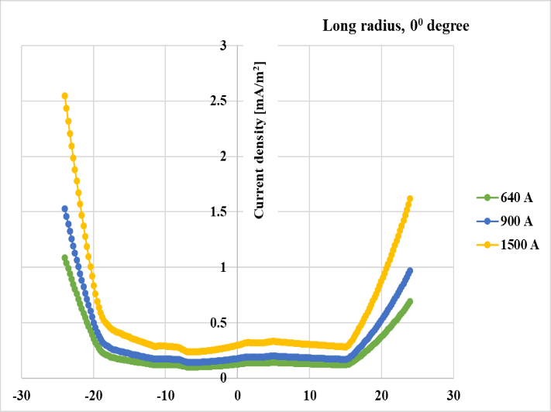
Fig. 3. Maximal coupling, along the perimeter associated with the large radius, the trunk parallel to the plane of the pillars
The distribution of current density in the horizontal plane along the small axis for the minimum coupling is shown in Fig.4.

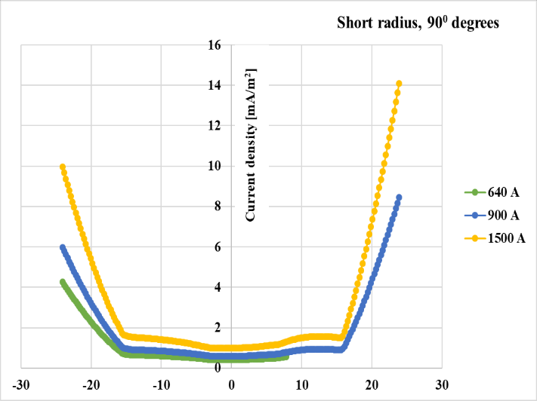
Fig.4. Minimal coupling, along the perimeter associated with the small radius, which is normal on the plane of the pillars.
Two comments are required:
• The induced current densities do not respect the proportionality of the currents for the three types of networks because the effect of a higher current is (partly) reduced by the higher height of the standardized pillars for that network.
• A certain degree of unbalance of the current density distributions in the horizontal plane is due to the presence of hands in the here proposed elliptical model. In the case of the circular model developed in [14] this asymmetry does not appear.
- conclusions and further attempts

The modeling and simulations presented in this paper are consistent with those obtained through the use of other software or communicated in significant journals,
demonstrating the important resources of CST Studio Suite, including the study of ELF electrical and magnetic fields such as 50 Hz. Because the human trunk was modeled as an elliptic cylinder, it was possible to study the distribution of the loop currents induced by the horizontal component of the magnetic field generated by various types of electrical energy transmission networks, both on the peripheral perimeter associated with the large axis of the cross section and on that associated with the small axis. Depending on the relative orientation of the human trunk toward the supporting pillars, the trend of variation of the two currents is in opposition. The result obtained provides a useful recommendation especially for maintenance employees who, working close to high voltage lines, should avoid the position where the large axis of the trunk is parallel to the plane of the supporting pillars. As a further attempt we aim to perform a more refined study, which, based on a successive 10º-degree rotation, verifies by simulation the position for which the inductive coupling is minimal, taking simultaneously into account, the induced currents on both the maximum perimeter and the minimum one.
References
- European Commission, “Directive 2013/35/EU of the European Parliament and of the council of 26 June 2013 on the minimum health and safety requirements regarding the exposure of workers to the risks arising from physical agents (electromagnetic fields),” Official J. Eur. Union, 2013, 1791, pp. 1-21J.
- Furse, C.M. and GandhiO. P, Calculation of Electric Fields and Currents Induced in a Millimeter- Resolution Human Model at 60 Hz Using the FDTD Method, Bioelectromagnetics Volume 19, February 1998, pp. 293-299.
- https://www.cst.com/.
- Liang, Z,Jiang, Y. et al., Induced Current in Human Body by Electric Field of Overhead Lines, Proceedings of 2013 3rd International Conference on Computer Science and Network Technology, pp. 101 – 104, 2013.
- Medve, D, Mišenčík, L. et al.,Measuring of Magnetic Field around Power Lines, The 8th International Scientific Symposium Elektroenergetika, 2015.
- Ahmadi, S, Mohseniand A. A. et al.,Electromagnetic fields near transmission lines – problems and solutions, Iran. J. Environ,Health. Sci. Eng., Iranian Journal of Environmental Health, Science and Engineering, Iranian Association of Environmental Health (IAEH),Vol. 7, No. 2, 2010, pp. 181-188.
- Irimia, D and Bobric, E.C, Determination of Induced Currents in Human Body Sitting under an Overhead Power Line, 2015 9th International Symposium on Advanced Topics in Electrical Engineering (ATEE), 2015, pp. 404 – 407.
- Korovkin, N. and Goncharov, V,Calculation of Induced EMF by Overhead Lines, 2016 IEEE NW Russia Young Researchers in Electrical and Electronic Engineering Conference (EIConRusNW), 2016, pp.608 – 610.
- Anis,H,Comparative Exposure to Magnetic Fields ofLive-Line Workers on Power Lines, Hatem ElBidweihy ;, PES T&D 2012, 2012, pp. 1 – 8.
- Wu, X, Meisner,D. J. et al.,Induced Voltage & Current Simulations, Safety Criterion, and Mitigations for EHV Transmission Lines in Close Proximity, 2018 IEEE Industry Applications Society Annual Meeting (IAS), 2018, pp. 1 – 8.
- Kuznetsov, B.Bovdui, I. et al.,Modeling and Active Shielding of Magnetic Field in Residential Buildings Located near Group of High Voltage Power Lines, 2018 IEEE 3rd International Conference on Intelligent Energy and Power Systems (IEPS), Kharkiv, Ukraine, 2018.
- Ögel, E.G., Özen, S. et al.,Evaluation of the electric and magnetic field levels of around the medium voltage power lines in related to public health, 2010 15th National Biomedical Engineering Meeting, Antalya, Turkey,21-24 April 2010,2010.
- Xudong, D, Guangning, W. et al.,Influence Analysis of Soil Resistivity to Induced Voltage and Current for Transmission Systems, 2012 IEEE Symposium on Electrical & Electronics Engineering (EEESYM), Kuala Lumpur, Malaysia, 06 August 2012.
- Paulet, M. V., Lazarescu,C. et al.,Modeling the Currents Induced in the Human Body by an Overhead High Voltage Power Line, 10th International Conference and Exposition on Electrical and Power Engineering (EPE 2018), Iasi, Romania, 2018.
- Paulet, M, Lazarescu, C. et al., Study on Induced Currents in an Elliptical Cylindrical Model by Overhead High Voltage Power Lines, THE 11th INTERNATIONAL SYMPOSIUM ON ADVANCED TOPICS IN ELECTRICAL ENGINEERING March 28-30, Bucharest, Romania – in press, 2019.

