Neural network models for soil moisture forecasting from remote sensed measurements
Andrea Marini¹, Loris Francesco Termite^{2,3}, Alberto Garinei^{1,4}, Marcello Marconi^{1,4}, Lorenzo Biondi^{1,4}
¹ Idea-re S.r.l., Via Cornelia, 498, 00166, Rome, Italy
² Radarmeteo S.r.l., via IV Novembre 119, 35020, Due Carrare (PD), Italy
³ Agrosit S.r.l., Via Briganti 75, 06127, Perugia, Italy
⁴ Department of Sustainability Engineering, Guglielmo Marconi University, via Plinio 44, 00193, Rome, Italy
ABSTRACT
Machine learning techniques are employed to describe the temporal behavior of soil moisture using meteorological data as inputs. Three different Artificial Neural Network models, a feedforward Multi-Layer Perceptron, a Long-Short Term Memory and the Adaptive Network-based Fuzzy Inference System, are trained and their results are compared. The soil moisture is expressed in terms of Soil Water Index, derived from satellite retrievals, with the last known value also being used as input. The results are promising as the proposed methodology relies on free-access data with a worldwide coverage, allowing to easily estimate the forthcoming soil moisture. The knowledge of the expected value of this variable could be extremely useful for irrigation scheduling and it is the basis of Decision Support Systems to efficiently manage water resources in agriculture.

Section: RESEARCH PAPER
Keywords: Soil Water Index modeling, Machine Learning, Artificial Neural Network, LSTM, ANFIS
Citation: L.F. Termite, A. Garinei, A. Marini, M. Marconi, L. Biondi, Neural network models for soil moisture forecasting from remote sensed measurements, Acta IMEKO, vol. A, no. B, article C, Month Year, identifier: IMEKO-ACTA-A (Year)-B-C
Section Editor: name, affiliation
Received month day, year; In final form month day, year; Published Month Year
Copyright: This is an open-access article distributed under the terms of the Creative Commons Attribution 3.0 License, which permits unrestricted use, distribution, and reproduction in any medium, provided the original author and source are credited.
Funding: The study presented in this paper is part of the WATCH-Decision support system for sustainable water management in agriculture under climate change project financed by Regione del Veneto POR FESR 2014-2020, Italy.
Corresponding author: Paul P. L. Regtien, e-mail: paul@regtien.net

- Introduction
The knowledge of soil moisture (SM) is fundamental in several scientific fields, such as rainfall-runoff modelling, landslide forecasting, soil nutrient cycling processes, drought monitoring and agriculture [1]. In particular, it is obvious the importance of having a clear control over soil moisture in agricultural businesses. This has become even greater in recent years due to the climate changes that are increasingly affecting our world. In middle-latitude zones the effects are visible as both long drought periods – and consequent yield reduction – or extremely intense and localized rainfall events, which could not only ruin the harvest, but also lead to crisis when flooding risk occurs. In such a context it is mandatory to properly schedule irrigation practices, that rely on SM as a key variable determining the actual need for water of the crops. Nevertheless, managing irrigation systems could be not straightforward, especially if irrigation is managed through the help of channels deriving from bigger water bodies, as for the Po valley in Italy. Authorities are responsible for the management of wide networks of interconnected channels, whose flow is regulated by the movement of inline or lateral gates. Generally, a gate is open in order to move irrigation water towards a specific area, and is closed to direct the flow elsewhere. Traditionally gates are open or closed manually, yet in the last years an automation process has started, through the introduction of remotely-controlled actuators for moving the gates [2], [3]. However, planning the maneuvers still remains a complex task. Decision-makers are often called to face water requests from different stakeholders and to deal with conflicting objectives [4], [5]. Sometimes, the schedule of gates opening and irrigation planning is not consistent with the actual crop need or with the forthcoming weather conditions. In this context, a Decision Support System (DSS) could be helpful. DSSs are information systems supporting decision-making processes, usually including a software component, and are emerging as powerful tools in several water management contexts [6], [7]. Considering Power’s classification [8], data-driven, knowledge-driven and model-driven DSSs, or a mix of the three, are proper to be used in irrigation management and scheduling.
The common feature of DSSs in the hydrological context is the collection of in situ and remotely-sensed variables describing the past and current status of the physical processes, and their elaboration aimed to forecast their evolution, so that decision-makers could promptly act. In this way, real innovative irrigation “smart grids” could be realized. In a cultivated area, the knowledge of SM may give an indication on the crop status and help the decision-makers to decide whether to schedule irrigation or not. Thus, monitoring SM values and forecasting its evolution are among the primarily features to be implemented in a DSS aimed to optimally manage the irrigation water resource.
SM can be monitored in several ways. Naively, the most efficient one is by direct in situ measurements through specific sensor devices, as the TDR [9] or FDR probes [10]. However, at the time of writing, the actual diffusion of these sensors is quite limited and this does not allow to have a reasonably uniform cover of the variable on extended areas [11]. Paying the price of a lower accuracy and spatial resolution of the measurements, an alternative way of deriving the water content information is by means of satellite data, thanks to recently developed Earth observation programs [12]. The great advantage in using satellite data is that they are easily accessible and also provide a worldwide coverage.
Moreover, knowing the SM evolution within the next days could improve the irrigation scheduling, e.g. avoiding water supply if SM is estimated to increase because of weather variables. The temporal dynamic of SM can be estimated through physically-based, conceptual or data-driven models [13]. The latter are used in this paper to carry out an exploratory quantitative analysis on the temporal behavior of the SM in the agricultural fields.
The use of Machine Learning has become widespread in many different contexts, ranging from medical [14] to industrial [15] applications. In the hydrological and environmental field, Machine Learning is widely used to predict the future behavior of several relevant variables [16].
In this study, using machine learning techniques, three Artificial Neural Network (ANN) models are trained to predict soil moisture; subsequently they are tested and their results are compared. Among the models’ inputs, remotely-sensed data are used as a measure of the water content in soil.
The main objective of the paper is to build up a model describing the SM evolution in terms of meteorological data, which are clearly among the key factors affecting it. This will allow to forecast the future behavior of the water content in the fields and thus it will possibly represent the basis of a DSS for water management in irrigation.
- Materials and methods
A specific case study is considered by selecting a limited geographic area in the Italian region of Veneto. In particular the area taken into account is located between the cities of Venice and Padua, next to the Venetian Lagoon (Figure 1). This can be considered as a strategic location for the analysis since it is traditionally devoted to agriculture and is furnished with a wide and diffused water grid used for irrigation and land reclamation.
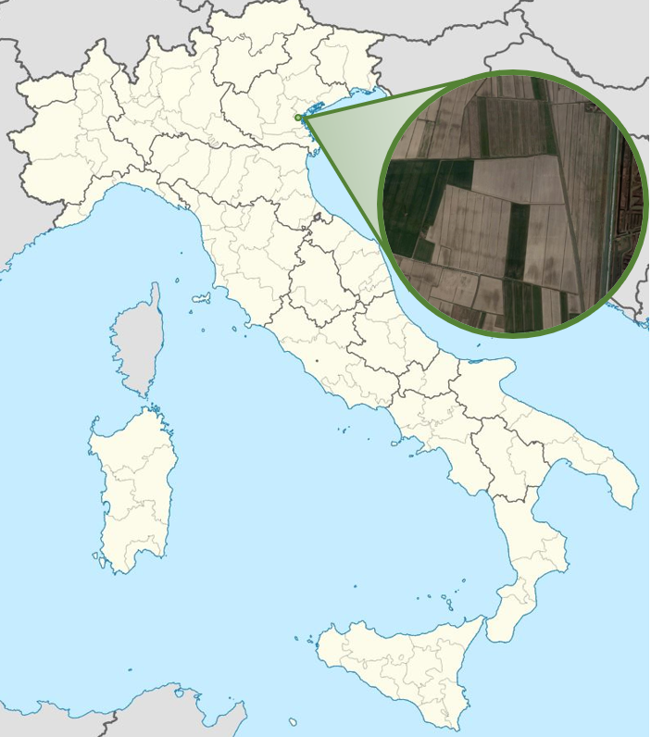
Figure 1. Study area.
The proposed approach makes use of remotely-sensed SM data retrieved from Copernicus, the Earth observation program developed by European Union and European Space Agency. In particular the SM, which is the target variable to be modeled, is described through the Soil Water Index (SWI), that provides an estimate of the water content at various depths in the soil and is computed from satellite measurements of the Surface Soil Moisture (SSM) [17]. SSM, and consequently SWI, are expressed as relative soil moisture, i.e. percent saturation. SWI data can be accessed freely from Copernicus Global Land Service [18], which is part of the Copernicus program. Copernicus SWI data for the Europe area have 1 km resolution and are based on SSM from Sentinel-1/C-band SAR and MetOp/ASCAT sensors [19], [20].
SWI allows to control soil moisture at different depths through a parameter T called characteristic time length. This parameter describes the temporal dynamics of the water flux below the surface: increasing values of T correspond to deeper soil layers. The great advantage in using SWI is that it requires to fix only one parameter, namely T , which is usually calibrated by means of comparison with probe measurements at the soil depth of interest [21]. Copernicus Global Land Service provides SWI values for eight different characteristic time lengths, varying from 1 to 100. The value of characteristic time length that was taken into account in this study is T=15. Of course, the same approach presented here can be equally repeated for other choices of T.
The meteorological data taken into account in the analysis are the daily measurements of rainfall, minimum and maximum temperatures, average relative humidity and wind speed. These data are measured by both ground-based and remote meters (weather radars) and are provided by Radarmeteo company. The meteorological data are available for the 2015- 2018 years, so the analysis is focused on this time period.
The selected methodology consists in using machine learning techniques, in particular ANN models, to estimate the future evolution of SWI given the available meteorological information. The last observed SWI value, assumed to be known four days earlier, is also used as input. The target is the expected difference, ΔSWI, between the current day SWI and the last observed SWI value. Table 1 summarizes the symbolism used for the models’ variables.
Three ANN models have been taken into account in this study: a Multi-Layer Perceptron (MLP), a Long-Short Term Memory (LSTM) network [22] and an ANFIS (Adaptive Network-based Fuzzy Inference System) model [23].
Table 1.Input symbols.
Symbol | Description
$R_{t}$ | Rainfall on day t
$T_{t}^{min}$ , $T_{t}^{max}$ | Minimum and maximum temperatures on day t
$T_{t}$ | Mean temperature on day t ^{(a)}
${RH}_{t}$ | Mean relative humidity on day t
${ws}_{t}$ | Mean wind speed on day t
${SWI}_{t}$ | Soil Water Index on day t
${\overline{X}}_{t_{1},t_{2}}$ | Mean of variable X over days t₁ ÷ t₂
$X_{t_{1},t_{2}}^{Σ}$ | Cumulative value of variable X over days t₁ ÷ t₂
^{(a)} The mean temperature $T_{t}$ has been computed as the arithmetic mean of the minimum and the maximum daily temperatures.
A single hidden layer structure is selected to implement the MLP (Figure 2). The number of units in the hidden layer is 40. The MLP inputs are
$R_{t}$, $R_{t-1}$, $R_{t-2}$, $R_{t-3}$, $R_{t-4}$,
$T_{t}$, ${\overline{T}}_{t-4,t-1}$,
${RH}_{t}$, ${\overline{RH}}_{t-4,t-1}$,
${ws}_{t}$, ${\overline{ws}}_{t-4,t-1}$,
${SWI}_{t-4}$.
Note that also meteorological variables on day t are used as inputs of the model. In real predictive applications forecasted values have to be used for such inputs.
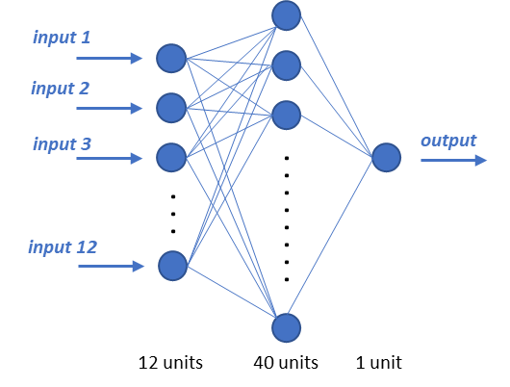
Figure 2. Scheme of the MLP network.
The LSTM network belongs to the wider class of Recurrent Neural Networks (RNNs), i.e. those having feedback connections that allow information to persist over the data sequence. This characteristic makes them naturally suited for modeling time-series datasets. The second model taken into account in this study is an ANN with one hidden layer formed by 20 LSTM cells (Figure 3). The inputs used in this setup are
$R_{t}$, $T_{t}^{min}$, $T_{t}^{max}$, ${RH}_{t}$, ${ws}_{t}$, ${SWI}_{t-4}.$
In this case it is enough passing the current values of the variables as inputs since the model is already capable by itself of keeping the relevant past information for the predictions.
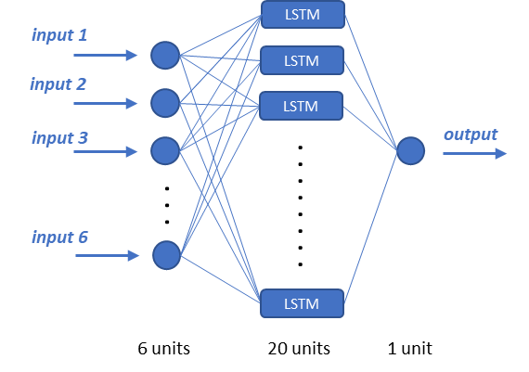
Figure 3. Scheme of the LSTM network.
ANFIS is a particular type of ANN aimed to implement Fuzzy Inference Systems (FIS), i.e. inference rules based on the Fuzzy Logic concept [24], [25]. It has a fixed structure of five layers corresponding to the five FIS steps (input variables fuzzification, antecedent values combination, implication, aggregation of the consequents, defuzzification of the output variable). Since the number of ANFIS parameters to be optimized grows exponentially with the number of inputs, the available meteorological data have been aggregated differently with respect to the two previous considered models, in order to keep the number of inputs small. Thus, the inputs used in the ANFIS model are
$R_{t-4,t }^{Σ}$, ${\overline{T}}_{t-4,t-1}$, ${\overline{RH}}_{t-4,t-1}$, ${\overline{ws}}_{t-4,t-1}$, ${SWI}_{t-4}$.
A schematic representation of the ANFIS network is depicted in Figure 4. For each ANFIS input, three membership functions defined in equation (1) are used:
$$f_{memb}\left(x;μ,σ,ν,α\right)=exp\left[⁡-\frac{{\left|x-μ\right|}^{ν}}{σ^{2}} \frac{1}{1 + e^{-α x}}\right]$$ | (1)
Each membership function has four free parameters, namely μ, σ, ν, and α, and it can be seen as a deformation of the gaussian: indeed, setting ν = 2 and α = 0 yields the usual gaussian function with mean μ and variance σ². The parameter ν allows to have different peak shapes, while the sigmoid factor ${(1 + e^{-α x})}^{-1}$ allows for skewness.
It is customary in Machine Learning applications to split the available dataset in three subsets: the training, the validation and the test sets. The training set, which usually comprises the largest amount of data, is used to feed the learning algorithm; the validation set is used for selection of the model’s hyperparameters or for models comparison; the test set is only used at the end to evaluate the performance of the selected model (see how well the model works when applied to unseen data). In this analysis, in order to exploit as much data as possible for training, the data has been split only in training and validation sets, disregarding the test set. In practice, the validation set has been used both for the model selection and for the final assessment of the selected model. Though not optimal from a statistical point of view, this strategy is quite commonly used when the amount of available data is quite limited.
For all the three models, data from January 2015 till December 2017 are used for training and data from January to December 2018 are used for validation.
As usual in this kind of modeling, the dataset has been normalized in order to facilitate the training procedure; the normalization has been performed in such a way that all the variables have zero mean and unitary standard deviation, i.e. by computing the standard scores.
As loss function it has been used the Mean Squared Error for the output variable. Regularization strategies have been exploited in order to keep possible overfitting issues under control: for the MLP and LSTM network dropout technique has been used [26]; in the ANFIS model instead a L2 regularization penalty for the consequents’ weights has been added to the loss function.
The training has been performed minimizing this loss function by means of ADAM optimization [27]. The training procedure has been carried out one hundred times for all the considered models and then the values of the parameters have been set to the ones giving the least value of the mean squared error for the validation set. Models have been evaluated by means of root mean square error (RMSE) and Nash-Sutcliffe efficiency (NSE) index computed for the validation data.
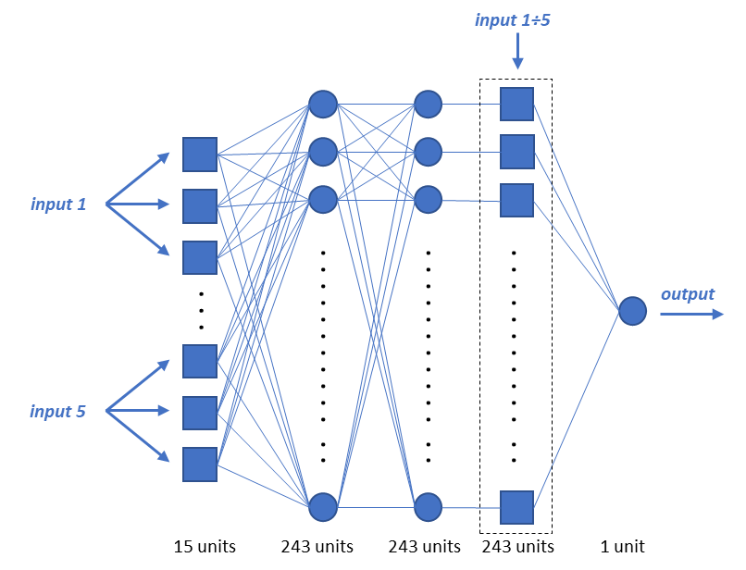
Figure 4. Scheme of the ANFIS network.

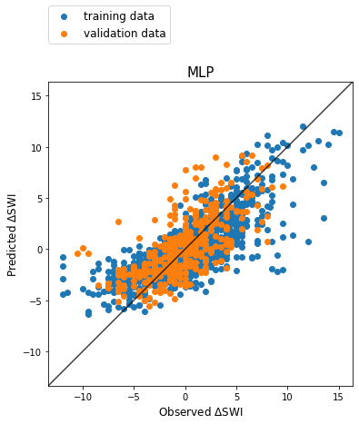

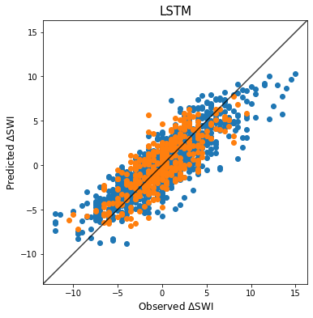

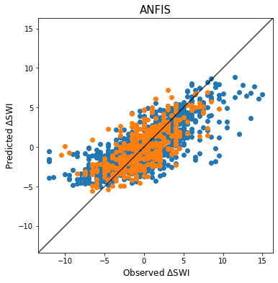
Figure 5. Scatter plots of the predicted vs. observed ΔSWI for the three models.
- Results
At the end of the training phase the best MLP, LSTM and ANFIS models have been selected according to the above-mentioned criterion and a deeper analysis on the results has been carried out.
Figure 5 shows the scatter plots of the predicted vs. observed ΔSWI for the three selected models; the blue dots refer to the training set and the orange ones to the validation set. From these plots a good agreement of the predictions can be observed when the actual ΔSWI is in the intermediate region (approximately between -7 and 7). Conversely, the predictions seem to be less accurate in correspondence of the remainder external regions of the observed ΔSWI, where the points deviate more markedly from the perfect forecast line: in these regions the models tend to underestimate the amplitude of the real ΔSWI. It can be clearly observed that this effect is sharper for the MLP and the ANFIS models than for the LSTM. A possible explanation of this issue may be related to the small number of occurrences of this kind of events in the available dataset. Note however that the difficulty of correctly reproducing extreme observations is also a known problem in machine learning modeling [28].
The plots in Figure 6 show the temporal behavior of the ΔSWI predicted by the MLP, LSTM and ANFIS models on the validation set, along with the corresponding observed values.
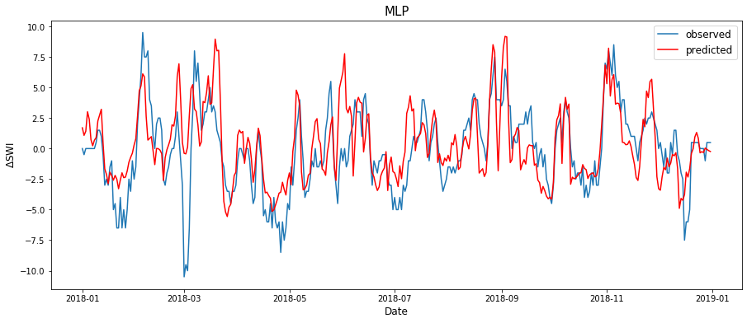
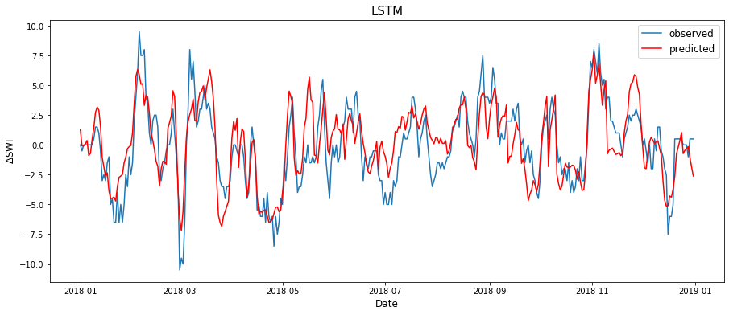
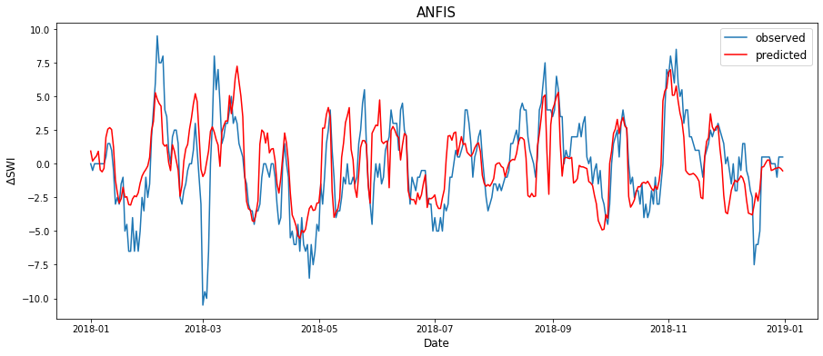
Figure 6. predicted and observed ΔSWI for the validation set.
The evaluation metrics, NSE and RMSE, are shown in Table 2 for both the training and validation data. In particular the metrics for the validation set are the most interesting ones for an assessment of the models.
The results in Table 2 shows that among the three models taken into account the ones that has the best performances, both in terms of least RMSE and higher NSE, is the LSTM one; the ANFIS model slightly outperforms the MLP.
Table 2.Models’ results.
 | Training |  | Validation
 | NSE | RMSE | NSE | RMSE
MLP | 0.590 | 2.579 | 0.397 | 2.599
LSTM | 0.746 | 2.027 | 0.606 | 2.113
ANFIS | 0.558 | 2.677 | 0.468 | 2.440

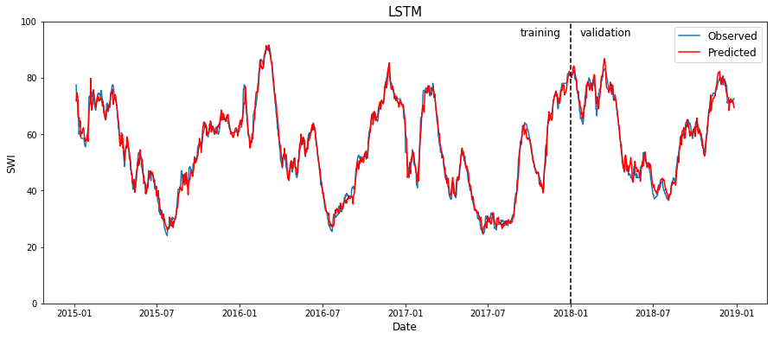
Figure 7. SWI time-series reconstructed from the LSTM model.
It is interesting to notice that the RMSE on the validation set and that on the training set are quite similar. This is quite surprising, since usually one expects a worsening of the performance metrics on the validation set compared to that of the training set. Actually, for the ANFIS model the validation RMSE is even better than the training RMSE. This “strange” behavior is probably due to the presence of a higher number of outliers in the training set with respect to the validation set.
- Conclusions
This paper presented an approach for modeling soil moisture using machine learning techniques. SM is expressed in terms of Soil Water Index retrieved from satellite measurements. These products are released on the Copernicus website with a time delay of two days after observation. To be cautious it has been assumed that the last available SWI value dates back to four days earlier. Thus, the variation of SWI in a four days period has been modeled through three different network-based models: a single hidden layer feedforward Multi-Layer Perceptron (MLP), a Long-Short Term Memory (LSTM) network and a neuro-fuzzy network (ANFIS). Meteorological data, comprising rainfall, temperature, relative humidity and wind speed records, have been used as inputs in both models along with the last known SWI value.
From a qualitative analysis, the temporal behaviors of the predicted and the observed ΔSWI appear to be well correlated. Yet at the quantitative level the agreement is not always satisfying, especially when the observed value lies in the tail of the ΔSWI distribution. However, when modeling a complex phenomenon using only a limited fraction of the actual set of variables influencing it, it is essential for the measured data to be extremely accurate and numerous. On the contrary, in this research, the available dataset spans over just four years (only three were used for training), and it could be not enough extended to guarantee an adequate generalization capability to the models. Moreover, while been extremely useful thanks to their worldwide coverage and daily frequency, the SWI data obviously do not have the same accuracy as in situ measurements. Finally, due to lack of historical records all the variables influencing the system status related to human interventions, e.g. irrigation supplies, have been neglected.
The comparison of the results of the models taken into account indicates that the LSTM model outperforms the other two selected ANNs.
The output of the models, i.e. ΔSWI, may be added to last known SWI value, ${SWI}_{t-4}$, in order to obtain the predicted SWI, SWI_{pred}, which is what the decision-makers are eventually interested to. The time series of the observed SWI and the LSTM SWI_{pred} are shown in Figure 7.
The results of the research are encouraging as they show that, in the absence of networks of in situ sensors, satellite-derived measurements of SM can be forecasted by machine learning models, using simple meteorological data as inputs. This could be extremely useful in managing water resources, since SM is a fundamental variable to be considered when supplying irrigation.
The proposed approach can be in principle applied in all those settings where measurements from different sources over large areas (whether ground-based or remote-sensing), meteorological data, and in general any quantitative information needs to be processed to provide synthetic outputs for the final user. The exploitation of artificial intelligence techniques allows for modeling complex and highly nonlinear processes. Furthermore, it makes possible to avoid the use of those parameters which would be necessary in physical-based modelling and would require extensive field campaigns to characterize the study area, or should be estimated during model calibration. As an example, no information about the hydraulic and pedologic characteristics of the soil is provided to the ANN models presented in this study.
One limitation of the proposed approach is that it allows a modelling of the soil moisture on a scale which is larger than the typical plot dimension. The resolution of this approach is indeed set by that of the satellite data, namely 1 km. However, this resolution is high enough to provide a decision support tool for the authorities which are responsible for irrigation turns scheduling over large areas.
Moreover, even if the spatial resolution of this kind of model is coarse when compared with the typical field dimensions, valuable information can be extracted also at such smaller scale. Indeed, it has been proved that soil moisture follows a similar behaviour at global and local scales and this allows a downscaling of satellite measurements of this variable [29].
Acknowledgement
The authors are grateful to Acque Risorgive Consorzio di Bonifica (www.acquerisorgive.it) for providing the information and the data of the water channels system it manages. They also thank L. Brocca (Research Institute for Geo-Hydrological Protection IRPI, Italian National Research Council) for the useful discussion and the advises on the use of remotely-sensed data.
References
- J. Dari, R. Morbidelli, C. Saltalippi, C. Massari and L. Brocca, Spatial-temporal variability of soil moisture: Addressing the monitoring at the catchment scale. Journal of hydrology, 570, (2019), 436-444.
- S. Choy and E. Weyer, Reconfiguration schemes to mitigate faults in automated irrigation channels, Control Engineering Practice, vol. 16, no. 10, (2008), pp. 1184–1194.
- H. A. Nasir, M. Cantoni, and E. Weyer, An efficient implementation of stochastic mpc for open channel water-level planning, in 2017 IEEE 56th Annual Conference on Decision and Control (CDC). IEEE, (2017), pp. 511–516.
- J. R. Ribas, An assessment of conflicting intentions in the use of multipurpose water reservoirs, Water resources management, vol. 28, no. 12, (2014), pp. 3989–4000.
- S. H. Zyoud, L. G. Kaufmann, H. Shaheen, S. Samhan, and D. Fuchs-Hanusch, A framework for water loss management in developing countries under fuzzy environment: Integration of fuzzy ahp with fuzzy topsis, Expert Systems with Applications, vol. 61, (2016), pp. 86–105.
- E. Giusti and S. Marsili-Libelli, A fuzzy decision support system for irrigation and water conservation in agriculture, Environmental Modelling & Software, vol. 63, (2015), pp. 73–86.
- H. Zamani Sabzi, S. Abudu, R. Alizadeh, L. Soltanisehat, N. Dilekli, and J. P. King, Integration of time series forecasting in a dynamic decision support system for multiple reservoir management to conserve water sources, Energy Sources, Part A: Recovery, Utilization, and Environmental Effects, vol. 40, no. 11, (2018), pp. 1398–1416.
- D. J. Power, Decision support systems: concepts and resources for managers. Greenwood Publishing Group, 2002.
- G. C. Topp, J. Davis, and A. P. Annan, Electromagnetic determination of soil water content: Measurements in coaxial transmission lines, Water resources research, vol. 16, no. 3, (1980) pp. 574–582.
- S.U. Susha Lekshmi, D. Singh, and M. S. Baghini, A critical review of soil moisture measurement, Measurement, vol. 54, (2014) pp. 92–105.
- L. Brocca, L. Ciabatta, C. Massari, S. Camici, and A. Tarpanelli, Soil moisture for hydrological applications: open questions and new opportunities, Water, vol. 9, no. 2, (2017), p. 140.
- A. S. Belward and J. O. Skøien, Who launched what, when and why; trends in global land-cover observation capacity from civilian earth observation satellites, ISPRS Journal of Photogrammetry and Remote Sensing, vol. 103, (2015), pp. 115–128.
- L. Brocca, S. Camici, F. Melone, T. Moramarco, J. Martínez-Fernández, J.-F. Didon-Lescot, and R. Morbidelli, Improving the representation of soil moisture by using a semi-analytical infiltration model, Hydrological Processes, vol. 28, no. 4, (2014), pp. 2103–2115.
- J. K. Kueper, A. L. Terry, M. Zwarenstein, and D. J. Lizotte, Artificial intelligence and primary care research: a scoping review. The Annals of Family Medicine, 18(3), (2020), 250-258.
- S. Ilić, A. Selakov, S. Vukmirović, A. Erdeljan and F. Kulić,
Short-term load forecasting in large scale electrical utility using
artificial neural network, Journal of Scientific and Industrial
Research, 72 (12), (2013), pp. 739-745.
- S. Ardabili, A. Mosavi, M. Dehghani, and A. R. Várkonyi-Kóczy, Deep learning and machine learning in hydrological processes climate change and earth systems a systematic review, International Conference on Global Research and Education, (2019), pp. 52-62.
- W. Wagner, G. Lemoine, and H. Rott, A method for estimating soil moisture from ers scatterometer and soil data, Remote sensing of environment, vol. 70, no. 2, (1999), pp. 191–207.
- Soil Water Index, Copernicus Global Land Service. Online [Accessed 5 March 2020] https://land.copernicus.eu/global/products/swi
- B. Bauer-Marschallinger, C. Paulik, S. Hochstöger, T. Mistelbauer, S. Modanesi, L. Ciabatta, C. Massari, L. Brocca, and W. Wagner, Soil moisture from fusion of scatterometer and SAR: Closing the scale gap with temporal filtering, Remote Sensing, vol. 10, no. 7, (2018), p. 1030.
- Copernicus Global Land Operations, Algorithm theoretical basis document – Soil Water Index collection 1km, Version 1 (2019). Online [Accessed 5 March 2020] https://land.copernicus.eu/global/sites/cgls.vito.be/files/products/CGLOPS1_ATBD_SWI1km-V1_I1.20.pdf
- C. Paulik, W. Dorigo, W. Wagner, and R. Kidd, Validation of the ASCAT Soil Water Index using in situ data from the International Soil Moisture Network, International journal of applied earth observation and geoinformation, 30, (2014), 1-8.
- S. Hochreiter, S. and J. Schmidhuber, Long short-term memory, Neural computation, 9(8), (1997), 1735-1780.
- J.-S. Jang, Anfis: adaptive-network-based fuzzy inference system, IEEE transactions on systems, man, and cybernetics, vol. 23, no. 3, (1993), pp. 665–685.
- L. A. Zadeh, Fuzzy sets, Information and control, vol. 8, no. 3, (1965), pp. 338–353.
- L. A. Zadeh, Fuzzy logic and approximate reasoning, Synthese, vol. 30, no. 3-4, (1975), pp. 407–428.
- N. Srivastava, G. Hinton, A. Krizhevsky, I. Sutskever and R. Salakhutdinov, Dropout: a simple way to prevent neural networks from overfitting, The journal of machine learning research, 15(1), (2014), 1929-1958.
- D. P. Kingma and J. Ba, Adam: A method for stochastic optimization, (2014), arXiv:1412.6980.
- C. Imrie, S. Durucan, and A. Korre, River flow prediction using artificial neural networks: generalisation beyond the calibration range, Journal of hydrology, vol. 233, no. 1-4, (2000), pp. 138–153.
- L. Brocca, T. Tullo, F. Melone, T. Moramarco, and R. Morbidelli, Catchment scale soil moisture spatial–temporal variability, Journal of hydrology, 422, (2012), 63-75.

