Degradation rate of eight photovoltaic plants: results during six years of continuous monitoring
A. Carullo¹, A. Castellana¹, A. Vallan¹, A. Ciocia², F. Spertino²
¹Politecnico di Torino, Dipartimento di Elettronica e Telecomunicazioni, Torino, Italy, alessio.carullo@polito.it
² Politecnico di Torino, Dipartimento Energia, Torino, Italy, filippo.spertino@polito.it

Abstract – The results of six years of continuous monitoring are presented in this paper that refer to eight outdoors PhotoVoltaic (PV) plants. The monitored plants are based on different technologies: mono-crystalline silicon (m-Si), poli-crystalline silicon (p-Si), string ribbon silicon, Copper Indium Gallium Selenide (CIGS) thin film and Cadmium Telluride (CdTe) thin film. Mono-crystalline silicon modules and thin-film modules are used both in fixed installation and on x-y tracking systems. The results are expressed in terms of degradation rate of the efficiency of each PV plant, which is estimated from the measurements provided by a multi-channel data-acquisition system that senses both electrical and environmental quantities. A comparison with the electrical characterization of each plant obtained by means of the transient charge of a capacitive load is also proposed. The capacitive-load technique has been implemented immediately after the installation of the PV plants and after 78 months of operation.
The obtained results show that both the m-Si plants in fixed installation and on the tracking system had a negligible degradation, while p-Si and string-ribbon Si exhibited a moderate degradation. Higher was the degradation obtained for the thin-film based plants, with a worst behaviour of the plants installed on the tracking systems.

Keywords – Photovoltaic power systems, Degradation, Electric variables measurement, Data acquisition
- Introduction
The continuous worldwide increase of installed PhotoVoltaic (PV) plants [1] is demanding for a reliable estimation of their long-term performance. The main parameters of interest are the PayBack Time (PBT) and the Energy PayBack Time (EPBT) [2-6]. Such parameters are largely affected by the actual degradation the PV modules are subjected to, which reduces efficiency during their life time. As an example, for a
small-size 3 kW plant whose expected energy production is 4500 kWh/year, in the conditions defined in the web tool [7], a payback time of 9 years and 8 months is estimated using a decay module PV of 0.70 %/year, as suggested in the IEA document [8] for mature module technologies. However, if the used PV modules exhibit a degradation rate of 2.40 %/year, the estimated payback time becomes 10 years and 4 months.
With the aim of estimating the degradation rate of commercially available PV technologies, the authors have monitored eight different outdoor PV plants since 2010. Electrical and environmental quantities are continuously monitored by means of a specifically conceived data-acquisition system, which is subjected to a metrological confirmation program [9]. This allows measurement traceability to be ensured and uncertainty to be stated for each of the measured parameters. Preliminary results related to the first three years of operation have been reported in [10-11]. Updated results are here reported that refer to the degradation rate of the monitored PV plants estimated from September 2010 to August 2016.
- TEST FACILITY
- Monitored PV plants
The eight PV plants under monitoring are located in Piemonte (Italy) at a latitude of about 45 °N, in the Cwc Köppen-Geiger climate zone [12]. Table 1 summarizes the main characteristics of the monitored PV plants, which include silicon based modules (plants A, B, C and A_{ts}) and thin-film based modules (D, E, D_{ts} and E_{ts}). The subscript “ts” denotes the plants whose modules are installed on a x-y tracking system, while the others are oriented towards South (azimuth angle of about 0°) and mounted in a fixed position with a tilt angle of 35°.
In the table 1, A_{PV}, P_{nom} and η_{nom} are the nameplate area (m²), power (kW) and efficiency (%), respectively. Immediately after the installation of the PV plants, their I-V electrical characteristics have been measured at natural sunlight by means of the acquisition of the transient charge of a capacitive load [13] and the actual power P_{act} and efficiency η_{act} at Standard Test Conditions (STC) have been then estimated, which are also reported in table 1. The relative expanded uncertainty (coverage factor k = 2) for both parameters is about 3.5 %.
- Monitoring system
The monitoring system is able to measure direct voltage V_{dc} and direct current I_{dc} (upstream the inverter), and temperature t_{m} of a PV module for each of the eight PV plants. The solar irradiance G_{m} is also measured on the plane of the PV modules by means of two secondary standard pyranometers: the first one is mounted with the same orientation of the fixed plants, while the second one is mounted on the x-y tracking system of the plant A_{ts}. A measurement of each quantity is carried out every 10 s and stored in a daily file. The architecture of the monitoring system is described in [10] and its metrological confirmation process is described in [9]. The calibration is performed with a periodicity of one year and includes the initial verification of each measuring chain, the adjustment that allows offset and gain drifts to be compensated, and the final verification. The maximum admitted errors used during the verifications are:
- (0.5% ⋅ reading + 0.2 V) for the voltage V_{dc} in the range from 100 V to 450 V;
- (0.4% ⋅ reading + 5 mA) for the current I_{dc} in the range from 0.5 A to 7 A;
- (2.0% ⋅ reading + 5 W/m²) for the irradiance G_{m} in the range from 500 W/m² to 1200 W/m²;
- (0.6% ⋅ reading + 0.55 °C) for the temperature t_{m} in the range from 10 °C to 80 °C.
- Data processing
The efficiency η of each plant at STC is obtained as:
(1)
where G_{STC} = 1000 W/m² is the reference irradiance value, A_{PV} is the area of the PV modules as reported in the table 1, P_{max,STC} is the maximum measured power reported at STC through the simplified model:
(2)
where I_{SC,act} and R_{S,act} are the short-circuit current at STC and the series resistance of each plant as obtained during the preliminary I-V characterization, α (A/°C) and
β (V/°C) are the absolute current and voltage temperature coefficients, respectively, while the correction coefficients C_{G} and C_{t} are obtained as:
Table 1. Main characteristics of the monitored PV plants.
Plant | PV technology | A_{PV} (m²) | P_{nom} (kW) | P_{act} (kW) | η_{nom}  (%) | η_{act}  (%)
A | m-Si | 11.2 | 2.03 | 1.93 | 18.1 | 17.2
B | p-Si | 13.8 | 1.85 | 1.80 | 13.4 | 13.1
C | String ribbon Si | 17.9 | 2.28 | 2.16 | 12.7 | 12.1
D | CIGS | 17.5 | 1.80 | 1.68 | 10.3 | 9.6
E | CdTe | 17.3 | 1.74 | 1.61 | 10.1 | 9.3
A_{ts} | m-Si | 11.2 | 2.03 | 1.93 | 18.1 | 17.2
D_{ts} | CIGS | 17.5 | 1.80 | 1.68 | 10.3 | 9.6
E_{ts} | CdTe | 17.3 | 1.74 | 1.61 | 10.1 | 9.3

(3)
Starting from the available data, a clear day has been selected per each month (for each couple of months in the period from September 2010 to December 2013), then equations (1)-(3) have been implemented for each plant using measured parameters that correspond to values of irradiance G_{m} greater than 800 W/m².
According to the uncertainty estimation procedure described in [11], which takes into account both repeatability contributions and uncertainty of each measuring chain (the maximum admitted errors periodically verified), the standard uncertainty u(P_{max,STC}) has been estimated for each PV plant. One should note that the uncertainty of the efficiency η obtained by means of equation (1) mainly depends on the uncertainty of the parameter P_{max,STC}, being G_{STC} a conventional reference value and A_{PV} known with a negligible uncertainty.
- EXPERIMENTAL results
An example of the obtained results that refer to the selected day 17th January, 2016 is reported in the table 2, where u_{A}(P) represents the standard deviation of the set of values P_{max,STC,i} corresponding to the G_{mi} values greater than 800 W/m², while u_{B}^{x}(P) is the uncertainty contribution related to the measured quantity x. Among the different contributions, the one that mainly accounts for the uncertainty of the parameter P_{max,STC} and, in turn, of the estimated efficiency η, is that related to the correction coefficient C_{G}, that depends on the measured quantity G_{m}. Since this quantity is sensed through a secondary standard pyranometer, this contribution cannot be significantly reduced for outdoor monitored PV plants. In the same table, the estimated efficiency η at STC is reported for each plant with the corresponding standard uncertainty u(η). Similar uncertainty values of the parameters P_{max,STC} and η have been obtained during the whole monitored period.
Table 2.Example of uncertainty budget - Selected day: January 17, 2016.
Plant | u_{A}(P) (W) | u_{B}^{Idc}(P) (W) | u_{B}^{Vdc}(P) (W) | u_{B}^{CG}(P) (W) | u_{B}^{tm}(P) (W) | u(P_{max,STC}) (W) | P_{max,STC} (W) | η  (%) | u(η)  (%)
A | 8.2 | 5.0 | 5.7 | 26 | 3.2 | 28 | 1941 | 17.33 | 0.25
B | 8.4 | 4.4 | 5.0 | 40 | 4.1 | 42 | 1725 | 12.50 | 0.21
C | 11.7 | 5.4 | 6.2 | 27 | 4.9 | 31 | 2107 | 11.77 | 0.16
D | 10.9 | 3.4 | 4.1 | 14 | 3.2 | 19 | 1376 | 7.95 | 0.16
E | 4.9 | 3.0 | 4.3 | 8.5 | 3.1 | 12 | 1413 | 8.07 | 0.16
A_{ts} | 8.0 | 5.9 | 5.7 | 24 | 3.2 | 26 | 1991 | 17.78 | 0.25
D_{ts} | 3.7 | 4.0 | 3.8 | 10.8 | 3.5 | 13 | 1348 | 7.70 | 0.16
E_{ts} | 3.9 | 3.9 | 3.9 | 11.0 | 2.6 | 13 | 1357 | 7.84 | 0.16

- m-Si based plants
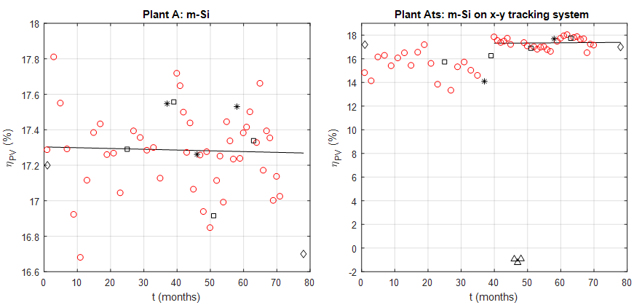
Figure 1.Estimated efficiency of the plants based on m-Si PV modules: A in fixed installation, A_{ts} on x-y tracking system.

The estimated efficiency η of the plants based on
m-Si PV modules during the monitored period is reported in figure 1. The left chart refers to the plant A (fixed position), while the right chart refers to the plant A_{ts} (x-y tracking system). The red circles represent the estimated η values, while the black squares are the values obtained after the adjustment of the monitoring system and the black stars represent the value obtained after the PV modules have been washed. The former intervention does not show significant effects on the estimated efficiency, thus highlighting that the drift of the measuring-chain characteristics during the calibration period is acceptable. In the figure 1, the efficiency values obtained with the capacitive-load technique at the months 1 and 78 are also reported (black diamonds), which show a behaviour in agreement with the observed season variability. The black triangles identify not valid data, which are due to a fault of the plant A_{ts} during the months 46, 47 and 48. The continuous straight line is obtained by fitting only the valid η values through a least square algorithm.
One should note that for the plant A_{ts} the straight line has been fitted starting from the month 40, since previous efficiency estimations were affected by a fault of the board that connects the positive pole of the PV modules to ground. Due to this non proper grounding of the PV modules, the two poles of the plant were floating, thus exposing the modules to the Potential Induced Degradation (PID) [14], which is one of the causes of efficiency loss. After the grounding board has been replaced, the plant A_{ts} has exhibited efficiency values very similar to the plant A.
The fitted straight line can be represented as:
(4)
where t is the time (months), while S_{η} is the slope of the fitted line (%/months).
The parameter S_{η} and its standard uncertainty u(S_{η}) have been obtained according to the procedure described in [11], taking into account the standard uncertainty u(η_{i}) corresponding to each monthly estimation. Starting from the obtained values, the yearly percentage degradation rate DR (%/year) has been estimated as:
(5)
For the m-Si based plant A, a degradation rate DR_{A} of -0.03 %/year, expanded uncertainty (95% confidence level) U(DR_{A}) = 0.30 %/year, has been obtained, while for the plant A_{ts} the obtained value is DR_{Ats} = 0.20 %/year, U(DR_{Ats}) = 0.80 %/year. Regardless of the very high uncertainty of the parameters DR_{A} and DR_{Ats}, the m-Si based plants have not shown a significant degradation in the monitored period.
- CIGS based plants
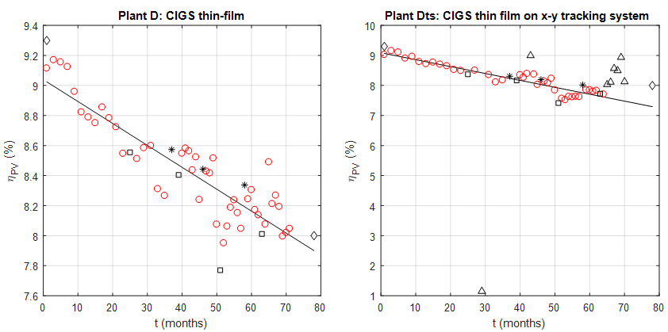
Figure 2. Estimated efficiency of the plants based on CIGS PV modules: D in fixed installation, D_{ts} on x-y tracking system.

The results in terms of efficiency η of the plants based on CIGS thin-film PV modules are reported in figure 2: left chart for the plant D (fixed position) and right chart for the plant D_{ts} (x-y tracking system). The meaning of the symbols is the same as in the figure 1. In this case, not valid data in the efficiency of the plant D_{ts} is due to:
- month 29 – fault in the cable connection;
- month 71 – missing data due to a fault in the measuring chain of the pyranometer installed on the tracking system of the plant A_{ts};
- months 43, 65, 66, 67, 68, 69, 70 – misalignment between the tracking systems of the plant A_{ts} and of the plants D_{ts} and E_{ts}, due to a fault in the tacking-system control.
An example of occurrence of the last problem is shown in the picture of figure 3, where the pyranometer installed on the tracking system of the plant A_{ts} is visible in the top-right side of the picture. The other two plants D_{ts} and E_{ts}, which are correctly oriented, are visible in the left part of the picture. Results obtained in this condition are considered not valid since the measurement of the pyranometer installed on the plant A_{ts} is not representative of the irradiance on the plants D_{ts} and E_{ts}.
Also for these plants there is a good agreement with respect to the values obtained with the capacitive-load technique (black diamonds at the months 1 and 78) and the results obtained after the adjustment of the monitoring system (black squares) do not significantly differ from the others.
For the CIGS thin-film based plants, the estimated degradation rates are DR_{D} = -2.08 %/year, U(DR_{D}) = 0.16 %/year, and DR_{Dts} = -3.34 %/year, U(DR_{Dts}) = 0.26 %/year. In this case the uncertainty is low enough to state that the CIGS thin-film modules are subjected to an important degradation and that the modules installed on the x-y tracking system exhibit a larger degradation than the same modules in fixed position.
- CdTe based plants
Figure 4 shows the efficiency η of the plants based on CdTe thin-film PV modules, where the left chart refers to the plant E (fixed position) and the right chart to the plant E_{ts} (x-y tracking system). The same symbols of the figures 1 and 2 have been used and the reason of not valid data is the same as for the plant D_{ts}. The efficiency values obtained with the capacitive-load technique at the months 1 and 78 (black diamonds) are in good agreement with the observed season variability.
The estimated degradation rates for these plants are DR_{E} = -2.06 %/year, U(DR_{E}) = 0.26 %/year, and
DR_{Ets} = -2.56 %/year, U(DR_{Ets}) = 0.14 %/year. Also in this case it is possible to state that the degradation of the CdTe thin-film modules is high, since it is about an order of magnitude greater than the degradation exhibited by the m-Si modules. However, due to the estimated uncertainty it is not possible to clearly distinguish between the behaviour of the modules in fixed position with respect to the modules installed on the x-y tracking system, even though the latter seems to have a faster decay.
- p-Si and string ribbon Si based plants
The results of the last two monitored plants are shown in figure 5: the left chart refers to the plant based on p-Si PV modules, while the right chart refers to the plant that uses string-ribbon Si modules.
As for the other plants in fixed position, all the estimated efficiency values η are valid and the adjustment of the monitoring system does not significantly change the efficiency estimations. The comparison between the fitted straight lines of the two plants highlights a very similar behaviour, which is confirmed by the numerical results: for the p-Si based plant, the estimated degradation rate DR_{B} is -0.52 %/year, U(DR_{B}) = 0.46 %/year, while for the string-ribbon Si based plant the obtained value is DR_{C} = -0.64 %/year, U(DR_{C}) = 0.28 %/year.
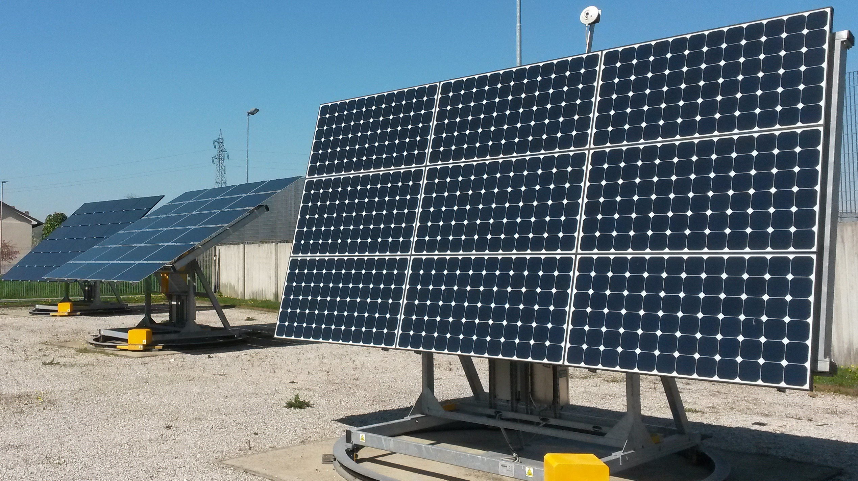
Figure 3. Example of misalignment between the plant A_{ts} (right-side of the picture) and the plants D_{ts}
and E_{ts} (left-part of the picture).

- CONCLUSIONS
The results of the monitoring of eight outdoor PV plants based on different technologies along a period of six years have been presented in this paper. The parameters that have been taken into account in order to assess the performance of the PV plants under investigations are the maximum power and the PV efficiency at STC. The latter parameter allowed the degradation rate of each plant to be obtained, which provided interesting information related to the behaviour of the different kind of plants.
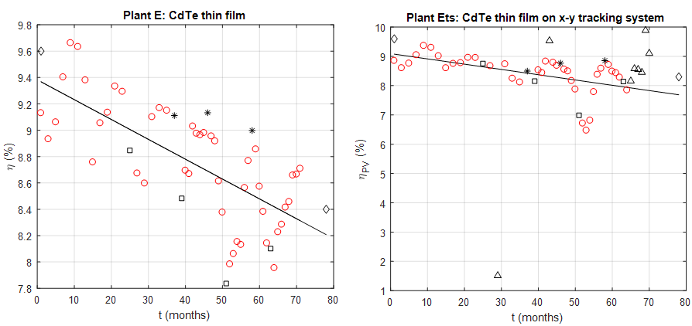
Figure 4. Estimated efficiency of the plants based on CdTe PV modules: E in fixed installation, E_{ts} on x-y tracking system.
The plants that use silicon-based PV modules are subjected to a degradation rate that is significantly lower than the plants based on thin-film PV modules. Taking the estimated uncertainty into account, the PV plants that use m-Si, p-Si and string-ribbon Si PV modules exhibited a degradation rate that is in agreement with the indication given in [8] for mature module technologies. On the contrary, the plants based on thin-film PV modules exhibited degradation rates that exceed the typical value for mature technologies. Furthermore, both for CIGS and CdTe thin-film based plants, the worst degradation rate has been obtained for the plants installed on the tracking systems.
With the aim of deeply investigating the degradation factors of PV modules exposed to outdoor conditions, the authors started a research that is based on the application of a single stress factor to each PV module and on the electrical and optical characterization of the stressed modules. Preliminary related results related to this activity can be found in [15].
References
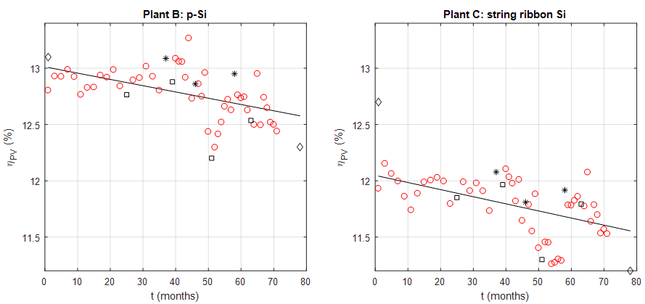
Figure 5. Estimated efficiency of the plants based on p-Si modules (left chart) and string ribbon Si modules(right chart).
- International Energy Agency - Photovoltaic Power Systems Programme - Annual report 2015.
- Francke, L., Armand, M.S. et. al, GHG Emissions and Energy Payback Time of AC electricity generated by the SunPower® Oasis® photovoltaic power plant, IEEE 42nd Photovoltaic Specialist Conference (PVSC), New Orleans, LA, USA, 2015.
- Held, M. and Ilg, R., Update of environmental indicators and energy payback time of CdTe PV systems in Europe, Progress in Photovoltaics, vol 19, issue 5, August 2011, pp.614-626.
- Sherwania, A.F., Usmanib, J.A. et. al, Life cycle assessment of solar PV based electricity generation systems: A review, Renewable and Sustainable Energy Reviews, vol 14, issue 1, January 2010, pp. 540–544.
- Lu, L. and Yang, H.X., Environmental payback time analysis of a roof-mounted building-integrated photovoltaic (BIPV) system in Hong Kong, Applied Energy, vol 87, issue 12, December 2010, pp. 3625-3631.
- Nishimuraa, A., Hayashia, Y. et. al, Life cycle assessment and evaluation of energy payback time on high-concentration photovoltaic power generation system, Applied Energy, vol 87, issue 9, September 2010, pp. 2797-2807.
- SunEarthToll.com – Photovoltaic payback, https://www.sunearthtools.com/solar/payback-photovoltaic.php#top
- International Energy Agency - Methodology Guidelines on Life Cycle Assessment of Photovoltaic Electricity - Report IEA-PVPS T12-03:2011.
- Carullo, A., Corbellini, S. et al., In situ calibration of heterogeneous acquisition systems: The monitoring system of a photovoltaic plant, IEEE Trans. on Instrum. and Meas., vol. 59, n. 5, pp. 1098-1103, 2010.
- Carullo, A. and Vallan, A., Outdoor Experimental Laboratory for Long-Term Estimation of Photovoltaic-Plant Performance, IEEE Trans. on Instrum. and Meas., vol. 61, n. 5, pp. 1307-1314, 2012.
- Carullo, A., Vallan, A. et al., Uncertainty analysis of degradation parameters estimated in long-term monitoring of photovoltaic plants, Measurement, vol. 55, pp. 641-649, 2014, http://dx.doi.org/10.1016/j.measurement.2014.06.003
- Rubel, F. and Kottek, M., Observed and projected climate shifts 1901 – 2100 depicted by world maps of the KÃüppen-Geiger climate classification, Meteorologische Zeitschrift, 19(2):135–141, April 2010.
- Spertino, F., Ahmad, J. et al., Capacitor charging method for I–V curve tracer and MPPT in photovoltaic systems, Solar Energy, Vol. 119, September 2015, Pages 461-473.
- M. Martin, R. Krause et al., Investigation of potential induced degradation for various module manufacturers and technologies, in 27th European Photovoltaic Solar Energy Conference and Exhibition, Frankfurt (Germany), 2012, pp. 3394–3398.
- A. Carullo, A. Castellana et al., Uncertainty issues in the experimental assessment of degradation rate of power ratings in photovoltaic modules, Measurement, Article in Press, DOI: 10.1016/j.measurement.2017.04.038.

