Variability of track to ground conductance measurement
Jacopo Bongiorno¹, Andrea Mariscotti²
¹Università di Genova, Genova, Italy, jacopo.bongiorno@edu.unige.it
²ASTM sagl, Chiasso, Switzerland, andrea.mariscotti@astm-e.ch

Abstract – A previous work, published in ACTA IMEKO journal, pointed out the attention about probable variability performing track to ground conductance measurements, using the method indicated in the A.3 of the IEC 62128-2 international standard. In this work the presence of such measurement variability has been proven by on site measurements.

Keywords – track-to-ground conductance measurement; soil resistivity measurement; DC traction systems; electric measurement; transportation testing; stray current; measurement variability.
- Introduction
Stray current phenomenon, particularly significant for DC electrified transportation systems, is proportional to the insulation level of the traction current return path from the surrounding structures and soil [1][2]. Effects of stray current: induced corrosion on metallic structures and on the rails themselves, are more evident and serious the larger is the traction return current leaking from the rails [3][4][5]. A correct measurement of rail-to-earth conductance is therefore a very important activity during the entire life of an electrified transportation system.
The IEC 62128-2 international standard [6] identifies some methods to perform this measurement, which however are affected by a large variability due, not only to the characteristics of the measured system, but also to the applied method. In a previous work measurement variability introduced by several arbitrary factors was numerically evaluated [7] and was estimated lower than 1%. The measured rail-to-earth conductance, however, depends on several factors, which hardly can be thoroughly modeled and accurately predicted [8]; therefore a confirmation of the results using on site measurements as indicated in IEC 62128-2 is needed.
As it is commonplace, when performing measurements during the installation phases of a system [9], the installed tracks behind the measured section, which the standard identify as the grounding path for the negative of the power supply, cannot be available and the negative terminal of the power supply shall be connected to grounded structures or to an electrode driven into the soil. As a consequence, the resistance to ground of the negative circuit of the power supply may take very different values. Such variation, according to the simulated results in [7], is expected to create variability in the measured conductance. This variability is demonstrated and quantified by on site measurement and a comparison with the variability forecasted by the simulation model is performed.
- tRACK TO GROUND CONDUCTANCE Measurement method reported in IEC 62128-2
IEC 62128-2 [6] standard proposes and describes in its appendix A, section A.3. a track conductance measurement method. The measurement set-up is shown in Fig. 1, and its use is suggested in case of track section delimited by an electrical separation to the continuing running rail by rail cuts or insulated rail joints (IRJs); the section length L shall be lower than 2km.

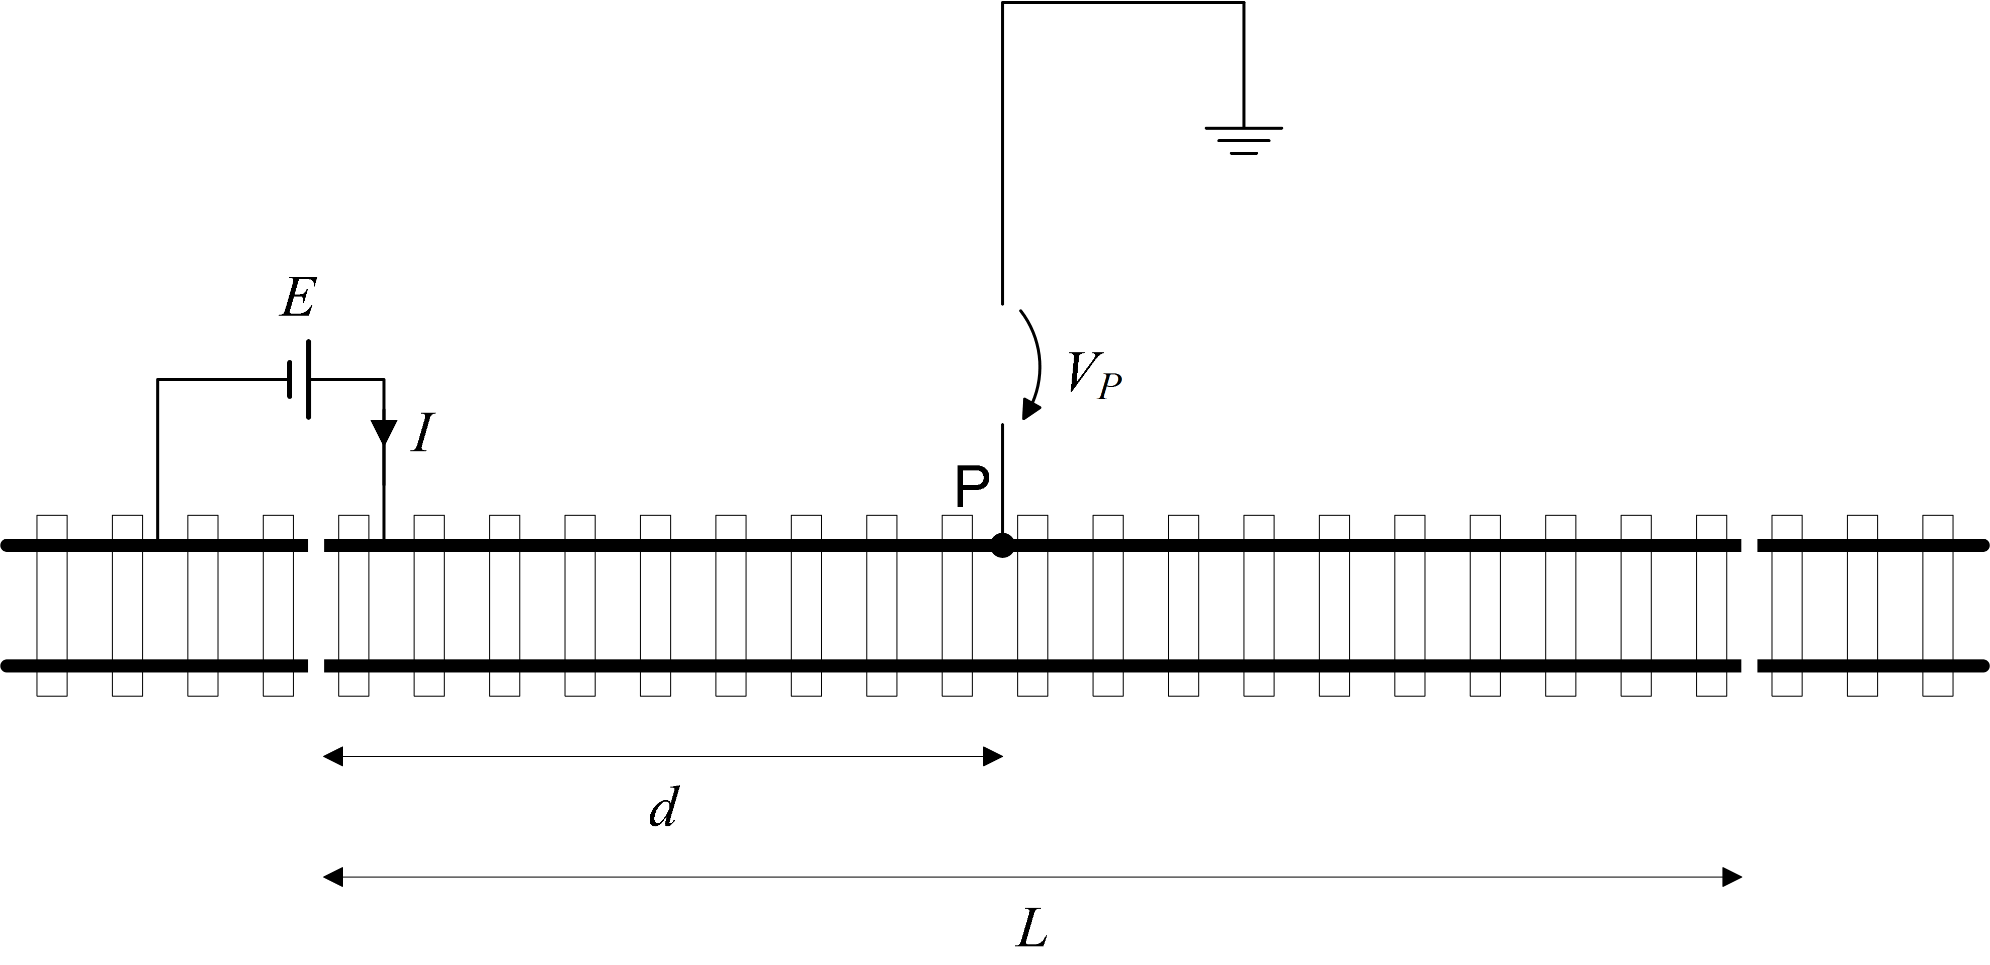
Fig. 1 Test setup for track conductance (IEC 62128-2 Annex A.3)
A Direct Current voltage power supply (PS) is connected across the first rail cut and it is used to obtain a nearly constant current, which flows from the measured track to earth. The higher is the track-to earth conductance inside the measured section, the higher is the current, which leaks from track to ground. (In the following we identify with the term “measured section” or “track section” either the track or a single rail if no need to specify the real configurations occurs).
The PS current I and the voltage to ground V_{P} at a distance d from the current injection point, are the two measured sizes. V_{P} voltage is measured against a reference electrode (RE) or a grounding circuit used as reference, with respect to which the track conductance is to be determined (e.g. concrete reinforcement, SC collector, SC mesh, etc.). The standard considers the ground reference as ideal and gives precise indications about its distance from the track, that however, cannot be always fulfilled in practical situations.

The conductance to earth is estimated using the current I of the PS, the voltage to ground V_{P} and the track/rail section length L, with the equation (1).
$G_{\text{re}}^{'}=\frac{I}{V_{P}L}$ 
- model for theoretical calculations
The model used for theoretical calculations proposed in [7] is briefly reported here for completeness.
A ladder circuit is used to model the measured track section. Per-unit-length values of track resistance and track to ground conductance, are used to calculate the resistance and conductance of the circuit cells, (R_{r,i} and G_{r,i}), once defined the equivalent circuit cell length. The resistance to earth of the grounding electrode (GE) of the power supply or the equivalent resistance of the track section behind the rail cut are represented by R₀.
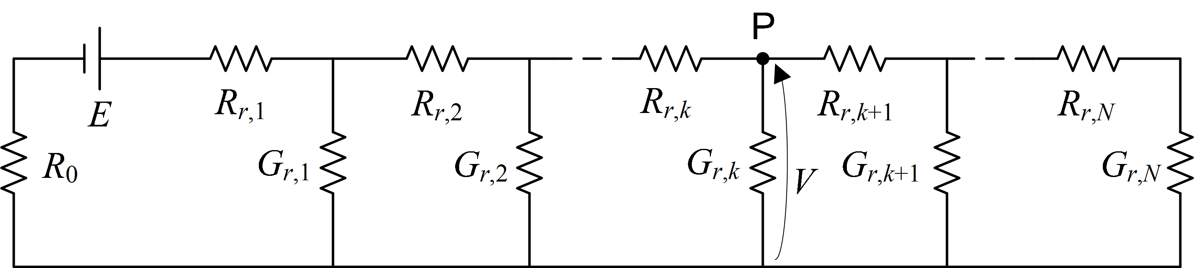
Fig. 2 Equivalent circuit of the track section measured; the voltage source E is applied with positive pole on the track and negative on the ” grounding electrode (GE)”/“behind section”. The voltmetric measure is V at point P; the ideal ground is considered as reference potential.
For any chosen point P the series parallel equivalent resistance and the Thevenin equivalent can be calculated respectively for the right and the left part of the circuit. The former is calculated starting from the last N element and going iteratively to the point P, the last is calculated considering the circuit elements from the source to the point P. The reference potential is considered as given by an ideal soil, and thus avoiding to consider all the variability due to not-ideal the soil or due to RE or GE too close to the track.
- vARIABILITY OF RESULTS
As pointed out in the introduction and in [7] there are many sources of variability in rail-to-ground conductance measurements using the IEC standard method. Some variability can be avoided adopting precautions when performing measurements [7], other depend on contingency, characteristics of the measurement site, availability of connections, etc.
The variability due to the resistance to ground of the negative connection of the power supply (R₀) was analyzed from a theoretical point of view in [7], and the conclusion was that variability in the measured conductance due to R₀ is around 1%, but highly dependent on the physical characteristic of the measured system.
Variability is here demonstrated using on site measurement results; for a comparison between modeled and measured variability, the physical conditions of the system subject to measurement were carefully taken into account.
- Description of the measured sections
The on site measurements were performed in two track sections, A and B, with different characteristics.
Length of section A is 74.9 m and measured rail p.u.l. resistance is 43.15 mΩ/km. Section A is characterized by a very short section of behind tracks to connect to the negative of power supply, and the resistance to ground of this section is estimated in 93Ω (see section B-1). One copper electrode was driven into the soil to be used as alternative grounding means for the power supply.
Length of section B is 60.8 m and measured rail p.u.l. resistance is 42.27 mΩ/km. This section, unlike the other section A, has a very long track section behind it, with an estimated resistance to ground lower than 5 Ω (see section B-1). One copper electrode was driven into the soil to be used as alternative grounding means for the power supply.
- Measurements
On site measurements of the rail-to-ground conductance were performed with both the scope to demonstrate the variability due to the resistance of the grounding path of the power supply forecasted in [7], and to validate the numerical simulations proposed in [7]. Measurements of rail-to ground conductance were performed for both section A and B. Preliminary steps were the measurement of the resistance to ground of power supply grounding electrode (GE) and the estimation of the resistance to ground of the behind track section, as described in subsection 1.
- Grounding electrode (GE) resistance to ground
The used grounding electrode is a copper cylindrical rod with a length of 1.5 m and a diameter of 2.54 cm.
The resistance to ground of the (GE) was measured using an AEMC/Chauvin Arnoux mod. 6471 “digital ground resistance and soil resistivity tester” [10]. The method used is the 3-pole earth/ground measurement with the 62% method [11]. Two auxiliary electrodes (EH and ES) are placed in a straight line from the electrode under test, at a distance ruled by the 62 % method. The electrode S, the closest to the measured electrode (GE), was placed at a distance (d) equal to 10.5 m that is more than 8 times the driven depth of the GE electrode (1.1 m). The electrode EH is placed in a straight line with electrode GE and ES at a distance d-62%d. The measurement was repeated rotating the electrodes EH and ES in three different positions around the electrode GE, to verify the homogeneity of the surrounding soil and the absence of interference
The track-to-earth resistance of the track section behind the injection point is estimated using as input values the track length and a conductance value of 0.092 S/km. The choice of such conductance value comes from conductance measurements performed in other track with similar characteristics of the behind sections and assuming homogeneous the track insulation.
At site A: the measured value of earth to ground resistance of the GE is 59.0 Ω with an intrinsic error declared by the AEMC of ±2%. The variations among the three measurements around the grounding electrode are ±1.5% of the mean of the measured values; the low variability indicates a good homogeneity of the soil surrounding the electrode, as well as a lower instrument uncertainty. The track section behind injection points is in this site very short, 117 m, leading to an estimated resistance to earth of 92.9 Ω.
At site B: the measured value of earth to ground resistance of the GE is 61.4 Ω with an intrinsic error declared by the AEMC of ±2%. The variations among the three measurements around the grounding electrode are ±1.7% of the mean among the measured values; the low variability again indicates good soil homogeneity and lower instrument uncertainty The track section behind the injection point was in this site very long, more than 2 km. As the precise length couldn’t be measured a value of 5 Ω is assumed for its resistance to ground.
- Rail to ground conductance measurements
The results of the rail to ground conductance measurements for both sites A and B are reported in Table 1. The voltmetric measurement point P is fixed at 50 m from the injection point and the reference electrode (RE) is placed 30m away from the center of the track). The column “ΔGmeas” represents the percent of variation with respect to the mean conductance value between measurements using the section behind injection point and the grounding electrode as ground return for power supply. The values of the resistance to ground of the negative pole of PS are reported in column “R₀”.
The measured conductance variability, depending on R₀, is clearly visible for all measurements. The measured rail to ground conductance increases for larger R₀ values. The observed variability, considering the mean of the two measured values as reference, is in the ±0.6%, ± 1.7% range, with a peak value of ± 7.96% for the measurement A2. It is underlined that for measurement A2 the voltmetric measurement at point P was performed using a RE placed at the opposite side of the measured rail, oppositely to all other measurements, where the reference electrodes was placed always at the same side of the track of the measured rail. The presence of the other rail in the path between measured rail and reference electrode can disturb the electric field created by the measured rail and the measurements could be affected by this distortion.

- Simulations
As mentioned in the previous section, the numerical calculation performed in [7] shows that the variability in the measured conductance, due to power supply resistance to earth R₀, highly depends on the physical characteristic of the measured system (e.g. real conductance and track length). New numerical calculations are thereof performed, in order to obtain variability results comparable to measurements in sites A and B. The input parameters of the model are thereof set according to the physical parameters of the system listed in the previous sections.
Soil resistivity is not considered directly in the model, as its effect on the voltage drop between the two electrodes (the reference electrode and the grounding of the power supply negative, either by behind track or additional electrode) was considered negligible. The closer the elements, the larger the influence of the electric field and the voltage drop in the soil.
Results of numerical calculations are shown in Table 1, where the column “ΔG_{sim}” represents the variability of the simulated values expressed in percent, considering the different values of power supply resistance to ground R₀ when using the track section behind and a vertical grounding electrode. The simulated variability is always lower than ± 0.03% taking as reference the mean of the two calculated results.
- Comparison
Measurement results reported in Table 1 shows that both in case A and B, the simulated variations of the measured conductance, due to R₀ variations, highly underestimates the variations that occurs in real measurements. The underestimation is about two orders of magnitude and for the measurement A2 it increases to three orders of magnitude.
The extreme simplicity of the model used: neglecting soil resistivity and consequential voltage drop, discontinuities, field distortion due to conductors in the nearby and so on, can be used as justifications of such difference.
Table 1.Rail to ground conductance measurement and variations against different resistance to ground of the power supply.
Site | R₀ [Ω] | G_{meas}  [S/km] | ΔG_{meas} | G_{sim}  [S/km] | ΔG_{sim}
A1 | 92.9 | 0.3805 | ±1.7% | 0.37442 | <±0.01%
A1 | 59.0 | 0.3678 | ±1.7% | 0.37438 | <±0.01%
A2 | 92.9 | 1.2986 | ±7.96% | 1.20390 | ±0.01%
A2 | 59.0 | 1.1070 | ±7.96% | 1.20382 | ±0.01%
B1 | 5 | 2.6394 | ±0.62% | 2.65674 | <±0.03%
B1 | 61.4 | 2.6721 | ±0.62% | 2.62832 | <±0.03%
B2 | 5 | 2.5158 | ±1.04% | 2.54311 | <±0.03%
B2 | 61.4 | 2.5686 | ±1.04% | 2.54460 | <±0.03%

- Conclusions
The variability in rail to ground conductance measurement due to a different resistance to ground of the power supply used to apply the method described in the appendix A.3 of the IEC 62218-2 standard [6] has been experimentally proven. The comparison with numerical simulations shows that in real cases the variability is larger than those predicted by numerical calculations. The discrepancies with numerical calculations can be justified considering that the measured sections were very short and the soil characteristics should be taken into account: an improved and more complex model should be used losing however the advantage of simplicity. The variability in rail to track conductance measurements due to the grounding resistance of the power supply in real cases is about few percent, but increases to about 10% when the reference electrode for the voltmetric measurement is placed opposite to the measured rail. This behaviour suggests that the voltmetric reference electrode shall be placed on the same side of the measured rail.
In the other cases a variability of some percent of measured conductance results can be considered acceptable for the type of measurement.
Future measurements framed within foreseen testing activities are envisaged to assess the variability of the results due different soil resistivity values and voltmetric point (P) location along the measured track section.
An improvement of the simulation model would be useful to include soil resistivity and related voltage drops by using lumped longitudinal resistive elements. Estimating correctly the measurement variability due to the above factors would bring to define corrective factors to obtain an estimate of the real conductance of the system.
References
- P. Aylott, The application of modelling systems at the design stage to the mitigation of stray current interference, Corrosion 2003, NACE International.
- A. Ogunsola, A. Mariscotti, L. Sandrolini, Estimation of stray current from a DC-electrified railway and impressed potential on a buried pipe, IEEE Transaction on Power Delivery, Vol. 27, No. 4, Oct. 2012, pp. 2238-2246.
- T. Barlo, A. Zudnek, Stray Current Corrosion in Electrified Rail Systems, Final Report, Nortwest engineering pubblications, May 1995
- L. Bertolini, M. Carsana, P.Pedeferri, Corrosion behaviour of steel in concrete in the presence of stray current, Corrosion Science, Vol. 49, No. 3, Year 2007, pp. 1056-1068.
- A. Ogunsola, L. Sandrolini, A. Mariscotti, Evaluation of stray current from a DC-electrified railway with integrated electric-electromechanical modeling and traffic simulation, IEEE Transactions on Industry Applications, Vol. 51, No. 6, Year 2015.
- IEC 62128-2, Railway applications - Fixed installations -Electrical safety, earthing and the return circuit - Part 2:Provisions against the effects of stray currents caused by d.c.traction systems, 2012
- J. Bongiorno, A. Mariscotti, Accuracy of railway track conductance and joint efficiency measurement methods, Acta IMEKO, vol. 4, No. 4, Dec 2015, pp.82-87.
- C. Charalambous, I.Cotton, P.Aylott, A simulation tool to predict the impact of soil topologies on coupling between a light rail system and buried third-party infrastructure, IEEE Transactions on Vehicular Technology, Vol 57, No. 3, May 2008, pp. 1404-1416.
- P.Aylott, I. Cotton, C. Charalambous, Impact and management of stray current on DC rail systems, IET Seminar Digest, 2011.
- AEMC / Chauvin Arnoux, Digital ground resistance and soil resistivity tester mod. 6471,User Manual
- F. Dwalaibi, C. Mukhledkar, Ground electrode resistance measurements in non uniform soils, Power Apparatus and Systems, Apr. 1973, pp. 109-115.
- IEEE Std 80, IEEE Guide for Safety in AC Substation Grounding, Feb.2013.
.

