Measurement technologies

for permanent magnets

S. Möwius, N. Kropff and M. Velicescu

BEC GmbH, D- 47443 Moers, Germany, [stmoewius@bec-gmbh.d](mailto:stmoewius@bec-gmbh.d)e, Tel. +49-2841 9550 661

***Abstract:*** **Permanent magnets have wide applications in all important fields of our modern technology; they became indispensable in automotive industry, aerospace, acoustic, telecommunications, energy generation and in many more. Physically the permanent magnets are metastable systems. Fluctuations in the composition and of the processing parameters can cause fluctuations of the magnet properties. To obtain the optimal performances of their applications, the users are requiring careful controlling of non-machined parts as well as of the finished machined magnets. In most of the cases, measurement records of the final control of the assembled magnetic systems have to be performed.**

**The aim of this paper is to review most typical measuring methods used for the magnetic properties of the permanent magnets, to comment their advantages and their limits and to discuss the accuracy which can be achieved.**

*Keywords* – *Permanent Magnets, hysteresis-graph Helmholtz-coil*

INTRODUCTION

The permanent magnets are electrotechnical devices able to induce a magnetic flux in an air gap, without the need for any other energy except that used for their magnetisation. For the manufacture of permanent magnets a magnetic material must combine optimal intrinsic hard magnetic properties with a suitable metallurgical microstructure. Useful magnetic materials are expected to have:

* a Curie temperature, Tc, high enough to enable the operation of permanent magnets at temperatures up to 200°C, without appreciable irreversible polarization losses,
* a high saturation polarization, Js, in the temperature range from -40°C to 200°C in order to obtain a high remanent polarization, Br, and to store a maximum of magnetic energy density, (BH)max , and
* a strong uniaxial magneto crystalline anisotropy, HA, to achieve a high coercive field strength HcJ.

Due to the remanent polarization the magnet is inducing a magnetic flux , which is the sum of the magnetic force lines through a defined cross section in a heterogeneous magnetic field [2]:

☞ = (1)

where B = magnetic flux density or the magnetic induction, A = cross section.

In the case of a homogenous magnetic field

☞ = B **\*** A

The characteristic lines of a permanent magnetic material are the hysteresis loops of the polarization J (H), an intrinsic magnetic property of the material, and the induced flux density B(H), both plotted versus the magnetic field strength H. The B(H) and J(H) loops are correlated by the relationship

B = J + µ0H, (2)

where µo is the universal electromagnetic constant: µo = 1.256 * 10-6 Vs/Am.

Permanent magnet users are mainly interested in the 2nd quadrant of the hysteresis curve, i.e. in the demagnetization curves of the used permanent magnetic material, and the load line of the permanent magnet, which is depending on the specific magnet geometry. The demagnetization curve J(H) shows how the external magnetic field changes the remanent polarization of the magnet, while the B(H) demagnetization curve shows the magnet induction in a real air gap and is used especially for designing the magnet systems.

For their application the users have a plethora of permanent magnetic materials on their disposal. The commonly used hard magnetic materials available in mass production are AlNiCo, Hard Ferrite and the permanent magnet materials based on rare earth alloys, namely SmCo5, Sm2Co17 and NdFeB. The characteristic magnetic properties of the permanent magnetic materials are provided by manufacturers in their corresponding data sheets. The principal magnetic properties, the remanence Br, the coercive forces of the polarization HcJ and of the induction HcB, and the maximal energy density (BH)max are specified according to the typical experimental demagnetization curve J(H) and to the resulting curve B(H) according to the equation (2).

The properties of the permanent magnets are generally very sensitive to the composition and to manufacturing parameters. In each type of permanent magnet manufactured in mass production, they are fluctuating, leading to fluctuations in the microstructure and as consequence to fluctuations in the magnet properties. The increasing use of the permanent magnets in essential applications is implementing safety actions to assure their optimal performances. The quality assurance in the permanent magnet technology is demanding quality controlling of the magnet properties from product development to serial production.

In this paper the most typical magnetic measurement methods and adequate equipment for quality control and monitoring of permanent magnets from raw sintered parts to finished magnets are reviewed. The advantages, the weakness and the achieved accuracies will be presented.

MEASUREMENT METHODS FOR PERMANENT MAGNETS

As already mentioned, the role of a permanent magnet is to induce a magnetic flux. The permanent magnet behaviour under the influence of the temperature, of opposite magnetic fields and of the environmental conditions is decisive for the performance of every application. The user is requiring a high magnetic flux, created by a high remanence, a high stability in opposite magnetic fields especially at higher temperatures, which depends on the coercive force of the material and on its temperature coefficients and corrosion stability against the environment operating conditions, assured by the permanent magnet compositions and by surface protections.

For the characterisation of the permanent magnets roughly two ways can be used: in a closed or in an open magnetic circuit. In a closed magnetic circuit the magnet is in closed contact with magnetic conducting parts, for example between the poles of an electromagnet, and so the magnet flux is closed, without any airgaps between magnet and the ferrous parts. In an open circuit, the magnet is not in contact with ferrous parts, the measurement signals depend on the induced magnetic flux, i.e. is dependent on the magnet shape and thus on its load line. These signals must be converted by simulation models in signals corresponding to the closed circuit.

Different international and national standards are recommending measurement methods of the magnetic properties of permanent magnetic materials, for example [3-5]. They recommend the measurement in a closed circuit, commonly performed in a hysteresis-graph. The highest accuracy is given only for magnets having a straight magnet axis and being produced with a constant cross section along the axis of magnetization. Furthermore, the magnet volume of the used samples must be not less than 1 cm³ and the smallest magnet dimension shall be 5 mm [3,4].

The performance of a magnetic application depends on the used permanent magnet material, as well as on their dimensions, air-gaps and on the soft magnetic components of the circuit. The number of new applications is continuously rising, very often leading to special and critical geometries and to requirements of very narrow magnetic tolerances. The aim of a measurement method is to determine the magnetic properties of magnets or of a magnetic system. Depending on the application, the magnet characterization means not imperatively to determine its principal magnetic parameters resulting from the characteristic lines J(H) and / or B(H). To ensure the high quality demanded by users, additional methods to control special magnetic properties are used.

In Table 1 an overview of the most typical measurement methods used for the characterization of the permanent magnets inspired from [6] and adjusted for this paper is presented. In this table the methods used for free magnets and those for magnets which have been assembled are separately mentioned.

*Choice of the measuring methods*

For the choice of the measurement method, several factors must be considered. In the case of mass production controlling, economic factors as for example the throughput of pieces which have to be characterized, the measurement time per magnet, the costs, as well as the required accuracy need to be considered. For the serial characterization, non – destructive measurement methods are more economical and thus preferred. Depending on these requirements, the most suitable commercial available equipment has to be used. For development and testing under laboratory conditions, equipment with improved accuracy is increasing the magnitude order of accuracy.

*Short description of the measuring methods*

Besides the classical hysteresis - graph, the demagnetizations curves can be traced by newly developed pulse-filed magnetometers for series measurement, while the Foner magnetometer is usually the preferred equipment for material research and development activities. For the measurement of the magnetic field strength and of the magnetic induction a Gaussmeter + Hall probe is the universal equipment for decades. The use of Helmholtz – coils for measurements of remanence in open circuit and of the magnetic moment is making this equipment quite indispensable in laboratories and for incoming controls of magnets. Furthermore, the homogeneity and 3D magnetic profiles can be controlled by 3D magnetic field mapping systems.

*Table 1: the most typical measurement methods used for the characterization of the permanent magnets*



*Hysteresis graph*

The function principle of a hysteresis-graph according to the IEC recommendation is shown in Fig.1 [3]. The measurement of the samples occurs in a closed circuit between two polar pieces with adjustable air gap. The intensity of the magnet field is measured by a Hall sensor or by a coil, while a surrounding coil is detecting the flux density B(H). The modern equipment is using only one compensated coil for the measurements of the both parameters J(H) and B(H). It is additionally equipped with heating plates for tracing the demagnetization curves at higher temperatures up to 200°C.

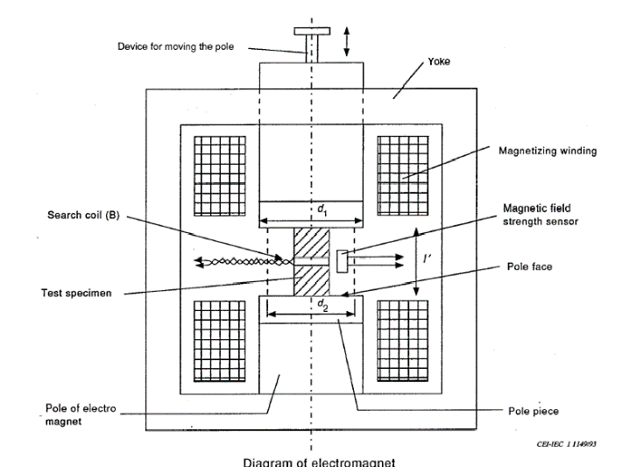

*Fig. 1: Working principle diagram of a hysteresis graph*

Hysteresis graphs are the most used equipment for tracing accurate demagnetization curves J(H) and B(H); from these curves the principal permanent magnet parameter, Br, HcJ, HcB and (BH)max are deduced. The used samples must be cut to specific sized for the measurement, making the test destructive to the sample [7]. They have to be plan-parallel, the maximal achievable magnetic field between the pole pieces is limited up to about 1500 - 2000 kA/m, depending on the sample height. The sample preparation is very important to achieve a high measurement accuracy, namely the plan-parallelism, and the dimensions.

*Pulse field magnetometer*

The first experiments to pulse fields for the measurement of high coercive forces have been performed in 1988 by Grössinger [8]. Intensive R&D activities of a European group [9], shown that this method can be applied for the industrial characterization of permanent magnets. The functional diagram of the pulse field measurement method after [10] is presented in Fig.2. A sinusoidal magnetic damped field is generated by discharging a bank of capacitors trough the solenoid. The magnetic polarization of the sample is measured by pickup coils, while Hall probe or another field sensor is measuring the field strength, leading to the tracing of the J(H) curve.

This method is showing several important advantages, namely the high magnetizing field strength, which ranges between 7 and 15 T, and the facility to measure on non – destructive way samples having arbitrary geometric forms, for example arc segments, bread shape, diametrical oriented cylinders and other forms. Despite the fact that this method has not been recognized by an international norm until now, this equipment is produced serially today and is already used on big scale for research, development as well as for serial quality control. The measurement can be performed up to 200°C. Specials facilities have been developed to perform measurements in the low temperature range 20° to – 40°C [11].

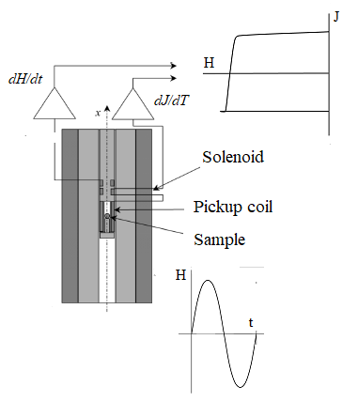

*Fig. 2: Working principle of a pulse field magnetometer*

In the electrical conducting metallic magnets like SmCo or NdFeB, this method induces eddy currents, which influences the value of remanent polarization. In order to correct the measured data, modeling calculations have been developed.

*Foner or Vibrating Sample Magnetometer (VSM)*

The vibrating sample magnetometer (VSM) has been developed in the 50s by Foner [12], therefore it is also called Foner magnetometer. Fig. 3 is showing the measuring principle of this method. Initially a loudspeaker membrane [13] was used for the vibration of a sample holder and so of the sample. An electromagnet is creating the variable external magnetic field; its strength is measured by a Hall sensor. Other sources of variable magnetic field have been developed, for example superconducting solenoids [14], Bitter coils [15] or even permanent magnet assembled systems [16,17].

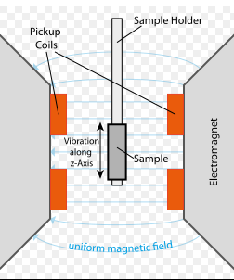

*Fig. 3: Working principle of the Foner magnetometer*

By a vertical vibration of 80 Hz [12], the sample induces a signal proportional with its magnetic polarization in the pickup coil. The samples are measured in open circuit and the signal requires corrections caused by the shearing of the demagnetization factor of the polarization.

For a long time, the Foner Magnetometer was the usual measurement method for soft and hard magnetic materials in the temperature range 2 – 1000 K. The sample size is limited to any mm3. The measurement accuracy depends on the measurements accuracy of the sample volume. Nowadays, the VSM method is used in research centers.

*The Helmholtz – Coil (HHC)*

The Helmholtz coil (HHC) has been invented in the end of the 19th century to generate small, very uniform magnetic fields. It consists in two identical coils connected in series, placed symmetrically along an axis, separated by a distance equal to their radius. Its initial idea has been reversed. For magnetic measurements, the coils are used as flux sensing coils, to accurately measure magnetization in open circuit [7]. Fig. 4 shows the typical configuration of the HHC.

By connecting it with an electronic fluxmeter, the HHC allows the measurements of the remanence in open circuit, of the magnetic moment and of the deviation angle between the magnetic and geometric axis with high accuracy and can be performed for serial productions. The HHC became an indispensable equipment for incoming control of the permanent magnets and for laboratory tests.

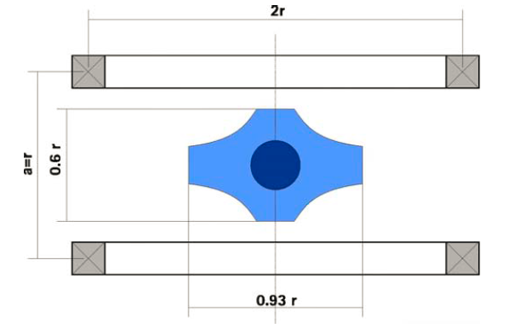

*Fig. 4: Typical configuration of the Helmholtz coil according to [18]*

*Gaussmeter*

Gaussmeters combined with a Hall probe are a universal equipment to measure the magnetic flux density B or the magnetic field strength H statically, in a desired point or space. Both parameters can be determined in air gaps too, for example in motors or loudspeakers.

Gaussmeter is a suitable device for the quality controls of serial produced magnets by measurements of the magnetic field strength in a definite point at a definite distance from the magnet surface. The “quality” of the tested magnet is to evaluate comparatively with the flux density of a calibrated reference magnet.

The resolution and the accuracy of a Hall Gaussmeter are depending on the size and the properties of the Hall sensor [19]. Newly developed Hall Gaussmeters, using miniaturized horizontal and vertical Hall devices, the so called integrated 3-axis Hall probes, are achieving extremely high resolutions and accuracies [20].

*3D mappers*

In many permanent magnet applications, the magnetic field distribution over an axis, area or volume is essential for the magnetic system. It concerns rotation and linear motors and especially magnets assembled in positioning sensors systems. The control of the magnetic field near and around the magnets can be performed with the so called magnetic field mapper. The block diagram of a commercial available 3D mapper is presented in Fig. 5 [21]. The main parts of such mapper are the moving platform, the Hall probe, the electronic box with digital processing, motor drives and power supply and a PC and software for measured data acquisition, visualization and analysis.

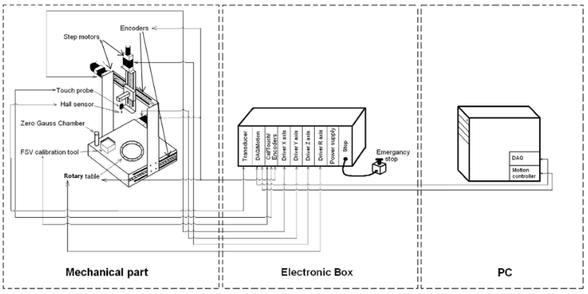

*Fig. 5: Block diagram of a commercial available magnetic*

*Mapper, reprinted with permission of SENIS.*

CONCLUSIONS

We reviewed the most typical methods to magnetically characterize the permanent magnets in laboratories, for example in their development state, as well as to control them in serial production.

Different measurement methods and suitable measurement equipment are commercially available for most of required characterizations related to the magnetic properties and magnetic behavior of permanent magnets.

By choosing the most adequate measuring method, unnecessary controlling costs can be avoided.

The combined use of more measurement methods can contribute to the improvement of knowledge concerning the behavior of the used permanent magnets and so to achieve a high-quality assurance. The BEC laboratory is equipped according to this regard.

Acknowledgment

The authors wish to thank Dr. Dragana Popovic Renella for helpful discussion by preparing the manuscript.

REFERENCES

1. Grieb, B. : *Hartmagnetische Werkstoffe. Magnetwerkstoffe für technische Anwendungen. Essen, Haus der Technik, 2016*
2. Steingroever, E., *Magnetic Measuring Techniques*,
3. IEC International Standard 60404 Part 5: *Permanent magnet (magnetically hard) materials – Methods of measurement of magnetic properties”, Issue 2015*
4. DIN EN 60404 – 5VDE 0354-5: 2016-02 *“Magnetische Werkstoffe”*
5. MMPA Standard 0100-00: *“Standard specifications for permanent magnet materials “*
6. Kuntze, K. *Chapter 6*, *in TAE Band 672, “Dauermagnete”, Expert Verlag,2015*
7. Trout, S.*R., in IEEE Trans. Mag. Vol. 24, no 4, 1988, p. 2108*
8. Grössinger, R., Gigler, C. and Keresztes, A, *in IEEE Trans. Magn., vol 24, no.2, 1988, p. 970*
9. Cornelius, R., Dudding, J., Grössinger, R.,Enzberg-Mahlke, B., Fernengel, W., Knell, M.P., Küpferling, M., Taraba, M., Toussaint, J.C., Wimmer, A, and Edwards, D, *in IEEE Tans. Mahn. Vol. 38, no. 5, 2002, p. 2462*
10. Fiorillo, F., Beatrice, C., Bottauscio, O. and Patroi, E. *in IEEE Trans. Magn., vol. 43, no. 7, 2007, p. 3159*
11. Van Bockstal, L*. technical presentation HyPulse technology, 2017*
12. Foner, S., *Rev. Sci. Instrum., 30 (/), 1959, p. 548*
13. Feldmann, D. and Hunt, *R.P., Z.Instr.,72, 1964, Heft 11, P 313*
14. Foner, S. *J. Appl. Phys. 79 1996,, p 4740*
15. Das, D.K. and Harrold, W.J., *IEEE Trans. Magn. 17, 1981, p. 281*
16. Cugat, O., Hansen, P. and Coey J.M.D, in IEEE Trans. MAG 30, 1994, p. 4602
17. Coey, J.M.D., *J. Magn. Magn. Mat. 248,, 2002, p. 441*
18. Brockhaus - Messtechnik *Data sheet “measurements using the Helmholtz coil”*
19. Popovic, R.S. [*Hall Effect Devices, Second Edition*](https://www.crcpress.com/Hall-Effect-Devices-Second-Edition/Popovic/p/book/9780750308557)*, 200, CRC Press, Taylor & Francis Group*
20. Popovic Renella, D., Dimitrijevic, S., Spasic, S. and Popovic, R.S. , *20th IMEKO Int. Symp. 2014, Italy*
21. Spasic, S*.,* [*Magnetics.*](http://c1940652.r52.cf0.rackcdn.com/58485609b8d39a3eff0006de/Magnetic-Field-Mapping-System-MMS-1A-RS_rev.9.pdf) *Business & Technology, Spring 2015, p. 16*