3D Imaging of Paintings by Scanning with a Portable EDXRF-Device

Roberto Cesareo¹, Stefano Ridolfi², Antonio Brunetti³, Ricardo T. Lopes⁴, Giovanni E. Gigante⁵
- Università di Sassari, Sassari, Italy;cesareo@uniss.it
- Arsmensurae, Rome, Italy, stefano@arsmensurae.it
- Dipartimento di Scienze politiche, scienza della comunicazione ed ingegneria dell’informazione, Università di Sassari, Sassari, Italy, brunetti@uniss.it
- COPPE, Universidade Federal do Rio de Janeiro, Rio de Janeiro, Brasil, ricardo@lin.ufrj.br
- Dipartimento di Scienze di base ed applicate per l’ingegneria, Università di Roma “La Sapienza”, Rome, Italy, giovanni.gigante@uniroma1.it

Abstract - 3D map of chemical elements distribution from energy-dispersive X-ray fluorescence (EDXRF) analysis would be a perfect conclusion to study in detail any type of artifact. This map can be easily achieved by using synchrotron light as source of radiation, and micro-optics both at the source and at the detector. In such a manner a micro-voxel is irradiated and detected, which can be at any depth with respect to the surface of the artifact. This method is effective but needs a synchrotron; therefore its use in archaeometry is greatly limited. An alternative method is proposed in the present paper, which uses the altered Kα/Kβ or Lα/Lβ-ratios to localize the chemical elements. This method employs a portable EDXRF-device, characterized by a small size X-ray tube and a Si-drift detector. Several examples are described.

INTRODUCTION
Many artefacts have a multilayered structure, not only all types of paintings, which are composed of at least by two-three layers, but also gilded or silvered metals, tumbagas (poor gold-alloy subject to depletion gilding), bronzes with patina, corroded silver and so on. The most useful analytical information about these multilayered structures can only be three-dimensional, in spite of the fact that the third dimension is of the order of mm for paintings and of tens of microns for metals.
2D scanning of paintings using energy-dispersive X-ray fluorescence (EDXRF)-analysis, are currently often carried out, by using collimated X-ray beams (µEDXRF). In such a manner maps of chemical elements in a painting are obtained, strongly increasing the level of information. 2D scanning are carried out in the best manner by using synchrotron radiation, but also X-ray tubes may be employed, due to the general high concentration of chemical elements in pigments.
EDXRF-analysis is also able to reconstruct a 3D-map of the elemental distribution by a confocal set-up realized by adding two optics in the excitation (synchrotron light) and in the detection channel. A depth-selective elemental imaging is obtained. However this approach requires a high intensity X-ray source, the related device is, of course, not portable and only a few artefacts can be scanned. An alternative approach was therefore developed to carry out in situ 3D maps, which is based on the use of a portable EDXRF-equipment and on accurate analysis of the internal ratios of X-rays emitted by the chemical elements. These ratios (Kα/Kβ and Lα/Lβ) depend on the depth-position of the involved chemical elements. Fig. 1 shows: EDXRF-analysis in confocal manner (left) and EDXRF-analysis by using the internal X-ray ratios (right).
Besides of being non-destructive and multielemental, another feature of EDXRF is that the half attenuation value of incident X-rays in painting is greater than the total thickness of all pigments, while the path of secondary radiation emitted by the chemical elements present in the pigments is, in many cases, of the same order of magnitude or slightly larger than the total thickness off all pigments. For this reason the EDXRF-spectrum of an irradiated and analyzed volume of a painting contains the X-ray peaks of all elements present in that volume (with exclusion of low Z-elements), and the K or L internal ratios depend on the depth from which X-rays of these element are coming and on the overlying attenuating pigments and protective layers [1,2]. In many cases, and when the number of pigment layers is not too great, this dependence of X-ray peaks from the depth can be determined, by carefully processing the X-ray spectrum in terms of elemental Kα/Kβ and/or Lα/Lβ-ratios. In fact these ratios depend on the location in the corresponding elemental layer, according to all the attenuation processes to which the X-rays emitted by this element are subject, i.e. self-attenuation in its same layer, and attenuation by the other superimposed layers.
In this paper, several examples are given of 3D reconstruction of paintings.

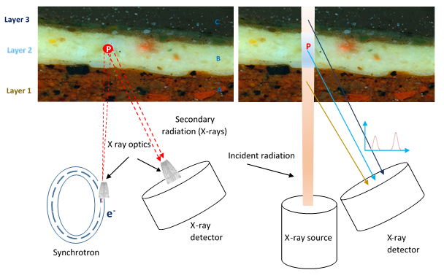
Fig. 1. (left image): Micro-EDXRF-analysis in confocal manner: a micro-volume is identified by two optics at the X-ray source and detector, and a 3D-map is obtained when moving the measuring table orthogonally with respect to the artefact to be scanner. Voxels at any depth are then analyzed. (right image): All chemical elements excited in the truncated cone can reach the detector and no information is obtained about the originating depth, unless the internal X-ratios are processed; in fact X-rays emitted by an internal point (P) are characterized by their altered Kα/Kβ or Lα/Lβ-ratios, which hallows to correctly localize them, and, finally, to obtain a 3D-mage.

THEORETICAL BACKGROUND

A. Kα/Kβ and Lα/Lβ ratios
Kα and Kβ are defined as the X-rays produced by transitions from the n=2 to n=1 and n=3 to n=1 atomic levels respectively [1]. The K-X ray spectrum shows two well separated lines, an apparently single Kα and a more complex Kβ line, which, however, can be processed as a single line.
Lα and Lβ are defined as the X-rays produced by transitions from the n=3 to n=2 and n=4 to the n=2 atomic levels respectively [1]. By considering medium-high atomic number elements, the L-X ray spectrum shows an apparently single Lα-line and a more complex Lβ-line. However, in the X-ray spectrum, two separated Lα and Lβ structures can be identified and processed.
The Kα/Kβ and Lα/Lβ ratios for all elements have been calculated and, in several cases measured [1,2]. Theoretical values are calculated for infinitely thin samples, i.e. when secondary interactions in the sample are negligible. This corresponds to very low thicknesses, generally lower than 1 µm.
The ratios Kα/Kβ and Lα/Lβ can vary, even widely:
-when the layer of the considered element, in the form of a single element, or compound or mixture, is not “infinitely thin”; this effect, called self-attenuation, depends on the involved material and thickness and gives rise to a maximum variation of about 40% for K-lines and 50% for L-lines (see Fig. 2 and 3);
-when a layer of different material, in the form of a single element, or compound or mixture, is covering the considered element; also this effect depends on the attenuating material and thickness; in this case the maximum variation has no limit [3].
In a multi-layered sample, Kα/Kβ and Lα/Lβ ratios allow, at least in principle, to measure position and thickness of any element, compound or mixture, and to locate it in the correct layer. This is approximately true for metal layers. For pigment layers, where the pigment contains one or more chemical element, an “equivalent thickness” maybe determined, i.e. the elemental (metal) thickness which would give the same attenuation as the pigment does. Further, the layer of a pigment generally has variable thickness, and will generate variable attenuation of X-rays.
The behavior of Kα/Kβ and Lα/Lβ ratios versus atomic number Z, for thin and thick layers, are shown in Fig. 2 and 3 respectively.

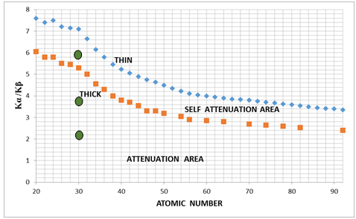
Fig. 2. Average Kα /Kβ ratio versus atomic number Z, for infinitely thin (blue rhombs) and thick (red squares) single element layer. The points for thin layers were deduced from various calculations; The points for thick layers were calculated according to Eq.: (Kα/Kβ)_{thick}= (Kα/Kβ)_{thin} (µ₂)/(µ₁),where µ₁ and µ₂ are the attenuation coefficients at energy of Kα and Kβ radiation respectively. The possibility to measure an elemental thickness by self-attenuation is related to the difference between thin and thick samples. The area between thin and thick curves defines the self-attenuation region, while the region below the thick sample defines the attenuation by a second layer, when the first one is thick. The green ellipses show the Kα/Kβ ratio of Zn (in the form of white zinc pigment of intermediate thickness WZP), of WZP covered by a red pigment containing Se and Cd (WZP + RP), and finally of WZP + RP covered by a green pigment containing Cu and Br (WZP + RP + GP).

EXPERIMENTAL SET-UP
A sketch of the experimental set-up for scanning a painting to obtain a 3D-Image is shown in Fig. 4. It is mainly composed of:
-a well collimated X-ray beam, mono energetic or bremsstrahlung, generated by a synchrotron or by a X-ray tube [4,5]; this incident beam irradiates the painting surface orthogonally, identifying the volume of a truncated cone;
-a X-ray detector, with excellent energy resolution and efficiency [4,7]; the detector collects X-rays at an angle ϑ as close as possible to the normal of the painting surface; the detector detect the photons emitted by the truncated cone;
-a X-Z movable table to translate the device (or the painting) in the X-Z plane;
-a sophisticated software to process with high accuracy and precision the X-ray spectra [6]; more into details, a complex set of X-rays is generally collected in the detector and processed in the pulse height analyzer. This complex spectrum requires to be processed by a software, in order to determine first the chemical elements present in the picture, second to quantitatively evaluate the Kα/Kβ and/or Lα/Lβ ratios of these elements, third to locate the element in the correct layer and fourth, to determine the “equivalent” elemental layer thickness.
Calibration, sensitivity and errors of the described methods, are, of course, of primary importance, and will be discussed in a future paper.

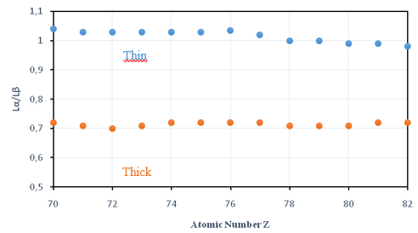
Fig. 3. Average Lα /Lβ ratio versus atomic number Z, for infinitely thin and thick single element layers. The points for thin layers were deduced from various calculations and a few measurements; The points for thick layers were calculated according to equation: (Lα/Lβ)_{thick}=(Lα/Lβ)_{thin} (µ₂)/(µ₁),where µ₁ and µ₂ are the attenuation coefficients at energy of Lα and Lβ radiation respectively. The area between thin and thick curves defines the self-attenuation region, while the region below the thick sample defines the attenuation by a possible second layer

RESULTS AND DISCUSSION
Simulations were carried out, using following pigments spread on a wood substrate (Fig. 5):
A first layer of white Zinc of mean thickness d₁;
Part of the first layer covered with a protective plastic layer, of mean thickness d₂;
A second layer of a green pigment composed of copper and bromine, of mean thickness d₃;
A third layer of red pigment containing selenium and cadmium, of mean thickness d₄.

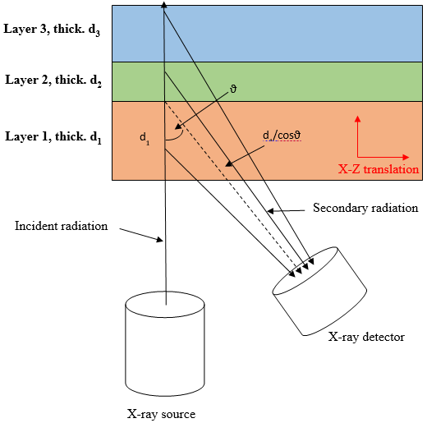
Fig. 4. Experimental set-up to scan a painting, composed of various pigment layers. It is composed of a collimated X-ray beam emitted by a X-ray tube and a Si-drift detector which collect the secondary fluorescent X-rays. The intersection of the two beams identifies the irradiated and analyzed truncated cone of the painting. By moving the painting in the X-Z plane, the whole painting is EDXRF-analyzed.

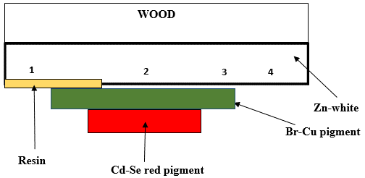
Fig. 5. pigment layers; from the surface: zinc-white, Br-Cu pigment, Cd-Se red pigment. On the left side, Zn-white is covered by a protective resin.

A linear scan of the painting area, is shown in Fig. 6, where the values of Zn(Kα/Kβ) versus position are shown. Following mean values were measured:
Zn(Kα/Kβ) = 6.0 ± 0.1 (zinc-white, area 4 in Fig. 5),
Zn(Kα/Kβ) = 5.65 ± 0.2 (zinc-white covered by a protective resina, area 1 in Fig. 4),
Zn(Kα/Kβ) = 4.6 ± 0.25 (Zn crossing the Br-pigment, area 3 in Fig. 5),
Zn(Kα/Kβ) = 2.9 ± 0.3 (Zn crossing the Cd-Se pigment plus the Br-pigment, area 2 in Fig. 5).
Then, from the relative intensity of zinc-lines, attenuated and not, the approximate thickness of Br and Cd-pigments can be calcolate; it ranges between 80 and 110 µm for the Cd-Se pigment and between 60 and 100 µm for the Br-pigment.
Similar results were obtained in a simulation involving L-lines, in following sequence of pigment layers (from the wood substrate): white lead, bromine pigment, cadmium – selenium pigment. Scanning of this sequence gave results for the Pb(Lα/Lβ) ratio, which are shown in Fig. 7.
Following mean values were measured:
Pb(Lα/Lβ) = 0.8 ± 0.02 (lead-white),
Pb(Lα/Lβ) = 0.45 ± 0.03 (Pb crossing the Br-pigment),
Pb(Lα/Lβ) = 0.36 ± 0.03 (Pb crossing the Cd-Se pigment plus the Br-pigment).
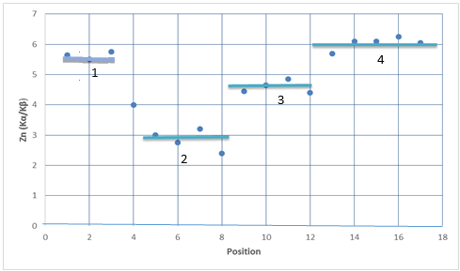
Fig. 6. Linear scanning of Zinc (Kα/Kβ) ratio, for the set of pigments show in Fig. 5. Scanning was carried out in areas 1 to 4; 1: Zn white plus resins, Zn(Kα/Kβ) ratio=5.6; 2: Zn-white plus Br-Cu pigment plus Cd-Se pigment, Zn(Kα/Kβ) ratio=2.9; 3: Zn-white plus Br-Cu pigment, Zn(Kα/Kβ) ratio=4.55; 4: Zn-white, Zn(Kα/Kβ) ratio=6.0. The difference between points of the same pigment reflects the variable thickness of the pigments.

In many cases a 3D-map is not required, and the described methods, of evaluating the self-attenuation and the attenuation effects, was largely employed in the case of gilding, silvering, tumbaga and so, by using only single measurements [4,5,6]. The same in the case of the halos of Giotto’s fresco in the chapel of the Scrovegni in Padua, where the multilayered structure was reconstructed, on the basis of K- and L-internal ratios [8].
By concluding, accurate evaluation of K and L-internal ratios when carrying out EDXRF scanning of a multilayered artifact is able to generate 3D-imaging.

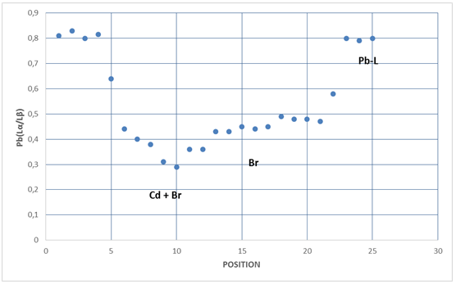
Fig. 7. Linear scanning of Lead (Lα/Lβ) ratio. From left: Pb (Lα/Lβ)= ~ 0.8, for Pb alone; Pb covered by a pigment containing Cd, plus a pigment containing Br, Pb (Lα/Lβ) = 0.36; Pb covered by a pigment containing Br, Pb (Lα/Lβ) = 0.45; Pb alone, Pb (Lα/Lβ) =0.8. Differences of Pb (Lα/Lβ)ratio inside the same pigment reflects the thickness variation of the pigment layer.

REFERENCES
- R.Cesareo, “X-Ray Physics: Interaction with matter, production, detection”, in: La Rivista del Nuovo Cimento, Ed. Compositori, Bologna, 2000.
- S.Cesia and A. Saadia, “Analytical significance of peaks and peak ratios in x-ray fluorescence analysis using a high resolution semiconductor detector. Analysis of uranium solutions by x-ray spectrometry” Analytical Chemistry Vol. 43 (8), 1971, pp..
- B. Ertugral, et al., “Kβ/Kα X-ray intensity ratios for elements in the range 16-92 excited by 5.9, 59.5 and 123.6 keV photons”, Radiation Phys. and Chem. Vol. 76, 2001 pp.15-22.
- R.Cesareo, A. Brunetti, S. Ridolfi, “Pigment layers and precious metal sheets by energy-dispersive x-ray fluorescence analysis” X-Ray Spectrometry, Vol.37 (4), 2008, pp. 309-316.
- R. Cesareo et al., “The structure of two-layered objects reconstructed using EDXRF-analysis and internal X-ray ratios” , X-Ray Spectrometry, Vol. 44 (4),2015, pp. 233-238.
- R. Cesareo et al. “Analysis of the spectacular gold and silver from the Moche tomb Señora de Cao” X-Ray Spectrometry Vol. 45, 2016, pp. 138-154.
- AMPTEK Inc., 6 De Angelo Drive, Bedford, MA 01730-2204, USA.
- R. Cesareo, “Non-destructive EDXRF-analysis of the golden haloes of Giotto’s frescos in the Chapel of the Scrovegni in Padua” Nucl. Instrum. and Methods in Phys. Res. Vol. B211,2003, pp. 133-137.

