Welding Brazing and Soldering of Gold and Silver by the Moche Tombs “Señor de Sipán” and “Señora de Cao”

Roberto Cesareo¹, Angel Bustamante², Regulo Franco Jordan³, Arabel Fernandez³, Soraia
Azeredo⁴, Ricardo T. Lopes⁴, Walter Alva⁵, Luis Chero⁵, Antonio Brunetti ⁶, Giovanni E.
Gigante ⁷, Stefano Ridolfi ⁸

- Università di Sassari, Sassari, via Nulauro 3, 07041 Alghero, Italy, cesareo@uniss.it
- Universidad Nacional Mayor de San Marcos, Lima, Perù, angelbd1@gmail.com
- PACEB Museo Cao e Fundacion Wiese, Trujillo, Perù
- COPPE, Universidade Federal do Rio de Janeiro, Rio de Janeiro, Brazil; ricardo@lin.ufrj.br
- Museo “Tumbas Reales de Sipán”, Lambayeque, Perù
- Dipartimento di Scienze politiche, scienza della comunicazione ed ingegneria dell’informazione, Università di Sassari, Sassari, Italy; brunetti@uniss.it
- Dipartimento di Scienze di base ed applicate per l’ingegneria, Università di Roma “La Sapienza”, Rome, Italy, giovanni.gigante@uniroma1.it
- Arsmensurae, Rome, Italy, stefano@arsmensurae.it

Abstract – About 200 gold and silver funerary ornaments from the Moche tombs “Señor de Sipán” and “Señora de Cao” were analyzed to determine their metallurgic characteristics. Of particular interest was the question about the gold-silver joining process. To this aim, following methods were employed, all based on the use of X-rays:
-energy dispersive X-ray fluorescence;
-transmission of monoenergetic fluorescent X-rays;
-radiography.
At least three following joining methods were possibly identified:
-of gluing gold and silver sheets;
-of brazing using a proper solder;
-of using a mercury amalgam.

INTRODUCTION
On the north coast of present-day Peru developed between 1200 BC and 1375 AD approximately, various relevant civilizations. Among them the most important, from the point of view of metallurgical ability, was the Moche civilization (also called Mochica) .
The Moche civilization flourished mainly in the Moche and Chicama valley (Fig. 1), where its great ceremonial centres have been discovered, from around 100 BC to 600 AD, producing painted pottery, gold-silver ornaments and beautiful tissues. The Moche were known as sophisticated metal smiths, both in terms of their technology, and of the beauty of their jewels. The Moche metalworking ability was impressively demonstrated when Walter Alva and co - workers discovered in 1987 the “Tumbas Reales de Sipán” ^{[1,2]} and, more recently, when Regulo Franco Jordan discovered in 2005 the tomb of the “Lady of Cao” (Fig.1)^{[3-6]} . Spectacular gold and silver funerary ornaments were excavated, and are now exposed in the Museum “Tumbas Reales de Sipán” in Lambayeque, close to Chiclayo, and in the site Museum of Cao, about 60 km north to Trujillo .
Previously, in the late 1960, tombs rich of metals, attributed to the Moche, were discovered and located in a site that came to be known as Loma Negra. Hundreds of objects attributed to Loma Negra were sold to US-collectors and finally partially transferred to the Metropolitan Museum of New York ^{[78]}. The site of Loma Negra was dated about 2nd-3th Century A.D., possibly before the tombs of the lady of Cao (~300 A.D.) and of the lord of Sipán (~350 A.D.). However dates are rather uncertain.
As explained in previous papers ^{[9-11]}, the manufacturing technology of the Moche was very various and partially unknown, and, also after six campaigns of analysis, many questions remain open:
- why the Moche used to put relatively high quantities of Gold in the Silver sheets (tomb of Cao)?
- why the Gold artifacts from the tomb of Cao have approximately the same composition, differently from the Gold from the tomb of Sipán ?
- How are joint together Gold and Silver sheets?
We can only make hypothesis on the first two questions; to answer to the last question a sub-millimetric EDXRF portable equipment was developed to carry out detailed millimetric measurements on the Au/Ag interface; further radiographs were carried out with special attention to the interfaces.

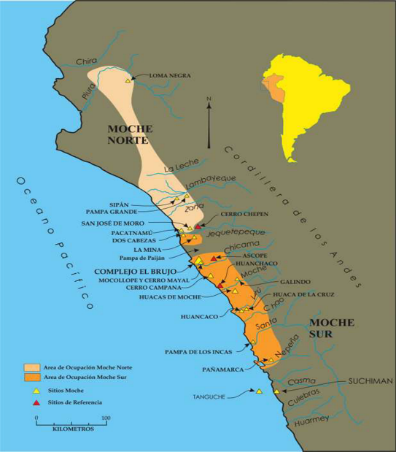

Fig. 1. Map of the Moche territory, covering an area of about 50000 km^{2,} showing the Moche sites Loma Negra, Sipán and El brujo. The tomb of the lady of Cao is located in the “complejo el brujo”. (Courtesy of Fundacion Wiese).

EXPERIMENTAL SET-UP
The equipment employed for EDXRF-analysis and for radiographic measurements is described in Ref.[9].

RESULTS
By analyzing the Gold-Silver interfaces of many of the forty nose ornaments, at least four typical situations were identified, and an additional fifth hypothesis was considered:
1. Silver sheets glued to Gold sheets; this is the case of nose decoration PACEB-F4-00002 (see Figures 2 and 3), where the Silver huts and disk are glued to the Gold body; this is not a common case and was also observed only in nose decoration PACEB-F4-00006.
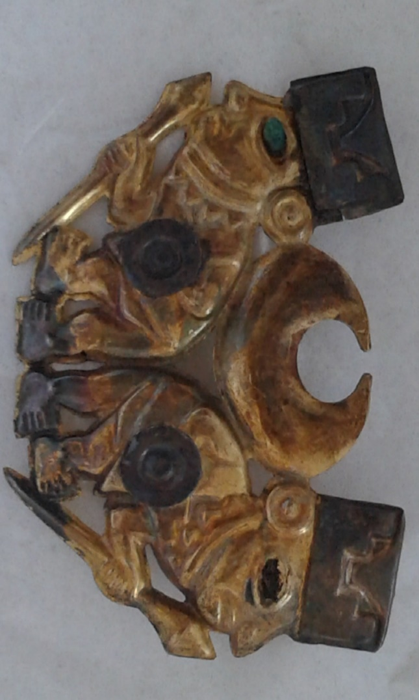
Fig. 2. Front side of the nose decoration PACEB-F4-0002 from the tomb of the lady of Cao. It is composed of a body on a gold-alloy sheet with, superimposed, two shields on silver and, partially superimposed, two huts on silver. Silver huts and shields, these last only present in the front side, were probably glued to the gold body with an organic resin.

2. Silver and Gold sheets brazed together; this is the case of nose decoration PACEB-F4-00106 (Figures 4 and 5) and peanut MB-8404 from the tombs of Sipan (see Fig. 6), where the presence of additional Silver in the Au/Ag interface was identified in the X-ray spectrum, and also can be hypothesized from several radiographic measurements; this is a common case, and was observed in many other nose ornaments.

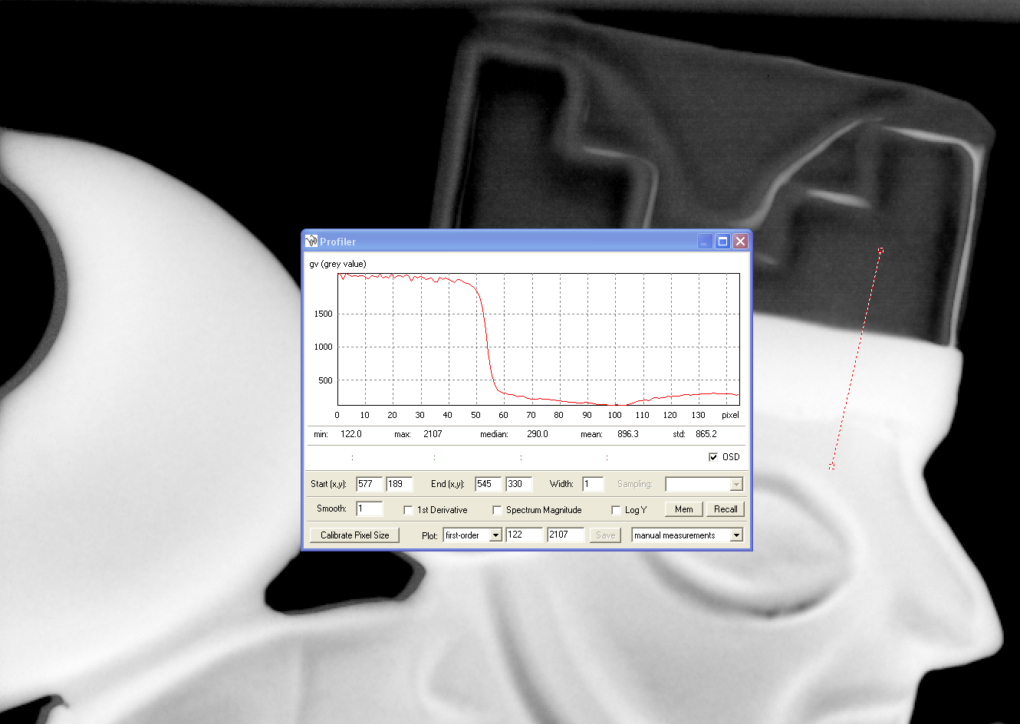
Fig. 3. Radiography of nose-ornament shown in Fig. 2, and behaviour of grey numbers in the interface Au/Ag.The grey number curve depicted in the last Fig. shows a sharp discontinuity between the Ag hut and the area where Ag is glued to Au. Then there is a discontinuity between this area and the Au area.

3 .Silver and Gold sheets joint together by using mercury amalgam; this is the case of nose decoration PACEB-F4-00011 (Fig.7), where the systematic presence of Mercury, identified in the X-ray spectra of the Au/Ag interface, and only there, indicates the use of mercury for soldering together gold and silver. A test carried out by joining a gold to a silver foil by using mercury confirms this hypothesis.

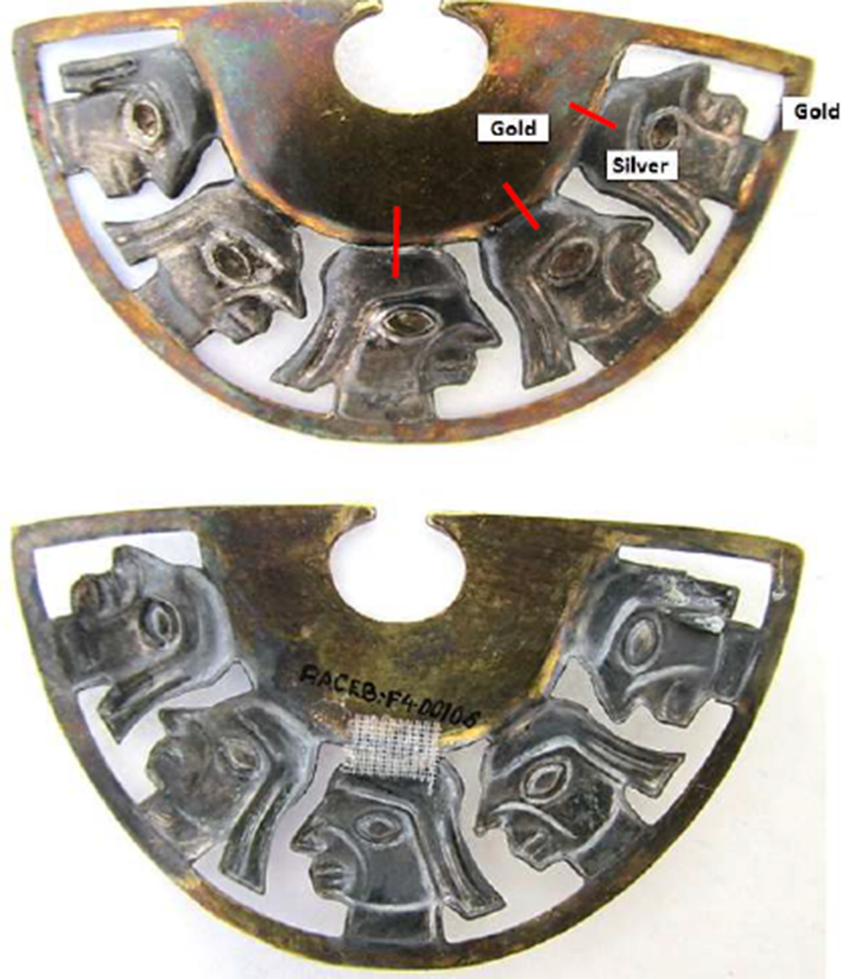
Fig. 4. Front and rear side of the nose decoration PACEB-F4-00106 from the tomb of the lady of Cao. It is composed of a body on a gold-alloy sheet, soldered on five heads on Silver, which are further soldered to a half-moon sheet on Gold. The soldering between the head in the middle and the upper gold shows a gap, which was covered in the rear side by a tape.

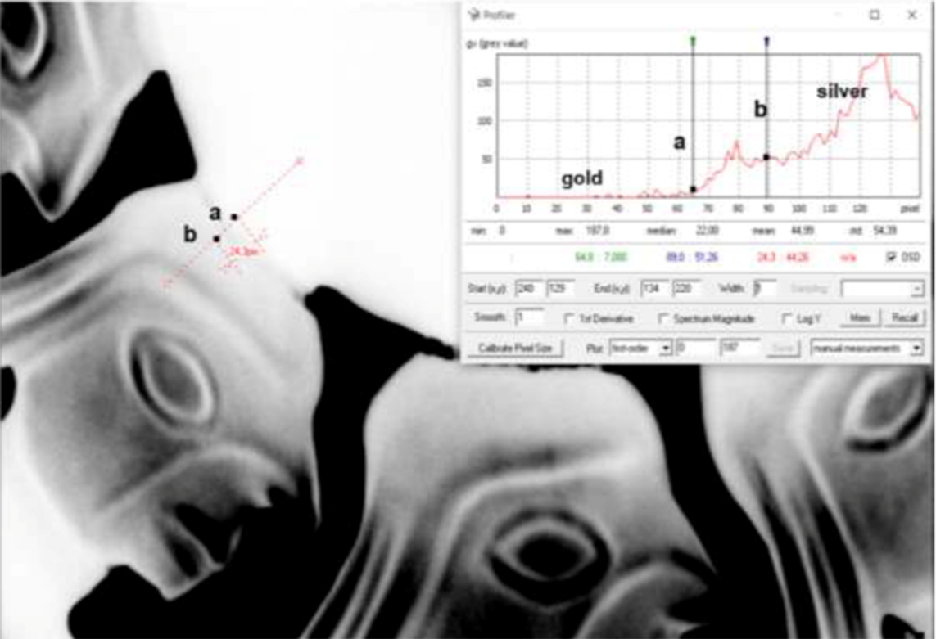
Fig. 5. Radiography of nose decoration PACEB-F4-100106 (second Ag-head from the left and interface gold-silver, see Fig. 4). The region between a and b corresponds to the soldering region, possibly carried out with a Ag-alloy. .

4. It cannot be completely excluded that in a few cases a unique sheet on silver or on gold could have been employed, and a process of depletion gilding or silvering applied to the desired area. This possibility was considered in the case of nose decoration PACEB-F4-00018, where attenuation of X-rays by silver and gold areas, determined by radiographic measurements, are similar.

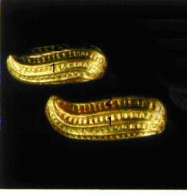
Fig. 6. Two peanuts on Gold, from the royal tombs of Sipan, code MB-9404 and MB-9405. Each peanut is composed of two parts soldered with a Ag-alloy containing Cu and Br. The same method was employed by the Moche for soldering front and rear side of the famous mask MB-09398.
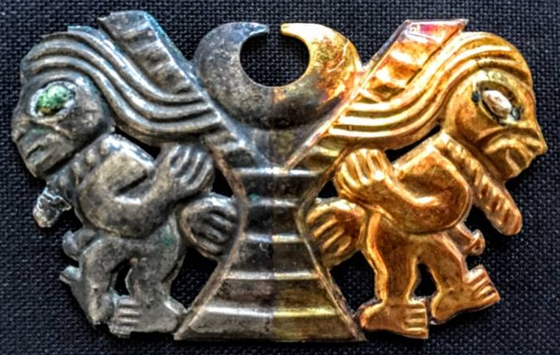
Fig. 7. Front side of nose ornament PACEB-F4-00011, composed of two sheets on Ag and Au, joined together by using a mercury amalgam; along the red line in the upper Fig., it was observed the systematic presence of mercury.

CONCLUSIONS
From all measurements, following may be deduced on the forty nose ornaments:
-the Moche artisans employed different techniques to join together gold and silver: by gluing, by using an Ag brazing alloy and by using a mercury amalgam; a simultaneous process of heating can never be excluded.
-the gold sheets of the forty nose ornaments from the tomb of the lady of Cao have a quite similar composition;
-the silver sheets of these forty nose ornaments have a completely erratic composition, with large differences also inside the same object. Also thickness differences were observed;
Obvious deductions from above points are:
-The forty-two nose decorations were produced in different periods and by different artisans; this is not surprising, because it is likely that the lady of Cao may have inherited several of the nose decorations, and also that the others may have been made in different times;
-the Moche possibly knew how to reproduce gold-alloys with the same composition. This consideration also derives from the previous point;
-the Moche were possibly trying to yield silver alloys with special characteristics of visual aspect and/of resistance to oxidation, by putting relatively high concentrations of gold; the presence of gold in silver is almost constant, while its concentration is highly variable. This could indicate a continuous investigation to produce an ideal silver-alloy;
The extraordinary metallurgic ability of the Moche, at least in the period characterized by the tombs of Span and Cao must be finally pointed out.

REFERENCES
[1] W. Alva, SIPAN, descrubrimiento y investigation, Quebecor World Perù S.A: Lima 2004.
[2] .W. Alva, C.B. Donnan,The Royal Tomb of Sipán, Los Angeles Fowler Museum of Cultural history; University of California: Los Angeles 1993.
[3] R.Franco Jordan, in “Señores de los reinos de la luna”, Ed. Krzysztof Makowski, Banco de Crédito del Perù: Lima 2008, pp.280-287.
[4] R.Franco Jordan, los secretos de la huaca Cao Viejo, Fundacion Wiese y Petrolera Transoceanica S.A.: Lima 2009.
[5] R. Franco Jordan, Pour la Science 2010, 390, 8 Paris, France .
[6] R. Franco Jordan, La Dama de Cao. Investigacion y Ciencia: 68-74, Bercelona, Spain 2011.
[7] H. Lechtman, American Antiquity 1998, 47(1), 3.
[8] D. Schorsch, Metropolitan Museum Journal, 1998, 33 109.
[9] R. Cesareo, R. Franco Jordan, A. Fernandez, A. Bustamante, J. Fabian, S. Zambrano A., S. Azeredo, R.T. Lopes, G. Ingo, C. Riccucci, G. Di Carlo, G.E.Gigante, Analysis of the spectacular gold and silver from the Moche tomb “Señora de Cao”, X-Ray Spectrometry 45,3 pp.138-154, 2016.

