Point cloud processing techniques and image analysis comparisons for boat shapes measurements
Sofia Catalucci^{1,2}, Roberto Marsili¹, Michele Moretti¹, Gianluca Rossi¹
¹ Università degli Studi di Perugia, Dipartimento d’Ingegneria, Via Goffredo Duranti 93, 06125 Perugia, Italy
² Present adress: University of Nottingham, Advanced Manufacturing Building, Jubilee Campus, NG81BB Nottingham, United Kingdom

ABSTRACT
Photomodelling is a new and fast solution for 3D modelling, based on the same principles of photogrammetry. The comparison between photomodelling and the metrological technique of structured light 3D scanning, provided by the Creaform Go Scan 50 with metrological certification, is the aim of this paper, defining performances and verifying the potential of this innovative, simple and economical technique.

Section: RESEARCH PAPER
Keywords: photomodelling; metrology; point clouds; Iterative Closest Point algorithm
Citation: Thomas Bruns, Dirk Röske, Paul P.L. Regtien, Francisco Alegria, Template for an IMEKO event paper, Acta IMEKO, vol. A, no. B, article N, month year, identifier: IMEKO-ACTA-0A (year)-0B-0N
Section Editor: name, affiliation
Received month day, year; In final form month day, year; Published month year
Copyright: © year IMEKO. This is an open-access article distributed under the terms of the Creative Commons Attribution 3.0 License, which permits unrestricted use, distribution, and reproduction in any medium, provided the original author and source are credited
Funding: This work was supported by the Engineering Department, Università degli Studi di Perugia
Corresponding author: Sofia Catalucci, e-mail: sofia.catalucci@gmail.com

- Introduction
The design and modelling of a boat involve complex free-form geometric shapes, difficult to measure and survey with traditional metrology methods. Scan data allow creating precise 3D models that can be used by naval designers and engineers to ensure the quality of interior and exterior construction, as well as for simulation and inspection purposes.
For this purpose, the paper describes photomodelling technique, a recent and fast image processing and alignment method that leads to the reconstruction of 3-dimensional models, starting from the simple acquisition of photographic images. Close to photogrammetry, the result obtained is a 3D point cloud, a set of x,y,z space coordinates, first form of the object surveyed [1].
A point cloud can be identified as a pixel cloud, because of the direct relationship between photomodelling and photography: each pixel of an image corresponds to a point of the cloud, thus preserving the chromatic characteristics of the object surveyed [2], [16], [17], [18], [19].

- TEST PERFORMED
Object of the survey is a Beneteau First 456/s boat (Figure 1), 1984, with 3 cabin all with toilets, engine Yanmar 55 cv, 14 m length.
The measurements have been performed on the driving seat area, by using photomodelling technique and the Creaform 3D scanner, on the same surface (Figure 2).
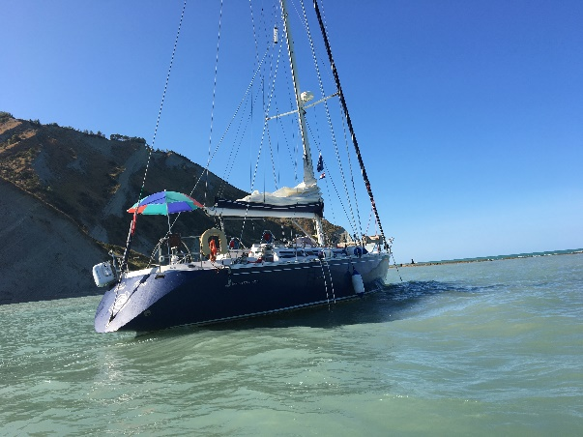
Figure 1. The Boat.
At first, the survey has been performed using the 3D scanning system (Figure 3); target stickers have been applied randomly to facilitate the capture process, due to the auto similarity of the surface pattern.
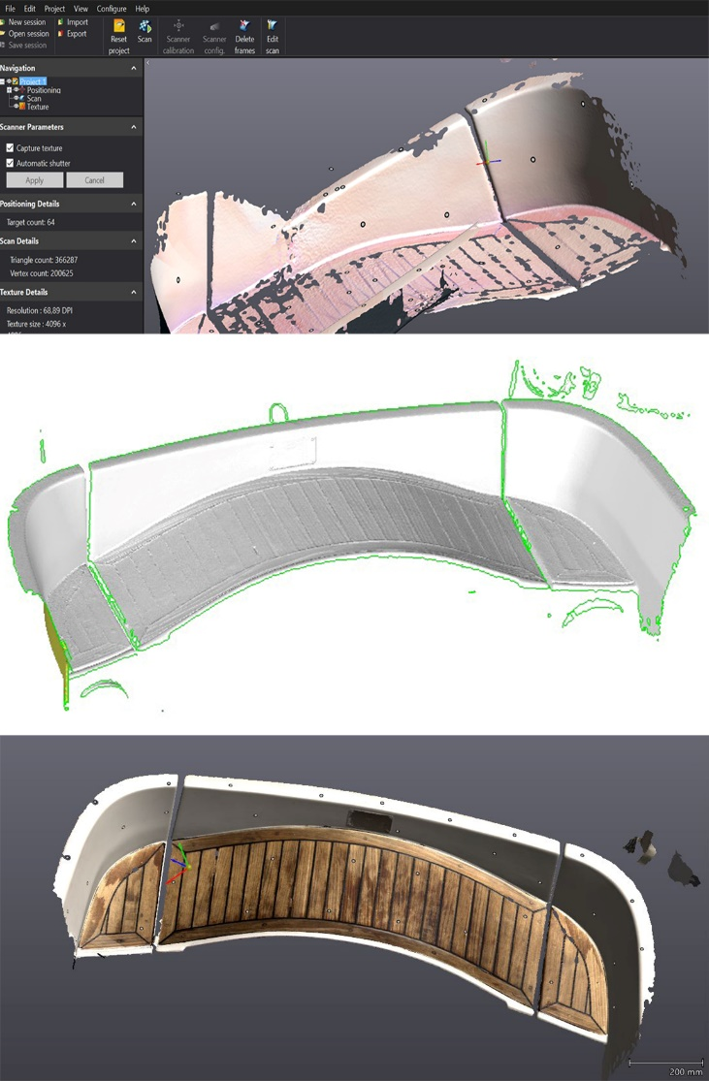
Figure 3. Boat surface scanning by Creaform ScanGo 50.
The survey carried out by the photomodelling technique included a totality of 20 images, loaded in three different dedicated software: Agisoft Photoscan, Visual SfM and Autodesk Remake. Each instrument is different because of their time data processing, difficulty of use, accuracy and precision of results [3]. Furthermore, the applications proposed are both open-source and commercial software.
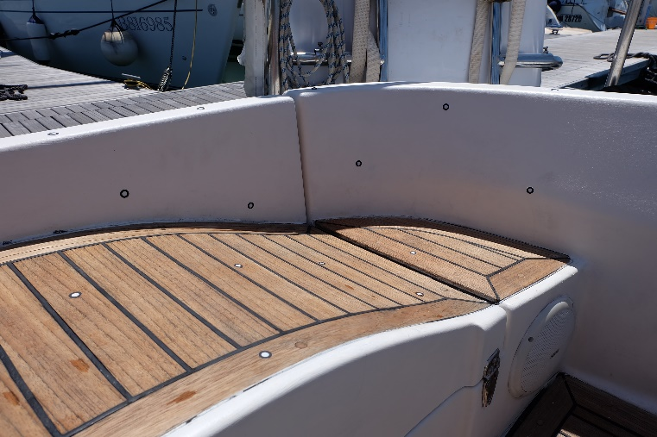
Figure 2. Driving seat area.
- DATA PROCESSING
The 3D data processing is the same for each software: the first operation is the manipulation of the 3D point cloud. The next step is the creation of three-dimensional model, called “triangulation”: starting from the input data vertices, edges and faces are generated. The result obtained is a set of coordinates, which is converted into a polygonal surface [4], [5], [6]. With editing software as MeshLab and Geomagic Studio, it is possible to perform manual editing of data, merging, scaling, aligning of different surfaces, creating a three-dimensional surface with the aid of different algorithms [7], [8], [9] (Figure 4, Figure 5, Figure 6).
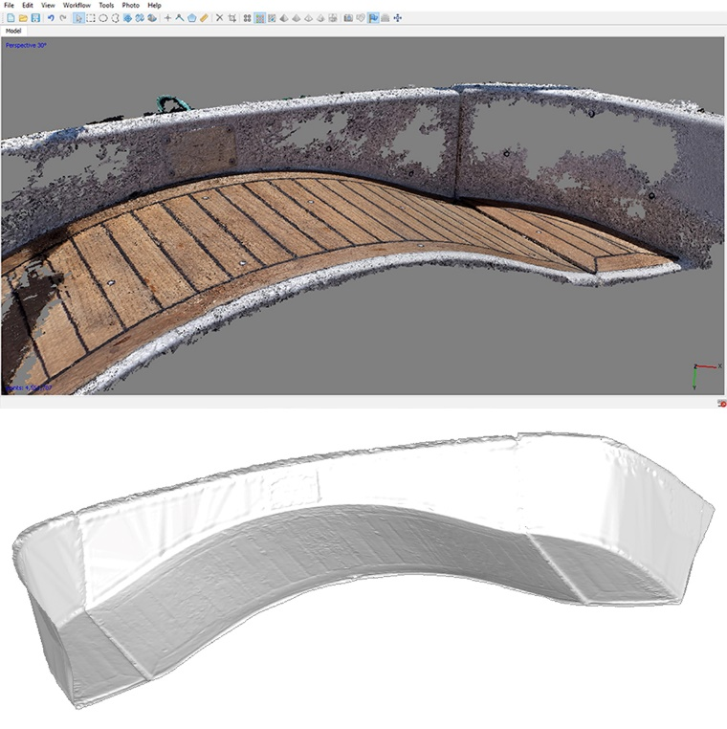
Figure 4. Surface 3D model and point cloud by Agisoft Photoscan.

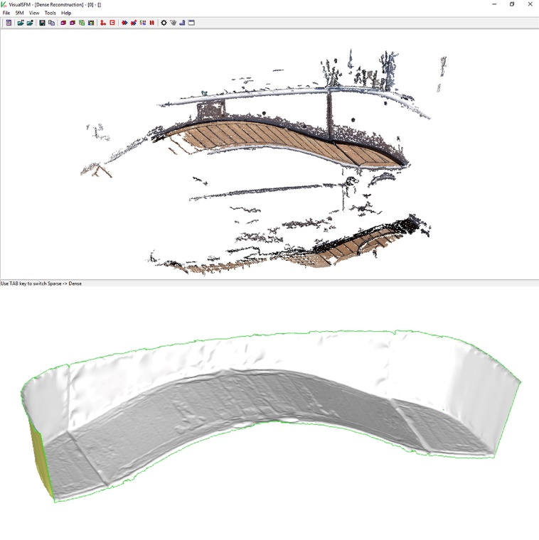
Figure 5. Surface 3D model and point cloud by Visual SfM.
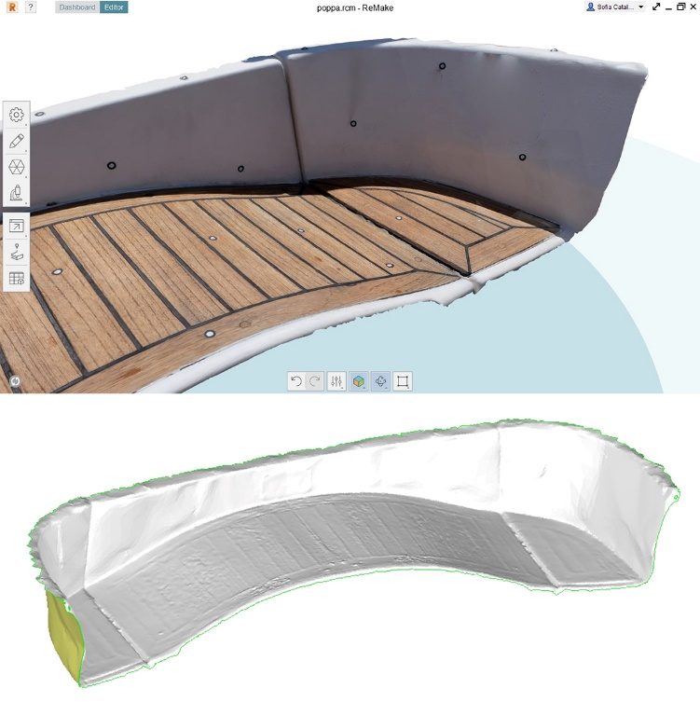
Figure 6. Surface 3D model by Autodesk Remake.
- COMPARISON
After the alignment process, the research concerned the comparison between the results of photomodelling technique, identified as TEST, and a REFERENCE model. It has been chosen as reference, the surface reconstructed by the scanning system [10], [11], [12].
The software chosen for the comparison is Geomagic Qualify. The comparison has been made using algorithms that provide variances and deviations between geometric entities in the space and it had as output 2D and 3D maps of such deviations. It was possible to derive a matrix in .CSV format of the spatial coordinates x,y,z of the test and reference points and the values of the mutual distances for each pair of points.
After the manual and automatic alignment process, a spectrum of 15 intervals of values has been set: -10 and +10 mm deviation is the range of acceptability; the range between -1 and +1 mm is the optimum correspondences between the test and reference points.
As it is clear from the various elaborate graphs, the best result is the comparison with the TEST model of Agisoft Photoscan (Table 1, Figure 7). The results obtained with Visual SfM are close to the previous ones (Table 1, Figure 8). On the contrary, Autodesk Remake highlight the differences in terms of precision and accuracy of each software, especially the second one. Autodesk Remake is a simple software, which can be used by every kind of users, and it does not elaborate significant results (Table 1, Figure 9). After the comparison, the next step is to upload the data into MATLAB, processing the data in histograms of frequency, absolute values of deviations and curves of the probability density (Table 2, Figure 10).

Max +/- : 54.381 / -63.689 mm
Average +/- : 2.652 / -3.080 mm
Mean value of the distance between TEST/REFERENCE models:-0.27303 mm
Standard Deviation: 3.9393 mm
Mean value of all differences +-devstd: (3.6663,-4.2124) mm
Number of measured points: 249761

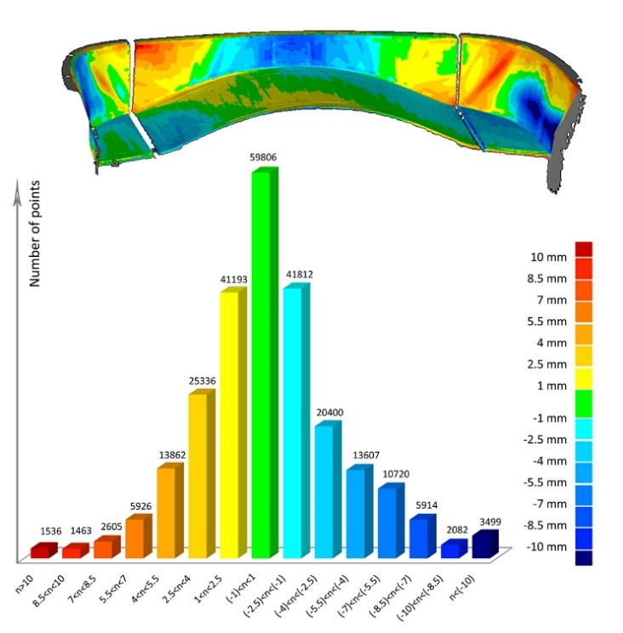
Figure 7. Maps of deviation distribution (Agisoft Photoscan).
Max +/- : 51.380 / -22.958 mm
Average +/- : 2.271 / -4.750 mm
Mean value of the distance between TEST/REFERENCE models:-0.81653 mm
Standard Deviation: 4.9616 mm
Mean value of all differences +-devstd:(4.1451,-5.7781) mm
Number of measured points: 306617

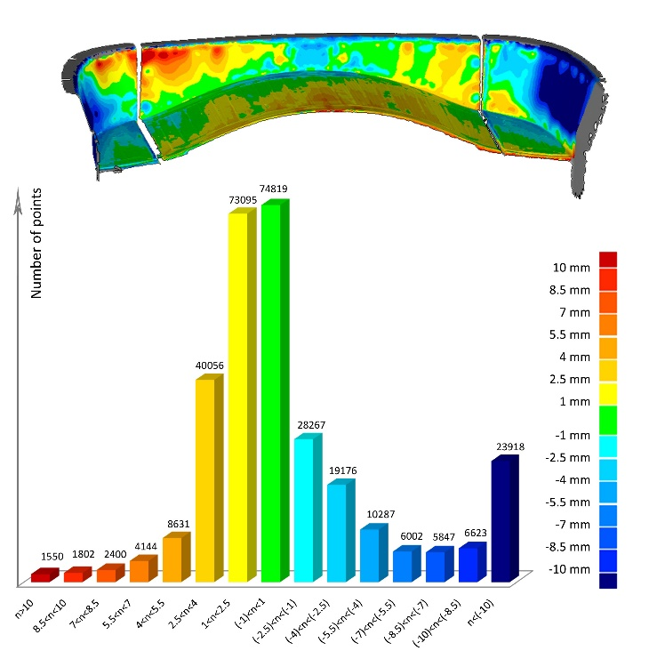
Figure 8. Maps of deviation distribution (Visual SfM).

Max +/- : 27.726 / -45.905 mm
Average +/- : 7.499 / -7.730 mm
Mean value of the distance between TEST/REFERENCE models: -1.2971 mm
Standard Deviation: 8.772 mm
Mean value of all differences +-devstd: (7.4748,-10.0691) mm
Number of measured points: 73071

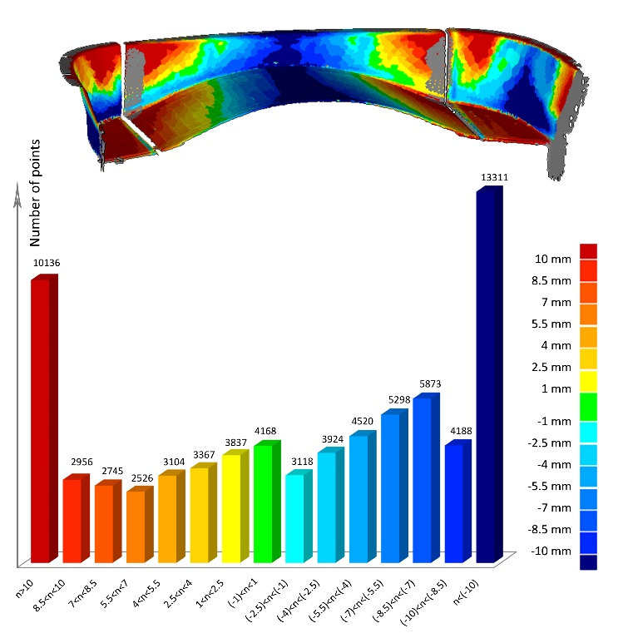
Figure 9. Maps of deviation distribution (Autodesk Remake).
Table 1. Deviation distributions.
Deviation distribution range | Agisoft Photoscan  Number of points | Visual SfM  Number of points | Autodesk Remake  Number of points
n>10 | 1536 | 1550 | 10136
8.5<n<10 | 1463 | 1802 | 2956
7<n<8.5 | 2605 | 2400 | 2745
5.5<n<7 | 5926 | 4144 | 2526
4<n<5.5 | 13862 | 8631 | 3104
2.5<n<4 | 25336 | 40056 | 3367
1<n<2.5 | 41193 | 73095 | 3837
(-1)<n<1 | 59806 | 74819 | 4168
(-2.5)<n<(-1) | 41812 | 28267 | 3118
(-4)<n<(-2.5) | 20400 | 19176 | 3924
(-5.5)<n<(-4) | 13607 | 10287 | 4520
(-7)<n<(-5.5) | 10720 | 6002 | 5298
(-8.5)<n<(-7) | 5914 | 5847 | 5873
(-10)<n<(-8.5) | 2082 | 6623 | 4188
n<(-10) | 3499 | 23918 | 13311
n>10 | 1536 | 1550 | 10136
8.5<n<10 | 1463 | 1802 | 2956
7<n<8.5 | 2605 | 2400 | 2745
5.5<n<7 | 5926 | 4144 | 2526
4<n<5.5 | 13862 | 8631 | 3104
2.5<n<4 | 25336 | 40056 | 3367
1<n<2.5 | 41193 | 73095 | 3837
(-1)<n<1 | 59806 | 74819 | 4168
Figure 10. Probability density diagram.

Table 2. Total number of measured points.
Agisoft Photoscan | 249761
Visual SfM | 306617
Autodesk Remake | 73071

A "measure" is a range of values, acquired with the purpose of controlling a process, perform the calibration of an instrument or allow the physical understanding of a partially known phenomenon [13], [14], [15].

Binding to this assertion, to further support the experimentation, the same obtained 3D models have been imported into the multi-paradigm numerical computing environment MATLAB. Through the elaboration of chromatic maps (Figure 13, Figure 14, Figure 15), which identify the volumetric error distribution and the distance between the closest point-to-surfaces of the meshes composing the models, it has been possible to compare the 3-dimensional surfaces through an algorithm. This algorithm is based on a modified function based on the ICP (Iterative Closest Point) approach, which minimize the distance between two dispersion of multidimensional points, i.e. the two point clouds to be registered and compared, respectively labelled as Reference Point Cloud (RPC) and Measured Point Cloud (MPC). The algorithm works through an iterative process and its goal is to minimize the value of a global goal function. In this case the global function as been developed as the global volumetric error (GVE), calculated as the sum of volumes of the single prismatic element, as shown in (Figure 11).
The approach in terms of volumes instead of the classic point-to-point distance gives an improved information: the value of GVE takes in account the size of the element of the triangulated meshes. Flat areas with large mesh size have a larger weight than areas characterised by a small mesh size. This behaviour is characteristic of volumetric approach. For each comparison, the algorithm has elaborated box plot statistical diagrams and volumetric error distribution graphs (Table 3, Figure 12).
It is possible to notice that the volumetric error distribution is quite similar to the behaviour of point-to-point approach, due to the high regularity of mesh sizing of both reconstructed surfaces.
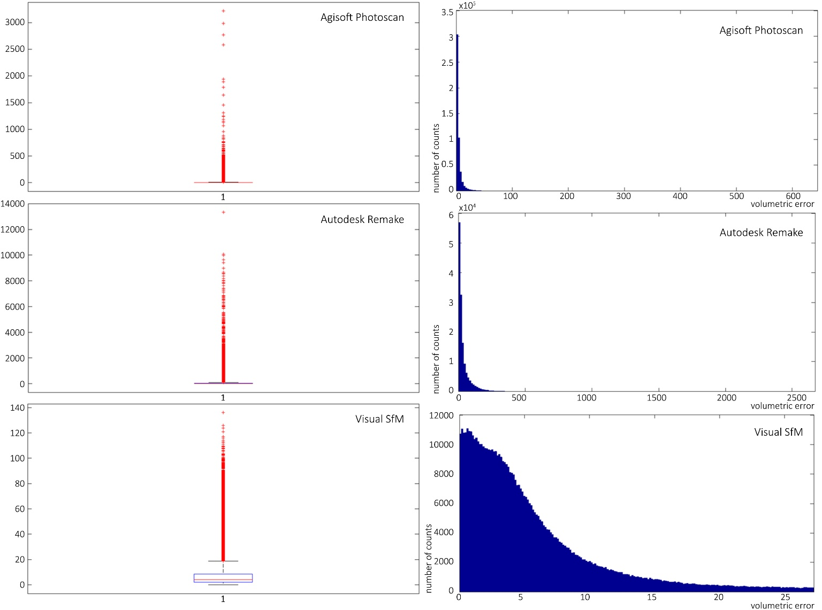
Figure 12. Volumetric error distribution and Box Plot: Agisoft Photoscan, Visual SfM and Autodesk Remake.
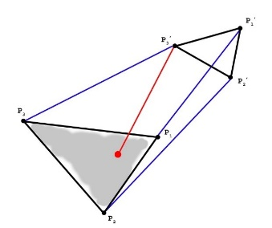
Figure 11. Triangular mesh distance (mm): ICP function (Iterative Closest Point).

Table 3. Volumetric error distribution.
Agisoft Photoscan | Mean=5.6638 mm³  STD=19.5801
Visual SfM | Mean=7.8655 mm3  STD=10.4855
Autodesk Remake | Mean=54.5649 mm3  STD=223.882

- Conclusions
The paper presents the metrological characteristics of simple and economical photomodelling techniques for boat shape measurements. The surfaces generated by two different techniques as photomodelling and a structured light 3D scanner with metrological certification has been detected in order to investigate the alignment error due to a poor geometry reconstruction. The comparison was made between three photomodelling process performed by the software Agisoft Photoscan, Visual SfM and Autodesk Remake; the results show different performances, in terms of deviation distributions and volumetric errors. The registration of the measured point clouds and the analysis of the error distribution have been carried out with the commercial software Geomagic Qualify. A tailored software in MATLAB environment has been realised in order to modify the target of registration algorithms through the global volumetric error calculation.
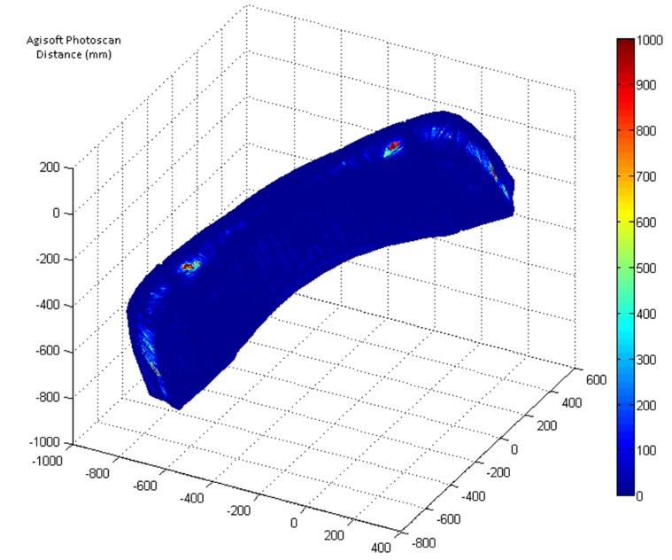
Figure 13. Chromatic maps: Agisoft Photoscan.

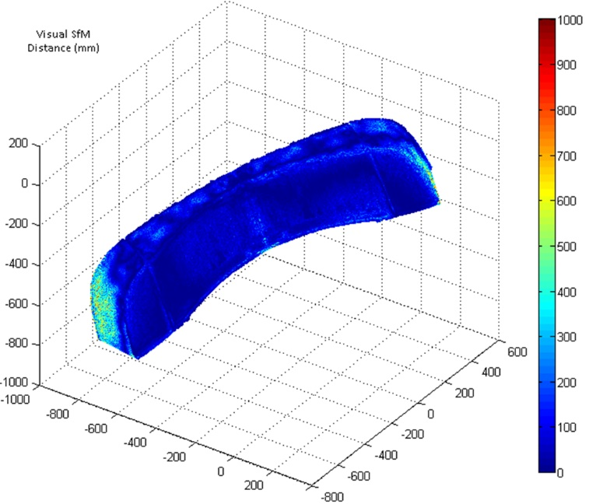
Figure 14. Chromatic maps: Visual SfM.

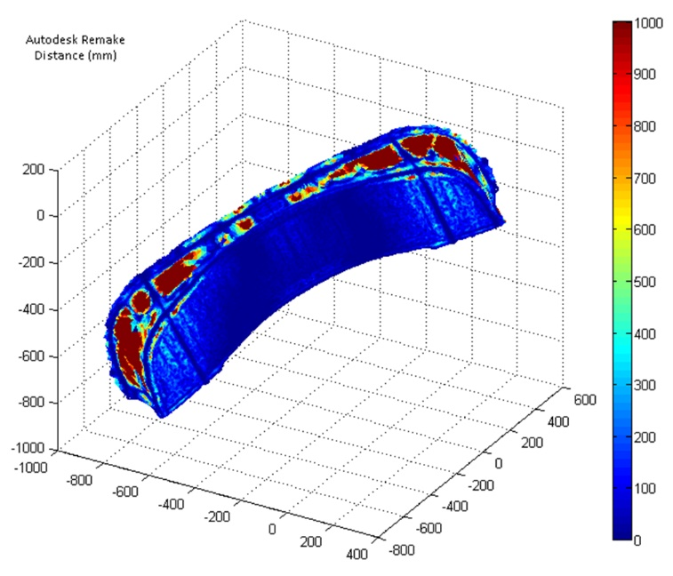
Figure 15. Chromatic maps: Autodesk Remake.
References
- L.De Luca, “La fotomodellazione architettonica. Rilievo, modellazione, rappresentazione di edifici a partire da fotografie”, Dario Flaccovio Editore, Palermo, 2011, pp.19-30.
- M.Filippucci, “Nuvole di pixel. La fotomodellazione con software liberi per il rilievo d’architettura”, Disegnarecon, 2010, vol.3(6), pp.50-63.
- V.A.Girelli, “Tecniche digitali per il rilievo, la modellazione tridimensionale e la rappresentazione nel campo dei Beni Culturali”, Tesi Dottorato di ricerca in Scienze Geodetiche e Topografiche, Alma Mater Studiorum Università di Bologna, ciclo XIX.
- R.Marsili, A.Garinei, “Thermoelastic Stress Analysis of the Contact Between a Flat Plate and a Cylinder”, Measurement: Journal of the International Measurement Confederation, 2014, vol.52(1), pp.102-110. Available from: http://dx.doi.org/10.1016/j.measurement.2014.03.005
- R.Marsili, M.Moretti, G.L.Rossi, “Thermoelastic Modal Stress Analysis”, IMAC XXVI Conference & Exposition on Structural Dynamic, Orlando, Florida USA, 4 – 7 February 2008; ISBN: 0912053984 ISBN 9781605600666
- R. Marsili, G. Brustenga, M. Moretti, J. Pirisinu, G.L. Rossi, “Measurement on rotating mechanical component by thermoelasticity”, Journal Applied Mechanics and Materials, ISBN 0-87849-987-3 ISSN 1660-9336, Vols 3-4, August 2005, pp 337-342, pp 411– 416
- M.Kazhdan, M.Bolitho, H.Hoppe, “Poisson Surface Reconstruction”, Eurographics Symp. on Geometry Processing, ed K Polthier and A Sheffer, 2006.
- F.B.J.Mittleman, H.R.C. Silva, G. Taubin, “The Ball-Pivoting Algorithm for Surface Reconstruction”, IEEE Transactions on Visualization and Computer Graphics, 1999, vol.5(4).
- R. Marsili, A. Garinei, “Design of an optical measurement system for dynamic testing of electrospindles”, in Measurement, 2013, vol.46, Issue 5 (Amsterdam: Elsevier), pp.1715-1721. DOI information: 10.1016/j.measurement.2013.01.006, ISSN: 0263-2241
- J.F.Brouckaert, R.Marsili, G.Rossi, “Development and experimental characterization of a new non contact sensor for blade tip timing”, 10th International Conference on Vibration Measurements by Laser and Noncontact Techniques - AIVELA, Ancona, ITALY, JUN 27-29, 2012 Conference Proceedings Volume 1457 Pages: 61 - 68 DOI: 10.1063/1.4730543 Published: 2012 IDS Number: BBI34 ISSN: 0094-243X ISBN: 978-0-7354-1059-6
- E.Cardelli, A.Faba, R.Marsili, G.Rossi, R.Tomassini, “Magnetic nondestructive testing of rotor blade tips”, Journal of Applied Physics 117, 17A705 (2015); doi: 10.1063/1.4907180
- R.Marsili, A.Garinei, “Development of a new capacitive matrix for a steering wheel's pressure distribution measurement”, International Journal of Industrial Ergonomics Volume 44, Issue 1, January 2014, Pages 114-119 doi: 10.1016/j.ergon.2013.11.012
- G.Rossi, “Misure meccaniche e termiche. Basi teoriche e principali sensori e strumenti”, Carocci, Roma, 2010.
- M.Becchetti, R.Flori, R.Marsili, M.Moretti, "Comparison between digital image correlation and thermoelasticity for strain field analysis", (2010) 9th International Conference on Vibration Measurements by Laser and Noncontact Techniques and Short Course; Ancona; Italy; 22 June 2010 - 25 June 2010 AIP Conference Proceedings, Volume 1253, pp. 233-240, doi=10.1063/1.3455462 ISSN: 0094243X ISBN: 978-073540802-9
- R.Marsili, G.L.Rossi, M.Becchetti, R.Flori, “Stress and strain measurements by image correlation and Thermoelasticity”, Society for Experimental Mechanics - SEM Annual Conference and Exposition on Experimental and Applied Mechanics 2009, Volume 1, 2009, Pages 70-75; Albuquerque, NM; United States; 1 June 2009 through 4 June 2009; Code 78716; ISBN: 978-161567189-2; 978-161567189-2
- I. E. De Napoli, E. M. Zanetti, G. Fragomeni, E. Giuzio, A. L. Audenino, G. Catapano. “Transport modeling of convection-enhanced hollow fiber membrane bioreactors for therapeutic applications”, (2014) Journal Of Membrane Science, vol. 471, p. 347-361, ISSN: 0376-7388, doi: 10.1016/j.memsci.2014.08.026
- E.M. Zanetti, A.L. Audenino; “Differential Thermography for Experimental, Full-field Stress Analysis of Hip Arthroplasty” (2010) J. Mechanics in Med&Biol., Vol. 10(3), World Scientific Journals, London, UK, pp. 515-529. ISSN: 0219-5194, doi: 10.1142/S0219519410003496.
- E. Speranzini, R. Marsili, M. Moretti, G. Rossi, “Image analysis technique for material behavior evaluation in civil structures”, (2017) Materials, 10 (7), art. no. 770, doi: 10.3390/ma10070770
- E. Speranzini, S. Tralascia, "Engineered Lumber: LVL and solid wood reinforced with natural fibres", (2010) WCTE 2010 – 11th Word Conference on Timber Engineering, editrice Pergine, Trento, 2, pp. 1685-1690, ISBN: 978-162276175-3, Scopus: 2-s2.0-84870414692

