From: Prof. Salvatore Gaglione (Corresponding author)
Centro Direzionale - Isola C4
(80143) Napoli – Italy
ph.: +39 081 5476610
@: salvatore.gaglione@uniparthenope.it

Date: January 15th 2018

Sub: Submission of Research Paper for ACTA IMEKO

Please find enclosed our manuscript, “Using local redundancy to improve GNSS absolute positioning in harsh scenario”.
This study is an upgrade of the one, titled “Enhanced pseudorange weighting scheme using local redundancy”, submitted to "IMEKO TC19 WORKSHOP on METROLOGY FOR THE SEA held in Naples, (Italy) on October 11th – 13th 2017”. The extension of this paper are related to:
- the use of GPS/Glonass multi-costellation;
- a more capillary review on the weighting schemes existing in literature;
- more weighted schemes configurations are tested.
With the submission of this manuscript I would like to undertake that the above mentioned manuscript has not been published elsewhere, accepted for publication elsewhere or under editorial review for publication elsewhere; and that my Institute’s representative, Parthenope University of Naples, is fully aware of this submission. All authors have approved the manuscript and agree with its submission to your Journal.
We believe our findings would appeal to the readership of Acta IMEKO

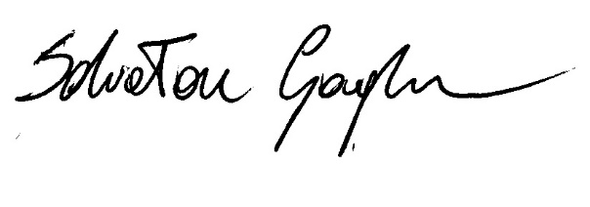
Best Regards

Salvatore Gaglione

