Signal analysis based diagnostics of switch-mode power converter in mixed-signal simulation environment
Gábor Kohlrusz¹, Krisztián Enisz¹, Bence Csomós¹, Dénes Fodor¹
¹ Dept. of Automotive Mechatronics, Institute of Mechanical Engineering, University of Pannonia, Egyetem 10, 8200 Veszprém,Hungary
ABSTRACT
In this work the input and output capacitors of a digitally controlled Buck converter have been tested in 4 different cases with unused and worn out capacitors. The information extracted from interactions between the subsystems of an electric energy conversion system requires the implementation of the whole system from network to load. A complex simulation environment has been implemented where digital and analogue domains can be connected. The input and output capacitor aging have a significant influence on time domain characteristics, but the evaluation of frequency-domain data is supposed to be required to extract information from the noisy and distorted time-domain signal. The presented diagnostic approach aims to analyze signals that are used by the control loop in order to avoid expensive additions to existing circuits.

Section: RESEARCH PAPER
Keywords: Discrete Fourier Transform; digitally controlled converter; capacitor degradation diagnostics; mixed-signal simulation
Citation: Thomas Bruns, Dirk Röske, Paul P.L. Regtien, Francisco Alegria, Template for an IMEKO event paper, Acta IMEKO, vol. A, no. B, article N, month year, identifier: IMEKO-ACTA-0A (year)-0B-0N
Section Editor: name, affiliation
Received month day, year; In final form month day, year; Published month year
Copyright: © year IMEKO. This is an open-access article distributed under the terms of the Creative Commons Attribution 3.0 License, which permits unrestricted use, distribution, and reproduction in any medium, provided the original author and source are credited
Funding: This work was supported by the Hungarian Government and co-financed by the European Social Fund and European Union
Corresponding author: Gabor Kohlrusz, e-mail: gkohlrusz@almos.uni-pannon.hu

- Introduction
A mixed-signal simulation environment is capable to prognosis failure or wear out phenomena during the design phase. The simulation results affect the controller design process and circuit components sizing. The purpose of this paper is to present the possibilities of signal analysis based diagnostics in switch-mode power converters. Signal-based diagnosis looks for the known fault signatures in quantities sampled from the actual system. In order to identify fault or degradation in the analyzed system the sampled signals are evaluated by signal processing techniques. Typically, frequency analysis is used, but time-frequency analysis and other advanced methods can also be advantageous according to the literature [1].
In this work the input and output capacitors of a digitally controlled Step-Down DC-DC converter (Buck converter) have been tested in 4 different cases with unused and worn out capacitors. The applied diagnostic technique focuses on both the detection of dominant frequency components occurred by degradation and change in operation-related components due to capacitor aging. The tests were performed by exploiting the advantages and possibilities of a mixed-signal simulation environment which is well-suited for energy conversion system modelling and analysis.
Many contributions can be found in literature dealing with capacitor aging diagnosis in PWM converters, but they have a lack of considering the effect of signal conversion and signal processing or realistic noisy operational circumstances. In [2] the authors analyze the effect of capacitor degradation in digitally controlled PWM converter, but without considering the discrete-time operation of the controller. It also assumes ideal DC voltage at the converter input.
In the related area, most of the diagnostic methods utilize dynamic model of the analyzed system [3], [4] while the presented diagnostic approach requires only signals that are necessary for normal operation of the controller.
- ModelLing in mixed-signal simulation environment
The digitally controlled power converters are mixed-signal systems containing both analogue and digital signals. In order to analyze these systems close to realistic behaviour it is worthy to design and to model the analogue and digital subsystems separately. The electric part of the system can be modelled properly in a circuit design environment, while the digital environment and the control algorithm should be implemented in an environment that is capable to run numerical computations. In such a complex development and test environment it is possible to simulate signal conversion and signal processing processes which have a significant effect on the system behaviour and generally are neglected. In this work a digitally controlled Buck converter has been analyzed using OrCAD circuit design environment and MATLAB/Simulink environment interconnected (Figure 1).
  - Modelling of Step-Down DC-DC converter
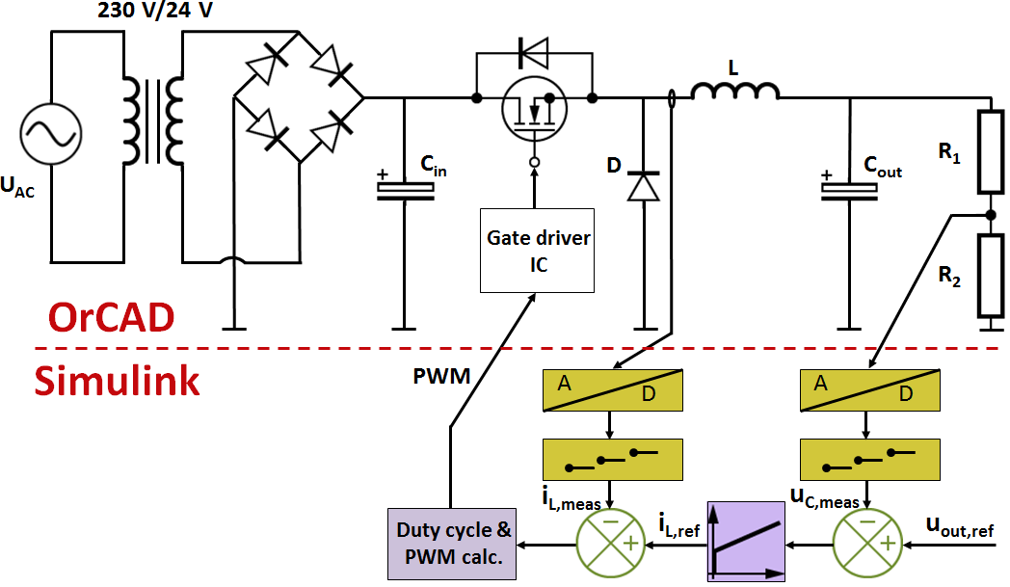
Figure 1. Mixed-signal simulation environment for digitally controlled electric drive and power converter analysis
The analogue part of the electric energy conversion system is a Buck DC-DC converter fed by a single phase diode rectifier. The converter is designed for providing 16 VDC output voltage when 24 VDC input voltage is supplied by the rectifier. The design specifications can be found in Table 1.
The circuit of the converter has been implemented in OrCAD environment. It was extended with additional components in order to reflect the realistic behaviour:
- wire resistances and parasitic inductances;
- inductor model extended by coil resistance;
- standard model for input and output capacitor.
Aluminium electrolytic capacitors are modelled by an electrical equivalent circuit (Figure 2) which is the so-called “standard model” and is used in the industry by several manufacturers such as Epcos, Jianghai, Nichicon or Vishay. The substitution of the input and output capacitor by the standard model makes component aging simulation possible.
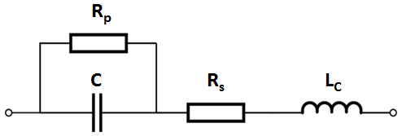
Figure 2. Standard model of electrolytic capacitor

Table 1. Buck converter specifications.
Input voltage (u_{in}) | 24 VDC
Output voltage (u_{out}) | 16 VDC
Operating frequency (f) | 20 kHz
Output current (i_{out}) | 2.25 A
Inductor current ripple (Δi_{L}) | 0.5 A
Output voltage ripple (Δu_{C}) | 0.5 V
  - DC-DC converter digital controller design and implementation
The digital part of the system has been implemented in MATLAB/Simulink. It includes the controller algorithm, the A/D converters etc. The controller is responsible for holding the 16 VDC at the converter output. The closed-loop control system is implemented in the structure as it can be seen in Fig. 1.
Based on the difference between reference voltage and measured output voltage signal, the error signal can be calculated that serves as the input of the PI regulator. The regulator has been tuned by direct synthesis method that required the transfer function between output voltage and inductor current. The output of the PI regulator is the reference current of the inductor. Comparing the controller output and the measured inductor current, an error signal can be generated. The duty cycle is calculated by considering inductor current error signal (1). [5]
(1)
where D is the duty cycle, L is the inductance of the inductor, u_{in} is the input DC voltage of the converter, T_{s} is the sampling time of the digital platform, i_{L,avg} is the measured current, i_{ref} is the current reference provided by the PI regulator, u_{C} is the output voltage of the converter and k is the discrete time.
As it can be found in Table 1, the operating frequency of the converter is 20 kHz, hence the control algorithm runs in every 50 μs. Therefore, 50 μs timeframe is available for realistic signal conversion, data processing and duty cycle calculation. It introduces 50 μs time delay that is treated by Smith-predictor.
- ModelLing of Capacitor degradation
Due to the complexity of electric drives, faults can be occurred related to several components. Focusing only to the power converter, faults are categorized as sensor faults, conducting part faults, passive component faults and switching element faults.
In this paper, a passive component aging is introduced to the power converter, more precisely capacitor degradation has been modelled by the assistance of the standard model (Figure 2.). Even the capacitor has significant degradation, the catastrophic failure should be avoided. It is sufficient to notice the wear out before it causes short-circuit through the capacitor and affects other components. In order to avoid damage, it is sufficient to notice faults as early as possible.
The aim of the presented analysis is to find quantities which may vary with the aging or carries information about degradation. The mixed-signal model environment is a tool to analyze signals that may not be accessible on a real device.
Four different case studies were performed during converter operation:
- new/unused input and output capacitors;
- only output capacitor is degraded;
- degraded input and output capacitors;
- only input capacitor is degraded.
Table 2. Parameters of new and aged capacitor.
 | Input capacitor |  | Output capacitor
 | New | Aged | New | Aged
R_{s} | 0.02 Ω | 0.1 Ω | 0.03 Ω | 0.15 Ω
R_{p} | 40 MΩ | 2.4 MΩ | 16 MΩ | 1.6 MΩ
C | 10 000 μF | 9 000 μF | 12.5 μF | 11.25 μF
L_{C} | 0.7 nH | 0.7 nH | 0.3 nH | 0.3 nH
In the four different simulations the Buck converter was operated under conditions detailed above, the new and aged capacitor values were determined based on Table 2.
Due to the PWM operation of converter and the harmonics occurred, the aging of the capacitor can be observed. The main wear out failure mechanism is the evaporation of the electrolyte solution which causes a decrease in capacitance (C) and an increase of the equivalent series resistance (ESR).
In the case of aged capacitor, the series resistance was increased by the factor 5 while the capacitance was decreased by 10 % compared to the unused capacitor values. The parallel resistance models the leakage current of the capacitor. The leakage current should be around 1-2 μA in the case of a new capacitor, however, this value is 8-10 μA for an aged capacitor [6]. The inductance of the capacitor foil is irrelevant since its value is less than 1 nH. The values shown in Table 2 belong to a capacitor used in practical application and do not concern with theoretical domain.
- Signal analysis based degradation detection
The presented approach utilizes measurement of voltage and current that are also required by the control system and it does not mean extra effort or cost. Consequently, the diagnostic approach aims to analyze the output voltage waveform, inductor current and input capacitor voltage. These signals serve as a basis of a diagnostic technique which focuses on the detection of dominant frequency components or distorted frequency spectrum of the measured signals caused by the aging.
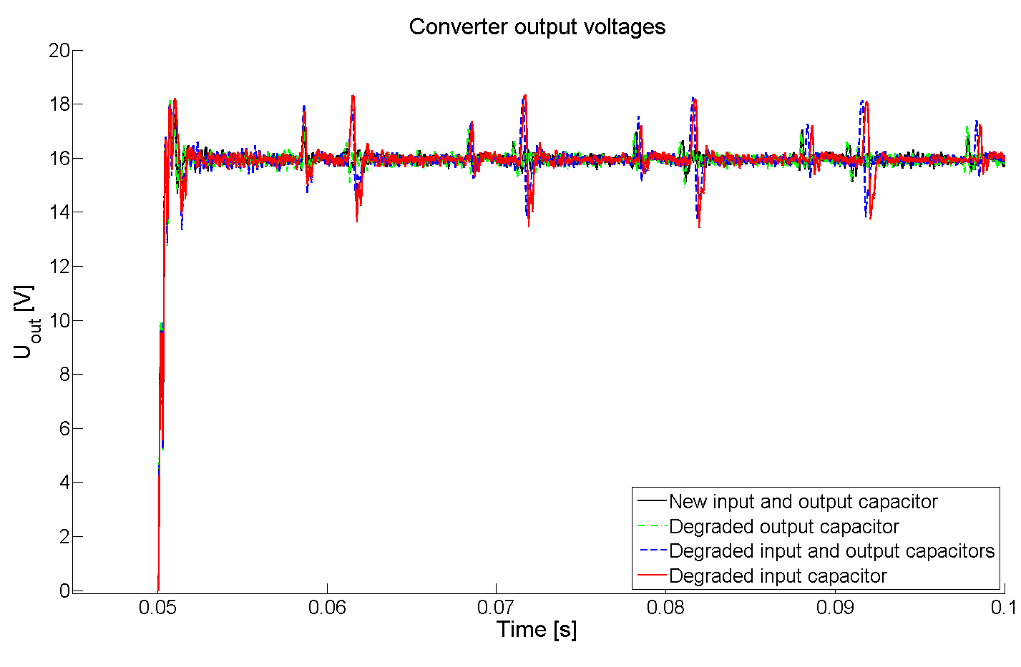
Figure 3. Time-domain output voltages in four test cases
Figure 3 shows the output voltages of the Buck converter when a 16 V output reference has been applied.
Simulations were run to all the four cases. The input and output capacitor aging have a significant influence on time domain characteristics (Figure 3). The spikes on the characteristic are caused by the minimum and maximum values of the rectified voltage ripple that change corresponding to aging. The evaluation of frequency-domain data is supposed to be required to extract information from the noisy and distorted time-domain signal.
The signal analysis has been performed by DFT (Discrete Fourier Transform) when the recorded signals are in steady state and under load change. The input data of DFT was sampled by 10 MHz sampling frequency and sample count (N) was equal to data length. The frequency analysis was run on only the steady-state region in order to supress the effect of the transient part of the response. The DC component was removed by subtracting the average voltage from the data.
The amplitude-frequency diagram of the frequency-domain data has been augmented to include a second chart which emphasizes the dominant frequency values. The DFT of the steady-state signals resulted in frequency components with amplitude less than 0.1 V. In order to distinguish the dominant frequencies easier (2) has been introduced.
(2)
where A(f_{i}) is the amplitude of the i-th downsampled component, A(f_{n}) is the amplitude of n-th frequency component according to the results of DFT, i = 0,1,…
It means ten times downsampled frequency-domain data whereas the points are square-rooted. The square-root reduced the difference between the components with high and small amplitudes. Since the frequency intervals are Δf = 20 Hz, the summary in (2) results in amplitudes valid for 200 Hz intervals.
- simulation results
The output voltage of the capacitor has been analyzed in the first case. Besides evaluating the steady-state waveforms, it seemed to be beneficial to gather information about capacitor aging upon load-change.
  - Analysis of steady-state output voltage waveform
The upper part of Figure 4 shows the frequency-amplitude characteristics of voltage output of the converter in steady-state for 4 different capacitor conditions. In all cases, the switching frequency fundamental at 20 kHz and its higher order harmonics can be observed. The fundamental component is operational-related property, so it was reasonable to track its amplitude in all test cases. When the output capacitor was selected for degraded component, the amplitude of fundamental component started to increase. Nevertheless, when the input capacitor was degraded, the amplitude of 20 kHz fundamental frequency component decreased. However, the capacitor parameter variation does not have significant influence on 20 kHz component within the range set in Table 2, therefore, the variation of fundamental component amplitudes is not practically measurable.
There are considerable harmonics in the 0-4000 Hz interval due to aperiodic spikes in the voltage time-domain waveform (Figure 3). The worn out input capacitor amplifies the amplitudes of spikes because the filtering function of the capacitor is getting insufficient. It leads to increased harmonic amplitudes in the 0-4000 Hz region. The effect of aged output capacitor on the inspected spectrum is negligible compared to the new one.
The corresponding phase chart has also been generated. Tracking the phase of aperiodic signals is unreliable and thus, unreasonable, consequently, the phase of fundamental and its higher order harmonics were investigated. These phase values have completely overlapped in all test cases.

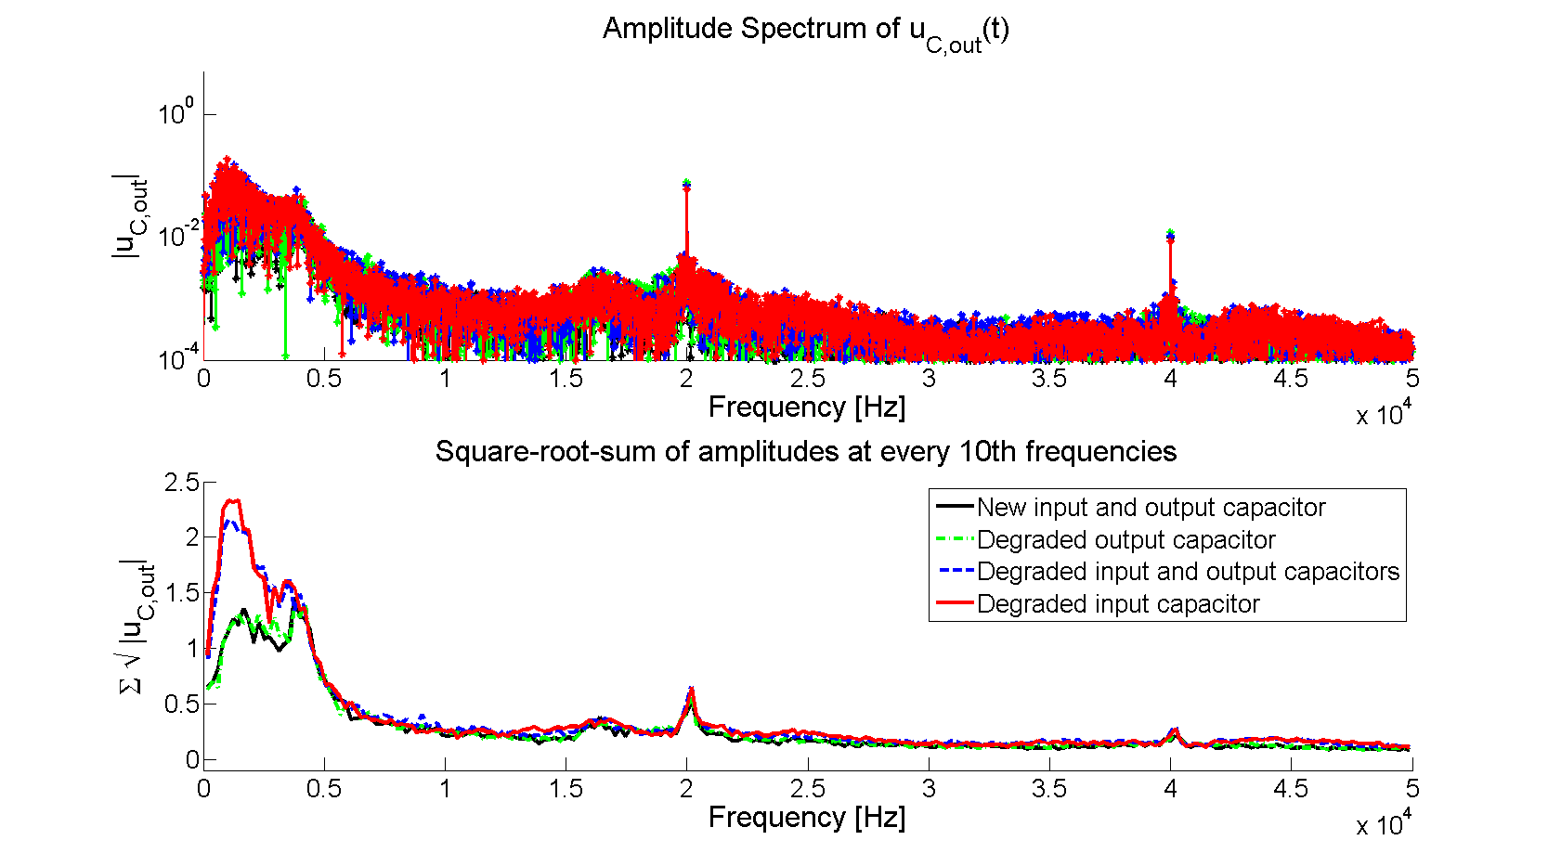
Figure 4. Frequency spectrum of output capacitor steady-state voltage
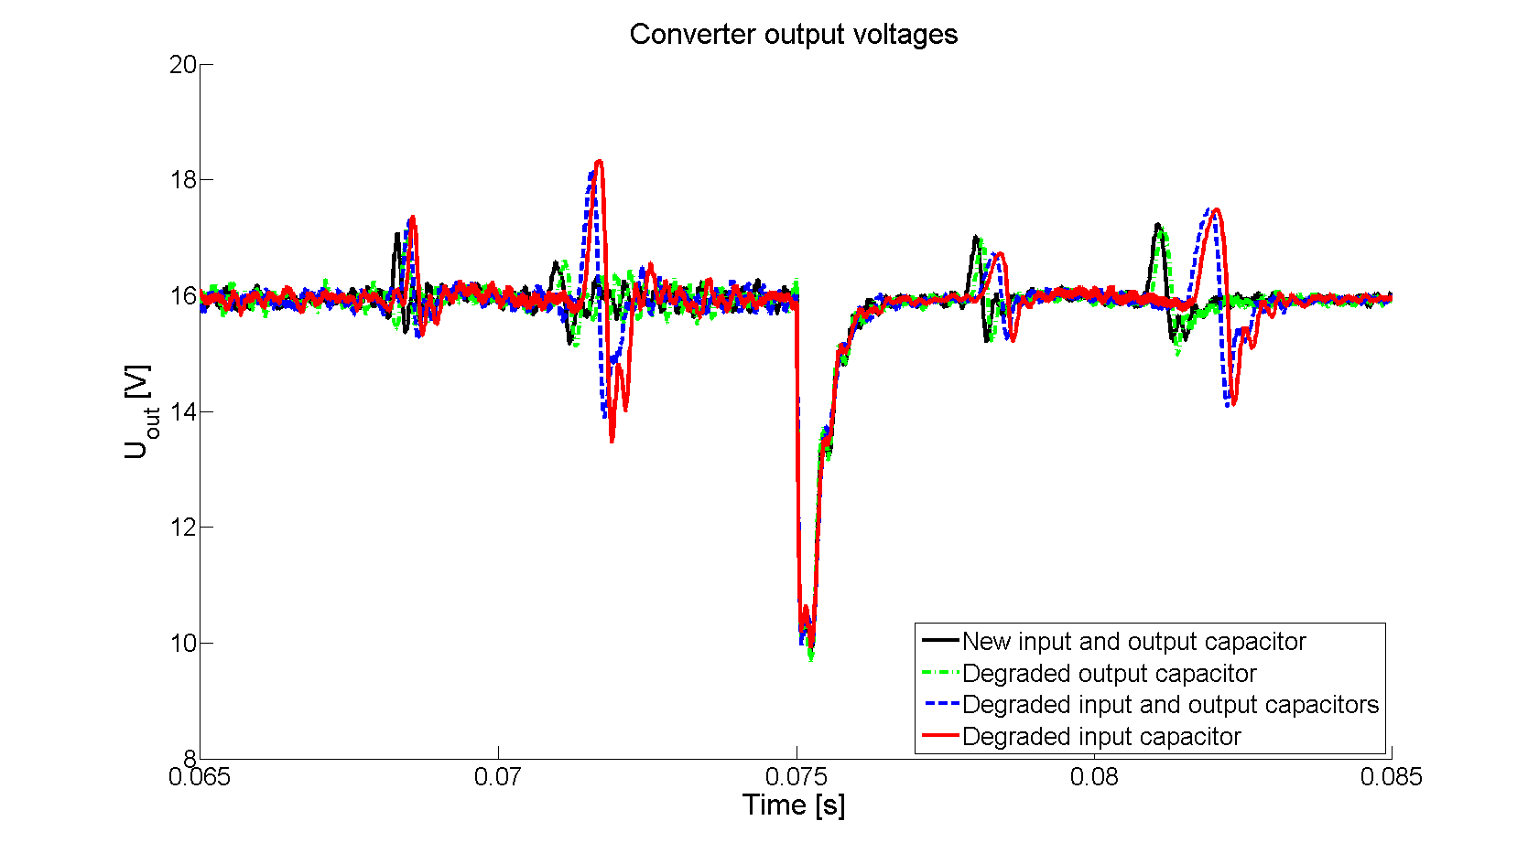
Figure 5. Effect of load-change in output capacitor voltage waveform
  - Analysis of transient state output voltage waveform
The change in the capacitance due to aging is supposed to have an influence on the time constant of system output that in this case is an LC filter. In order to retrieve information about degraded capacitors in the circuit, analysis of voltage signal response during transient seemed to be reasonable.
The transient has been introduced by load change that was twice as many as in the beginning. The load change was applied at the time t = 0.075 ms (Figure 5). As the figure shows the capacitor aging has no effect on the transient of the time-domain signal. The transient spike becomes dominant in frequency-domain and therefore, the differences between harmonics in 0-4000 Hz interval have vanished.
  - Analysis of inductor current waveform
Besides the output voltage, the inductor current is also used by the control loop so it was analyzed in frequency-domain, as well. The frequency spectrum of inductor current is very similar to the spectrum of output voltage but the amplitudes in the region of lower harmonics are less significant. The output capacitor does not play an important role in the harmonic content because the capacitance of the output capacitor is much smaller than the input one. Consequently, simulations that subjected the aged output capacitor and unused input and output capacitors together show the same results, however, the degraded input capacitor has noticeable effect on harmonic amplitudes.
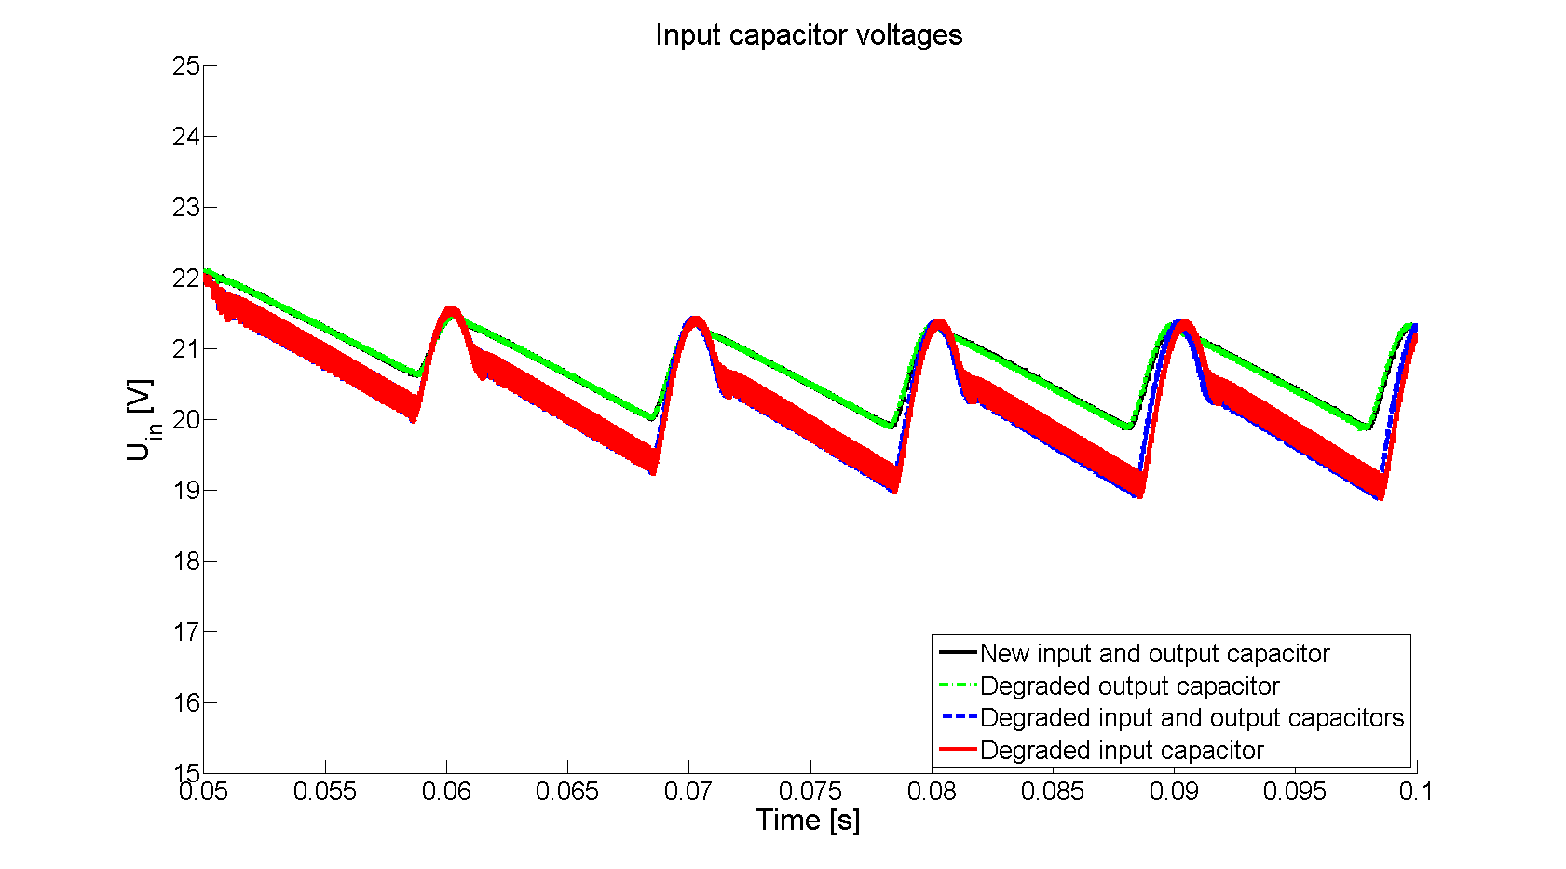
Figure 6. Input capacitor voltage waveform
The fundamental component of the switching frequency at 20 kHz varies in amplitude due to the dominance of input capacitor. In the case of unused input capacitor the amplitude of 20 kHz component is 0.1 A, while this value is 0.118 A when input capacitor is degraded.
  - Aging effects of input capacitor
According to (1), the calculation of duty cycle requires the input voltage that can be considered constant in certain circumstances or can be measured for more reliable operation. Although the converter can operate without knowing the accurate value of input voltage, it is practical and easy to measure this and applicable for diagnostics. The function of the input capacitor is smoothing the voltage ripple at the converter input. The filtering effectivity and characteristic of the capacitor is strongly related to its parameters. If a change occurs in its capacitance, the input voltage characteristic of the converter is distorted. Figure 6 shows different results of aging of the input and output capacitors. The voltage signal contains the ripple caused by the 50 Hz AC voltage as well as the 20 kHz PWM switching harmonics. Both of the mentioned voltage ripple have been amplified by aging but only the effect of the input capacitor degradation is outstanding. This phenomenon can be explained by the reduction of capacitance.
The amplitude difference between the minimum and the maximum value of the ripple is 1.5 V when input capacitor is new and 2.5 V when it is aged. The peak-to-peak voltage ripple is 75 mV and 340 mV, respectively.
In frequency domain, the fundamental component and its higher harmonics are remarkably increased (Figure 7). Note that the amplitudes are manipulated according to (2). In case of new capacitors and degraded output capacitor, the component’s amplitude is 26 mV at 20 kHz and 18 mV at 40 kHz and in case of degraded input and degraded input and output capacitor it reaches 112 mV at 20 kHz and 72 mV at 40 kHz.
The amplitude of the smaller additional harmonic components has been also slightly increased when degraded input capacitor has been chosen.
Conclusions
The present paper concerns a Buck converter that has been undergone a simulation analysis where the aging phenomenon was inspected in the filtering input and output capacitors for diagnostic purposes.
The information extracted from interactions between the subsystems requires the implementation of the whole electric energy conversion system from network to load. It led to a universal and modular structure of simulation environment. A complex simulation environment has been implemented where digital and analogue domains can be connected and run simultaneously. It supports the analysis with practical aspects introducing cycle time and delays to the model and also, establishes connection between continuous and discrete domains. The continuous part of the simulation environment is based on OrCAD while the discrete domain is implemented in Simulink. Consequently, the circuit has been implemented in OrCAD and the controller algorithm has been realised in Simulink.
The diagnostic capabilities and features of the simulation environment have been validated on a Buck converter because its structure is quite general to model most of the switch-mode power converters. For diagnostic purposes, the simulation has also included the rectifying stage to make the converter output effect at the input realistic.
To avoid expensive additions to existing circuits or to well-integrated designs, it is advantageous to use signals for diagnostics that are already present in the controller. After the analysis of input and output voltages and inductor current of the converter, it can be concluded that the capacitor aging can be observed in the amplitude variation of voltage spikes.
Based on observations of time-domain signal distortion it was reasonable to analyze the frequency-domain of the measured signals. In frequency-domain the signatures of capacitor aging appeared in the 0-4000 Hz region of output voltage signal, however, during load-change this phenomenon become invisible since the harmonics due to load-change become dominant. This can be handled by the application of frequency analysis using sliding window where it can be seen how frequencies change through time. The amplitude of the operation-related 20 kHz harmonic component changes when the output or input capacitor degrades. The 20 kHz component amplitude of the output voltage waveform changes with a small amount with the aging of the capacitors.
The ripple in the input voltage waveform has been amplified by aging of input capacitor. The variation of input voltage can be well-observed, but it can be difficult the measurement of this change in time-domain. In frequency domain, the fundamental component and its higher harmonics are remarkably increased so the detection of aging-related signal distortion is effortless.
Acknowledgement
This research is supported by EFOP-3.6.1-16-2016-00015 project. The project is supported by the Hungarian Government and co-financed by the European Social Fund.
The project has been supported by the European Union, co-financed by the European Social Fund. (EFOP- 3.6.2-16-2017-00002).
References
- Y. Gritli, “Diagnosis and Fault Detection in Electrical Machines and Drives based on Advanced Signal Processing Techniques”, Ph.D. dissertation, Department of Electrical, Electronic, and Information Engineering, University of Bologna, 2014.
- R. Marschalko, D. Fodor, P.Teodosescu, M. Bojan, “Influence of DC-Link Capacitor Aging on the PWM Converters Operation”, ACTA Electrotehnica, Vol. 52 (4), 2011.
- K. Abdennadher, P. Venet, G. Rojat, J. Retif, C. Rosset, “A Real-Time Predictive-Maintenance System of Aluminum Electrolytic Capacitors Used in Uninterrupted Power Supplies”, IEEE Transactions on Industry Applications, Institute of Electrical and Electronics Engineers, 2010, Vol. 46 (4), pp. 1644 - 1652.
- J. Poon, I. C. Konstantakopoulos, C. Spanos, S. R. Sanders, “Real-Time Model-Based Fault Diagnosis for Switching Power Converters”, IEEE Applied Power Electronics Conference and Exposition (APEC), 2015.
- K. Wan, “Advanced current-mode control techniques for DC-DC power electronic converters” Ph.D. dissertation, Missouri University of Science & Technology, 2009.
- L. Kovács, D. Fodor, Estimation of the maximum applicable voltage level of aluminium electrolytic capacitors by automated spark-detection measurement, Hungarian Journal of Industrial Chemistry, 2011, Vol. 39 (1), pp. 73-78.
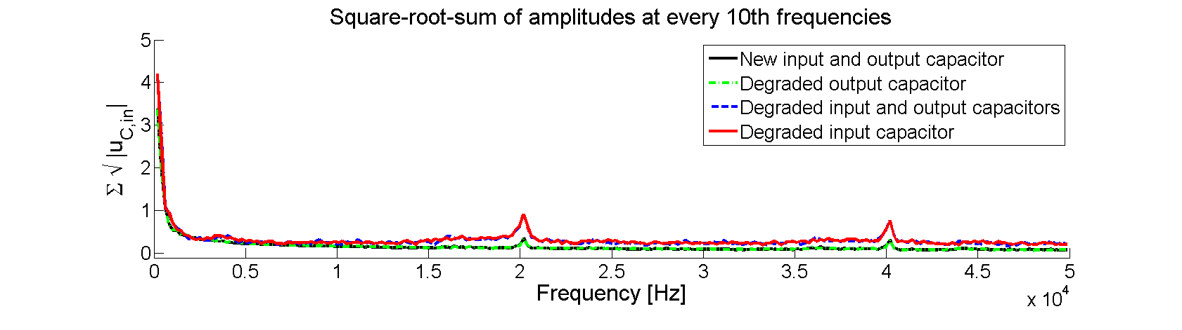
Figure 7. Frequency-domain data of input capacitor voltage signal

