A new system for the measure of gripping force based on the scattering
M. Becchetti¹, R. Marsili¹, F. Cannella², A. Garinei³
¹ Dipartimento di Ingegneria, Università degli Studi di Perugia, Perugia, 06125, Italy
² Istituto Italiano di Tecnologia, Genova, 16163, Italy
³ DMII, Università degli Studi Guglielmo Marconi, Roma, 00193, Italy
The measurement of contact pressure of human fingers is very important to understand human perceptual mechanisms, that is the main goal of most of the neuroscientific studies. It may also lead to a correct development of tactile devices and haptic systems, as they are intended to convey controllable and effective stimuli.
In this work, an optical measurement system based on Frustrated Total Internal Reflection (FTIR) is proposed for the measurement of the pressure distribution on the contact area between a human finger and a flat surface. The feasibility study performed shows that the tested sensor can be effectively used for the measurement of the fingertip contact pressure both on static and dynamic conditions..

Section: RESEARCH PAPER
Keywords: Frustrated Total Internal Reflection (FTIR), fingertip contact pressure, biomechanics
Citation: Thomas Bruns, Dirk Röske, Paul P.L. Regtien, Francisco Alegria, Template for an IMEKO event paper, Acta IMEKO, vol. A, no. B, article N, month year, identifier: IMEKO-ACTA-0A (year)-0B-0N
Section Editor: name, affiliation
Received month day, year; In final form month day, year; Published month year
Copyright: © year IMEKO. This is an open-access article distributed under the terms of the Creative Commons Attribution 3.0 License, which permits unrestricted use, distribution, and reproduction in any medium, provided the original author and source are credited
Funding: This work was supported by Measurement Science Consultancy, The Netherlands
Corresponding author: Roberto Marsili, e-mail: roberto.marsili@unipg.it

- Introduction
The investigation of the mechanisms of human tactile perception represents a fundamental topic in haptics. The fingertip deformation is the basic mechanical action in the tactile perception, since tactile sensitivity depends on the tissue strain and hence on the contact area. Different models are available to predict the behaviour of the fingertip in terms of contact area, deformation and pressure distribution [1,2]. Measurements are thus required both to determine the static fingertip area and force as input to the numerical models and to measure the area and the pressure necessary for numerical model validation. When measuring the contact pressure, the goal is to set up a measurement system with high sensitivity at low pressure, since, for specific applications, the typical pressure range is from 0 Pa to 50000 Pa.
The main objective of this work is the development of a measurement system, which allows to characterize the different aspects of the interaction finger - contact surface, through

the measurement of the contact area and of the pressure distribution, both in static and dynamic conditions.
Many sensors based on different physical principles have been proposed for the measurement of pressure at contact surface between two rigid or flexible bodies. Some contact pressure measurement systems have been used for measuring pressure distribution at interfaces between objects, with application to comfort analysis and improvement of vehicle seats [3], for various biomedical applications such as measurement of contact pressure between hand and handle of a tool in order to analyze vibration transmission to the hand [4, 5] or between foot and ground for plantar pressure analysis [6, 7]. Many applications have been developed [8, 13] also in other fields such as robot technology (tactile sensors), for contact force mapping of mechanical parts. The film sensors used for those applications are based on piezo-polymers, capacitive, conductive-ink or resistive polymers sensing elements. However, many metrological problems remain unresolved, due to non-linearity, reological behaviour, mounting surface curvature and shape, dynamic characteristics, etc. Also frequency limitations can be due to the sensor itself or to the electronic processing and data acquisition system, when a matrix of many sensing elements is necessary. Piezo-polymers have probably the best metrological characteristic but cannot measure very slow fluctuations or static pressure components. Sensors based on conductive ink or resistive polymers showed from preliminary tests that metrological characteristics change with time and have large hysteresis. The capacitive sensing elements can be used to measure both dynamic and static pressure with acceptable linearity and hysteresis, but their sensitivity is low and they cannot measure very small pressures.
Here an optical measurement system based on light scattering is developed and analyzed.
The outline of this paper is as follows. First, the design of an optimized measurement system based on Frustrated Total Internal Reflection (FTIR) is described. Then the results of specific tests performed on the measurement system are shown, to define its static and dynamic behaviour and to evaluate if the proposed measurement technique can be effectively used to measure human fingertip mechanical properties in terms of contact area and pressure distribution.
- Experimental background and setup
The principle of the measurement system is the light reflection/refraction at the interference between two transparent media. When the light passes through an interference between media of different refractive indices, the path of travel changes (Snell’s Law).
Thus when a light source is installed at the edge of a thin glass plate and the incident angle ϑ₁ exceeds the critical angle ϑ_{critical} (Figure 1a), the plate acts as a light guide. In this case (total internal reflection) the light cannot be seen when observing the plate from below the plate.
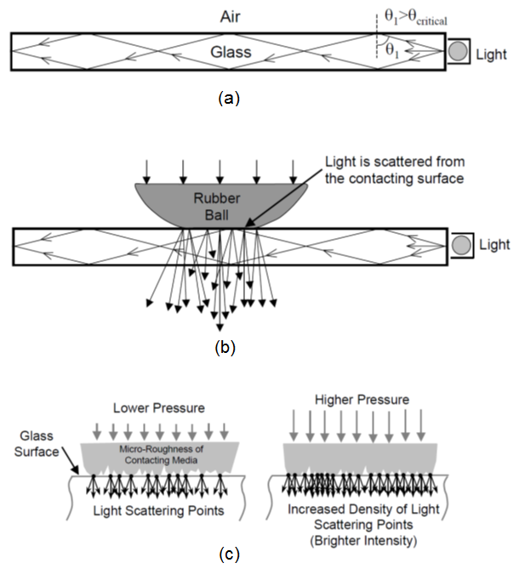
Figure 1. Principle of measurement [9].
If a reflecting media is pressed against the plate, the surface of the media will scatter light in the contact surface, being the media with a refractive index different than the refractive index of the air (Figure 1b). By observing the light scattered, it is thus possible to view the shape of the contact surface. Depending on the roughness of the contact surface, the contact area will increase with the contact pressure, thus the light intensity can be used to measure the contact pressure between the two media (Figure 1c).
Methods based on white light refraction are used for the measurement of normal contact stress between 'soft' structures and a rigid planar surface, specifically for application to tire footprint analysis [9, 10]. These systems are optimized to measure tire footprint pressures and are not suitable for the measurement of low pressures. The design of the proposed measurement system was developed to permit the measurement of low pressures that characterize human fingertip contact. The roughness and the mechanical characteristics of the contact surface are the most critical parameters for the realization of an effective pressure measurement system based on FTIR. These parameters must be carefully evaluated, because of their effects on the range and on the sensitivity of the measurement system.
The measurement system setup is shown in Figure 3: a sliding system realized through threaded rods permits to adjust the camera position depending on its optics; a 200 mm x 200 mm x 200 mm darkroom was realized to avoid the interference of light from external environment; a 150 mm x 150 mm x 10 mm glass plate was fixed on a square support with a green LED strip installed around the perimeter.
The main characteristics of the glass plate are shown in Table 1.

Table 1: Glass plate characteristics

Chemical glass composition | (SiO₂) + oxides
Aspect | Transparent
Crystallinity | Amorphous
Refractive index | 1,458 ÷ 1,86
Nominal tensile strength | 4 MPa
Nominal compression strength | 1 GPa
Nominal bending strength | 40 MPa

- System characterization
  - Static characterization
A first static analysis of the system was performed to characterize the behaviour of the sensor when a constant pressure is applied on it. For this purpose, the glass plate was covered with a thin membrane and fixed on a square support with a green LED strip installed around the perimeter.
A Plexiglas frame was then realized to install the thin lattice membrane at the top of the glass plate: the membrane is stretched, thus there is a thin air gap (no contact) between the membrane and the glass plate in the starting configuration. The lattice membrane is talc-covered to increase the roughness of the contact surface and thus the sensitivity of the measurement system.
Figure 2 illustrates a typical result, from the literature, of the load-deformation curve for the latex membrane used.

Figure 2. Typical pressure - sensor thickness reduction curve [11].

From this result it is possible to see, in general, the non-linear behavior of the latex membrane. However in the pressure range of interest (0 – 50000 Pa), as a first approximation, we can consider linear the curve pressure–thickness reduction.
For the static calibration, a reference pressure is applied to the sensor by the thin membrane, which is loaded by a constant pressure chamber, whose pressure is measured by a pressure sensor connected to a Scandura Pascal 100 system. In order to avoid pressure losses, the contact between the pressure chamber and the glass plate is realized through an O-Ring for pneumatic applications (Figure 3).
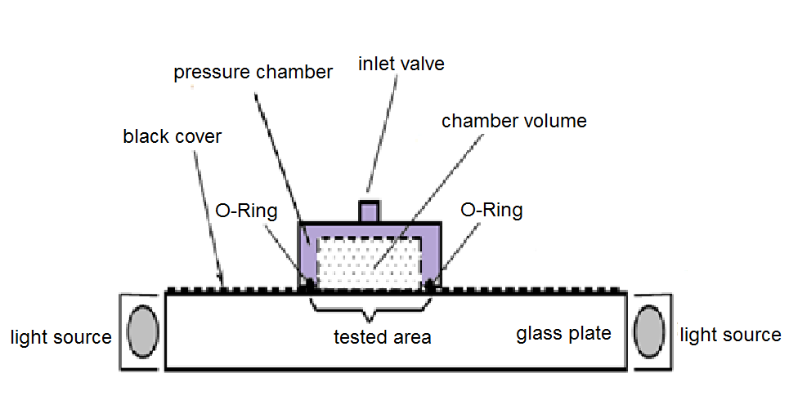
Figure 3. Test bench for static calibration.

The reference pressure varies from 0 Pa to 100000 Pa, that is the maximum pressure to avoid fracture of the glass plate.
A high performance reflex digital camera (Canon EOS 1100D, with a 12,2 megapixel CMOS sensor), was used to take high resolution grey-level images. The camera was equipped with a 18-55mm f/3.5-5.6 lens: the distance from the camera to the glass plate was adjusted depending on the focal length of the camera. The camera parameters (ISO settings, shutter speed, white balance) were adjusted to obtain maximum sensitivity for the specific setup (f-number = 5,6, exposure time = 1/8 s, ISO 400).
The raw images (4272 x 2848 pixels) were acquired with the software Canon Eos Utility, converted in .tiff format and thus post-processed with Matlab toolbox. Images were acquired for each pressure step (5000 Pa – 21 steps) in the calibration range.
For a given pressure, the grey level of each pixel varies depending on the pixel location and on the local characteristics of the contact surface (roughness). The uncertainty is less than 1% full scale. Figure 4 illustrates a typical static calibration diagram: abscissa refers to the reference pressure (q_{i} [Pa]); ordinate refers to the grey-level measured by the sensor (q_{o} [bar]). The calibration curve is obtained using the method of least squares.

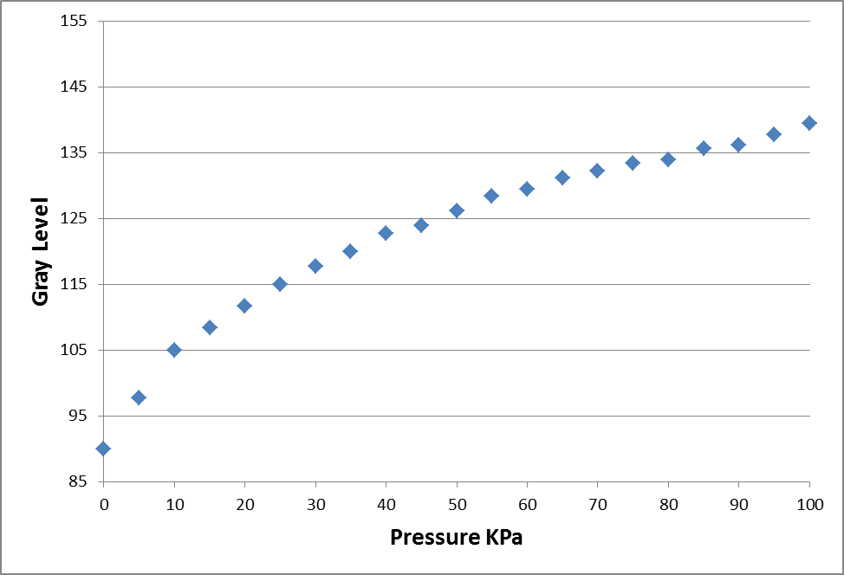
Figure 4. Typical static calibration diagram for a pixel.

After these first measurements, a measurement area was defined to reduce the dispersion due to the localized imperfections of the contact surfaces (Figure 5). This is the most effective sensor area both for static and dynamic measurements.

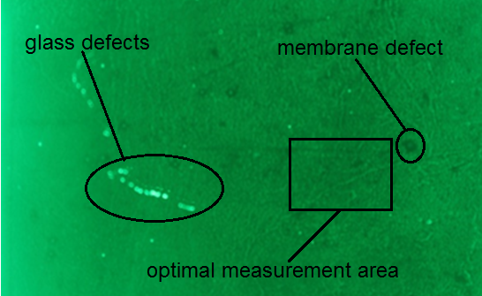
Figure 5. Measurement area selection.

  - Preliminary dynamic characterization
Then a dynamic characterization was performed by loading the sensor with a sinusoidal excitation applied through a rigid feeler pin (Figure 6). The compression force, generated by the electrodynamic exciter, is measured by a load cell.
Figure 6. Test bench for dynamic characterization.
Tests were performed using sine excitation: typical signals obtained are shown in Figure 7.
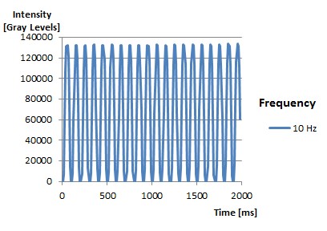
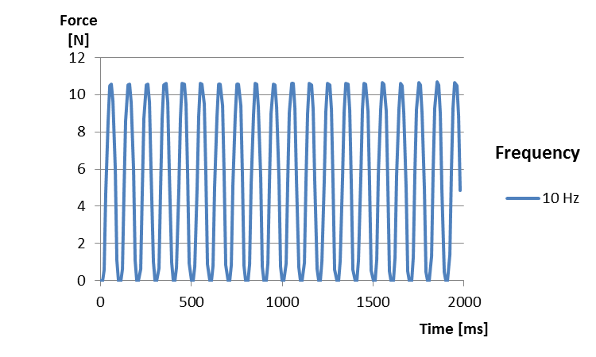
Figure 7. Time history output system and force.

For the images processing a specific software in LabView has been developed (Figure 8).

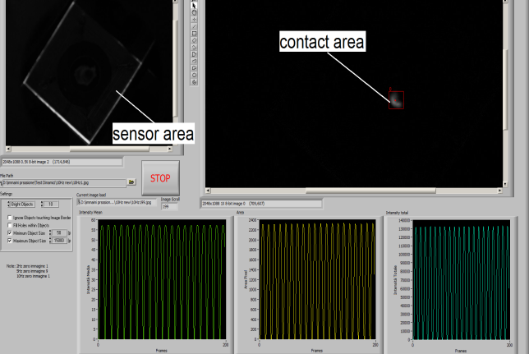

Figure 8. Image processing software interface.

Changing excitation frequency keeping fixed the level of force the ratio between system output (gray level) and force amplitude vs frequency is plotted in Figure 9.

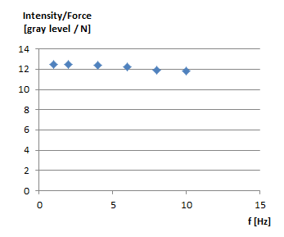
Figure 9. Time history output system and force.

These results allow establishing that a useful bandwidth is from 0 up to 10 Hz with tolerable response decrease lower than 5%.
- Conclusions
The analysis of the contact pressure between the finger and a contact surface is of remarkable interest in the field of biomedical design, to characterize human fingertip mechanical properties in terms of contact area, deformation and pressure distribution.
In this work a measurement technique based on FTIR is proposed for the analysis of contact pressure between the finger and a flat contact surface (glass plate).
A FTIR measurement system was designed and tested to evaluate the feasibility and effectiveness of this measurement technique to measure the contact area and the pressure necessary for numerical fingertip model validation.
Results showed that there are good assumptions to use the sensor for the measurement of the fingertip contact pressure both on static and dynamic conditions.
Consistency and repeatability observed at this first stage is very encouraging for the development of an effective fingertip pressure measurement system based on FTIR.
This will permit to analyze the behavior of the finger for different conditions, and thus to validate numerical models not only in contact area and force, but also in pressure, that is suitable for investigating the fingertip deformation in static and dynamic conditions.
Plans for future work are to further explore new materials for higher sensitivity, test different configurations with a complete set of loading conditions.

References
- J. Z. Wu, R. G. Dong, S. Rakheja, A. W. Schopper, and W. P. Smutz, “A structural fingertip model for simulating of the biomechanics of tactile sensation,” Med. Eng. Phys., Mar. 2004, vol. 26, no. 2, pp. 165–175.
- S. Shimawaki, N. Sakai, “Quasi-static deformation analysis of a human finger using a three-dimensional Finite Element Model Constructed from CT Images”, Journal of Environment and Engineering, 2007, Vol. 2, no. 1.
- M. Shiratori, M. Ishida, “Development of body pressure distribution measurement device”, JSAE Review, July 1992, Vol. 13 n. 3
- R. Marsili, G.L. Rossi, “The measurement of contact and grip force as reference for human hand transmitted vibration evaluation by laser scanning vibrometers”, II Int. Conf. on Vibration Measurements by Laser Techniques, 23-25 Sept. 1996, Ancona Italy, SPIE Vol. 2868.
- R. Gurram, G.J. Gouw, S. Rakheja, “Grip pressure distribution under static and dynamic loading”, Int. Jou. of Experimental Mechanics.
- P. Sanfilippo, R. Stress, K. Moss. “Dynamic plantar pressure analysis”, Jou. of the American Pediatric Medical Associations, 1992; Vol. 82 n. 10 pp 507-514.
- A. Mair, W. Diebschlag, O. Distl, H. Krausslich, “Measuring device for the analysis of pressure distribution on the foot soles of cattle”, J. Vet. Med, 1988; A 35 pp 696-707.
- R. Marsili, A. Garinei, "Design of an optical measurement system for dynamic testing”, Measurement Volume 46, Issue 5, June (2013), pp. 1715-1721 DOI information: 10.1016/j.measurement.2013.01.006, ISSN: 0263-2241, Elsevier Science.
- V. Roth, B. Moore, J. Turner, “An Optical Method for Normal Contact Stress Measurement with Applications to Tire-Road Interaction”, SEM X International Congress & Exposition on Experimental & Applied Mechanics, 2004.
- A. N. Gent, J. D. Walter, “The Pneumatic Tire”, The National Highway Traffic Safety Administration, U.S. Department of Transportation, Washington DC 20590, August 2005, pp 248-250.
- R. Marsili, A. Garinei, “Thermoelastic Stress Analysis of the Contact Between a Flat Plate and a Cylinder”, Measurement: Journal of the International Measurement Confederation, 52 (1), pp. 102-110 (2014) http://dx.doi.org/10.1016/j.measurement.2014.03.005 (2014).
- E. Cardelli, A. Faba, R. Marsili, G. Rossi, R. Tomassini, “Magnetic nondestructive testing of blade tips”, Journal of Applied Physics 117, 17A705 (2015); doi: 10.1063/1.4907180
- R. Marsili, A. Garinei, “A new diagnostic technique for ball screw actuators”, Measurement, Volume 45, issue 5 (June, 2012), p. 819-828, ISSN: 0263-2241 DOI: 10.1016/j. measurement. 2012.02.23, Elsevier Science.

