Approach on the Evaluation of Exposure to Low Frequency Electric Fields
Alexandru Salceanu¹, Maria Magdalena Poenaru², Mirela-Adelaida Anghel³, Marius Paulet¹
¹”Gheorghe Asachi” Technical University of Iasi,Iasi, Mangeron Str. 67, Romania,
asalcean@tuiasi.ro, mpaulet@tuiasi.ro, +40232701157
²University of Craiova, Craiova, Romania, poenaru_magdalena@yahoo.com,
³Romanian Bureau of Legal Metrology, Bucharest, Vitan Barzesti Road nr.11, Romania,
mirela.a.anghel@gmail.com, +40213320954

Abstract – Since July 1, 2016 the Directive 2013/35 / EU on the protection of human health against the effects of non-ionizing electromagnetic radiation, acquires the force of law.
As regards low frequency exposure assessment, it requires a clearly different treatment of electric and respectively magnetic fields, from all the important perspectives: sensors, measuring techniques, biological effects and methods of protection.
In this paper we propose a methodology accessible (both for SME employers and for a regulatory and/or control authority at the beginning of its activity) for the characterization of a workspace, in terms of exposure to low-frequency electric fields.
After a review of the main sources of such fields, we have done a comparative summary of the exposure levels considered acceptable by the leading global institutions involved in this domain (ICNIRP, IEEE, WHO). We have presented our artisanal electric field sensor, the low-frequency handheld spectrum analyzer, spatial and temporal averaging techniques, methods for summarizing the fields and harmonics of different frequencies and specific uncertainties that should be considered.
Finally we have presented a case study on the assessment of exposure to low frequency electric fields produced in a laboratory room where a network of 16 computers was working.

Keywords – Directive 2013/35/EU, low frequency electric fields, exposure
- Legal framework of our attempt

On the 26-th of June 2013 was published in the Official Journal of the European Union, the Directive 2013/35/EU of The European Parliament and of The Council [1], focused on the minimum health and safety requirements regarding the exposure of workers to electromagnetic fields. The issue is up-to-date and challenging, a plain argument being the dynamic of the European legislation in the field: the presently repealed Directive 2004/40/EC had been elaborated just only 9 years before.
This Directive will enter into force on the 1-st July of this year; consequently, there is a large concern between employers, stakeholders and authorities regarding the effective application of the associated settlements. How could be decided that we have to deal or not with a dangerous situation? For the very beginning, it is the responsibility of the employer, but in the second phase, a state protection authority should check the orderliness and the conformation to the imposed limits.
Obviously, the 2013/35 Directive is not concentrated on the long-term effects of the existence of electromagnetic fields. Even if direct biophysical effects and indirect effects have been studied and demonstrated, there is not a generally accepted, scientifically proved relationship between normally encountered electromagnetic fields (EMF) and human health risks. The cautious approach should be that is better to prevent than to cure and, undoubtedly, all the workers in the European Union must be protected against the possible risks arising from various time varying electromagnetic fields.
Any employer should adopt actions aiming to protect his employees, by respecting these lower values for two physical quantities: the exposure limit values (ELVs) and, respective, the action levels (ALs) regarding the electromagnetic fields. The ELVs and ALs, laid down in this Directive are founded on the suggestions released by the International Commission on Non-Ionizing Radiation Protection (ICNIRP). The ELVs refer to the maximum levels accepted for the electric fields induced in the human body due to the presence in the workers’ environment of any alternative magnetic or electric field. With other words, ELVs are corresponding to the basic restrictions, limiting the induced, internal electric field while ALs represent the corresponding reference values for the external electric (and magnetic) fields that could be directly measured.
The effects are direct (mainly thermal, heating but also non-thermal, electric fields induced in the body, determining stimulation of muscles, nerves or sensory organ or currents established in the limbs) or indirect, caused by the action of a specific object placed in the field (pacemakers or other implants, detonators or fires produced by sparks).
The guidelines evolved by international authorities, mainly focused on health effects of the electric and magnetic fields, generally consider three “frequency milestones”, 1 Hz, 100 kHz and 10 MHz that divide the spectrum in four ranges: static, low frequency, medium frequency and high frequency. This partition is justified by the intrinsic nature of the dominant effects: thermal or non-thermal, with different measurement techniques and associated instrumentation used for an accurate determination.
The second chapter of this Directive is executive, being entitled “Obligations of Employers”, with three consecutive types of action: the assessment of risks, (identification of places with possible high exposure followed by its determination, by measurements or calculation), actions that should be done in order to avoid or at least to reduce the assessed risks and the effective participation of the workers at miscellaneous programs of training, also including continuous information and consultation.
For the effective implementation of 2013/35 Directive, the Commission has elaborated various practical guides, accepted by the regulation authorities in the field that should provide a reliable scientific approach of the effective exposure to non-ionizing radiations, coupled with the evaluation of the efficiency of the adopted reducing methods.
It is expectable that a medium or small employer cannot afford to permanently engage high qualified workforce, needing expensive instrumentation and sophisticated software for a reliable certification of the adherence to the stipulated exposure limits. Pre-compliance tests and methodologies should be easier to be performed, offering a good preparation for the strictly specialized measurements. The main objective of the here presented paper is to propose a practicable sequence and an affordable device for assessing the low frequency E-fields in the residential or occupational environment.
- The boundary between (acceptable or not) exposure to electric fields

In the low frequency domain (up to 100 kHz), the near field border is at least at 500 m distance from the source, that implies the compulsoriness of different measurements for the electric and respective magnetic fields [2]. The electric fields are generated by the electric charges that produce difference of potential between the “plates” of a permanent or just occasionally appeared capacitor. The bi-univocal link between voltage and electric field could be very easy disturbed by any object with some electric properties placed between the source and the measuring point. More specifically, the human body, a good conductor at low frequencies, disturbs the distribution of the electric field lines in its vicinity.
There are many international agencies and organizations involved in establishing exposure restrictions on scientific basis: World Health Organization (WHO), International Commission on Non-Ionizing Radiation Protection (ICNIRP), International Agency for Research on Cancer (IARC) and Institute of Electrical and Electronics Engineers (IEEE). Exposure to low frequency external electric fields could induce internal electric fields, complementary with the electric charge of the skin. These oscillating charges placed on the surface of the body produce currents inside it.
The total current density J[A/m²] and the induced internal electric field E_{int}[V/m] are related by the electrical conductivity σ [S/m] of the medium,
 1
Experts dealing with the dosimetry for exposure to low frequency electric fields, in principle agree with some general statements:
• considering a certain external field, the highest values of the internal electric field are registered when the body is firmly electrically grounded, while the lowest values are associated with the “free space” situation (body insulated from the ground);
• the current established in the grounded body is significantly influenced by its physical dimensions and also by the posture (seated, standing or even lying on the floor);
• the distribution of the induced currents inside the body is not uniform, being decisively determined by the conductivity of various organs and tissues;
• the maximum coupling is met when the external field is parallel to the body axis.
It is useful to remember that a contact with a good conductor placed in an electric field could be a source for indirect currents set up in the body.
As an order of magnitude, the internal induced field is much smaller than the exterior one (for instance, about six time smaller at the power frequency). The internal electric field strength is very complicated to be assessed but could be computed by using electrically sophisticated heterogeneous models. For instance, the factor recommended by ICNIRP at 50 Hz, for a rough conversion between the external magnetic field and the induced electric internal field (in the domain where appear relevant effects on the central nervous system), it is about 33V/m for 1 Tesla. It is advisable to apply a supplementary reduction factor of 3 to the so calculated values, in order to cover the great uncertainties in the dosimetric domain [3].
There are two levels of exposure limits:
• for general population, also called ”public”, (people of various ages and state of health, including children and grey-headed persons, untrained and uninformed, being possible to live 24 to 24 hours with that medium);
• for certain groups of workers (the so-called, occupational exposure), for trained, informed and well-conditioned adults, working only a few hours per day in that restricted environment, respecting some protection rules.
The reference values for the external E-field strength, accepted by ICNIRP [4], are synthesized in Table 1.

Table 1. Reference levels (rms values) for exposure to time varying electric fields

Frequency range | E-field strength(kV/m), occupational exposure | E-field strength(kV/m), general public exposure
1Hz-50 Hz | 20 | 5
50 Hz-3 kHz | 5 x 10²/f | 2.5 x 10²/f
3 kHz-10 MHz | 17 x 10⁻² | 8.3 x 10⁻²

The frequency f included in these formulae is expressed in Hz.
The maximum permissible exposure (MPE) of the human whole body for the sinusoidal electric fields in the background, stipulated in IEEE Standards [5], [6] is synthesized in Table 2. For occupational situations, IEEE utilizes the around synonymous ”controlled environment”. The ratio between occupational and public acceptable level is 4 (frequency up to 50 Hz) and varies from 2 (ICNIRP recommendation) to 3 (IEEE restrictions) for the higher spectrum.

Table 2. Maximum permissible exposure (MPE) to low frequency electric fields

Frequency range | E (kV/m)-rms  Controlled environment | E (kV/m)-rms  General public
1 Hz-272 Hz | 20 | 5
272 Hz-368 Hz | 5.44 x 10³/f | 5
368 Hz-3 kHz | 5.44 x 10³/f | 1.84 x 10³/f
3 kHz-10 MHz | 181 x 10⁻² | 61 x 10⁻²

The European Directive 35/2013 is more concentrated on occupational exposure, with two levels of ”alarm”, low and high, presented in Table 3. While reaching them, some actions are strictly recommended, aiming to reduce the exposure, e.g., to increase the distance or to screen.
Table 3. Action levels (rms values) for occupational exposure, according to 35/2013 EU Directive (f expressed in Hz)

Frequency range | E-field strength(kV/m),  Low ALs | E-field strength(kV/m),  High ALs
1Hz-25 Hz | 20 | 20
25 Hz-50 Hz | 5 x 10²/f | 20
50 Hz-1.64 kHz | 5 x 10²/f | 10³/f
1.64 kHz-3 kHz | 5 x 10²/f | 61 x 10⁻²
3 kHz-10 MHz | 17 x 10⁻² | 61 x 10⁻²

- Main sources of low frequency electric fields (LFEF)

The most frequently encountered sources of LFEF (being significant even in terms of the power involved or due to their omnipresence in our daily environment) are:
• 50 Hz, mains power transport and distribution system (North America and partly, Japan use the frequency of 60 Hz);
• there is a certain variety of the power supplied for traction systems. For instance, there are trams supplied at 600 Volts d.c., while electric locomotives in Romania are supplied with 50 Hz power. In Germany, Deutsche Bahn network uses power having the frequency of 16.7 Hz;
• electrical welding installations or other equipment requiring higher voltages, use working frequencies between 50 Hz and 200 Hz;
• most power converters have operating frequency between 200 Hz and 1 kHz;
• older generation Cathode Ray Tube Monitors and TVs have 31 kHz as operating frequency;
• the working frequency of economic lamps is varying in the range 40- 45 kHz, depending on power and manufacturer;
• the working frequency of LCD monitors made in technology TFT (Thin Film Transistor) is in the range 42 kHz – 57 kHz (depending on the manufacturer, but also on the diagonal-size);
• switched mode power supplies, equipping PCs, laptops or printers have their working frequencies in the range 30-70 kHz;
• ignition systems of injection engines;
• a specific type of radio-frequency service system (RFID ), which uses electromagnetic fields to identify and automatically track a specific labeled object (which received a " tag" that contains electronically stored information), usually uses the 125-135 kHz frequency range.
Anyway, the distance d between the emitting source and the measuring point is essential. The electric field is inversely proportional to d³ for high impedance sources, or only to d² for sources having low impedance.
- Determination of the exposure metric

Aiming to predict and to avoid health risks in epidemiology, there were established some recommended exposure limits. The issue is very complicated as the electric field strength is a multi-dimensional quantity that varies over space and time, while its interaction with the human body is considerably influenced by the frequency. The approach is even more challenging if the field polarization is nonlinear [7], the sources have multiple-frequencies, the fields are non-uniform (spatially or temporally), non-sinusoidal or with high harmonic content [8]. It is strongly desirable to have a single number summing up a certain exposure that should be compared with the MPEs. There are necessary many measurements and an algorithm for data processing and analysis.
In the low frequency domain (up to 100 kHz), the metrics with high significance are the peak vector magnitude or, mainly, the rms vector magnitude, averaged along the specified period.
In situation of simultaneous exposure to E fields having different frequencies or non-sinusoidal fields, having significant harmonics, compliance with the imposed limits should be additively checked:
        
where E_{imeas} represents the rms values of electric field measured for every frequency of the spectrum and E_{iRef} is the corresponding reference value for that frequency, as it is specified in the appropriate Table 1, 2 or respective 3.
Aiming to decompose the fields with complex, pulsed patterns, the best option are the Fast Fourier Transformation techniques, materialized by a (hand-held) spectrum analyzer.
- Case study: exposure to LFEF in a laboratory class with 16 networked PCs.

As basic device we have used a hand-held, low frequency spectrum analyzer, SPECTRAN NF 5305, through USB-connected to a laptop running the MCS dedicated software produced by Aaronia AG Electronics Manufacturer, Germany. Even if this spectrum analyzer already has an integrated sensor for electric fields, we have complementary used an external capacitive sensor, battery powered, connected at the provided external input (SMA socket) of the device, Fig. 1.
The sensor’s geometry could be plate (rectangular) or even spherical. The induced charge on one half of this field meter is directly proportional to the electric field that is parallel to its axis:
where S is proportional with the sensor’s active surface area, in our case 50 cm² (the surface of a circle with 4 cm radius).
The current established between the electrodes of the capacitive sensor is the time derivative of the induced charge (the field being time-harmonic), the meter is considered as “free body” (isolated from the ground):
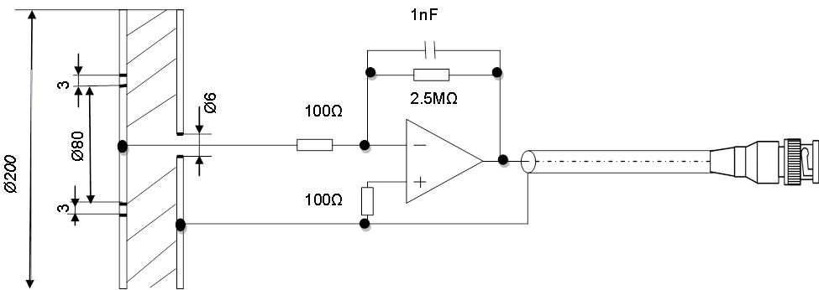
Fig.1. Capacitive E-field sensor made from PCB double layer,
2mm thickness
We wanted to trace the profiles of the electric fields in the laboratory class, the contours and a 3D map. We proposed to measure the exposure around the regions where are expected to be placed the heads of the 15 students. The electric field could be easily perturbed by any (conductive) object; consequently, the classroom was without students, the sensor was mechanically introduced in the aria of interest by using a 1.5 meter fiberglass extension pole and the PC-s were running a repetitive routine. At the first survey, there were encountered E-fields having three frequencies: 50 Hz (the mains power), 56 kHz (working frequencies of the 16 TFF-LCD displays) and 62 kHz (much lower values than the previous ones, being associated with the Switched Mode Power Supply of the PC-s, easy to be shielded).
The rms readings were averaged in space and in time (5 minutes).
These values, expressed in V/m, for the 16 places of interest and 2 frequencies are synthesized in Fig. 2.

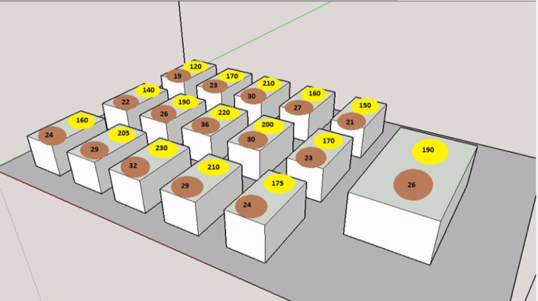
Fig.2. The measured values of the E-field, at 50 Hz (light yellow) and 56 kHz (dark brown)
Their spatial distribution in the laboratory room is presented in Fig. 3.a. (for 50 Hz) and Fig. 3.b. (for 56 kHz).

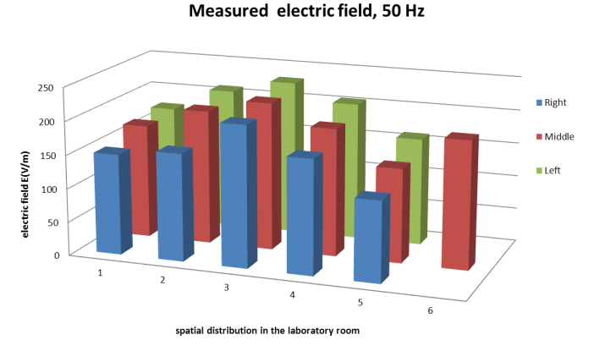
Fig. 3.a. The 3D map of the 50 Hz E-fields

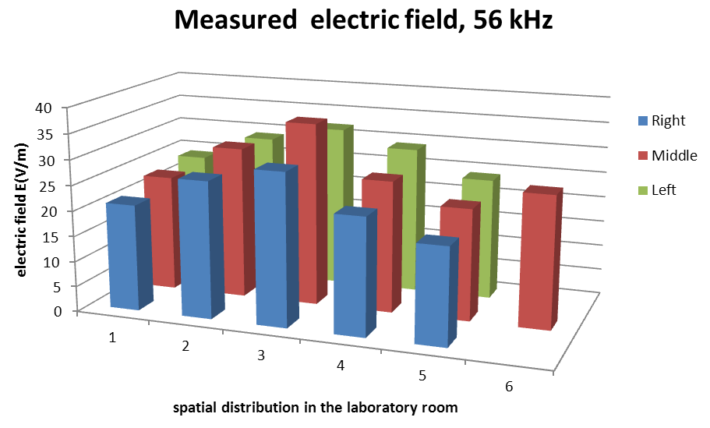
Fig 3.b. The 3D map of the 56 kHz E-fields
- Conclusions

We have applied Eq.(2) as ratio between the highest E-field values measured in the laboratory class, at 50 Hz, 56 kHz and 62 kHz and the corresponding reference levels accepted for public exposure.

This value is much below the acceptable limits, even for public, non-occupational exposure.
Starting from the 1-st of July 2016, the Directive 35/2013 enters into force. It is necessary to provide, both for the employers and for the appropriate authorities, an applicable procedure, based on the simplest metric and affordable equipment, aiming to decide by measurements, if a specific location is risky or not from the point of view of the exposure to electric and magnetic fields. We have presented only the approach intended to deal the issues of the low frequency electric fields, based on an affordable handheld spectrum analyzer, an easy to be made sensor and a metric derived from the rms vector magnitude.
References
- Directive 2013/35/EU of the European Parliament and of the Council of 26 June 2013 on the minimum health and safety requirements regarding the exposure of workers to the risks arising from physical agents (electromagnetic fields), (2013)
- Morega M., Baran I. M., Morega A. M., “Evaluation of Environmental Low Frequency Magnetic Fields in Occupational Exposure”, Proc. 8th Int. Conf. and Exposition on Electrical and Power Engineering EPE-2014, pp. 522-527, Iasi, Romania, (2014)
- ISO/IEC Guide 98-3:2008, Uncertainty of measurement-Part 3: Guide to the expression of uncertainty in measurement, (2008)
- ICNIRP, Guidelines for Limiting Exposure to Time-Varying Electric and Magnetic Fields (1 Hz - 100 kHz), Health Physics 99(6):pp.818-836, (2010)
- IEEE Standard C95.6-2002, Standard for Safety Levels with Respect to Human Exposure to Electromagnetic Fields, 0-3 kHz, (2002)
- IEEE Standard C95.3.1-2010, IEEE Recommended Practice for Measurements and Computations of Electric, Magnetic, and Electromagnetic Fields with Respect to Human Exposure to Such Fields, 0 Hz to 100 kHz, (2010)
- J. D. Bowman, M. A. Kelsh, W. T. Kaune, “Manual for Measuring Occupational Electric and Magnetic Field Exposures”, DHHS (NIOSH) Publication No. 98-154, (1998)
- ICNIRP, "ICNIRP Statement-Guidance on determining compliance of exposure to pulsed and complex non-sinusoidal waveforms below 100 kHz with ICNIRP guidelines,"Health Physics, vol. 84, no. 3, pp. 383-387, ( 2003)

