A totally new digital 3D approach for reassembling fractured archaeological potteries using thickness measurements
Michail I. Stamatopoulos², Christos-Nikolaos Anagnostopoulos¹
¹ Social Sciences School, Cultural Technology and Communication Dpt., University of the Aegean, Lesvos isl., Mytilene, 81100, Greece
² School of Science and Technology, Computer Science Dpt., Hellenic Open University, Patra, 26335, Greece
ABSTRACT
The reassembly of a broken archaeological ceramic pottery from its fragments (called sherds or ostraca) is an open and complex problem, which remains a scientific process of extreme interest for the archaeological community. All the solutions suggested by various research groups and universities, depend on external information such, the outline of sherds, the corners of their contour, some geometric characteristics, the matching of the discontinued surfaces due to fracture, the angles and curves on its boundaries, etc. In our approach the reassembly process is based on a different and more secure idea, since it is focuses on the thickness information encapsulated in the inner part of the sherds, which is not -or at least not heavily- affected by the presence of harsh environmental conditions and is safely kept within the sherd itself. The method is verified in various use case experiments, using cutting edge technologies and precise measurements on 3D models.

Section: RESEARCH PAPER
Keywords: Thickness Profile; Pottery reassembly; Photogrammetry; 3D Acquisition
Citation: Thomas Bruns, Dirk Röske, Paul P.L. Regtien, Francisco Alegria, Template for an IMEKO event paper, Acta IMEKO, vol. A, no. B, article N, month year, identifier: IMEKO-ACTA-0A (year)-0B-0N
Section Editor: name, affiliation
Received month day, year; In final form month day, year; Published month year
Copyright: © year IMEKO. This is an open-access article distributed under the terms of the Creative Commons Attribution 3.0 License, which permits unrestricted use, distribution, and reproduction in any medium, provided the original author and source are credited
Corresponding author: Christos-Nikolaos Anagnostopoulos, e-mail: canag@aegean.gr

- Introduction
In every archaeological excavation, a variety of small ceramic pottery fragments (called sherds or ostraca) are revealed, which will provide valuable data and will be used by archaeologists as a dating stamp for the excavation itself. The nature of these small objects (due to four elements, soil, water, heat and air) give them some special properties and make them highly resistant to time and wear. Moreover, sherds are not stolen, they remain to the place where the ceramic pottery is destroyed and like little papyri, they carry unique undeleted information over the centuries.
The quantity and the high value of such information, rightly gives to sherds, the title of best data carrier from ancient times to our days.
- related work
For the reassembly of a ceramic pottery, the majority of the scientific methods suggested by various research groups and universities, depend on external information such, the outline of sherds, the corners of their contour, some geometric
characteristics, the matching of the broken surfaces, the geodesic distances, the angles and curves on its boundaries, the axis of symmetry, the colors or even on the theme portrayed on it [1]-[14].

All these techniques suffer from the problems introduced by the external wear and decay of the material during the exposure in the soil. As a result, many characteristics on the surface of the sherds have been altered during the long time of exposure, leading to severe decrease in the efficiency of research methods based on external characteristics [15], [16] and [17]. Therefore, it is no surprise that, to our knowledge and after extensive search in museum laboratories in countries with high archaeological interest (Greece, Italy, Vatican and Egypt), an automatic method that works effectively to restore a true ancient theme is not available. In contrast, the process is performed manually by experts in the field, aligning the fragments by minimizing the distance between their adjoining regions while simultaneously trying to ensure geometric continuity across them (if possible).

- the thickness profile method (tp)
The proposed methodology is based on a new approach that can be considered scientifically more effective than others, as we seek important information encapsulated inside the core of the sherd and not on its surface. Our approach works even if some of the sherds are missing, it is not affected by the presence of external wear and damages, nor by the geometrical shapes or by the colour degradation of the pottery. The new method is based on exploration, extraction and utilization of all possible thickness information (i.e. Thickness Profile) which may have encapsulated inside each sherd. All this information, as a sequence of numbers, can be sorted, compared and provide a complete and efficient solution for the complex problem of reconstruction, reassembling, restoration and recovery of an ancient broken ceramic pottery which is fragmented into pieces, of random sizes and shapes. The basic idea is based on the fact that as the potter artist rotates the pliable clay on the wheel to create the pottery, he/she creates distinguishing thickness measurements, which are unaltered and they can easily be detected. The gradual construction of a pottery on a wheel, starts from the base, continues up to the main body and usually ends at the neck and at the rim. This gradual upward movement of the artist in the clay body, creates a certain thickness profile which can be detected, as they vary, with absolute certainty, from point to point, from height to height and of course from pottery to pottery. This distinction generates the image of a structure, which resembles a stack of horizontal rings, with specific thickness in relation to the pottery height. Specifically, as the fingers of potter push outwards (expansion of the clay body), the clay in these points is getting thinner, while in the case of inward pressure (contraction of the clay body) the clay is getting thicker. Based on the above, it is reasonable to consider, that each sherd can theoretically fit to a specific point of the stack of rings and hence to a corresponding point in the overall thickness profile or thickness contour of a particular pottery. The new proposed methodology comprises of three basic steps, namely: i) the appropriate orientation (Figure 2) and 3D scanning (Figure 3/a) of each fragment, ii) the extraction of their optimal thickness profile (TP) as an intersection of the 3D model with a properly oriented vertical plane (Figure 3/b, Figure 3/c and Figure 3/d) and iii) the repetitive process for maximizing matching results between TPs in order to achieve a locally optimal alignment between possibly neighboring sherds (Figure 5/d, Figure 5/e and Figure 5/f).
  - Creation of 3D models (point clouds)
As it is absolutely necessary for the archaeologists, to obtain the appropriate profile measurements without damaging the sherds, our method is implemented and validated using their identical 3D models, making the extraction of measurements fully reproducible and non-intrusive for the sherd itself. Initially, on each sherd we choose and draw a specific vertical straight line (Figure 2) through which we expect to extract the largest possible thickness profile. For the process we use some special crosshair beam lasers (Figure 1/bottom-left) and a special stable XYZ positioning platform (Figure 1/bottom-right). Then each sherd is placed on a stable basis and photographed panoramic, from close distance, from all sides and from various angles (Figure 3/a). The result is a set of 30-50 photos for each sherd, which is transformed into a 3D model (point clouds or mesh), using a specialized photogrammetry software (Figure 3/b).
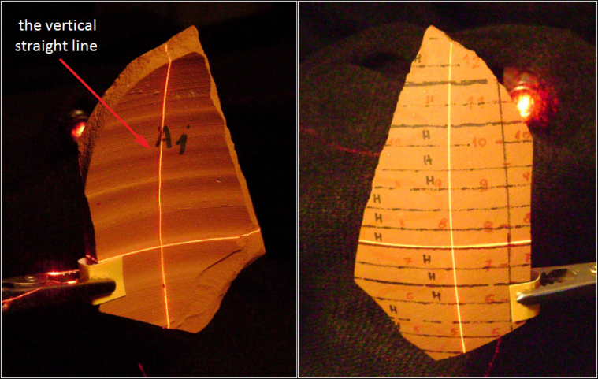
Figure 2. The orientation procedure with a sherd between two crosshair beam lasers (left and right, back and front view respectively).
  - Thickness profile extraction
It is very important for each sherd, to detect the ideal vertical plane with the richest information concerning thickness. The highest vertical plane to the horizontal rings is selected that allows the extraction of the maximum possible thickness profile (Figure 3/c). This is especially important, since the best possible thickness profile for each sherd is needed, in order to perform the optimum thickness matching result (best "score") between neighbouring sherds. This vertical flat plane is absolutely oriented with the horizontal inner lines of the sherd and using an appropriate 3D modelling software, the TP of the sherd is calculated accurately. For the calculation, we perform thickness sampling for every 1 mm (Figure 3/d and Figure 3/e).
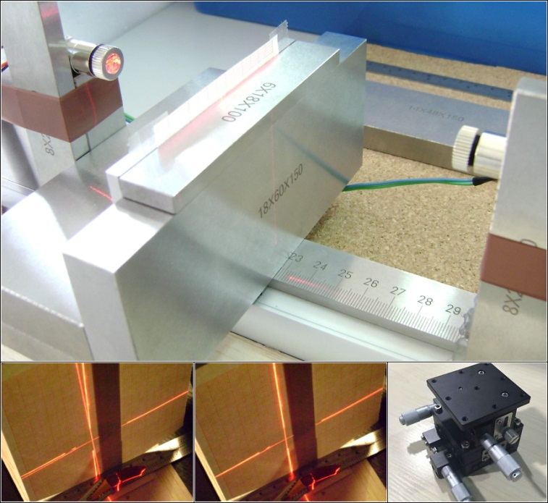
Figure 1. Our special equipment.
  - Thickness profile matching
Following the previous steps, by the process of sliding small thickness profiles across larger ones (Figure 5/e) until the achievement of optimum fit, the method retrieves candidate matches between sherds performing local score optimization (Figure 5/d). The Thickness Profile method, is a semi-automatic method, as in the case of two adjoining sherds, it cannot decide which one will be placed left and which will be placed right. At this point the expert eye of the archaeologist/user, should give the correct arrangement (left or right). In addition, small sherds usually do not have the ability to give adequate thickness information and therefore the probability for erroneous arrangement is increased. For these reasons, the process is done in stages, starting from the largest available sherd and moving gradually to the smaller ones. Starting from a master sherd, the main target is to stack progressively more and more thickness information (Figure 5/f) and thus greater thickness profile, increasing the chances to match the remaining sherds in the right place. Hence, at the beginning of the process, the largest available sherd is assigned with the role of the "driver" (master sherd) and as the process is executed and two or more pieces are matched together, a single meta-sherd is formed with an increased thickness profile (Figure 5/c). Intuitively, this corresponds to virtually gluing sherds together, while the matched parts of TPs become common values to TP of the meta-sherd. This approach ensures that parts of TPs that have previously been matched in the some pair of sherds are no longer considered for future pairings. Our matching procedure looks like a "fluctuation" smaller thickness profiles on larger ones. The search for the ideal match, could be found only if two profiles fit perfectly together and the sequential numbers of the small sherd match somewhere in the sequence of numbers of the large sherd. The perfect match would be possible only in an ideal case and not on real data. Besides, our method is based on the plurality of measurements and less in the high accuracy of measurements. Therefore, the method is searching for the best "score", with the fewer differences in most possible comparisons. The best "score" is defined as the sum of the absolute differences between the more possible comparisons between two sherd profiles (Figure 5/d). The Thickness Profile method, works better for pottery vessels, that were built on recently archaeological periods (Archaic, Classical and Hellenistic period) as these potteries were manufactured with finest "technology" characteristics (better wheels, clay quality, best cook, etc.). As a result they feature more sophisticated geometric features and are characterized by distinctive thickness information that can be exploited by our method.
Figure 3. The photogrammetric process, the 3D model and the thickness profile (TP) acquisition.
- EXPERIMENTAL VALIDATION
Using handmade replicas of ancient ceramic potteries we demonstrate in this section the accuracy and efficiency of the proposed method. A ceramic handmade replica (Figure 4) are intentionally broken and all the useful resulting material (34 sherds) are digitally reassembling by the Thickness Profile method. Before breaking the pottery, horizontal and vertical lines are marked on the surface which will be later used and confirm our methodology. Specifically, the pottery was placed on a horizontal surface and concentric circular contours (every 0,5 cm) were drawn in its external surface. Furthermore the outer surface is partitioned into eight different vertical areas (i.e. A, B, C, D, E, F, G and H) using vertical lines at 45, 90, 135, 180, 225, 270, 315 and 360 degrees. The marking procedure was confirmed by lighting a vertical laser beam on and along the outer surface of the pottery at the above mentioned angles.
Figure 5. The five known neighboring sherds, the five thickness profiles, the matching process and the results.
  - Demonstration of the efficiency of TP method
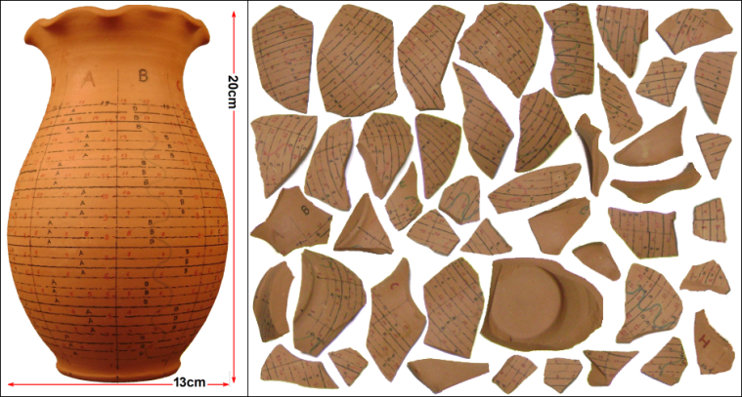
Figure 4. The pottery replica and the 46 sherds after intentionally broken.
For the shake of simplicity, we demonstrate the efficiency of Thickness Profile method using five known neighboring sherds (A4, A5, B10, C2 and C15) of the specific pottery. Figure 5/a, demonstrates the acquired 3D models of those five fragments and the extraction of the optimal plane for the calculation of the distinctive thickness measurements. Then, the 3D software performs thickness sampling for every one millimeter (as in Figure 3/e) and the thickness profile for each plane is created. Figure 5/b, indicates all the acquired thickness measurements from the five sherds in this example. Using the repetitive procedure described in section 3.3, the results validate that our method allows for accurate reassembly of the five sherds to be achieved with minimal human interaction. Figure 5/f and Figure 5/g, demonstrate the effective matching of the five sherds in terms of selected planes and thickness profiles respectively. Finally, Figure 5/h presents the final reassembled external surface of the five assembled fragments. It should be noticed, that the Thickness Profile method is effective even if some (or many) small pieces of the pottery are still missing. This has significant implications for archaeology since until now, manual reassembly is usually based on contour based methods that exploits local surface characteristics on the fragments. However, if such small parts are missing or are altered, severe problems in the reassembly process are imposed.
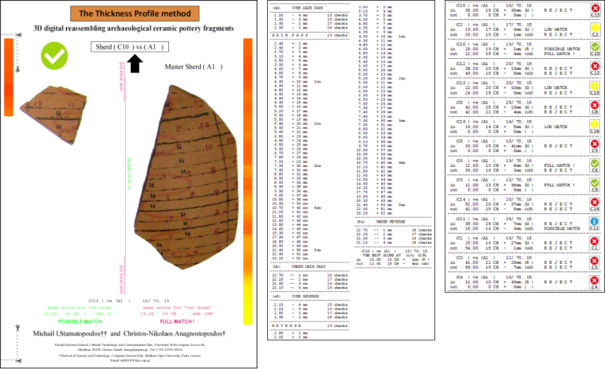
Figure 6. The 3 report pages. Right the aggregated page.
  - The special software and how the user read the results
Figure 7. All the instructions for the two important lines.
In order to manage the thickness measurements we develop a special software (25.293 lines of code) to perform all the necessary matching calculations. For each pair of sherds, our software created report in two pages (Figure 6) with all the necessary information for the guidance of the archaeologist. One of the two pages in full graphical. The software defines and print exactly the point of matching and the human interaction involves the correct placement of the fragments to the left of to the right of the master sherd. At the end of the process, the software prints an aggregated page that includes information for all the sherds from the pottery. The most important information on the report pages is a two lines area as marked and explained in Figure 7. The explanations are for the first left top checking pair (B2 vs A5) of sherds, inside the table below the Figure 11.
  - Accuracy in TP method and accuracy of measurements
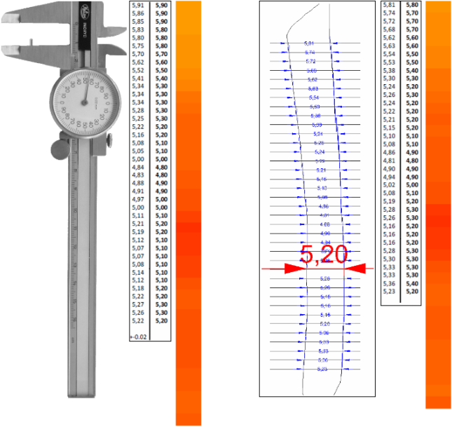
Figure 8. The accuracy standards that we use.
A critical point for the success of Thickness Profile method is the thickness precision that the researcher [18], [19] can retrieve from the available sherds. To our knowledge, the average thickness size of sherds, usually lies between 2-15 mm. These limits are fully confirmed on all the exposed sherds in the National Archaeological Museum in Athens. Our methodology requires discrimination capabilities in hundredths of a millimeter (0,01 mm). In order to demonstrate the accuracy, we used a calliper (the precision instrument used by the archaeologists) to manually capture the thickness measurements from a specific sherd (i.e. B10). The measurements were then compared against those acquired using photogrammetry and 3D software. Figure 8, present the results, depicting on the left column the measurements using the calliper and on the right those acquired by photogrammetry. On both ends, left and right respectively, the respective color map is illustrated (completely distinct and nearly identical).
  - The "Dwarfs and the Giant" experiment
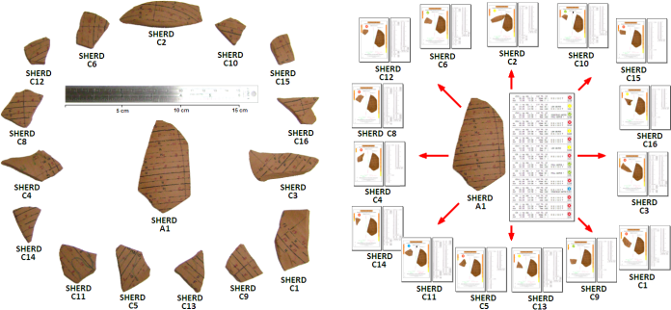
Figure 9. The 15 small sherds “Dwarfs” against the “Giant”.
During the reassembly of broken ceramic pottery, the available material includes and a proportion of small fragments which may have little identification information and thus complicate the task of reconstruction. For this complex scenario, we have chosen to show the value of Thickness Profile method, onto the ceramic replica that originally used for
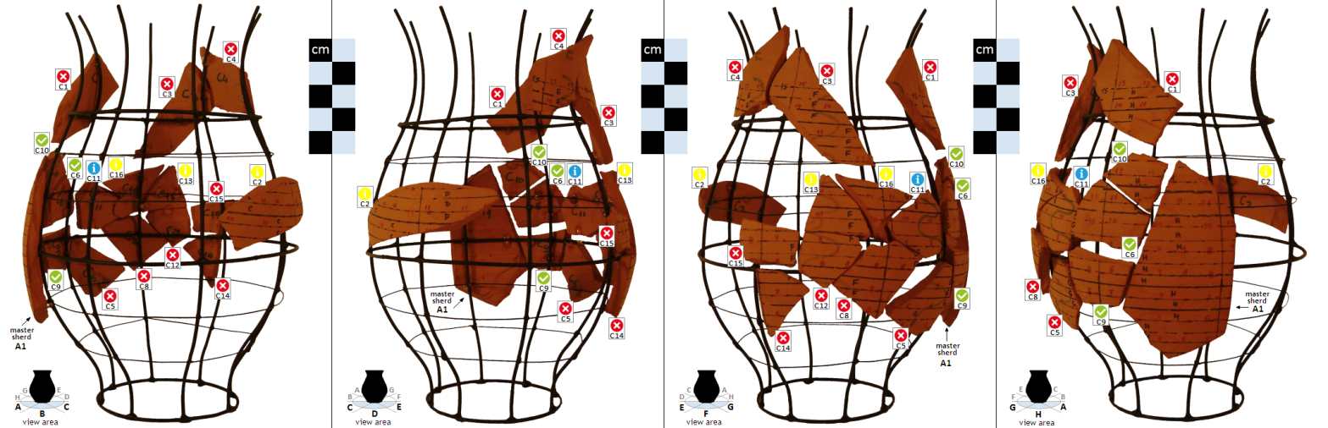
Figure 10. The optical results from the "Dwarfs and the Giant" experiment. The 15 small sherds against the largest sherd A1. Below in a table format all the necessary information from the software for the guidance of the archaeologist. The suggestions for each pair.
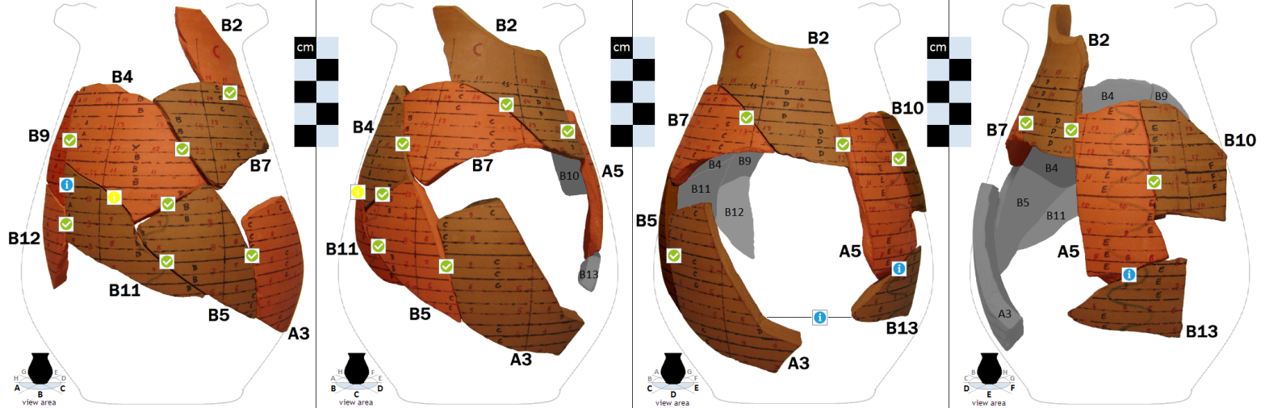
Figure 11. The optical results from the successful assemblage of all wall sherds. Below in a table format all the necessary information from the software for the guidance of the archaeologist. The appropriate suggestion position for each matching pair.
our experiment in section 4.1. After intentionally broken, our ceramic pottery had 15 small sherds (12 %). With the special software based on TP, all these 15 small sherds ("Dwarfs") of the broken pottery were placed successfully against the largest available sherd A1 ("Giant"). For the "Dwarfs and the Giant" experiment, we used all the available thickness measurements that we had from the previous processes. It should be emphasized that even for small sherds that are not adjoined with the master sherd, the TP method successfully places them in the appropriate height based on the overall thickness profile or thickness contour of the pottery under investigation. The 16 sherds (15+1), from the experiment, were placed on a metal mesh (model of the ceramic vessel) (Figure 10), for demonstrating the dynamic and the effectiveness of our method and the respective software.
Table 1. The acquired TPs from the 34 pottery sherds.
A1 | A2 | A3 | A4 | A5 |  | B1 | B2 | B3 | B4 | B5 | B6 | B7 | B8 | B9 | B10 | B11 | B12 | B13 | B14 | -
5,27 | 5,54 | 5,17 | 5,44 | 5,94 |  | 10,16 | 5,16 | 7,28 | 5,92 | 5,26 | 8,83 | 5,91 | 4,87 | 5,94 | 5,81 | 5,72 | 5,44 | 5,38 | 7,10
5,35 | 5,62 | 5,10 | 5,56 | 5,94 |  | 10,68 | 5,34 | 7,53 | 5,92 | 5,21 | 8,44 | 5,99 | 4,91 | 5,96 | 5,74 | 5,54 | 5,49 | 5,29 | 7,12
5,32 | 5,66 | 5,33 | 5,41 | 5,86 |  | 10,98 | 5,44 | 7,76 | 5,88 | 5,03 | 8,27 | 6,04 | 4,98 | 5,90 | 5,72 | 5,35 | 5,52 | 5,30 | 7,14
5,25 | 5,54 | 5,83 | 5,44 | 5,80 |  | 11,28 | 5,53 | 8,17 | 5,92 | 5,01 | 7,95 | 6,00 | 5,02 | 5,88 | 5,68 | 5,30 | 5,50 | 5,32 | 7,23
5,24 | 5,40 | 5,92 | 5,28 | 5,74 |  |  | 5,61 | 8,42 | 5,98 | 5,11 | 7,69 | 6,00 | 5,09 | 5,82 | 5,62 | 5,35 | 5,44 | 5,50 | 7,33
5,23 | 5,30 | 5,96 | 5,34 | 5,73 |  |  | 5,61 | 8,56 | 5,98 | 5,21 | 7,48 | 6,02 | 5,12 | 5,74 | 5,63 | 5,48 | 5,27 | 5,54 | 7,38
5,12 | 5,21 | 5,98 | 5,34 | 5,62 |  |  | 5,64 | 8,87 | 5,87 | 5,82 | 7,42 | 6,02 | 5,12 | 5,66 | 5,54 | 5,58 | 5,18 | 5,56 | 7,44
5,11 | 5,25 | 5,98 | 5,46 | 5,46 |  |  | 5,67 | 9,05 | 5,81 | 5,85 | 7,31 | 6,02 | 5,14 | 5,63 | 5,53 | 5,70 | 5,12 | 5,34 | 7,50
5,08 | 5,38 | 5,83 | 5,56 | 5,42 |  |  | 5,69 | 9,48 | 5,72 | 5,87 | 7,28 | 6,00 | 5,19 | 5,66 | 5,38 | 5,77 | 5,16 | 5,22 | 7,54
5,14 | 5,90 | 5,64 | 5,36 | 5,38 |  |  | 5,72 | 9,60 | 5,72 | 5,86 | 7,25 | 6,00 | 5,24 | 5,64 | 5,30 | 5,81 | 5,15 | 5,19 | 7,91
5,20 | 6,08 | 5,55 | 5,34 | 5,32 |  |  | 5,74 | 9,70 | 5,66 | 5,78 | 7,18 | 6,00 | 5,27 | 5,54 | 5,24 | 5,63 | 5,24 | 5,24 | 8,18
5,22 | 6,04 | 5,48 | 6,33 | 5,23 |  |  | 5,80 | 9,80 | 5,56 | 5,68 | 6,96 | 5,99 | 5,31 | 5,46 | 5,26 | 5,23 | 5,63 | 5,67 | 8,48
5,28 | 6,03 | 5,33 | 5,38 | 5,13 |  |  | 5,84 | 9,96 | 5,50 | 5,58 | 6,74 | 5,99 | 5,38 | 5,38 | 5,24 | 5,16 | 5,70 | 5,94 | 8,78
5,39 | 5,98 | 5,33 | 5,44 | 5,01 |  |  | 5,86 | 10,08 | 5,45 | 5,47 | 6,46 | 5,94 | 5,44 | 5,35 | 5,22 | 5,12 | 5,65 | 6,09 | 8,86
5,51 | 5,92 | 5,38 | 5,40 | 4,97 |  |  | 5,92 | 10,42 | 5,43 | 5,41 | 6,38 | 5,78 | 5,50 | 5,27 | 5,21 | 5,10 | 5,53 | 6,19 | 9,01
5,41 | 5,88 | 5,58 | 5,40 | 4,83 |  |  | 5,96 | 10,72 | 5,35 | 5,45 | 6,35 | 5,64 | 5,51 | 5,30 | 5,15 | 5,28 | 5,42 | 6,31 | 9,34
5,34 | 5,88 | 5,63 | 5,33 | 4,77 |  |  | 6,06 | 10,88 | 5,30 | 5,55 | 6,36 | 5,61 | 5,61 | 5,24 | 5,10 | 5,41 | 5,31 | 6,30 | 9,58
5,32 | 6,01 | 5,59 | 5,26 | 4,81 |  |  | 6,06 | 10,95 | 5,21 | 5,68 | 6,35 | 5,62 | 5,64 | 5,19 | 5,08 | 5,53 | 5,27 | 6,30 | 9,81
5,38 | 6,36 | 5,48 | 5,06 | 4,88 |  |  | 6,06 | 10,98 | 5,28 | 5,87 | 6,30 | 5,60 | 5,68 | 5,22 | 4,86 | 5,53 | 5,29 | 6,32 | 9,86
5,45 | 6,48 | 5,28 | 4,99 | 4,95 |  |  | 6,07 | 11,06 | 5,19 | 5,77 | 6,30 | 5,50 | 5,73 | 5,23 | 4,81 | 5,54 | 5,48 | 6,33 | 9,88
5,48 | 6,60 | 5,16 | 5,12 | 5,01 |  |  | 6,00 | 11,12 | 5,14 | 5,62 | 6,24 | 5,40 | 5,81 | 5,23 | 4,90 | 5,52 | 5,66 | 6,36 | 9,95
5,50 | 6,63 | 5,18 | 5,80 | 5,12 |  |  | 5,98 | 11,28 | 5,16 | 5,42 | 6,20 | 5,36 | 5,81 | 5,24 | 4,94 | 5,44 | 5,75 | 6,35 | 10,02
5,53 | 6,68 | 5,90 | 6,07 | 5,24 |  |  | 5,91 | 11,68 | 5,20 | 5,38 | 6,20 | 5,26 | 5,80 | 5,19 | 5,02 | 5,36 | 5,77 | 6,35 | 10,07
5,57 | 6,73 | 5,99 | 5,98 | 5,22 |  |  | 5,88 | 12,08 | 5,20 | 5,43 | 6,13 | 5,20 | 5,78 | 5,16 | 5,08 | 5,34 | 5,66 | 6,41 | 10,76
5,52 | 6,83 | 6,09 | 5,91 | 5,14 |  |  | 5,84 | 12,38 | 5,21 | 6,09 |  | 5,14 | 5,77 | 5,11 | 5,19 | 5,36 | 5,58 | 6,61 | 10,97
5,43 | 6,85 | 6,15 | 5,88 | 5,10 |  |  | 5,78 | 12,78 | 5,24 | 6,20 |  | 5,14 | 5,75 | 5,13 | 5,28 | 5,48 | 5,41 | 6,79 | 11,22
5,32 | 6,88 | 6,16 | 5,80 | 5,11 |  |  | 5,71 | 13,15 | 5,17 | 6,22 |  | 5,16 | 5,67 | 5,15 | 5,26 | 5,54 | 5,32 | 7,02 | 11,36
5,26 | 6,93 | 6,18 | 5,70 | 5,18 |  |  | 5,61 | 13,38 | 5,18 | 6,24 |  | 5,16 | 5,58 |  | 5,16 |  | 5,23 | 7,04
5,25 | 7,01 | 6,15 | 5,56 | 5,32 |  |  | 5,56 |  | 5,31 | 6,21 |  | 5,22 | 5,50 |  | 5,16 |  | 5,23
5,25 | 7,58 | 6,15 | 5,56 | 5,30 |  |  | 5,51 |  | 5,30 | 6,20 |  | 5,20 | 5,47 |  | 5,16 |  | 5,36
5,44 | 8,01 | 6,18 | 5,46 | 5,28 |  |  | 5,44 |  | 5,31 | 6,18 |  | 5,18 | 5,45 |  | 5,28 |  | 5,92
5,70 | 8,29 | 6,25 | 5,37 | 5,30 |  |  | 5,41 |  | 5,38 | 6,20 |  |  | 5,38 |  | 5,30 |  | 5,99
5,73 | 8,32 | 6,48 | 5,31 | 5,32 |  |  | 5,36 |  | 5,58 | 6,28 |  |  | 5,34 |  | 5,33 |  | 5,92
5,57 | 8,58 | 6,70 | 5,37 | 5,28 |  |  | 5,32 |  | 5,55 | 6,35 |  |  | 5,32 |  | 5,33 |  | 5,86
5,43 | 8,76 | 6,97 | 5,50 | 5,34 |  |  | 5,27 |  | 5,50 | 6,45 |  |  | 5,30 |  | 5,36 |  | 5,80
5,38 | 9,05 | 7,04 | 5,57 | 5,21 |  |  | 5,24 |  | 5,41 | 6,92 |  |  | 5,24 |  | 5,23
5,34 | 9,27 | 7,03 | 5,61 | 5,24 |  |  |  |  | 5,36 | 6,95 |  |  | 5,19
5,46 | 9,43 | 7,08 | 5,36 | 5,27 |  |  |  |  | 5,42
5,63 | 9,56 | 7,08 | 5,21 | 5,25 |  |  |  |  | 5,45
5,82 | 9,69 | 7,14 | 5,14 | 5,26 |  |  |  |  | 5,52
5,86 | 9,88 | 7,17 | 5,16 | 5,28 |  |  |  |  | 5,54
5,82 | 10,06 | 7,14 | 5,86 | 5,20 |  |  |  |  | 5,60
5,75 | 10,29 | 7,18 | 6,04 | 5,06
5,59 | 10,66 | 7,20 | 6,01 | 5,01 |  | C1 | C2 | C3 | C4 | C5 | C6 | C8 | C9 | C10 | C11 | C12 | C13 | C14 | C15 | C16
5,49 | 10,84 | 7,62 | 6,13 | 5,08
5,36 | 10,88 | 7,90 | 6,18 | 5,52 |  | 5,21 | 4,94 | 5,78 | 5,61 | 5,55 | 4,89 | 5,60 | 5,44 | 5,30 | 4,96 | 5,15 | 4,96 | 5,36 | 5,26 | 4,89
5,29 | 10,86 | 8,08 | 6,16 | 5,83 |  | 5,29 | 4,98 | 5,79 | 5,65 | 5,74 | 4,92 | 5,73 | 5,68 | 5,27 | 5,04 | 5,15 | 5,08 | 5,28 | 5,20 | 4,95
5,37 | 10,80 | 8,38 | 6,16 | 6,07 |  | 5,31 | 4,96 | 5,87 | 5,67 | 5,59 | 4,97 | 5,84 | 5,86 | 5,15 | 5,11 | 5,06 | 5,16 | 5,28 | 5,22 | 5,03
5,76 | 10,89 | 8,48 | 6,18 | 5,99 |  | 5,32 | 5,02 | 5,87 | 5,75 | 5,46 | 5,03 | 5,75 | 6,30 | 5,15 | 5,27 | 4,94 | 5,33 | 5,36 | 5,21 | 5,10
6,00 | 11,58 |  | 6,16 | 5,96 |  | 5,36 | 5,07 | 5,90 | 5,76 | 5,31 | 5,09 | 5,72 | 5,84 | 5,15 | 5,36 | 4,96 | 5,36 | 5,51 | 5,10 | 5,29
5,99 | 12,28 |  | 6,20 | 5,86 |  | 5,46 | 5,22 | 5,91 | 5,83 | 5,22 | 5,17 | 5,67 | 5,76 | 5,18 | 5,26 | 5,10 | 5,26 | 5,56 | 4,96 | 5,28
5,96 | 12,53 |  | 6,26 | 5,66 |  | 5,50 | 5,23 | 5,90 | 5,85 | 5,25 | 5,38 | 5,55 | 5,66 | 5,20 | 5,18 | 5,67 | 5,20 | 5,58 | 4,90 | 5,19
5,93 |  |  | 6,34 | 5,54 |  | 5,55 | 5,20 | 5,82 | 5,83 | 5,38 | 5,42 | 5,48 | 5,55 | 5,15 | 5,18 | 5,81 | 5,25 | 5,43 | 5,02 | 5,16
5,80 |  |  | 6,74 | 5,39 |  | 5,63 | 5,13 | 5,78 | 5,86 | 5,79 | 5,38 | 5,32 | 5,43 | 5,11 | 5,28 | 5,83 | 5,30 | 5,27 | 5,60 | 5,17
5,74 |  |  | 6,94 | 5,33 |  | 5,70 | 5,15 | 5,75 | 5,89 | 5,98 | 5,29 | 5,23 | 5,36 | 5,10 | 5,33 | 5,83 | 5,42 | 5,19 | 5,72 | 5,16
5,72 |  |  | 7,08 | 5,32 |  | 5,73 | 5,21 | 5,70 |  | 6,17 | 5,33 | 5,16 | 5,47 | 5,07 | 5,37 | 5,77 | 5,44 | 5,22 | 5,86 | 5,30
5,79 |  |  | 7,13 | 5,32 |  | 5,76 | 5,32 | 5,67 |  | 6,25 | 5,38 | 5,17 | 5,68 | 5,00 | 5,40 | 5,71 | 5,42 | 5,34 | 5,86 | 5,34
6,00 |  |  | 7,23 |  |  | 5,81 | 5,32 | 5,61 |  | 6,31 | 5,52 | 5,23 | 6,01 | 4,98 | 5,44 | 5,57 | 5,38 | 5,91 | 5,86 | 5,33
6,33 |  |  | 7,56 |  |  | 5,84 | 5,34 | 5,57 |  | 6,36 | 5,51 | 5,46 |  | 5,03 | 5,46 | 5,47 | 5,39 | 5,98 | 5,72 | 5,31
6,52 |  |  | 7,58 |  |  | 5,78 | 5,46 | 5,53 |  | 6,44 | 5,54 | 5,58 |  | 5,10 | 5,39 | 5,37 | 5,28 | 6,11 | 5,70
6,63 |  |  | 7,62 |  |  | 5,77 | 5,39 | 5,47 |  |  | 5,56 | 5,49 |  | 5,15 | 5,24 | 5,30 | 5,21 | 6,17
6,69 |  |  |  |  |  |  | 5,31 | 5,35 |  |  | 5,54 | 5,41 |  | 5,23 | 5,21 | 5,26 | 5,18 | 6,28
6,73 |  |  |  |  |  |  |  | 5,28 |  |  | 5,49 | 5,20 |  | 5,42 | 5,20 | 5,31 | 5,20 | 6,28
6,78 |  |  |  |  |  |  |  | 5,19 |  |  | 5,39 | 5,18 |  | 5,46 | 5,23 | 5,48 | 5,19 | 6,29
6,83 |  |  |  |  |  |  |  | 5,18 |  |  |  | 5,21 |  |  | 5,23 | 5,60 | 5,14 | 6,35
6,83 |  |  |  |  |  |  |  | 5,22 |  |  |  | 5,40 |  |  | 5,20
6,87 |  |  |  |  |  |  |  | 5,24 |  |  |  | 5,84 |  |  | 5,25
6,85 |  |  |  |  |  |  |  |  |  |  |  | 6,01 |  |  | 5,35
6,88 |  |  |  |  |  |  |  |  |  |  |  | 6,15 |  |  | 5,31
6,94 |  |  |  |  |  |  |  |  |  |  |  | 6,22 |  |  | 5,21
  - Effectiveness at 95 %
The handmade pottery was finally full digitally reassembled successfully by the Thickness Profile method, with coverage and effectiveness at 95 % on the available material. Additional Figure 11, shows the successful assemblage of all the main wall sherds with the highly successful suggestions from the software. Table 1, indicates all the acquired thickness measurements from the 34 sherds of the specific intentionally broken pottery.
- WORKING WITH REAL POTTERIES FROM THE PAST
In this section we demonstrate the Thickness Profile method on a real ancient pottery. As the method is effective even if some (or many) small pieces of the pottery are still missing or some of the sherds has been damaged (i.e. has a "damages gap" inside the broken side surfaces) this real theme is ideal to show the benefits of the new method. Any other method (based on matching the broken surfaces) will be fail and this can be has significant meaning for the archaeologists.
Figure 12. Two complete Lopas is illustrated [20].
Figure 13. The nine real thin sherds from Lopas (400 B.C.).
Table 2. The acquired TPs from Lopas. The "swelling gap" in yellow.
S1 | T1 | T2 | T3 | T4 | Y1 | Y2 | Y3 | Y4
3,52 | 3,57 | 2,82 | 3,13 | 2,98 | 4,16 | 3,40 | 2,70 | 3,23
3,57 | 3,62 | 2,88 | 3,17 | 3,08 | 4,13 | 3,45 | 2,68 | 3,27
3,58 | 3,64 | 2,93 | 3,20 | 3,13 | 4,10 | 3,50 | 2,73 | 3,20
3,52 | 3,63 | 2,94 | 3,24 | 3,17 | 4,11 | 3,41 | 2,76 | 3,22
3,54 | 3,64 | 2,96 | 3,30 | 3,21 | 4,07 | 3,42 | 2,77 | 3,28
3,51 | 3,67 | 2,99 | 3,38 | 3,27 | 4,08 | 3,40 | 2,75 | 3,28
3,47 | 3,68 | 3,02 | 3,40 | 3,31 | 4,09 | 3,37 | 2,75 | 3,30
3,45 | 3,69 | 3,08 | 3,42 | 3,36 | 4,10 | 3,38 | 2,75 | 3,34
3,45 | 3,66 | 3,04 | 3,48 | 3,40 | 4,12 | 3,37 | 2,75 | 3,38
3,38 | 3,68 | 3,07 | 3,54 | 3,43 | 4,12 | 3,38 | 2,78 | 3,40
3,43 | 3,67 | 3,13 | 3,55 | 3,48 | 4,13 | 3,37 | 2,78 | 3,39
3,43 | 3,63 | 3,13 | 3,59 | 3,47 | 4,16 | 3,38 | 2,77 | 3,45
3,44 | 3,61 | 3,15 | 3,61 | 3,43 | 4,16 | 3,37 | 2,78
3,38 | 3,62 | 3,16 | 3,66 | 3,41 | 4,10 | 3,36 | 2,78
3,37 | 3,61 | 3,17 | 3,70 | 3,39 | 4,07 | 3,34 | 2,76
3,36 | 3,56 | 3,16 | 3,76 | 3,45 |  | 3,34
3,40 | 3,54 | 3,20 | 3,78 | 3,47 |  | 3,38
3,41 | 3,50 | 3,21 | 3,81 | 3,46 |  | 3,39
3,40 | 3,47 | 3,23 | 3,81 | 3,49 |  | 3,41
3,40 | 3,46 | 3,28 | 3,84 | 3,44
3,40 | 3,44 | 3,30 | 3,86 | 3,48
3,41 | 3,43 | 3,31 | 3,89 | 3,49
3,44 | 3,44 | 3,31 | 3,94 | 3,52
3,43 | 3,42 | 3,36 | 3,98 | 3,55
3,46 | 3,44 | 3,38 | 4,01 | 3,57
3,52 | 3,45 |  | 4,14
3,47 | 3,43
3,48 | 3,46
3,50 | 3,48
3,49 | 3,50
3,50 | 3,50
3,47 | 3,50
3,44 | 3,54
3,45 | 3,56
3,42 | 3,54
3,43 | 3,55
3,42 | 3,54
3,40
3,38

We investigate an unpainted real ancient ceramic pottery from 400 B.C., probably from a Lopas (Figure 12), which constitutes an unglazed cooking pottery (chytra). The nine small Lopas sherds (Figure 13), is from an excavation, very close to a sea coast of Athens. Some sherds of the pottery have been damaged. Figure 14, demonstrates the various views of sherds at the orientation procedure, the acquired 3D models and the extraction of the optimal plane for the calculation of the distinctive thickness measurements. Table 2, indicates all the thickness measurements from the sherds in this example. Figure 15, presents the final reassembled external surface of the nine assembled fragments.
The sherds with id T3 and Y1, have a local "swelling gap" (i.e. "damage gap") as marked in Figure 15/right, and therefore cannot easily be matched with others. Even in this very difficult case with very small and some damaged fragments, our method achieved very satisfying results, as shown in corresponding table, below the Figure 15.

The results validate that our method allows for accurate reassembly of the nine sherds to be achieved with minimal human interaction. Our software defines the point of matching and the human interaction involves the correct placement of the fragments to the left of to the right of the driver sherd. The software has also the ability to automatically find the ground truth (as sorting the numbers), so it is not necessary to find and mark the ground truth on each sherd at the alignment process with the laser beams.

Figure 15. The reassembled external surface of Lopas. Below in a table format all the necessary information from the software. In the Top-Right the "swelling gap" (i.e. "damage gap") on the material.
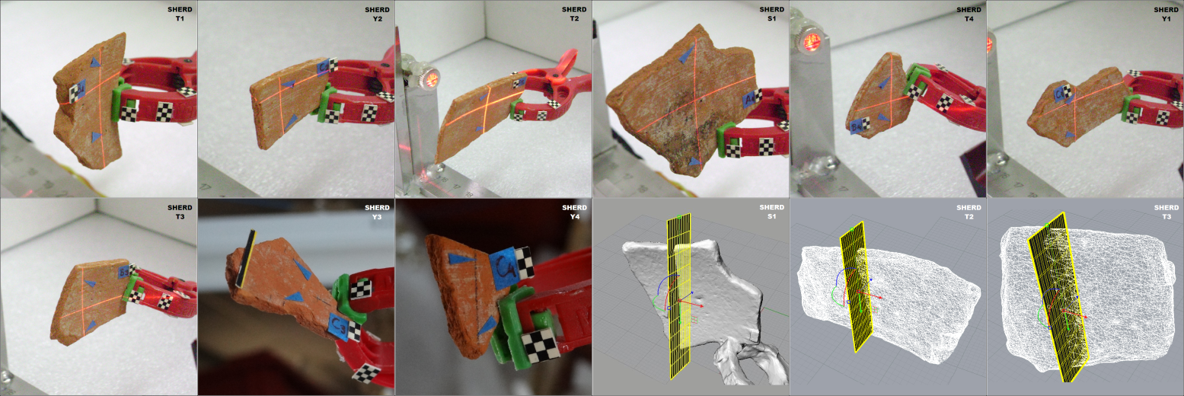
Figure 14. Multiple views of sherds at the orientation procedure and the extraction of their optimal thickness profiles (TPs).

- Conclusions
We presented a new digital approach for reassembling ancient ceramic pottery based on 3D models of their fragments and the exploitation of their thickness profile. The results show that our method allows for accurate reassemblies to be achieved with minimal expert interaction. The method is based on thickness, which is an information encapsulated in the inner part of the sherd that cannot be affected by the presence of harsh environmental conditions. Our method is verified on real and synthetic potteries. Using photogrammetry, 3D representations and precise measurements we demonstrated the validity of new method. To our knowledge, we have introduced a new method that bridges the gap between top-down and bottom-up approaches and answers difficult problems in the excessively time consuming task of manual reassembly of ancient pottery. We intend to expand and fine-tune our methodology with more complex experiments using real archaeological potteries from some museum collection in high archaeological interest countries (especially on themes from Archaic, Classical or Hellenistic period).
Acknowledgement
The authors would like to thank Mrs. Maria Giamalidi and Mrs. Katerina Panagopoulou, Hellenic Ephorate of Antiquities of West Attika, Piraeus and Islands, for their archaeological support. Furthermore we would like to thank all the archaeologists from the Archaeological Museum of Piraeus and specially from the Archaeological sub-department in Hellinicon.
References
- M.Kampel, R.Sablatnig, H.Mara, "Robust 3D Reconstruction of Archaeological Pottery based on Concentric Circular Rills", In: Magnenat-Thalmann, N., Rindel, J.H. (Eds.), The 6th International Workshop on Image Analysis for Multimedia Interactive Services, Montreux Switzerland, 2005, pp.14-20.
- R.Sablatnig, C.Menard, "3D Reconstruction of Archaeological Pottery using Profile Primitives", Proceeding of the International Workshop on Synthetic-Natural Hybrid Coding and 3D Imaging, Rhodes, Greece, Sept.1997, pp.93-96.
- M.Kampel, R.Sablatnig, "Detection of Matching Fragments of Pottery", Computer Applications and Quantitative Methods in Archaeology, Beyond the artifact digital interpretation of the past, Prato, Italy, April 2004.
- M.Kampel, R.Sablatnig, "Profile-based Pottery Reconstruction", IEEE, Proceedings of Conference on Computer Vision and Pattern Recognition Workshop, Wisconsin, U.S.A., June 2003, pp.1-6.
- G.Papaioannou, E.A.Karabassi, "On the automatic assemblage of arbitrary broken solid artefacts", Image and Vision Computing, Elsevier, vol.21, no.5, May 2003, pp.401-412.
- M.Kampel, H.Mara, R.Sablatnig, "Automated Investigation of Archaeological Vessels", 14st European Signal Processing Conference, EUSIPCO 2006, Florence, Italy, September 2006.
- D.Filippas, A.Georgopoulos, "Development of an algorithmic procedure for the detection of conjugate fragments", XXIV International CIPA Symposium, Strasbourg, France, 2-6 Sept. 2013.
- M.Kampel, F.J.Melero, "Virtual Vessel Reconstruction from a Fragment's Profile", 4th International Symposium on Virtual Reality, Archaeology & Intelligent Cultural Heritage, VAST 2003, Brighton, United Kingdom.
- I.Marie, H.Qasrawi, "Virtual assembly of pottery fragments using moire surface profile measurements", Journal of Archaeological Science, vol.32, 2005, pp.1527-1533.
- G.Papaioannou, E.A.Karabassi, T.Theoharis, "Virtual Archaeologist: Assembling the past", IEEE Computer Graphics and Applications, vol.21, no.2, March-April 2001, pp.53-59.
- G.Papaioannou, E.A.Karabassi, T.Theoharis, "Reconstruction of Three-Dimensional Objects through Matching of Their Parts", IEEE transactions on pattern analysis and machine intelligence, vol.24, no.1, January 2002, pp.114-124.
- G.Papaioannou, T.Theoharis, "Fast Fragment Assemblage Using Boundary Line and Surface Matching", Conference: Computer Vision and Pattern Recognition Workshop, vol.1, Wisconsin, U.S.A., June 2003.
- N.A.Rasheed, M.J.Nordin, "A Survey of Computer Methods in Reconstruction of 3D Archaeological Pottery Objects", International Journal of Advanced Research, vol.3, no.3, 2015, pp.712-714.
- A.Karasik, U.Smilansky, "3D scanning technology as a standard archaeological tool for pottery analysis: practice and theory", Journal of Archaeological Science, vol.35, 2008, pp.1148-1168.
- K.Son, E.B.Almeida, D.B.Cooper, "Axially Symmetric 3D Pots Configuration System using Axis of Symmetry and Break Curve", Computer Vision and Pattern Recognition, 2013 IEEE Conference on. IEEE, 2013, pp.257-264.
- Q.X.Huang, S.Flory, N.Gelfand, M.Hofer, H.Pottmann, "Reassembling Fractured Objects by Geometric Matching", ACM Transactions on Graphics, vol.25, is.3, N.Y., U.S.A., July 2006, pp.569-578.
- A.R.Willis, D.B.Cooper, "Bayesian Assembly of 3D Axially Symmetric Shapes from Fragments", Conference on Computer Vision and Pattern Recognition, vol.1, June 2004, pp.82-89.
- I.Giannoukos, C.N.Anagnostopoulos, E.Kayafas, V.Loumos, "Dental measurements using 3D models of plaster imprints", 17th Symposium IMEKO TC4 - 15th International Workshop - 3rd Symposium IMEKO TC19, Kosice, Slovakia, September 2010.
- A.Gomez-Gutierrez, J.J.Sanjose-Blasco, J.Matias-Bejarano, F.Berenguer-Sempere, "Comparing Two Photo-Reconstruction Methods to Produce High Density Point Clouds and DEMs in the Corral del Veleta Rock Glacier", Remote Sensing, 6, Spain, 2014, pp.5407-5427.
- A Lopas image: available online at: http://www.britishmuseum.org/research/collection_online/collection_object_details/collection_image_gallery.aspx?partid=1&assetid=1594884001&objectid=3309459

