Utilization of Mobile Ultrasonic Contact Impedance (UCI) Hardness Testers for Check the Residual Operation Life and Their Calibration
Michal Junek¹, Jiří Janovec¹, Petr Ducháček¹
¹ CTU in Prague, Faculty of mechanical engineering, Department of Materials Engineering, Praha 2, Karlovo náměstí 13, Czech Republic
ABSTRACT
The paper deals with the hardness measurement by mobile UCI hardness testers as a mean of determining the residual operation life of the power unit components. It aims to answer questions regarding the level of dependence of UCI hardness on Young´s modulus of creep-resistant steels and determining the conditions of UCI hardness tester calibration. The experimental part describes comparative measurements of hardness values obtained using stationary hardness tester and UCI hardness tester.

Section: RESEARCH PAPER
Keywords: Ultrasound Hardness Tester, Young´s Modulus of Elasticity, Calibration, Creep-resistant Steel, Residual operation life
Citation:
Section Editor: name, affiliation
Received month day, year; In final form month day, year; Published month year
Copyright: © year IMEKO. This is an open-access article distributed under the terms of the Creative Commons Attribution 3.0 License, which permits unrestricted use, distribution, and reproduction in any medium, provided the original author and source are credited
Funding: This work was supported by the Ministry of Education, Youth and Sport of the Czech Republic within the project No. LO1207 of the program NPU1
Corresponding author: M. Junek, e-mail: michal.junek@fs.cvut.cz

- Introduction
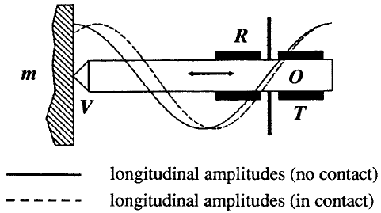
Figure 1. UCI probe schematics [1]
At present there exists a trend of development of hardness measurements by portable hardness testers allowing "non-destructive" hardness measurements of large construction parts without any need of specimen separation for stationary hardness testers. Four physically distinct methods used are: UCI ultrasonic method, dynamic rebound method, optical method TIV (Through Indenter Viewing) and electrical resistance method (Handy Esatest). In following text, the focus was aimed only on the UCI method.
One of the many possibilities of using portable UCI hardness testers is the hardness measurement in assemblies (steam boilers, steam pipe-lines) functioning in energy units, which operate in the creep conditions (temperature app. 550 °C and a pressure app. 15 N.mm⁻²). Long-term operation (2.5 . 10⁵ hours) in these conditions leads to degradation of the material accompanied by a decrease of the hardness values. UCI hardness measurement method should thus serve to detect thresholds hardness values that indicate the poor mechanical properties of the material, the risk of failure and the necessity of a more thorough examination of the experimental material state (microstructure evaluation, small punch samples preparation).
- THE UCI METHOD OF HARDNESS MEASUREMENT
An UCI probe consists of a Vickers diamond tip attached to the end of a metal rod, which is excited into longitudinal oscillation of 70 kHz frequency by piezoelectric transducers (Figure 1).
Where T is the Piezo Transducer, R the Piezo Receiver, O the oscillating rod, V the indenter (for example Vickers diamond) and m is the test material.
The UCI method does not require the diagonals of the test indentation to be measured which is necessary for the Vickers hardness determining. In this method, the shift of an ultrasonic frequency of the oscillating indenter is electronically related with the area of the indentation and thus resulting in the final hardness value. The deeper the diamond indenter penetrates, the larger is the indentation area, the larger is frequency shift of the diamond tip and the lower is then the resulting hardness, see equation (1), (2) and Figure 2. [2]
$∆f=f(E_{eff}∙A)$ (1)
$HV=F/A$ (2)
Table 1. Recommended applications for hardness measurement by portable hardness testers [2]
Applications | Dynamic rebound method | UCI method | TIV method | Handy Esatest
Solid (big) parts | * | * | o | o
Coarse-grained materials | * | x | x | x
Steel and aluminium cast alloys | * | o | o | o
HAZ with welds | x | * | * | *
Tubes: wall thickness > 20 mm | * | * | * | *
Tubes: wall thickness < 20 mm | x | * | * | *
Inhomogeneous surfaces | o | x | x | x
Sheet metal, coils | x | o | * | *
Thin layers | x | o | * | *
Hard to get at positions | x | * | x | *
Coarse surfaces | * | x | x | o
Finally machined surfaces | o | * | * | *
Electrically conductive materials | * | * | * | x
Dusty environments | * | o | o | x

Explanatory notes to table:
x | Not recommended
o | Sometimes suitable (In the case of elimination conditions having adverse impacts on results of measurement)
* | Especially well-suited

Where Δf is the frequency shift, E_{eff} the effective modulus of elasticity (contains the elastic constants of both the indenter and the test piece), A is the area of indentation, HV the Vickers hardness value and F is the test load.
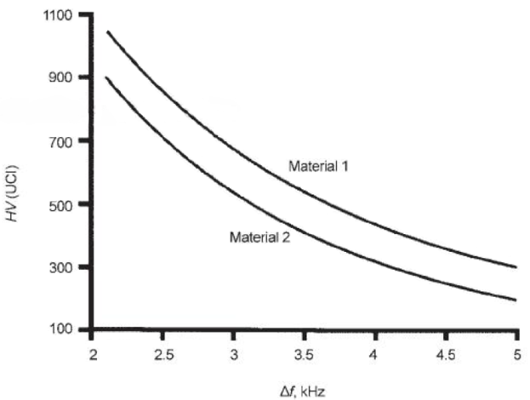Figure 2. Frequency shift of an ultrasonic contact impedance (UCI) probe as a function of hardness [3]
The equation (1) implies that a frequency shift depends on effective modulus of elasticity as well. Therefore, Young´s modulus of elasticity in tension must be considered in practical use of the UCI method. Equipment must be calibrated if determining hardness of different materials with different hardness values. But the question is to what extent does the UCI hardness depend on the modulus of elasticity? [2]
  - Calibration
The ASTM A1038 – 05 standard [1] states that the UCI hardness testers usually has been calibrated on non-alloyed and low-alloyed steel, that is, certified hardness reference blocks with Young´s modulus of elasticity 210 000 N.mm⁻². Because unalloyed or low-alloy steels have a similar Young’s modulus of elasticity, accurate results are obtained with the standard calibration. In many cases, the difference in Young’s modulus of medium-alloy and high-alloy steels is so insignificant that the error created falls within the allowable tolerances of the part. But the question is what is considered as a similar Young’s modulus of elasticity?
Hardness references block are needed for calibration to other materials with different Young’s modulus of elasticity. This paper should answer the question of calibration UCI hardness testers used for hardness measurement of components functioning in energy units.
  - Comparison of non-destructive methods of hardness measurement
Several methods for non-destructive hardness measurement are used in practice. The following Table 1 shows various methods for non-destructive measuring of hardness using portable hardness testers. Furthermore, there is a comparison of the areas of applications of each portable hardness testers. From this comparison, the UCI method seems to be best for hardness measurement of large construction parts functioning in energy units (steam pipe-lines, steam boilers and welds of these parts).
- Degradation Mechanisms of HIGH PRESSURE (hP) STEAM PIPe-lines
The best resistance against operating in conditions of creep damage shows CrMoV low-alloy steels in the normalized or heat-treated state (13CrMo4-5, 14MoV6-3, 10CrMo9-10). In case of higher operating parameters, it is modified 9-12% Cr martensitic steel X10CrMoVNb9-1 (P91) and X10CrWMoVNb9-2 (P92) steel. The main factors affecting the lifetime of HP steam pipelines is a combination of their material properties and operating conditions. The main degradation mechanisms therefore include material degradation in the form of structural changes caused by coagulation of carbide particles and the nucleation and formation of cavities due to creep damage. This degradation is accompanied by a reduction of hardness. [4]
The structural changes are temperature and time dependent processes which could lead to a decrease in both short-term characteristics (yield strength, ultimate strength, hardness, and fracture toughness) and the long-term characteristics (creep strength, creep deformation, plasticity). In case of low-alloy creep-resistant steels there exists an area of predominant hardening and an area of predominant softening. Hardening of the material (up to 1000 hours of operation) in CrMoV steels is caused by additional precipitation of vanadium carbides, thereby increasing the number of new dispersed particles, reducing their average size, increasing their volume fraction and decreasing their interparticle distance. On the other hand, during material softening there occurs coarsening of dispersed particles via diffusion processes, resulting in increase of their average size, volume fraction decrease and increase of the interparticle distance. [4]
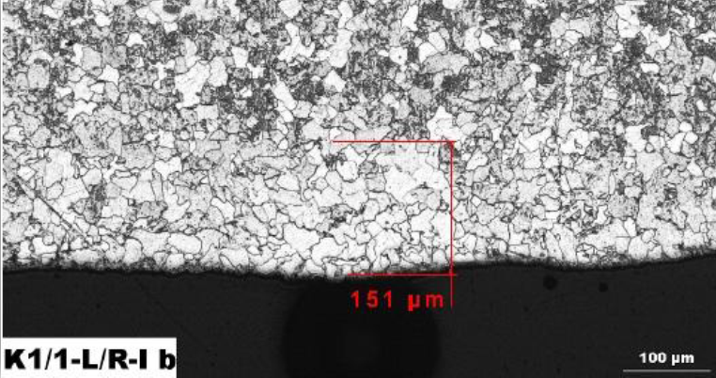
Figure 4. Surface decarburization of HP steam pipe-line of fossil fuel power plants
Stages of degradation of creep resistant, low-alloy steel of chemical composition of 0.5% Cr - 0.5% Mo - 0.25% V (14MoV6-3) subjected to creep exposure are in Fig. 3. Stage 0 corresponds to the initial state with ferritic-bainitic structure at the beginning of creep exposure (Figure 3 - Stage 0). The first stage of structural changes is characterized by a moderate decomposition of bainite. That is accompanied by coagulation of M3C carbides in these areas and further precipitation of M23C6 carbides along the ferritic grains boundaries. At the same time, very fine MC carbides precipitate within the ferrite grains (Figure 3 - Stage 1). The next stage is characterized by significant decomposition of bainite and coagulation of M3C carbides into relatively large carbide particles at the grain boundaries. The M23C6 carbides precipitate on the boundaries of ferritic grains and form chains. Simultaneously, fine MC carbides are observed within ferritic grains (Figure 3 - Stage 2). Final structural changes result into ferritic matrix containing MC and M6C carbides inside ferrite grains and large M23C6 carbides precipitated along the grain boundaries (Figure 3 - Stage 3). Depending on the operating conditions, the material may contain also other types of carbides, e.g. M7C3 carbides. After such a degradation of the material microstructure and further creep exposure the creep cavities are formed. [5]

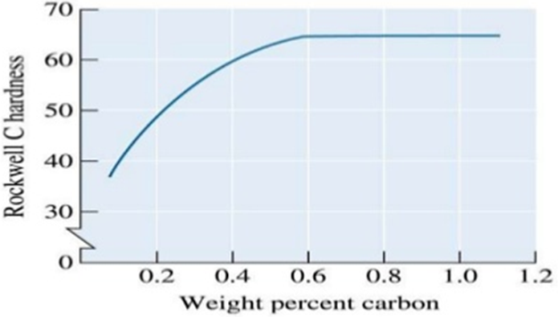
Figure 5. Dependence of Rockwell hardness on the carbon content [6]

  - Surface Decarburization
Surface decarburization takes place most frequently on the outer surface of steel components and is accompanied by rapid reduction of carbon content on the surface due to diffusion caused by high temperature.
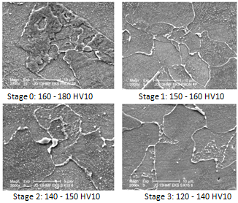
Figure 3. Stages of microstructure degradation after the creep exposure [5]
Decarburized layer has a lower hardness than the material below the layer due to reduced carbon content. Carbon content gradient in the decarburized layer increases with the distance from the outer surface, see Figure 4 and Figure 5. Therefore, the hardness values measured after removal of decarburized layer are higher. Since the hardness is measured on the outer surface components, it is imperative to remove this layer in order to achieve relevant results. Decarburized layer has a thickness usually of up to 1.0 mm.
- EXPERIMENTAL
The experimental part was focused on determining UCI hardness dependence on Young´s modulus of elasticity in tension via comparative measurement of hardness values obtained by classic HV10 Vickers method and values obtained using UCI hardness tester. Deviation of the mean values measured by UCI hardness tester and by stationary (laboratory) hardness tester were evaluated.
  - Used Measurement Equipment
Comparative measurements as a mean of determining of UCI hardness on E were performed in accord with ČSN EN ISO 6507-1 standard using calibrated stationary hardness tester by Vickers method with load of HV10. As a representative of portable hardness testers the UCI hardness tester Krautkrämer MIC20 and Krautkrämer MIC10 with UCI probe MIC 2010 of load of 98 N was selected.

  - Experimental Materials
Materials with different Young´s modulus E were selected for comparative measurements. Values of Young´s modulus E were verified using literary resources. The mean values without standard deviations are shown in Table 2. The experimental determination of the Young´s modulus values was not carried out due to lack of time.
The experimental samples were removed from the steam pipe-lines or boiler tube in different states of degradation. In the case of steels X20CrMoV12-1 and X5CrNiCuNb17-4-4, it was possible to get the samples from the rotor blades. Table 3 shows a description of individual samples.
  - Preparation of the Measurement Site
Hardness of the materials described above was measured always on the outer surface (approximately 0.5 to 1.0 mm was grinded off in order to remove decarburized layer), and across the tube wall thickness. In case of steels of a tensile modulus of 200 N.mm⁻² hardness was measured only in the cross-section of the blade lock. The surface was prepared using metallographic grinder with sandpaper grit of 400, thereby achieving the surface roughness R_{a} 0.07 – 0.12 µm (Measured by Surface Roughness Tester Hommelwerke LV-5E). Selected number of indentations on every surface was 10.
  - Measurement Process
On the prepared surfaces with an approximate area of 10 mm² at first the hardness was measured according to ČSN EN ISO 6507-1 using a stationary hardness tester (Vickers method) with a load of HV10. Subsequently, UCI hardness tester was used for hardness measurement in close vicinity (approximately 5 mm) of these indentations.
During UCI tester measurements the following finding was observed. The probe MIC 2010 was firstly used for measuring of the initial state hardness (without perpendicularity providing fixture). Hardness values measured in this way showed significant deviations and unreal values. Therefore, it was decided to use the probe with perpendicularity providing fixture to solve the problem. It implies that when measuring the hardness, it is necessary to keep the probe perpendicular to the surface, which can be achieved by installing the fixture or by a properly trained and experienced person performing the measurements.
  - Results of Measurements
Table 2. Selected materials and their Young´s modulus values
Materials | E [N.mm⁻²]
X10CrMoVNb9-1 (P91) X10CrWMoVNb9-2 (P92) | 218 000
14MoV6-3  T23  T24 | 210 000
X20CrMoV12-1  X5CrNiCuNb17-4-4 | 200 000
Steel Super 304H | 193 000

All results of hardness measurement are summarized in Table 3 - Table 10. The tables contain the average hardness value from 10 measurements for each samples measured on the surface and throughout the wall thickness by laboratory hardness tester and by UCI hardness testers. Tables further include standard deviations (STD) of measured values and the deviation of the average value of the UCI hardness from average values measured by stationary hardness tester (LAB).

- Steels with E = 218 000 N.mm⁻²
Table 3. Selected samples of materials and their state of operating (laboratory) degradation
Material | Sample - State of degradation
X10CrMoVNb9-1 | P6 – lab. ageing at 600 °C/10 000 hours  P21 – initial state after heat treatment
X10CrWMoVNb9-2 | BT3 – lab. ageing at 650 °C/20 000 hours  T33 – lab. ageing at 650 °C/5 033 hours
14MoV6-3 | K1 – degraded at 525 °C/240 000 hours  EPR – degraded at 560 °C/261 800 hours  EPC – degraded at 540 °C/240 066 hours
T23 | V23 – initial state after heat treatment  D23 – lab. ageing at 650 °C/5 033 hours
T24 | V24 – initial state after heat treatment  D24 – lab. ageing at 650 °C/5 033 hours
X20CrMoV12-1 | L1 – Unknown
X5CrNiCuNb17-4-4 | L2 – Unknown
Steel Super 304H | 2030 – Dissolving annealing 1150 °C/2 min

Table 4. Steel X10CrMoVNb9-1; samples P21 and P6
X10CrMoVNb9-1; Sample P21
(Ø 324 x 28 mm); initial state after heat treatment
Measured on surface |  |  |  |  | Measured through the wall thickness
 | LAB | MIC 20 | MIC 10 |  | LAB | MIC 20 | MIC 10
 | HV10 | UCI HV10 | UCI HV10 |  | HV10 | UCI HV10 | UCI HV10
Avg. | 201 | 187 | 186 |  | 215 | 199 | 195
STD | ± 5 | ± 6 | ± 9 |  | ± 5 | ± 11 | ± 10
Deviation |  | - 14 | - 15 |  |  | - 16 | - 20
X10CrMoVNb9-1; Sample P6
(Ø 270 x 25 mm); laboratory ageing at 600 °C/10 000 hours
Avg. | 228 | 208 | 206 |  | 238 | 218 | 217
STD | ± 5 | ± 5 | ± 5 |  | ± 4 | ± 6 | ± 6
Deviation |  | - 20 | - 22 |  |  | - 20 | - 21

In case of steels with the same Young´s modulus 218 000 N.mm⁻² the measurements show that the values of the deviations of both UCI hardness testers (Krautkrämer MIC20 and MIC10) vary in the same trend. The average value of the deviations is approximately -21 HV (see Tables 4 and 5).
Table 8. Steel T24; samples V24 and D24
T24; Sample V24
(Ø 38 x 5.6 mm); initial state after heat treatment
Measured on surface |  |  |  |  | Measured through the wall thickness
 | LAB | MIC 20 | MIC 10 |  | LAB | MIC 20 | MIC 10
 | HV10 | UCI HV10 | UCI HV10 |  | HV10 | UCI HV10 | UCI HV10
Avg. | 229 | 250 | 239 |  | 228 | 243 | 231
STD | ± 2 | ± 12 | ± 7 |  | ± 5 | ± 6 | ± 11
Deviation |  | 21 | 10 |  |  | 15 | 3
T24; Sample D24
(Ø 38 x 5.6 mm); laboratory ageing at 650 °C/5 033 hours
Avg. | 175 | 186 | 192 |  | 176 | 199 | 190
STD | ± 2 | ± 12 | ± 8 |  | ± 4 | ± 11 | ± 11
Deviation |  | 11 | 17 |  |  | 23 | 14

- Steels with E = 210 000 N.mm⁻²
Table 5. Steel X10CrWMoVNb9-2; samples BT3 and T33
X10CrWMoVNb9-2; Sample BT3
(Ø 350 x 39 mm); laboratory ageing at 650 °C/20 000 hours
Measured on surface |  |  |  |  | Measured through the wall thickness
 | LAB | MIC 20 | MIC 10 |  | LAB | MIC 20 | MIC 10
 | HV10 | UCI HV10 | UCI HV10 |  | HV10 | UCI HV10 | UCI HV10
Avg. | 226 | 211 | 207 |  | 232 | 205 | 211
STD | ± 2 | ± 9 | ± 9 |  | ± 3 | ± 5 | ± 7
Deviation |  | - 15 | - 19 |  |  | - 27 | - 21
X10CrWMoVNb9-2; Sample T33
(Ø 528 x 94 mm); laboratory ageing at 650 °C/5 033 hours
Avg. | 223 | 204 | 198 |  | 230 | 205 | 216
STD | ± 3 | ± 12 | ± 6 |  | ± 3 | ± 7 | ± 6
Deviation |  | - 19 | - 25 |  |  | - 25 | - 14

Table 9. Steel X20CrMoV12-1; sample L1
X20CrMoV12-1; Sample L1
(rotor blades); unknown state
Measured through the cross-section |  |  |  |  | Measured through the cross-section
 | LAB | MIC 20 | MIC 10 |  | LAB | MIC 20 | MIC 10
 | HV10 | UCI HV10 | UCI HV10 |  | HV10 | UCI HV10 | UCI HV10
Avg. | 352 | 348 | 347 |  | 361 | 357 | 355
STD | ± 5 | ± 11 | ± 13 |  | ± 5 | ± 7 | ± 7
Deviation |  | - 4 | - 5 |  |  | - 4 | - 6

Table 10. Steel X5CrNiCuNb17-4-4; sample L2
X5CrNiCuNb17-4-4; Sample L2
(rotor blades); unknown state
Measured through the cross-section |  |  |  |  | Measured through the cross-section
 | LAB | MIC 20 | MIC 10 |  | LAB | MIC 20 | MIC 10
 | HV10 | UCI HV10 | UCI HV10 |  | HV10 | UCI HV10 | UCI HV10
Avg. | 503 | 502 | 500 |  | 508 | 509 | 504
STD | ± 7 | ± 8 | ± 7 |  | ± 3 | ± 10 | ± 6
Deviation |  | - 1 | - 3 |  |  | 1 | - 4

In case of 14Mo6-3 steel and T23, T24 steels with the same Young´s modulus 210 000 N.mm⁻² it was observed that the values of the deviations of both UCI hardness testers (Krautkrämer MIC20 and MIC10) vary in the inverse trend. The average value of the deviations is approximately -13 HV for 14Mo6-3 steel and 13 HV for T23, T24 steels (see Table 6 - Table 8).
Table 6. Steel 14MoV6-3; samples PK1, EPR and EPC
14MoV6-3; Sample K1
(Ø 273 x 26 mm); degraded at 525 °C/240 000 hours
Measured on surface |  |  |  |  |  | Measured through the wall thickness
 | LAB |  | MIC 20 | MIC 10 |  | LAB | MIC 20 | MIC 10
 | HV10 |  | UCI HV10 | UCI HV10 |  | HV10 | UCI HV10 | UCI HV10
Avg. | 201 |  | 191 | 187 |  | 214 | 202 | 202
STD | ± 3 |  | ± 7 | ± 7 |  | ± 5 | ± 9 | ± 14
Deviation |  |  | - 10 | - 14 |  |  | - 12 | - 12
14MoV6-3; Sample EPR
(Ø 245 x 36 mm); degraded at 560 °C/261 800 hours
Avg. | 151 |  | 137 | 133 |  | 150 | 138 | 133
STD | ± 1 |  | ± 11 | ± 7 |  | ± 2 | ± 8 | ± 8
Deviation |  |  | - 14 | - 18 |  |  | - 12 | - 17
14MoV6-3; Sample EPC
(Ø 324 x 48 mm); degraded at 540 °C/240 066 hours
Avg. |  | 128 | 121 | 119 |  | 133 | 117 | 119
STD |  | ± 4 | ± 2 | ± 7 |  | ± 3 | ± 5 | ± 5
Deviation |  |  | -7 | -9 |  |  | -16 | -14

Table 7. Steel T23; samples V23 and D23
T23; Sample V23
(Ø 38 x 5.6 mm); initial state after heat treatment
Measured on surface |  |  |  |  | Measured through the wall thickness
 | LAB | MIC 20 | MIC 10 |  | LAB | MIC 20 | MIC 10
 | HV10 | UCI HV10 | UCI HV10 |  | HV10 | UCI HV10 | UCI HV10
Avg. | 205 | 222 | 214 |  | 201 | 221 | 210
STD | ± 4 | ± 11 | ± 6 |  | ± 1 | ± 6 | ± 6
Deviation |  | 17 | 9 |  |  | 20 | 9
T23; Sample D23
(Ø 38 x 5.6 mm); laboratory ageing at 650 °C/5 033 hours
Avg. | 157 | 169 | 167 |  | 166 | 176 | 169
STD | ± 2 | ± 8 | ± 8 |  | ± 3 | ± 9 | ± 9
Deviation |  | 12 | 10 |  |  | 10 | 3

- Steels with E = 200 000 N.mm⁻²
The deviation values measured in steels with Young´s modulus of 200 000 N.mm⁻² of both UCI hardness testers (Krautkrämer MIC20 and MIC10) are similar. The average value of the deviations is approximately -3 HV, (see Tables 9 and 10).

- Steels with E = 193 000 N.mm⁻²
In case of austenitic steel Super 304H with Young´s modulus 193 000 N.mm⁻² it was observe that the measured values show large measurement error. The standard deviation of measured value by UCI hardness tester is up 59 HV.
Measurement of hardness of austenitic steels is generally a problem due to their strengthening. The dynamic rebound method (Brinell method) was not carried out because specimens, on whom the measurement was to be performed, did not reach the required minimum weight of 5 kg and minimum wall thickness 20 mm. The average value of the deviations is very different, (see Tables 11).

- CONCLUSION
The original idea of practice that hardness measurement by mobile UCI hardness testers is independent of the values of Young´s modulus has proven not to be entirely correct. The experimental results show the following (see Table 12). The larger is Young´s modulus the large is the negative deviations of measured hardness. Explanation of this dependence is evident from the Figure 2, which shows that the greater the frequency shift the smaller the measured hardness. Therefore, we can say that steel with a higher modulus of elasticity has a greater frequency shift. Therefore, we measured lower hardness for steels with higher Young´s modulus.
The measured results showed the existing dependence of UCI hardness on Young´s modulus. Although the dependence is very low, it is necessary to consider it and to perform the proposed calibration of UCI hardness testers using suitable calibration plates.
The measured results are summarized in Table 12. From the results it is possible to state that with increasing Young´s modulus of elasticity E the value of the negative deviation of hardness values measured by UCI hardness tester increases in comparison with the values measured using a stationary (laboratory) tester. The dependence can be considered as linear. However, that doesn´t apply in the case of T23 and T24 steels with Young´s modulus of 210 000 N.mm⁻² where deviation of UCI hardness varies in the opposite trend.
Table 12. A summary of the results of the average deviations
Materials | E [N.mm⁻²] | Average deviations HV10
X10CrMoVNb9-1 (P91) X10CrWMoVNb9-2 (P92) | 218 000 | -21
14MoV6-3 | 210 000 | -13
T23  T24 | 210 000 | 13
X20CrMoV12-1  X5CrNiCuNb17-4-4 | 200 000 | -3

The general validity of these conclusions has not been confirmed in one case. T23 and T24 steels showed the deviation trend opposed to the deviation measured in 16MoV6-3 steel. The average value of the deviations is approximately -13 HV for 14Mo6-3 steel and 13 HV for T23, T24 steels.
Finding the reasons of this difference in deviations values is not yet completed. Possible cause could be a different wall thicknesses, because boiler tubes from these materials has thickness wall 5.6 mm and steam pipe-lines from other materials has thickness wall from 20 up to 80 mm. The observation of the influence of different wall thicknesses (steam and boiler tubes), the influence of microstructure and verification of the real Young´s modulus will be subjects for the further research.

Considering the above measured results, we propose following groups of calibration plates:

- Calibration plates for 9% Cr martensitic steel – made
from P91 (P92) steel: E = 218 000 N.mm⁻²

- Calibration plates for low alloy CrMoV steels – made
from 16MoV6-3 steel: E = 210 000 N.mm⁻²

- Calibration plates for 2% Cr steels – made from T23
(T24) steel: E = 210 000 N.mm⁻²

- Calibration plates for steels for rotor blades – made
from X20CrMoV12-1 steel: E = 200 000 N.mm⁻²

It will be necessary to determine the hardness of these calibration plates at the lower and upper limit of practically measured values of HV hardness in operating conditions.
The rebound method was not carried out because specimens, on whom the measurement was to be performed, did not reach the required minimum weight of 5 kg. Measured values would be thus misleading.
These results are used in normatively technical documentation for requirements for hardness measurement by portable hardness testers in Czech classic power plants.
ACKNOWLEDGEMENT
Table 11. Steel Super 304H; sample 2030
Super 304H; Sample 2030
(Ø 38 x 6.3 mm); Dissolving annealing 1150 °C/2 min
Measured on surface |  |  |  |  | Measured through the wall thickness
 | LAB | MIC 20 | MIC 10 |  | LAB | MIC 20 | MIC 10
 | HV10 | UCI HV10 | UCI HV10 |  | HV10 | UCI HV10 | UCI HV10
Avg. | 181 | 366 | - |  | 176 | 227 | -
STD | ± 2 | ± 59 | - |  | ± 4 | ± 32 | -
Deviation |  | 185 | - |  |  | 49 | -

This work was supported by the Ministry of Education, Youth and Sport of the Czech Republic within the project No. LO1207 of the programme NPU1.
References
- ASTM A1038 – 05. “Standard Practice for Portable Hardness Testing by the Ultrasonic Contact Impedance Method”. West Conshohocken: ASTM International, 2005.
- S. Frank, “Mobile Hardness Testing Application Guide for Hardness Testers”. General Electric Company [online]. 2005 [cit. 2015-02-13]. Available from: http://www.acutech.gr/ media /pdf/Hardness%20Testing%20Applications%20Guide.pdf.
- K. Herrmann, “Hardness testing: principles and applications”. Materials Park, Ohio: ASM International, 2011. ISBN 978-1-61503-832-9.
- M. Junek, „Posouzení životnosti VT parovodů v podmínkách creepového poškození“. Diploma thesis. Praha: 2014. CTU in Prague, Faculty of mechanical engineering, Department of Material Engineering. 87 p.
- PA. PHILADELPHIA, “Power plant life management and performance improvement” Woodhead Pub. Ed. John E. Oakey, 2011, 684 p. ISBN 978-184-5697-266.
- Slide share. Slide share [online]. 2013 [cit. 2015-08-29]. Available from: http://image.slidesharecdn.com/f4-131118222248-phpapp 02/95/hardening-14-638.jpg?cb=1384813955.

