Utilization of Mobile Ultrasonic Contact Impedance (UCI) Hardness Testers for Check the Residual Operation Life and Their Calibration
Michal Junek¹, Jiří Janovec¹, Petr Ducháček¹
¹ CTU in Prague, Faculty of mechanical engineering, Department of Materials Engineering, Praha 2, Karlovo náměstí 13, Czech Republic
ABSTRACT
The paper deals with the hardness measurement by mobile UCI hardness testers as a mean of determining the residual operation life of the power unit components. It aims to answer questions regarding the level of dependence of UCI hardness on Young´s modulus of creep-resistant steels and determining the conditions of UCI hardness tester calibration. The experimental part describes comparative measurements of hardness values obtained using stationary hardness tester and UCI hardness tester.

Section: RESEARCH PAPER
Keywords: Ultrasound Hardness Tester, Young´s Modulus of Elasticity, Calibration, Creep-resistant Steel, Residual operation life
Citation:
Section Editor: name, affiliation
Received month day, year; In final form month day, year; Published month year
Copyright: © year IMEKO. This is an open-access article distributed under the terms of the Creative Commons Attribution 3.0 License, which permits unrestricted use, distribution, and reproduction in any medium, provided the original author and source are credited
Funding: This work was supported by the Ministry of Education, Youth and Sport of the Czech Republic within the project No. LO1207 of the program NPU1
Corresponding author: M. Junek, e-mail: michal.junek@fs.cvut.cz

- The main Additions (marked in red)
  - Calibration
The ASTM A1038 – 05 standard [1] states that the UCI hardness testers usually has been calibrated on non-alloyed and low-alloyed steel, that is, certified hardness reference blocks with Young´s modulus of elasticity 210 000 MPa. Because unalloyed or low-alloy steels have a similar Young’s modulus of elasticity, accurate results are obtained with the standard calibration. In many cases, the difference in Young’s modulus of medium-alloy and high-alloy steels is so insignificant that the error created falls within the allowable tolerances of the part. But the question is what is considered as a similar Young’s modulus of elasticity?
Hardness references block are needed for calibration to other materials with different Young’s modulus of elasticity. This paper should answer the question of calibration UCI hardness testers used for hardness measurement of components functioning in energy units.
  - Comparison of non-destructive methods of hardness measurement
Several methods for non-destructive hardness measurement are used in practice. The following Table 1 shows various methods for non-destructive measuring of hardness using by portable hardness testers. Furthermore, there is a comparison of the areas of applications of each portable hardness testers. From this comparison, the UCI method seems to be best for hardness measurement of large construction parts functioning in energy units (steam pipe-lines, steam boilers and welds of these parts).
  - Surface Decarburization
Surface decarburization takes place most frequently on the outer surface of steel components and is accompanied by rapid reduction of carbon content on the surface due to diffusion caused by high temperature.
Decarburized layer has a lower hardness than the material below the layer due to reduced carbon content. Carbon content gradient in the decarburized layer increases with the distance from the outer surface, see Figure 4 and Figure 5. Therefore, the hardness values measured after removal of decarburized layer are higher. Since the hardness is measured on the outer surface components, it is imperative to remove this layer in order to achieve relevant results. Decarburized layer has a thickness usually of up to 1.0 mm.

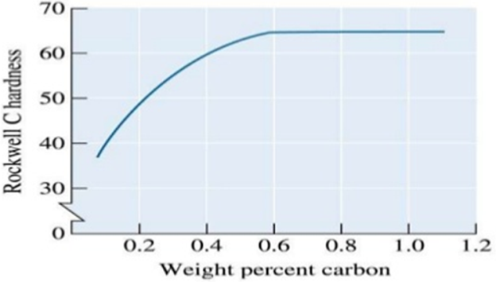
Figure 5. Dependence of Rockwell hardness on the carbon content [6]

Table 1. Recommended applications for hardness measurement by portable hardness testers [2]
Applications | Dynamic rebound method | UCI method | TIV method | Handy Esatest
Solid (big) parts | * | * | o | o
Coarse-grained materials | * | x | x | x
Steel and aluminium cast alloys | * | o | o | o
HAZ with welds | x | * | * | *
Tubes: wall thickness > 20 mm | * | * | * | *
Tubes: wall thickness < 20 mm | x | * | * | *
Inhomogeneous surfaces | o | x | x | x
Sheet metal, coils | x | o | * | *
Thin layers | x | o | * | *
Hard to get at positions | x | * | x | *
Coarse surfaces | * | x | x | o
Finally machined surfaces | o | * | * | *
Electrically conductive materials | * | * | * | x
Dusty environments | * | o | o | x

Explanatory notes to table:
x | Not recommended
o | Sometimes suitable (In the case of elimination conditions having adverse impacts on results of measurement)
* | Especially well-suited

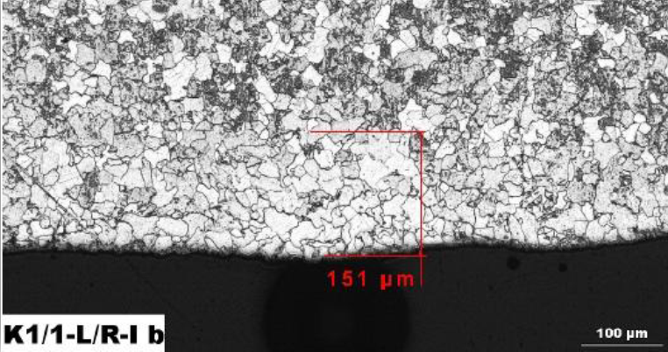
Figure 4. Surface decarburization of HP steam pipe-line of fossil fuel power plants
  - Results of Measurements

- Steels with E = 193 GPa
Table 11. Steel Super 304H; sample 2030
Super 304H; Sample 2030
(Ø 38 x 6.3 mm); Dissolving annealing 1150 °C/2 min
Measured on surface |  |  |  |  | Measured through the wall thickness
 | LAB | MIC 20 | MIC 10 |  | LAB | MIC 20 | MIC 10
 | HV10 | UCI HV10 | UCI HV10 |  | HV10 | UCI HV10 | UCI HV10
Avg. | 181 | 366 | - |  | 176 | 227 | -
STD | ± 2 | ± 59 | - |  | ± 4 | ± 32 | -
Deviation |  | 185 | - |  |  | 49 | -

In case of austenitic steel Super 304H with Young´s modulus 193 GPa it was observe that the measured values have large an error of measurement. The standard deviation of measured value by UCI hardness tester is up 59 HV.
Measurement of hardness of austenitic steels is generally a problem due to their strengthening. The dynamic rebound method (Brinell method) was not carried out because specimens, on whom the measurement was to be performed, did not reach the required minimum weight of 5 kg and minimum wall thickness 20 mm. The average value of the deviations is very different, (see Tables 11).
Table 3. Selected samples of materials and their state of operating (laboratory) degradation
Material | Sample - State of degradation
X10CrMoVNb9-1 | P6 – lab. ageing at 600 °C/10 000 hours  P21 – initial state after heat treatment
X10CrWMoVNb9-2 | BT3 – lab. ageing at 650 °C/20 000 hours  T33 – lab. ageing at 650 °C/5 033 hours
14MoV6-3 | K1 – degraded at 525 °C/240 000 hours  EPR – degraded at 560 °C/261 800 hours  EPC – degraded at 540 °C/240 066 hours
T23 | V23 – initial state after heat treatment  D23 – lab. ageing at 650 °C/5 033 hours
T24 | V24 – initial state after heat treatment  D24 – lab. ageing at 650 °C/5 033 hours
X20CrMoV12-1 | L1 – Unknown
X5CrNiCuNb17-4-4 | L2 – Unknown
Steel Super 304H | 2030 – Dissolving annealing 1150 °C/2 min

Table 2. Selected materials and their Young´s modulus values
Materials | E [GPa]
X10CrMoVNb9-1 (P91) X10CrWMoVNb9-2 (P92) | 218
14MoV6-3  T23  T24 | 210
X20CrMoV12-1  X5CrNiCuNb17-4-4 | 200
Steel Super 304H | 193

