Traceable Torque Calibration for Nacelle Test Benches in the MN·m Range
Christian Schlegel, Holger Kahmann, Rolf Kumme¹
¹ Physikalisch Technische Bundesanstalt, Bundesallee 100, D-38116 Braunschweig, Christian.Schlegel@ptb.de, Holger.Kahmann@ptb.de, Rolf.Kumme@ptb.de

Abstract – To verify all technical aspects of wind turbines, more and more nacelle test benches have come into operation. One crucial parameter is the initiated torque in the nacelles, which amounts to several MN·m. So far, no traceable calibration to national standards has been performed in such test benches. The paper will show calibration possibilities which already exist and also show future prospects.
- Introduction
The portion of renewable energies for electricity production is rising dramatically. For instance, last year the fraction of renewable energies in Germany was 32.5%. The portion of energy which was produced by wind energy was thereby 44.3% based on all renewable energies. The German government will increase the share of renewable energy in power generation to 40-45 % in 2025. From this development it is clear that by wind energy is likely to provide the greatest contribution to this planned expansion. Associated with this is a significant increase in the performance of the wind generators. This will lead to individual wind turbines more powerful in height, in wing span as well as in the provided electrical power, as seen in Fig. 1, taken from [1].
It is obvious of course that a reliable energy production from wind turbines will strongly depend upon their technical reliability. For that reason, several nacelle test benches have been established in the past. One crucial parameter for such a nacelle is the torque load which is initiated in the field according to the strength of the wind field. In nacelle test benches, instead of using wind power, a special motor is used to create the torque. Often an additional device is located between the motor and the nacelle to create axial forces as well as parasitic bending forces and moments onto the drive train.
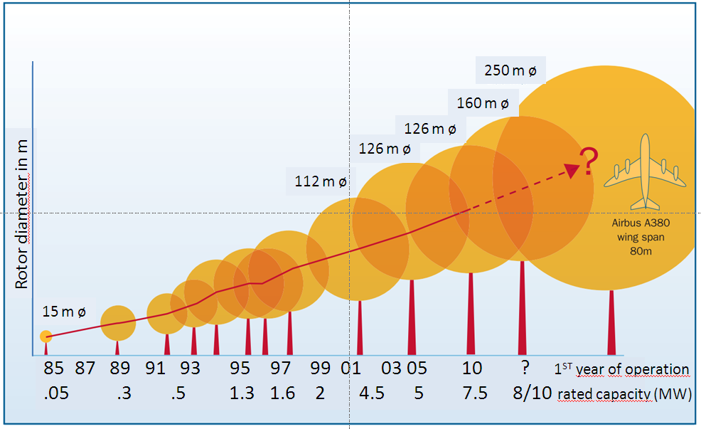
Fig. 1. Development of the size of wind turbines.
One of the most important parameters of such test benches is the torque which is initiated in the nacelle. The torque M is directly related to the electrical power P_{el} and depends on the revolution speed n.
(1)
Table 1 shows an example of two points of operation.
As shown in equation 1, the torque can be determined by an electrical power measurement. Nevertheless, this kind of measurement results in relative uncertainties of several percent; that is a more precise mechanical measurement of the torque is necessary.

Electrical Power  in MW | Revolution Speed  in rpm | Torque  in MN·m
5 | 14 | 3.4
10 | 9 | 10.6
Table 1. Examples of the relation of electrical power and torque.

Special torque transducers were built to measure the torque in the drive train. Unfortunately, not all of these transducers are calibrated in the MN·m range due to the lack of a calibration facility. Sometimes they are calibrated partially and extrapolated, e.g. via finite element calculations, to the nominal torque.
In the next chapters we will introduce a torque calibration machine which is able to calibrate torques up to 1.1 MN·m. Furthermore we will present a 5 MN·m torque transducer which will be investigated for the application of torque measurement.

- Traceable Calibartion of torque
According to the definition of the torque traceability can be realized via a lever arm l on which a Force is acting perpendicular which in the simplest case is the gravitational force m·g_{loc}, whereby m is the mass and g_{loc} is the gravitational constant.
(2)

Based on this principle there are torque calibration machines, which for the force initiation use mass stacks which can be varied in such a way that various torque steps can be applied [2]. Often the masses are coupled to the lever arm by means of thin metal bands (e.g. 20-30 µm) to get a very precise contact point for the deadweight force.
Unfortunately this principle cannot be further used by very high torques which are in the MN·m range. In these cases, one can apply a system where the torque is created by an actor lever system and measured by a second force lever system. This principle is used for example by the PTB 1.1 MN·m Standard Calibration Machine [3], see Fig. 2. On the measuring side, which is the upper traverse in Fig. 2, the lever is connected at both ends with force transducers. In this way, the torque is traced back by the length of the lever arm and the measured forces of the calibrated force transducers. In the machine, two different pairs force of transducer can be used, one (120 kN) for a lower range up to 220 kNm and one pair (550 kN) for the upper range up to 1.1 MN·m. In the range up to 220 kNm one has a relative uncertainty of the torque of 1.0·10⁻³, whereby in the upper range one obtains 0.8·10⁻³. The torque itself is created by two mechanical spindles as main drives which are located between the two lower platforms, see Fig. 2.
Fig. 2. The 1.1 MNm Standard Calibration Machine of PTB.
In addition, there is a secondary drive to define the horizontal position (left) and to reduce the cross force F_{x} and bending moment M_{z}. To compensate the vertical force F_{z} generated by the transducer weight and the lower lever arm, a hand-operated drive unit (under the lower lever arm) can be used. Connected to the measuring lever are spring elements to measure the parasitic mechanical components in the contact area between force transducer and lever arm. With the aid of these spring elements, all parasitic components can be minimized during a calibration procedure. Last but not least, a reference torque transducer is mounted in the lower part of the machine (the red flange) which is, in addition equipped with measuring bridges for bending forces and moments. This transducer offers additional possibilities to check the adjusted torque and the alignment of the whole measuring axis.
The calibration procedure which is used for the transducer under test usually follows German Standard DIN 51309.
- Torque Transfer transducer for NacellE Test Bench Calibration

In order to realize a traceable calibration for nacelle test benches, the EMPIR project: ”Torque measurement in the MN·m range” was started in October 2015 [3]. One of the objectives of this project is to develop novel traceable calibration methods for torque values in nacelle test benches with the use of transfer standards for the range above 1 MN·m.
For the realization of this goal, a commercial torque transducer with a nominal range of 5 MN·m from HBM will be used, see Fig. 2. During the above mentioned EMPIR project, an extrapolation procedure for the range above 1.1 MN·m will be developed.
In Fig. 3, the commercial transducer from HBM is depicted together with 2 DMP 41 bridge amplifiers. The transducer is equipped with two independent torque channels, two channels for transverse bending forces, two channels for bending moments and two channels for axial forces. Due to these additional channels, an investigation
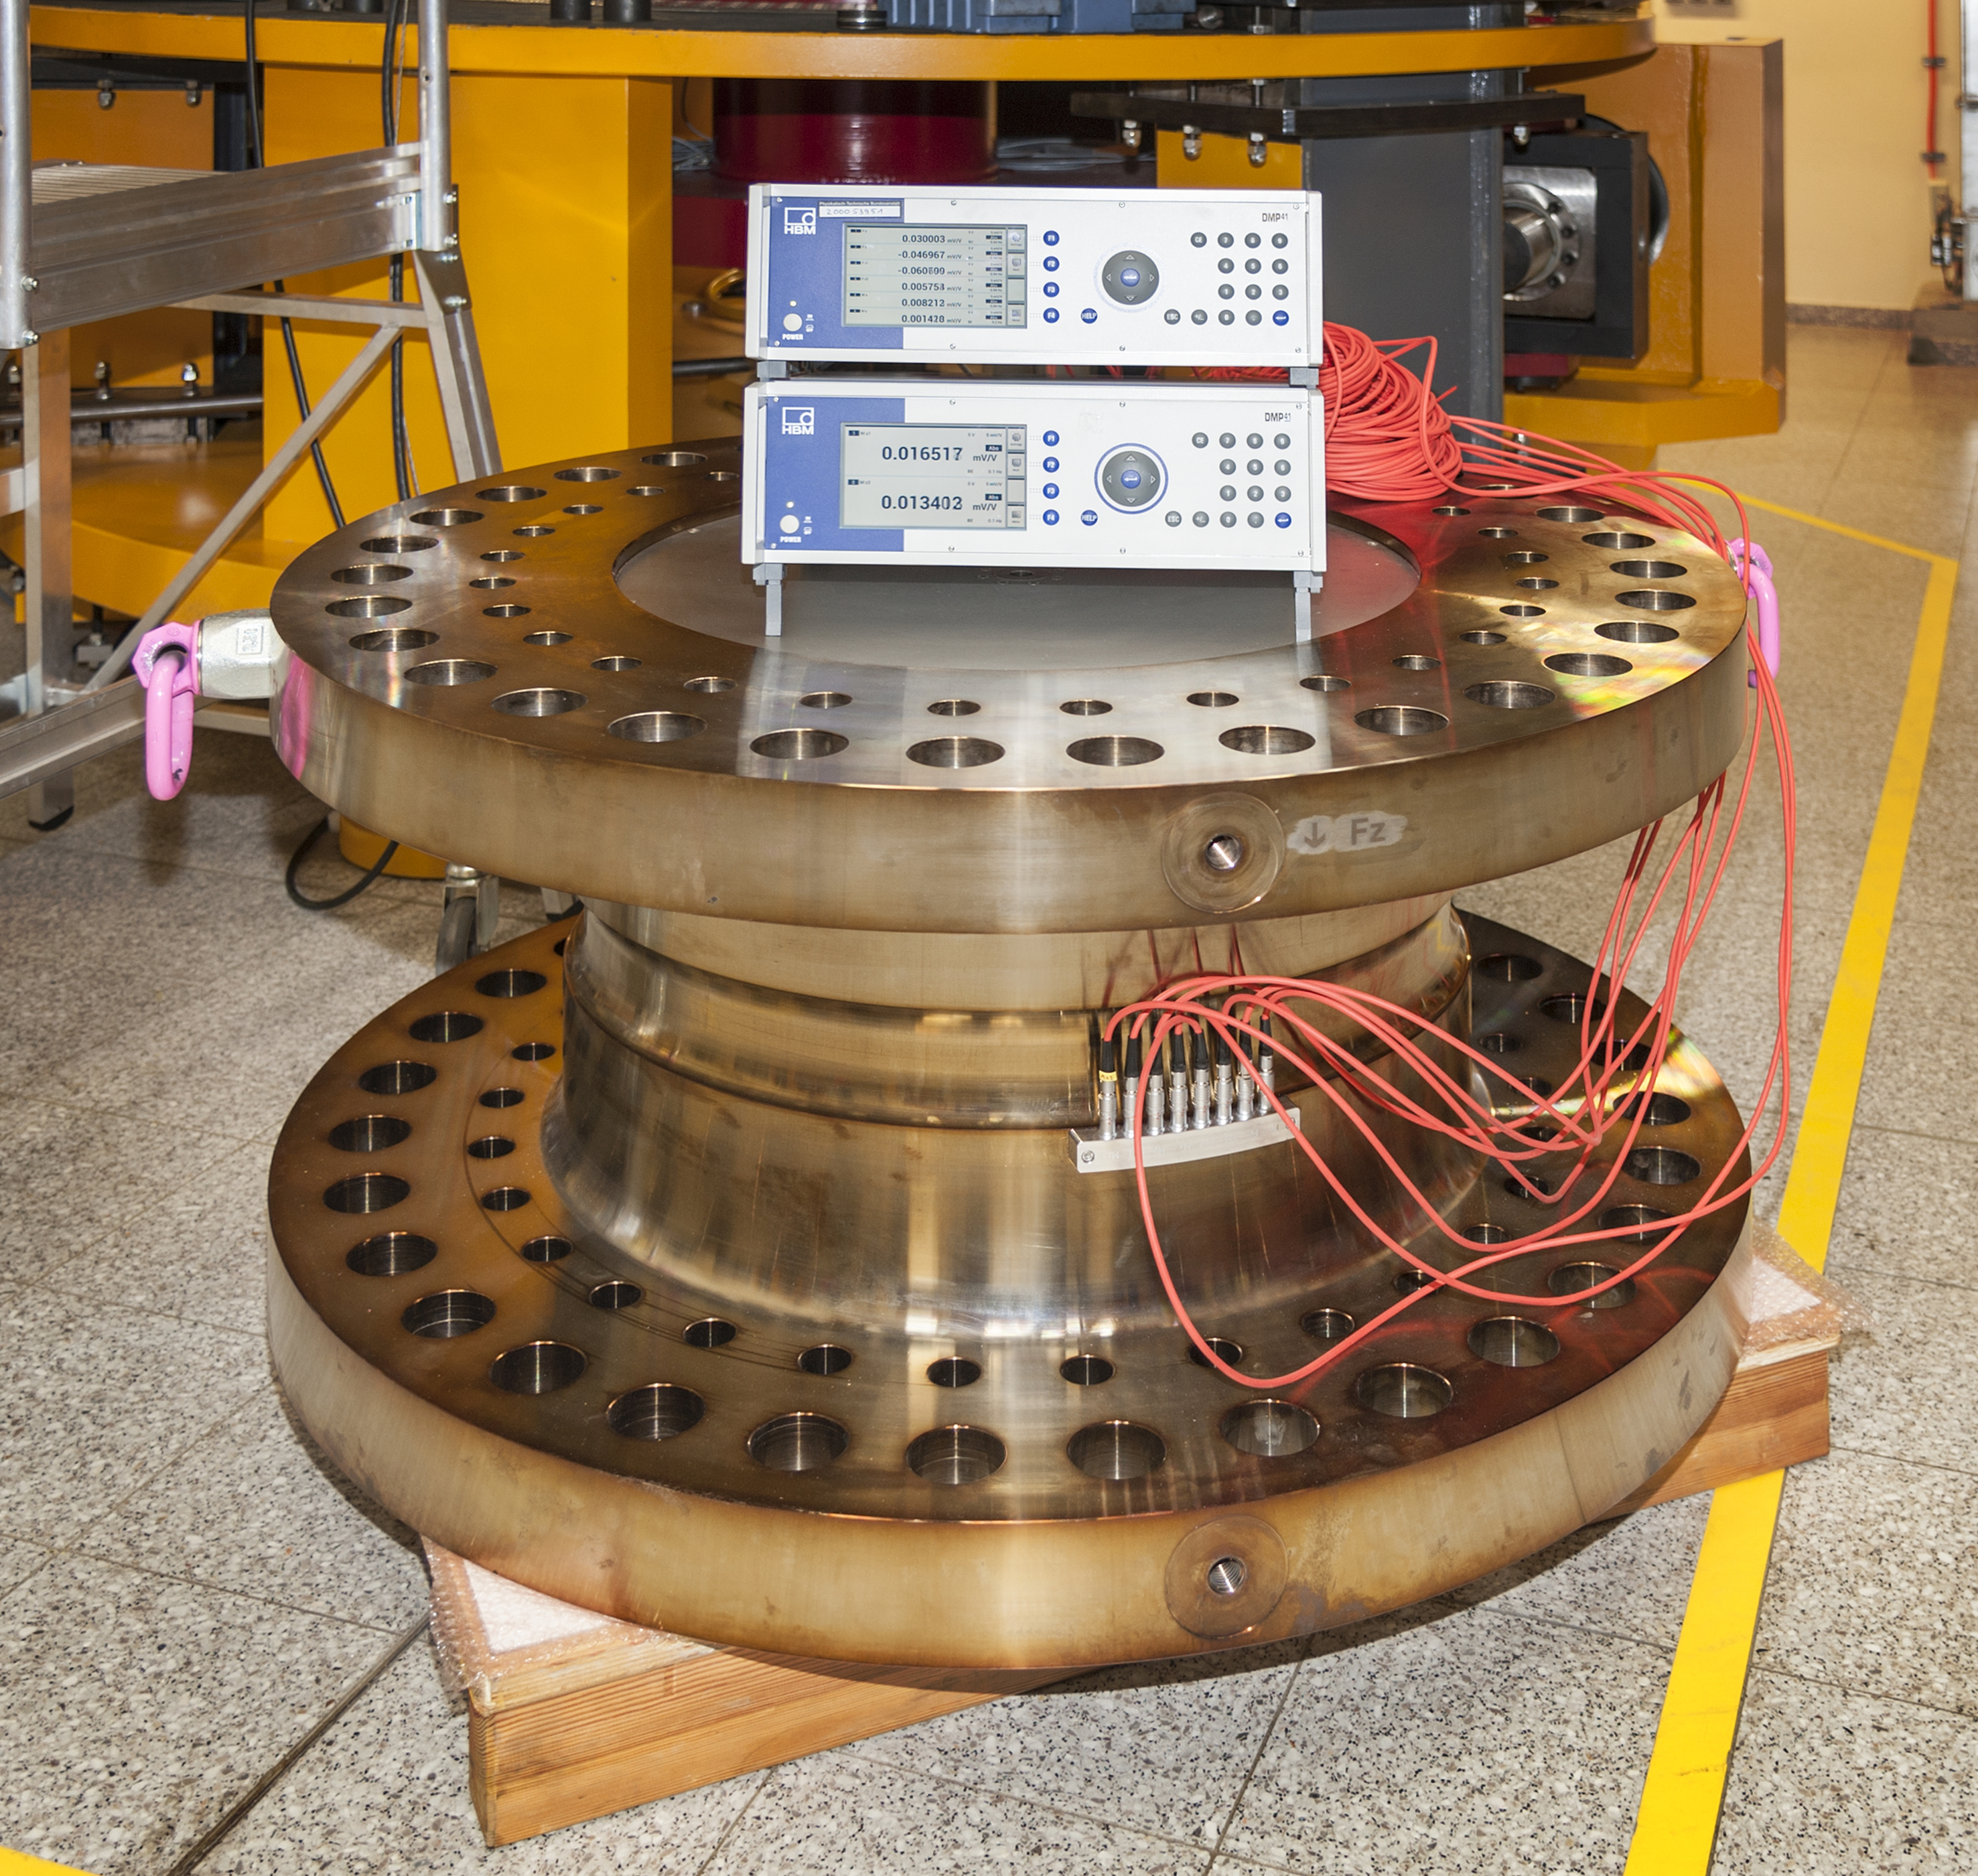
Fig. 3. 5 MN·m torque transducer together with two DMP41 bridge amplifiers for the readout of the 8 channels of the transducer.

of multi-component loading on the measurement of torque will be possible. In particular, crosstalk effects in the case of 6-component loading (3 directional forces, 2 directional bending torque) will be studied to describe effects on the torque measurements which occur in large nacelle test benches. Finally, a calibration procedure for large nacelle test benches will be developed during the EMPIR program. The calibration procedure will enable the traceability of torque loads up to 20 MN m and will include an uncertainty model that considers cross-talk effects.
First calibration measurements were performed with the shown 5 MN·m torque transducer in the above described PTB 1.1 MN·m Standard Calibration Machine. Thereby, the procedure according the German Standard DIN 51309 was applied [4].
Fig. 4 shows the calibration procedure according to DIN 51309. After three preloads, a certain number of upward and downward steps are performed in three mounting positions. At least 8 steps are required to determine a linear or polynomial fit. From the data, several characteristic parameters are derived which are used for the determination of the measurement uncertainty as well as a classification of the torque transducer. The parameters are indicated in Fig. 4. in the calibration procedure.
One characteristic result of the calibration is the deviation from linearity shown in Fig. 5. The curves reﬂect the relative deviations of the measured values from a ﬁtting straight line; the deviations are related to the measured mean value of the ﬁnal value. The ﬁtting straight line is deﬁned by the value of its slope; the axis intercept is zero.
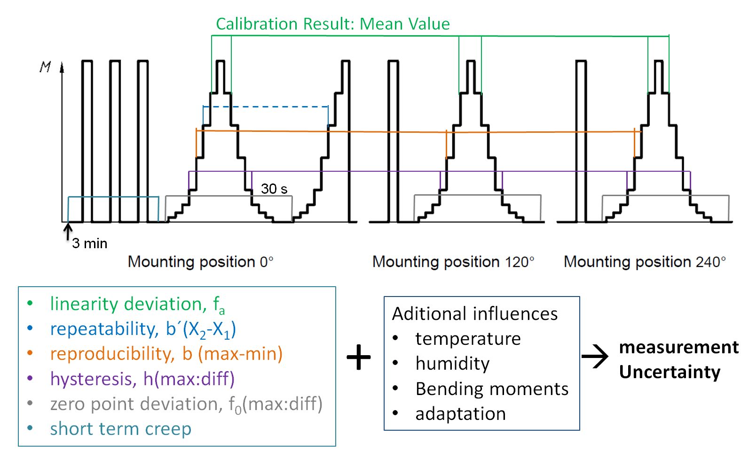
Fig. 4. Calibration procedure according to the German Standard DIN 51309. Indicated are several parameters which will be derived from the calibration data.
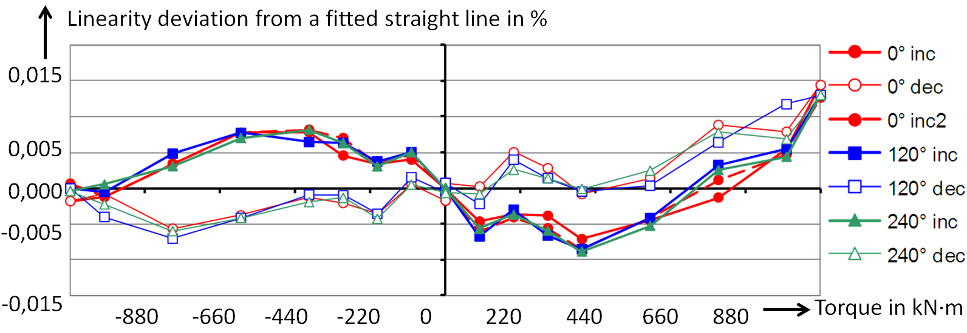
Fig. 5. Linearity deviation from a fitted straight line through the origin at zero. The deviations are related to the measured mean values of the final value.
During the measurement campaign, also partial ranges in between the 1.1 MN·m range were measured. This data will be used to develop extrapolation procedures. In addition, also the signals from the other six parasitic channels were recorded. The analysis of these data will provide information about the correlations of the torque from the bending forces and moments as well as the axial force.

IV. Development of a torque Calibration Machine for a Range up to 20 MN·m

To extend the torque calibration range above 1,1 MN·m, a complete new calibration machine will be built at PTB. This machine will be part of a Wind Competence Center which is funded by the German Federal Ministry of Economy Affairs and Energy. This center also includes besides the new torque calibration machine a big coordinate measuring machine and a wind channel for the calibration of LIDAR systems. The coordinate measuring machine should be able, e.g., to geometrically measure the gear parts of the nacelles. The capacity will be sufficient for gearwheels with a diameter of up to 3 m. To realize this new center two new buildings will be built on the PTB site, one for the coordinate measuring machine and the LIDAR system and one specially for the new torque calibration machine.
The new torque calibration machine (see Fig. 6) will be designed in a first stage for torques of up to 5 MN·m, and in a second stage up to 20 MN·m. Similar to the 1,1 MN·m calibration machine, the operation principle will also be based on two lever systems: one actor lever and a measuring lever. On the actor lever the forces will be created by two 1 MN servo-hydraulic cylinders.
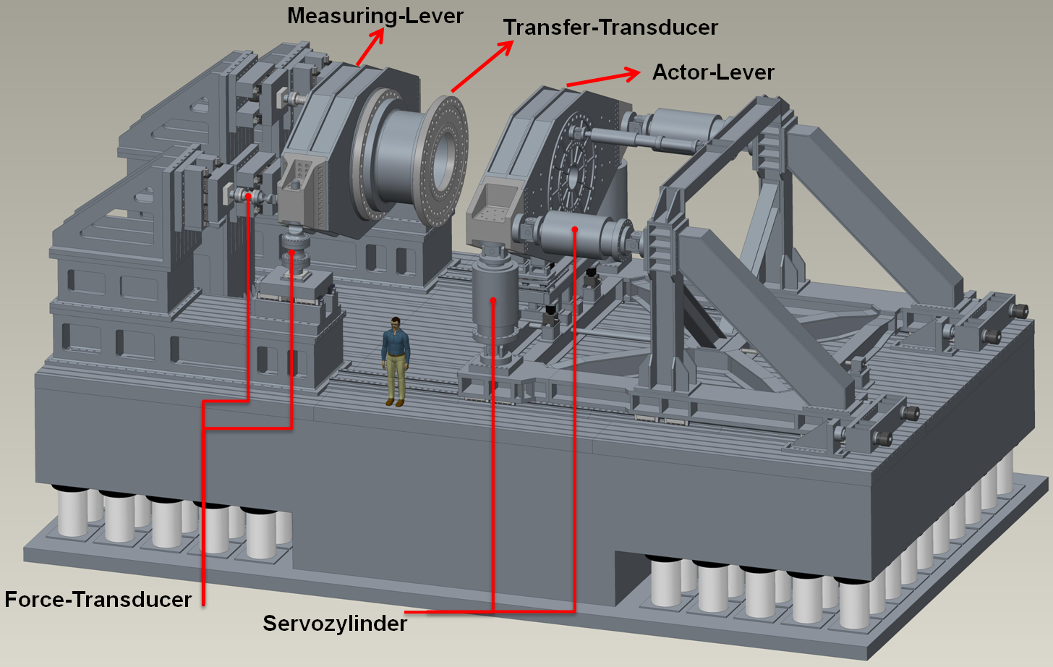
Fig. 6. Design of a new standard torque calibration machine for torques up to 20 MN·m.
In addition, also bending moments and axial forces can be applied by a pair of horizontally aligned servo- cylinders. Last but not least, the servo cylinders will also be able to operate dynamically in a frequency range of up to 3 Hz. For that reason the foundation of the machine is mounted on air springs. Each spring can be individually adjusted in pressure to achieve an optimal damping and to avoid resonance frequencies. The measuring lever system includes a pair of force transducers to measure the main force component of the torque and several spring elements for the detection of parasitic bending forces and moments.
- Conclusion
To increase the reliability of wind turbines, extensive technical tests are performed in nacelle test benches. One important aspect of these tests is the torque in the MN·m range which is initiated in the nacelle. Traceable torque calibration in the MN·m range can so far only realized by the 1.1 MN·m Standard Calibration Machine at PTB. One solution for a traceable torque calibration of nacelles is to use transfer torque transducers which are calibrated in special standard calibration machines which are traced back to the SI. Currently a calibration up to 1.1 MN·m of such transducers can be realized. For the above-mentioned torques, special extrapolation procedures have to be developed. To overcome the lack of calibration range, a new machine will be built insight the PTB´s new Wind Competence Center. This machine will be able to calibrate torques up to 5 MN·m in a first, stage and up to 20 MN·m in a second stage.

Acknowledgement

The research within the project has received funding from the European Union.

References
- www.ewea.org; UpWind “Design limits and solutions for very large wind turbines”,
The Sixth Framework Programme for Research and Development of the European Commission (FP6)
- D. Röske et. all., Metrological characterization of a 1 N·m torque standard machine at PTB, Germany
Metrologia 51 (2014) 87-96
- D. Peschel et. all., The new 1,1 MNm Torque Standard Machine of the PTB Braunschweig/Germany, Proceedings of the IMEKO-TC3 Conference, Cairo, Egypt 2005, pp.40.
- EMPIR-Program: “Torque Measurement in the MN·m range”, www.euramet.org/research-innovation/empir/empir-calls-and-projects/empir-call-2014/
- DIN 51309:2005-12, Materials testing machines - Calibration of static torque measuring devices.

