XXI IMEKO World Congress “Measurement in Research and Industry”

August 30 − September 4, 2015, Prague, Czech Republic

dEVELOPMENT OF THREE-CYCLE UNIVERSITY STUDIES IN METROLOGY

Marija Cundeva-Blajer

Ss. Cyril and Methodius University, Faculty of Electrical Engineering and Information Technologies,
Skopje, R. Macedonia, email: mcundeva@feit.ukim.edu.mk

Abstract− Process of creation of three-cycle university education in metrology area is presented. The case study of development of higher education model in the metrology field at the Ss. Cyril & Methodius University is analysed. The structure of BSc, MSc and joint PhD study program initiated by a group of 12 European universities is shown. International consortium of universities, participated in creation of joint PhD studies. The specifics and goals of the three-level metrology study programs are given.
Keywords: metrology education, three-cycle study, Bologna process, international cooperation

1. INTRODUCTION
The cooperation in the field of education enables development of the technological collaboration. The processes initiated by the Bologna Declaration from (1999), [1] for internationalization and more intensive cooperation in the higher education through opening of the national systems of higher education, exchange of academic staff and students mobilities, gives opportunities for more intensive regional and international cooperation in engineering education. However, the development of the metrology infrastructure at national, regional as well as international level is pre-determined by the education and training opportunities [2, 3]. Therefore the innovation of metrology education according to the Bologna Declaration is not only possibility, but necessity because of the demanded highest level of academic staff and research facilities at all three levels of higher education (BSc, MSc and PhD), [4].
Metrology-the measurement science is international and inherited in all engineering fields, [2]. It is represented at the universities in the region of South-East Europe (SEE):
- Ss. Cyril & Methodius University-Skopje, R. Macedonia,
- South-Eastern European University-Tetovo, R. Macedonia,
- University of Zagreb, R. Croatia,
- University of Split, R. Croatia and
- University of Prishtina, R. Kosovo.
Until 2010 year at these universities, knowledge in the field of metrology was gained through accredited study programmes at the first (BSc) and the second cycle (MSc) of studies according to the European Credit Transfer System (ECTS) and in line with the Bologna principles.
At the Ss. Cyril and Methodius University in Skopje, the first international cooperation for higher education reform in the field of metrology was initiated in 2005 through the EU funded project “Introduction of Two-tier Studies of Metrology”, an European project financed by the European Training Foundation, TEMPUS JEP CD 19010_2004 with partners from:
- Holland (TU Delft),
- Poland (AGH University-Krakow) and
- Italy (Politechnico di Milano), 2005-2007, [5].
Innovated BSc courses in metrology were introduced and a completely new MSc study program in Metrology and Quality Management was accredited as outcomes of the project.
Following the process of realization of higher education according to the Bologna Declaration, [1] with three cycles of studies (graduate BSc, master MSc and doctoral PhD studies), organization of third cycle of studies in the multidisciplinary field of metrology as a need was posed [6, 7]. The mutual interest of the above mentioned universities was expressed in the initiative for creation and realization of joint third cycle study program-PhD studies in metrology.

BSc studies (comprising metrology courses)
240 ECTS
MSc studies in Metrology and Quality Management
60 ECTS
Joint PhD studies in Metrology
180 ECTS

Fig. 1. Three-cycle studies in metrology at the Ss. Cyril and Methodius University in Skopje according to Bologna Declaration.
In the frame of the TEMPUS IV program, this initiative was accepted by the European Commission and the Education, Audiovisual and Cultural Executive Agency (EACEA), which financed the realization of the project 158599-TEMPUS-MK-TEMPUS-JPCR „Creation of the Third Cycle of Studies-Doctoral Studies in Metrology“, [8].
In the creation of the joint PhD study program, beside the five above mentioned SEE universities, following EU universities participated:
- University of Pavia, Italy,
- Braunschweig University of Technology, Germany,
- Czech Technical University in Prague,
- Graz University of Technology, Austria,
- University of Zaragoza, Spain,
- University of Gavle, Sweden,
- Superior School of Metrology, Douai, France and
- Bureau of Metrology of R. Macedonia.
Currently, at the Ss. Cyril and Methodius University in Skopje the higher education in metrology is structured according to the Bologna three cycles of study as represented in Figure 1, where ECTS denotes European Credit Transfer System.

2. PHASE 1: Innovation of bsc STUDY PROGRAM courses IN METROLOGY
After the ratification of the Bologna Declaration, [1] by the Parliament of R. Macedonia in 2004, [6], the process of higher education reform has intensively started in all study fields. Metrology science before the Bologna process was thought at the Ss. Cyril and Methodius University in Skopje, with the obligatory courses at the third semester of Electrical Engineering Studies through the course of Electrical Measurements, the course of Power Measurements at the study program of Power Engineering and the course of Electrical Measurements of Non-Electrical Quantities at 9th semester.
In 2005 new reformed BSc studies in Electrical Engineering, harmonized with the Bologna principles were accredited. The curriculum in measurement education was innovated through some updated, but also through some completely new metrology courses given in Table 1 a-c.

Table 1a. Metrology in BSc studies in Electrical Engineering and Information Technologies.
Course/  Study program/  Electiveness | Competences | Content
Electrical Measurements/  all in Electrical engineering/  Obligatory | Knowledge of methods for measurements of electrical quantities, principles and usages of measurement instruments. | Basic terms and definitions in measurement techniques. Legal metrology. Static and dynamic characteristics and block structures of measuring devices. Theory of uncertainty, errors of repeatable and indirect measurements. Measurement transducers, AC/DC transducers. Analogue instruments. Digital instruments, structural elements, time interval and frequency measurements. DMM. Oscilloscope. Measurement bridges. Introduction in remote measurements and measuring systems.

Table 1b. Metrology in BSc studies in Electrical Engineering and Information Technologies.
Course/  Study program/  Electiveness | Competences | Content
Electrical Measurements of Non-Electrical Quantities/  Power engineering/  Elective | Knowledge on measurements systems and elements of the measurement systems, basic sensor technologies, methods for measurement of non-electrical quantities by electrical procedures, process monitoring systems, application of modern virtual instrumentation and computer techniques for measurements | Introduction to electrical measurements of non-electrical quantities. Application of measurement systems. Elements of a measurement system. Choice of a proper measurement device or system. Basic sensor technologies (resistance, capacitance, magnetic sensors, Hall effect sensors, piezoelectric transducers, strain gauges, piezo-resistive sensors, optical sensors, ultrasound sensors, nuclear sensors). Micro-sensors and special sensor technologies. Smart sensors. Measurement noise. Measurement signals conditioning. A/D conversion. Telemetry. Measurement of mechanical quantities (dimensions, translation, translation and rotation velocity, acceleration, mass, force, torque, pressure). Measurement of sound, noise and vibrations. Measurement of speed, flow and fluid level. Humidity measurement. Temperature measurement. Radiation measurement. Systems for monitoring and process measurements. Modern virtual instrumentation and computer techniques for measurement of non-electrical quantities.
LabVIEW Practicum/  Power engineering/  Elective | Basic knowledge about Labview program, interfacing of measurement devices with PC, analysis and data acquisition of measurement data. Programming of SCADA systems, communication with programmable logic controllers. | Virtual instrumentation and Labview. Labview environment. Declaration of variables, matrices and arrays. Cycles, state machines, clusters and arrays. Graphical user interface. File generation, data acquisition, measurement and signal generation. Labview advanced features. Measurement control systems in Labview. Communication interfaces in Labview. Distributed measurement systems in Labview.
Fundamentals of Measurement Systems/  computer engineering/  elective | Knowledge of basic methods for measuring the electrical and non-electrical quntities. Introduction to the principles of analogue and digital measuring instruments. | Basic concepts and definitions in the measurement techniques. Static and dynamic characteristics of measurement devices. Fundamentals of uncertainty, errors in indirect measurements. Basic characteristics of analog and digital measuring instruments. Sensors and converters. Classification of measurement sensors. Introduction to resistive, inductive and capacitive sensors for measurement of various physical quantities. Signal conditioning and basic configurations of measurement circuits.

Table 1c. Metrology in BSc studies in Electrical Engineering and Information Technologies.
Course/  Study program/  Electiveness | Competences | Content
Computerized Measurements/  Computer engineering/  Elective | Capability for development and support of computer-based measurement systems and measurement data transmission. Design and realization of information measurement systems. | Architecture of computer elements for data acquisition. Measurements signal conditioning. A/D and D/A conversion. Standard interfaces, serial and parallel. Virtual measurement systems. Graphical programming and introduction to LabVIEW. Work with variables, their declaration, cycles, areas and clusters. User interface, measurement data recording and display. Examples of measurement information and measurement controlled PC systems.
Power Measurements  Power engineering/  Obligatory | Knowledge for measuring methods and instrumentation for measurements in electrical networks. | Voltage and current measuring transformers, applications and errors. Methods for measuring one-phase and three-phase power and power factor. Electronic and digital watt-meters. Digital electricity meters, principles and errors. Introduction to remote measurements and measurements data transmission. Grounding grid measurements, touch and step voltages, earth specific measurements. Power quality measurements.
Process Measurements/  Automatics, system engineering and robotics/  Elective | Development of measurement systems applicable in industrial processes. | Introduction to measurement systems in processes and their role in automated systems. Classification of sensors and transducers. Transmission of measurement data, voltage and current loops, industrial communication protocols. Sources of errors in processes measurement systems, electromagnetic interferences, active and passive shields. Microprocessor based measurement systems, smart sensors and MEMS. Materials and technologies of fabrication of smart sensors.
Telecommunication Measurements/  Telecommunications/  Elective | Capability to work with measurement devices and measurement information systems in telecommunication | Measurement role in quality control of telecommunication equipment. Programmable measurement devices. Microprocessors and measurement applications. Interfaces. Measurement data acquisition. Frequency and period measurement. High frequency power measurement. Measurement errors in high frequency power measurements. Measurements of non-linear distortions. Pulse generator. Signal analyzer. Spectral analyzer. Logic analyzer. Digital storage oscilloscope.
Principles of Quality Control/  Automatics, system engineering and robotics/  Elective | Introduction to the basic principles of quality control and the necessary mathematical background; Introduction to the ISO 9001 standard. | History and development of quality control. Introduction to the basic terms. The ISO 9001 quality standard. Total quality management. Mathematical models for quality control, review of basic terms and concepts. Introduction to diagrams for quality control. Special control diagrams for attributes and variables in quality control. Specification of limit values, tolerance and other techniques. Process control. Industrial experiments. Design of robust systems.
The BSc study programs with the courses programs in metrology were re-accredited in 2011.

3. PHASE 2: MSc study program in METROLOGY and quality management
Before the Bologna process reform the metrology education at the Ss. Cyril and Methodius University at postgraduate level was represented through the curriculum of Electrical Measurements and Materials (with several metrology courses).
In 2008 a completely new study program in Metrology and Quality Management was accredited and after some innovation in 2013 it was re-accredited.
The objectives of MSc study program in Metrology and Quality Management is to educate masters of sciences in the field of metrology and quality management who will be capable to work in:
- different companies from industry,
- companies from power sector,
- industrial and scientific laboratories where precise measurements are important factor in the production,
- companies which are selling and servicing measurement equipment and instrumentation,
- in the laboratories which are part of metrological infrastructure, as well as
- all others companies where measurements and measurement systems are part of their production process.
The study program produces engineers who can work in different sectors and industries, where metrology is a pillar for their successful development.
The future master’s can work also in scientific institutions and universities, research centers, different laboratories, etc.
The recent accredited MSc courses in metrology are:
- Principles of metrology and quality management;
- Uncertainty in measurement and calibration;
- Sensors and measurement transducers;
- Microprocessor-based programmable instrumentation
- Legal and industrial metrology;
- Power systems measurements;
- Processing and transmission of measurement data;
- Computerized measurement systems and virtual instrumentation;
- Digital signal processing;
- Measurement and control systems;
- Environmental monitoring;
- Computer and numerical methods in metrology;
- Quality assurance and quality control;
- Project management;
- Nanometrology and standardization;
- Techniques for non-destructive testing;
- Nanomaterials and nanostructures;
- Metrology of geometrical quantities.
The innovation and creation of the BSc as well as the MSc courses and curricula were performed through the EU project “Introduction of Two-tier Studies of Metrology” and by active support of the:
- TU Delft-Holland,
- AGH University, Krakow, Poland and
- Politechnico di Milano, Italy, [5].

4. PHASE 3: CREATION OF PHD STUDY PROGRAM IN METROLOGY
The development of the metrology is tightly connected to the development of the industrial production, technical cooperation and trade. In the region of South-Eastern Europe the development of metrology was behind the needs of the industry, trade and society, [2]. The metrological infrastructure and especially the national metrological institutes have lack of highly educated staff which would be the carriers of the further development, [2]. Therefore in 2010 an EU initiative was launched in three South-East European (SEE) countries jointly to create a study program at doctoral level in metrology.
The countries which jointly developed the joint study program are R. Macedonia, R. Croatia and R. Kosovo, i.e. the universities:
- Ss. Cyril and Methodius-Skopje,
- University of Zagreb,
- University of Split,
- University of Prishtina and
- South-Eastern European University in Tetovo.
Beside in the three above mentioned countries, there is also a lack of staff in the field of metrology in the other Balkan countries (Greece, Serbia, Bulgaria, Bosnia and Herzegovina, Montenegro, Albania etc.), [8].
By taking into account that metrology is a science represented in all technical disciplines and activities, the candidates which would accomplish the doctoral studies would have wide opportunities for application of their knowledge through activities in numerous fields through problems solving in the industry, health and food sector, environmental protection, energy, transportation and trade sector. So, conditions for development of the metrological infrastructure for the above mentioned areas were created.
The wider goals of joint PhD education are:
- Enhancement of the quality and relevance of the higher education in metrology in Macedonia, Croatia and Kosovo.
- To upgrade the capacities of the SEE universities for international cooperation and for permanent modernisation.
- Orientation of the SEE universities to offer high quality education in metrology for the necessary industrial development and economic co-operation with the EU.
- To intensify the co-operation of the academic staff of the SEE and EU universities.

The specific objectives are:
- Harmonisation of the studies in metrology in three cycle degree system according to Bologna process.
- Creation of PhD studies in metrology at SEE universities.
- Development of new courses and modernisation of the existing.
- Upgrading of laboratories for practical training to PhD students in metrology.
- Establishment of joint PhD study program in metrology among the SEE universities.
- Transfer of knowledge and experience in the area of metrology.
The creation of the joint study program in metrology was realized through set of joint activities of the SEE universities, such as:
1. Elaboration of new regulation on third cycle of PhD studies in metrology harmonised with the Bologna principles.
2. Elaboration and adoption of joint study programme for the PhD studies in metrology.
3. Creation and maintenance of a web-page of the PhD studies in metrology (www.tempus-metrology.ukim.edu.mk)
4. Promotion of the PhD studies in metrology.
5. Development of the content and teaching materials of the new and modernized courses for PhD studies in metrology.
6. Acquisition of laboratory equipment.
7. Elaboration of an agreement for joint PhD study program among the SEE universities.
8. Training of academic staff of the SEE universities by the EU universities through study visits, workshops and invited lectures.
9. Enrolment of PhD students at the study programme of metrology and students exchange.
10. Dissemination of the results and experience from the creation of joint PhD study program
11. Insurance of sustainability of the PhD study program.

These activities were jointly realized.

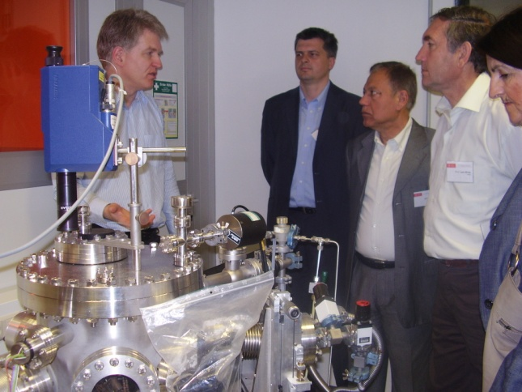

Fig. 2. Joint study visit of SEE academic staff to laboratories of the Braunschweig University of Technology.
In Figures 2 and 3 the joint study visit to the laboratories of the Braunschweig University of Technology and the Swedish National Metrology Institute SP in Boras are shown, respectively.

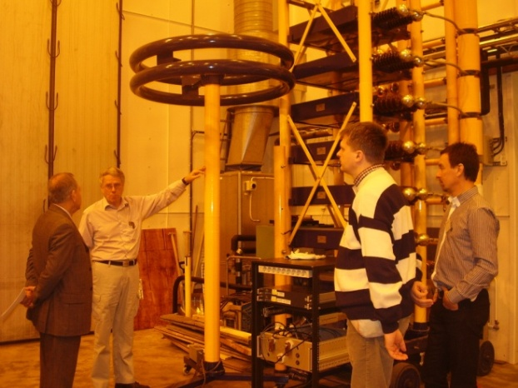

Fig. 3. Joint study visit of SEE academic staff to laboratories of the Swedish National Metrology Institute SP-Boras.
The joint PhD study program in metrology consists of four pillars:
- ICT in metrology;
- Instrumentation, industrial metrology, quality science;
- Metrology for life and society;
- Scientific metrology.
The pillars are covering the most challenging areas in contemporary metrology. Each of these pillars comprises several courses given in Table 2.

Table 2. PhD Study Program in Metrology
Pillars | Courses
ICT in Metrology | 1. Data acquisition and data processing  2. Sensors and sensor networks  3. Applicative software for metrology  4. Modeling and numerical methods in metrology  5. Knowledge discovery and data mining
Instrumentation, Industrial Metrology | 1. Signal conditioning  2. Complex monitoring and control systems  3. Metrology for energy  4. RF Measurements and metrology in telecommunications  5. Diagnostics, NDT and quality control
Metrology for life and society | 1. Metrology for life sciences-environmental monitoring  2. Metrology for chemistry, biochemistry and food quality and safety  3. Electromagnetic fields, electrical safety EMC  4. Sensor systems for biomedical measurements and medicine
Scientific Metrology | 1. Quantum metrology and nanometrology  2. Primary standards, precise measurements and calibration  3. Metrology of mechanical quantities

The courses are lectured by at least two professors: one from the SEE universities and one from the EU universities. The students choose four of the elective courses for their curriculum and choose a supervisor from the SEE universities and a co-supervisor from the EU universities for the PhD research. The program is realized by sharing of academic staff, laboratories facilities and through common students’ pool.
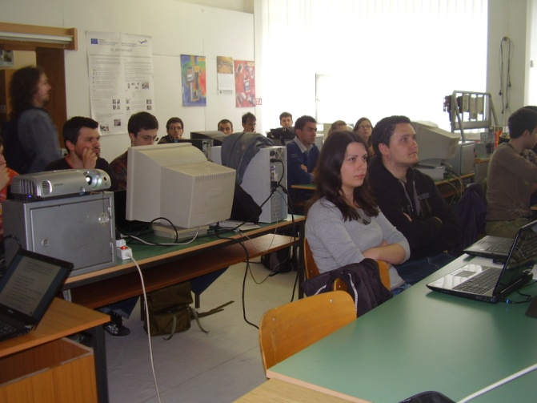

Fig. 4. Joint lectures for PhD students in metrology.
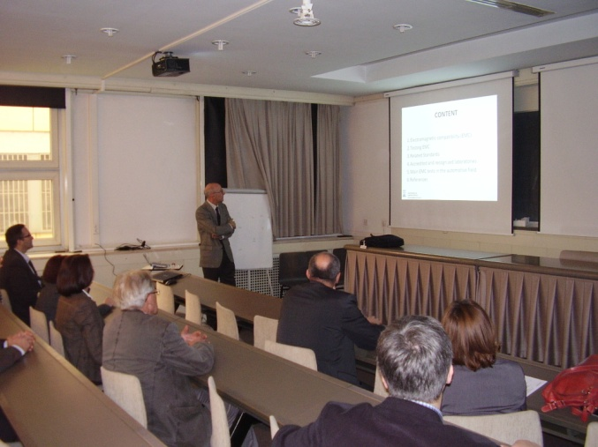

Fig. 5. EU training of the SEE academic staff (professors) involved in the joint PhD study program in metrology.
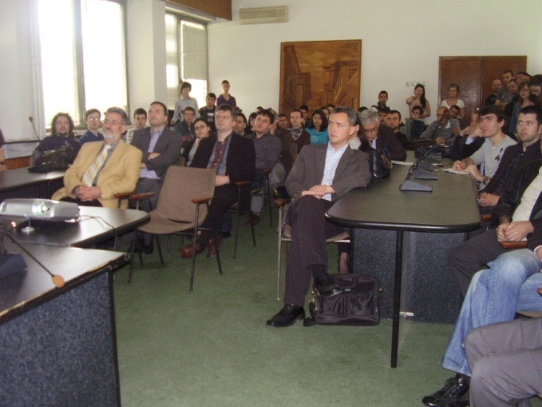

Fig. 6. Joint lectures for PhD students in metrology open for the wider audience-with participation of metrologists from the industry and other metrology stake holders.
The student mobility is one of the emphasised components in the realization of the joint PhD program in metrology. The mobility is implemented through joint lectures and workshops, PhD student conferences and presentations and study visits for accomplishment of the PhD research. This concept of realization of the joint PhD program implies not only educational cooperation, but also scientific bonding through joint research projects and exchange of researchers. The results of the joint PhD study program in metrology are creation of high-qualified professionals and researchers with the following general competences:
- capability of research and development of solutions,
- documenting the scientific researches,
- working in interdisciplinary scientific research teams,
- analysis of scientific and expertise problems,
- application of the knowledge into praxis,
- application of scientific research procedures and methods,
- possibility of systematization of knowledge,
- capability of generation of new ideas and solutions,
- knowledge of scientific ethics,
- presentation of scientific research results.
The specific competences of the doctors of science are:
- expert knowledge in the areas studied through the courses of the study program in metrology,
- management of scientific and metrology researches,
- design of new products and technologies,
- management and design of metrology processes,
- capability of management of the functions in a company and their integration through metrology,
- generation of innovative metrology approaches,
- solving practical problems by using scientific metrology methods and procedures,
- activities in metrology consulting services connected to design and engineering of products/processes,
- capability of relating theoretical knowledge and practical application of metrology in the engineering processes in the companies,
- capability of application of research methods in metrology praxis.
By accomplishment of the doctoral studies in metrology, the doctors of sciences in the field of metrology are competent for following job positions:
- Academic staff in higher education institutions;
- Researchers in research centers;
- Researchers in R&D centers in the industry;
- Researchers and managers in the metrological infrastructure and the national metrology institutes.

5. CONTRIBUTION, INTERNATIONAL IMPACT AND SUSTAINABILITY OF THE THREE-CYCLE STUDIES IN METROLOGY
The creation of the three-cycle university studies in metrology and the joint realization by the SEE and the EU universities potentially contributes to enhancement of the whole scientific and technical cooperation among these countries. The up-to-date experience shows that the results of this cooperation such as upgrading the level of the academic staff, upgrading the laboratories’ facilities or enhancement of exchange of knowledge, is not limited only to the formal university studies. It broadens also positive influence on life-long learning, professional development, and training and generally on the scientific work. It is achieved through mobilities of the academic staff, inclusion of professors from other universities, professionals from the NMIs, metrological infrastructure and industry. Invited lectures, workshops in metrology are open to all interested institutions and professionals. The network of the 5 SEE universities and 7 EU universities is extended to other universities and institutions in the region, but also wider in Europe. The realization of the joint PhD study program developed a common language among the participants in the project, initiation and launching of novel joint ideas for further scientific cooperation. This is a guarantee of the sustainability of the established three-degree study programs in metrology and for further enhancement of international impact.

6. CONCLUSIONS
The paper presented an original process of creation of three-cycle university education in the area of metrology. The specifics, achievements and contribution of the innovated and new study programs were given. The education cooperation through realization of joint study programs, such as presented in the paper, extends also the international scientific and technical cooperation. The jointly educated staff represents a bridge for realization and further development of education, scientific and technical cooperation among the universities, metrology infrastructure and countries. Education cooperation through the university programs in metrology is a form which is contributing to the joint technological and metrology infrastructure development.

REFERENCES
[1] The Bologna Declaration, 1999
[2] L. Arsov, M. Cundeva-Blajer, “Establishing a Metrological Infrastructure and Traceability of Electrical Power and Energy in the R. Macedonia”, ACTA IMEKO, Volume 2, No. 2, pp. 86-90, December 2013
[3] Education, Audiovisual and Culture Executive Agency, 2012 „Overview of the Higher Education Systems in the Tempus Partner Countries: Southern Mediterranean, A Tempus Study“, No 14, EACEA, Brussels, November 2012
[4] L. Arsov, M. Cundeva-Blajer, “Internationalization of the PhD Education in Metrology", Internationalisation In Higher Education: Evaluating Concepts, Challenges And Strategies IHE 2013, PRADEC Interdisciplinary Conf. Proc., Vol. 2, Prague, Czech Republic, Paper No. 7, 25-26 April, 2013
[5] V. Dimcev, M. Cundeva-Blajer et. al. “Introduction of Two-tier Studies of Metrology”, EU project financed by the European Training Foundation TEMPUS JEP CD 19010_2004, 2005-2007 ETF Final Report, Skopje, 2008
[6] Higher Education Law, Official Gazette of R. Macedonia No. 35, 2008
[7] Rulebook on the Conditions, Criteria and Rules for Enrolment and Studying at the Third Cycle of Studies-Doctoral Studies, Ss. Cyril and Methodius University-Skopje, University Gazette, No. 150, 2010
[8] L. Arsov, M. Cundeva-Blajer et. al. "Creation of the Third Cycle Studies-Doctoral Studies in Metrology", EU TEMPUS IV Joint Multi-country Project, 2010-2013, EACEA Final Project Report, Skopje, 2013

