XXI IMEKO World Congress “Measurement in Research and Industry”

August 30 − September 4, 2015, Prague, Czech Republic

Investigation and pilot comparison of low intensity shock calibration by laser interferometry

Qiao Sun ¹, Hong-bo Hu²

¹ National Institute of Metrology, Beijing, China, sunq@nim.ac.cn
² National Institute of Metrology, Beijing, China, huhb@nim.ac.cn

Abstract − This paper first presents the investigation work of the pilot comparison of low intensity shock calibration by laser interferometry. Two main technical concerns for a possible comparison are variety of primary shock calibration systems covered and feasibility of comparison artifact investigated. For the primary calibration system, homodyne or heterodyne laser interferometer is included as measurement standard, but the mechanical excitation is of three different types: hammer-anvil collision, pneumatic driven projectile impact and Hopkinson bar. The shock pulses generated are smooth monopole shape (half-sine or sine squared) by the first two types with air bearings, but dipole shape by the third type. For the comparison artifact, a standard accelerometer of single-ended type with a charge amplifier consists of an accelerometer measuring chain whose nonlinearity of amplitude and phase frequency responses is investigated. Based on the nonlinear fact of comparison artifact at frequency domain and the spectrum range difference of mechanical excitations of the calibration system, strict comparison conditions had to be laid down for measurement of shock sensitivity at specific acceleration levels and pulse durations. For the monopole excitation, the comparison acceleration range is from 500m/s² to 5000 m/s² and pulse duration is from 0.3 ms to 3 ms, with the reference of 2 ms at an acceleration of 1000 m/s². For the dipole excitation, the acceleration level is fixed as 1000 m/s² and pulse duration is from 0.03 ms to 0.2 ms, with the reference of 0.1 ms.
The pilot comparison of low intensity shock calibration, coded as APMP.AUV.V-P1, is successfully organized by Technical Committee of Acoustics, Ultrasound and Vibration (TCAUV) of Asia Pacific Metrology Program (APMP). Some comparison results of both monopole excitation and dipole excitation are shown with the expanded uncertainty. The degrees of equivalence calculated from the measurement results by the four participants support the uncertainty of measurement reported by them. The completion of this pilot comparison can serve as part of the basis for a planned key comparison targeted at a low intensity shock range at Consultative Committee level.

Keywords: Metrology, comparison, primary shock calibration, low intensity shock acceleration

1. Introduction
Accurate low intensity shock acceleration calibration is of special importance for automobile and civil industries worldwide. Physikalisch-Technicshe Bundesanstalt (PTB) set the first example of successful implementation of low intensity shock calibration by laser interferometry [1]. Recent years have witnessed the establishment of primary low intensity shock calibration standard and relevant scientific research project at different metrology institutes of APMP, such as National Metrology Institute of Japan [2], Industrial Technology Research Institute (ITRI) of Taiwan [3], and National Institute of Metrology (NIM), China [4].
International Organization for Standardization (ISO) 16063-13[5] describes primary low intensity shock calibration method, algorithm, and technical requirements, with an implementation example of rigid body collision as excitation from 100m/s² to 5000 m/s² with pulse duration less than 10 ms. However, in the metrological field of shock, there was no formal comparison either at Consultative Committee (CC) level or Regional Metrology Organization Technical Committee (RMO TC) level. Therefore, the unification of shock acceleration quantity was short of direct supporting evidence. Consultative Committee of Acoustics, Ultrasound and Vibration (CCAUV) has already planned to conduct key comparisons for shock in its strategic planning programme for 2013 to 2023 [6], possibly one key comparison for low intensity and the other for high intensity.
During the meeting of APMP TCAUV in 2011, the decision was taken to make preparations for a pilot comparison targeted at low intensity shock acceleration. Despite of scientific investigation of shock standards by individual institutes of APMP, guest scientist research of TC Initiative project as intra-APMP collaboration on this topic and dedicated sessions of TCAUV workshops in Japan in 2011 and in Thailand in 2014 made direct contribution to the successful completion of this APMP TCAUV pilot comparison of low intensity shock, coded as APMP.AUV.V-P1 with participants of NIM, ITRI, NIM Thailand and SPEKTRA (German DKD Lab) [7].
In this paper, the implementations of three different types of shock excitation suitable for laser interferometry are described. Rationale of strict comparison conditions are explained in details. The comparison results are presented in two groups: shock sensitivities of monopole excitation from 500m/s² to 5000 m/s² and shock sensitivities of dipole excitation at 1000 m/s². The organization of this pilot comparison by APMP TCAUV has proved, among the other things, the credibility of the primary low intensity shock calibration capability of the participants.

2. Implementation of low intensity shock calibration system
The primary low intensity shock calibration system consists of three main parts: shock excitation, laser interferometer and signal acquisition and data processing. For laser interferometer, either homodyne or heterodyne can meet the requirement as primary measurement standard of acceleration for the calibration system. The technology is available in previous research, such as [1] to [5]. Signal acquisition and data processing algorithms and procedures are also covered in details in [1] to [5]. The different shock excitation devices for primary laser interferometry calibration are of particular interest for the investigation of the pilot comparison in that their frequency spectrums can be quite different. Therefore, three different types of shock excitation devices which are employed in the pilot comparison are described.

2.1. Hammer-anvil excitation device
The shock excitation device based on hammer-anvil mechanical collision is called shock machine and its basic working principle is well explained in [5]. The actual implementation is verified. PTB uses spring unit as exciter to provide original shock force in [1]. NMIJ uses air pressure exciter [2] and ITIR uses electromagnetic exciter [3]. NIM’s shock excitation device consists of an electromagnetic exciter and a pneumatic exciter. This combination as mechanical power supply of the excitation device can deliver a wide range of shock acceleration levels and wider pulse durations [4]. All these four versions of implementation are in horizontal position. It is worth noticed that high resonant frequency airborne hammer and anvil as moving parts of the excitation device is the precondition for a high-quality monopole shock pulse generated. The thin stiff air films can largely reduce mechanical disturbances from other parts of the excitation device, and avoid dissymmetric impact forces to the anvil. As a result, the anvil can move rectilinearly with less rotational motion and produce repeatable shock pulses for calibration. Figure 1 gives an instance of primary shock calibration system based on hammer-anvil excitation device from NIM.
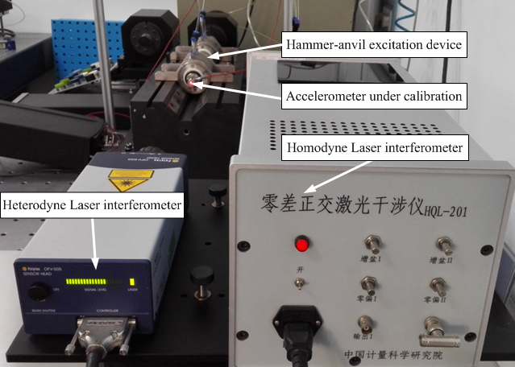
Fig. 1. Photo of NIM’s primary shock calibration system based on hammer-anvil excitation device

2.2. Pneumatic projectile excitation device
Pneumatically driven projectile excitation device is a vertical implementation for good-quality monopole shock pulse in the pilot comparison. A projectile accelerated by pressurized air functions as hammer. While the air pressure remains constant, the kinetic energy of the projectile can be controlled by a motor driven mechanical stop that allows a precise adjustment of the projectiles starting position and thus of the distance over which it is accelerated. Therefore, the repeatability of the shock pulse generated by this excitation device is good under the full automatic control of the target acceleration level.To be used as mechanical excitation source for laser interferometry measurement, an air bearing is equipped with the mounting part of the accelerometer to reduce transverse motion caused by the impact of the projectile. Figure 2 shows primary shock calibration system based on pneumatic projectile excitation device from SPEKTRA.
Fig. 2. Photo of SPEKTRA’s primary shock calibration system based on pneumatic projectile excitation device

2.3. Hopkinson bar excitation device
Hopkinson bar excitation device is based on wave propagation and reflection characteristics inside a long thin bar and can generate dipole shock pulse normally in the acceleration range from 1000 m/s² to 100000 m/s² as described in [5]. By careful determination of the dimension and length of the titanium Hopkinson bar and application of piezoelectric actuator as exciter, the shock acceleration range from 200 m/s² to 40000 m/s² can be achieved. But the pulse duration of the half sine shape is narrower than 0.2 ms [8].
The main parts of Hopkinson bar excitation device include Hopkinson Bar, piezoelectric actuator, reaction mass. When a driving voltage is applied to the actuator, the piezo-stack changes its length and a reaction force is generated by the reaction mass according to Newton’s 2nd law. This force acts as the input force on the end surface of Hopkinson Bar. The acceleration generated at the other end of the bar can be quite accurate because the driving voltage can be precisely controlled. Figure 3 shows primary shock calibration system based on pneumatic projectile excitation device from NIMT.
Fig. 3. Photo of NIMT’s primary shock calibration system based on Hopkinson bar excitation device should be used.

3. Pilot comparison

3.1. Background of the comparison
The accurate measurement of low intensity shock acceleration is vital in certain applications, for example car crash test. Efforts to decrease the losses in human lives on the roads during 1950s led to an increased research into the biomechanics of head impact. A break-through was made with the introduction of the Wayne State Tolerance Curve [9], shown in Figure 4. This curve was interpreted and a weighted injury criterion was developed. This criterion was later transformed into the Head Injury Criterion (HIC) to improve the crashworthiness of cars. HIC is a measure of the likelihood of head injury arising from an impact. The HIC can be used to assess safety related to vehicles and it is defined as:
(1)
where t₁ and t₂ are the initial and final times (in seconds) of the interval during which HIC attains a maximum value, and acceleration a is measured in g (standard gravityacceleration).
Normally the variable is derived from the acceleration/time history of an accelerometer mounted at the centre of gravity of a dummy’s head, like in the car crash test photo of Figure 4, when the dummy is exposed to crash forces. This means that the HIC includes the effects of head acceleration and the duration of the acceleration. Large accelerations up to 5000 m/s² may be tolerated for very short duration of less than 1 ms.
Therefore, a low intensity shock comparison is well justified with the acceleration range from 500 m/s² to 5 000 m/s² and duration of monopole shock pulse from 0.3 to 3 ms.
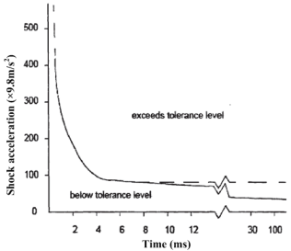
Fig. 4. Wayne State Tolerance Curve and Photo of car crash test in China

3.2. Comparison feasibility
It was found previously by PTB that different shock sensitivity of the same accelerometer under the same level of shock acceleration was obtained when it was exposed to the excitation of hammer-anvil device and Hopkinson bar device respectively. The sensitivity difference was about 4% at about 5000 m/s². Figure 5 reveals the cause of this sensitivity difference. The excitation of rigid body motion, the impact from hammer-anvil or pneumatic projectile, falls into a narrow low frequency range at the spectrum while the excitation by Hopkinson bar covers a wider spectrum range from low to high frequency. The sensitivity magnitude frequency response of the accelerometer only has a narrow linear working range at low frequency. The nonlinearity effect plays an increasing role when the shock pulse duration decreases and therefore covers a wide frequency range, which finally results in obvious sensitivity difference by two different excitations.
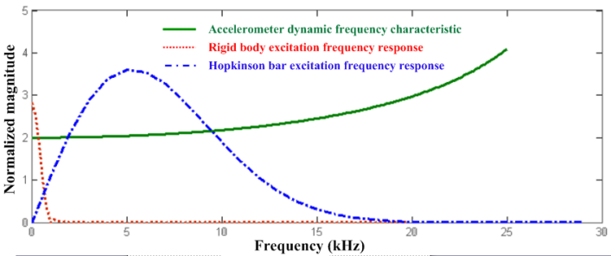
Fig. 5. Frequency responses of accelerometer, rigid body and Hopkinson bar
Therefore, pulse shape, pulse duration and acceleration level should be restricted for the feasibility of the pilot low intensity shock comparison. Hammer-anvil excitation and pneumatic projectile excitation can generate monopole pulse and fall into the same group of rigid body motion. Hopkinson bar excitation should be treated into a different group.
For the monopole group, participants are supposed to measure at the following acceleration levels (all values in m/s²): 500, 1000, 2000, 3000, 4000, 5000. A series of 0.5 ms, 1 ms, 1.5 ms and 2 ms of shock pulse are recommended, with the reference of 2 ms at the acceleration of 1000 m/s².
For the dipole group, participants are supposed to measure at 1000 m/s². A series of 0.03 ms, 0.05 ms, 0.07 ms, 0.10 ms, 0.15 ms and 0.20 ms are recommended, with the reference of 0.1 ms

3.3. Comparison results
For the purpose of the comparison the pilot laboratory selected an ENDEVCO 2270 (SN: 10466) with a Brüel & Kjær charge amplifier 2692 (SN: 2752215) as Accelerometer Chain of which monitoring data for 6 months were available and of which data were not included in any published international cooperation work. For this comparison, NIM used its hammer-anvil calibration system and Hopkinson bar calibration system; ITRI used its hammer-anvil calibration system; NIMT used its Hopkinson bar calibration system; and SPEKTRA used its pneumatic projectile calibration system and Hopkinson bar calibration system. In Table 1 and 2, the calibration results under monopole and dipole excitations are presented.

Table 1 Calibration results of the participants for voltage sensitivities Sva under monopole shock excitation with expanded relative uncertainty Uc (k = 2).
Acceleration  (m/s²) | Pulse duration  (ms) | NIM |  | ITRI |  | SPEKTRA
 |  | S_{va} (mV/(m/s²)) | U_{c} (%) | S_{va} (mV/(m/s²)) | U_{c} (%) | S_{va} (mV/(m/s²)) | U_{c} (%)
500 | 3.0 | 0.1967 | 0.5 | 0.1966 | 1.0 | 0.19727 | 0.5
1000 | 2.0 | 0.1968 | 0.5 | 0.1970 | 1.0 | 0.19746 | 0.5
2000 | 1.5 | 0.1970 | 0.5 | 0.1971 | 1.0 | 0.19749 | 0.7
3000 | 1.0 | 0.1973 | 0.5 | 0.1971 | 1.0 | 0.19755 | 0.7
4000 | 1.0 | 0.1973 | 0.5 | 0.1971 | 1.0 | 0.19735 | 0.7
5000 | 0.8 | 0.1973 | 0.5 | 0.1971 | 1.0 | 0.19734 | 0.7

Table 2 Calibration results of the participants for voltage sensitivities Sva under dipole shock excitation with expanded relative uncertainty Uc (k = 2).
Acceleration  (m/s²) | Pulse duration  (ms) | NIM |  | NIMT |  | SPEKTRA
 |  | S_{va} (mV/(m/s²)) | U_{c} (%) | S_{va} (mV/(m/s²)) | U_{c} (%) | S_{va} (mV/(m/s²)) | U_{c} (%)
1000 | 0.20 | 0.1972 | 0.5 | 0.1976 | 0.6 | 0.19765 | 0.5
1000 | 0.15 | 0.1973 | 0.5 | 0.1977 | 0.6 | 0.19744 | 0.5
1000 | 0.10 | 0.1976 | 1.0 | 0.1976 | 0.7 | 0.19765 | 0.5
1000 | 0.07 | 0.1981 | 1.0 | 0.1976 | 1.0 | 0.19776 | 0.8
1000 | 0.05 | 0.1985 | 1.5 | 0.1977 | 1.0 | 0.19758 | 0.8
1000 | 0.03 | 0.1990 | 1.5 | 0.1985 | 1.0 | 0.19718 | 0.8

The weighted mean was agreed upon by all participants to calculate the Pilot Comparison Reference Values (PCRV) for the APMP.AUV.V-P1 data. PCRVs were calculated separately at each acceleration or pulse duration point measured for Accelerometer Chain. Four typical degrees of equivalence with respect to PCRVs of the participants are shown in Figure 6 and 7. The degrees of equivalence also support the uncertainty of measurement of the participants at other acceleration levels and pulse durations.
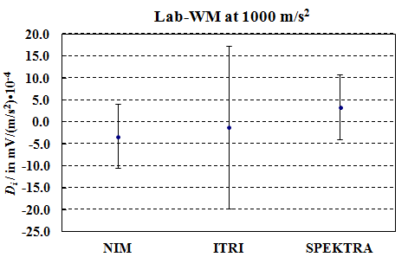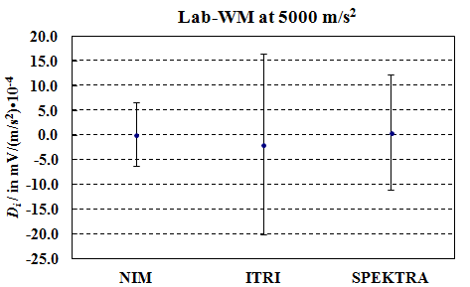
Fig. 6. Degree of equivalence for voltage sensitivities under monopole shock excitation at 1000 m/s², 2.0 ms and 5000 m/s², 0.8 ms
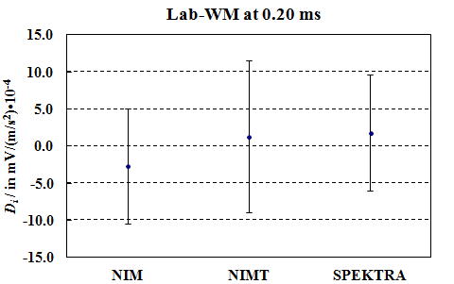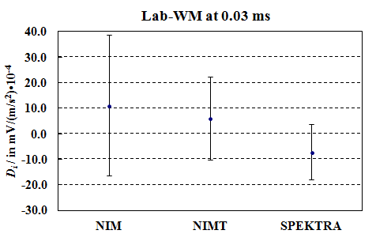
Fig. 7. Degree of equivalence for voltage sensitivities under dipole shock excitation at 1000 m/s², 0.20 ms and 0.03 ms

4. CONCLUSIONS
Based on the investigation work of primary low intensity shock calibration technique and feasibility of a pilot comparison, TCAUV of APMP has successfully conducted a pilot comparison of shock acceleration sensitivity at low intensity shock acceleration from 500 m/s² to 5000 m/s². Laser interferometer is a necessity as measurement standard of the calibration system. Three different types of mechanical shock excitation are employed by participants.
The comparison results are divided into two groups by the excitation pulse shape: monopole group and dipole group. The reported sensitivities and associated uncertainties by four participants NIM, ITRI, NIMT and SPEKTRA are used for the calculation of mean values of the pilot comparison results and their associated uncertainties, as well as the deviations to the mean values with associated uncertainties. The degrees of equivalence calculated from the measurement results by the four participants support the uncertainty of measurement reported by them at all acceleration levels and pulse durations specified in technical protocol.
The successful completion of this pilot comparison can serve, among other things, as part of the basis for a planned key comparison targeted at a low intensity shock range at CCAUV.

ACKNOWLEDGMENTS
This work was supported in part by General Administration of Quality Supervision, Inspection and Quarantine of the People’s Republic of China under Contract No. ALC1201 and was partly funded by APMP TC Initiative project No. TCI-2011-01-TCAUV and by APMP DEC project 2014. The authors would like to give special thanks to colleagues in ITRI, NIMT, NMIJ and SPEKTRA for their support and cooperation in this comparison, related research work and workshop activities.

REFERENCES
[1] Link A, von Martens HJ, Calibration of accelerometers by shock excitation and laser interferometry, Shock Vib, 2000 7:101-112.
[2] H Nozato, T Usuda, A Oota, T Ishigami, Calibration of vibration pick-ups with laser interferometry: part IV Development of a shock acceleration exciter and calibration system, Measurement Sci. Technol. 2010 21:065107.
[3] Yu-Chung Huang, Jiun-Kai Chen, Hsin-Chia Ho, Chung-sheng Tu, Chao-Jun Chen, The set up of primary calibration system for shock acceleration in NML, Measurement, 2012 45: 2383-2387.
[4] Qiao Sun, Jian-lin Wang, Hong-bo Hu, A primary standard for low-g shock calibration by laser interferometry, Measurement Sci. Technol. 2014 25:075003.
[5] ISO 16063-13, Methods for the calibration of vibration and shock transducers. Part 13: Primary shock calibration using laser interferometry, 2001.
[6] CIPM CCAUV, Strategy document for rolling programme development for 2013 to 2023, www.bipm.org/en/committees/cc/ccauv.
[7] Qiao Sun, HongBo Hu. Final Report on Pilot Comparison of Low Intensity Shock APMP.AUV.V-P1. Metrologia Tech. Suppl., 2015, 52: 09002.
[8] SPEKTRA, Data sheet of SE-220 HOP-MS Hopkinson Bar Shock Exciter, www.spektra-dresden.com/spektra.
[9] Lissner HR, Lebow M, Evans FG 1960 Experimental studies on the relation between acceleration and intracranial pressure change in men Surgery Gynecology and obstetrics 111: 329

