XXI IMEKO World Congress “Measurement in Research and Industry”

August 30 − September 4, 2015, Prague, Czech Republic

Proficiency test with the information of uncertainty: analysis with the maximum likelihood method

Katsuhiro Shirono ¹, Masanori Shiro ², Hideyuki Tanaka ³, Kensei Ehara ⁴

¹ National Metrology Institute of Japan, Tsukuba, Japan, k.shirono@aist.go.jp
² National Metrology Institute of Japan, Tsukuba, Japan, shiro@ni.aist.go.jp
³ National Metrology Institute of Japan, Tsukuba, Japan, tanaka-hideyuki@aist.go.jp
⁴ National Metrology Institute of Japan, Tsukuba, Japan, ehara.kensei@aist.go.jp

Abstract − The analysis methods of proficiency test (PT) data, when the uncertainty information is given, and a reference laboratory does not exist, are investigated in this study. Mainly two methods are characterized; the analyses with (i) the robust method which we developed, and (ii) the maximum likelihood estimation. Consequently, it is confirmed that the applicability latter approach is validated only when some conditions are satisfied. Therefore, the former analysis is basically recommended.
Keywords: proficiency test, ISO 13528, E_{n} number, measurement uncertainty, posterior predictive check

1. INTRODUCTION
The proficiency test (PT) with the interlaboratory comparison is an effective tool to assure the quality of the measurement of the calibration and testing laboratory. The participation to the PT is usually required as one of the methods to validate the measurement capability.
Usually, for the performance evaluation in the PT with the information of uncertainty, the comparison with the result of the reference laboratory is implemented using the E_{n} number as shown in ISO 13528 [1], which is the standard for the statistical methods for the PT tests. Given that the measurement value and its expanded uncertainty of Laboratory k are respectively x_{k} and U_{k} while those of the reference laboratory are respectively X_{ref} and U_{ref}, the E_{n} number for Laboratory k is defined as follows:
$E_{n}^{\left(k\right)}=\left(x_{k}−X_{\text{ref}}\right)/\sqrt{U_{k}^{2}+U_{\text{ref}}^{2}}$ (1)
where the superscript of (k) means Laboratory k. When |E_{n}^{(k)}| ≤ 1 and > 1, the performance of Laboratory k is evaluated as “satisfactory” and “unsatisfactory”, respectively.
The performance evaluation for the cases where the appropriate reference laboratory does not exist has not yet been described in ISO 13528. However, in the key comparison test, which is the PT for the national metrology institutes, the comparison is basically implemented without a specific reference laboratory. Cox [2] offered a guideline of the statistical methods for the key comparison. Moreover, the analysis with the largest consistent subset (LCS) also proposed by Cox [3] has been popularly employed in the analysis. The LCS is the subset with the largest data size among the subsets whose consistencies are confirmed through the χ² test. Some other methods have been proposed so far [4 − 10]. It is worth to be noted that the statistical models employed in these proposals are different from each other.
We also developed the analysis method robust to the outliers [11, 12]. This method comprises of two steps; (1) the detection of an unknown random effect, and (2) the performance evaluation through the local maximum likelihood method (MLM). The summary of this method is given in Appendix. The advantage of this method is to emit the signal when an unknown random effect is detected, and to lessen the risk that the performances are evaluated based on inappropriate data. Moreover, the performance evaluation can be conducted based on the model employed in the random effect detection. This method is referred to as the robust method in this paper.
The purpose of this study is to clarify a condition in which the performance evaluation through the global MLM (in other words, the MLM in a usual sense) is identical to that through the robust method. The robust method may give the impression to be slightly hard to use because of the computational complication. On the other hand, the local maximum likelihood estimator employed in the second step in the robust method is, in most cases, identical to the global maximum likelihood estimator. Since the global MLM is quite simple and useful in an actual PT, we believe the conditioning is meaningful from a practical perspective.
To put it simply, the conditioning is given by the setting a minimum permissible uncertainty. This is because, when an outlier has an extremely small uncertainty, the global MLM offers the different result from the local MLM. More specifically, an expected uncertainty is determined, and the appropriate ratio of the minimum permissible and expected uncertainties is discussed in this paper.
This paper is organized as follows: Section 2 provides the basic theory of the robust method. The comparison among the robust method, the maximum likelihood estimation, and the other methods is shown in Section 3. The brief conclusion is offered in Section 4.

2. Theory and procedure OF
In this Section, the robust method we developed is explained. In this method, the model section (or the optimization of the parameters of the model) is implemented through the comparison of the marginal likelihood. The statistical model with the following parameters is considered:
1. The number of the data to which the common random effect is given; m (m = 0, 2, 3, …, n) ,
2. The identification numbers for the correspondence of the laboratory and the data; K(1), K(2), …, K(n) (K(1) < K(2) < … < K(m), K(m+1) < K(m+2) < … < K(n)),
3. The parameters for the prior α, β_{m+1}, β_{m+2}, …, and β_{n}. (1 ≤ α < +∞, 1 ≤ β_{i} (i = 1, 2, …, n)),
where n is the number of the participant laboratories.
Suppose that Laboratory K(i) reports the measurement value x_{i} and its standard uncertainty u_{i} (i = 1, 2, …, n). Let q_{i} = u_{i}² for simplicity of the description. Since all of x_{i} are the measurement values for the same measurand, x_{i} is assumed to be derived from the normal distribution with the same mean of μ. On the other hand, the variances of the distribution for the reported values of Laboratories K(i) (i = 1, 2, …, m) are assumed to be q_{i} + θ_{c}, where θ_{c} is the variance caused by the unknown random effect. The variances for the reported values of Laboratories K(i) (i = m + 1, m + 2, …, n) are assumed to be q_{i} + θ_{i}, where θ_{i} is the variance caused by the unskillfulness of these laboratory. Thus, the model distributions of x_{i} are given as follows:
$\begin{aligned}x_{i}\text{\sim }N\left(μ,q_{i}+θ_{c}\right)\text{ for }i=K\left(1\right),⋯,K\left(m\right), \\ x_{i}\text{\sim }N\left(μ,q_{i}+θ_{i}\right)\text{ for }i=K\left(m+1\right),⋯,K\left(n\right)\text{.}\end{aligned}$ (1)
Defining
$φ_{c}={\left(\sum_{i=1}^{m}{\frac{1}{q_{i}+θ_{c}}}\right)}^{−1},φ_{i}=q_{i}+θ_{i}$, (2)
the priors of μ, φ_{c}, and φ_{i} (i = m + 1, …, n), p(μ), p(φ_{c}) and p(φ_{i}), are given as follows:
$\begin{aligned}p\left(μ\right)∝1 \left(−∞<μ\text{<+}∞\right), \\ p\left(φ_{c}\right)∝φ_{c^{−α}} \left(φ_{c}≥{\left(\sum{q_{i}^{−1}}\right)}^{−1}\right), \\ p\left(φ_{i}\right)∝φ_{i^{−β_{i}}} \left(φ_{i}q_{i}\right)\text{.}\end{aligned}$ (3)
The priors of θ_{c} and θ_{i}, p(θ_{c}) and p(θ_{i}), are given accordingly. The hyper-parameters of m, K(i),α and β_{i} are optimized to maximize the following modified marginal likelihood:
$Λ=\int{\int{l\left(μ,θ_{c},θ|x\right)p\left(θ_{c}\right)\prod_{i=m+1}^{m}{p\left(θ_{i}\right)}{dμdθ}_{c}dθ}}$ (4)
where x = (x₁, …, x_{n})^{T}, and θ = (θ_{m+1}, …, θ_{n})^{T}. l(μ, θ_{c}, θ|x) is the likelihood of m, θ_{c} and θ given x.
The point is that if m ≥ 2 is chosen as the optimized parameter, the performance evaluation should not be implemented. Because m ≥ 2 means θ_{c} > 0. θ_{c} is the variance of a random effect (ex. the instability and the inhomogeneity of the measured items and the vagueness in the definition of the measurand). The effect must be corrected before the performance evaluation.
Only when m = 0 is chosen, the performance evaluation is given. However, in the optimized model, the additional variances are considered. In this analysis, the additional uncertainties other than the reported ones are taken in to consideration. However, a performance evaluation should serve as an index to check the validity of the reported uncertainty. Therefore, additional uncertainties must not be incorporated into the statistical model.
Thus, the following statistical model is proposed to evaluate the performance of Laboratory k:
$\begin{aligned}x_{k}\text{\sim }N\left(μ,q_{k}\right), \\ x_{i}\text{\sim }N\left(μ,φ_{i}^{\text{LML}}\right) \left(i=1,\text{.}\text{.}\text{.},k−1,k+1,\text{.}\text{.}\text{.},n\right),\end{aligned}$ (5)
where φ_{i}^{LML} is the local maximum estimator of φ_{i}. In actuality, letting the posterior mean of μ with the optimized model as μ_{rob}, φ_{i}^{LML} is determined through the algorithm entailing the following five steps:
Step 1 $μ^{\text{temp}}=μ_{\text{rob}}$
Step 2 $φ_{i}^{\text{LML}}=\text{max}\left[q_{i},{\left(x_{i}−μ^{\text{temp}}\right)}^{2}\right]$
Step 3 $μ^{\text{LML}}={\left(\sum{1/φ_{i}^{\text{LML}}}\right)}^{−1}\left(\sum{x_{i}/φ_{i}^{\text{LML}}}\right)$
Step 4 If $\left|μ^{\text{LML}}−μ^{\text{temp}}\right|>ε{\left(\sum{1/φ_{i}^{\text{LML}}}\right)}^{−1/2}$, then $μ^{\text{temp}}=μ^{\text{LML}}$ go to Step 2.
Step 5 For i = 1 to n, $φ_{i}^{\text{LML}}=\text{max}\left[q_{i},{\left(x_{i}−μ^{\text{LML}}\right)}^{2}\right]$.
In Step 3, ε is just a calculation parameter with a small number like 10⁻³. The calculation of Steps 2 and 5 is derived from the fact that, when μ is fixed, the maximum likelihood estimator of φ_{i} is given as max[q_{i}, (x_{i}−μ)²].
Based on the same idea as that in [11], we propose the index for the performance evaluation of Laboratory k as follows:
$E_{n}^{\left(k\right)}=\frac{x_{k}−{\left(\sum{1/φ_{i}^{\text{LML}}}\right)}^{−1}\left(\sum{x_{i}/φ_{i}^{\text{LML}}}\right)}{2\sqrt{u_{k}^{2}+{\left(\sum{1/φ_{i}^{\text{LML}}}\right)}^{−1}}}$, (6)
where Σ${}^{\text{ni}≠k}$ denotes the summation for i = 1, 2, …, k − 1, k + 1, …, n. As well as E_{n} number in (1), when |E_{n}^{(k)}| ≤ 1 and > 1, the performance of Laboratory k is given as “satisfactory” and “unsatisfactory”, respectively.
E_{n}^{(k)} in (8) is the similar index to check the statistical model by the Bayesian posterior predictive check offered by Kacker, Forbes, Kessel, and Sommer [10]. The E_{n} number in (1) can be derived based on their study, though the derivation was not directly mentioned in their study. In this sense, the E_{n} number proposed in the present study can be interpreted as the extended version of the E_{n} number for the case without a reference laboratory.

3. Comparison between the robust method and the maximum likelihood METHOD

3.1. Procedure using the maximum likelihood estimation
Even in the procedure using the maximum likelihood estimation, the same likelihood is employed as that in Section 2. However, the parameter of m is fixed to 0. Furthermore, since the parameters of K(i) (i = 1, 2, …, n) are no longer the parameters of the likelihood when m = 0, K(i) = i for i = 1, 2, …, n. Thus, the likelihood of the following model is considered:

Fig. 1. Example of PT data: (x₁, x₂, …, x₇) = (1, 1, 4, 4, 4, 6, 7) and (u₁, u₂, …, u₇) = (0.03, 0.03, 0.3, 0.3, 0.3, 0.1, 0.1). Error bars show the 95 % coverage intervals.

Fig. 2. Plot of L(μ) for the data in Fig. 1 in the absolute scale.

Fig. 3. Plot of L(μ) for the data in Fig. 1 in the logarithmic scale.

$x_{i}\text{\sim }N\left(μ,φ_{i}\right)$. (7)
Actually, the following function L(μ) seems to provide some qualitative information about the mathematical features on the likelihood:
$L\left(μ\right)=\prod_{i=1}^{n}{{\left(2π{\hat{φ}}_{i}\left(μ\right)\right)}^{−\frac{1}{2}}\text{exp}\left(−\frac{1}{2}\frac{{\left(x_{i}−μ\right)}^{2}}{{\hat{φ}}_{i}\left(μ\right)}\right)}$ (6)
where $\hat{φ}$_{i}(μ) = max[q_{i}, (x_{i}−μ)²]. The global maximum likelihood estimator of μ, μ^{GML}, matches the maximize of L(μ). The global maximum likelihood parameter of φ_{i}^{GML} is given as $\hat{φ}$_{i}(μ^{GML}).
Then, the E_{n} numbers are computed with the following equation:
$E_{n}^{\left(k\right)}=\frac{x_{k}−{\left(\sum{1/φ_{i}^{\text{GML}}}\right)}^{−1}\left(\sum{x_{i}/φ_{i}^{\text{GML}}}\right)}{2\sqrt{u_{k}^{2}+{\left(\sum{1/φ_{i}^{\text{GML}}}\right)}^{−1}}}$, (8)
instead of (6). Define the global maximum likelihood estimator of μ as μ^{GML}.

3.2. Case 1: A consistent subset and some outliers
Fig. 1 shows an example of the PT data. L(μ) for the data in Fig. 1 is given as Fig. 2. This figure implies L(μ) have only a single mode at μ = 4.0. However, it is not true. Fig. 3 shows L(μ) in its logarithmic scale, and it is found that L(μ) has five modes. However, the other modes than that at μ = 4.0 is negligibly small. Thus, μ^{GML} = 4.0 is given. Actually, μ^{LML} is also 4.0 in this case.
Thus, it can be said that, when L(μ) has only a single significant mode and several negligible modes, μ^{LML} = μ^{GML}. In this case, μ^{LML} could be determined without the Bayesian analysis to obtain μ_{rob}. The analysis of the PT can be, hence, implemented in a very simple manner.
E_{n}⁽¹⁾, E_{n}⁽²⁾, …, and E_{n}⁽⁷⁾ are calculated to be – 8.6, –5.8, 0.0, 0.0, 0.0, 5.8, and 8.6. The LCS gives that E_{n}⁽¹⁾, E_{n}⁽²⁾, …, E_{n}⁽⁷⁾ = – 8.5, –5.7, 0.0, 0.0, 0.0, 5.7, and 8.5. Theses means the reasonable performance evaluations are given in this case with both of the robust method and the maximum likelihood method.

3.2. Case 2: A consistent subset and an extreme outlier
Fig. 4 shows a set of another virtual PT data. There seem relatively consistent data of x₁ to x₆ and an extreme outlier of x₇. Fig. 5 supports this from the perspective of the likelihood. The two large peaks can be found around μ = 4 and 7, which match to (x₃, x₄, x₅) and x₇, respectively. It can be said from the magnitude relation of L(4) and L(7) that μ = 7 is more likely than μ = 4. Precisely, μ^{GML} = 7.0. On the other hand, μ^{LML} = 4.0. Thus, μ^{LML} ≠ μ^{GML} in this case.
With the maximum likelihood estimation, E_{n}⁽¹⁾, E_{n}⁽²⁾, …, E_{n}⁽⁷⁾ are given as – 3.0, – 2.5, – 1.5, -– 1.5, – 1.5, – 0.5, and 1.0. The results imply that this method is obviously influenced by the outlier of x₇ = 7.
On the other hand, With the robust method, E_{n}⁽¹⁾, E_{n}⁽²⁾, …, E_{n}⁽⁷⁾ = – 1.4, –0.9, 0.0, 0.0, 0.0, 0.9, and 3.0. Also, with the LCS analysis, E_{n}⁽¹⁾, E_{n}⁽²⁾, …, E_{n}⁽⁷⁾ = – 1.1, –0.6, 0.6, 0.6, 0.6, 1.4, and 4.5. While the quantitative trends are quite different between them, only the result of Lab. 6 is different from the qualitative perspective (i.e. “satisfactory” and ”unsatisfactory”). At least, it can be said that the results with the LCS analysis is strongly affected by the reported value of x₁, whose performance is regarded as “unsatisfactory”. Hence, we believe the analysis with the robust method offers the better results.
It can be concluded that, when there is only one extreme outlier, the analysis with the maximum likelihood estimation gives unnatural results.

3.3. Case 3: Data with an unknown random effect
The most typical difference between the analyses with the robust method and the maximum likelihood method can be seen at the detection of an unknown random effect. Fig. 6 shows a set of a virtual PT data. In this example, there is no consistent data. Apparently, L(μ) has the seven local maximums which corresponds to x₁ to x₇, respectively. In this case, not m = 0 but m = 7 is chosen in the robust method. Thus, the warning is emitted that the some corrections are necessary before the performance evaluation.

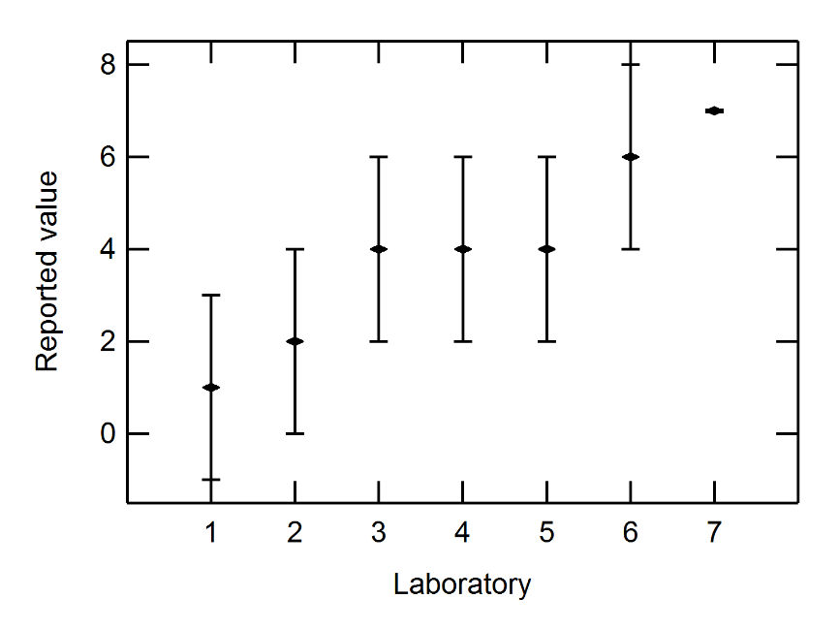

Fig. 4. Example of PT data: (x₁, x₂, …, x₇) = (1, 1, 4, 4, 4, 6, 7) and (u₁, u₂, …, u₇) = (0.03, 0.03, 0.3, 0.3, 0.3, 0.1, 0.1). Error bars show the 95 % coverage intervals.

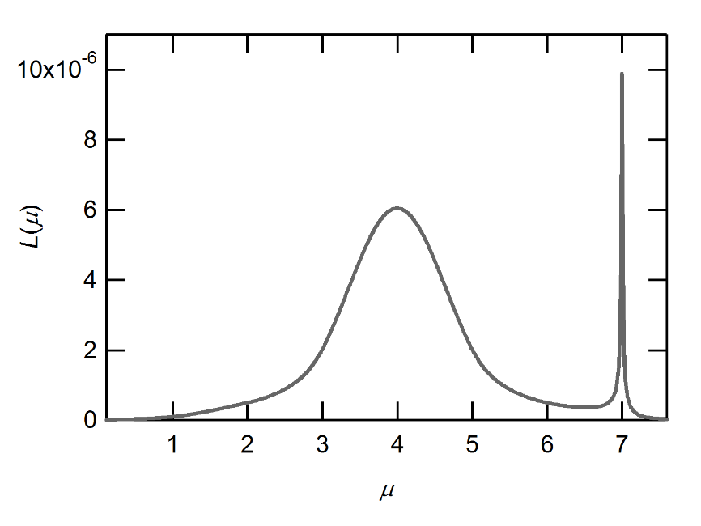

Fig. 5. Plot of L(μ) for the data in Fig. 4 in the absolute scale.

On the other hand, the analysis with the maximum likelihood estimator cannot give the warning principally. μ^{GML} is given as 4.0, and E_{n}⁽¹⁾, E_{n}⁽²⁾, …, E_{n}⁽⁷⁾ are calculated to be – 5.5, – 3.7, – 1.9, 0.0, 1.9, 3.7, and 5.5. It is technically possible that while only Lab. 3 has the adequate skill in this measurement, the other laboratories need to improve their measurement systems. However, at least, we need to consider the possibility that the quality of the PT is impaired seriously by an unknown random effect such as the instability and the inhomogeneity of the measured items and the vagueness in the definition of the measurand. Only after the inexistence of these kinds of the random effect is confirmed from the technical aspect, the calculated E_{n} numbers has the meaning to evaluate the performance of the laboratories.
It can be concluded that, when there is the possibility that the quality of the PT is impaired by an unknown random effect, the analysis with the maximum likelihood estimator is not recommended to be employed.

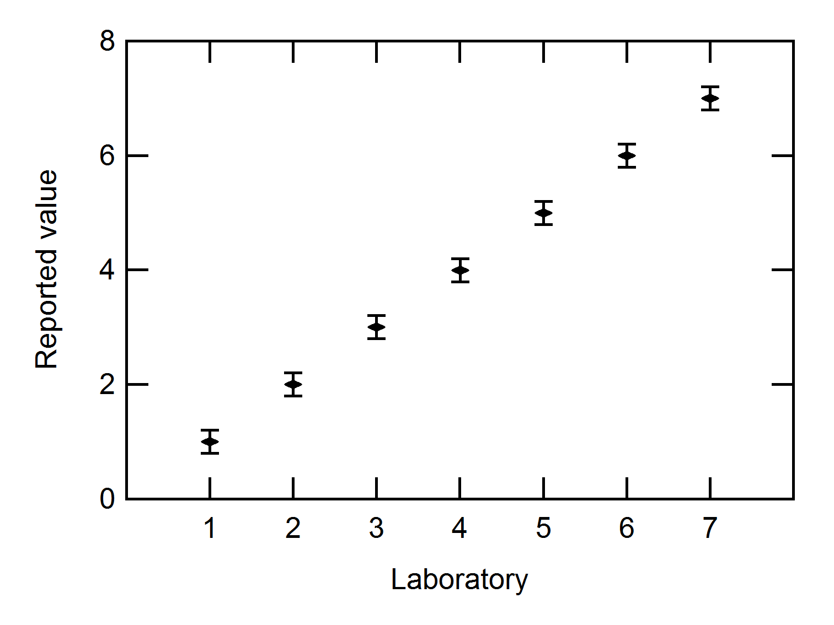

Fig. 6. Example of PT data: (x₁, x₂, …, x₇) = (1, 1, 4, 4, 4, 6, 7) and (u₁, u₂, …, u₇) = (0.2, 0.2, 0.2, 0.2, 0.2, 0.2, 0.2). Error bars show the 95 % coverage intervals.

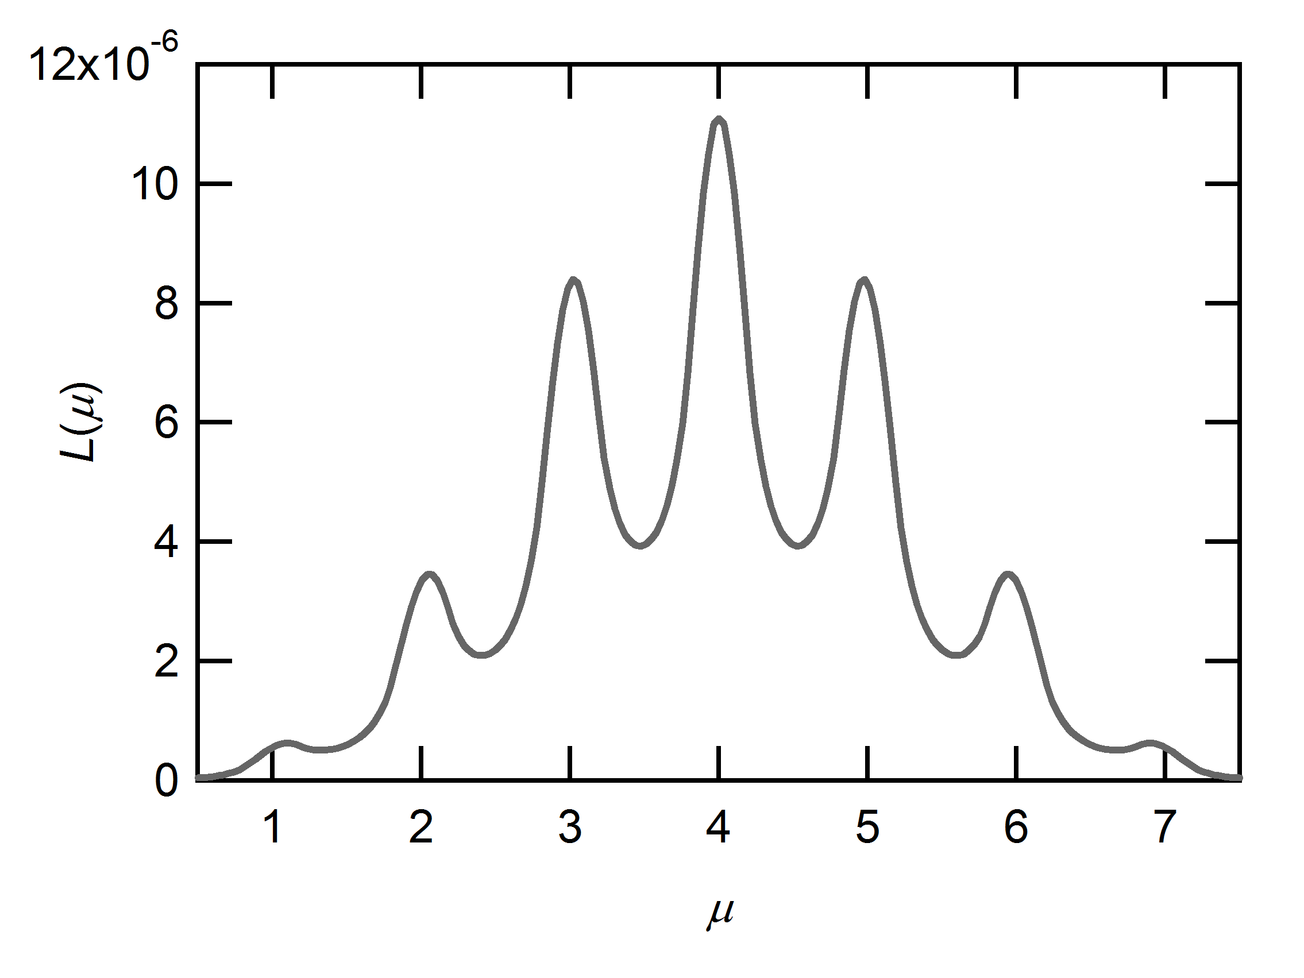

Fig. 7. Plot of L(μ) for the data in Fig. 6 in the absolute scale.

In this case, since there are no consistent subsets, the LCS analysis cannot be implemented. However, the same can be said to the LCS analysis.

3.4. Discussion
From the analysis of Cases 1-3, it can be said that the analysis with the maximum likelihood estimator of μ^{GML} is applicable when
- no extreme outliers are reported in the PT, and
- the inexistence of an unknown random effect is confirmed through the technical aspect.
Otherwise, the analysis with the robust method is recommended. The second point must be investigated, because some random effects are reported even in an actual PT. On the other hand, an extreme outlier which affects the applicability of the analysis with the maximum likelihood estimation is not usually reported.
We believe the analysis with the maximum likelihood is adequately applicable in most of PTs. However, it is also confirmed that the efficacy of the robust method is not impaired in both of the cases. Thus, the analysis with the robust method is always recommended.

4. CONCLUSIONS
The analysis methods of PT data, when the uncertainty information is given, and a reference laboratory does not exist, are investigated in this study. The two conditions with which the analysis with the maximum likelihood estimation is applicable are clarified as follows: (1) No extreme outliers are reported in the PT. (2) The inexistence of an unknown random effect is confirmed through the technical aspect. Moreover, the efficacy of the analysis with the robust method is shown even in the case in which the analysis with the maximum likelihood estimation is inapplicable. Consequently, it can be said that the analysis with the robust method is always recommended, when the computational program can be properly prepared.

ACKNOWLEDGMENTS
This work was supported by a Grants-in-Aid for Scientific Research (No. 26870899) from the Japan Society for the promotion of Science (JSPS).

REFERENCES
[1] ISO/IEC, ISO/IEC 13528: Statistical methods for use in proficiency testing by interlaboratory comparisons, ISO, Geneva, 2005.
[2] M. G. Cox, “The evaluation of key comparison data”, Metrologia, vol. 39, pp. 589–595, 2002.
[3] M. G. Cox, “The evaluation of key comparison data: determining the largest consistent subset.”, Metrologia, vol. 44, pp. 187–200, 2007.
[4] R. C. Paule and J. Mandel, “Consensus values and weighting factors”, J. Res. Natl. Inst. Stand. Technol., vol. 87, pp. 377-385, 1982.
[5] A. G. Chunovkina and C. Elster and I. Lira and W. Wöger
[6] B. Toman, A. Possolo, “Laboratory effects models for interlaboratory comparisons”, Accred. Qual. Assur., vol. 14, pp. 553-563, 2009.
[7] R. Willink, “Models for the treatment of apparently inconstant data”, in Advances in Mathematical and Computational Tools in Metrology and Testing X (vol.10), World Scientific, Singapore (2015) pp. 78-89.
[8] S K. Shirono and H. Tanaka and K. Ehara, “Bayesian statistics for determination of the reference value and degree of equivalence of inconsistent comparison data”, Metrologia, vol. 47, pp. 444-452, 2010.
[9] R. N. Kacker, A. Forbes, R. Kessel, and K.-D. Sommer, “Bayesian posterior predictive p-value of statistical consistency in interlaboratory evaluations”, Metrologia, vol. 45, pp. 512–23, 2008.
[10] K. Shirono, M. Shiro, H. Tanaka, K. Ehara, “Novel reference value and DOE determination by model selection and posterior predictive checking”, in Advances in Mathematical and Computational Tools in Metrology and Testing X (vol.10), World Scientific, Singapore (2015) pp. 357-366.
[11] K. Shirono, H. Tanaka, M. Shiro, K. Ehara, Proficiency tests with uncertainty information: Detection of an unknown random effect, Measurement (2016), http://dx.doi.org/10.1016/j.measurement.2016.01.002.
[12] K. Shirono, H. Tanaka, M. Shiro, K. Ehara, Proficiency tests with uncertainty information: Extension of the E_{n} number for cases with no reference laboratory, Measurement (2016), http://dx.doi.org/10.1016/j.measurement.2015.09.035.

