XXI IMEKO World Congress “Measurement in Research and Industry”

August 30 − September 4, 2015, Prague, Czech Republic

OPTIMIZATION METHODS IN METROLOGY of ELECTRICAL QUANTITIES

Marija Cundeva-Blajer

Ss. Cyril and Methodius University, Faculty of Electrical Engineering and Information Technologies,
Skopje, R. Macedonia, email: mcundeva@feit.ukim.edu.mk

Abstract−In electrical quantities metrology numerous examples of stochastic processes exist and a need for optimal solutions is posed. Here stochastic genetic algorithm optimization is used for solving two typical metrological problems: errors minimization in process of instrument’s design and predicting metrological reference standards time-drift. The first case is optimal metrological design of a combined instrument transformer and the second case is analysis of resistance standard time-drift.
Keywords: optimization, genetic algorithm, electrical measurements, instrument transformer, resistance standard

1. INTRODUCTION
In metrology among other problems two of them represent general challenges:
- Reduction of errors and uncertainties during the process of design of measurement instrumentation and devices;
- Prediction of the time-behaviour of measurement instrumentation or standards, i.e. estimation of optimal recalibration interval.
In electrical measurements numerous examples of stochastic processes exist, like the electrical quantities standards time-behaviour, [1, 2].
In recent years application of stochastic optimization tools for design of electrical devices (including electrical instrumentation) is evident, [6-9]. Design applications generally aim to minimise manufacturing or material costs subject to performance criteria, which is an inverse problem requiring optimisation techniques, [3]. What mathematical physics denotes as inverse problems is the class of problems which are fundamental in measurement theory and practice, [4]. The main objective of such problems is to develop procedures for acquiring information on object and phenomena, accompanied by decreasing the distortion caused by measuring instruments, [4]. In [3] the implementation of Levenburg-Marquardt, sequential quadratic programming, Nelder-Mead, simulated annealing and practical swarm optimisation for metrology and design with continuous models is reported. In [6-9] the genetic algorithm (GA) as stochastic optimization method is applied for optimal design.
Calibration consists of two stages, [11]. In stage 1 a relation is established between values provided by measurement standards and corresponding instrument response values. In stage 2 this relation is used to obtain measurement results from further response values. Polynomials of various degrees, determined by least squares, are extensively used as empirical calibration functions in metrology, [5]. In this contribution an original computer program with embedded genetic algorithm developed at the Ss. Cyril and Methodius University in Skopje, [6] is used for solving two metrological problems:
- Metrological optimal design of combined instrument transformer;
- Predictions of resistance standards time drift for determination of the optimal recalibration period, [12].

2. description of genetic algorithm program for metrological optimization
On one side the concept of genetic algorithm is very simple as displayed in Figure 1, but on the other side it is a very powerful and robust computational tool. The GA implemented in the original computer program developed at the Ss. Cyril and Methodius University in Skopje, [6] starts with the initial units (chromosomes) stochastic generation. Each chromosome is composed of same number of genes. It is the initial population (generation). The size of the population is between 20 and 100. An iteration in the GA is the cycle of estimation, selection and reproduction of the population. Each unit represents the eventual optimal solution. The possible solution, i.e. each unit is estimated according to defined criterion: the value of the goal function and each solution is assigned an adequacy measure. According to the comparison of all adequacy measures of the units, a decision is made which one of them will be allowed to form the next generation and with which probability in the step of selection. The selection strategy is the “virtual roulette wheel”. All population units are potentially capable for reproduction. However, whether the unit will be selected depends on the value of the goal function (a sorted ranking list is formed). Finally, the virtual roulette wheel is formed according to the assigned number in the list. Conditionally, most of the “positions” in the wheel are assigned to the best units and the worst units have no “positions”. The selected units from the “virtual roulette wheel” are copied into a new generation ready for generic operation cross-over and mutation. The elitism function is embedded, enabling automatic coping (cloning) of the best unit (according to the goal function value). Thus, the danger of losing the best unit during the cloning process is avoided.
Initial population generation by random selection
Calculation and saving of the goal function of each unit
Determination of selection probability of each unit according to the value of the goal function
(Assignment of Adequacy Measure and forming of Sorted Ranking List)
(Virtual Roulette Wheel)

Generation of next population by stochastic selection of units which create the next generation ready for the genetic operations:
- cross-over
- mutation
GA START
No. of Generation > >Predefined No. ?
No
Yes
OPTIMUM
Unit with best value of goal function
END

Fig. 1. Genetic algorithm for solving problems of stochastic nature in metrology of electrical quantities.
In the next step reproduction between pairs is performed, through simple coping of the units in the next generation. This is a process until the moment when cross-over and mutation happen according to previously defined probability. The selection of units exposed to the process of cross-over is random. They are grouped and the spot of division of the genes from the two parents is random again. Through the cross-over an exchange and recombination of the genetic material is achieved which forms a new chromosome with genes from the two parents. The mutation is a change of a unit in the chromosome. The mutation is a very important factor in the evolution, because it introduces new genes in the process. This additionally increases the diversity of the units in the population. Pairs of chromosomes (parents) are exposed to the process of cross-over and the mutated units are returned in the population of the new generation. The cycle of estimation, selection and reproduction continues until predefined acceptable behaviour level is achieved. If the termination condition is the predefined generation number, then the best unit in the last generation is the optimum. The population units (chromosomes) in each next generation are more similar to each other with convergence towards specific part of the search space.

3. CASE STUDY NO. 1 - ga Optimal design of an instrument transformer
The instrument transformers are of great metrological significance in the electrical power measurements, especially in the field of legal metrology and trade of electrical energy. The accurate metrological analysis of a 20 kV combined instrument transformer (CIT) (voltage transformation ratio and current transformation ratio 100 A : 5 A) is possible only by numerical calculation of the magnetic field distribution in the 3D domain, [7]. The following four metrological parameters are relevant to the CIT:
- voltage measurement core (VMC) voltage error p_{u},
- VMC phase displacement error δ_{u},
- current measurement core (CMC) current error p_{i},
- CMC phase displacement error δ_{i}.
The CIT must comply with the standard IEC 61869-4, [10]. It comprises two transformer systems in complex electromagnetic coupling:
- a current measurement system with a regime close to a short circuit in the secondary winding and
- a voltage measurement system with a regime of almost unloaded transformer, i.e. open-circuit regime.
Both measurement systems are in a common housing with strong electromagnetic influence which significantly contributes to the metrological properties of the whole device. The geometry of the CIT is displayed in Figure 2. The goal during the optimal design process of the CIT is the minimisation of its metrological parameters p_{u}, δ_{u}, p_{i} and δ_{i}, as well as the VMC voltage error p_{u0,25} at 0,25 of VMC rated load, according to the specifications of the IEC standard [10], as discussed and with initial results given in [7, 8]. Also, the difference of the absolute values of the VMC voltage error at rated load and at 0,25 of the rated load should be as minimal as possible. The minimization requirements of all the metrological parameters could be contradictory. So, the process of metrological optimal design has to be performed by posing a single objective function comprising them all. This is an example of a multi objective optimisation problem. The optimization design of the 20 kV CIT, the case study in this paper, is made through variation of eleven input constructional and geometrical variables of the CIT. The program GA maximizes the objective function, therefore the reciprocities of the errors are considered.
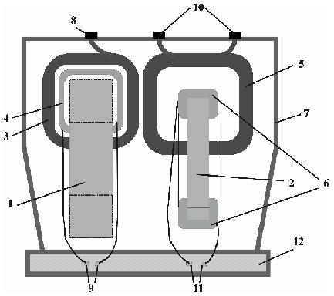

Fig. 2. Geometry of instrument transformer

1. VMC iron core
2. CMC iron core
3., 4. VMC windings
5., 6. CMC windings
The objective function can be defined with a conservative approach from metrological point of view - the certain measurement errors expressed through the absolute values are the metrological objective function:
(1)
as combination of the VMC voltage error p_{u} at rated load, VMC voltage error p_{u0,25} at 0,25 of the rated load and CMC current error p_{i} at rated load. The phase displacement errors are constraints during the optimization process in order to satisfy the achieved accuracy class of the both measurement cores. The CIT is a highly non-linear electromagnetic system, with mutual electromagnetic influence of both cores which determines the metrological performance of the device. The GA optimal design is coupled to the results of the FEM-3D analysis of the magnetic field distribution in the CIT as in [7, 8]. Some of initial results of the optimal design process with the goal function defined as in (1) are given in [7, 8].
According to the Guide for Expressing the Uncertainty in Measurements (GUM) [11], a statistical approach can be applied:
(2)
In the objective functions (1) and (2) the phase displacement error δ_{u} and δ_{i} are constraints (a control criterion of the maximal allowed values of the phase displacement errors for certain CIT accuracy classes in the GA algorithm CIT mathematical model is embedded, as in [10]). The CIT optimal design starts with the parameters derived by classical analytical design of the CIT based on the T-equivalent circuit as a CIT model given in [7, 8] by coupling with FEM-3D modelling and calculation of the main electromagnetic characteristics. The chromosome comprises 11 genes (input variables-geometrical, constructional and electrical parameters). The mapping range of the eleven GA input variables is defined according to the previously derived results by FEM-3D and the analytical transformer design, some most characteristic are given in Table 1. The optimal solution is derived by the following genetic parameters: cross-over probability 0,65, mutation probability 0,03, population size 16, maximal number of generations 30000.

Table 1. Input variables for CIT optimal design (mapping range)
Input variable | Minimum | Maximum | Initial value (analytical)
VMC primary winding number of turns | 23584 | 24000 | 24000
VMC primary winding current density [A/mm²] | 1,5 | 3,0 | 2,04
VMC secondary winding current density[A/mm²] | 2,0 | 3,0 | 2,61
VMC magnetic core outside length [mm] | 183 | 193 | 185
CMC secondary winding number of turns | 115 | 125 | 120
CMC primary winding current density [A/mm²] | 1,0 | 1,6 | 1,36
CMC secondary winding current density [A/mm²] | 2,0 | 3,0 | 2,55
CMC magnetic core outside length [mm] | 136 | 162 | 142

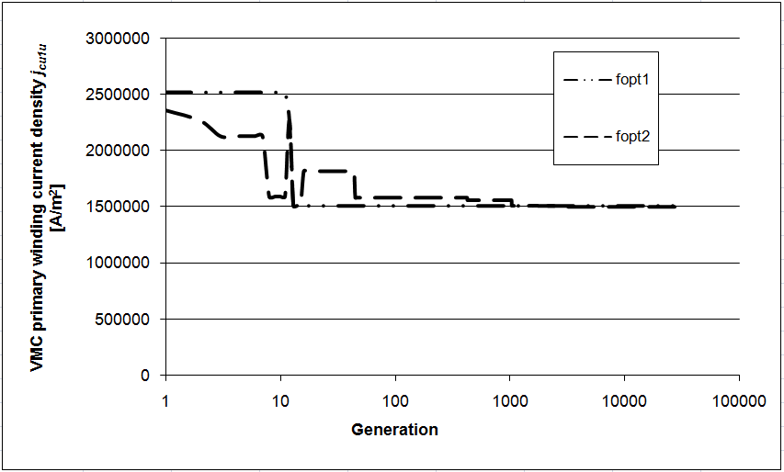

Fig. 3. Genetic algorithm changes through the generations of the VMC primary winding current density.
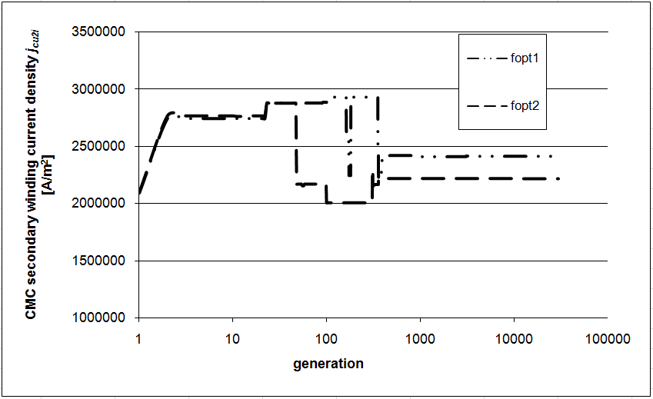

Fig. 4. Genetic algorithm changes through the generations of the CMC secondary winding current density.
In Figures 3-5, the changes throughout the 30000 generations in the GA optimisation process of the current densities in the CIT windings, as input variables (genes) are comparatively displayed for the both objective functions: conservative approach f_{opt1} and statistical approach f_{opt2}.

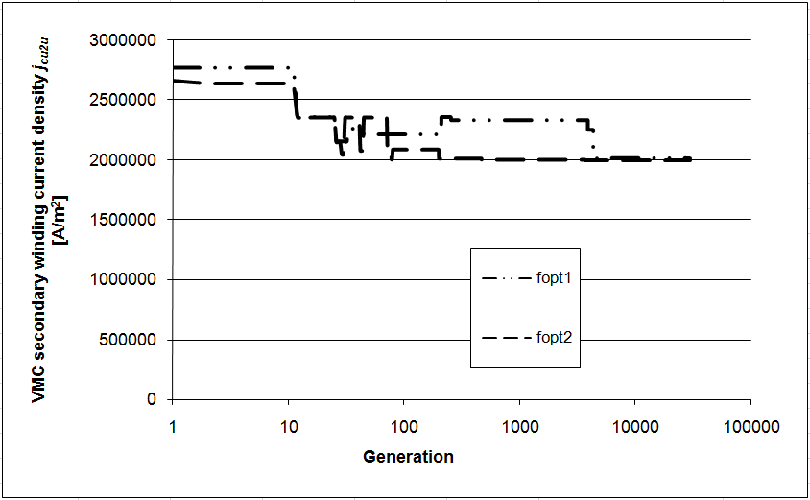

Fig. 5. Genetic algorithm changes through the generations of the VMC secondary winding current density.
The main input variables in the calculation of the CIT metrological parameters are the equivalent T-circuit parameters, i.e. the windings resistances and the leakage reactances. In Figures 6-12, changes throughout the 30000 generations in the GA optimisation process of the CIT equivalent T-circuit parameters are comparatively displayed for the both objective functions: conservative approach f_{opt1} and statistical approach f_{opt2}.

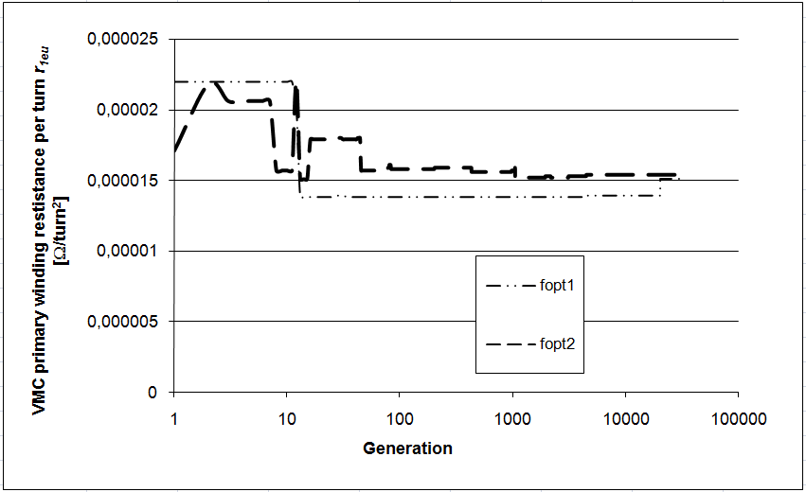

Fig. 6. Genetic algorithm changes through the generations of the VMC primary winding resistance per turn.

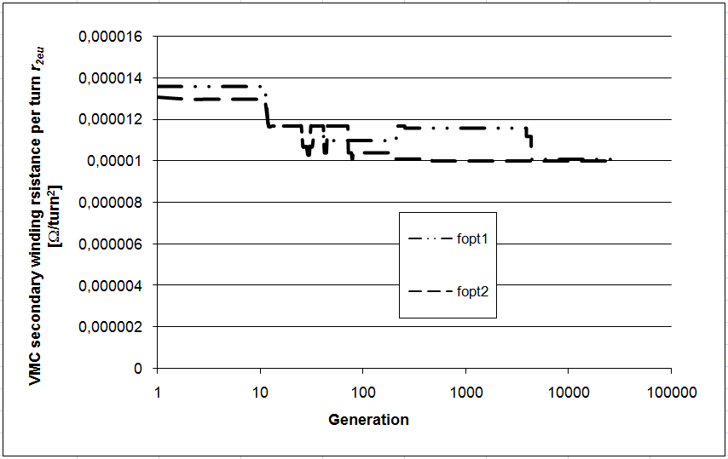

Fig. 7. Genetic algorithm changes through the generations of the VMC secondary winding resistance per turn.
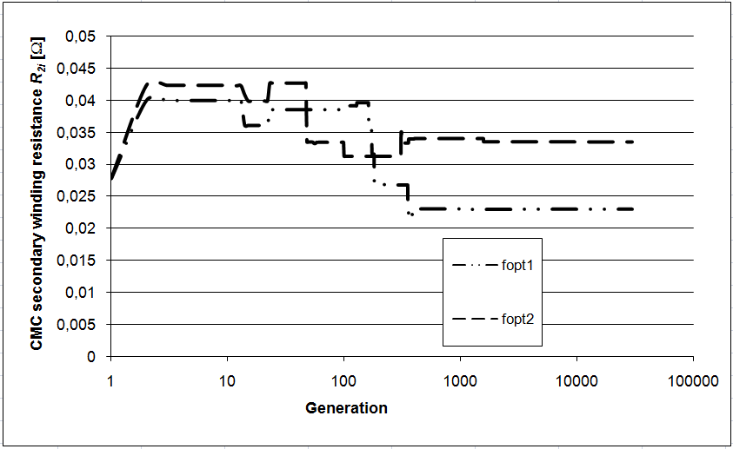

Fig. 8. Genetic algorithm changes through the generations of the CMC secondary winding resistance per turn.

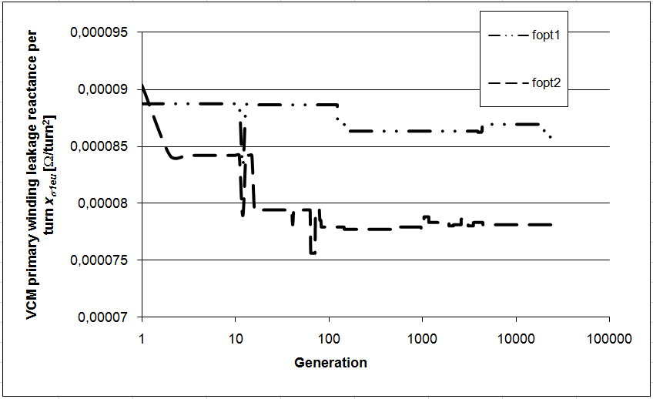

Fig. 9. Genetic algorithm changes through the generations of the VMC primary winding leakage reactance per turn.

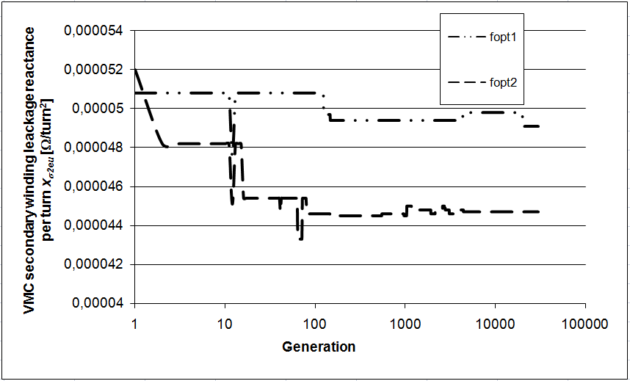

Fig. 10. Genetic algorithm changes through the generations of the VMC secondary winding leakage reactance per turn.

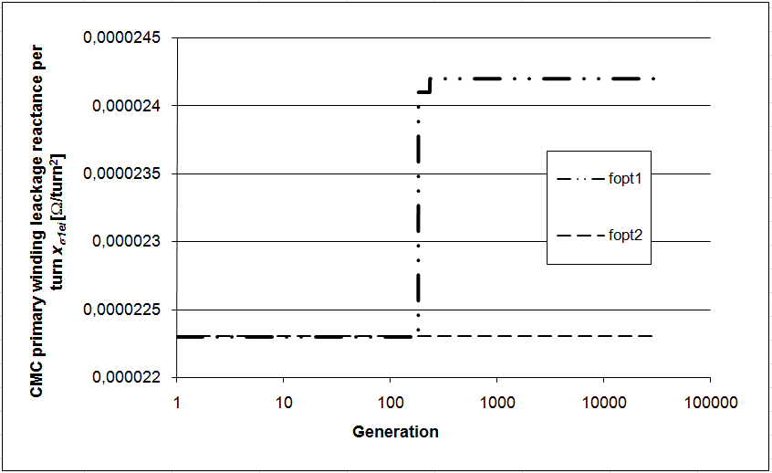

Fig. 11. Genetic algorithm changes through the generations of the CMC primary winding leakage reactance per turn.

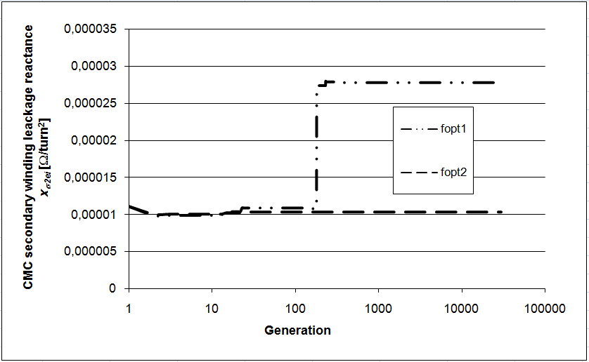

Fig. 12. Genetic algorithm changes through the generations of the CMC secondary winding leakage reactance per turn.

Table 2. Comparison of the CIT metrological, electromagnetic and constructive parameters derived by goal function with conservative and statistical approach
GA derived CIT parameter | Conservative approach | Statistical approach
p_{u} [%] | -0,795 | -0,625
p_{u0,25} [%] | 0,795 | 0,855
p_{i} [%] | 0,0 | 10⁻⁷
δ_{u} [min] | -69,43 | -61,62
δ_{i} [min] | -10,45 | 2,30
B_{mu} [T] | 0,424 | 0,336
B_{mi} [T] | 0,539 | 0,165
m_{Fe} [kg] | 35,18 | 46,58
m_{Cu} [kg] | 12,02 | 13,57

In Table 2 some of the optimal results (metrological parameters, geometrical, constructional and electromagnetic) derived by the both goal functions (1)-conservative approach and (2)-statistical approach are compared.

4. CASE STUDY NO. 2 - ga for prediction of RESISTANCE standards time drift
The estimation of the optimal moment for calibration of the standards is a challenge for most of the metrological laboratories, [12]. The decisions are made based on the empirical experience of the laboratory staff, the behaviour history and the conditions of the standard, [12]. The trend lines are usually extrapolated to predict the time-behaviour of the standards by using the classical least squares method, as in [1]. However, these models do not take into account the random nature of the calibration results and uncertainties.
In this contribution a new model of time-drift trend line of resistance standard derived by using the Lagrange polynomial (LP), coupled with genetic algorithm optimization is presented. The time points of the performed calibrations and the gained values of standard resistance are input data. The final model of the trend line using five input experimental values can be reduced to polynomial of fourth order:
R(t)=a₀⋅t⁴+ a₁⋅t³+ a₂⋅t²+ a₃⋅t+ a₄ (3)
where t is the time, R is the resistance and a_{i}, i=0,...,4 are the LP coefficients, depending on the values of the resistance at five calibration moments. The LP model is derived on the basis of the experimental data of calibrations of 1 Ω standard in time intervals from 1996 to 2005 year as in Table 3. The goal function of the optimization process by genetic algorithm (GA) is the minimum difference between the theoretical resistance value, derived by the LP, and the experimental value of the resistance at certain time moment (20. 04. 2007). The original GA program maximizes the goal function and the following goal function f_{opt} is given in the optimization process:
(4)
where R₆=R₂₀₀₇ is the resistance of the standard derived by the LP, determined by GA, at the time moment 20. 04. 2007 and R_{6exp} is the resistance of the standard derived by experimental calibration on 20. 04. 2007.

Table 3. The experimental GA input data for LP model
Time moment | R [Ω] | Uncert. of R [Ω]
26. 09. 1996 | 0.999992300 | ±5⋅10⁻⁷
23. 10. 1998 | 0.999992450 | ±3⋅10⁻⁸
28. 12. 2000 | 0.999992330 | ±6⋅10⁻⁹
08. 04. 2003 | 0.999992306 | ±6⋅10⁻⁹
09. 05. 2005 | 0.999992353 | ±1⋅10⁻⁸
20. 04. 2007 | 0.999992349 | ±1⋅10⁻⁸
14. 06. 2010 | 0.999992461 | ±1⋅10⁻⁸

A verification of the gained model with known experimental data is done (for the time point 14. 06. 2010). The verification criteria k is:
(5)
where R₇=R₂₀₁₀ is the resistance of the standard derived by the LP, determined by GA, at the time moment 14. 06. 2010 and R_{7exp} is the resistance of the standard derived by experimental calibration on 14. 06. 2007, s_{R7} and s_{R7exp} are the respective uncertainties. The optimal solution is at following genetic parameters: cross-over probability 0,65, mutation probability 0,03, population size 10, maximal number of generations 10000.

Table 4. Input variables derived from the GA optimization process
R₁₉₉₆ [Ω] | R₁₉₉₈ [Ω] | R₂₀₀₀ [Ω] | R₂₀₀₃ [Ω] | R₂₀₀₅ [Ω]
0,99999245 | 0,99999242 | 0,9999923 | 0,9999923 | 0,99999235

The values of the five input variables derived from the process of genetic algorithm optimization are in Table 4. The derived GA results after 10000 generations for the Lagrange polynomial coefficients are given in Table 5.

Table 5. The GA output data for LP model
LP coeficient | GA derived value
a₀ [Ω/month⁴] | 0,00000000000
a₁ [Ω/month³] | 0,00000000000
a₂ [Ω/month²] | -0,00000000025
a₃ [Ω/month] | 0,00000000378
a₄ [Ω] | 0,999992438

The value of the 1 Ω standard resistance in 2007 derived by the LP coupled with the GA optimization process is R₂₀₀₇ =0,999992349 Ω. The verification of the method is done through comparison of the theoretical standard resistance in 2010, with experimentally derived value through calibration. The theoretical value of the standard resistance on 14. 06. 2010 gained by the LP trend line and through the GA process is 0,9999916844, with difference of -7,77⋅10⁻⁷ Ω, which is the same order of uncertainty as the input variable with highest uncertainty R₁₉₉₆. The experimental input values of the 1 Ω resistance standard are compared in Figure 13 to the resistance values in different time points derived by the Lagrange polynomial coupled to the genetic algorithm optimization process. The uncertainties of the theoretical values are compared to the measurement uncertainties of the experimental data and overlapping of the both uncertainties interval exists. The overlapping is satisfactory for the point in 2010, which is a verification point of the methodology.

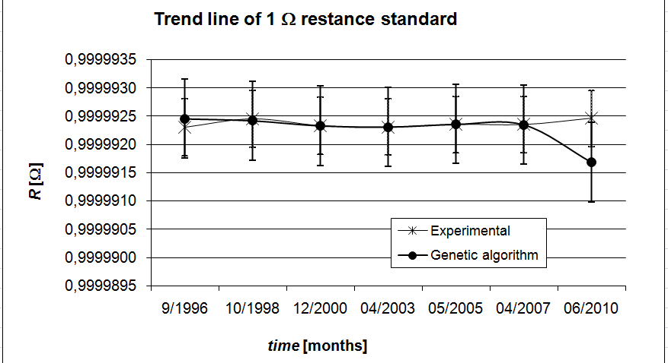

Fig. 13. Comparison of the GA derived LP time-trend line and the experimentally derived time-drift of 1 $Ω$ resistance standard.

5. CONCLUSIONS
In the paper the stochastic optimization method-genetic algorithm is applied for gaining solution of two different, but challenging problems in metrology of electrical quantities:
- Reduction of errors and uncertainties during the process of design of an instrument transformer;
- Prediction of time-drift of a resistance standard.
One original GA software solution is used for two problems of diverse nature. The derived results are satisfactory and verified. It can be concluded that lots of options exists, i.e. the genetic algorithm further to be applied for gaining other optimal solutions in different metrology areas and problems.

REFERENCES
[1] P. Mostarac, R. Malarić, H. Hegeduš “Extrapolation of Resistance Standard Values between Calibrations“, Conf. Proc. of the IX Nat. Conf. with Int. Part. ETAI, Ohrid, Macedonia, CD ROM Е2-2, 2009.
[2] M. Cundeva-Blajer, L. Arsov “Prediction of Resistance Standards Time Behaviour by Stochastic Determination of Lagrange Polynomial”, Series on Advances in Mathematics for Applied Sciences-Vol.84, Advanced Mathematical and Computational Tools in Metrology and Testing IX, World Scientific Publishing Co. Pte. Ltd, pp. 102-109, 2012.
[3] C. E. Matthews, L. Wright, X-S Yang “Metrology and Design with Continuous Models: tools for optimisation, sensitivity and uncertainty evaluation”, Series on Advances in Mathematics for Applied Sciences-Vol.84, Advanced Mathematical and Computational Tools in Metrology and Testing IX, World Scientific Publishing, pp. 260-267, 2012.
[4] K. K. Semenov, G. N. Solopchenko “Inverse Problems in Theory and Practice of Measurements and Metrology”, Series on Advances in Mathematics for Applied Sciences-Vol.86, Advanced Mathematical and Computational Tools in Metrology and Testing X, World Scientific Publishing Co. Pte. Ltd, pp. 330-339, 2015.
[5] M. Cox, P. Harris “Polynomial Calibration Functions Revisited: Numerical and Statistical Issues”, Series on Advances in Mathematics for Applied Sciences-Vol.86, Advanced Mathematical and Computational Tools in Metrology and Testing X, World Scientific Publishing Co. Pte. Ltd, pp. 9-16, 2015.
[6] G. Cvetkovski, L. Petkovska, S. Gair, “Specific power as objective function in GA optimal design of permanent magnet disc motor”, COMPEL: Int. Jour. for Computation and Mathematics in Electrical and Electronic Engineering 29, Iss. 4, pp. 964-973, 2010.
[7] M. Cundeva-Blajer, L. Arsov „Computer Aided Techniques for Estimation and Reduction of Electromagnetic Measurement Devices Uncertaintes“, Int. Journal of Metrology and Quality Engineering, Vol. 2, EDP Sciences, Paris, pp. 89-97, 2010.
[8] M. Cundeva-Blajer, L. Arsov “Influence of the Objective Function in the Process of Optimal Design of an Electromagnetic Measurement System”, Int. Journal of Applied Electromagnetics and Mechanics Vol. 39, IOS Press, Amsterdam, pp. 705-710, 2012.
[9] D. Filipovic-Grcic, M. Pljak, Z. Stih, “Optimization of the Paper-Oil Insulation of High Voltage Inverse Current Transformers Using Genetic Algorithm”, Proc. of 13th Int. Symp. on Electromagnetic Fields in El. Eng. ISEF’07, Prague, (paper ID 065 on a CD ROM), 2007.
[10] IEC 61869-4, Edition 1.0, 2013-11: Instrument transformers, Part 4: Additional requirements for combined transformers, Geneva, 2013
[11] Expression of the Uncertainty of Measurements in Calibration, (GUM), JCGM 100 with member organizations (BIPM, IEC, ILAC, OIML, ....), 1999
[12] ILAC-G24:2007 / OIML D 10:2007 (E) Guidelines for the determination of calibration intervals of measuring instruments, 2007

