3D survey technologies applied to the archaeology for the new "Municipio" underground station in Naples
Daniela Giampaola¹, Vittoria Carsana², Cristiana Achille³, Sebastiano Ackermann³,
Francesco Fassi³, Luigi Fregonese³, Alessia Nobile³

¹ Superintendence Archaeology Campania, Piazza Museo Nazionale, 19 - 80135 - Naples, Italy, daniela.giampaola@beniculturali.it
²Assistant of the Superintendence Archaeology Campania, Via del Marzano, 6 - 80123 - Naples, Italy, carsana@iol.it
³ Polytechnic of Milan, Department of Architecture, Built Environment and Construction Engineering ABC, Via Ponzio 31 - 20133 – Milan, Italy, (cristiana.achille, sebastiano.ackermann, francesco.fassi, luigi.fregonese, alessia.nobile)@polimi.it

KEYWORDS: Archaeology, Photogrammetry, laser scanner, 3D-models

Abstract – Advanced 3D survey technologies, such as Digital Photogrammetry and Laser Scanner, are nowadays widely used in several fields such as Cultural Heritage and Archaeology, allowing to obtain detailed 3D textured models in a fast way for different purposes.
These technologies are usually employed to perform single individual surveys but they have rarely been considered for continuous surveys like being part of a “production line”.
The construction of the new “Municipio” underground station in Naples, due to its position in one of the historical area of the city, coexists with the archaeological excavations and is strictly tied to their evolution. With such surveys, the need to reduce as much as possible time to build a public infrastructure, with the one to produce accurate documentation of what is considered archaeologically important are combined.
- Introduction
The construction of the new underground station “Municipio” in Naples, interchange point between two underground lines and the touristic harbour, has produced time expensive archaeological investigations within the construction areas. These investigations were arranged with the Italian Cultural and Activities Heritage Ministry, the Municipality of Naples and “Metropolitana di Napoli S.p.A.”, concessionaire for the construction of the underground. These archaeological investigations are a precocious example of “planned archaeology” applied to an important public infrastructure: indeed, they have been started a few years before the introduction of the “Rescue Archaeology” law, issued in 2006.
By following the principles of the “urban archaeology”, the investigations have allowed to explore all the human settlements originated within the area, from the most ancient to the modern ones. These investigations represent an unexampled fact-finding model applied to a critical area of the historical centre of Naples, an area that couldn’t be differently investigated due to the complexity of the urban situation, the depth of the evidences and the contextual presence of a phreatic layer. In this paper, survey methodologies applied on the below described evidences and adapted to the specific cases will be presented.
- THE ARCHAEOLOGICAL EVIDENCES
The old costal landscape shape in front of the historical Neapolitan settlement has been reconstructed thanks to the archaeological investigations. However, the area delimited by the actual Via Medina, Via Depretis, Piazza Municipio and Castel Nuovo was deeply different by the one known as-is today, outcome of secular natural and anthropic transformations (Fig.1). At the beginning, it was the south-west zone of a wide inlet delimited, from south-west to north-east respectively, by the promontory where now is located Castel Nuovo and by the elevation where now is located the S.Maria di Porto Salvo church.
From the end of the 4th century B.C. to the 5th century A.D., the above described area matched with the port basin of Neapolis and with the neighbouring seaboard as well [1]. The laying out of the harbour has dated back to the end of the 4th century/beginning of the 3rd century B.C., thanks to the founding of tracks related to an extended dredging operation (about 3750 m²) on the deepest sea bottoms levels, operations that modified the original shape of the inlet. In the same epoch, the above slope was regularized by rising up walls for terracing purposes made with panelled masonry or tuff blocks technique, probably for the protection of the basin. A ramp made with tuff blocks was also built, maybe for mooring purposes.

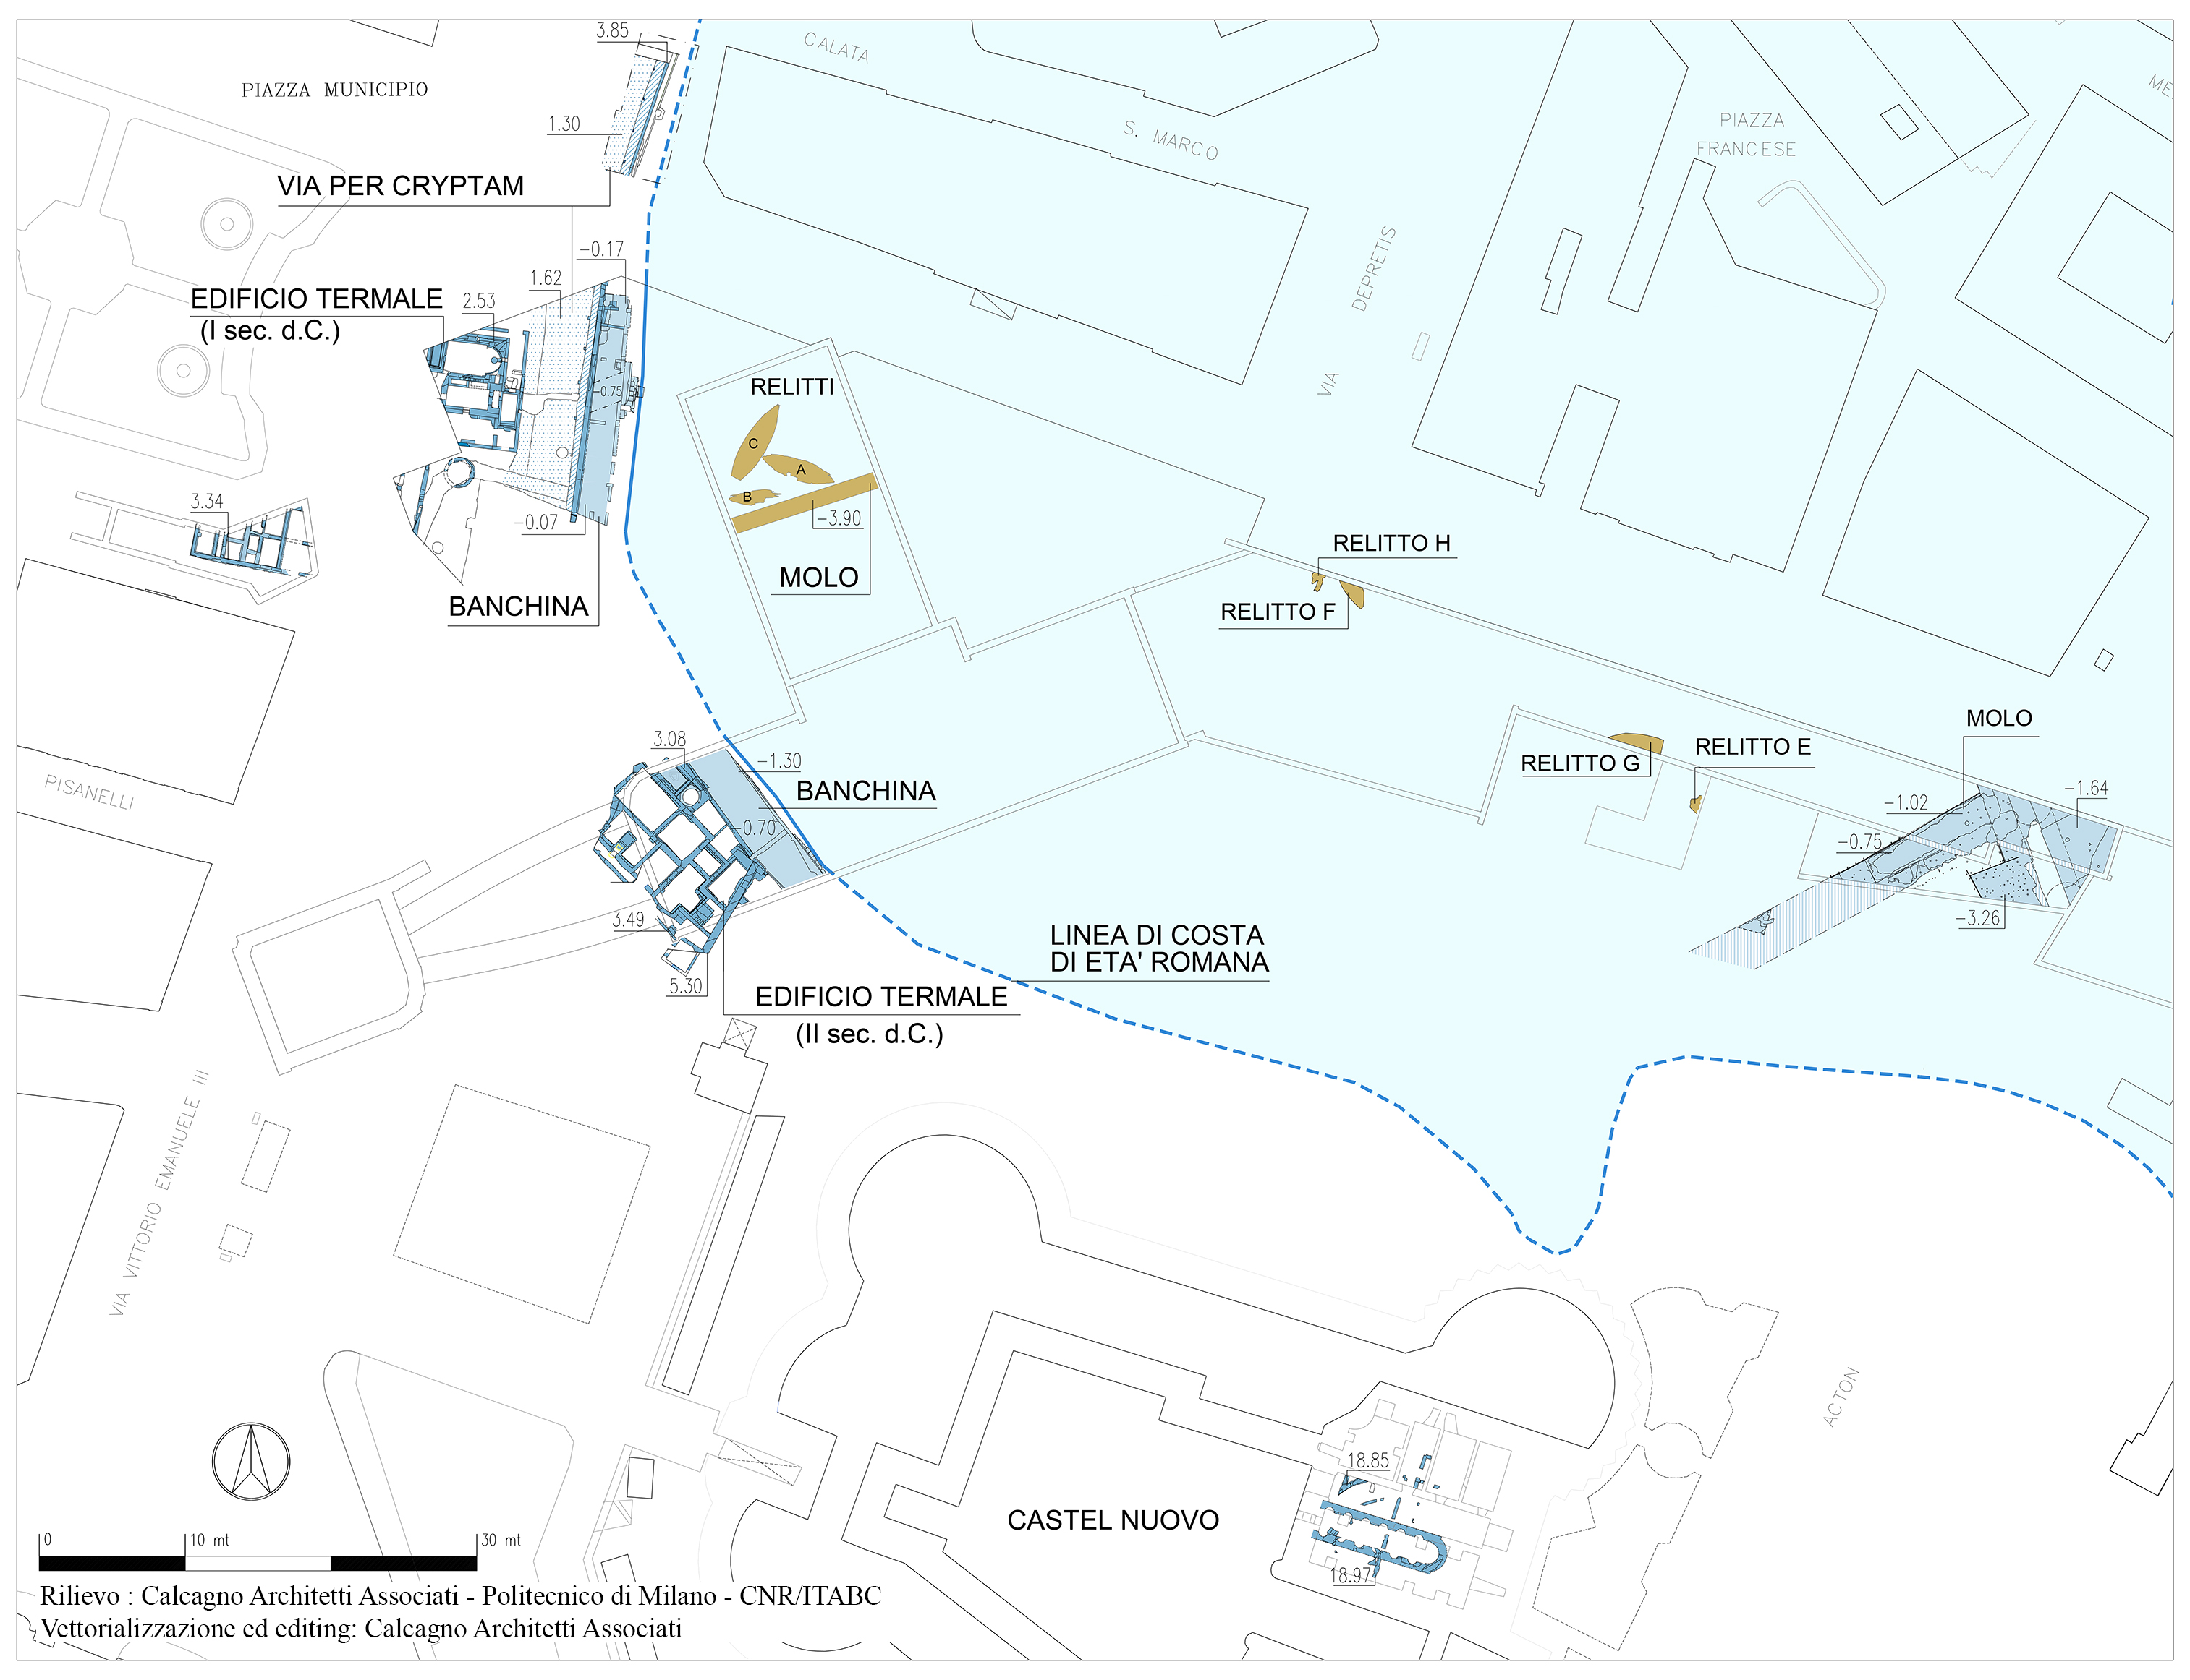
Fig. 1. Roman evidences and reconstructed costal landscape shape.

During the Augustan age, the area was differently reorganized, and important harbour and street infrastructures were set up. Next to the inside edge of the inlet, a quay made with concrete, superimposed over tuff blocks lines and delimited by a reticulated work type wall, was built, and the natural tuff bank was also worked. The presence of an erosional line characterized by the presence of malacofauna (barnacles and oysters) proves that the sea level during the roman imperial age was about 1,70/1,80m below the actual sea level. In the south-east area of the inlet, a much more complex harbour infrastructure, still under investigation, has been recently discovered: it’s composed by concrete structures, built by using a wooden formwork, that probably were used as docks or breakwaters to protect the entrance of the port basin. The regularized coastline area was employed to build a thermal structure (1st and 2nd century A.D) along a route, probably the via per cryptam from Neapolis to the Phlegraean Fields.
Among other things, the stratigraphic sequence of overlapping sea bottoms that included a high number of ceramic and organic evidences (such as waste, ship equipment or lost objects), was also excavated. During these investigations, six shipwreck were found: poor rests of two shipwrecks dated 2nd century B.C. (named “Napoli E” and “Napoli H”), two ships dated 1st century A.D. ( “Napoli A” and “Napoli C”), and other three boats, maybe sunk due to a storm at the end of the 2nd century A.D. (“Napoli B”, “Napoli F”, “Naples G”). All the boats were built according to the shell-first method, with the planks fitted edge to edge and fastened by mortise-and-tenon joints technique [2]. Shipwrecks A, B and F were sail-boat type used for commercial purposes, whereas C and G ones had a flat vertical stern, belonging to the horeiae class, probably pushed by using both sail and oars with multi-purposes employment, details known just from iconographic sources (a mosaic found in Althuburus, Tunisia) [3]. While the A and C boats were entirely removed by constructing a fiberglass case around them, the F, G and H boats, found in 2015, due to their worse condition, have been accurately disassembled and each component has been stored within water tanks to preserve them. The disassembling process has been set up and executed with the cooperation of the ISCR (National Institute for Conservation and Restoration) and the naval archaeologists G.Boetto (CNRS – Center Camille Jullian) and C.Zazzaro (University of Naples “L’Orientale”).
The archaeological excavations revealed a mutation of the inlet morphology at the beginning of the 5th century A.D.: the coast line moved toward east and so the port basin. In addition, the previous built construction were abandoned or reorganized to be used in different manner.
The urban history of the area completely changed from the construction of Castel Nuovo in the 1279 up to the last square realized in the second half of the 19th century.
- advanced survey techniques for the archaeology
One of the issue that affects the Cultural Heritage field is the need to storage a huge number of evidences found during archaeological excavations. Most of them are usually preserved in storehouses: the employment of digital technologies allows to obtain accurate three dimensional models and to share them through the web network, strongly changing the way to benefits from such ancient treasures. Virtual archaeology is nowadays a constant element within the professional life of an archaeologist. In addition to the possibility to carry out metric and semantic information of an object without physically measuring the real evidence, such technologies are almost a mandatory step especially to document those artefacts that could not be preserved, as in the case of the construction of a public infrastructure.
Three-dimensional data is today a recursive variable in the archaeology field: the use of advanced survey methodologies to obtain such kind of data are nowadays widely employed to reconstruct stratigraphy of inspected sites, to create GIS database or virtual museums. Because of the three-dimensionality of architectonic and archaeological structures, the best way to represent them is to reproduce them by keeping all the three dimensions, while the exclusive use of two-dimensional drawing approach always means the loss of important information [4].
Since 2012, the concessionaire for the underground construction, together with the “Superintendence Archaeology Campania”, has set up a cooperation with the “3D Survey Group” of the “Polytechnic of Milan”, whose know-how in updated survey technologies, such as Digital Photogrammetry and Laser Scanner, well satisfy the requirements of both archaeologists and contractors.
The systematic usage of these technologies (not just for isolated cases) has met the need to produce adequate and detailed documentation of the found evidences within a huge construction area as it is Piazza Municipio. The 3D models obtained from each survey session performed in different moments and positions can be successively combined together in order to have a global vision of the found evidences, making possible also to understand the stratigraphic sequence and to reconstruct the ancient scenery and its transformation from the Hellenistic era up to the 19th century. The adopting of such new techniques sensibly reduced the acquisition time and as a consequence improved the efficiency of the excavation process.
The strong cooperation between surveyors and archaeologists required to tune up a process schedule among the survey step and the preliminary restitution of the related orthophoto, that permit a practical verification by the archaeologist before let the excavations go on. In a second moment, without the need to halt anymore the excavations, phase drawings, architectonic and stratigraphic sections are carried out in cooperation with the “Calcagno Architetti Associati” company.
- cases study
Laser Scanner allows to obtain high-resolution dense point clouds within short time, while Digital Photogrammetry permits to obtain three-dimensional reconstruction of objects from images [5].
The documentation to produce within the “Municipio” construction yard with such technologies is basically composed by orthophotos and 3D point cloud models. During the last three years, several tests with both survey techniques have been conducted on an elevated number of evidences that differ in terms of type and dimension, reaching the best approach to use depending on the case.
At the beginning, digital photogrammetry has been mainly used to generate orthophotos while laser scanner to obtain 3D point clouds. However, the improvements of the actual photogrammetric software, mostly thanks to the fusion between “classical” photogrammetry and computer vision world, allow now to obtain accurate dense point clouds in an almost fully-automatic way. The obtained results that will follow encourages the use of this image-based technique to extract also 3D point clouds, reserving the use of the laser scanner for particular cases and even lower much more the acquisition time as well as the halt of the excavations.A series of surveys related to particular and different type of evidences and stratigraphy will be presented and discussed. In some case, specific additional solution were adopted to perform the survey and to achieve the requested results in term of precision and resolution.
- Dredging tracks
One of the most interesting and particular discoveries has been the finding of the rests of dredging operations on the tuff rock stratum. Because these tracks have been found about 7 meters below the actual sea level, it is supposed they were probably realized by employing a dredge mounted on a boat or on a buoyant platform [1].
These tracks have been localized in different but neighbouring excavation areas of the construction yard, and they have been excavated in different moments as well. Due to these reasons, it wasn’t possible to have a complete physical global view of the tracks all together.
The proposed technologies has been employed in the most part of the area in which the dredging tracks have been found. Except for the dredging found in 2004 during the line 1 station shaft excavations, for which less updated survey methodologies were employed, all the remaining areas in which they have been discovered, have been surveyed with actual technologies.
The dredging tracks discovered in the line 6 station shaft have been surveyed in 2014. Due to the fact that they were partially found below a reinforced concrete slab, built during the archaeological excavations two years before, the natural light condition was poor, and the laser scanner was preventively preferred to carry out the 3D model. The complexity of the site, due to the irregularity of the elevation profile of the area, and the requested high resolution of the model, required an elevated number of scans and an intensive post-processing work as well.
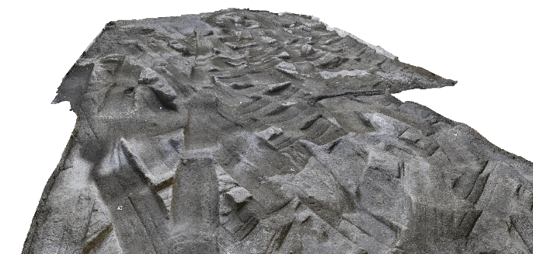
Fig. 2. Dredging tracks found in the line 6 station shaft.

Thanks to the high quality of the surveys’ results in terms of level of detail and degree of realism, and to the potentiality allowable by such digital technologies, the archaeologists have now the possibility to observe the site overall on a computer, from almost infinite points of view, to better recognize the directions of the dredging tracks in order to identify the ones belonging to a single dredge passage and also a valid support to study the possible shapes of the tool used to dredge the sea bottom (Fig 2).
In addition, as the surveys have been topographically georeferenced in a global reference system, the combining of all the surveys performed - or to be performed - in the neighbouring areas, and the possibility to see all the 3D digital models together, will permit to have an overall view of the whole excavated area. Last, all the a posteriori analysis intended to extract in detail measurement information can be performed directly on the 3D model and without a specific urgency, allowing the contractors the prosecution of the station construction and optimizing the infrastructure construction time as well.

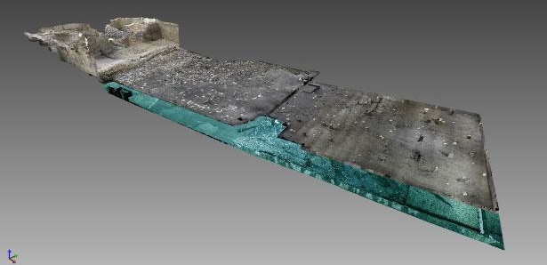
3.60 m
Fig. 3. Perspective view of a 3D model of line 6 station shaft excavation site where the first and last surveyed sea bottoms have been highlighted.
- Sea bottoms stratigraphy
The use of advanced survey technologies to document the stratigraphy sequence of the sea bottoms (Fig. 3) entailed to plan a process schedule in which a strict interaction between surveyors and archaeologists has been necessary. A new concept of “measurable” stratum in three-dimensions has been adopted, bringing to an important improvement if compared to the traditional survey techniques, mainly based on 2D maps and sparse 3D measured points. However, the added value of this approach is not so much the three-dimensional data stand-alone, as the data georeferenced with regard to a unique coordinate reference system that allow to extract absolute 3D information from all the surveyed strata. In addition, the “digital assembling” of all the surveyed stratums together made possible to reconstruct the entire sequence of sediments settled or removed over the centuries, metrically and semantically as well, deleting any possible individual interpretation [6].

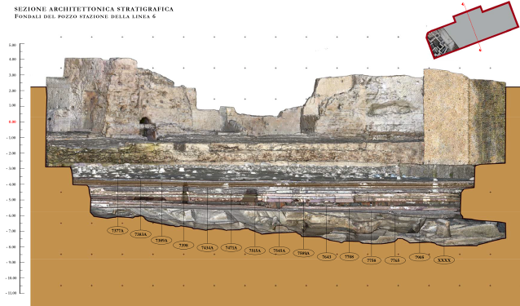
3.60 m
Fig. 4. Stratigraphic section carried out from the combined 3D models of all the surveyed sea bottoms.

Within this archaeological area of the line 6 station shaft, a total amount of 16 different sea bottom stratums were surveyed: approximatively, a volume of about 5000m³ was removed by following the rules of the archaeologic investigations, obtaining a height difference between the first and the last stratum surveyed of about 3.60m (Fig. 3 and 4).
- Thermal Structure
When a complex ruin has to be excavated, especially if it is characterized by great extensions and big dimensions, or in case of lack of important structure elements, the understanding of the whole structure utility could appear arduous. An orthographic vertical view as well as a 3D model of the area can give a valid help to understand its shape otherwise not always comprehensible just looking at it on the excavation site. (Fig. 5).
In such cases, the availability of an accurate model and the possibility to observe it from infinite points of view, gives to the archaeologist a huge additional working instrument.

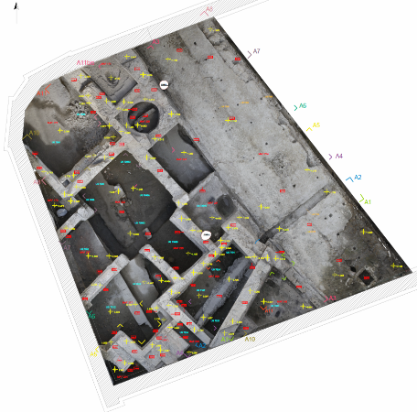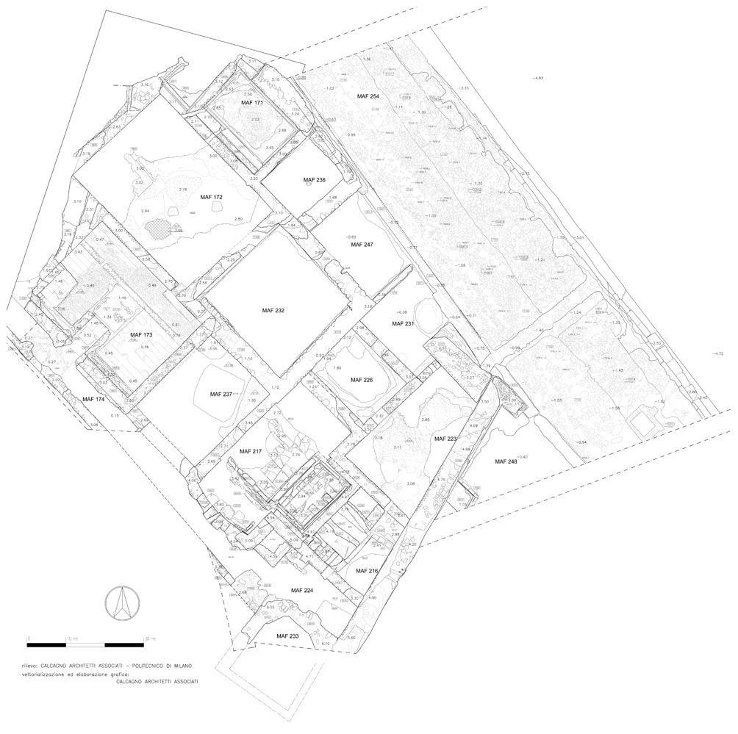

Fig. 5. Thermal structure and quay true orthophoto and vector map

The survey of the Roman thermal structure found in the line 6 station shaft appeared as an extreme difficult task due to the complexity of the site and to the restricted working spaces. Beyond the survey of each single walls’ façades of the structure, a global survey of the entire area, by using a bird’s eye view, was necessary. Due to the presence of several obstructions that made impossible the employment of auxiliary flying units such as hanging baskets or UAVs, a flexible and cheap solution has been designed and manufactured. In order to take vertical photos, the camera was mounted on a horizontally movable aluminium frame controlled in one direction by a sort of “clothesline” and in a second direction by a movable roof previously positioned on two rails to preserve the ruins during the excavation progress [5]. This stratagem, besides its cheapness, turned up to be a good resource to overcome the above described difficulties. Thanks to this solution, a true orthophoto (Fig 5) of the entire visible parts of the structure was obtained, allowing to have a real perception of the building composition.
The 3D model of the same structure instead (Fig. 6), obtained by employing a laser scanner, allowed to have a good starting point for the prosecution of the excavation activities: indeed, a particularity of this structure is the fact that walls previously used for different purposes in Hellenistic epoch were reused to build it in Roman epoch.
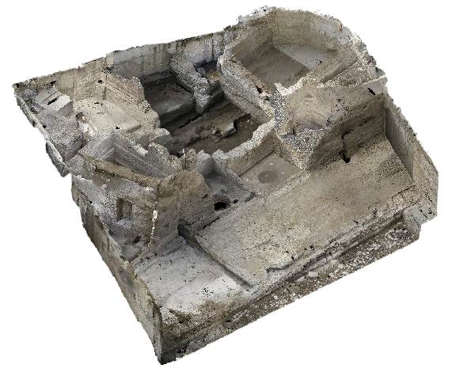
Fig. 6. Perspective view of the 3D model of the roman thermal complex and of the quay.

The surveys performed successively, during the prosecution of the excavations and contextually to the disassembling of the thermal structures, permitted to document the more ancient walls, allowing to digitally reconstruct older situations like a backwards travel through the time. In addition, the possibility to assemble and view together 3D models related to surveys performed in different excavation moments, even in different years, is an exhaustive tool to understand the original uses of the artefacts and the relationship among the structure of different epochs.

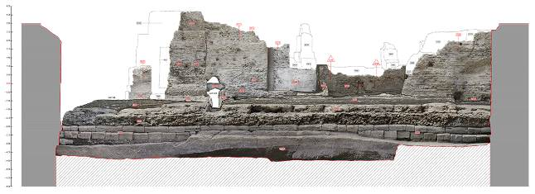
Fig. 7. Architectonic section of the thermal structure together with the front of the quay.

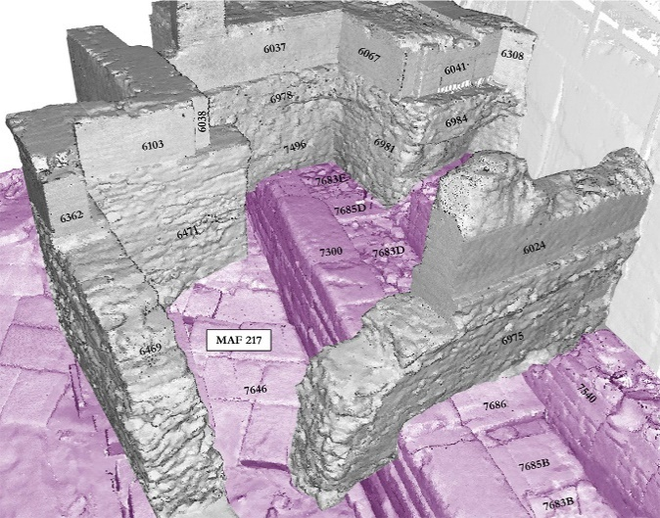
Fig. 8. 3D multi temporal view: Roman structures in grayscale, Hellenistic ones in magenta.

The accurate documentation of the much important artefacts produced during the excavation progress allowed to carry out graphic two-dimensional representation as well, such as maps, sections and perspective drawings with wall orthophotos façades (Fig.7). In addition, stratigraphic sections and 3D multi temporal views have been produced in order to show in a clear manner the relationship between different epochs structures. (Fig. 8).
Table 1. Thermal structure survey report.
Survey method | Photogrammetry | Laser Scanner
Object extension | ≈500 m²
No. photos/scans | 499 | 50
Resolution | 5616x3744 | 3mm@10m
Acquisition time | 360 mins. | 1 week
Elaboration time | 210 hours (estim.) | 1 month
No. points 3D model | N/A | ≈1 billion
- Shipwreck “Napoli G”
At the end of 2014, the partial bottom of a shipwreck, including edge-joined hull planks and transversal frames, was found (Fig. 9).

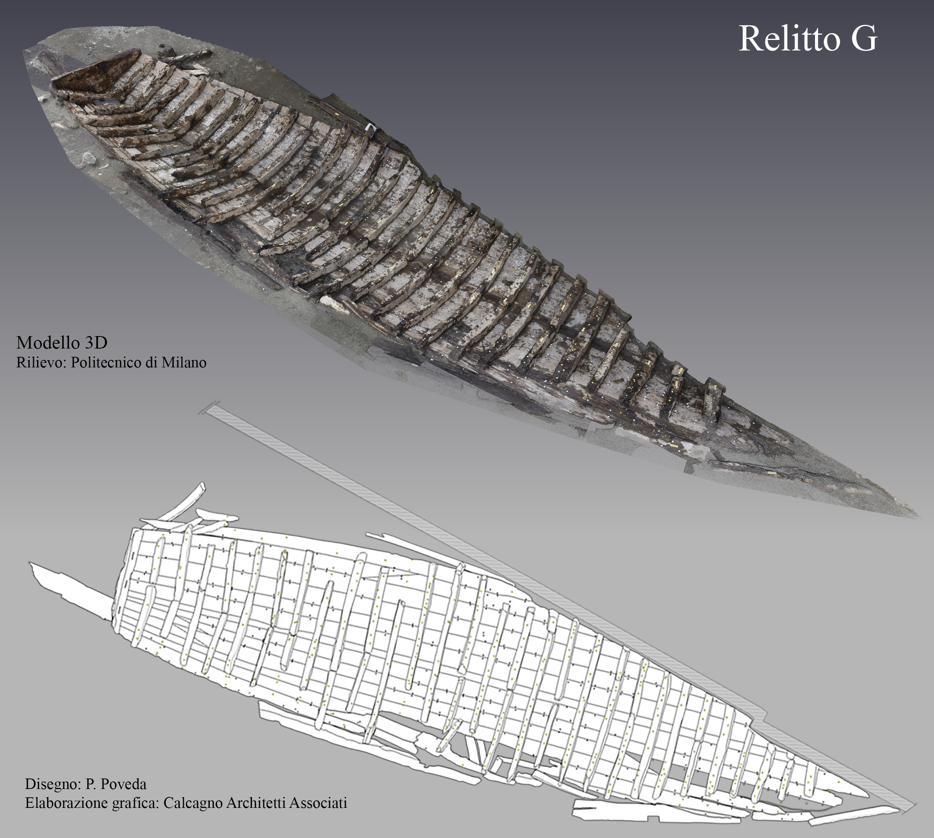
Fig. 9. Shipwreck “Napoli G” and related vector drawing.

Due to the particularity of the archaeological evidence and for the location of the finding, there was the necessity to pay serious attention to its excavation and to find a quick solution to provide exhaustive documentation of the evidence and disassemble the shipwreck in as less time as possible. This special case required a strictly cooperation between surveyors and archaeologists, as the start and the prosecution of the disassembling process depended by the preventive and quickly production of maps with orthopothos in specific moments, useful to the archaeologist to take note of each single disassembled part. For these reasons, high resolution orthophotos and accurate 3D models were requested. The high number of corners for the presence of several frames located in their original positon above the bottom of the boat, brought to choose the photogrammetry as the best survey solution in terms of quality of the final model and time-consuming. Indeed, with a range-based instrument like the laser scanner, a huge number of scans to avoid “holes” on the model would have been requested, with a consequent overabundance of unnecessary data, an intensive and time expensive editing activity and several junction zones between the scans to deal with. As additional negative surrounding condition, the boat was found partially cut by the bulkheads built before the beginning of the archaeological excavation activities. The presence of the bulkheads themselves too close to the boat on one side would have made impossible the acquisition with a laser scanner, while the flexibility of the photogrammetry made it possible even if with some difficulty. In order to keep a good range of DOF (Depth Of Field) and a suitable degree of sharpness in a low light condition, photos were taken with an elevated f-number and with the camera set on a tripod. Normal/nadiral photos were taken together with a set of tilted photos to well reconstruct each particular of the hull and to improve the quality of the camera network. A mobile platform on which place the camera was also prepared to move the camera itself above the shipwreck.
Table 2. Shipwreck “Napoli G” survey report.
Survey session | 1st | 2nd | 3rd | 4th
No. Photos | 334 | 278 | 285 | 213
Image Resolution | 5616x3744
Acquisition time (mins.) | 90 | 55 | 65 | 65
Orthophoto restitution time | 1 day
No. points 3D model (millions of points) | 117,3 | 100,4 | 79 | 74,0

For this evidence, four distinct surveys, which information are summarized in the table 2, were performed during the disassembling phases, in order to record as much construction details as possible.
Other than being a satisfying documentation, an accurate 3D reconstruction of such archaeological found can be an useful tool for historians of ancient naval architecture to better understand the typology of the vessel, the employed construction techniques or to have important elements to reconstruct a complete virtual or real model of the vessel reducing reconstruction hypothesis. Even a remounting of the shipwreck in a museum, as it was found, could be taken into consideration as each part was mapped in detail before being removed.
- Conclusions
The above described cases are just a selected group of the most exhaustive and interesting evidences found during the excavations activities to which advanced survey technologies have been applied. Even if these cases could appear as a small part of the enormous and continuous survey activity started in 2012 and still under way, they fully give an idea of the potentiality of such methodologies. The thermal structure in particular is a significant example of the possibility to virtually reconstruct the several historical stages came in succession from Hellenistic epoch on. Even if these technologies in such intensive use have been employed only from 2012 on, an integration with data previously obtained with less updated survey methods related to the overhead structures could also be attempted to reconstruct a much more complete historical sequence. Beyond the achievable information that can be extracted from detailed 3D models, the above shown results demonstrate the capability of such technologies to deal with continuous excavation activities that take places simultaneously in different areas of the construction yard and to perfectly satisfy the requirements of all the involved subjects.
Within the last three years, the improvements introduced in the actual data processing photogrammetric software (parallel computing, automatic point cloud generation, etc.) brought to reorganize the two employed methodologies. Much more space has been reserved to the photogrammetric approach in the last months, sensibly reducing the acquisition time in the perspective of still optimize the work. Accurate 3D models in a limited time, depending on the complexity of the object, can now be obtained with the photogrammetry in a fast manner. In addition, this technique demonstrated its capability to be employed even in case of outstanding conditions, thanks to its flexibility.
References
- V.Carsana, S.Febbraro, D.Giampaola, C.Guastaferro, G.Irollo, M.R.Ruello, “Evoluzione del paesaggio costiero tra Parthenope e Neapolis”, in “People/environment relationships from the Mesolithic to the Middle Ages, recent geo-Archaeological findings in Southern Italy”, Méditerranée, No.112, 2009, pp. 14-22.
- E.Allevato, E.Russo Ermolli, G.Boetto, G.Di Pasquale, “Pollen-wood analysis at the Neapolis harbour site (1st -3rd century AD, southern Italy) and its archaeobotanical implications”, Journal of Archaeological Science, Vol. 37, 2010, pp.2365-2375.
- D.Giampaola, V.Carsana, G.Boetto, F.Crema, C.Florio, D.Panza, B.Pizzo, C.Capretti, G.Galotta, G.Giachi, N.Macchioni, M.P.Nugari, M.Bartolini. “La scoperta del porto di “Neapolis”: dalla ricostruzione topografica allo scavo e al recupero dei relitti”, in Archaeologia maritima mediterranea, An International Journal on Underwater Archaeology, No.2, 2005 (Pisa-Roma), pp. 48-91.
- F.Doglioni, “Stratigrafia e restauro. Tra conoscenza e conservazione dell’architettura”, ed. LINT, Trieste, 1997.
- F.Fassi, L.Fregonese, S.Ackermann, V.De Troia, “Comparison between Laser Scanning and Automated 3D modelling techniques to reconstruct complex and extensive cultural heritage areas”, Int. Arch. Photogramm. Remote Sens. Spatial Inf. Sci., Vol. XL-5/W1, 2013, pp.73-80.
- M.Peripimeno, “Sperimentazione di tecniche 3D laser scanning per l’analisi e la conservazione del patrimonio archeologico e storico-monumentale. Definizione di procedure e campi di utilizzo”, Proc. of National Congress SIFET - Integrazione tra le tecniche innovative del rilievo del territorio e dei beni culturali, Mondello, 29-31 june 2005.

