Bayesian analysis and the way to look at absolute dating
Francesco Maspero^{1,2}, Emanuela Sibilia^{1,2}, Marco Martini^{1,2}
¹ CUDAM, Università degli Studi di Milano Bicocca, Piazza della Scienza 1, 20125 Milano
² INFN – sezione di Milano-Bicocca e Dipartimento di Scienza dei Materiali, Università degli Studi di Milano Bicocca, via Roberto Cozzi 55, 20126 Milano

- Introduction
Absolute dating has become a powerful tool in archaeology. However, the interpretation of the archaeometric data can be sometimes difficult, especially in the case of non-Gaussian probability distributions (e.g. radiocarbon dates). Moreover, prior information about analyzed samples and provenance sites are not usually taken into account in real synergy with experimental data and historical studies, giving space to subjective interpretations, sometimes in conflict.
Fig. 1: Representation of a Bayesian analysis
A great help comes from the Bayesian statistical approach, a model that combines in a single formal analysis the experimental results coming from scientific analyses together with the present knowledge of an archaeological problem, in order to make inferences that can contextualize the problem in a coherent interpretation.

- case studies
The Bayes’ theorem states that the posterior probability of an event is proportional to the likelihood times the prior probability, or formally:

$$P\left(E_{1} | E_{2}\right)=\frac{P\left(E_{2} | E_{1}\right)}{P(E_{2})}P(E_{1})$$

where $P(E_{n})$ are the probabilities of the single events, and $P\left(E_{m} | E_{n}\right)$ are the likelihood of the two events to be linked.
Bayesian statistics uses probability as a means of measuring one’s strength of belief in a particular hypothesis being true[1]. In other words, the application of Bayesian statistics allows the selection of the most significant data in the experimental set, rejecting the ones not supported by historical evidences or by a relevant likelihood.
The application of this method can bring some strange and unconventional results, which can be understood only after the comprehension of the Bayesian “way of thinking”. A special fictional case can help: in Fig.1 is 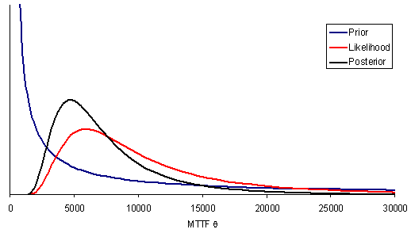depicted a prior probability of an event A (blue line) that has a maximum corresponding to the 0 value; the likelihood graph (black line) states that the probability that event A occurs in conjunction with an event B has a peak corresponding to the 5000 value. Combining this data produces a posterior probability curve extremely different from the prior one, but closer to the real probability distribution, taken into account all the available data.
The powerfulness of this method is well represented by the calibration of radiocarbon dates to obtain the probability density curve a scientist is accustomed to (Fig. 2): in this case the prior information is the
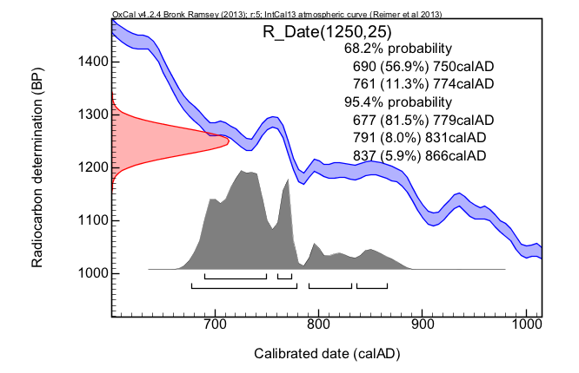
Fig. 2: Example of radiocarbon date calibration
A
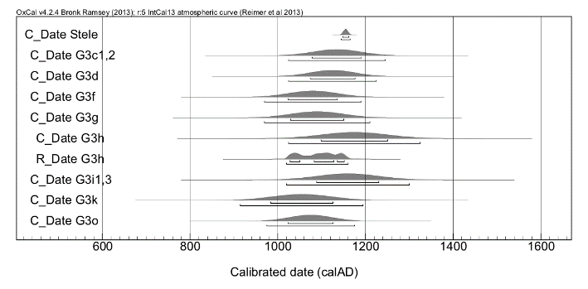
B
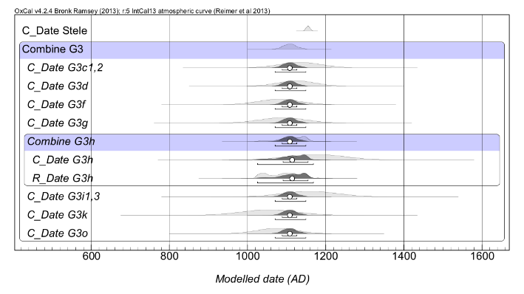
Fig. 3: A, unmodelled representation of radiocarbon and thermoluminescence dates on My-Son samples;
B, Bayesian analysis of the same dates

radiocarbon date (a Gaussian variable, red curve), which is related to the calibration curve INTCAL (the likelihood parameter, blue curve). The projection of the Gaussian variable on the calibration curve is a density curve (black curve) from which the most credible date intervals (HPD, highest posterior density regions) can be extracted. Note that the probability shape changes radically from the Gaussian initial one[2].

This approach is extremely useful when there is the need to match multiple dates and prior knowledge about a site or an artifact.
In this case, the same formal procedure is used, putting one of the collected dates as a prior information, and using the known connections between the stratigraphy layers or building phases as likelihood parameters.

A first example of this approach is the dating of the site of My-Son, a cluster of abandoned and partially ruined Hindu temples constructed between the 4th and the 14th century AD by the kings of Champa in Quang Nam Province (Central Vietnam). The available materials included 3 sets of bricks from one of the latest construction phases, and some charcoal pieces included in the brick stratigraphy (Fig.3A). A memorial stele commemorating the dedication of the temple (1155 a.D., C_Date T) gives an historical boundary. Both
Fig. 4:Logical deduction path for G3 phase dating

thermoluminescence (TL) and radiocarbon were used when possible.
The selected samples come from three different sections of the structure walls, and the archaeological question was if the masonries were contemporary or not. The ages obtained for the bricks allowed to identify three main groups: one (60%) consisted in reused material, whose dates were well before 1155 AD, the dedication year; another surely posterior to that date; the last (G3 phase) with dates in between. The components of the first group are characterized by a density distribution completely shifted on the left of the stele boundary and their date is univocally assessed before the stele foundation, suggesting a probable reuse from a preexisting structure. The components of the second group are completely shifted on its right (G4 phase, Fig.3A), stressing the possibility of restoration performed in later times. The main question regarding the samples of the third group was if they were reused or purposely made for the edification of the site.
In Fig. 3B the same results as in fig. 3A are represented, but after the application of the Bayesian statistics. The dark grey curves represent the posterior probability density distribution: it is clear that G3h has a large probability to be dated just before 1155 AD (stele), supported by a non-zero probability that comes from the radiocarbon dating of a piece of burned wood embedded in the brick paste. The similarity in the probability distribution allows to extend the production of all G3 bricks before 1155 AD (Fig. 4).

A second case regards a Neolithic site in Southern Italy. It shows how the Bayesian analysis can extract extended information on a site integrating prior hypothesis and dating. Here the information needed is not about the refining of the site chronology, as the collected samples are common wares used in everyday life during all the occupation period, and cannot represent an a priori restrain; instead, it is possible to extrapolate data about the site life span, beside the beginning and end of its occupation. For this settlement, the continuity of site 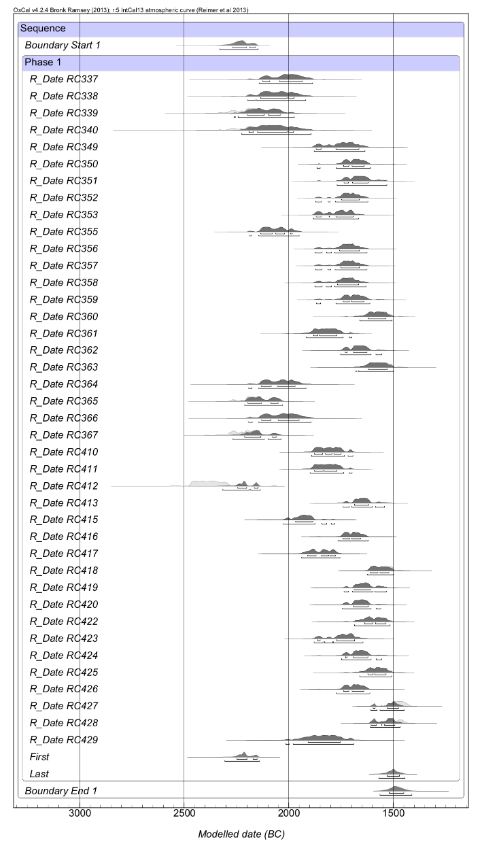
Fig. 5: Bayesian analysis of radiocarbon and thermoluminescence dates on Southern Italy samples
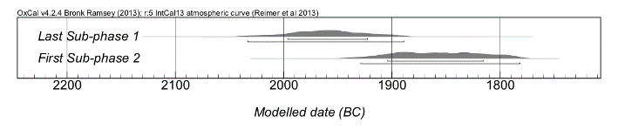
Fig. 6: Bayesian analysis of radiocarbon and thermoluminescence dates on Southern Italy samples
occupation was hypothesized. After a first analysis (Fig. 5), it was possible to identify two sub-phases, which were further modeled to find a possible hiatus between the two periods. The resulting data are showed in Fig. 6: the end of the first sub-phase and the beginning of the second are not overlapping, but there is a gap of about 100 years in the probability distribution curves. This can be a signal of a temporary site leaving, as well as of a period of crafting
A
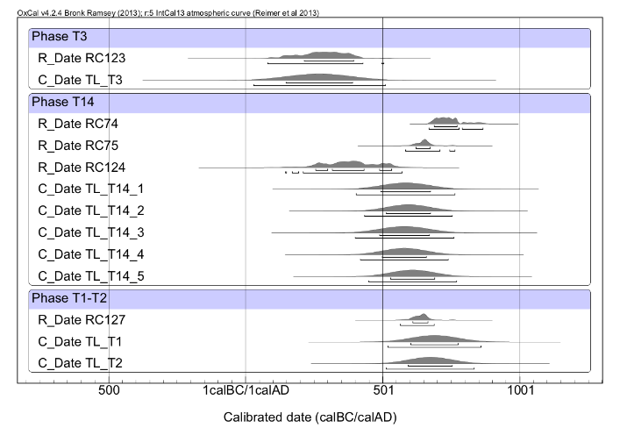
B
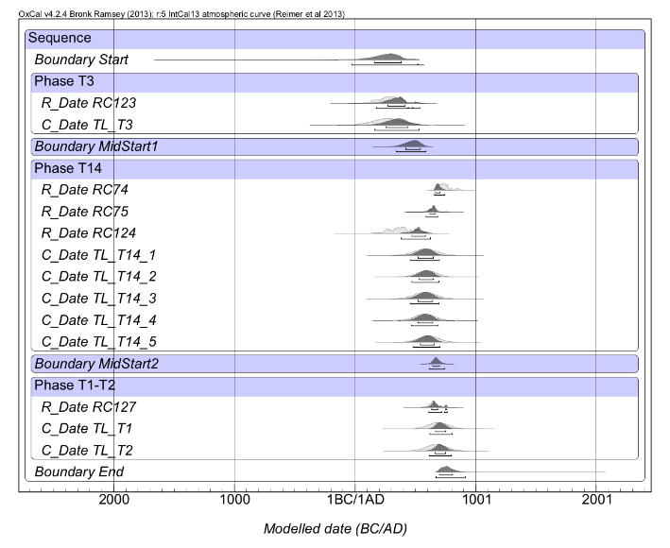
Fig. 7: A, unmodelled representation of radiocarbon and thermoluminescence dates on My-Son samples;
B, Bayesian analysis of the same dates
decadence. It is clear that such a result could have not been obtained through a rough qualitative interpretation of the results.

The last example regards the dating campaign of three burials in the archaeological site of Sipan in Northern Peru. It shows that the precision of the chronological boundaries of an event can be enhanced combining the site stratigraphy with the whole set of dating results. During this campaign, three different tombs were dated, using both TL and radiocarbon techniques. While the stratigraphic evidence clearly stated their relative temporal sequence, the archaeological request was the refinement of the absolute dating of the Warrior-priest tomb (T14). Looking at the raw results, it appears that the age of all the examined materials, given the experimental uncertainty, is practically the same (Fig. 7A). However, using the tombs relative chronologies as the main constraint the most probable period of T14 construction is severely restricted (Fig. 7B).

- discussion and conclusion

The described examples are aimed to underline the importance of a correct approach during the statistical elaboration of the results of absolute dating techniques. They are not only numbers, but a source of linked information that can be extracted imposing the right conditions and constraints. The right approach is not to put the obtained data in a supposed model, rejecting what doesn’t fit or “doesn’t sound well”; every information should be analyzed and criticized, trying to shape the historical model in a feedback process, involving physicians and statisticians in the discussion.
Furthermore, the use of all the available information in the refining process of the statistical data takes into account the uniqueness of every site, with the great advantage to take into account the uniqueness of the experimental evidences [3].
The potential of a Bayesian approach in archaeology will reach its maximum when a tight interdisciplinary collaboration between archaeologists and staticians will come true. This requires archaeologists to be comfortable in analyzing a situation and defining the archaeological problem in a realistic but not over-refined way. In wider terms, they require to communicate their ideas to statisticians speaking a “shared” language, and to explain the importance of their work in simple terms.

References

[1] G.A. Barnard and T. Bayes, "Studies in the History of Probability and Statistics: IX. Thomas Bayes's Essay Towards Solving a Problem in the Doctrine of Chances", Biometrika, Vol. 45, No. 3/4, 1958, p. 293-315.
[2] C.B. Ramsey, "Bayesian Analysis of Radiocarbon Dates", Radiocarbon, Vol. 51, No. 1, 2009, p. 337-360.
[3] C.E. Buck, W.G. Cavanagh, and C.D. Litton, "Bayesian approach to interpreting archaeological data", John Wiley & Sons, 1996.

