Multi-channel System for Remote Power Quality Monitoring
of Electricity Supplied by Public Distribution Networks

Aleksandar Nikolic¹, Blagoje Babic¹, Aleksandar Zigic¹, Nikola Miladinovic¹,
Srdjan Milosavljevic¹

¹ Electrical Engineering Institute Nikola Tesla, , University of Belgrade, Koste Glavinica 8a, 11000 Belgrade, Serbia, phone +381-11-3952029, fax +381-11-3690823, anikolic@ieent.org)

Abstract-Multi-channel system for remote power quality monitoring of distribution power stations in low and medium voltage supply networks is presented in the paper. The goal was to develop low-cost, space saving device that could simultaneously take measurements from all (usually eight or up to twelve) outgoing three-phase feeders in distribution substation. In that case, we should perform at least 3 voltage measurements and 36 current measurements at the same time. In order to save space, but not to reduce the measurement accuracy, a data acquisition system is designed based on real-time multiprocessing with microcontroller and FPGA circuit. Voltage and current measurements and their corresponding high-order harmonics are calculated using fast FPGA circuit, while other calculations (power, power factor, voltage and current phase angles, etc.) are performed in microcontroller. Further savings are obtained using multichannel analog input modules with multiplexed inputs. Communication with supervising computer is done using GPRS modem or wireless network module depending of station location. Results obtained on the developed industrial prototype confirm proposed solution.

I. Introduction

Increased demands for electricity created extensive power generation and distribution grids. Industries demanded larger and larger shares of the generated power, which, along with the growing use of electricity in the residential sector, stretched electricity generation to the limit. Today, electrical utilities are no longer independently operated entities; they are part of a large network of utilities tied together in a complex grid. The combination of these factors has created electrical systems requiring power quality [1]. Contemporary concepts of measuring instruments for monitoring power quality are based on sophisticated solutions in the field of information technology with advantages in terms of reliability, conformance, speed of operation, automatic control and management of quality on the principles of distributed intelligent measurement methods using software tools, especially virtual instrumentation.

II. Requirements for data acquisition equipment

The choice of components and equipment in the preparation of the conceptual design of the measuring system whose function is to measure and analyse the power quality is defined by the needs of distribution companies. Given the needs of distribution substations where the usual number of feeders to consumers are 8 or 12, as the demand arise solution that will allow simultaneous measurements on the (maximum) 12 feeders. In this way, in the case of an analysis of the impact of changes in consumer power quality on the part of the network that is powered from a substation could unambiguously determine the feeder with the problem. Another limiting factor is typical device dimensions [2], [3]. The device shall be mounted on the wall inside the building substation or pole-mounted transformer with pole. Also, to provide mobility, i.e. portability, device should be as small as possible just in case that it is used in a number of substations. Some problems that could arise are summarized as follows.
Three phase measurements without phase delay between phases of the same feeder as a consequence of multiplexing several analog inputs using one A/D converter are achieved by connecting each phase of one feeder to different input module. Since measurement on all modules could be initiated in the same time without delay, than all three phase currents of one feeder could be measured without phase delay between phases. Phase delay between adjacent phases as an effect of multiplexer is lower than acceptable accuracy level. Since this phase delay is constant, it could be additionally compensated in software if higher accuracy is requested. Proposed measuring principle is shown in Fig. 1, where AI denotes analog inputs (±500mV level) on 32 channel modules connected on the same data communication bus.
Figure 1. Proposed measurement principle

Measurement range is selected based on the output of split core current transformers that have 333mV rated output. Such a transformers are choosed in order to have a simple installation in the field with a opportunity to move acquisition system to another power station. Also, mV output gives possibility to directly feed signal to the acquisition system without requirements for additional signal conditioning. A way of connecting current transformers on one three-phase feeder is shown in figure 2.
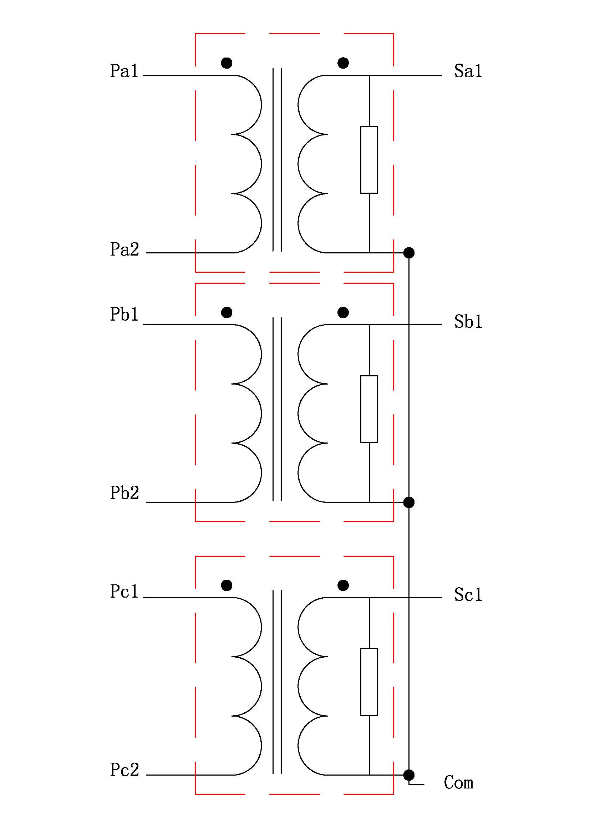
Figure 2. Connection of split core current transformers with voltage output
Due to necessity to set some parameters with a frequency at least 10kHz in order to better register voltage and current waveforms, and thus the potential disturbances to the sine waveform, it is required that acquisition software could measure values ​​in a real time. Additionally, because of the need to apply the discrete Fourier transform (DFT) to calculate the content of higher harmonics [4] of voltage and current of up to 50th order, the programmable FPGA circuits and their flexible reprogramming that enables the use of rapid calculations on a hardware level are considered [5]. Data acquisition system, based on real-time multiprocessing with microcontroller and FPGA circuit is shown in figure 3.
Figure 3. Block diagram of multiprocessor data acquisition system (left) and a measurement principle (right)

III. Laboratory prototype

In order to check the functionality and accuracy of the system, at first a laboratory prototype is developed. It is based on data acquisition USB card and electronics card that simulates three-phase system [6]. This specialy developed card have two inputs connected to data acquisition card used for simulating voltage and current. In order to have three voltage and three current signals at the output, electronics card uses phase shifters to provide additional signals with 120° phase difference. This card needs external power supply of ±15VDC.
Proposed multi channel power quality acquisition system is built up using programmable controller NI cRIO 9076 with 4 modules, one 230VAC three channel voltage measurement module and three 32ch voltage analog input modules. The same controller configuration is used for industrial prototype.
On the following figure the complete laboratory setup is shown. Electronics card that emulates three phase system is placed on the top of DC power supply.

Electronics for emulating three phase system
USB daq
Controller
Figure 4. Laboratory prototype
IV. Developed software

Real-time application, developed in LabVIEW with Real-time and FPGA options, is consist of three parts and it is the same both for laboratory and industrial prototype. This approach provide possibility to test every aspect that could be occurred in the real system, while reducing time for final tunings of software.
The first part of application shows measured or simulated input voltages and currents per feeder, phasor diagram, phase angles and calculated power (active, reactive and apparent) and power factor. It is also possible to get accumulated values (Power Usage) in Wh/kWh/МWh. This part of application is shown in figure 5.

Figure 5. First part of real-time application

The second and third part of application are indicated as Vh and Ah, respectively. Both parts are devoted to high-order harmonics of voltages (Vh) and currents (Ah) shown in tables, with clear indication if values exceeds limits defined in standard [7], [8]. Also, a total harmonic distortion (THD) are shown both for voltage and current, with color signal indicating higher values from limits (8% for voltage and 12% for current). These two parts of application are shown in next two figures.

Figure 6. Voltage high-order harmonics

Figure 7. Current high-order harmonics

V. Results and analysis

In order to check proposed multichannel power quality measurement system, at first a test signal of 230VAC 50Hz is used (pure sine signal). In that case we could easily verify correct calculations in software. Next, test signal is superimposed with harmonics (100, 150, 200, 250, 300, 350, 400, 450, 500, 1200 and 1250 Hz) of 10V amplitude. Obtained signal is shown on the next figure. It could be observed that total harmonics distortion is higher than permissive value from standard [7]. On the bottom diagram a Fast-Furier transformation of the signal is shown. Several values of high-order harmonics that exceeds limits are indicated as FAILED in the table shown in figure 8.

Figure 8. Results of the measurements using test signal with superimposed harmonics

Obtained results shows correctness of the proposed method. Also, developed part of the system based on FPGA provide fast, real-time calculations on several channels. That enables power quality analysis on 12 channels simultaneosly, what is a merit of proposed system and also requirement of distributor operator is fulfilled.
VI. Conclusions

One solution for solving requirements for simultaneous multi-channel power quality measurement in distribution networks is presented in the paper. It is shown that using state-of-art FPGA technology and properly configuring real-time software computationally intensive tasks like DFT of signals with harmonics up to 50th could be solved. Furthermore, with proposed measurement arrangement it is possible to measure simultaneously up to 32 feeders or 96 currents along with 3 voltages, while device dimensions are still less than required 500x500x200mm (WxHxD) and 5kg. In this case mobility requirements for measuring system are also retained.

References

[1] C. Sankaran, Power Quality, CRC Press LLC, Florida, 2002.
[2] Chen, S.; Zhang, C.L.; Liu, Y.Z., "A multi-channel monitoring system for system-wide power quality measurements," Power System Technology, 2000. Proceedings. PowerCon 2000. International Conference on , vol.2, no., pp.953-958 vol.2, 2000.
[3] Lee, R.P.K.; Lai, L.L.; Tse, N., "A Web-based multi-channel power quality monitoring system for a large network," Power System Management and Control, 2002. Fifth International Conference on (Conf. Publ. No. 488) , vol., no., pp. 112-117, 17-19 April 2002.
[4] J. Arrillaga, N.R. Watson, Power System Harmonics, John Wiley & Sons, Ltd, New Jersey, 2003
[5] N. Kehtarnavaz, S. Mahotra, Digital Signal Processing Laboratory: LabVIEW-Based FPGA Implementation, BrownWalker Press, Florida, 2010
[6] Cuk, V.; Nikolic, A.; Zigic, A., “A Development System for Testing Integrated Circuits Used for Power and Energy Measurements,” in Proceedings of 13th International Power Electronics and Motion Control Conference EPE-PEMC 2008, pp. 1426-1431, Poznan, Poland, September 2008.
[7] Power Quality Standard EN 50160:2010, Voltage characteristics of electricity supplied by public electricity networks, 2010.
[8] Nikolic, A.; Naumovic-Vukovic, D.; Skundric, S.; Kovacevic, D.; Milenkovic, V., “Methods for power quality analysis according to EN 50160,” in Proceedings of the 9th International Conference Electrical Power Quality and Utilization EPQU 2007, pp. 1-6, Barcelona, Spain, October 2007.

