Measuring system and power management of the Guanay II AUV

Ivan Masmitjà, Julián González, Gerard Masmitjà, Spartacus Gomáriz, Joaquín del-Río-Fernández

SARTI Reserch Group, Electronics Dept., Universitat Politècnica de Catalunya (UPC), Rambla Exposició 24, 08800, Vilanova i la Geltrú. Barcelona. Spain +(34) 938 967 200. www.cdsarti.org
Abstract- This paper presents a measurement system and energy management for Guanay II autonomous underwater vehicle (AUV). The system performs the measurement, monitoring and control of the state of charge of the batteries, allowing simultaneous charging of all batteries from outside of the vehicle, and a wireless connection/disconnection mode. Considering the type of batteries used in the vehicle, it is used the current integration as methodology for measuring the charge level of the battery. Laboratory and vehicle navigation tests performed have validated the correct operation of the system and the reliability of the measured data. These data are sent to the mission control of the vehicle in order to optimize and guarantee its navigation.
Keywords– state of charge, batteries, AUV, Ni-Cd
I. Introduction

The AUV Guanay II [1] is a vehicle developed by SARTI group of Technical University of Catalonia with the objective of providing a platform for measuring oceanographic variables, such as temperature and salinity of the water column, with a high simultaneously spatial and temporal resolution. The knowledge of the charge status of the batteries in an autonomous vehicle is an important factor to ensure security of the vehicle and mission.

This work presents a measurement system and energy management for Guanay II vehicle. Initially it is analyzed different solutions for electrically measuring the batteries charge state, and it is chosen the methodology of current integration [2] due the nature of the batteries used in the Guanay II. Subsequently, it is presented the construction of a prototype and the experimental tests performed both in laboratory and field missions in order to validate the correct operation of the device. Finally, this device is complemented with a design of a battery charger system, accessible from outside the vehicle, which allows simultaneous charging of all battery packs, and with a wireless connection-disconnection of the battery.

II. Measurement system for battery state of charge

Several methods of estimating the state of charge (SOC) of a battery have been used. Some are specific to particular cell chemistries. This work is subject to the use of Ni-Cd batteries that are in Guanay II. For such batteries there are different methods of measuring the charge, such as the measurement of voltage, impedance and the current integration.

Voltage based SOC estimation uses the voltage of the battery cell as the basis for calculating the remaining capacity. Results can vary widely depending discharge rate and temperature and compensation for these factors must be provided to achieve a reasonable accuracy. The figure 1 shows the relationship between the voltage and the capacity at different discharge rate.

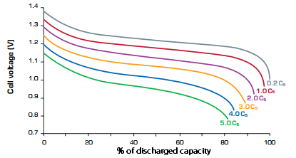

Figure 1. Relationship between the voltage and the capacity at different discharge rate. Source: Saft batteries [7].
Other problem is the rapid fall in cell voltage at the end of the cycle in low discharge rates. In the other hand, this fall in voltage could be used as an indication of imminent, complete discharge. For this reason this is not the best method for estimate the SOC of Ni-Cd batteries, but can be used as an indicator of complete discharge battery, half-charged battery or full-charged battery [3].

Internal impedance measurements can also be used to determine SOC however these are not widely used due to difficulties in measuring the impedance while the cells is active as well as difficulties in interpreting the data and requires very complex calculations [4] and [5].

Current based SOC estimation, known as coulomb counting [2], which is currently selected, calculates the state of charge by measuring the instantaneous current of the battery and integrating in time, both in the process of charging and discharging. The reason for using this method is due to the obtaining a good correlation in the measure and to the fast implementation because the existence of a specific IC. This allow us a rapidly prototype development that can be used to estimate the battery remaining charge in Guanay II and to perform some field tests. In its implementation we have used the bq2013 IC (a Gas Gauge IC for Power-Assist Applications) from Texas Instruments Company, specifically designed for Ni-Cd batteries. The prototype developed is shown in Figure 2, where the communication ports with the PC-104 and visual indication LEDs can be seen. This IC includes a simple single-pin (HDQ plus return) serial data interface with command-based protocol. For this reason a RS-232 to HDQ interface has been developed to communicate both gas gauge and PC-104 systems[6].

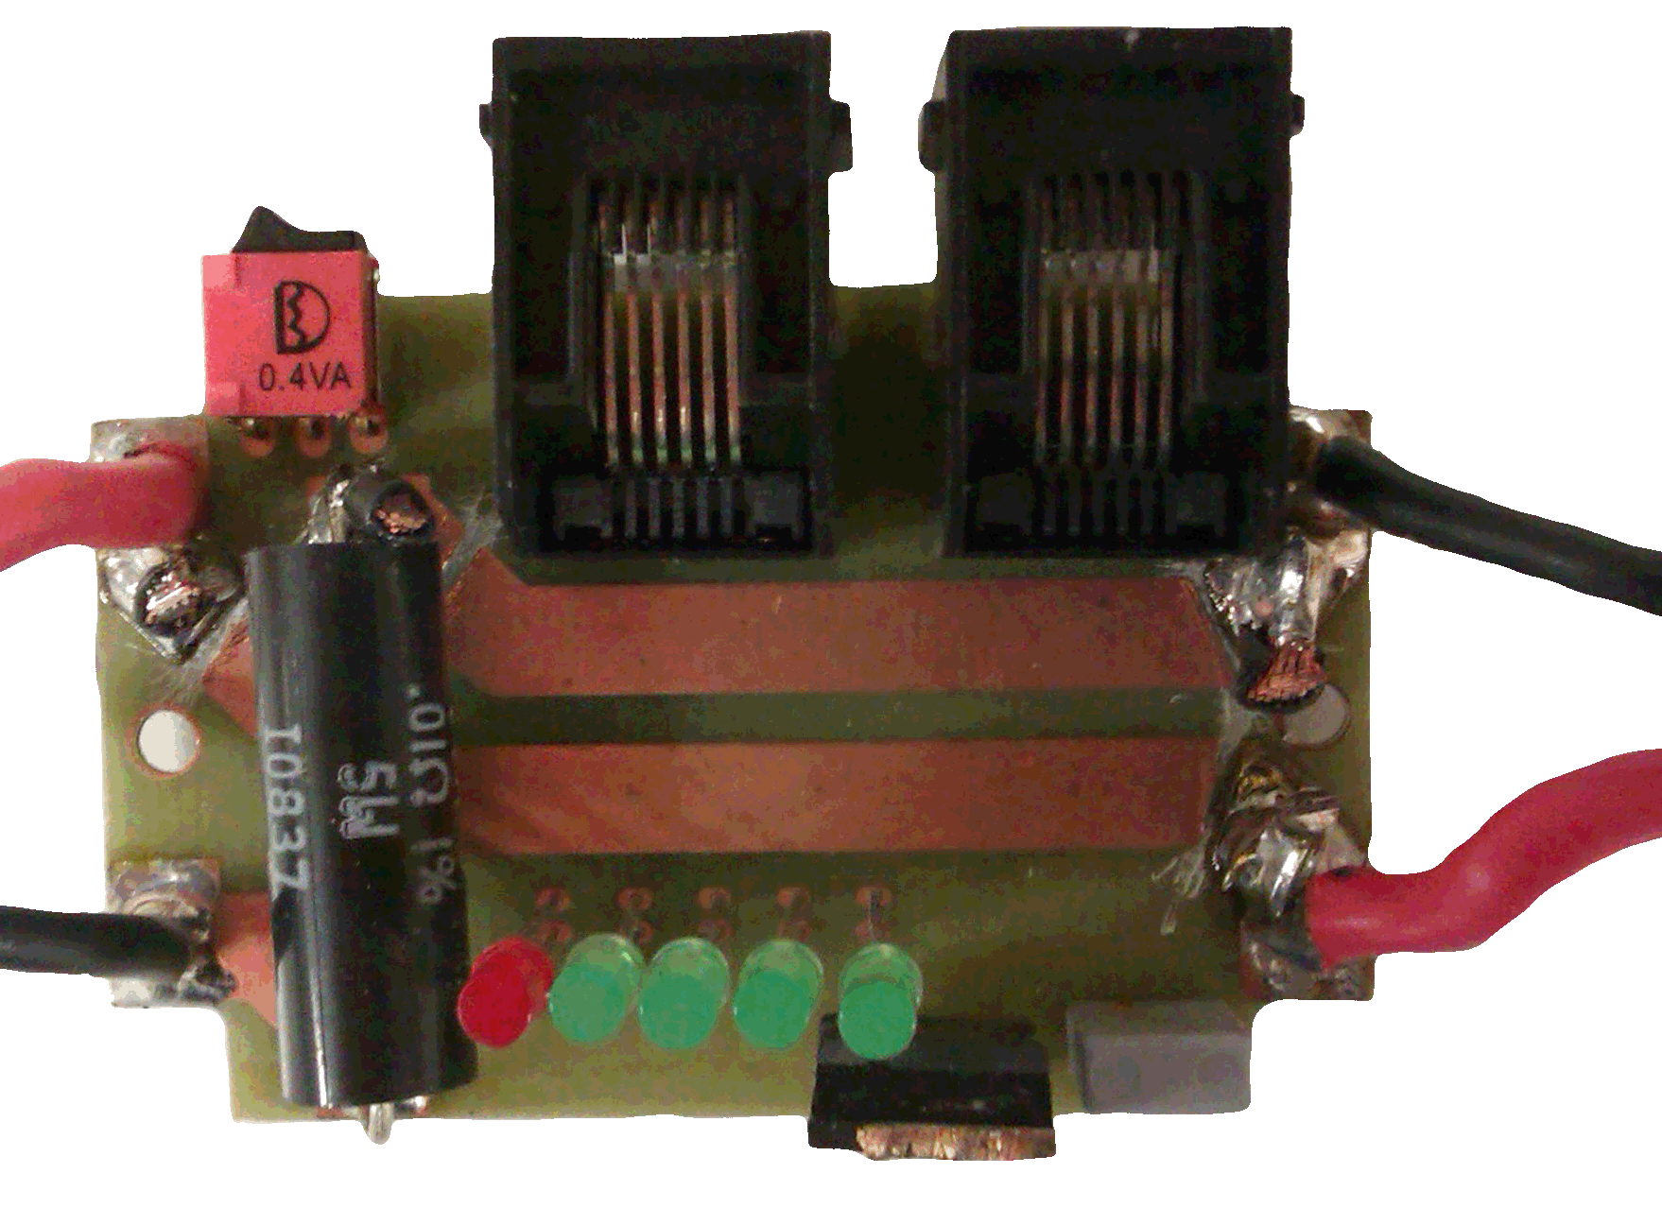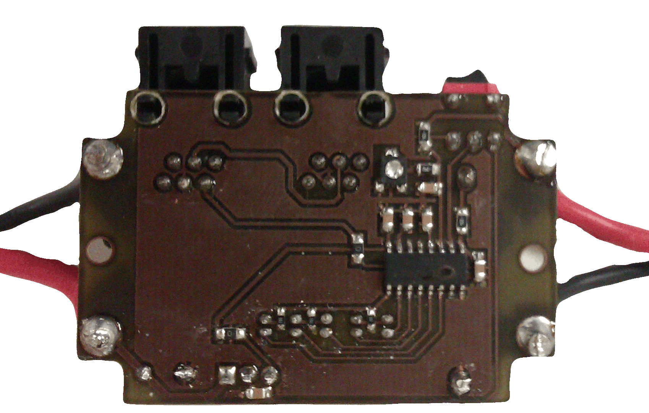
A
B

Figure 2. State of charge measuring prototype. A) Top view. B) Bottom view.

Texas Instruments provides the expression (1) to obtain the value of the internal register NAC (Nominal Available Capacity) of bq2013 IC, which monitors the voltage drop across a resistor connected in series between the battery and ground. The NAC value depends on the capacity of the battery and determines it’s charging and discharging, therefore, consumption can be calculated from the expression (2).

$NAC \left(mVh\right)=Batterycapacity \left(mAh\right)*Sense resistor \left(Ω\right)*Scale$ (1)

$Consumption \left(A\right)=\frac{ΔNAC (mVh)}{Δt(s)}*\frac{3600}{640*1000*0.01}$ (2)

III. Charging system and battery connection

The energy of Guanay II comes from 2s3p batteries packs that can provide 24 Vdc and 21 Ah. However, this configuration of the packs makes a problem when it is the time to charge. Many manufacturers don’t recommend charge two batteries pack in parallel because can damage it, especially in high charge rates. Until now, a type of chargers that can only charge a single pack were used, but the vehicle must be opened every time. In order to maximize the mission time a system was designed for simultaneous parallel charging of all battery packs through a single external connector. The location of this single point for charging allows avoiding disassembles the mechanics or electronics of the vehicle to access it and it speeds up the operation. After contact with batteries manufacturer, has been decided use a low rate constant voltage charge applied to all the 2s3p batteries pack to prevent damages. Figure 3 shows a schematic model of this system.

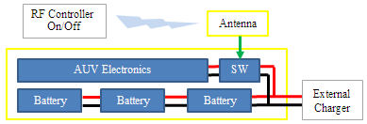

Figure 3. Scheme of charging system and battery connection
In order to have control and easy access to the battery connection/disconnection to electronics and propulsion of the vehicle, it has been incorporated a wireless device that acts as a switch. By having access to the switch through radio frequency, operation enables the connection or disconnection of the batteries in the water, obtaining greater security in vehicle. A HIR6-433 RF AM 433 MHz receiver/decoder from rfsolutions has been used for this purpose. And a new antenna with epoxy resin has been designed to allocate it and provide the necessary protection in the water and in the depth. Figure 3 shows a schematic model of this system.

IV. Experimental Results

Initially the both systems, the connection/disconnection the battery and his charging and SOC estimation has been tested in the laboratory, where was verified the proper functioning of all systems designed. For example, several processes of simultaneous charging of all the battery packs have been monitored and completed successfully. Figure 4 shows the current of the three packs of batteries during his charging in parallel mode. In this picture can observe that after 10 hours of charge the current drops to 0.15A and battery is practically charged. Also, can be seen the difference of the current charge in one of the packs, this is one reason for is not recommended the high rate currents charge in order to prevent damages.

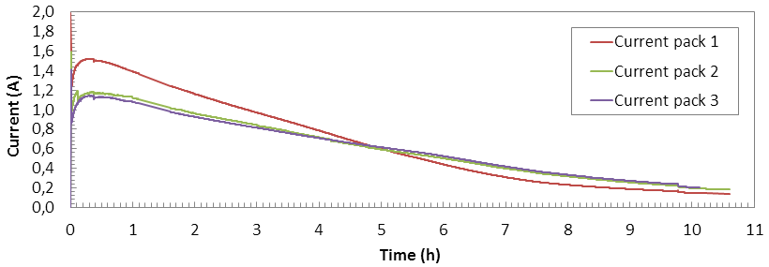
Figure 4. The current of the three packs of batteries during a low rate charge in parallel.

In the other hand, figure 5 shows power consumption of Guanay II. Blue line represents the current from the sensor bq2013, red line is the real current measured with ammeter and green line is a filtered estimate current from bq2013. For this laboratory experiment has been used a bank of five loads in parallel. Each load of 18 ohms introduces a 433mA of consumption current. Results have been compared with manufacturer equations (2) and can observe the correlation between both.

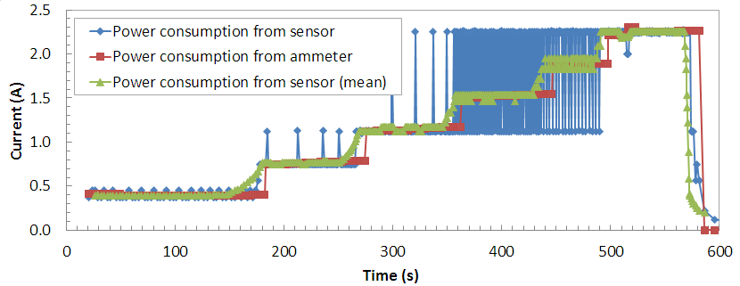
Figure 5. Power consumption from Guanay II. It has been used different loads to estimate the current based NAC register from SOC IC. Blue: Power consumption from sensor using equation (2). Red: Real power consumption from ammeter. Green: filtered graphic blue.

Observe that using Nominal Available Charge (NAC) register from IC bq2013, it is possible to estimate the power consumption from Guanay II. Figure 6 shows a real test field.
Afterwards, these systems have been validated in various vehicle navigation tests. Figure 6 shows the instantaneous battery consumption due to the action of the propulsion engine and two direction motors of the vehicle during a path on the water. These tests also confirmed that disconnecting the batteries when the vehicle is still in the water provides security at its landing ground.

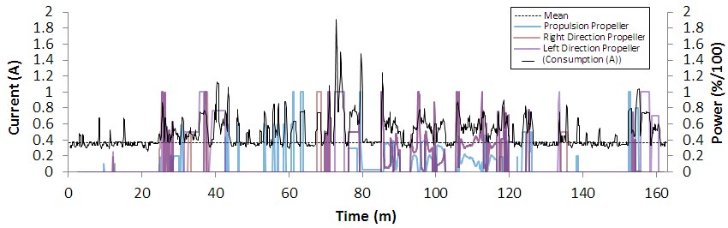

Figure 6. Consumption of the vehicle versus power of the propellers

IV. Conclusions

A system has been designed for measurement and energy management for an underwater vehicle. The system monitors the state of charge of the batteries and the instantaneous consumption of the thrusters, information that control mission needs to optimize and facilitate navigation. A single external access connector in the vehicle allows charging of all batteries and a radio frequency controlled switch makes the connection or disconnection of the vehicle power, even in the water. The navigation tests performed confirm a proper system operation and reliability of the measured data.

Acknowledgment
This work was supported by the Spanish Ministry of Economy and Competitiveness under the research project: “Sistemas Inalambricos para la Extension de Observatorios Submarinos” (CTM2010-15459).

References

[1] S. Gomáriz, J. González, A. Arbos, I. Masmitja, G. Masmitja, J. Prat. "Design and construction of the Guanay-II Autonomous Underwater Vehicle". Oceans 2011 IEEE/OES. Santander, Spain. June 2011.
[2] F.Codecà, S. M. Savaresi, V. Manzoni. “The mix estimation algorithm for battery State-of-Charge estimator – Analysis of the sensitivity to measurement errors” in Join 48th IEEE Conference on Decision and Control and 28th Chinese Control Conference Shangahai, P.R. China, December 16-18, 2009.
[3] M. Gonzlaez, M.A. Perrez, J.C. Viera, C. Carballo, A. Garrido. “A new, reliable and easily implemented NiCd/NiMH battery state estimation method”. Instrumentation and Measurement Technology Conference, 1999. IMTC/99. Proceedings of the 16th IEEE. Page(s): 1260 – 1264 vol.2
[4] N. Kato, K. Yamamoto. “Estimation of the capacity of nickel-cadmium batteries by measuring impedance using electrolyte-deficient battery characteristics” Telecommunications Energy Conference, 1995. INTELEC ’95. 10.1109/INTLEC.1995.499046
[5] I. Damlund. “Analysis and interpretation of AC-measurement on batteries used to assess state-of-health and capacity-condition” Telecommunications Energy Conference, 1995. INTELEC ’95. 10.1109/INTLEC.1995.499055
[6] Texas Instruments. “HDQ Communication Basics”. Application Report. SLUA408A – December 2006 – Revised September 2008-
[7] Saft Batteries. http://www.saftbatteries.com/Technologies_Nickel_NiCd_293/Language/en-US/Default.aspx. May 2013

