Programmable power spectral density noise source

L. Angrisani, M. D’Arco, E. Napoli

Dep. of Electrical and Information Technologies Engineering
University of Naples ‘Federico II’
via Claudio 21, 80125 Napoli, ITALY
Phone: +390817683237, Fax +390812396897,
Email: angrisan@unina.it, darco@unina.it, etnapoli@unina.it

Abstract- Operation and effectiveness of most electronic systems is strongly affected by their noise rejection capability. The performance they exhibit in the presence of noise is therefore assessed since the early production stage, as well as routinely during periodical maintenance actions. To carry out appropriate tests suitable noise sources are needed. Actually, only white noise sources are widely available on the market; generators capable of producing colored noise are instead very unusual. In theory, ordinary arbitrary waveform generators could be used, once suitably programmed to serve as noise sources. But, test and measurement technicians charged barely find application notes that support them in taking this step. The paper gives relevant remarks concerning the simulation of colored noise, and proposes an analog generator that exploits an arbitrary waveform generator as noise source. The proposed generator is capable of producing noise signals characterized by structured spectral patterns.

I. Introduction

Noise has been extensively studied during the twentieth century. The first model introduced to describe its randomness is the white noise model, which is, at present, widely used to examine the behaviour of most electronic systems. Many analog white noise sources can be found on the market, and dedicated instruments, capable of assessing the performance of electronic devices, components and systems in the presence of this kind of noise, are currently realized and marketed.
Many natural phenomena, however, produce a different kind of noise, commonly referred to as colored noise [1],[2], which exhibits dissimilar characteristics with respect to those peculiar to white noise. Due to the complex mechanisms behind colored noise, and especially to the most recently discovered ones, practical descriptive models are not available yet. Consequently, the synthesis of digital noise signals with features concurring with targeted ones, which is precious for simulations, is not a straightforward task. This problem makes the successive generation of the noise in analog form even more difficult [3]-[6]. The use of colored noise, in fact, appears only in theoretical approaches; it is not common in experimental tests because of the superior complexity of a colored noise generator [7]-[9].
The paper presents a suitable approach for synthesizing digital signals that represent colored noise, and provides practical guidelines for the design of a programmable power spectral density (P-PSD) noise generator, which allows the user to choose the power spectral features of the noise he wants to produce.
This type of generator can be utilized anytime the equipment under test has to be stimulated by a signal with power residing in assigned frequency intervals. Its main applications consist of: noise sensitivity analysis, characterization of sensors and actuators, and identification of linear and time invariant systems. As an example, the proposed generator can be used to test the capabilities of radio cognitive systems to discriminate between fake and authentic communications: the noise stimuli characterized by a structured spectral pattern mimic the transmission channels exploited by the digital telecommunication systems using noise-like signals.

II. Noise sources remarks

a) Noise applications
Noise sources are regularly employed in several applications such as: the measurement of the frequency response of linear systems, the measurement of noise figures, the functional test of microwave and optoelectronic links.
For instance, very fast full frequency response measurements can be gained using thermal noise, which is characterized by a flat spectrum that agilely spans whichever band of interest. Whereas using noise sources in conjunction with a calibrated instrument allows the measurement of noise figures of delicate equipment, such as mixers or receiver front ends: measurements are performed directly on the wafer of the semiconductor device in order to reduce path losses and reflection coefficients by exploiting connections that are prearranged by the designers of the integrated circuit. Radar and digital communication links are intermittently verified by means of built-in noise sources that are activated during off-times [10]. Alternatively, the noise is superimposed to signals including modulated data to perform measurements also during on-times. Such measurements mainly address the bit error rate (BER) curves of both the digital receivers adopted by CDMA telephony systems and WiFi wireless LAN [11],[12]. Finally, data transmission capabilities of optoelectronic systems through fiber cables require instead the use of a noise source in conjunction with phase modulators and oscillators to produce jitter in timing signals.
Furthermore, noise sources play an interesting role also in the enhancement of analog-to-digital converters performance [13],[14] and in data encryption applications [15].
Noise permits to enhance the linearity and the dynamic range of high-speed digital-to-analog converters by means of dithering [16],[17]. Dithering consists in adjoining noise characterized by spectral contents residing outside the band of interest and proves effective to smooth the spurs due to poor linearity. It is performed by means of simple circuits which are essentially small surface mount diodes acting as analog noise generators. For advanced encryption applications, robust random occurrences of digital codes can be produced by sampling a voltage generated by a real noise source [18]. These codes require much more efforts to be cracked by hackers with respect to the pseudorandom codes produced by calculus schemes.

b) Noise metrics
An exhaustive characterization of noise can be gained by measuring its power spectral density (PSD). Despite the PSD of any random process, such as noise, is defined as the Fourier transform of its autocorrelation function, it is usually gained through practical and straightforward estimators. In particular, it is measured by means of spectrum analyzers or FFT-based instruments, which provide the Fourier transform of a portion of the noise. It is worth noting, however, that the aforementioned estimator can be adopted only in the presence of white noise, while it produces biased results when applied to colored noise; even the calculation of scalar metrics such as the mean square value of the process could be not realistic in the presence of colored noise. Actually, the use of FFT Analyzers to measure noise spectral features is critical because they suffer from spectral leakage, which can be controlled only in the presence of repetitive signals, i.e. signals characterized by a discrete number of sinusoidal components. In these cases, coherent sampling or, alternatively, windowing can be used to counteract spectral leakage and obtain correct estimations of the magnitude of each component. Specifically, to get rid of spectral leakage, coherent sampling requires the acquisition and processing of a record of points including an exact number of cycles of the input signal; windowing instead provides the necessary tolerance for accurately measuring the magnitude of spectral components by reducing the broadband leakage at the expense of narrowband one. Unfortunately, in the presence of noise, there are no means to counteract spectral leakage, because neither coherent sampling condition exists, nor windowing would be effective: any trade-offs between broadband and narrowband spectral leakage would not compensate bias effects.
At the state of art, the most advanced solution to evaluate the spectral features of noise signals relies on the use of Welch’s averaged, modified periodogram method. Welch method is an FFT-based approach that involves averaging the results attained for partially overlapped segments of the input signal; averaging should mitigate bias effects and improve measurement accuracy and repeatability.
As an alternative to power spectral density measurements, scalar noise metrics such as noise factor (NF), equivalent noise temperature (T_{e}), noise power (P_{n}), excess noise ratio (ENR), etc. are utilized to characterize noise and its effects.

c) Noise with a given PSD
Different techniques to synthesize discrete-time colored noise sequences have been proposed in the recent past. The proposed one is not original in its basic approach because it derives colored noise according to a general and well-known technique, namely, by filtering white noise with a linear and time invariant filter. The underlying theory is well known: the power spectral density of the output noise is shaped by the frequency response of the adopted filter. For input noise characterized by a uniform power spectral density, the PSD of the output noise coincides with the squared modulus of the filter frequency response. Therefore, to obtain a discrete random signal y(n) with a pre-assigned real power spectral density S_{yy}(ν), the input white noise w(n) is chosen as to have a unitary power density S_{ww}(ν), and the frequency response H(ν) of the adopted filter as to satisfy:
$\left|H\left(ν\right)\right|=\sqrt{S_{\text{yy}}\left(ν\right)}$ (1)
Specifically, the proposed generator relies on the use of a filter with finite-impulse response. The user describes the shape of the frequency response of the filter, H(ν), through a frequency sampling approach. The user designs the filter specifying the number of coefficients of the filter, the bandwidth B in which he wants to confine the noise, and two short arrays of equal length: a frequency array, F, and a magnitude array, M. The frequency array contains in ascending order frequency values within (0, 1) that are normalized values with respect to the bandwidth B. The magnitude array expresses the gain of the filter at the normalized frequency values given in F. The short arrays typically contain a small number of elements, much less than the number of coefficients that the user may require to match precision goals. They serve to describe in a schematic way the desired PSD. The shape of the frequency response of the filter is then calculated through linear interpolation between the gain values defined in the magnitude array for a number of normalized frequencies equal to a half of the selected filter length. Also, the phase response β(ν) of the filter cannot be arbitrarily chosen but has to satisfy the constraints of physical realization. As a rule, a linear phase response that introduces a relevant amount of delay can assure the physical realization and can also avoid the use of complex arithmetic for the synthesis of the noise.
The procedure to synthesize the discrete-time noise with an imposed power spectral density can be definitively summarized as:
- selection of the number of coefficients, 2L, of the shaping filter;
- choice of the bandwidth B that the power spectral density of the noise should occupy;
- definition of the frequency and magnitude arrays, F and M, that specify the power spectral density of the target noise within the chosen bandwidth;
- calculation through interpolation of the L-sequence of the frequency response of the filter, {H(0), H(1/L), H(2/L), ... H(L/2L)}, i.e. the values for the normalized frequency values, ν, within the interval (0, 1/2);
- multiplication by -1 of the samples of the aforementioned L-sequence corresponding to odd normalized frequencies, H(1/L), H(3/L), H(5/L), …; this operation confers to the filter the linear phase response:
$−jβ\left(ν\right)=−jπ2Lν$ (2)
- specification of the filter H(ν) in terms of the 2L-sequence {H(0), H(1/L), H(2/L), ... H(2L-1/2L)} which gives the frequency response for normalized frequency values ν within the interval (0, 1). To this end the available L-sequence is prolonged trough mirroring preserving the Hermitian symmetry of the frequency response: samples at normalized frequencies (L + i)/2L must have the complex conjugate values of those at normalized frequencies (L - i)/2L, i ranging from 1 to L-1.
- calculation of the impulse response of the filter, h(n) through the inverse discrete Fourier transformation of the aforementioned 2L-sequence.
As commentary, it is worth nothing that:
- the proposed filter is characterized by a frequency response expressed by coefficients which are all real numbers: no complex values are processed;
- the filter, being a finite impulse response filter, is inherently stable, thus the output never diverge;
- the causality of the filter is granted at the mere expense of an output delay: the first output sample is available after L input samples;
- the sample rate related to the obtained noise signal is exactly twice its bandwidth.
The design of the filter could be optimized by windowing the obtained impulse response with an opportune window. There are many types of window such as: Bartlett, Blackman, Bohman, Chebyshev, Gaussian, Hamming, Hanning that could effectively work to the purpose. Anyway, it is not convenient to perform optimization at this level, because when the discrete sequence is played in order to produce the analog noise signal, the features of the synthesized noise are unavoidably modified, as it is illustrated in the next Section.

III. Stepping onward analog noise generation

In order to realize a programmable power spectral density (P-PSD) noise generator, i.e. a noise generator that allows the user to specify the features of the output power spectral density, an arbitrary waveform generator can be exploited. As well known, arbitrary generators read from a waveform memory a stream of digital data that is given in input to a digital-to-analog converter (DAC) [19]-[23]. The DAC operates as a clocked zero-order-hold circuit, hence the digital noise signal should appear as a piece-constant waveform; in other terms the generator keeps constant any voltage level for a time interval equal to the duration of the clock period, and at the occurrence of the clock pulse performs a step change of the output voltage. To highlight these effects several simulations have been performed utilizing 100 points for representing each voltage level kept constant by the DAC. Due to the abrupt step changes, aliases of the spectral contents of the analog output are expected to appear in the frequency intervals adjacent to the band of interest and centered at multiple values of twice the selected bandwidth B.
To counteract the undesired effects of aliasing, which are inherent to the use of a zero-order hold circuit, the use of smoothing analog filters is regularly considered. All arbitrary waveform generators are equipped with one or, in the case of more expensive models, a few internal low-pass filters, which can be selected according to the particular waveform to be played. When the noise is filtered, the step changes in the output voltage are smoothed and exhibit a finite rise time. The transient that characterizes the voltage change depends both on the type and the parameters of the filter. Since the number of available filters inside the generator cannot satisfy every need, the smoothing effect can often be poor. The result is that, despite the attenuation, the distortion effects witnessed by the aliases can be either inadequate or so significant to adversely affect the power spectrum of the signal.
To gain satisfying performance, the user should use an external filter specifically designed to match the features of the signal that he intends to play. This approach can, however, be very expensive. On the other hand, the use of hand-made filters manufactured in laboratory through printed-circuit-boards connection of discrete components can lead to poor results.
To enhance the integrity of the noise signal, the piece-constant waveform should be played imposing a generation frequency much greater than the related Nyquist frequency. This approach represents a simple and promising solution that also simplifies the work of the low pass filter in smoothing the abrupt voltage steps. The available filter becomes more effective because its intervention is now addressed to a kind of refinement.
In order to increase the generation frequency without modifying the power spectral density of the signal, appropriate interpolation algorithms are deployed. The interpolation should grant uniform gain within the bandwidth in which the noise is assigned, and a fast decaying frequency response in the transition bandwidth. Nonetheless, the computational burden of the interpolation should be thoroughly limited in order to grant real-time processing execution in the generation chain. To this end the discrete noise sequence is first upsampled, i.e. prolonged by inserting a given number of zeros between each couple of samples; the number of zeros inserted between adjacent samples is equal to UpF-1, being UpF the upsampling factor. The prolonged sequence is hence convolved with an opportune interpolating window in order to obtain the interpolated version of the noise. The choice of the type and length of the window should satisfy a trade-off between the accuracy of the spectral features of the noise and the cost required to the processing task. The time necessary for interpolation depends on the processing capabilities of the processor inside the generator, the length of the interpolation window, and the required generation frequency.
Figure 1 shows three power spectral densities traces: trace A is the power spectral density of the original noise, trace B the noise upsampled by UpF = 10 and interpolated with a Chebyshev window of length equal to 4UpF, trace C the noise upsampled by UpF = 10 and interpolated with a Chebyshev window of length equal to 3UpF. It highlights the benefits that should be expected when the described processing is performed; in particular, the interpolation window plays a chief role, being capable of significantly reducing the distortion effects. The performance of the interpolation window increases with the length of the window; on the other side a longer interpolation window is more demanding in terms of computational capabilities and can be not compatible with real-time processing constraints.
The work of the analog output filter should further improve the coherence between the expected output power spectrum and the reproducible one.
Figure. 1. Portion of the spectrum of the noise signal; the simulations show that in the generation the expected spectrum is replicated at a pace equal to the adopted clock rate.

VI. Experimental set-up

In order to confirm the results of the simulations shown in the previous section an experimental set-up has been arranged and some experiments have been carried out. In detail, the experimental set-up has included an RF vector signal generator (Agilent E4438C ESG), equipped with a 14 bit digital to analog converter (DAC) capable of functioning with a clock rate up to 100 MHz, and a spectrum analyzer (Hewlett Packard 8594E).
The vector signal generator can play RF signals that combine I and Q baseband modulating signals, which can be created by means of the internal 14 bit DAC. For the sake of clarity, both I and Q component of the modulated RF signal can be arbitrarily defined by the user. I and Q data points have to be created in a binary format, that is signed 2’complement 2-byte integer values in the range (-32767, +32767), big endian byte order. Then the I and Q data points have to be interleaved in a single array in order to create a data waveform that has to be successively downloaded to the local memory of the generator via ftp using the internal generator web server.
In the experimental tests, only the baseband section of the vector generator has been exploited. In particular, the synthesized noise has been assigned to the I component, and a zero Q component has been inserted to complete the data waveform. Then, the analog version of the I component played by the internal DAC has been picked-up at the auxiliary I/Q output connector. It is worth noting, however, that for applications that require noise residing in a radio-frequency band according to given patterns, it is sufficient to synthesize the baseband version of the noise and use a single sideband (SSB) modulation approach to transpose it at RF frequencies.
The digital sequence of the simulated colored noise has been properly formatted and downloaded to the arbitrary waveform generator as I components. For the purposes of the test very long sequences made up of 16384 kBytes have been adopted. The noise has been spread in a bandwidth B = 5 MHz, and hence played with a generation frequency equal to 10 MHz. Successively, also the noise signal obtained after upsampling by UpF = 10 and interpolation with a Chebyshev window of length equal to 3UpF has been downloaded and played, this time using a generation frequency equal to 100 MHz. Both signals have been picked up at the baseband I output connector and measured by means of the spectrum analyzer. Figure 2 a) and b) show respectively the power spectrum of the two versions of the noise in the frequency range (10 kHz, 20 MHz). The benefits assured by the proposed approach and already highlighted through simulations are proved also by the experimental tests that confirm the significant reduction of the power spectral leakage outside the band of interest, obtained without any intervention of low-pass filters.
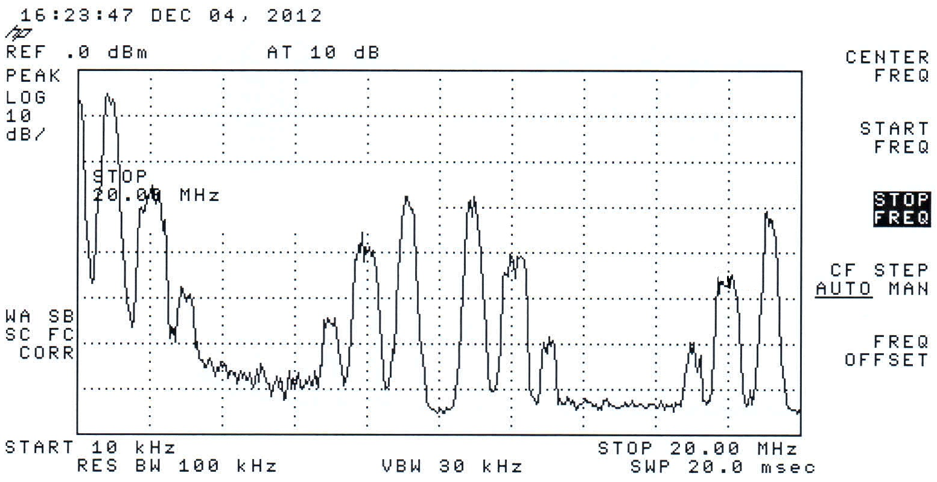
Figure 2a. Power spectrum of the noise signal affected by spectral leakage caused by the inherent functioning of the DAC that is used to play it in analog form (In the test the output low-pass filter of the generator has been disabled in order to evaluate the entity of the distortion due to the DAC).

VII. Conclusions

The paper presents a programmable power spectral density noise generator that relies on an original approach for the synthesis and analog reproduction of the noise.
At the synthesis stage, the output noise is obtained by filtering a white noise signal. The spectrum of the output noise is shaped by means of a filter suitably designed to match the specified spectral features, given in terms of occupied bandwidth and power levels for different frequency intervals.
With regard to the reproduction stage, it has been taken into account that (i) the reproduction of any digital signal in analog form through the internal DAC of arbitrary waveform generators introduces distortion that has to be removed, (ii) in several applications the use of the general purpose filter available in the arbitrary generator leads to poor results, (iii) the use of external low-pass filters proves to be an expensive solution. This is the reason why additional stages have been needed in the arbitrary generator, mandated to upsample and interpolate the digital noise before its reproduction. Thanks to them, it is shown that the action of the general purpose, low-pass filter of the generator is no longer necessary.
It is worth noting that the strength of the proposed approach consists in the distribution between the two stages of the computation needed to suitably synthesize the noise. Actually, the two stages are characterized by different demands in terms of processing rapidity. The first stage is less demanding and allows the consideration of digital filters with adequate length and related heavy computational burden to shape the spectrum of the noise. At the second stage the stream of sample values addressed to the DAC is increased by a factor equal to the upsampling factor UpF and convolved with an interpolating window; in order to grant real time functioning a minor computational burden is a vital requirement for the processing at this second stage.
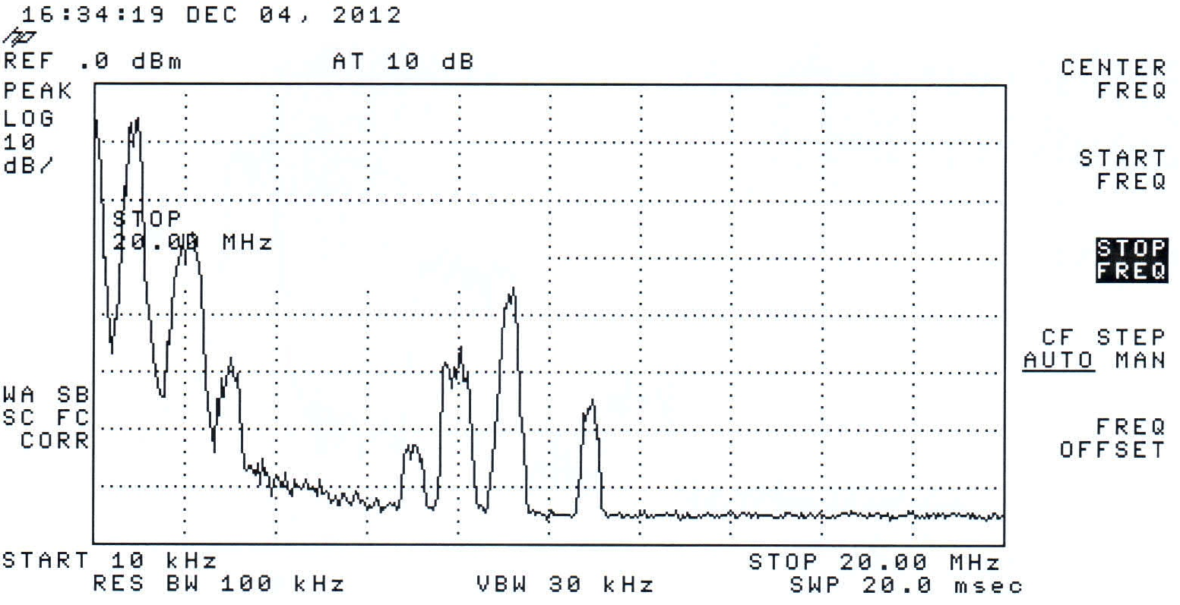
Figure 2b. Power spectrum of the noise signal with reduced spectral leakage, granted by upsampling and interpolation of the noise sequence before the analog reproduction. In the test the output low-pass filter of the generator has been disabled in order to evaluate the entity of the distortion due to the DAC.

References

- N.J.Kasdin, “Discrete simulation of colored noise and stochastic processes and 1/f^{α} power law noise generation,” Proceedings of the IEEE, vol. 83, No. 5, May 1995, pp. 802-827.
- Dong-U Lee, W.Luk, J.D.Villasenor, P.Y.K.Cheung “A Gaussian noise generator for hardware based simulations,” IEEE Transactions on Computers, vol. 53, No. 12, Dec. 2004, pp. 1523-1534.
- L.Angrisani, M.D’Apuzzo, M.D’Arco, “A new method for power measurements in digital wireless communication systems”, IEEE Transactions on Instrumentation and Measurement, Vol.52, n.4, August 2003, pp.1097-1106.
- Dong-U Lee, W.Luk, J.D.Villasenor, G.Zang, P.H.W.Leong, “A hardware Gaussian noise generator using the Wallace method,” IEEE Transactions on Very Large Scale Integration (VLSI), vol. 13, No. 8, August 2005, pp. 911-920.
- L.Angrisani, M.D’Apuzzo, M.D’Arco, “Modelling timing jitter effects in digital-to-analog converters,” IEEE Transactions on Instrumentation and Measurement, Vol.58, n.2, February 2009, pp.330-336.
- C.Imperiale, “Programmable uniform-Gaussian, quasi-white noise generator and data acquisition-processing system for electrophysiology,” Measurement, Vol.20, n.3, March 1997, pp.149-163.
- G.Corsini, R.Saletti, “A 1/f^{α} power spectrum noise sequence generator,” IEEE Transactions on Instrumentation and Measurement, Vol. 37, No. 4, Dec 1988, pp. 615-619.
- L.Angrisani, M.D’Arco, C.C.A.Greenhall, R.Schiano Lo Moriello, “A digital signal processing instrument for real-time phase noise measurement,” IEEE Transactions on Instrumentation and Measurement, vol.57, n. 10, October 2008, pp. 2098-2107.
- D.B.Percival, “Simulating Gaussian random processes with specified spectra,” Comput. Sci. Stat., vol. 24, pp. 534–538, 1992.
- P.Robbins, “Using Noise for RF receiver built-in test applications,” Microwave Journal, February 2004.
- L.De Vito, S.Rapuano, M.Villanacci, “Prototype of an automatic digital modulation classifier embedded in a real-time spectrum analyzer,” IEEE Transactions on Instrumentation and Measurement, Vol.59, October 2010, pp.2639–2651.
- D.L.Carnì, L.De Vito, S.Rapuano, “A portable instrument for automatic detection and classification of telecommunication signals,” Measurement, Vol.45, No.2, February 2012, pp.182-189.
- R.C.Martins, A.C.Serra, “ADC characterization by using the histogram test stimulated by Gaussian noise: Theory and experimental results,” Measurement, Vol.27, n.4, June 2000, pp.291-300.
- IEEE Std 1241-2000 “IEEE Standard for terminology and test methods for analog-to-digital converters”, Institute of Electrical and Electronics Engineers Inc., Published 13 June 2001.
- D.A.Lampasi, L.Podestà, P.Carbone, “Synthesis of binary test sequences with good spectral properties using an evolutionary algorithm,” Measurement, Vol.39, n.3, April 2006, pp.245-251.
- L.Krause, “Effective quantization by averaging and dithering,” Measurement, Vol.39, n.8, October 2006, pp.681-694.
- P.Carbone, D.Petri “Mean value and variance of noisy quantized data,” Measurement, Vol.23, n.3, April 1998, pp.131-144.
- L.Angrisani, F.Bonavolontà, M.D’Apuzzo, R.Schiano Lo Moriello, M. Vadursi, “A Compressive Sampling Based Method for Power Measurement of Band-Pass Signals”, in Proc. of IEEE I2MTC 2013, Minneapolis, USA, May 6-9, 2013.
- M.D’Apuzzo, M.D’Arco, L.Liccardo, M.Vadursi, “Modelling DAC output waveforms,” IEEE Transactions on Instrumentation and Measurement, vol.59, n.11, November 2010, pp.2854-2862.
- L.Angrisani, M.D’Apuzzo, M.D’Arco, “Fast transformation for DAC parameter identification,” IEEE Transactions on Instrumentation and Measurement, Vol.55, December 2006, pp.2007-2013.
- A.Baccigalupi, M.D’Arco, A.Liccardo, M.Vadursi, “Testing high resolution DACs: a contribution to draft standard IEEE P1658,” Measurement, Vol.44, n.6, July 2011, pp.1044-1052.
- M.D’Arco, A.Liccardo, N.Pasquino, “ANOVA based approach for DAC diagnostics,” IEEE Transactions on Instrumentation and Measurement, Vol.61, N.7, July 2012, pp.1874-1882.
- A.Baccigalupi, M.D’Arco, A.Liccardo, M.Vadursi, “Test equipment for DAC performance assessment: design and characterization,” IEEE Transactions on Instrumentation and Measurement, vol.59, n.5, May 2010, pp.1027-1034.

