**Application of intelligent instruments for the monitoring of thrust reverse noise at airports**

C. Asensio1, M. Ruíz1, M. Recuero1, G. Moschioni2, M. Tarabini2,

*1 Universidad Politécnica de Madrid (I2A2), 28031 Madrid (Spain), EUITT – Ctra. de Valencia km 7, Tfn: +34 91 336 7807, casensio@i2a2.upm.es*

*2 Politecnico di Milano (Dipartimento di Meccanica), 23900 Lecco (Italy), Via d'Oggiono 18, Tfn: +39 (0) 2 2399 8803, giovanni.moschioni@polimi.it*

***Abstract*-** Many airports all over the world have established some kind of restrictions for the use of thrust reverse for slowing down aircraft after landings, especially during the night period, as a way of reducing noise impact and the number of complaints in the vicinity of airports. This is the case of Madrid airport, where the Universidad Politécnica de Madrid, in collaboration with AENA, and the Politecnico di Milano have been researching, and developing intelligent instruments to improve the detection and classification of thrust reverse noise among other noise sources present in the airport.

Based on a traditional approach, the thrust reverse noise detection tool (TREND) detects two consecutive sound events, and applies pattern recognition techniques for the classification of each of them (such as landing and thrust reverse). A second improvement refers to the use of a microphone array linked to a noise monitoring unit, which enables tracking the direction of arrival of the sound, thus improving the classification rates. By taking the latter, it is also possible to track the aircraft location along the runway, which enables sound pressure measurements to be transformed into sound power level estimations. Although TREND must be optimized and customized, the results have shown quite good classification rates (over 90%).

**I. Introduction**

Noise is a major reason for concern regarding environmental protection around airports. Among all the noise sources, the activation of the thrust reverser to slow down the aircraft after landing is well known -by airport authorities- as a major cause of acoustic impact (and also emissions), annoyance and complaints in the vicinity of airports. Although the weight of this noise source on the overall long-term average noise assessment (Lden and Ln, for strategic noise mapping purposes) can be moderate, especially in those airports where runways are used either for landings and take-offs, the reverse thrust can be quite disturbing, as a rapid change of engine power from idle to reverse occurs causing a sudden burst of noise (in terms of LAmax, or LAE), as shown in Figure 1. Therefore, many airports have established restrictions for the use of thrust reversal after landing, especially during the night period, as a way of reducing the noise impact of airport operations on the community in circumstances where it is critical (for instance Paris-Orly, London-Heathrow, O’Hare-Chicago).

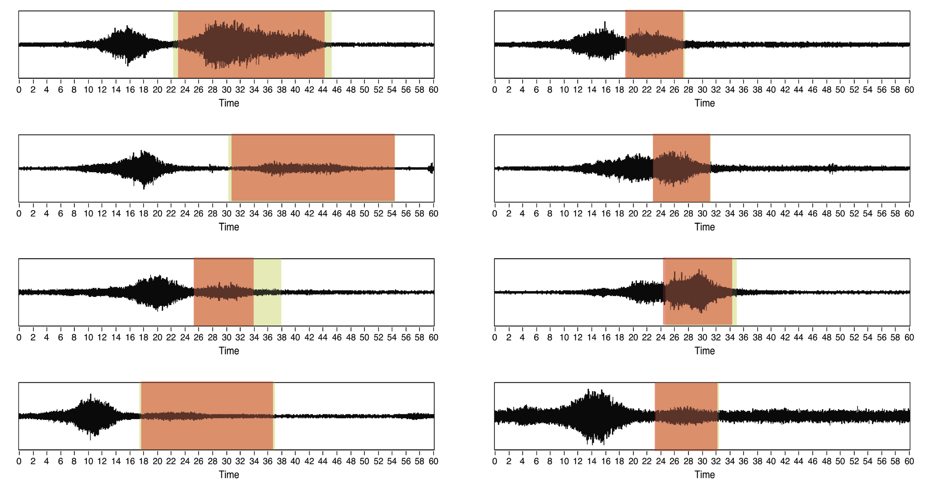

Figure 1. Audio signal of a landing with thrust reverse activation (highlighted)

The traditional approach for identifying thrust reverse noise is based on the detection of two consecutive sound events, by applying thresholds to the sound level measurements acquired by the airport’s noise monitoring units. But this technique has proved not to work properly in many cases, as there are many factors affecting the strength, separation and duration of the noise events: the aircraft model and the type of thrust reverser, the weather conditions, the company procedures, the aircraft’s final destination, the pilot’s behaviour…

The poor performance of the traditional methods, in practice, disables the sanctioning procedures, reducing the efficacy of regulations in fighting noise impact, and originating misalignment between environmental and time efficiency policies.

**II. Methodology**

The methodology described in this paper is also based on the detection of two consecutive sound events (EV1, for landing noise, and EV2, for sound reverse noise). But, in this case, the detection is improved by the application of acoustic modelling and signal processing practices. If the detectors are successful, EV1 and EV2 will be classified using statistical pattern recognition techniques. In order to complete the identification of a thrust reverse sound, both sound events must be detected and properly classified. Figure 2 shows the main system block diagram and Figure 3 shows a scheme on the field locations.



Figure 2. Thrust reverse noise detection system block diagram

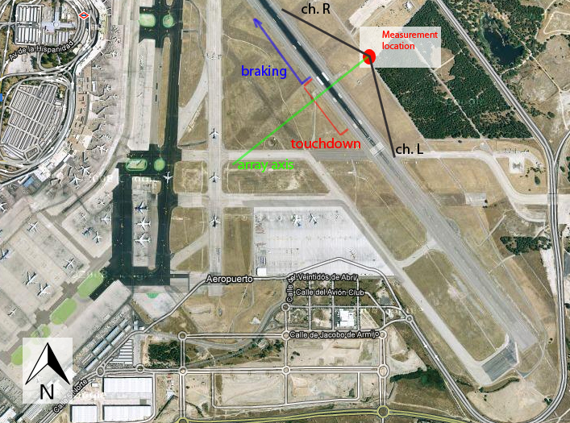

Figure 3. Field measurements scheme

**A. The EV1 detector**

The first stage in the TREND system is the detection of a landing sound event (EV1). A microphone acquires the sound signal, and the running sound pressure level is calculated and used for detection (Lp), applying time and level thresholds. Then, a band pass filter is applied to improve the detection by reducing the false positives rates (Lp(t), filtered). Figure 4 shows an example of the performance of the EV1 detector.

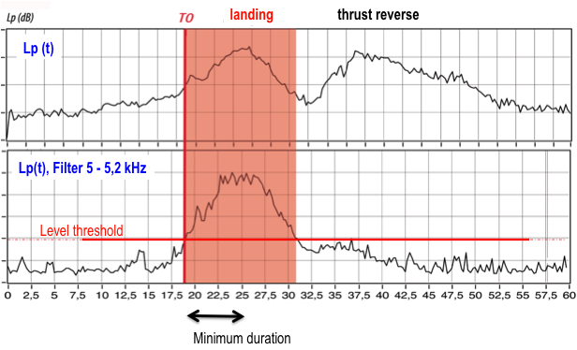

Figure 4. Example of EV1 detection

**B. The EV2 detector**

When a landing (EV1) is detected, the system starts searching for EV2 (Figure 5). The EV2 detector consists of a 2-channel microphone array, used for tracking the aircraft’s position along the runway. The delay between the signals captured in each microphone changes, depending on the relative position of the noise source (the aircraft) and the array. The delay is calculated using a cross-correlation method in the frequency domain [3]. This time delay of arrival allows estimating the direction of arrival of the sound [4], which is used to estimate the distance (r) between the aircraft and the sensors (see Equation 1, where d is the distance from the array to the runway, c is the speed of sound, xLR the distance between the two microphones in the array, and  is the delay obtained in the measurement).

|  |  |
| --- | --- |
| $$r=\frac{d}{sen\left(\cos^{-1}\left(\frac{c∙ΔT_{LR}}{x_{LR}}\right)\right)}$$ | (1) |

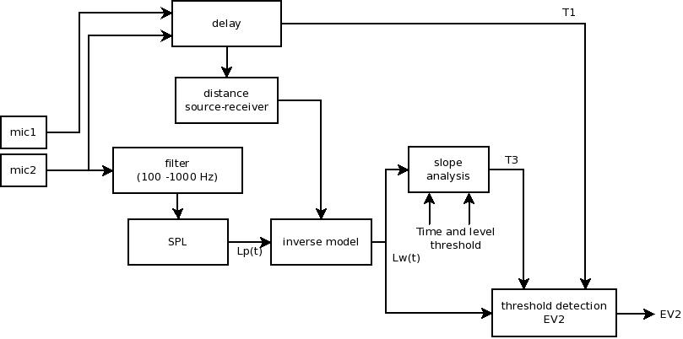

Figure 5. EV2 detector block diagram

Unlike sound pressure level, the distance from the source to the receiver does not affect sound power level; therefore, when the thrust reverser is activated, the sound power emitted increases suddenly, making it easier to detect. Taking advantage of this phenomenon, once we have calculated the distance, we use a simplified inverse sound propagation model to transform sound pressure level measurements into sound power level estimations using Equation 2.

|  |  |
| --- | --- |
| $Lw \left(t\right)=Lp\left(t\right)+20\log{r\left(t\right)}+\frac{r\left(t\right)}{1000}α+A$ $Lw \left(t\right)=Lp\left(t\right)+20\log{r\left(t\right)}+\frac{r\left(t\right)}{1000}α+A$ | (2) |

where Lw(t) is the sound power level (dB), Lp(t) the sound pressure level (dB), r(t) the distance from the source to the receiver (m), and α is a coefficient describing the atmospheric attenuation of sound with the distance (dB/Km), and A is a constant that counts for all other factors.

Using this transformation every thrust reverse sound event is enhanced, making its dynamic range higher (see Figure 6), thereby improving the performance of a threshold detector.

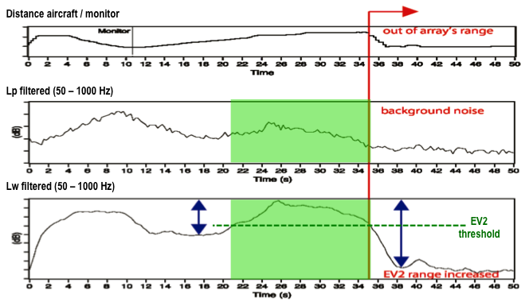

Figure 6. EV2 enhancement for detection

**C. EV1 detection improvement**

During landings, the aircraft arrives from the south (in this test case) and, as the distance decreases (Figure 3), the sound pressure level increases, triggering EV1 in time T0. At that time, the aircraft is at the left of the TREND system, and during EV1 the aircraft will change its position to the right. Therefore, during EV1 the array will detect a positive delay at the beginning that becomes negative in T1, which is the time when the aircraft is in front of the array axis (see Figure 7). In the event that a negative zero-crossing is not perceived within EV1, the event will be rejected (this is a constraint in this measurement setup). In the event that T1 is detected, the system starts searching EV2. This is a way to reduce the EV1’s false positive detection rates, as any sound event is rejected if its source was not strictly moving from left to right during the detection duration.

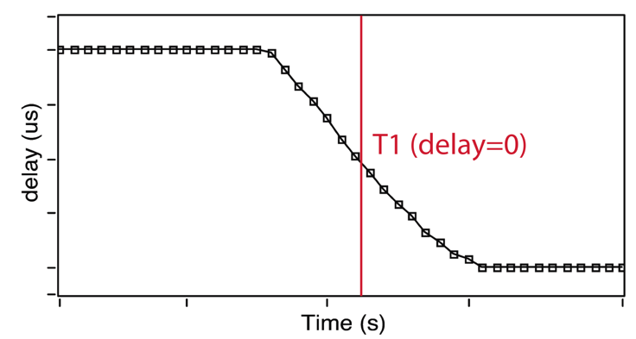

Figure 7. Time delay during a landing

**D. Events classification**

After detecting two consecutive sound events (EV1 and EV2), the system classifies them independently, in order to reduce the false positives identification rates. This process is carried out through the application of statistical pattern recognition techniques.

A feature extraction process is carried out for both events, describing the dynamic and frequency characteristics of the sounds, and also the position of the aircraft for each of the events. Mel frequency cepstal coefficients (MFCC) have shown a good performance in sound recognition applications, so the first 20 coefficients were selected. Two new features were selected to describe the evolution of the time delay between microphones during EV1 and EV2, which is highly correlated to the location and movement of the aircraft during both events.

The training and testing of the system was developed with Matlab-PRTools. The recognition process starts with a principal components analysis (PCA), used to decorrelate the data. Afterwards, a k-nearest neighbour [1] was used for thrust reverse events, and a Parzen classifier [2] was used for landing events.

The identification of thrust reverse activation is positive if the first event is classified as landing and the second one is classified as thrust reverse noise (see Figure 8).

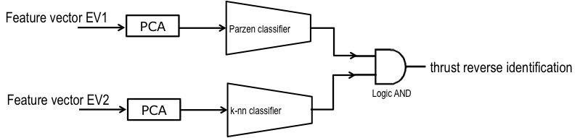

Figure 8. Thrust reverse noise identification

**II. Results**

Some tests were carried out at Madrid-Barajas airport. The recordings were manually edited and labelled, creating a sound events database, consisting of 315 landings with thrust reverse activation and 83 without it.

Table 1 shows the performance of the detectors. The EV1 detector has shown a great performance: only landings are detected as EV1s, and almost every landing is detected. On the other hand, EV2 detector performance is lower, as sources other than thrust reverse are incorrectly detected as EV2.

Table 1. Detection rates prior to classification

|  |  |  |  |
| --- | --- | --- | --- |
| **Detection rates** | **EV1 Detected** | **EV1 not detected** | **Error (%)** |
| Landings | 398 | 1 | 0.0 |
| Take-offs | 0 | 252 | 0.0 |
| **Detection rates** | **EV2 Detected** | **EV2 not detected** | **Error (%)** |
| Landings with thrust reverse | 315 | 14 | 4.0 |
| Landings without thrust reverse | 20 | 63 | 24.0 |

After the classification stage, the operation point of the detectors can be optimized, and the overall identification rates will be improved. The tests carried out showed an error rate lower than 10% (Table 2), which can still be optimized, on the one hand, with a proper customization of the sensors and the measurement setup, and on the other, with the use of the prior probability of thrust reverse occurrence during the training stage of the classifier.

Table 2. Overall identification results

|  |  |  |  |
| --- | --- | --- | --- |
|  | **Detection error rates (%)** | **Classification error rates (%)** | **Overall**  **error rates (%)** |
| Landing with thrust reverse | 4.0 | 4.9 | 8.5 |
| Landing without thrust reverse | 24.0 | 40.0 | 9.6 |

**II. Conclusions**

Threshold detections are not effective for identifyng thrust reverse noise at airports. Their performance can be improved by using pattern recognition techniques to classify previously detected sound events. Obviously, most of the noise events inside an airport are generated by aircraft, making it difficult to recognize each of them, as the different sound classes are not neatly separated. Tracking the location of the aircraft along the runway optimizes the performance of both the detection and the classification stages, reducing the error rates below 10%.

The sound power level estimation has shown a great performance for the identification of thrust reverse sound events, but it involves taking extra precautions, as not only the sound level is important, but also the cross-correlation between microphones (for instance, the protection of microphones against environmental conditions must be improved). It should be noted that the location of the TREND system must be carefully selected. The location must be as far as possible from the braking area in order to enhance the separation between sound events. But it must be close enough to capture the thrust reverse sound. The array parameters and the distance from the array to the runway must be chosen so that the operating angle of the instrument covers the typical landing and braking areas.

The described methodology can be implemented easily and reliably in an instrument, by simply applying common hardware and software resources to provide real time results regarding the activation of thrust reverse. These results, linked to those provided by noise monitoring units can be used, for instance, to complete any sanctioning procedure at an airport, or to analyze the effect or the need for restrictions regarding thrust reverser use. The methodology has been valid and effective for the measurements carried out at Madrid-Barajas airport.

**References**

[1] Cover, T.M.,Hart, P.E. 1967."Nearest neighbor pattern classification", IEEE transactions on information theory, vol. 13.

[2] Jain, A.K.,Ramaswami, M.D. 1988."Classifier design with Parzen windows", Pattern Recognition and artificial intelligence.

[3] Hertz, D. 1986."Time delay estimation by combining efficient algorithms and generalized cross-correlation methods", Acoustics, Speech and Signal Processing, IEEE Transactions on, vol. 34, no. 1, pp. 1-7.

[4] Valin, J.M., Michaud, F., Rouat, J. & Létoumeau, D. 2003, "Robust sound source localization using a microphone array on a mobile robot".

[5] Asensio, C.; Moschioni, G.; Ruiz, M.; Tarabini, M.; Recuero, M. Methodology and implementation of a thrust reverse noise detection system for airports. Transportation research Part D, 2013

[6] Asensio, C. Aportaciones a los sistemas de discriminación de Fuentes sonoras en la medida de ruido en aeropuertos. Universidad Politécnica de Madrid, 2012